TDA INTERNSHIP - WEEK 5 DOCUMENTATION
Advanced Data Manipulation with Pandas
Ankit Dash | Data Science Domain | May 2026 Batch

1. PROJECT OVERVIEW
Project Name: Customer Sales Analysis
Week: Week 5 - Advanced Data Manipulation with Pandas
Intern: Ankit Dash (EMP20260510-7263)
Domain: Data Science
Batch: 10-MAY-2026 | The Developers Arena (TDA)
Due Date: June 13, 2026
Description: A complete Pandas data manipulation project that loads sales and customer churn datasets, validates and cleans the data, creates calculated date and sales fields, performs aggregations and pivot tables, creates professional visualizations, and prepares business recommendations.
Goals & Objectives
- Use pandas to load, clean, validate, and analyze CSV datasets
- Group sales data by product, region, month, and customer
- Use multiple-condition filtering with AND and OR logic
- Apply string operations and datetime feature extraction
- Implement a merge audit between sales and customer datasets
- Create pivot tables for product-region and month-product summaries
- Create professional visual documentation and business recommendations

2. SETUP & INSTALLATION INSTRUCTIONS
Requirements: Python 3.10 or above, pandas, matplotlib, reportlab, python-docx, nbformat, pytest, and any OS with a terminal.
Step 1: Clone or download the GitHub repository.
Step 2: Open the project folder: cd TDA-Week-5-Customer-Sales-Analysis
Step 3: Install required libraries: pip install -r requirements.txt
Step 4: Run the analysis: python main.py
Step 5: Open the visualizations folder, outputs folder, analysis_report.pdf, and this documentation file.
Step 6: Run validation tests: pytest -q

3. CODE STRUCTURE EXPLANATION
TDA-Week-5-Customer-Sales-Analysis/
|-- README.md
|-- customer_analysis.ipynb
|-- main.py
|-- analysis.py
|-- requirements.txt
|-- sales_data.csv
|-- customer_data.csv
|-- analysis_report.pdf
|-- visualizations/
|-- reports/
|-- outputs/
|-- docs/
|-- tests/
- analysis.py contains reusable data loading, cleaning, filtering, aggregation, pivot table, merge audit, and formatting functions.
- main.py runs the full workflow, generates visualizations, writes output CSV files, creates the Markdown report, and exports the PDF report.
- customer_analysis.ipynb provides a notebook version of the analysis for review.
- tests/test_analysis.py validates schema, quality, summary metrics, filters, pivot tables, and merge-audit behavior.

4. SCREENSHOTS & VISUAL DOCUMENTATION
Figure 1
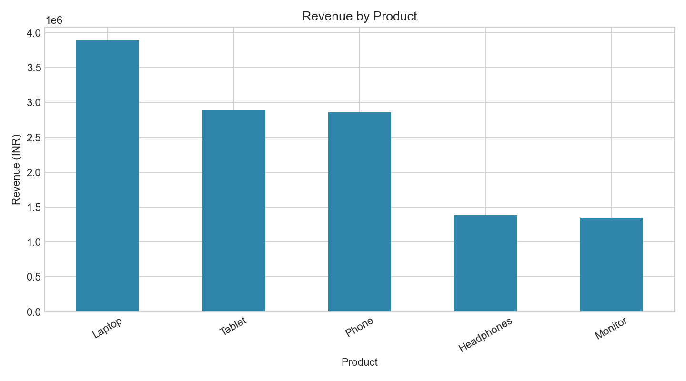
Figure 1: Bar chart showing total revenue by product
Figure 2
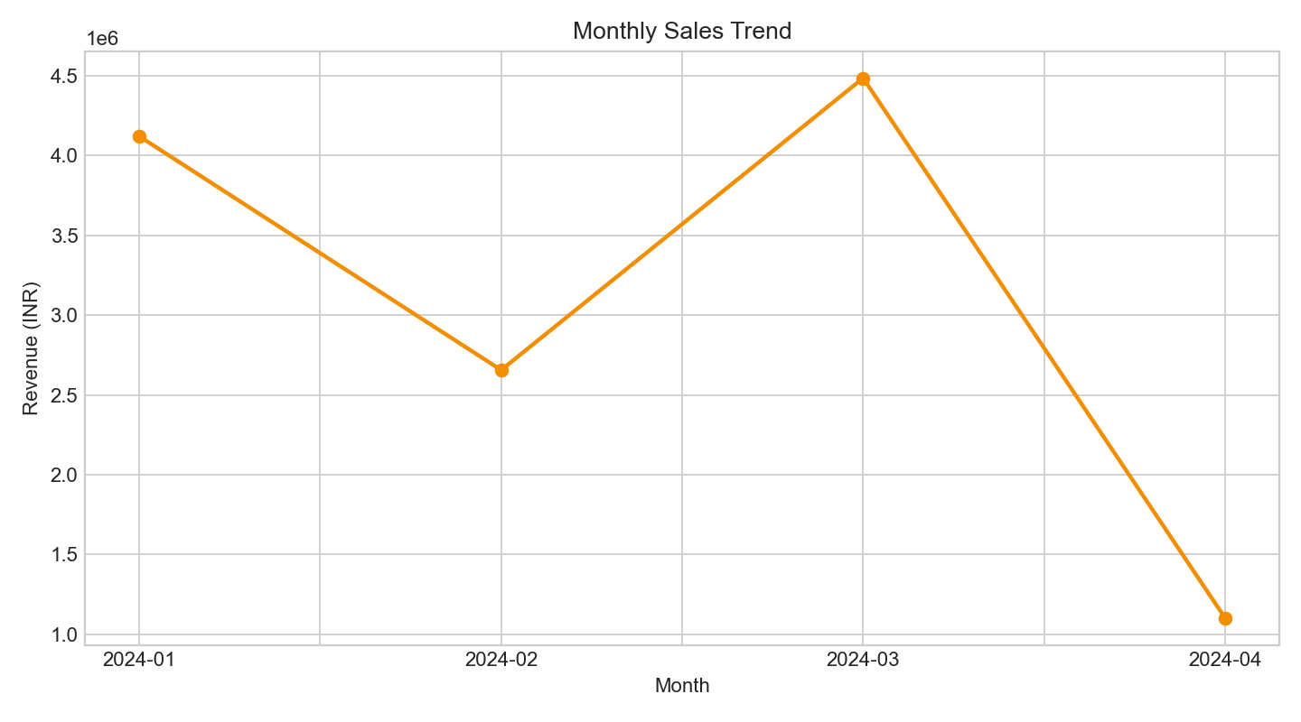
Figure 2: Line chart showing monthly sales trend
Figure 3
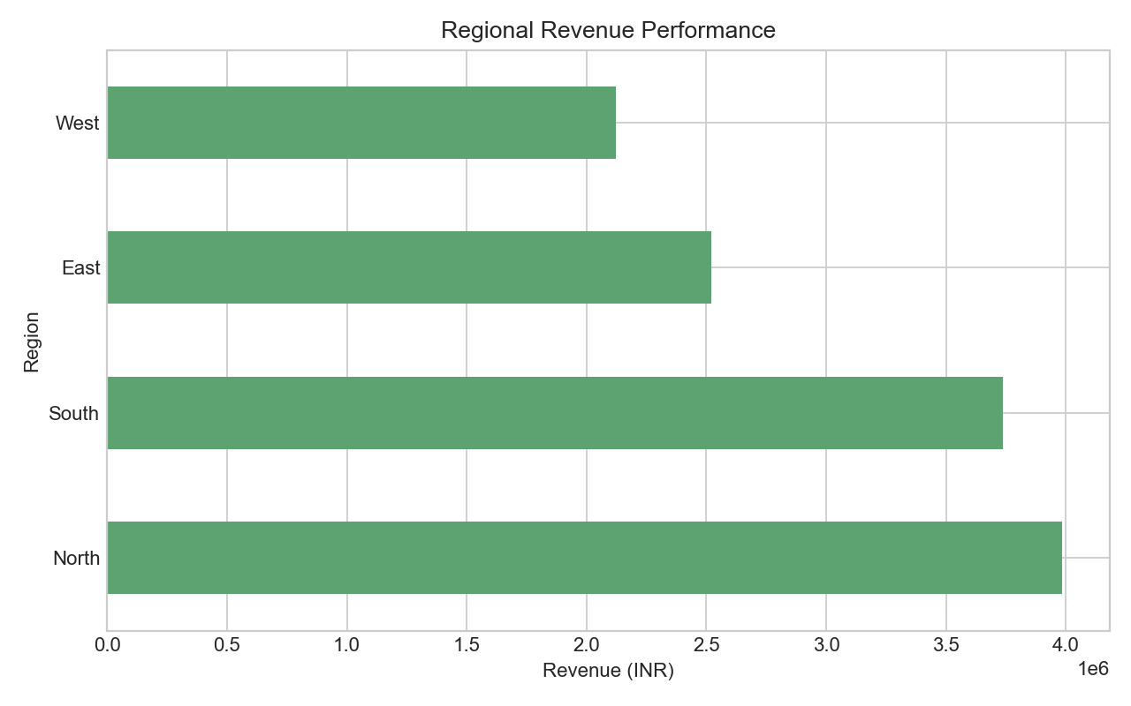
Figure 3: Horizontal bar chart showing regional revenue
Figure 4
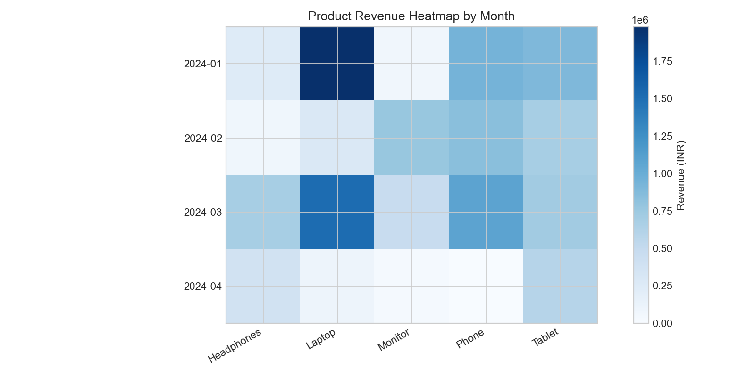
Figure 4: Heatmap showing product revenue by month
Figure 5
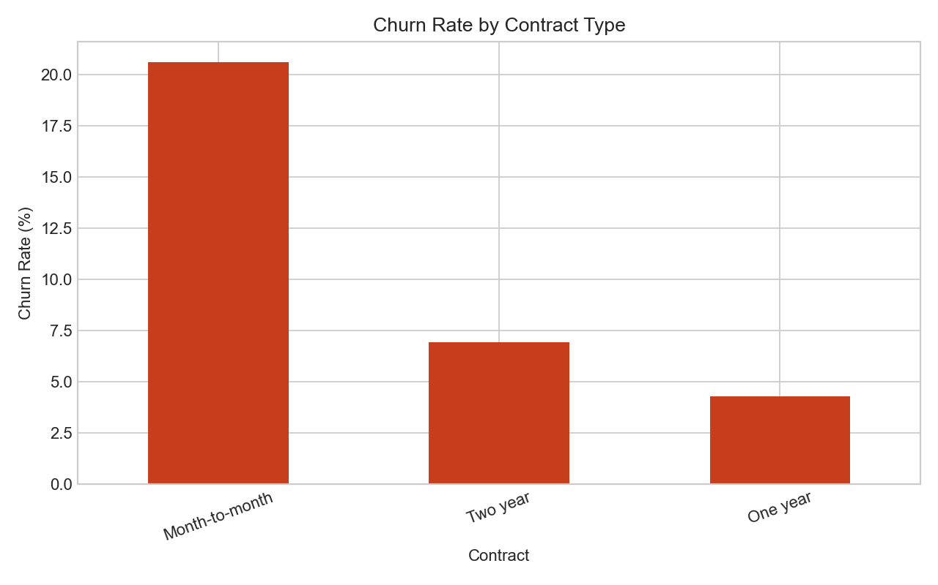
Figure 5: Churn rate by contract type

5. COMPLETE PROJECT REPORT WITH INSIGHTS
- Dataset contains 100 sales rows and 500 customer churn rows.
- No missing values and no duplicate rows were found in either dataset.
- Total revenue generated from the sales dataset is INR 12,365,048.
- Total units sold are 478 across 100 orders.
- Average order value is INR 123,650.
- Laptop is the strongest product category by revenue with INR 3,889,210.
- North is the highest-revenue region with INR 3,983,635.
- 2024-03 is the best month with INR 4,485,006 in sales.
- The customer churn dataset has an overall churn rate of 10.60%.
- The final PDF report is saved as analysis_report.pdf and the Markdown report is saved as reports/analysis_report.md.
Main Business Insights
- Laptop should be prioritized for stock planning and promotional focus because it contributes the highest revenue.
- North region shows the strongest sales performance and may be a good target for deeper customer analysis.
- March 2024 shows the highest monthly revenue, while April should not be compared directly because it is incomplete.
- Month-to-month contract customers should receive special retention attention because they have the highest churn risk.
- Future data collection should include shared customer IDs and order IDs to support true merging and cross-selling analysis.

6. TECHNICAL REQUIREMENTS - HOW I MET THEM
- Used pandas for all core data manipulation, cleaning, filtering, grouping, merging, and pivot tables.
- Created multiple aggregations: customer revenue, product revenue, regional revenue, monthly revenue, and churn by contract.
- Implemented data merging/joining through a customer profile merge audit between sales and churn data.
- Used pivot tables for product-region and month-product revenue summaries.
- Created five professional visualizations with titles, labels, colors, and readable formatting.
- Documented dataset limitations honestly where the supplied files could not support retention or cross-selling calculations.

7. ALGORITHMS & DATA STRUCTURES USED
- Sequential execution workflow: load data, validate, clean, analyze, visualize, report, and test.
- pandas DataFrame: main structure for sales and churn records.
- pandas Series: used inside groupby calculations and summary metrics.
- Dictionary: used for filters, summary metrics, and generated artifact tracking.
- Groupby aggregation: used for product, region, customer, month, and contract summaries.
- Datetime conversion: extracted year, month, day, month name, and period from sales dates.
- Pivot tables: summarized revenue by product-region and month-product combinations.
- Merge indicator: used to prove that sales and churn customer IDs do not overlap.
- Matplotlib plotting: used for bar, line, horizontal bar, heatmap, and churn charts.

8. TESTING EVIDENCE
Test Case 1 - Sales CSV Loading
Input: sales_data.csv
Output: Dataset loaded successfully with 100 rows - Passed
Test Case 2 - Customer CSV Loading
Input: customer_data.csv
Output: Dataset loaded successfully with 500 rows - Passed
Test Case 3 - Required Column Validation
Input: sales and customer DataFrames
Output: All required columns confirmed - Passed
Test Case 4 - Missing Values and Duplicates
Input: Original datasets
Output: Missing values = 0 and duplicate rows = 0 - Passed
Test Case 5 - Total Sales Validation
Input: Quantity and Price fields
Output: Quantity * Price matched Total_Sales for all rows - Passed
Test Case 6 - Aggregation Accuracy
Input: Clean sales data
Output: Total revenue INR 12,365,048 and total units 478 - Passed
Test Case 7 - Pivot Table Output
Input: Clean sales data
Output: Product-region and month-product pivot tables created - Passed
Test Case 8 - Merge Audit
Input: Sales customer IDs and churn customer IDs
Output: Zero matching IDs documented correctly - Passed
Test Case 9 - Visualization Output
Input: Analysis summary
Output: Five chart PNG files created in visualizations folder - Passed
Test Case 10 - Final Program Output
Input: python main.py
Output: Reports, outputs, and visualizations generated - Passed
Automated Test Command: pytest -q

9. QUALITY STANDARDS CHECKLIST
- Project Overview: Clear description of project goals and objectives included
- Setup Instructions: Step-by-step installation and run guide included
- Code Structure: Well-organized file hierarchy explained
- Visual Documentation: Five numbered figures included
- Technical Details: Algorithms, data structures, libraries, and architecture explained
- Testing Evidence: Test cases and validation examples included
- Complete Report: Final report with metrics, charts, and written insights included
- Professional Formatting: Numbered sections and clean documentation style used

10. WHAT I LEARNED
- Advanced Pandas operations make business analysis faster and more reliable.
- Pivot tables are useful for summarizing revenue across multiple business dimensions.
- Datetime features help identify monthly and seasonal patterns.
- Merge audits are important because datasets may not actually connect even when both contain customer fields.
- Good documentation should explain both findings and limitations.

11. CHALLENGES FACED
- Customer ID mismatch: Sales IDs and churn IDs used different formats, so the merge produced no matched records.
- Retention analysis limitation: Every sales customer appears once, so repeat-purchase retention cannot be calculated from sales data.
- Cross-selling limitation: Each sales row contains one product and no order ID, so product-pair analysis is not supported.
- Incomplete April data: April contains only nine days, so April was not treated as a full monthly comparison.
- Documentation challenge: The project explains limitations clearly while still meeting the Pandas manipulation requirements.
Document prepared by Ankit Dash for TDA Internship Week 5 Submission
The Developers Arena | Data Science Domain | May 2026 Batch

