TDA INTERNSHIP - WEEK 6 DOCUMENTATION
Data Visualization Mastery with Seaborn
Ankit Dash | Data Science Domain | May 2026 Batch

1. PROJECT OVERVIEW
Project Name: Interactive Sales Dashboard
Week: Week 6 - Data Visualization Mastery with Seaborn
Intern: Ankit Dash (EMP20260510-7263)
Domain: Data Science
Batch: 10-MAY-2026 | The Developers Arena (TDA)
Due Date: June 20, 2026
Description: A complete dashboard project that uses Seaborn statistical visualizations and Plotly interactivity to explain product performance, regional distribution, sales trends, customer/order segmentation, and metric relationships.
Goals & Objectives
- Create professional statistical visualizations with Seaborn
- Use box plots and violin plots to understand distributions
- Build correlation heatmaps for numerical variables
- Create a coordinated 2x2 subplot dashboard
- Build an interactive Plotly HTML dashboard with hover details
- Document how every visualization should be interpreted

2. SETUP & INSTALLATION INSTRUCTIONS
Requirements: Python 3.10 or above, pandas, numpy, matplotlib, seaborn, plotly, imageio, reportlab, python-docx, nbformat, nbclient, and pytest.
Step 1: Clone or download the repository.
Step 2: Open the project folder: cd wix-6
Step 3: Install required libraries: pip install -r requirements.txt
Step 4: Run the dashboard generator: python dashboard.py
Step 5: Open outputs/interactive_sales_dashboard.html in a browser.
Step 6: Review visualizations, dashboard_demo.gif, dashboard_report.pdf, and reports/dashboard_guide.md.
Step 7: Run validation tests: pytest -q

3. CODE STRUCTURE EXPLANATION
wix-6/
|-- README.md
|-- dashboard.ipynb
|-- dashboard.py
|-- analysis.py
|-- sales_data.csv
|-- requirements.txt
|-- dashboard_demo.gif
|-- dashboard_report.pdf
|-- visualizations/
|-- outputs/
|-- reports/
|-- docs/
|-- tests/
- analysis.py handles data loading, cleaning, feature creation, and dashboard summary metrics.
- dashboard.py creates Seaborn charts, Plotly interactive HTML dashboard, GIF demo, report files, and output summaries.
- dashboard.ipynb gives a notebook-based explanation of the dashboard workflow.
- tests/test_dashboard.py validates dataset quality, metrics, summaries, visual output generation, and Plotly HTML generation.

4. SCREENSHOTS & VISUAL DOCUMENTATION
Figure 1
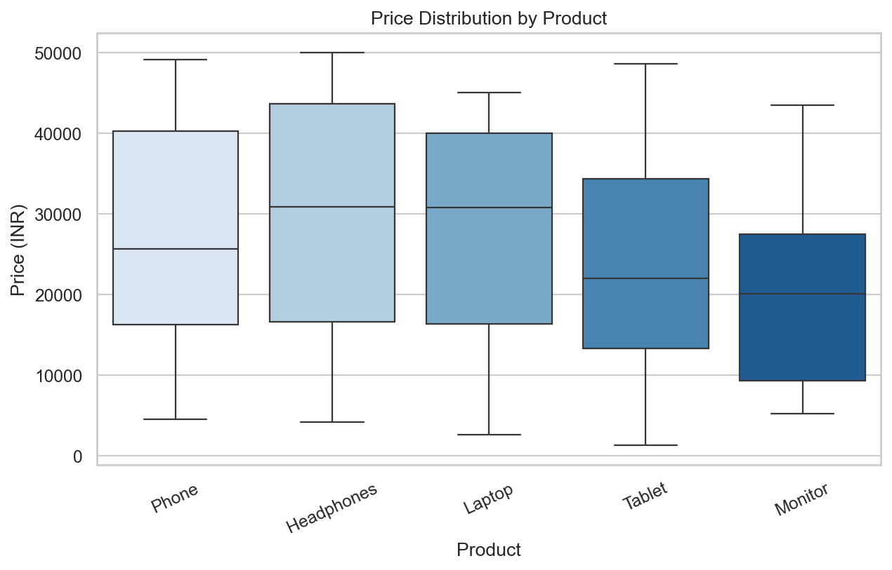
Figure 1: Box plot showing price distribution by product
Figure 2
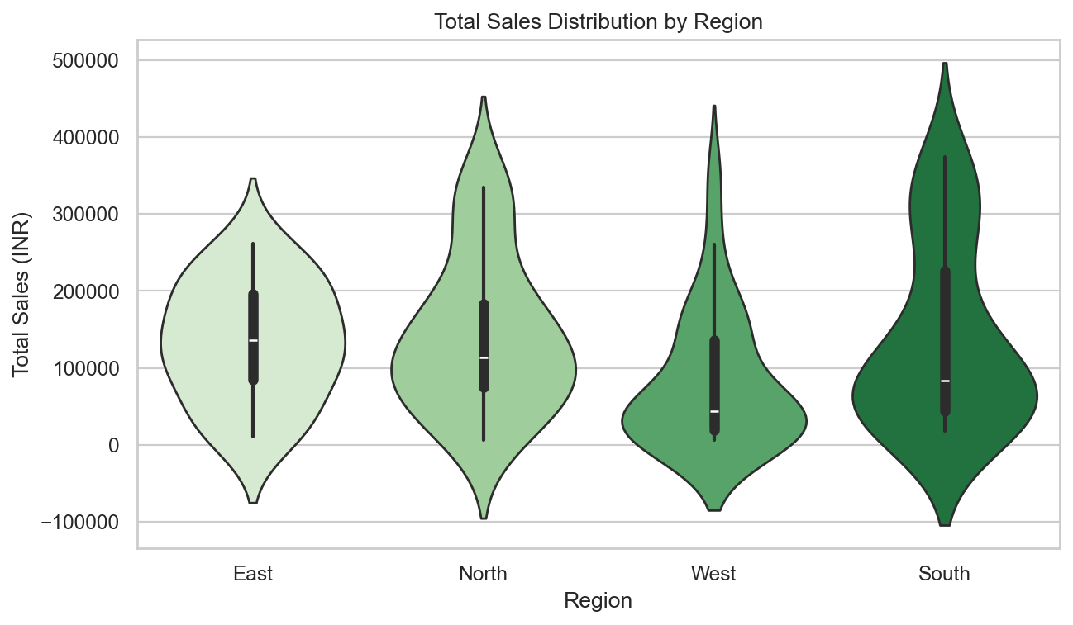
Figure 2: Violin plot showing total sales distribution by region
Figure 3
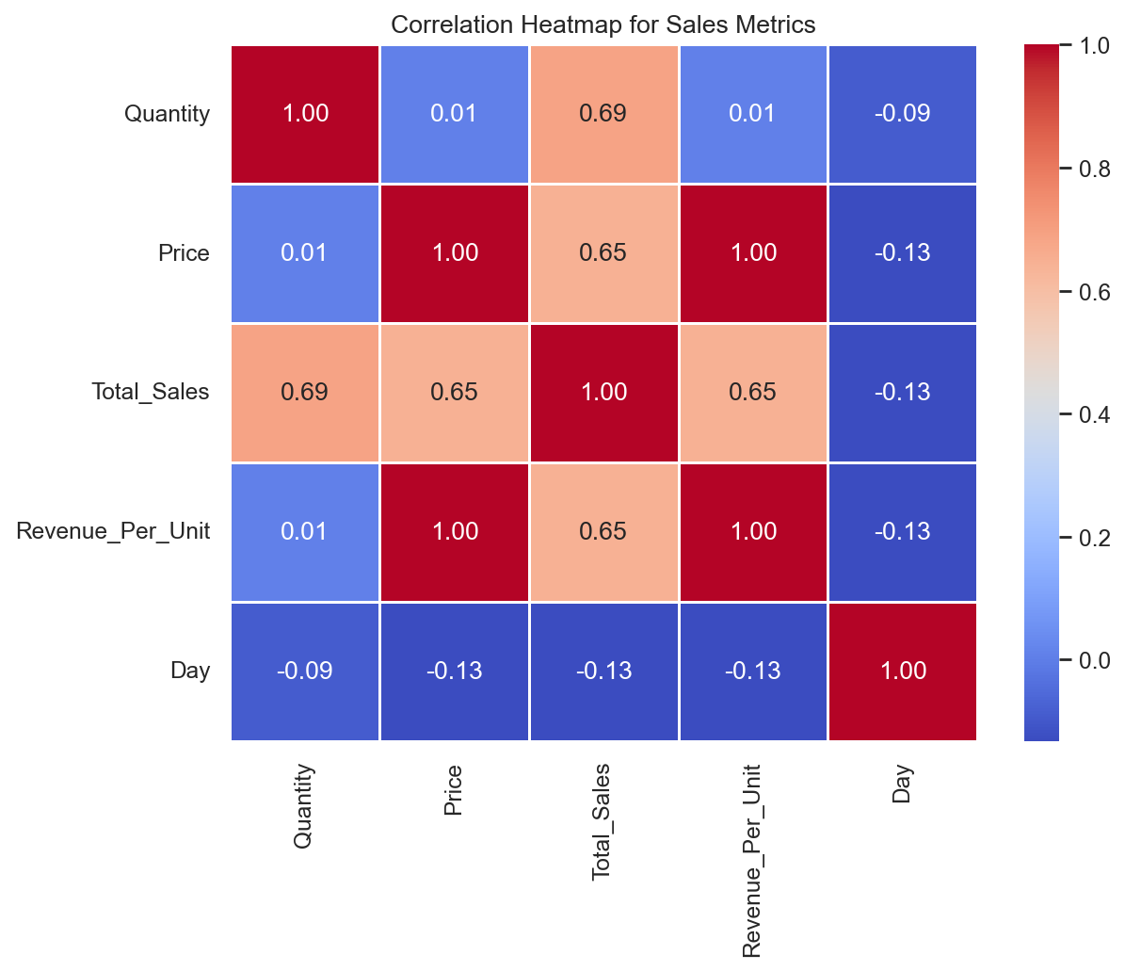
Figure 3: Correlation heatmap for numerical sales metrics
Figure 4
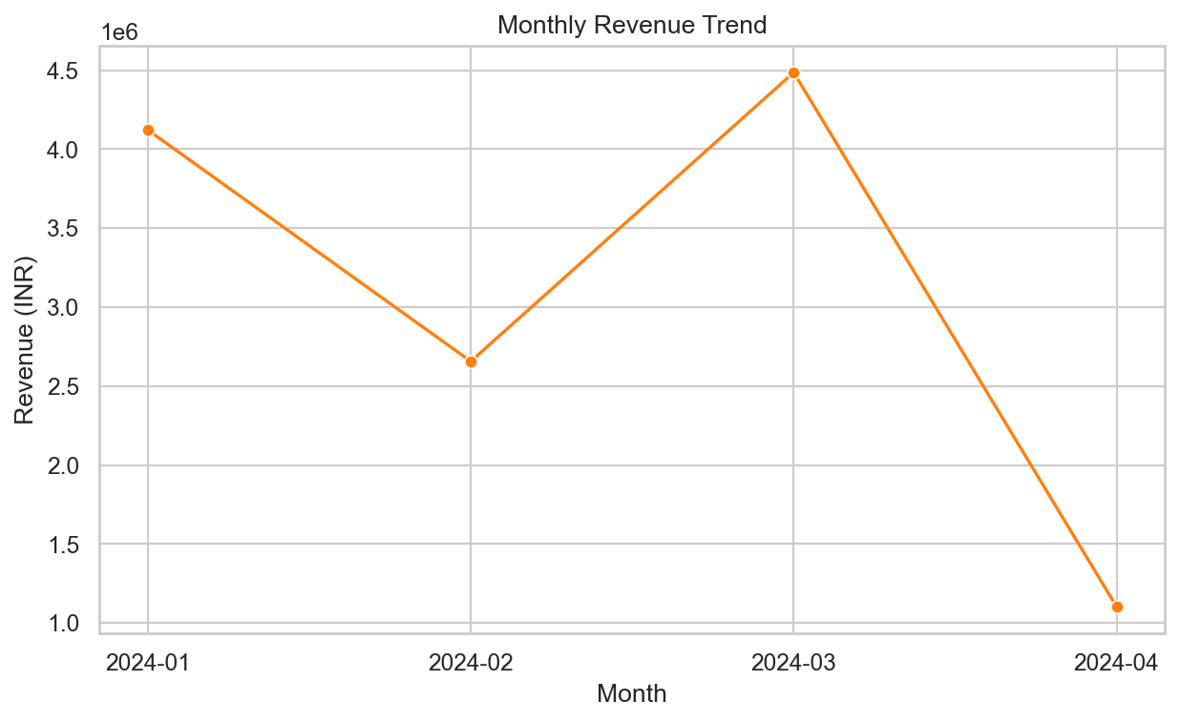
Figure 4: Line chart showing monthly revenue trend
Figure 5
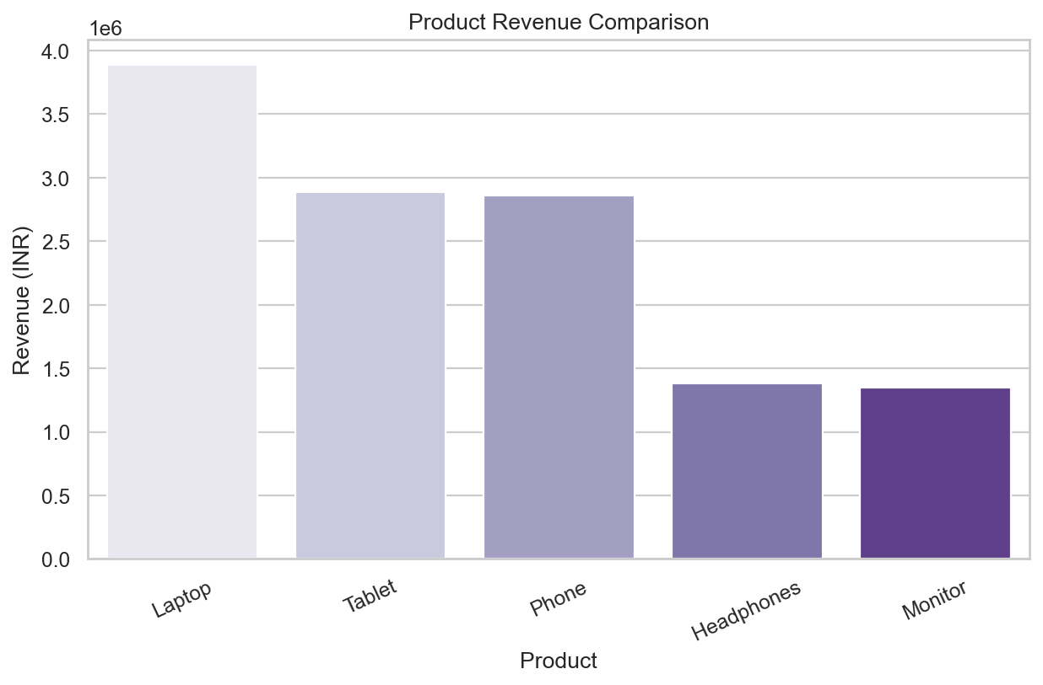
Figure 5: Bar chart comparing product revenue
Figure 6
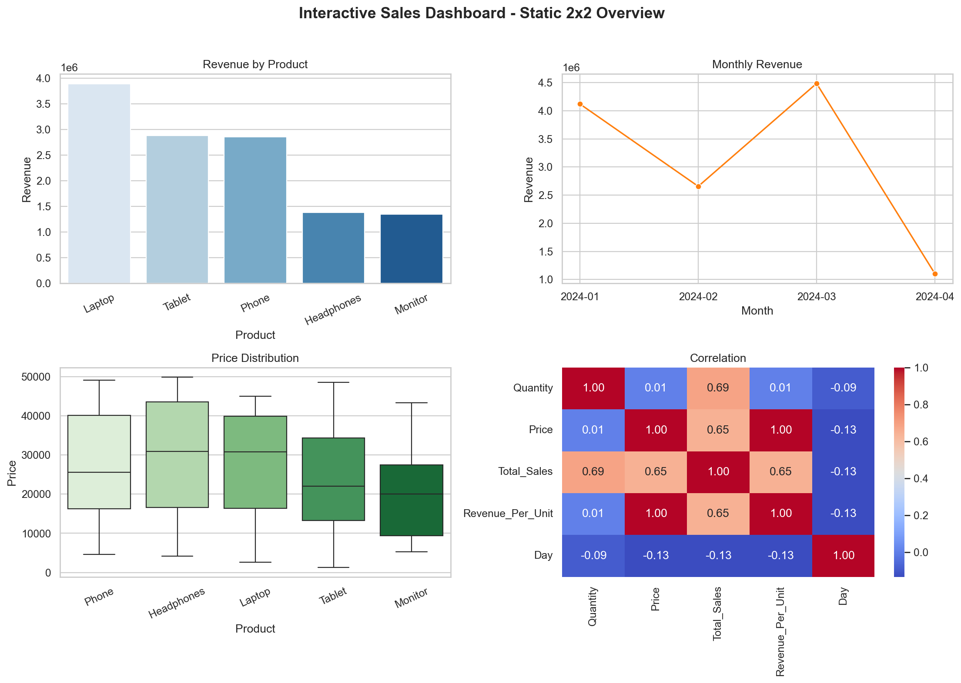
Figure 6: Professional 2x2 dashboard overview

5. COMPLETE DASHBOARD GUIDE WITH INSIGHTS
- Total revenue generated from the sales dataset is INR 12,365,048.
- Total orders are 100 and total units sold are 478.
- Average order value is INR 123,650.
- Laptop is the strongest product category by revenue.
- North is the highest-revenue region.
- 2024-03 is the best month in the dataset.
- The interactive dashboard is saved as outputs/interactive_sales_dashboard.html.
- The dashboard guide is saved as reports/dashboard_guide.md.
Visualization Interpretations
- Box plot: compares product price distribution and highlights spread.
- Violin plot: shows regional sales density and distribution shape.
- Heatmap: reveals correlations between quantity, price, total sales, unit revenue, and day.
- Monthly trend line: shows how revenue changes over time.
- Bar chart: ranks products by revenue.
- 2x2 dashboard: combines the most important visuals into a single executive view.
- Plotly dashboard: allows interactive hover-based exploration.

6. TECHNICAL REQUIREMENTS - HOW I MET THEM
- Used Seaborn for statistical plots including box plot, violin plot, heatmap, bar plot, and line plot.
- Created more than five chart types and exported them to the visualizations folder.
- Built interactive elements with Plotly in outputs/interactive_sales_dashboard.html.
- Applied a cohesive professional color palette across charts.
- Created a professional dashboard layout using a 2x2 subplot grid.
- Created dashboard_demo.gif to demonstrate visual outputs.

7. ALGORITHMS & DATA STRUCTURES USED
- pandas DataFrame: main structure for sales data.
- Datetime conversion: created month, month name, and day fields.
- Categorical segmentation: created order value bands for dashboard segmentation.
- Groupby aggregation: summarized product, region, monthly, and order-segment performance.
- Correlation matrix: calculated relationships between numerical sales metrics.
- Seaborn statistical plotting: created distribution, relationship, and summary charts.
- Plotly subplot dashboard: combined interactive bar, line, and pie charts.
- ImageIO GIF generation: combined exported charts into dashboard_demo.gif.

8. TESTING EVIDENCE
Test Case 1 - CSV Loading
Input: sales_data.csv
Output: Dataset loaded successfully with 100 rows - Passed
Test Case 2 - Required Column Validation
Input: Sales DataFrame
Output: All required columns confirmed - Passed
Test Case 3 - Data Cleaning
Input: Raw sales dataset
Output: No missing values, duplicates, or total-sales mismatches - Passed
Test Case 4 - Dashboard Metrics
Input: Clean sales data
Output: Revenue INR 12,365,048, top product Laptop, top region North - Passed
Test Case 5 - Static Visualizations
Input: Summary metrics
Output: Six chart PNG files created - Passed
Test Case 6 - Interactive Dashboard
Input: Sales summary
Output: Plotly HTML dashboard created - Passed
Test Case 7 - Dashboard GIF
Input: Static chart images
Output: dashboard_demo.gif created - Passed
Test Case 8 - Final Script Execution
Input: python dashboard.py
Output: Visualizations, outputs, report, HTML dashboard, and GIF generated - Passed
Automated Test Command: pytest -q

9. QUALITY STANDARDS CHECKLIST
- Project Overview: Clear dashboard goal and objectives included
- Setup Instructions: Step-by-step installation and run guide included
- Code Structure: Well-organized file hierarchy explained
- Visual Documentation: Six numbered figures and dashboard GIF included
- Technical Details: Libraries, algorithms, data structures, and dashboard architecture explained
- Testing Evidence: Automated and manual validation examples included
- Dashboard Guide: Interpretation of each visualization included
- Professional Formatting: Numbered sections and clean documentation style used

10. WHAT I LEARNED
- Seaborn makes statistical visualization easier and more professional.
- Box plots and violin plots explain distributions better than simple averages.
- Heatmaps help communicate numerical relationships quickly.
- Plotly adds useful interactivity for business users.
- Dashboard design requires both visual quality and clear interpretation.

11. CHALLENGES FACED
- Selecting chart types: Chose chart forms that match the business question instead of repeating the same visual.
- Dashboard layout: Organized charts into a clear 2x2 structure for readability.
- Interactive output: Created an HTML Plotly dashboard that can be opened locally in a browser.
- GIF creation: Used exported visualization images to create a simple dashboard demonstration.
- Interpretation writing: Explained what each visualization means for non-technical readers.
Document prepared by Ankit Dash for TDA Internship Week 6 Submission
The Developers Arena | Data Science Domain | May 2026 Batch

