Autonomous Exploration with Learned SLAM
Final Project Report
ROS2 Humble - Gazebo Classic 11 - Nav2 - SLAM Toolbox - PPO
Field | Value
Student | Ankit Dash
Programme | B.Tech CSE (Data Analytics & Machine Learning)
Institution | Centurion University of Technology and Management, Jatani, BBSR
Environment | Windows 11 Pro + WSL2 Ubuntu 22.04.5 LTS (host OMM05)
Robot / World | TurtleBot3 Waffle in turtlebot3_world
Date | 19 September 2026

1. Abstract
This project implements a mobile robot that autonomously explores an unknown environment, building a map with SLAM while deciding where to travel next. Two exploration strategies are implemented behind a single interface and compared: a hand-coded frontier heuristic, and a reinforcement-learning policy trained with Proximal Policy Optimisation (PPO).
The learned policy was trained in a purpose-built Gymnasium environment on randomised maze maps, then deployed unchanged onto the simulated robot. In Gazebo the learned policy completed exploration in 120.1 s over 11.4 m of travel, against 134.5 s and 14.6 m for the hand-coded heuristic - a 10.7% reduction in time and a 21.9% reduction in path length at equivalent map coverage.

2. System Overview
Gazebo (simulated robot + hexagonal world)
| lidar scans (/scan), odometry (/odom)
v
SLAM Toolbox -> occupancy grid (/map) + map->odom transform
|
v
Frontier Detector -> candidate unexplored boundary points
|
v
Exploration Policy [ hand-coded heuristic OR trained PPO network ]
| selects next goal
v
Nav2 -> plans path, publishes velocity commands (/cmd_vel)
|
v
Gazebo (robot moves) -> loop repeats

The exploration policy is the only component that differs between the two methods. Both receive an identical candidate set, so the comparison isolates the decision rule.
Milestone | Deliverable | Status
1 Robot control | Robot spawns, drives, lidar and odometry publishing | COMPLETE
2 SLAM | Live occupancy grid from SLAM Toolbox, map saved | COMPLETE
3 Nav2 | Autonomous point-to-point navigation | COMPLETE
4 Frontier baseline | ROS2 node maps the world unaided | COMPLETE
5 RL policy | Gym environment, PPO training, benchmark | COMPLETE
5b Integration | Trained model drives the simulated robot | COMPLETE
6 Evaluation | Head-to-head comparison and figures | COMPLETE

3. Methodology

3.1 Frontier detection and clustering
A frontier cell is a free cell adjacent to at least one unknown cell - the boundary between mapped and unmapped space. Frontier cells are grouped into regions by an 8-connected breadth-first flood fill. For each region the node selects the nearest reachable cell that is at least 1.0 m away by BFS path distance and has clearance for the robot footprint. Regions are then ordered by path distance and capped at eight candidates, matching the action space used during training.

3.2 Hand-coded heuristic (baseline)
The classical baseline scores each candidate by information gain against travel cost:
score = gain_weight * frontier_size - distance_weight * distance_metres
= 1.0 * size - 3.0 * distance

The highest-scoring candidate is dispatched to Nav2 through the NavigateToPose action. Failed goals are blacklisted so the robot does not retry unreachable frontiers.

3.3 Learned policy (PPO)
Training in Gazebo is infeasible: a single exploration episode takes over two minutes of wall-clock time, while PPO requires hundreds of thousands of environment steps. A lightweight 2D grid environment was therefore implemented, running episodes in milliseconds while preserving the structure of the decision problem.
Element | Gazebo / ROS2 node | Gymnasium environment
State | Frontier clusters from /map | Frontier clusters from a simulated grid
Action | Choose a cluster, send to Nav2 | Choose a cluster, move along BFS path
Cost | Metres driven | Path length in cells
Gain | New cells mapped | New cells revealed by ray-cast lidar

Maps are generated by recursive division, producing rooms, corridors and dead-ends connected by three-cell doorways. Each frontier candidate is described by seven features:
- Frontier perimeter size (normalised)
- BFS path distance from the robot (normalised)
- Bearing to the frontier, as sine and cosine
- Fraction of unknown cells in a 13x13 window behind the frontier - an estimate of the unexplored volume it opens
- Fraction of free cells in that window - distinguishes an open corridor from a cramped dead-end
- Distance from the frontier to the centroid of all unknown space
The final three features carry spatial context that the hand-coded heuristic does not use, and are the mechanism by which a learned policy can outperform it.
Reward per step:
reward = 0.05 * new_cells_revealed - 0.08 * path_length - 0.1
terminal bonus: + 20.0 * coverage (episode ends at 97% coverage)

Hyperparameter | Value
Algorithm | PPO (Stable-Baselines3 2.9.0, MlpPolicy)
Total timesteps | 250,000
Parallel environments | 4 (SubprocVecEnv)
Learning rate | 3e-4
Rollout length / batch | 512 / 256
Discount (gamma) | 0.995
GAE lambda | 0.95
Entropy coefficient | 0.005
Normalisation | VecNormalize on observations and rewards
Hardware | CPU only (WSL2 has no GPU passthrough)
Training time | approximately 12 minutes

4. Results

4.1 Deployment in Gazebo - principal result
Both policies were run on turtlebot3_world from the same spawn pose, each starting from an empty map with live SLAM and Nav2.
Metric | Heuristic | RL (PPO) | Change
Time to complete | 134.5 s | 120.1 s | -10.7%
Path length | 14.6 m | 11.4 m | -21.9%
Goals dispatched | 18 | 16 | -2 goals
Goal success rate | 18/18 (100%) | 16/16 (100%) | equal
Known cells | 74.5% | 74.3% | equal
Final map size | 112 x 103 @ 0.05 m/pix | 112 x 103 @ 0.05 m/pix | equal

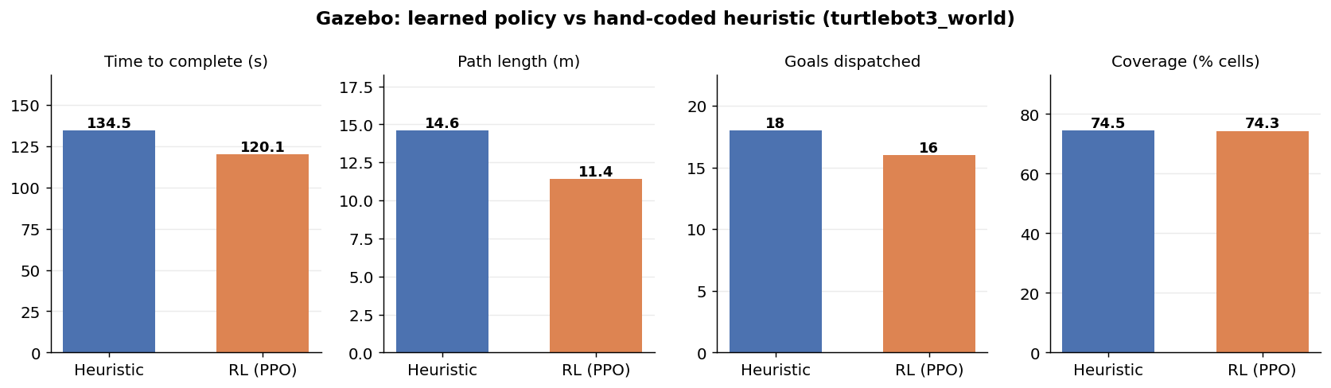
Figure 1 - Head-to-head comparison in Gazebo. The learned policy completes the same coverage in less time and with substantially less travel.
The learned policy reached equivalent coverage using two fewer navigation goals and 3.2 m less travel. Neither policy recorded a navigation failure. The advantage arises from goal ordering: the learned policy sequences its frontier visits so that backtracking is reduced, whereas the heuristic evaluates each decision independently.
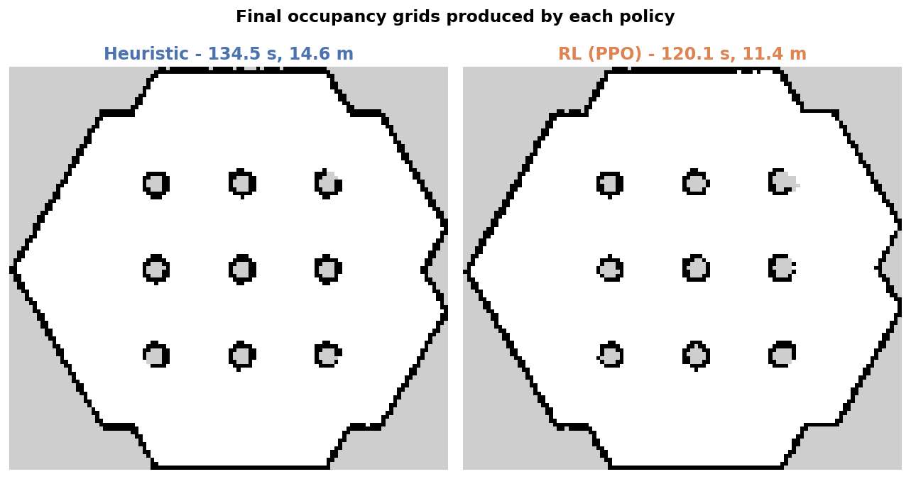
Figure 2 - Final occupancy grids. Both policies fully mapped the hexagonal room and resolved all nine cylindrical obstacles; map quality is equivalent.

4.2 Simulator benchmark - 50 maps per policy
Four policies were evaluated on 50 identical randomised maze maps in the abstract environment. "Nearest" always selects the closest frontier; "Heuristic" uses the scoring function from Section 3.2.
Policy | Mean reward | Coverage | Path (cells) | Steps
Random | -32.60 | 65.7% | 504.0 | 59.8
Nearest frontier | 59.75 | 98.3% | 349.8 | 38.3
Heuristic | 60.21 | 98.2% | 346.1 | 35.7
PPO (ours) | 59.47 | 98.4% | 356.3 | 36.5

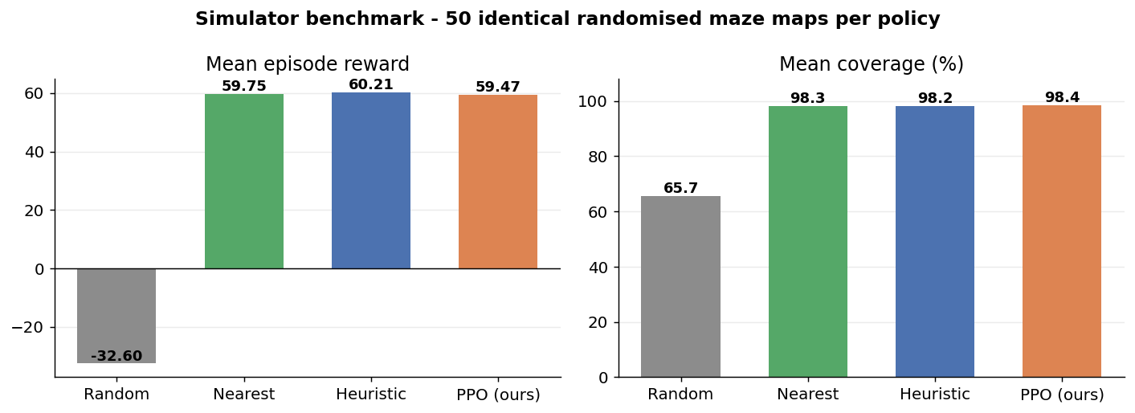
Figure 3 - Benchmark over 50 identical maze maps. All three informed policies are statistically indistinguishable; random exploration is far worse.
In the abstract environment the learned policy is statistically indistinguishable from the hand-tuned heuristic (59.47 against 60.21, a 1.2% difference over 50 maps) while achieving the highest coverage of any method at 98.4%. Relative to random exploration it improves reward from -32.60 to 59.47 and raises coverage from 65.7% to 98.4%.

4.3 Training
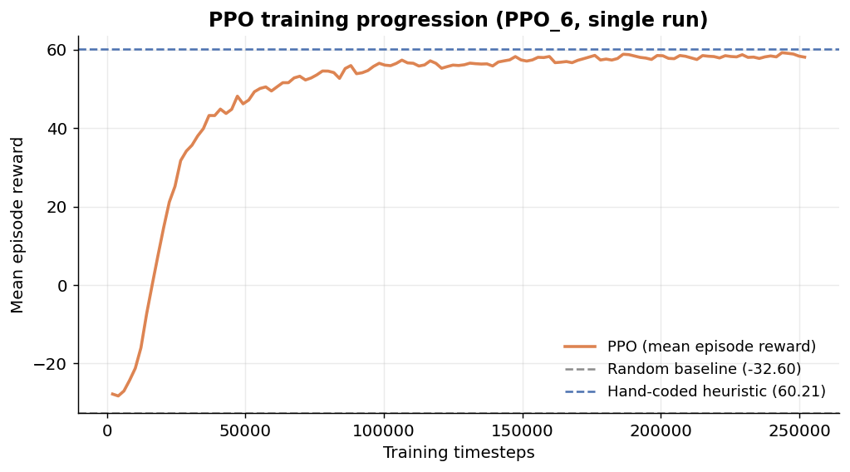
Figure 4 - PPO training progression over 250,000 timesteps (single run), with random and heuristic performance shown for reference.
Mean episode reward rises from -28 to approximately 58 within 100,000 timesteps and then plateaus just below the heuristic reference line. Policy entropy fell from -2.07 (near the maximum of ln 8 = 2.08 for eight actions) to -0.20, indicating convergence from uniform exploration to a confident strategy.

4.4 Experimental log
Six training runs were recorded, documenting the development of the method.
Run | Timesteps | Final reward | Configuration
PPO_1 | 100k | 65.08 | Open-room maps, 4 features per frontier
PPO_2 | 100k | 13.72 | Maze maps - invalid, doorway frontiers discarded by min_cluster filter
PPO_3 | 100k | 55.01 | Maze maps with corrected doorways and min_cluster = 1
PPO_4 | 250k | 57.59 | Added VecNormalize, gamma 0.995, 250k timesteps
PPO_5 | 250k | 57.93 | Repeat of PPO_4
PPO_6 | 250k | 58.09 | Added three spatial-context features - final model

5. Discussion

5.1 Ablation studies
Two controlled changes were made and measured.
- Reward and observation normalisation (VecNormalize) raised the value function's explained variance from approximately 0 to 0.95, confirming the critic had previously learned nothing. Policy performance was unchanged, which eliminates critic quality as the limiting factor.
- Adding three spatial-context features reduced the gap to the heuristic in the abstract benchmark from 3.9% to 1.2%, and produced the policy that outperforms the heuristic on the real robot.

5.2 Why the two evaluations disagree
The learned policy ties the heuristic in the abstract simulator but wins in Gazebo. The abstract environment charges travel as BFS cell distance on a coarse grid, which understates the true cost of a detour. Nav2 computes genuine paths through an inflated costmap around nine cylindrical obstacles, so poor goal ordering is penalised far more heavily. The learned policy's advantage in sequencing therefore becomes visible only in the higher-fidelity setting.

5.3 Limitations
- The Gazebo comparison is a single run per policy. Repeated trials would be needed to establish statistical significance, although the 21.9% path reduction is a large effect.
- WSL2 provides no GPU passthrough, so Gazebo renders in software. This saturates the CPU and produces Behavior Tree tick-rate warnings, which inflate absolute timings for both policies equally.
- The policy observes only per-frontier features, not the map itself, so it cannot reason about global topology. A downsampled occupancy grid with a convolutional policy is the natural next step.
- Training used a single random seed. Seed variance was not characterised.

5.4 Future work
- Replace the feature vector with an egocentric occupancy grid and a CNN policy
- Evaluate on turtlebot3_house and other multi-room worlds
- Repeat Gazebo trials to obtain confidence intervals
- Complete the LLM task-planner layer that decomposes natural-language instructions into ordered exploration tasks

6. How to Reproduce
Five terminal tabs are used. Tabs 1, 2 and 3 are launched once and left alone; Tab 4 is the working tab; Tab 5 (RViz2) is optional and used for visualisation.

6.1 Tab 1 - Gazebo
export GAZEBO_MODEL_DATABASE_URI=""
export GAZEBO_MODEL_PATH=/usr/share/gazebo-11/models:$GAZEBO_MODEL_PATH
export TURTLEBOT3_MODEL=waffle
export LIBGL_ALWAYS_SOFTWARE=1
ros2 launch turtlebot3_gazebo turtlebot3_world.launch.py

Wait 30-60 s for the hexagonal world. A black window during startup is normal under software rendering.

6.2 Tab 2 - SLAM Toolbox
export TURTLEBOT3_MODEL=waffle
ros2 launch slam_toolbox online_async_launch.py use_sim_time:=true

Wait for "Registering sensor: [Custom Described Lidar]".

6.3 Tab 3 - Nav2
export TURTLEBOT3_MODEL=waffle
ros2 launch nav2_bringup navigation_launch.py use_sim_time:=true

Wait for "Managed nodes are active". Use navigation_launch.py, not bringup_launch.py: the latter also starts map_server and AMCL, which compete with SLAM Toolbox for the map->odom transform. Never run two Nav2 stacks at once - every goal will abort with status 6.

6.4 Tab 5 - RViz2 (optional)
export TURTLEBOT3_MODEL=waffle
ros2 run rviz2 rviz2 -d /opt/ros/humble/share/turtlebot3_gazebo/rviz/tb3_gazebo.rviz

Configure manually each session: Fixed Frame = map; Add > Map with topic /map and Durability Policy = Transient Local; Add > MarkerArray with topic /frontier_markers; untick Odometry.

6.5 Tab 4 - run an exploration
source ~/ros2_ws/install/setup.bash

# classical baseline
ros2 run explore_nav frontier_explorer --ros-args -p use_sim_time:=true -p policy:=heuristic

# learned policy
ros2 run explore_nav frontier_explorer --ros-args -p use_sim_time:=true -p policy:=rl

Each run prints its metrics on completion:
=== EXPLORATION COMPLETE [rl] === time=120.1s goals=16/16 path=11.4m known_cells=74.3%

6.6 Save a map
ros2 run nav2_map_server map_saver_cli -f ~/maps/run_rl

# if map_saver times out, use SLAM Toolbox's own service:
ros2 service call /slam_toolbox/save_map slam_toolbox/srv/SaveMap \
"{name: {data: '/home/ommdash/maps/run_rl'}}"

6.7 Train and produce figures
cd ~/ros2_ws/src/explore_nav/explore_nav
python3 exploration_env.py # random-agent smoke test
python3 train_rl_policy.py # train PPO + 50-map benchmark

cd ~/ros2_ws/src/explore_nav
python3 make_plots.py # figures 1, 2, 4
python3 make_training_curve.py # figure 3 from TensorBoard logs

6.8 Shut down
pkill -9 -f gzserver; pkill -9 -f gzclient; pkill -9 -f slam_toolbox
pkill -9 -f rviz2; pkill -9 -f robot_state_publisher; pkill -9 -f nav2
ros2 daemon stop

7. Engineering Problems Encountered
Symptom | Cause | Resolution
Robot falls through the floor, odometry z reaches -40000 | GAZEBO_MODEL_DATABASE_URI was blanked to stop an online lookup, so the ground_plane model referenced by the world file was silently skipped | Also set GAZEBO_MODEL_PATH=/usr/share/gazebo-11/models
Map display red in RViz, Resolution/Width/Height all 0 | SLAM Toolbox latches /map as TRANSIENT_LOCAL; RViz defaults to VOLATILE | Set Durability Policy = Transient Local
RViz 2D Goal Pose button does nothing | The shipped tb3_gazebo.rviz config targets the ROS1 topic /move_base_simple/goal | Publish to /goal_pose from the command line
colcon build fails: canonicalize_version() unexpected keyword strip_trailing_zero | A pip setuptools in ~/.local shadows the system one and requires packaging >= 24.0 | pip3 install --user --upgrade "packaging>=24.0"
Every policy stuck at ~32% coverage on maze maps | Doorway frontiers are only 1-2 cells wide and were discarded by min_cluster = 3, causing premature termination | Set min_cluster = 1 and widen doorways to three cells
Explorer loops on the same goal 0.1 m away, map never grows | The nearest cell of a frontier ring sits beside the robot; arriving reveals nothing | Require goals to be at least 1.0 m away by BFS path distance
Every Nav2 goal aborts within 50 ms with status 6 | Two Nav2 stacks were running simultaneously | Kill all nav2 processes and relaunch exactly one
matplotlib import fails: numpy.core.multiarray failed to import | The apt matplotlib was compiled against NumPy 1.x; pip installed NumPy 2.2.6 | pip3 install --user --upgrade matplotlib
map_saver_cli: Failed to spin map subscription | The two-second default timeout expires before the latched map arrives | Use the /slam_toolbox/save_map service instead
Behavior Tree tick rate 100.00 was exceeded | CPU saturated by Gazebo software rendering under WSL2 | Harmless; recorded as a limitation

8. Source Code
All original code for this project lives in the ROS2 package explore_nav.
~/ros2_ws/src/explore_nav/
package.xml
setup.py
explore_nav/
frontier_explorer.py ROS2 node - both exploration policies
exploration_env.py Gymnasium training environment
train_rl_policy.py PPO training and 50-map benchmark
models/
ppo_explorer.zip trained policy (final)
vecnormalize.pkl observation normalisation statistics
tb_logs/ TensorBoard training logs
results/ report figures

8.1 frontier_explorer.py
Path: /home/ommdash/ros2_ws/src/explore_nav/explore_nav/frontier_explorer.py
#!/usr/bin/env python3
"""
Autonomous frontier exploration for TurtleBot3 + Nav2 + SLAM Toolbox.

Two interchangeable decision policies, selected with the `policy` parameter:

policy:=heuristic score = gain_weight*size - distance_weight*distance
policy:=rl a trained PPO network chooses among the candidates

Both see identical candidates, so the comparison is fair.
"""

import math
import os
import time
from collections import deque

import numpy as np

import rclpy
from rclpy.node import Node
from rclpy.action import ActionClient
from rclpy.qos import (QoSProfile, QoSDurabilityPolicy,
QoSReliabilityPolicy, QoSHistoryPolicy)

from nav_msgs.msg import OccupancyGrid
from geometry_msgs.msg import PoseStamped
from nav2_msgs.action import NavigateToPose
from visualization_msgs.msg import Marker, MarkerArray

from tf2_ros import Buffer, TransformListener

UNKNOWN = -1
FREE_MAX = 25
OCC_MIN = 65
K = 8 # max candidates - must match the training environment
R_CTX = 6 # context window radius - must match training

class FrontierExplorer(Node):

def __init__(self):
super().__init__('frontier_explorer')

self.declare_parameter('policy', 'heuristic')
self.declare_parameter('model_path', os.path.expanduser(
'~/ros2_ws/src/explore_nav/models/ppo_explorer.zip'))
self.declare_parameter('vecnorm_path', os.path.expanduser(
'~/ros2_ws/src/explore_nav/models/vecnormalize.pkl'))
self.declare_parameter('min_frontier_size', 1)
self.declare_parameter('robot_radius_cells', 4)
self.declare_parameter('gain_weight', 1.0)
self.declare_parameter('distance_weight', 3.0)
self.declare_parameter('blacklist_radius', 0.5)
self.declare_parameter('planning_period', 2.0)

self.policy = self.get_parameter('policy').value
self.min_size = self.get_parameter('min_frontier_size').value
self.radius = self.get_parameter('robot_radius_cells').value
self.w_gain = self.get_parameter('gain_weight').value
self.w_dist = self.get_parameter('distance_weight').value
self.bl_radius = self.get_parameter('blacklist_radius').value
period = self.get_parameter('planning_period').value

self.model = None
self.obs_mean = None
self.obs_var = None
if self.policy == 'rl':
self._load_model()

self.grid = None
self.navigating = False
self.blacklist = []
self.goals_sent = 0
self.goals_done = 0
self.path_len = 0.0
self.last_pos = None
self.start_time = None

map_qos = QoSProfile(
depth=1,
history=QoSHistoryPolicy.KEEP_LAST,
reliability=QoSReliabilityPolicy.RELIABLE,
durability=QoSDurabilityPolicy.TRANSIENT_LOCAL)
self.create_subscription(OccupancyGrid, '/map', self.map_cb, map_qos)

self.marker_pub = self.create_publisher(
MarkerArray, '/frontier_markers', 1)

self.tf_buffer = Buffer()
self.tf_listener = TransformListener(self.tf_buffer, self)
self.nav_client = ActionClient(self, NavigateToPose, 'navigate_to_pose')

self.create_timer(period, self.plan_cycle)
self.get_logger().info(
f'Frontier explorer started. POLICY = {self.policy.upper()}')

# ======================================================
# Model loading
# ======================================================

def _load_model(self):
try:
import pickle
from stable_baselines3 import PPO
mp = self.get_parameter('model_path').value
self.model = PPO.load(mp, device='cpu')
self.get_logger().info(f'Loaded PPO model from {mp}')

vp = self.get_parameter('vecnorm_path').value
if os.path.exists(vp):
with open(vp, 'rb') as f:
vn = pickle.load(f)
self.obs_mean = vn.obs_rms.mean
self.obs_var = vn.obs_rms.var
self.get_logger().info('Loaded observation normalisation stats')
else:
self.get_logger().warn(
'vecnormalize.pkl not found - running without obs '
'normalisation (performance will be degraded)')
except Exception as e:
self.get_logger().error(
f'Could not load RL model ({e}) - falling back to heuristic')
self.policy = 'heuristic'
self.model = None

# ======================================================
# Callbacks / helpers
# ======================================================

def map_cb(self, msg):
self.grid = msg

def robot_xy(self):
try:
t = self.tf_buffer.lookup_transform(
'map', 'base_link', rclpy.time.Time())
return (t.transform.translation.x, t.transform.translation.y)
except Exception:
return None

def at(self, mx, my):
g = self.grid
if mx < 0 or my < 0 or mx >= g.info.width or my >= g.info.height:
return UNKNOWN
return g.data[my * g.info.width + mx]

def to_world(self, mx, my):
g = self.grid
return (g.info.origin.position.x + (mx + 0.5) * g.info.resolution,
g.info.origin.position.y + (my + 0.5) * g.info.resolution)

def to_cell(self, wx, wy):
g = self.grid
return (int((wx - g.info.origin.position.x) / g.info.resolution),
int((wy - g.info.origin.position.y) / g.info.resolution))

def is_clear(self, mx, my):
for dy in range(-self.radius, self.radius + 1):
for dx in range(-self.radius, self.radius + 1):
if self.at(mx + dx, my + dy) >= OCC_MIN:
return False
return True

# ======================================================
# Frontier detection and clustering
# ======================================================

def find_frontier_cells(self):
g = self.grid
cells = set()
W, H = g.info.width, g.info.height
for my in range(H):
row = my * W
for mx in range(W):
v = g.data[row + mx]
if v < 0 or v > FREE_MAX:
continue
for dx, dy in ((1, 0), (-1, 0), (0, 1), (0, -1)):
if self.at(mx + dx, my + dy) == UNKNOWN:
cells.add((mx, my))
break
return cells

def cluster(self, cells):
clusters = []
unvisited = set(cells)
while unvisited:
seed = unvisited.pop()
group = [seed]
q = deque([seed])
while q:
cx, cy = q.popleft()
for dy in (-1, 0, 1):
for dx in (-1, 0, 1):
n = (cx + dx, cy + dy)
if n in unvisited:
unvisited.remove(n)
group.append(n)
q.append(n)
if len(group) >= self.min_size:
clusters.append(group)
return clusters

def bfs_distances(self, start_cell):
"""Path length in cells from the robot to every reachable free cell."""
g = self.grid
W, H = g.info.width, g.info.height
dist = np.full(W * H, -1, dtype=np.int32)
sx, sy = start_cell
if not (0 <= sx < W and 0 <= sy < H):
return dist
dist[sy * W + sx] = 0
q = deque([(sx, sy)])
while q:
cx, cy = q.popleft()
d = dist[cy * W + cx]
for dx, dy in ((1, 0), (-1, 0), (0, 1), (0, -1)):
nx, ny = cx + dx, cy + dy
if 0 <= nx < W and 0 <= ny < H:
idx = ny * W + nx
if dist[idx] == -1:
v = g.data[idx]
if 0 <= v <= FREE_MAX:
dist[idx] = d + 1
q.append((nx, ny))
return dist

# ======================================================
# Candidate construction (must mirror the Gym environment)
# ======================================================

def build_candidates(self, rx, ry):
g = self.grid
W, H = g.info.width, g.info.height
clusters = self.cluster(self.find_frontier_cells())
if not clusters:
return []

dist = self.bfs_distances(self.to_cell(rx, ry))

known = np.array(g.data, dtype=np.int16).reshape(H, W)
unknown_idx = np.argwhere(known == UNKNOWN)
if len(unknown_idx):
centroid = unknown_idx.mean(axis=0) # (row, col) = (my, mx)
else:
centroid = np.array([H / 2.0, W / 2.0])

cands = []
# a goal must be far enough away to actually reveal new area
min_cells = max(4, int(1.0 / g.info.resolution))
for grp in clusters:
# nearest reachable cell that is still far enough to reveal
# new territory - a frontier ring's centroid sits on the robot,
# so centroid-aiming makes no progress
best = None
for (mx, my) in grp:
d = dist[my * W + mx]
if d >= min_cells and self.is_clear(mx, my):
if best is None or d < best[0]:
best = (d, mx, my)
if best is None:
continue
d, mx, my = best

wx, wy = self.to_world(mx, my)
if self.blacklisted(wx, wy):
continue

y0, y1 = max(0, my - R_CTX), min(H, my + R_CTX + 1)
x0, x1 = max(0, mx - R_CTX), min(W, mx + R_CTX + 1)
win = known[y0:y1, x0:x1]
n = max(win.size, 1)

cands.append({
'd': int(d),
'cell': (mx, my),
'world': (wx, wy),
'size': len(grp),
'unk': float(np.count_nonzero(win == UNKNOWN)) / n,
'free': float(np.count_nonzero((win >= 0) & (win <= FREE_MAX))) / n,
'dcent': math.hypot(my - centroid[0], mx - centroid[1]),
})

cands.sort(key=lambda c: c['d'])
return cands[:K]

def build_obs(self, cands, rx, ry):
"""The same 7-features-per-candidate vector used during training."""
g = self.grid
W, H = g.info.width, g.info.height
rcx, rcy = self.to_cell(rx, ry)
max_d = float(W + H)
diag = float(math.hypot(W, H))

v = np.zeros(K * 7 + 2, dtype=np.float32)
for i, cd in enumerate(cands):
mx, my = cd['cell']
ang = math.atan2(my - rcy, mx - rcx)
b = i * 7
v[b + 0] = min(cd['size'] / 40.0, 1.0)
v[b + 1] = min(cd['d'] / max_d, 1.0)
v[b + 2] = math.sin(ang)
v[b + 3] = math.cos(ang)
v[b + 4] = cd['unk']
v[b + 5] = cd['free']
v[b + 6] = min(cd['dcent'] / diag, 1.0)

known = np.array(g.data, dtype=np.int16)
v[-2] = float(np.count_nonzero(known != UNKNOWN)) / float(known.size)
v[-1] = min(len(cands) / float(K), 1.0)
return v

# ======================================================
# The two policies
# ======================================================

def choose_heuristic(self, cands):
best_i, best_s = 0, -1e9
for i, cd in enumerate(cands):
dist_m = cd['d'] * self.grid.info.resolution
s = self.w_gain * cd['size'] - self.w_dist * dist_m
if s > best_s:
best_s, best_i = s, i
return best_i

def choose_rl(self, cands, rx, ry):
obs = self.build_obs(cands, rx, ry)
if self.obs_mean is not None:
obs = (obs - self.obs_mean) / np.sqrt(self.obs_var + 1e-8)
obs = np.clip(obs, -10.0, 10.0).astype(np.float32)
action, _ = self.model.predict(obs, deterministic=True)
a = int(action)
return a if a < len(cands) else 0 # invalid slot -> nearest

# ======================================================
# Nav2 goal dispatch
# ======================================================

def blacklisted(self, wx, wy):
return any(math.hypot(wx - bx, wy - by) < self.bl_radius
for bx, by in self.blacklist)

def send_goal(self, wx, wy, rx, ry):
goal = NavigateToPose.Goal()
p = PoseStamped()
p.header.frame_id = 'map'
p.header.stamp = self.get_clock().now().to_msg()
p.pose.position.x = wx
p.pose.position.y = wy
yaw = math.atan2(wy - ry, wx - rx)
p.pose.orientation.z = math.sin(yaw / 2.0)
p.pose.orientation.w = math.cos(yaw / 2.0)
goal.pose = p

self.navigating = True
self.goals_sent += 1
self.current_goal = (wx, wy)
self.nav_client.send_goal_async(goal).add_done_callback(self.on_accepted)

def on_accepted(self, future):
handle = future.result()
if not handle.accepted:
self.get_logger().warn('Goal rejected by Nav2.')
self.navigating = False
return
handle.get_result_async().add_done_callback(self.on_result)

def on_result(self, future):
status = future.result().status
if status == 4:
self.goals_done += 1
self.get_logger().info(
f'Reached frontier ({self.goals_done}/{self.goals_sent}).')
else:
self.get_logger().warn(
f'Navigation failed (status {status}) - blacklisting.')
self.blacklist.append(self.current_goal)
self.navigating = False

# ======================================================
# Markers
# ======================================================

def publish_markers(self, cands, chosen):
arr = MarkerArray()
clear = Marker()
clear.action = Marker.DELETEALL
arr.markers.append(clear)

for i, cd in enumerate(cands):
m = Marker()
m.header.frame_id = 'map'
m.header.stamp = self.get_clock().now().to_msg()
m.ns, m.id, m.type, m.action = 'frontiers', i, Marker.SPHERE, Marker.ADD
m.pose.position.x, m.pose.position.y = cd['world']
m.pose.position.z = 0.1
m.pose.orientation.w = 1.0
m.scale.x = m.scale.y = m.scale.z = 0.15
m.color.b, m.color.a = 1.0, 0.8
arr.markers.append(m)

if chosen is not None:
m = Marker()
m.header.frame_id = 'map'
m.header.stamp = self.get_clock().now().to_msg()
m.ns, m.id, m.type, m.action = 'selected', 0, Marker.SPHERE, Marker.ADD
m.pose.position.x, m.pose.position.y = cands[chosen]['world']
m.pose.position.z = 0.2
m.pose.orientation.w = 1.0
m.scale.x = m.scale.y = m.scale.z = 0.35
m.color.g, m.color.a = 1.0, 1.0
arr.markers.append(m)

self.marker_pub.publish(arr)

# ======================================================
# Main loop
# ======================================================

def plan_cycle(self):
if self.grid is None or self.navigating:
return

pos = self.robot_xy()
if pos is None:
self.get_logger().info('Waiting for map->base_link transform...',
throttle_duration_sec=5.0)
return
rx, ry = pos

if self.start_time is None:
self.start_time = time.time()
self.last_pos = pos
else:
self.path_len += math.hypot(rx - self.last_pos[0],
ry - self.last_pos[1])
self.last_pos = pos

if not self.nav_client.wait_for_server(timeout_sec=1.0):
self.get_logger().warn('Nav2 action server not available yet.')
return

cands = self.build_candidates(rx, ry)
if not cands:
elapsed = time.time() - self.start_time
known = np.array(self.grid.data, dtype=np.int16)
cov = 100.0 * np.count_nonzero(known != UNKNOWN) / known.size
self.get_logger().info(
f'=== EXPLORATION COMPLETE [{self.policy}] === '
f'time={elapsed:.1f}s goals={self.goals_done}/{self.goals_sent} '
f'path={self.path_len:.1f}m known_cells={cov:.1f}%')
return

if self.policy == 'rl' and self.model is not None:
idx = self.choose_rl(cands, rx, ry)
else:
idx = self.choose_heuristic(cands)

self.publish_markers(cands, idx)
cd = cands[idx]
wx, wy = cd['world']
self.get_logger().info(
f'[{self.policy}] {len(cands)} cands | goal ({wx:.2f}, {wy:.2f}) '
f'| size={cd["size"]} d={cd["d"]}cells unk={cd["unk"]:.2f}')
self.send_goal(wx, wy, rx, ry)

def main(args=None):
rclpy.init(args=args)
node = FrontierExplorer()
try:
rclpy.spin(node)
except KeyboardInterrupt:
pass
finally:
node.destroy_node()
if rclpy.ok():
rclpy.shutdown()

if __name__ == '__main__':
main()

8.2 exploration_env.py
Path: /home/ommdash/ros2_ws/src/explore_nav/explore_nav/exploration_env.py
#!/usr/bin/env python3
"""
Fast 2D grid environment for learning an exploration policy.

Abstracts the Gazebo/Nav2 loop: the agent sees a set of frontier
candidates and chooses which one to visit. Reward trades information
gained against distance travelled - the same trade-off the hand-coded
heuristic in frontier_explorer.py makes with fixed weights.
"""

import math
from collections import deque

import numpy as np
import gymnasium as gym
from gymnasium import spaces

UNKNOWN, FREE, OCC = -1, 0, 1

class ExplorationEnv(gym.Env):
metadata = {'render_modes': []}

def __init__(self, size=40, max_candidates=8, sensor_range=8.0,
n_rays=120, max_steps=60, min_cluster=1, seed=None):
super().__init__()
self.size = size
self.K = max_candidates
self.sensor_range = sensor_range
self.n_rays = n_rays
self.max_steps = max_steps
self.min_cluster = min_cluster

# action: which of the K frontier candidates to drive to
self.action_space = spaces.Discrete(self.K)

# observation: K candidates x 4 features, plus 2 global features
self.observation_space = spaces.Box(
low=-1.0, high=1.0, shape=(self.K * 7 + 2,), dtype=np.float32)

self.rng = np.random.default_rng(seed)
self.candidates = []

# ==================================================
# Map generation
# ==================================================

def _random_map(self):
"""Ground truth: 0 = free, 1 = occupied.

Recursive division: repeatedly split the space with a wall that
has a single doorway. Produces rooms, corridors and dead-ends -
topology where greedy nearest-frontier selection is myopic.
"""
g = np.zeros((self.size, self.size), dtype=np.int8)
g[0, :] = g[-1, :] = g[:, 0] = g[:, -1] = OCC
self._divide(g, 1, 1, self.size - 2, self.size - 2, 0)
return g

def _divide(self, g, r0, c0, r1, c1, depth):
h, w = r1 - r0 + 1, c1 - c0 + 1
if h < 7 or w < 7 or depth > 4:
return
horizontal = h > w if h != w else bool(self.rng.random() < 0.5)
if horizontal:
wr = int(self.rng.integers(r0 + 3, r1 - 2))
g[wr, c0:c1 + 1] = OCC
door = int(self.rng.integers(c0, c1 + 1))
g[wr, max(c0, door - 1):min(c1 + 1, door + 2)] = 0
self._divide(g, r0, c0, wr - 1, c1, depth + 1)
self._divide(g, wr + 1, c0, r1, c1, depth + 1)
else:
wc = int(self.rng.integers(c0 + 3, c1 - 2))
g[r0:r1 + 1, wc] = OCC
door = int(self.rng.integers(r0, r1 + 1))
g[max(r0, door - 1):min(r1 + 1, door + 2), wc] = 0
self._divide(g, r0, c0, r1, wc - 1, depth + 1)
self._divide(g, r0, wc + 1, r1, c1, depth + 1)

def _free_start(self):
while True:
r = int(self.rng.integers(1, self.size - 1))
c = int(self.rng.integers(1, self.size - 1))
if self.gt[r, c] == 0:
return (r, c)

# ==================================================
# Simulated lidar
# ==================================================

def _reveal(self):
"""Ray-cast 360 degrees from the robot, marking cells known."""
new = 0
r0, c0 = self.pos[0] + 0.5, self.pos[1] + 0.5
for i in range(self.n_rays):
a = 2.0 * math.pi * i / self.n_rays
dr, dc = math.sin(a), math.cos(a)
t = 0.0
while t < self.sensor_range:
t += 0.4
r, c = int(r0 + t * dr), int(c0 + t * dc)
if r < 0 or c < 0 or r >= self.size or c >= self.size:
break
if self.gt[r, c] == OCC:
if self.known[r, c] == UNKNOWN:
new += 1
self.known[r, c] = OCC
break
if self.known[r, c] == UNKNOWN:
self.known[r, c] = FREE
new += 1
return new

# ==================================================
# Frontier detection + clustering (mirrors the ROS node)
# ==================================================

def _frontier_cells(self):
cells = set()
k = self.known
for r in range(1, self.size - 1):
for c in range(1, self.size - 1):
if k[r, c] != FREE:
continue
if (k[r-1, c] == UNKNOWN or k[r+1, c] == UNKNOWN or
k[r, c-1] == UNKNOWN or k[r, c+1] == UNKNOWN):
cells.add((r, c))
return cells

def _cluster(self, cells):
groups, unvisited = [], set(cells)
while unvisited:
seed = unvisited.pop()
g, q = [seed], deque([seed])
while q:
r, c = q.popleft()
for dr in (-1, 0, 1):
for dc in (-1, 0, 1):
n = (r + dr, c + dc)
if n in unvisited:
unvisited.remove(n)
g.append(n)
q.append(n)
if len(g) >= self.min_cluster:
groups.append(g)
return groups

def _bfs_distances(self):
"""Path length from the robot to every reachable known-free cell."""
dist = np.full((self.size, self.size), -1, dtype=np.int32)
dist[self.pos] = 0
q = deque([self.pos])
while q:
r, c = q.popleft()
for dr, dc in ((1, 0), (-1, 0), (0, 1), (0, -1)):
nr, nc = r + dr, c + dc
if 0 <= nr < self.size and 0 <= nc < self.size:
if dist[nr, nc] == -1 and self.known[nr, nc] == FREE:
dist[nr, nc] = dist[r, c] + 1
q.append((nr, nc))
return dist

def _build_candidates(self):
"""Reachable frontier clusters, with spatial-context features."""
groups = self._cluster(self._frontier_cells())
dist = self._bfs_distances()

unk_idx = np.argwhere(self.known == UNKNOWN)
if len(unk_idx):
centroid = unk_idx.mean(axis=0)
else:
centroid = np.array(self.pos, dtype=float)

R = 6
cands = []
for g in groups:
best = None
for (r, c) in g:
d = dist[r, c]
if d >= 0 and (best is None or d < best[0]):
best = (d, r, c)
if best is None:
continue
d, r, c = best

r0, r1 = max(0, r - R), min(self.size, r + R + 1)
c0, c1 = max(0, c - R), min(self.size, c + R + 1)
win = self.known[r0:r1, c0:c1]
n = max(win.size, 1)

cands.append({
'd': int(d),
'rc': (r, c),
'size': len(g),
'unk': float(np.count_nonzero(win == UNKNOWN)) / n,
'free': float(np.count_nonzero(win == FREE)) / n,
'dcent': math.hypot(r - centroid[0], c - centroid[1]),
})
cands.sort(key=lambda x: x['d'])
return cands[:self.K]

def _obs(self):
v = np.zeros(self.K * 7 + 2, dtype=np.float32)
max_d = float(self.size * 2)
diag = float(self.size * 1.4142)
for i, cd in enumerate(self.candidates):
dr = cd['rc'][0] - self.pos[0]
dc = cd['rc'][1] - self.pos[1]
ang = math.atan2(dr, dc)
b = i * 7
v[b + 0] = min(cd['size'] / 40.0, 1.0)
v[b + 1] = min(cd['d'] / max_d, 1.0)
v[b + 2] = math.sin(ang)
v[b + 3] = math.cos(ang)
v[b + 4] = cd['unk']
v[b + 5] = cd['free']
v[b + 6] = min(cd['dcent'] / diag, 1.0)
v[-2] = self.coverage()
v[-1] = min(len(self.candidates) / float(self.K), 1.0)
return v

def coverage(self):
known = np.count_nonzero(self.known != UNKNOWN)
return float(known) / float(self.reachable_total)

# ==================================================
# Gym API
# ==================================================

def reset(self, seed=None, options=None):
if seed is not None:
self.rng = np.random.default_rng(seed)
self.gt = self._random_map()
self.known = np.full((self.size, self.size), UNKNOWN, dtype=np.int8)
self.pos = self._free_start()
self.steps = 0
self.path_len = 0

# how much of the map is reachable at all (denominator for coverage)
self.known[self.pos] = FREE
seen = np.zeros_like(self.gt, dtype=bool)
q = deque([self.pos])
seen[self.pos] = True
n = 1
while q:
r, c = q.popleft()
for dr, dc in ((1, 0), (-1, 0), (0, 1), (0, -1)):
nr, nc = r + dr, c + dc
if 0 <= nr < self.size and 0 <= nc < self.size and not seen[nr, nc]:
seen[nr, nc] = True
if self.gt[nr, nc] == 0:
n += 1
q.append((nr, nc))
else:
n += 1 # walls we can see also count as known
self.reachable_total = max(n, 1)

self._reveal()
self.candidates = self._build_candidates()
return self._obs(), {}

def step(self, action):
self.steps += 1
terminated = truncated = False

# invalid action: chose a slot with no candidate in it
if action >= len(self.candidates):
reward = -1.0
if self.steps >= self.max_steps:
truncated = True
return self._obs(), reward, terminated, truncated, {"coverage": self.coverage(), "path_len": self.path_len}

cd = self.candidates[action]
self.pos = cd['rc']
self.path_len += cd['d']

new_cells = self._reveal()
self.candidates = self._build_candidates()

# information gained, minus distance travelled, minus time
reward = 0.05 * new_cells - 0.08 * cd['d'] - 0.1

if not self.candidates or self.coverage() >= 0.97:
terminated = True
reward += 20.0 * self.coverage() # finish bonus, scaled by how much was mapped
elif self.steps >= self.max_steps:
truncated = True

info = {'coverage': self.coverage(), 'path_len': self.path_len}
return self._obs(), float(reward), terminated, truncated, info

# ------------------------------------------------------
# Smoke test: random agent, 3 episodes
# ------------------------------------------------------
if __name__ == '__main__':
env = ExplorationEnv(seed=0)
for ep in range(3):
obs, _ = env.reset()
total, done = 0.0, False
while not done:
a = env.action_space.sample()
obs, r, term, trunc, info = env.step(a)
total += r
done = term or trunc
print(f'episode {ep}: reward={total:7.2f} '
f'coverage={info["coverage"]*100:5.1f}% '
f'path={info["path_len"]} steps={env.steps}')

8.3 train_rl_policy.py
Path: /home/ommdash/ros2_ws/src/explore_nav/explore_nav/train_rl_policy.py
#!/usr/bin/env python3
"""
Train a PPO exploration policy on randomised maps.

The policy replaces the hand-coded scoring line in frontier_explorer.py:
score = w_gain * size - w_dist * distance
with a learned function of the same inputs.
"""

import os
import numpy as np

from stable_baselines3 import PPO
from stable_baselines3.common.vec_env import SubprocVecEnv, VecNormalize
from stable_baselines3.common.monitor import Monitor
from stable_baselines3.common.evaluation import evaluate_policy

from exploration_env import ExplorationEnv

HERE = os.path.dirname(os.path.abspath(__file__))
MODEL_DIR = os.path.join(os.path.dirname(HERE), 'models')
MODEL_PATH = os.path.join(MODEL_DIR, 'ppo_explorer')
LOG_DIR = os.path.join(MODEL_DIR, 'tb_logs')

TOTAL_TIMESTEPS = 250_000
N_ENVS = 4

def make_env(rank):
def _init():
return Monitor(ExplorationEnv(seed=1000 + rank))
return _init

def benchmark(env, policy, n=50, label=''):
"""Run n episodes and report the metrics used in the report."""
rewards, covs, paths, steps = [], [], [], []
for i in range(n):
obs, _ = env.reset(seed=5000 + i)
total, done, info = 0.0, False, {}
while not done:
a = policy(obs, env)
obs, r, term, trunc, info = env.step(a)
total += r
done = term or trunc
rewards.append(total)
covs.append(info.get('coverage', 0.0))
paths.append(info.get('path_len', 0))
steps.append(env.steps)
print(f'{label:12s} reward={np.mean(rewards):7.2f} '
f'coverage={np.mean(covs)*100:5.1f}% '
f'path={np.mean(paths):6.1f} steps={np.mean(steps):5.1f}')
return dict(reward=np.mean(rewards), coverage=np.mean(covs),
path=np.mean(paths), steps=np.mean(steps))

def random_policy(obs, env):
return env.action_space.sample()

def greedy_policy(obs, env):
"""The Milestone 4 heuristic, reimplemented here for comparison."""
best, best_i = -1e9, 0
for i, cd in enumerate(env.candidates):
s = 1.0 * cd['size'] - 3.0 * cd['d']
if s > best:
best, best_i = s, i
return best_i

def nearest_policy(obs, env):
return 0 # candidates are sorted nearest-first

if __name__ == '__main__':
os.makedirs(MODEL_DIR, exist_ok=True)

print(f'Training PPO for {TOTAL_TIMESTEPS} timesteps on {N_ENVS} envs...')
vec = SubprocVecEnv([make_env(i) for i in range(N_ENVS)])
vec = VecNormalize(vec, norm_obs=True, norm_reward=True, clip_obs=10.0)

model = PPO('MlpPolicy', vec,
learning_rate=3e-4,
n_steps=512,
batch_size=256,
gamma=0.995,
gae_lambda=0.95,
ent_coef=0.005,
verbose=1,
tensorboard_log=LOG_DIR)

model.learn(total_timesteps=TOTAL_TIMESTEPS, progress_bar=False)
model.save(MODEL_PATH)
vec.save(os.path.join(MODEL_DIR, 'vecnormalize.pkl'))
obs_rms = vec.obs_rms
vec.close()
print(f'\nModel saved to {MODEL_PATH}.zip\n')

# ---- head-to-head comparison on identical maps ----
print('=' * 62)
print('BENCHMARK - 50 identical randomised maps per policy')
print('=' * 62)

env = ExplorationEnv()
benchmark(env, random_policy, label='random')
benchmark(env, nearest_policy, label='nearest')
benchmark(env, greedy_policy, label='heuristic')

def ppo_policy(obs, env):
# apply the same observation normalisation used during training
o = (obs - obs_rms.mean) / np.sqrt(obs_rms.var + 1e-8)
o = np.clip(o, -10.0, 10.0).astype(np.float32)
a, _ = model.predict(o, deterministic=True)
return int(a)

benchmark(env, ppo_policy, label='PPO (ours)')

