**Project Report**

**Index**

|  |  |  |
| --- | --- | --- |
| **Sr. No.** | **Title** | **Page No.** |
| **1** | Introduction |  |
| **2** | Problem Definition & Scope |  |
| **2.1** | Problem Definition |  |
| **2.2** | Goals & Objectives |  |
| **2.3** | Major Constraints& Outcomes |  |
| **3** | Software Requirement Specification |  |
| **3.1** | Purposed System |  |
| **3.2** | Scope |  |
| **4** | System Modules |  |
| **5** | Performance-Requirements |  |
| **5.1** | H/W Requirements & S/W Requirements |  |
| **6** | UML Diagram |  |
| **6.1** | DFD |  |
| **6.2** | ERD |  |
| **6.3** | Use case diagram |  |
| **6.4** | Class Diagram |  |
| **6.5** | Sequence diagram |  |
| **6.6** | Activity Diagram |  |
| **6.7** | Deployment diagram |  |
| 6.8 | System Architecture |  |
| **7** | Test Cases |  |
| **8** | Screenshots |  |
| **9** | References |  |

1. **Introduction**

In today’s fast-paced educational environment, the need for efficient and integrated management systems has become paramount. Our project aims to develop a comprehensive web application that seamlessly combines an Institute Management System (IMS). This innovative solution is designed to streamline various administrative and academic processes, thereby enhancing the overall efficiency and effectiveness of educational institutions.

The primary purpose of the IMS component is to provide a robust framework for managing key educational activities, such as assessment and evaluation, student engagement and motivation, and education support. By leveraging modern technology, IMS aims to create a more interactive and supportive learning environment for students and faculty alike.

The target audience for this web application includes students, faculty members, and administrative staff within educational institutions. By addressing the unique needs of these diverse user groups, our project seeks to deliver a versatile and user-friendly platform that supports academic functions.

Overall, the implementation of this IMS is expected to significantly enhance the administrative and operational capabilities of educational institutions. It will not only improve the efficiency of routine tasks but also foster a more engaged and motivated academic community.

1. **Problem Definition & Scope**
   1. **Problem Definition**

Educational institutions often struggle with managing administrative and academic processes efficiently. Disjointed systems for managing assessments, student engagement, and education support lead to inefficiencies, data silos, and reduced productivity. There is a need for an integrated solution that combines various Institute Management functionalities to address these challenges comprehensively.

* 1. **Goals and Objective**
* To provide a centralized system for managing assessments and evaluations.
* To enhance student engagement and motivation through interactive tools.
* To offer robust education support services for students and faculty.
  1. **Major Constraints & Outcomes**

**Constraints:**

* Limited initial funding and resources for development.
* Integration challenges with existing systems and data.
* Ensuring data privacy and compliance with regulations.
* User adoption and training requirements.
* Technical limitations related to scalability and performance.
* Ensuring thorough testing to identify and resolve bugs and vulnerabilities.

**Expected Outcomes:**

* A fully integrated web application combining IMS functionalities.
* Improved efficiency in managing academic activities.
* Enhanced student and faculty satisfaction through better engagement and support.
* Secure and centralized data management ensuring easy accessibility and compliance.

1. **Software Requirement Specification**
   1. **Purposed System**

The proposed system is a comprehensive web application that integrates an Institute Management System (IMS) to streamline administrative and academic processes within educational institutions. The system aims to enhance efficiency, improve user experience, and provide robust functionalities to support educational needs.

* **Institute Management System (IMS):**
* **Assessment and Evaluation:** Provides tools for creating, administering, and grading exams and assignments. Offers analytics to track student performance and progress.
* **Engagement and Motivation:** Includes features like discussion forums, interactive content, and gamification to increase student participation and motivation.
* **Education Support:** Offers resources such as study materials, tutorials, and mentorship programs to support student learning and faculty teaching.
  1. **Scope**

**Functional Scope:**

* Develop a user-friendly web interface for the IMS component.
* Implement assessment tools for exams, quizzes, and assignments.
* Create interactive platforms for student engagement and motivation.
* Provide education support resources like digital libraries and tutoring systems.
* Ensure robust data security measures to protect sensitive information.

**Technical Scope:**

* Use modern web technologies (e.g., HTML, CSS, JavaScript, React) for frontend development.
* Implement backend services using scalable technologies (e.g., Node.js, Java) and databases (e.g., MySQL, MongoDB).
* Ensure compatibility with existing institutional systems and infrastructure.
* Design the system to be scalable to accommodate a growing number of users and data.
* Conduct thorough testing and quality assurance to ensure reliability and performance.

**User Scope:**

* Target users include students, faculty members, and administrative staff.
* Provide training and support to ensure effective use of the system.
* Design the system to be intuitive and user-friendly to minimize the learning curve.

**Operational Scope:**

* Ensure system uptime and reliability through robust infrastructure and support.
* Provide ongoing maintenance and updates to address user feedback and improve functionality.
* Establish support channels to assist users with technical issues and queries.

1. **System Modules**
2. **Performance-Requirements**
   1. **H/W Requirements & S/W Requirements**

**Hardware Requirements**

**Server-Side:**

* **Processor:** Multi-core CPU (e.g., Intel Xeon or AMD EPYC)
* **Memory:** Minimum 16 GB RAM, recommend scaling up based on expected user load
* **Storage:** SSD storage with RAID configuration, starting from 500 GB and scalable
* **Network:** High-speed internet connection with redundant connections
* **Backup:** Reliable backup solution, either cloud-based or physical

**Client-Side:**

* **Processor:** Dual-core CPU or better
* **Memory:** Minimum 4 GB RAM
* **Storage:** 20 GB free space
* **Network:** Stable internet connection
* **Display:** Minimum resolution of 1280x720

**Software Requirements**

**Server-Side:**

* **Operating System:** Linux or Windows Server
* **Web Server:** Apache
* **Database:** MySQL
* **Backend Technologies:** Node.js, Java (Spring Boot), or similar
* **API Server:** Express.js (if using Node.js)
* **Containerization (optional):** Docker and Kubernetes for deployment and scalability
* **Version Control:** Git

**Client-Side:**

* **Operating System:** Windows, macOS, or Linux
* **Web Browser:** Latest versions of Chrome, Firefox, Safari, or Edge
* **Frontend Technologies:** HTML5, CSS3, JavaScript, React.js

**Development Tools:**

* **IDE:** Visual Studio Code, IntelliJ IDEA, or any preferred IDE
* **Package Managers:** npm or yarn
* **Build Tools:** Webpack, Babel
* **Testing Frameworks:** Jest, Mocha, Chai
* **CI/CD Tools:** Jenkins, GitHub Actions, or GitLab CI

1. **UML Diagram**
   1. **DFD (Data Flow Diagram)**
   2. **ERD (Entity Relationship Diagram**

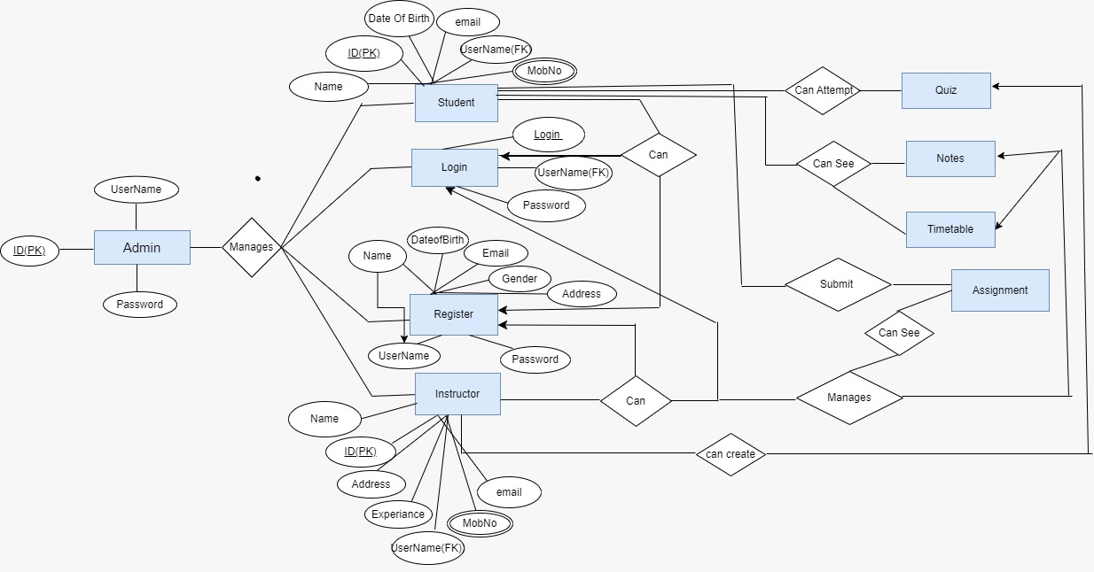

* 1. **Use Case Diagram**
  2. **Class Diagram**
  3. **Sequence Diagram**
  4. **Activity Diagram**
  5. **Deployment Diagram**
  6. **System Architecture**