FoodBox

The code for the project is hosted on: [GitHub](https://github.com/Ankit-mn/CapstoneProject.git) Project Developer: Ankit Patel

This document contains the following sections:

* Sprint Planning
* Core Concepts used in project
* Product capabilities and source code
* Unique Selling point of the Application
* Conclusion

# Sprint Planning and Task Completion

The project is planned to be completed in three Sprints. The task assumed to be completed are:

## Sprint 1:

* Deciding flow of the application
* Initializing Git repository to track changes of development
* Writing the backend source code
* Testing API with Postman

## Sprint 2:

* Planning Frontend design
* Writing the frontend source code
* Providing API interface to communicate with backend server (Tomcat)

## Sprint 3:

* Making Website mobile responsive
* Testing the application
* Pushing project to GitHub
* Creating documentation

# Core Concepts Used in the Project

* Java
* Spring Boot
* MySQL DB
* Postman
* Reactjs for UI
* Redux for state management
* Bootstrap for mobile responsiveness

Screenshots

Home Page

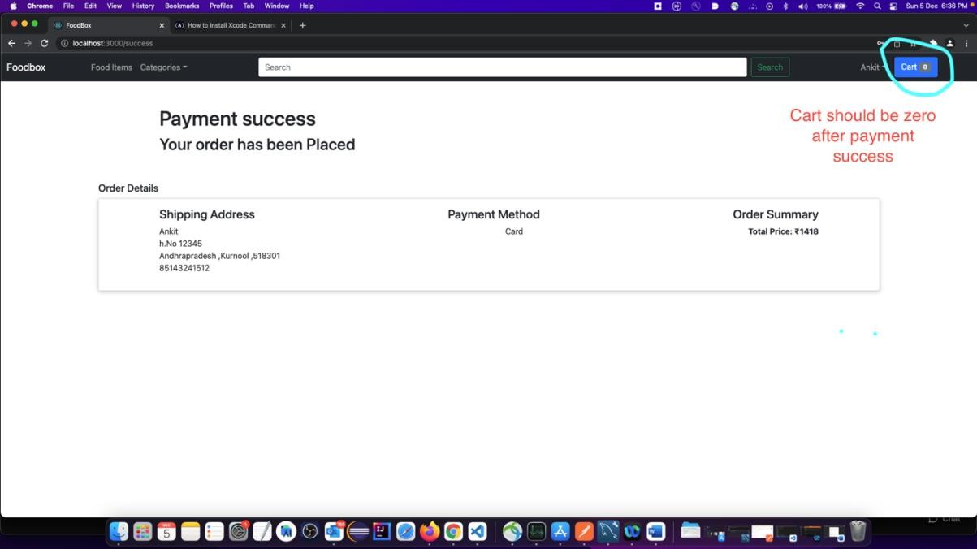

Checkout page

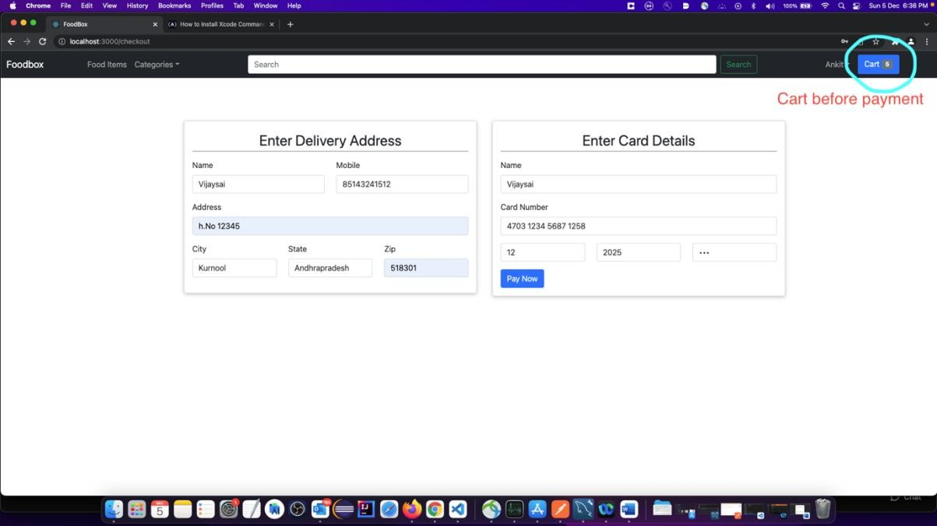

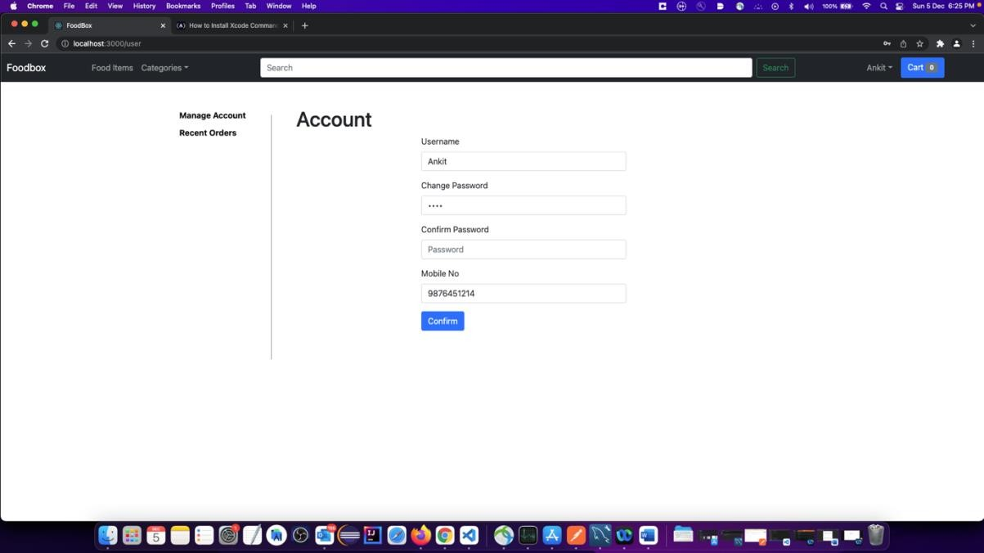

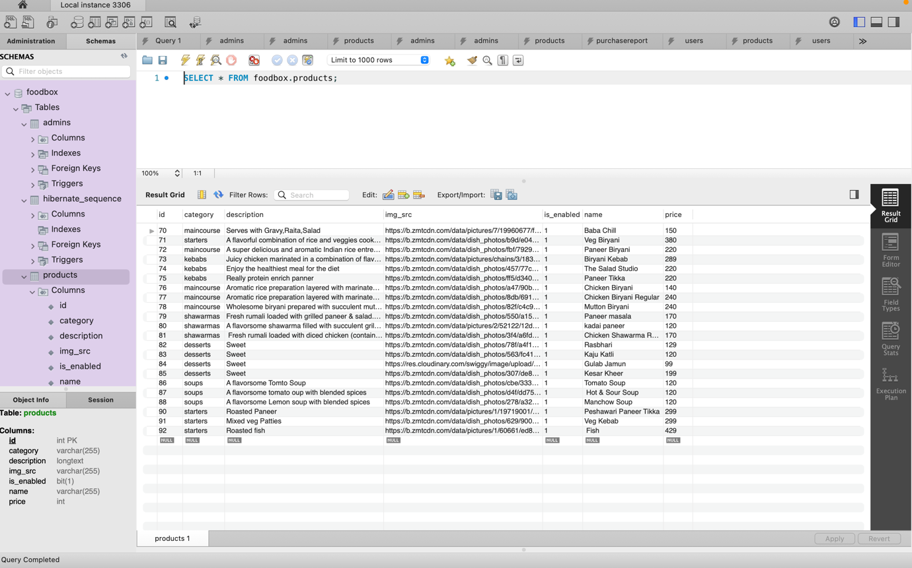

**Unique Selling Points of the Application:**

1. Fluid UI and responsive
2. Easy interaction within the UI
3. The application is designed to keep on running and taking user inputs even after exceptions occur.
4. Can search for product by different parameters such as category, keywords.
5. Front-end page will not crash even if server is down.
6. Secure -> user cannot checkout without logging in.
7. Persistent -> State of the webpage doesn’t get cleared with sudden refresh of

the page.

## Conclusion:

Further improvements to the application can be done which may include:

* + Improved design
  + Let users choose different payment methods.