Double-Pipe Heat Exchanger

Thermal Simulation Study Using COMSOL Multiphysics

# Introduction

Double-pipe heat exchangers are among the simplest and most cost-effective types of heat exchangers used in chemical process industries. With their characteristic U-turn shape, they consist of two concentric pipes where heat exchange occurs between two fluids flowing in opposite directions. These exchangers are widely used due to their low cost, ease of maintenance, and ability to operate under high pressure.

# System Description

The system under consideration is a double-pipe heat exchanger constructed from high-tensile steel (AISI 4340). The radii of the inner and outer pipes are 2.55 cm and 4.8 cm respectively, and the total length of the heat exchanger is approximately 6 meters.  
  
- Hot fluid (Engine oil): Flows through the outer pipe at an inlet temperature of 130°C and an average velocity of 0.09 m/s.  
- Cold fluid (Transformer oil): Flows in counter-current through the inner pipe at an inlet temperature of 60°C and a velocity of 0.205 m/s.  
  
The exterior surface of the outer pipe is exposed to ambient air, assumed to be thermally insulated due to negligible heat loss via natural convection.

# Flow and Thermal Properties

|  |  |  |  |
| --- | --- | --- | --- |
| Quantity | Symbol | Inner Pipe | Outer Pipe |
| Density | ρ | 850 kg/m³ | 825 kg/m³ |
| Inlet velocity | v | 0.205 m/s | 0.09 m/s |
| Hydraulic diameter | Dₕ | 5.1 cm | 1.3 cm |
| Dynamic viscosity | μ | 5×10⁻³ Pa·s | 1×10⁻³ Pa·s |

Based on these values, the Reynolds numbers are approximately 1800 (inner pipe) and 1000 (outer pipe), indicating laminar flow. Therefore, a laminar nonisothermal flow model is used in the simulation.

# Simulation Objectives

Using COMSOL Multiphysics, the system is simulated to analyze:  
- The temperature profile along the length and radius of the pipe.  
- Velocity and pressure distributions of both fluids.  
- Heat transfer coefficient between the fluids.  
  
The model employs:  
- Thin Layer boundary condition to account for conduction through the pipe wall.  
- Nonisothermal flow multiphysics coupling.  
- Swept meshing in straight segments and tetrahedral meshing in U-turns.

# Results Summary

- Engine oil is cooled from 130°C to approximately 123°C.  
- Transformer oil is heated from 60°C to about 70°C.  
- Pressure drop: ~1350 Pa (outer pipe), ~159 Pa (inner pipe).  
- Equivalent heat transfer coefficient: ~42 W/(m²·K).

# System Diagram

The image below represents the layout and flow configuration of the double-pipe heat exchanger.

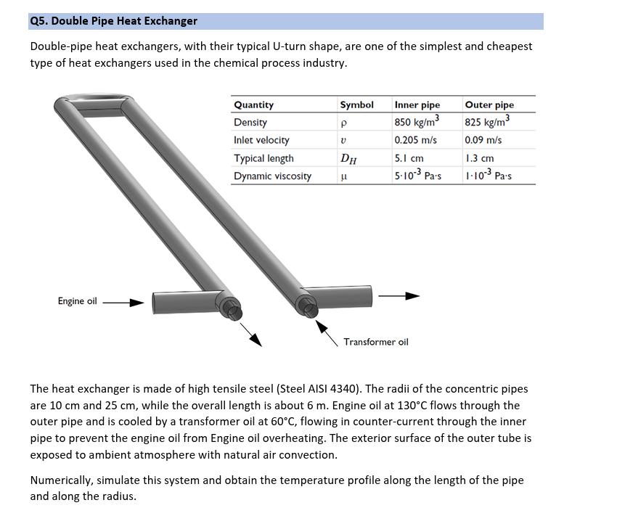

# Conclusion

The simulation validates the effective thermal performance of a double-pipe heat exchanger under laminar conditions. This model offers a foundation for optimization, such as enhancing wall conductivity, adjusting flow rates, or integrating insulation strategies.

# Simulation Figures

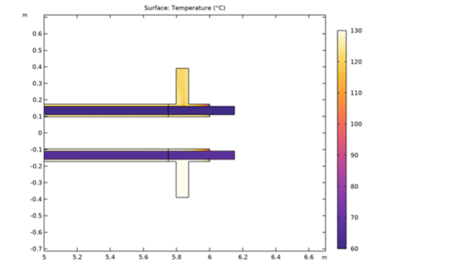

*Temperature distribution along the length of the pipes in the central plane.*