**MS RAMAIAHINSTITUTE OFTECHNOLOGY**

**(AutonomousInstituteAffiliatedtoVTU)**

**Departmentof Information ScienceandEngineering**



**JAVA SWING PROJECT**

**JAVA AND J2EE**

by

**Indresh Kumar 1MS15IS042**

**Ankit Kumar 1MS15IS015**

*Undertheguidanceof*

**KOUSHIK S**

AssociateProfessor DepartmentofISE, MSRIT Bengaluru– 56009

**Abstract**

This java project is made using a swing library and importing jar files to make a programme which can merge two pdf,split a pdf ,convert a doc file into a pdf and compare two pdf.

In this project we have used the Facade design pattern to give the user the better experience so as the user need not to worry about what is going inside the code.

Below is the graphical interface:-

1)Front Page:-

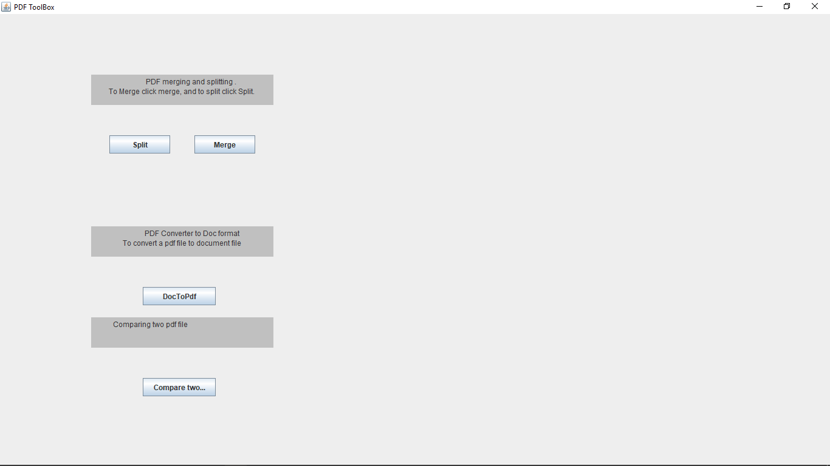

2)Split Page:-This page will ask the user the location of pdf,and the range of page the user want to split.

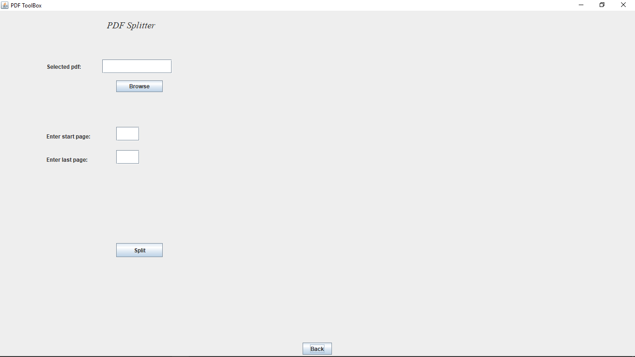

->Clicking the split button will open a new window asking for the location of new splitted pdf:-

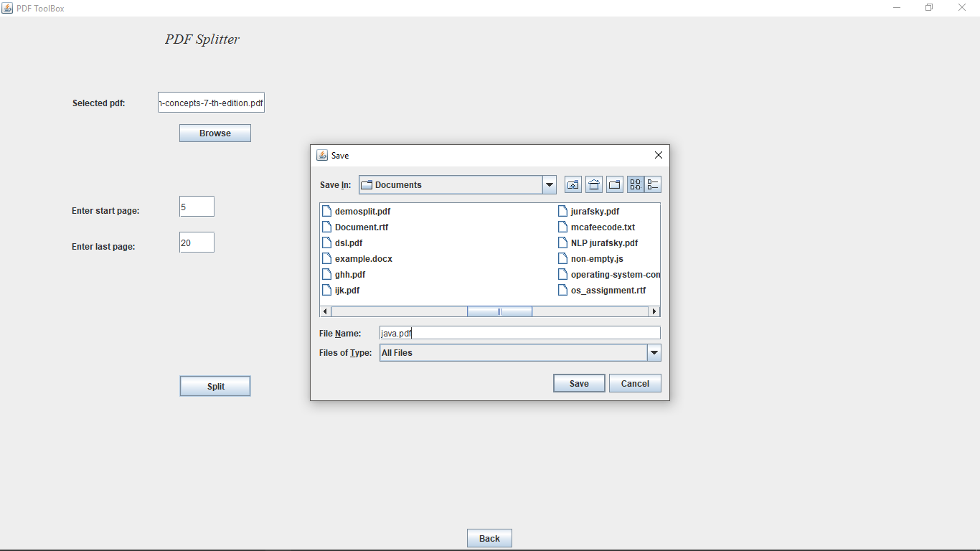

3)Merge window:-This window will ask the location of two pdf which the user want to merge:-

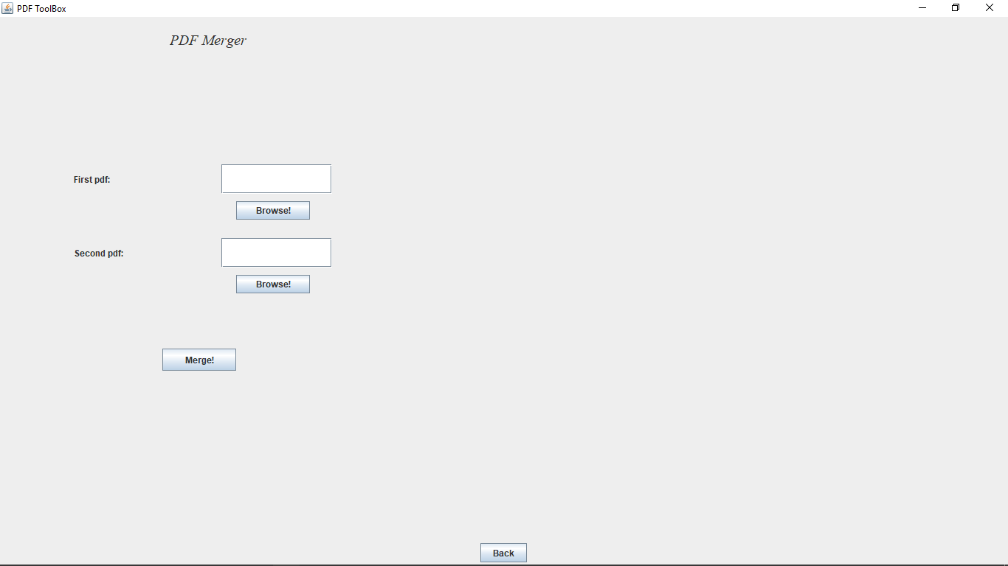

->Clicking the merge button will open a new window asking for the location of new merged pdf:-

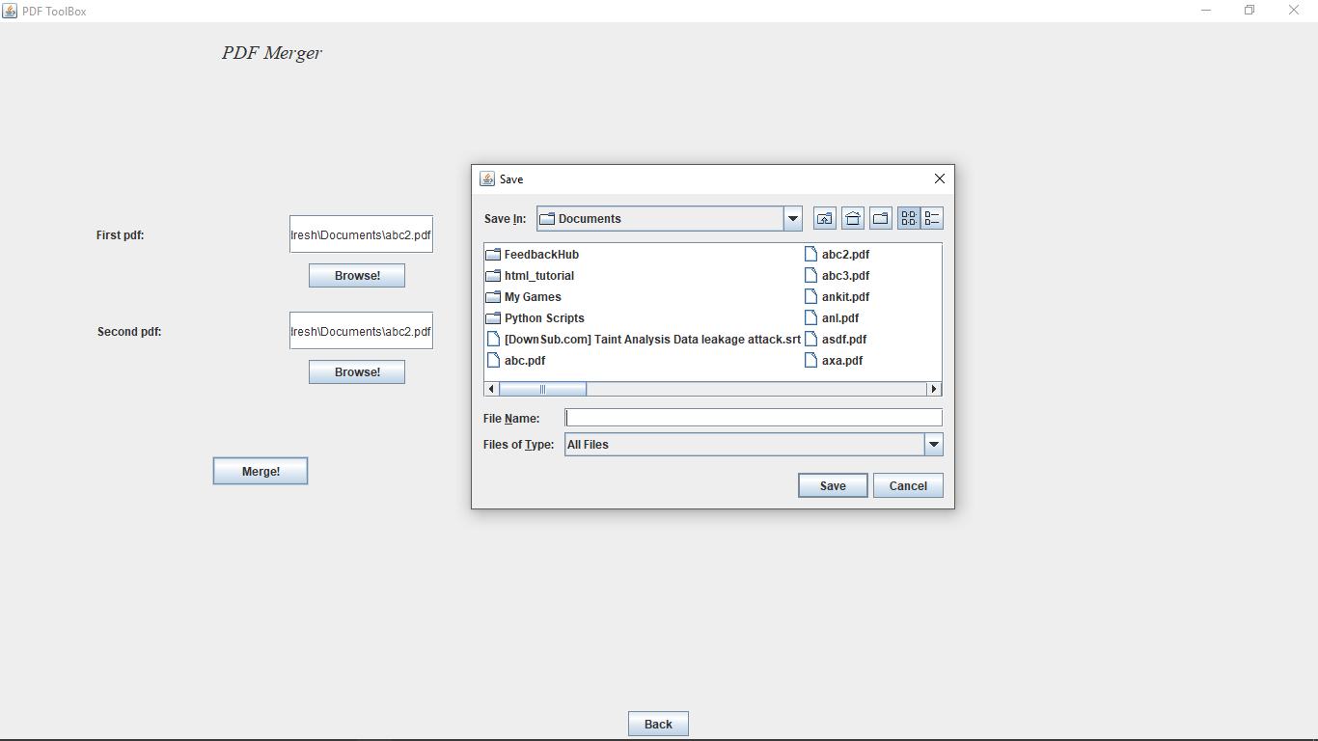

4)Convert word to pdf:-This window is created to convert the word file into a pdf:-

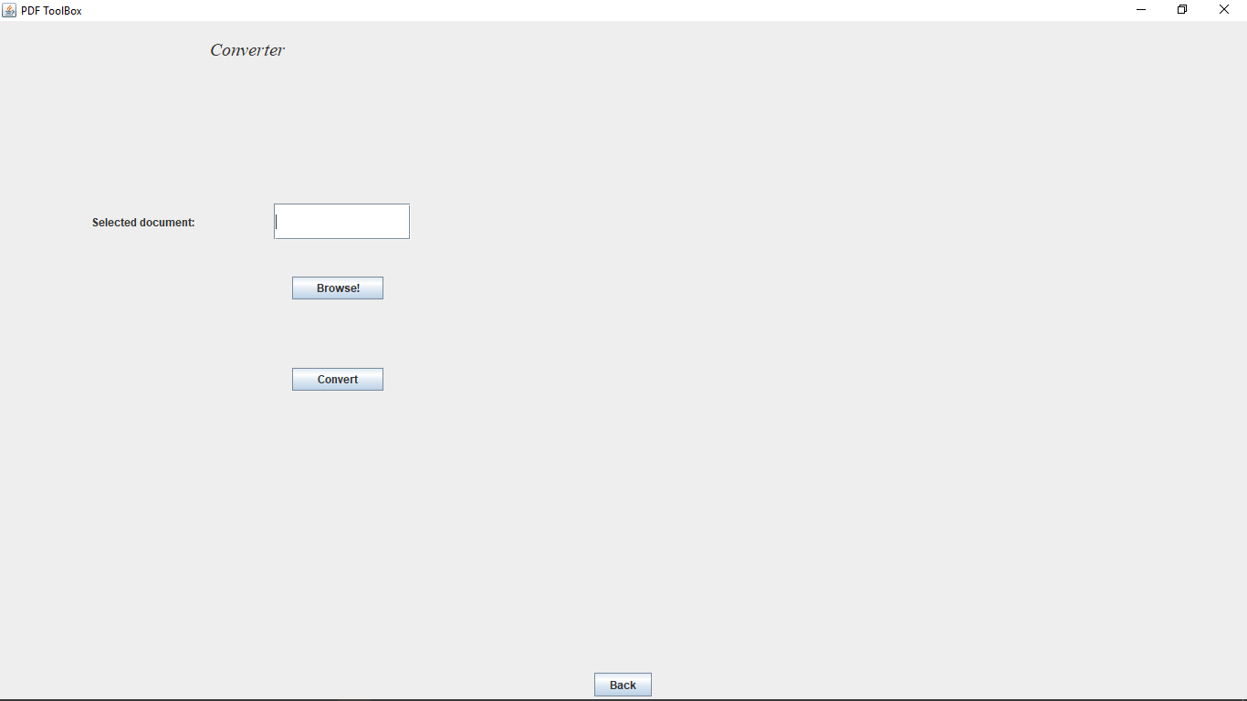

->Clicking the convert button will open a new window asking for the location of new converted pdf:-

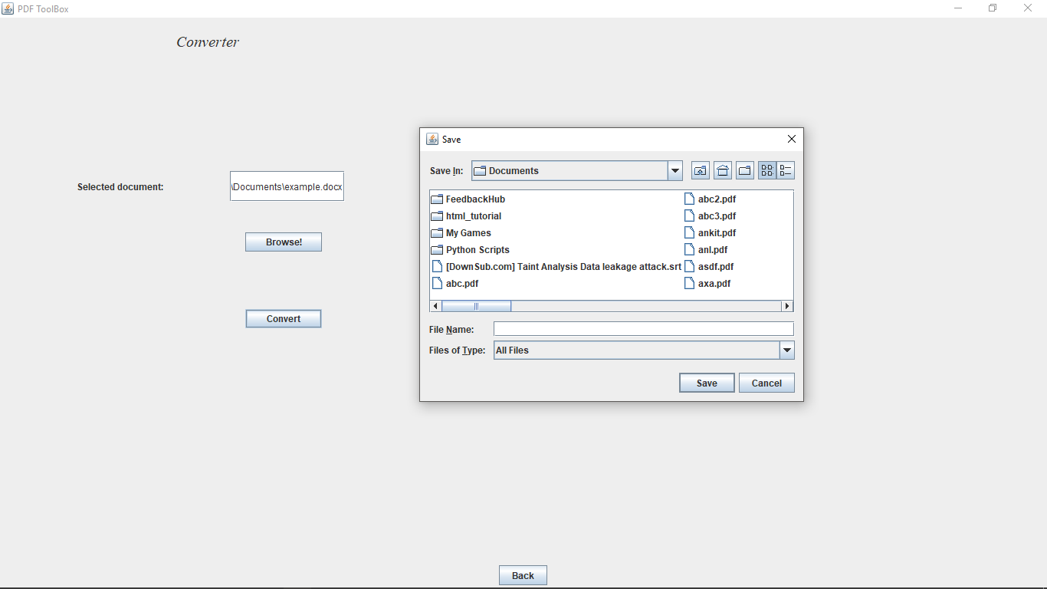

5)Comparing pdf:-This will compare two pdf or doc file and return true and false:-

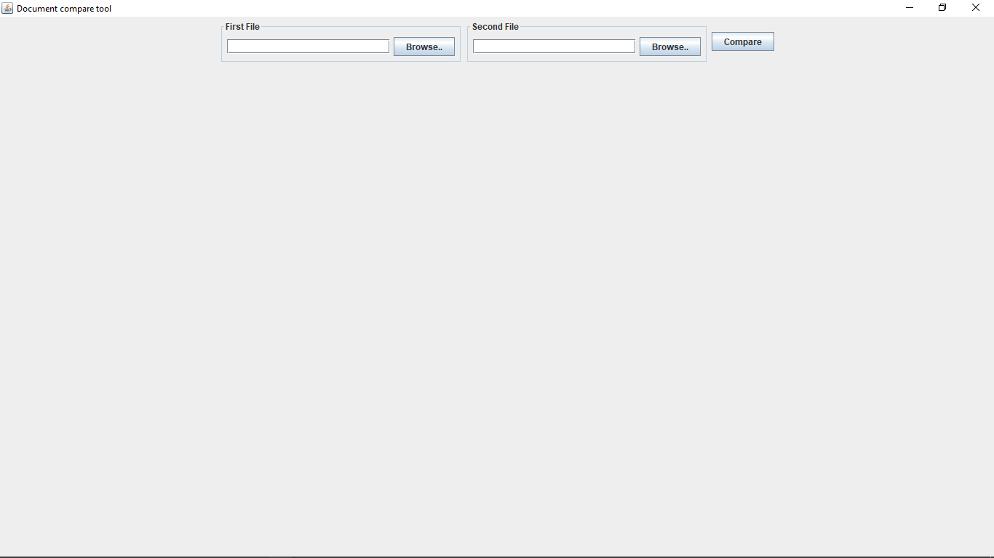

->Clicking the compare button will tell weather the files are equal or not:-

