Implementation of Procure-to-Pay (P2P) Cycle in SAP MM

Student Details
Name: Ankit Das
Roll Number: 23051408
Batch/Program: SAP Data Analytics

1. Organization Overview
This project is based on a fictitious company named “ABC Manufacturing Pvt. Ltd.”, which deals in production and distribution of electronic components. The company requires an efficient procurement system to manage vendor transactions, inventory, and financial processes.

2. Introduction
The Procure-to-Pay (P2P) cycle is a critical business process that manages the complete lifecycle of procurement, from identifying requirements to making payments to vendors. It ensures operational efficiency, cost control, and transparency.
This project presents a simulation-based implementation of the P2P cycle using SAP Materials Management (MM).

3. Problem Statement
Many organizations face challenges in managing procurement manually, including lack of transparency, delayed approvals, inaccurate data entry, and inefficient vendor handling.

4. Proposed Solution
The SAP MM module provides a structured and automated solution to manage procurement activities.
Business Benefits:
- Improved procurement planning
- Real-time tracking
- Better vendor management
- Reduced operational costs
- Enhanced accuracy

5. Process Flow of P2P Cycle

The Procure-to-Pay process in ABC Manufacturing Pvt. Ltd. follows a structured workflow to ensure efficient procurement and financial control.

5.1 Vendor Creation
Vendors are registered in the system with necessary details such as name, address, and payment terms.

5.2 Purchase Requisition (PR)
Departments generate purchase requisitions based on material requirements.

5.3 Purchase Order (PO)
A purchase order is created and sent to the vendor, specifying quantity, price, and delivery schedule.

5.4 Goods Receipt (GR)
Goods received are verified and recorded in the system, updating inventory.

5.5 Invoice Verification
Invoices are matched with purchase orders and goods receipt data to ensure accuracy.

5.6 Payment Processing
After verification, payment is processed to the vendor, completing the cycle.

6. Process Flow Diagram
Vendor → PR → PO → GR → Invoice → Payment

7. Detailed Process Explanation

The P2P process ensures that procurement activities are aligned with organizational needs. Each step plays a critical role in maintaining accuracy and efficiency.

The integration between SAP MM and SAP FI ensures seamless financial transactions and proper accounting of procurement activities.

This structured approach reduces manual errors and enhances transparency across departments.

8. Sap Module Mapping
Step | SAP Module | Description
Vendor Creation | MM | Vendor master data setup
Purchase Requisition | MM | Internal request generation
Purchase Order | MM | Vendor order creation
Goods Receipt | MM | Inventory update
Invoice Verification | FI | Financial validation
Payment Processing | FI | Vendor payment

9. Screenshots / Simulation
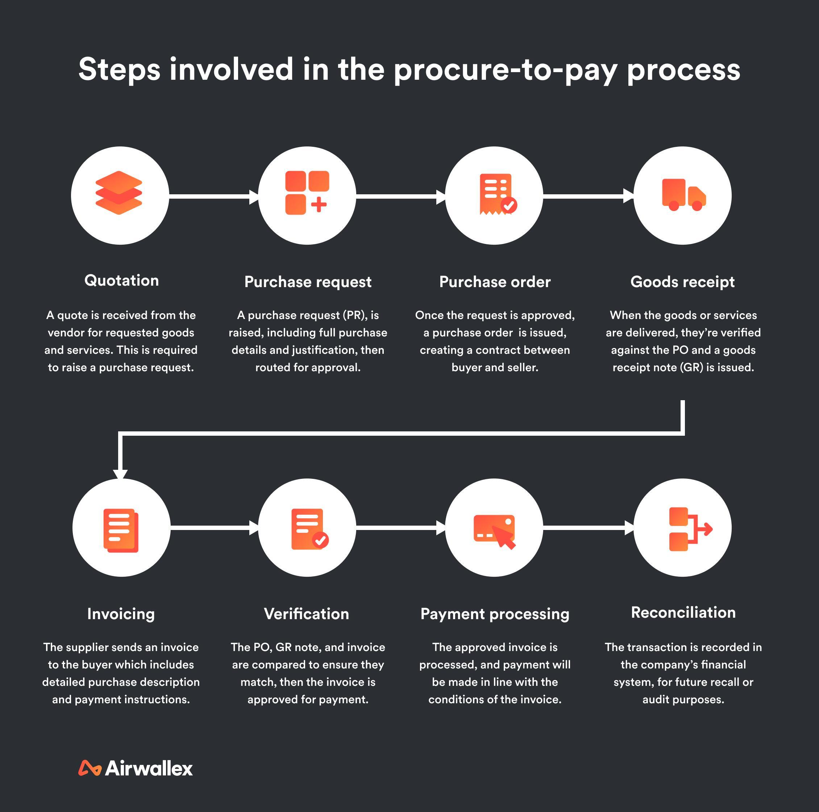

Figure 1: Procure-to-Pay Process Flow

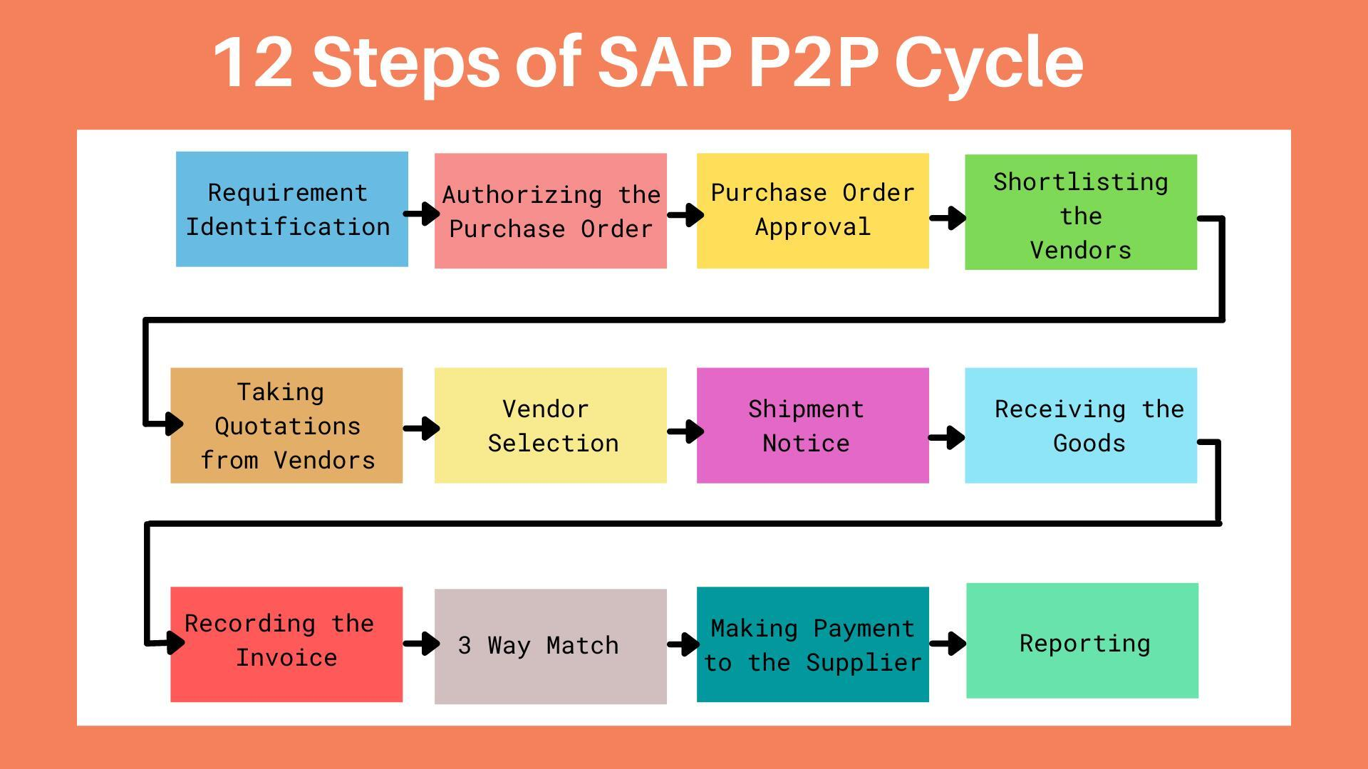

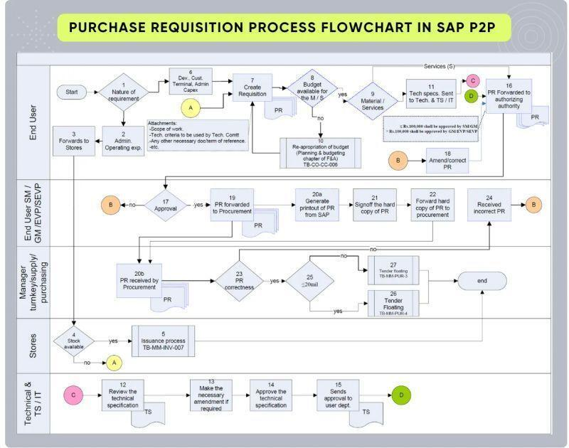
Figure 2: SAP P2P Workflow Diagram
Figure 3: Purchase Requisition Flowchart
10. Tech Stack
SAP ERP, SAP MM, Simulation Tools

11. Unique Features
- End-to-end simulation
- Realistic scenario
- Clear workflow mapping

12. Future Improvements
- SAP S/4HANA implementation
- Integration with FI
- Automation with Fiori

13. Conclusion
This project demonstrates how SAP MM streamlines procurement and ensures efficiency. This project also provides a strong conceptual understanding of ERP systems and prepares for real-world SAP implementation.

