OPStudents

User Guide

Welcome to OPStudents user guide. This text will guide you about how to use this application.

Mainly this application gives login, registration, about us, contact us and student success area.

OPStudents application start with welcome page which contains login/registration option and three basic information about OP which are know about op, contact us and student success.

**Home Page:**

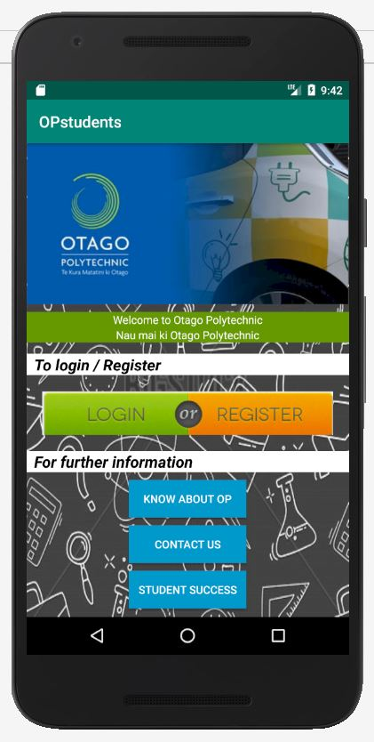

User can register with required details and after successfully registration user can login on this application and view own profile, edit profile except user name, delete profile and logout from user dashboard.

**Login/Registration page:**

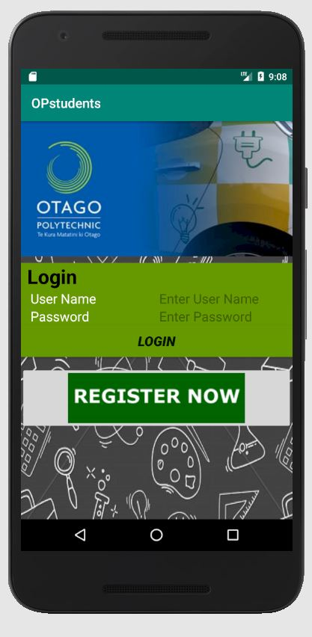

Once click on register now then registration page will be appear and fill your detail and click register button. If user realised that he or she fill incorrect information then user can click on clear button to re-enter al detail.

**Register page:**

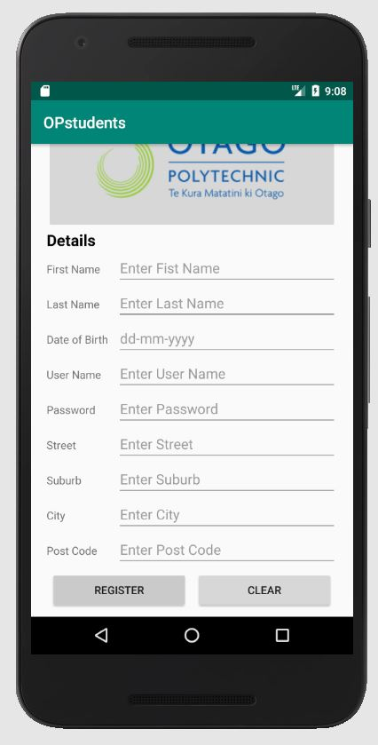

After registration user can take login with username and password.

**Login page:**



After successfully login user can view, edit, delete profile.

**User dashboard page:**

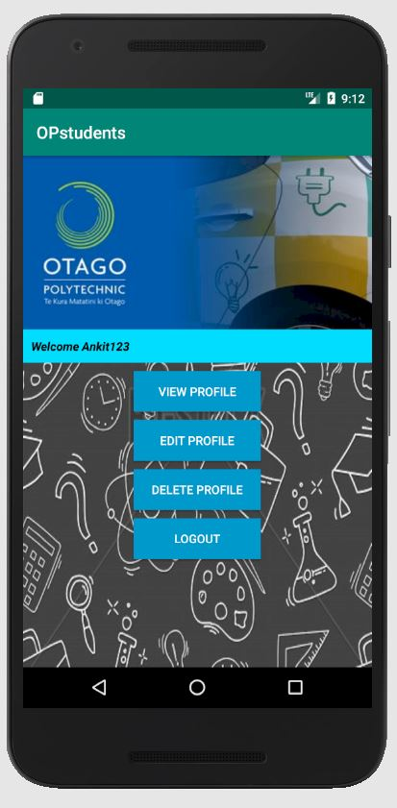

**View profile page:**

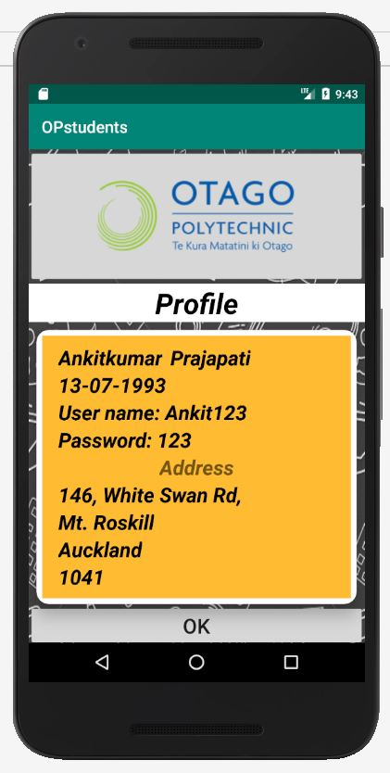

Click on ok button to go back.

**Edit profile page:**

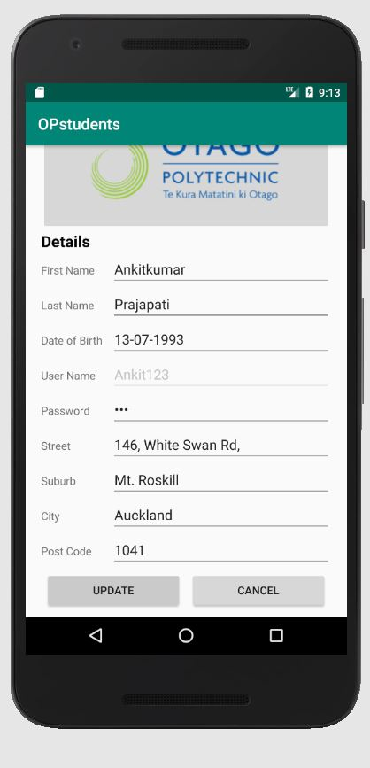

User can **update detail** by clicking update button.



User can delete own profile by clicking delete profile button and logout from OPStudents by clicking logout button.

Once user delete profile or logout then user can be navigated on OPStudents application home page.

As mention above, OPStudents application provide details about know about OP, contact Us and Student success.

When user click on **know about OP** button then user can get information about op like showing below.

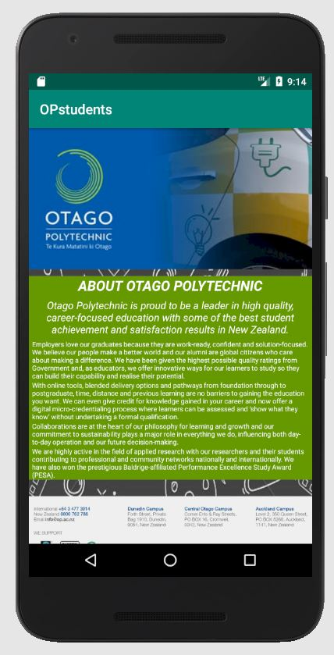

User can get contact detail by clicking **Contact Us** button.

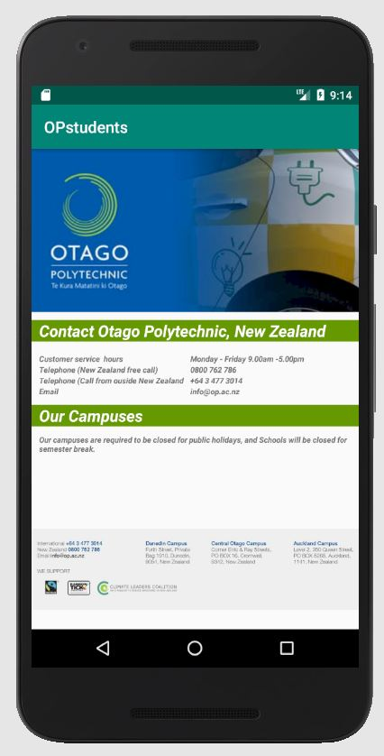

And finally, user can get detail of student success faculties by clicking **Student Success** button.

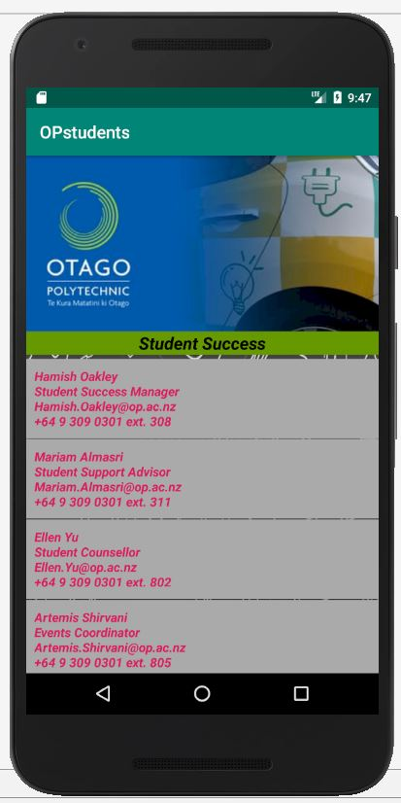

***Thank you for using our application.***