📘 Comprehensive Sales Dashboard Report

**Reporting Period**: November 2021 – May 2023

*🧾 Summary Metrics :*

Metric Value

* Total Sales :612.33K
* Total Profit :43.24K

*📊 Sales by Category:*

Category Sales (in K) Percentage

Furniture 195.99 32.01%

Office Supplies 197.13 32.19%

Technology 219.21 35.8%

*📌 Observation:*

* Technology leads in sales with 35.8%, indicating strong performance.
* Furniture and Office Supplies contribute almost equally.

*📈 Sales Trend Over Time (Month-Year) :*

* Sales remained steady during 2022.
* A significant drop in sales occurred in December 2022, mainly in the Furniture category.
* Slight fluctuations observed across early 2023.

*🗺 Sales by Region :*

Region Sales Trend

* West 🔼 Highest
* Central 🔼 High
* South 🔽 Medium
* East 🔽 Lowest

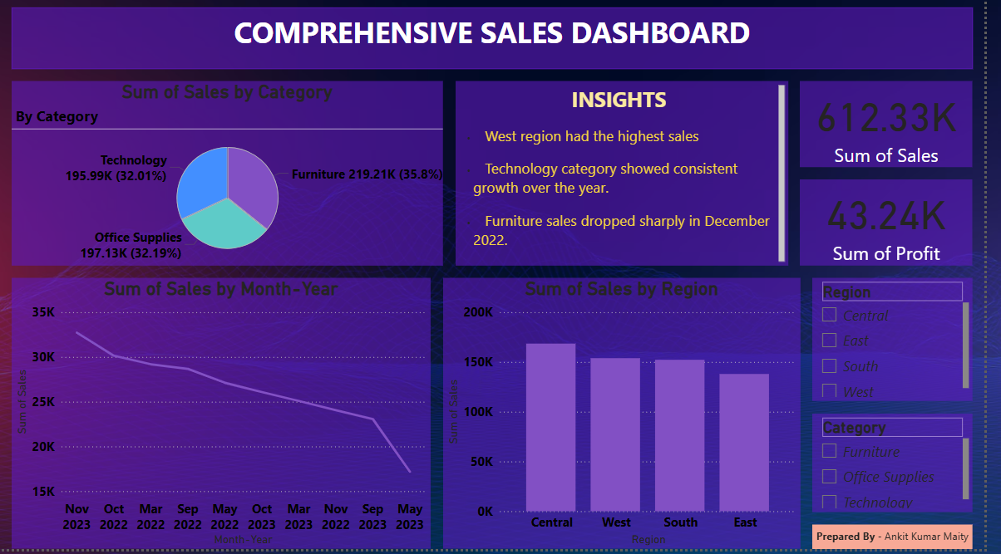

*🎯 Recommendations :*

* Focus more resources and marketing on the Technology category.
* Investigate Furniture category drop in late 2022 to mitigate risk.
* Consider region-specific promotions in the East and South to boost sales.

📝 Prepared By: Ankit Kumar maity

📅 Report Date: July 2025

----------------------------------------------------------------------------------------------------------------------------------------------------------------------------------------------------------------------------------------------------------------------------