Classification Algorithm in Machine Learning
As we know, the Supervised Machine Learning algorithm can be broadly classified into Regression and Classification Algorithms. In Regression algorithms, we have predicted the output for continuous values, but to predict the categorical values, we need Classification algorithms.

What is the Classification Algorithm?
The Classification algorithm is a Supervised Learning technique that is used to identify the category of new observations on the basis of training data. In Classification, a program learns from the given dataset or observations and then classifies new observation into a number of classes or groups. Such as, Yes or No, 0 or 1, Spam or Not Spam, cat or dog, etc. Classes can be called as targets/labels or categories.
Unlike regression, the output variable of Classification is a category, not a value, such as "Green or Blue", "fruit or animal", etc. Since the Classification algorithm is a Supervised learning technique, hence it takes labeled input data, which means it contains input with the corresponding output.
In classification algorithm, a discrete output function(y) is mapped to input variable(x).
- y=f(x), where y = categorical output
The best example of an ML classification algorithm is Email Spam Detector.
The main goal of the Classification algorithm is to identify the category of a given dataset, and these algorithms are mainly used to predict the output for the categorical data.
Classification algorithms can be better understood using the below diagram. In the below diagram, there are two classes, class A and Class B. These classes have features that are similar to each other and dissimilar to other classes.
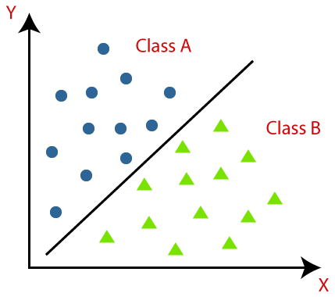
The algorithm which implements the classification on a dataset is known as a classifier. There are two types of Classifications:
- Binary Classifier: If the classification problem has only two possible outcomes, then it is called as Binary Classifier.
Examples: YES or NO, MALE or FEMALE, SPAM or NOT SPAM, CAT or DOG, etc.
- Multi-class Classifier: If a classification problem has more than two outcomes, then it is called as Multi-class Classifier.
Example: Classifications of types of crops, Classification of types of music.

Learners in Classification Problems:
In the classification problems, there are two types of learners:
- Lazy Learners: Lazy Learner firstly stores the training dataset and wait until it receives the test dataset. In Lazy learner case, classification is done on the basis of the most related data stored in the training dataset. It takes less time in training but more time for predictions.
Example: K-NN algorithm, Case-based reasoning
- Eager Learners: Eager Learners develop a classification model based on a training dataset before receiving a test dataset. Opposite to Lazy learners, Eager learners take more time in training and less time in prediction. Example: Decision Trees, Naïve Bayes, ANN.

Types of ML Classification Algorithms:
Classification Algorithms can be further divided into the mainly two category:
- Linear Models
  - Logistic Regression
  - Support Vector Machines
- Non-linear Models
  - K-Nearest Neighbours
  - Kernel SVM
  - Naïve Bayes
  - Decision Tree Classification
  - Random Forest Classification

Evaluating a Classification model:
Once our model is completed, it is necessary to evaluate its performance; either it is a Classification or Regression model. So for evaluating a Classification model, we have the following ways:
1. Log Loss or Cross-Entropy Loss:
- It is used for evaluating the performance of a classifier, whose output is a probability value between the 0 and 1.
- For a good binary Classification model, the value of log loss should be near to 0.
- The value of log loss increases if the predicted value deviates from the actual value.
- The lower log loss represents the higher accuracy of the model.
- For Binary classification, cross-entropy can be calculated as:
- ?(ylog(p)+(1?y)log(1?p))
Where y= Actual output, p= predicted output.
2. Confusion Matrix:
- The confusion matrix provides us a matrix/table as output and describes the performance of the model.
- It is also known as the error matrix.
- The matrix consists of predictions result in a summarized form, which has a total number of correct predictions and incorrect predictions. The matrix looks like as below table:
 | Actual Positive | Actual Negative
Predicted Positive | True Positive | False Positive
Predicted Negative | False Negative | True Negative
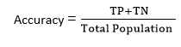
3. AUC-ROC curve:
- ROC curve stands for Receiver Operating Characteristics Curve and AUC stands for Area Under the Curve.
- It is a graph that shows the performance of the classification model at different thresholds.
- To visualize the performance of the multi-class classification model, we use the AUC-ROC Curve.
- The ROC curve is plotted with TPR and FPR, where TPR (True Positive Rate) on Y-axis and FPR(False Positive Rate) on X-axis.

Use cases of Classification Algorithms
Classification algorithms can be used in different places. Below are some popular use cases of Classification Algorithms:
- Email Spam Detection
- Speech Recognition
- Identifications of Cancer tumor cells.
- Drugs Classification
- Biometric Identification, etc.

Logistic Regression in Machine Learning
- Logistic regression is one of the most popular Machine Learning algorithms, which comes under the Supervised Learning technique. It is used for predicting the categorical dependent variable using a given set of independent variables.
- Logistic regression predicts the output of a categorical dependent variable. Therefore the outcome must be a categorical or discrete value. It can be either Yes or No, 0 or 1, true or False, etc. but instead of giving the exact value as 0 and 1, it gives the probabilistic values which lie between 0 and 1.
- Logistic Regression is much similar to the Linear Regression except that how they are used. Linear Regression is used for solving Regression problems, whereas Logistic regression is used for solving the classification problems.
- In Logistic regression, instead of fitting a regression line, we fit an "S" shaped logistic function, which predicts two maximum values (0 or 1).
- The curve from the logistic function indicates the likelihood of something such as whether the cells are cancerous or not, a mouse is obese or not based on its weight, etc.
- Logistic Regression is a significant machine learning algorithm because it has the ability to provide probabilities and classify new data using continuous and discrete datasets.
- Logistic Regression can be used to classify the observations using different types of data and can easily determine the most effective variables used for the classification. The below image is showing the logistic function:
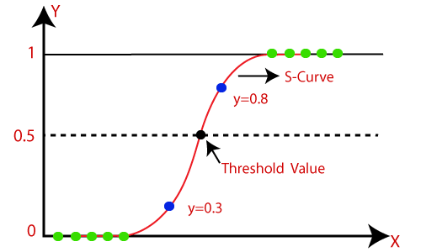

Note: Logistic regression uses the concept of predictive modeling as regression; therefore, it is called logistic regression, but is used to classify samples; Therefore, it falls under the classification algorithm.

Logistic Function (Sigmoid Function):
- The sigmoid function is a mathematical function used to map the predicted values to probabilities.
- It maps any real value into another value within a range of 0 and 1.
- The value of the logistic regression must be between 0 and 1, which cannot go beyond this limit, so it forms a curve like the "S" form. The S-form curve is called the Sigmoid function or the logistic function.
- In logistic regression, we use the concept of the threshold value, which defines the probability of either 0 or 1. Such as values above the threshold value tends to 1, and a value below the threshold values tends to 0.

Assumptions for Logistic Regression:
- The dependent variable must be categorical in nature.
- The independent variable should not have multi-collinearity.

Logistic Regression Equation:
The Logistic regression equation can be obtained from the Linear Regression equation. The mathematical steps to get Logistic Regression equations are given below:
- We know the equation of the straight line can be written as:
- In Logistic Regression y can be between 0 and 1 only, so for this let's divide the above equation by (1-y):
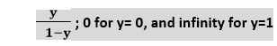
- But we need range between -[infinity] to +[infinity], then take logarithm of the equation it will become:
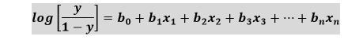
The above equation is the final equation for Logistic Regression.

Type of Logistic Regression:
On the basis of the categories, Logistic Regression can be classified into three types:
- Binomial: In binomial Logistic regression, there can be only two possible types of the dependent variables, such as 0 or 1, Pass or Fail, etc.
- Multinomial: In multinomial Logistic regression, there can be 3 or more possible unordered types of the dependent variable, such as "cat", "dogs", or "sheep"
- Ordinal: In ordinal Logistic regression, there can be 3 or more possible ordered types of dependent variables, such as "low", "Medium", or "High".

K-Nearest Neighbor(KNN) Algorithm for Machine Learning
- K-Nearest Neighbour is one of the simplest Machine Learning algorithms based on Supervised Learning technique.
- K-NN algorithm assumes the similarity between the new case/data and available cases and put the new case into the category that is most similar to the available categories.
- K-NN algorithm stores all the available data and classifies a new data point based on the similarity. This means when new data appears then it can be easily classified into a well suite category by using K- NN algorithm.
- K-NN algorithm can be used for Regression as well as for Classification but mostly it is used for the Classification problems.
- K-NN is a non-parametric algorithm, which means it does not make any assumption on underlying data.
- It is also called a lazy learner algorithm because it does not learn from the training set immediately instead it stores the dataset and at the time of classification, it performs an action on the dataset.
- KNN algorithm at the training phase just stores the dataset and when it gets new data, then it classifies that data into a category that is much similar to the new data.
- Example: Suppose, we have an image of a creature that looks similar to cat and dog, but we want to know either it is a cat or dog. So for this identification, we can use the KNN algorithm, as it works on a similarity measure. Our KNN model will find the similar features of the new data set to the cats and dogs images and based on the most similar features it will put it in either cat or dog category.
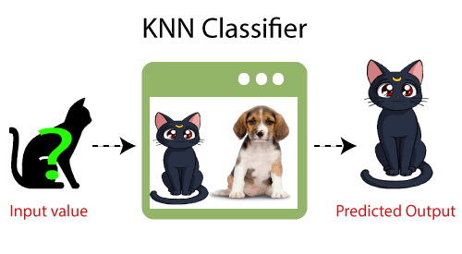

Why do we need a K-NN Algorithm?
Suppose there are two categories, i.e., Category A and Category B, and we have a new data point x1, so this data point will lie in which of these categories. To solve this type of problem, we need a K-NN algorithm. With the help of K-NN, we can easily identify the category or class of a particular dataset. Consider the below diagram:
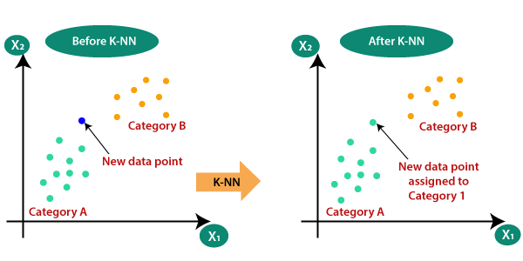

How does K-NN work?
The K-NN working can be explained on the basis of the below algorithm:
- Step-1: Select the number K of the neighbors
- Step-2: Calculate the Euclidean distance of K number of neighbors
- Step-3: Take the K nearest neighbors as per the calculated Euclidean distance.
- Step-4: Among these k neighbors, count the number of the data points in each category.
- Step-5: Assign the new data points to that category for which the number of the neighbor is maximum.
- Step-6: Our model is ready.
Suppose we have a new data point and we need to put it in the required category. Consider the below image:
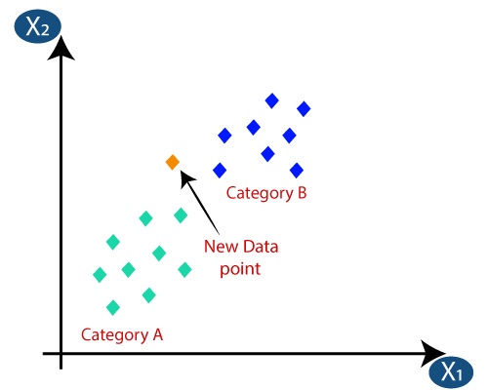
- Firstly, we will choose the number of neighbors, so we will choose the k=5.
- Next, we will calculate the Euclidean distance between the data points. The Euclidean distance is the distance between two points, which we have already studied in geometry. It can be calculated as:
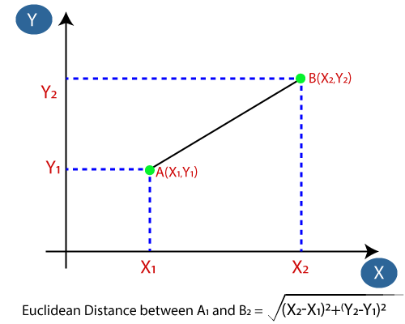
- By calculating the Euclidean distance we got the nearest neighbors, as three nearest neighbors in category A and two nearest neighbors in category B. Consider the below image:
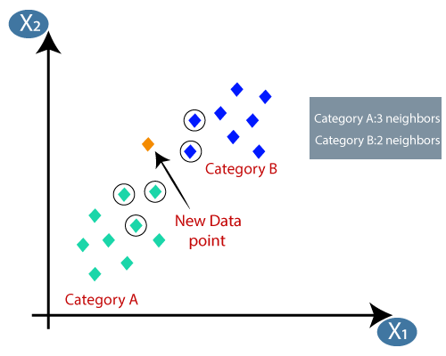
- As we can see the 3 nearest neighbors are from category A, hence this new data point must belong to category A.

How to select the value of K in the K-NN Algorithm?
Below are some points to remember while selecting the value of K in the K-NN algorithm:
- There is no particular way to determine the best value for "K", so we need to try some values to find the best out of them. The most preferred value for K is 5.
- A very low value for K such as K=1 or K=2, can be noisy and lead to the effects of outliers in the model.
- Large values for K are good, but it may find some difficulties.

Advantages of KNN Algorithm:
- It is simple to implement.
- It is robust to the noisy training data
- It can be more effective if the training data is large.

Disadvantages of KNN Algorithm:
- Always needs to determine the value of K which may be complex some time.
- The computation cost is high because of calculating the distance between the data points for all the training samples.

Support Vector Machine Algorithm
Support Vector Machine or SVM is one of the most popular Supervised Learning algorithms, which is used for Classification as well as Regression problems. However, primarily, it is used for Classification problems in Machine Learning.
The goal of the SVM algorithm is to create the best line or decision boundary that can segregate n-dimensional space into classes so that we can easily put the new data point in the correct category in the future. This best decision boundary is called a hyperplane.
SVM chooses the extreme points/vectors that help in creating the hyperplane. These extreme cases are called as support vectors, and hence algorithm is termed as Support Vector Machine. Consider the below diagram in which there are two different categories that are classified using a decision boundary or hyperplane:
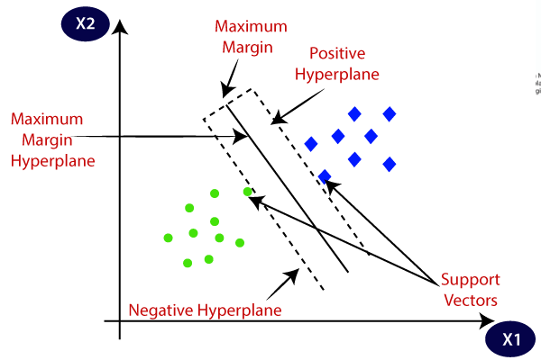
Example: SVM can be understood with the example that we have used in the KNN classifier. Suppose we see a strange cat that also has some features of dogs, so if we want a model that can accurately identify whether it is a cat or dog, so such a model can be created by using the SVM algorithm. We will first train our model with lots of images of cats and dogs so that it can learn about different features of cats and dogs, and then we test it with this strange creature. So as support vector creates a decision boundary between these two data (cat and dog) and choose extreme cases (support vectors), it will see the extreme case of cat and dog. On the basis of the support vectors, it will classify it as a cat. Consider the below diagram:
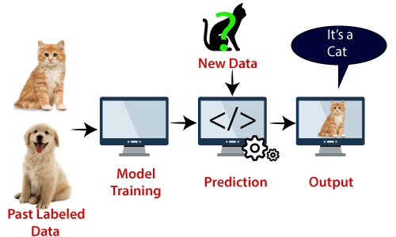
SVM algorithm can be used for Face detection, image classification, text categorization, etc.

Types of SVM
SVM can be of two types:
- Linear SVM: Linear SVM is used for linearly separable data, which means if a dataset can be classified into two classes by using a single straight line, then such data is termed as linearly separable data, and classifier is used called as Linear SVM classifier.
- Non-linear SVM: Non-Linear SVM is used for non-linearly separated data, which means if a dataset cannot be classified by using a straight line, then such data is termed as non-linear data and classifier used is called as Non-linear SVM classifier.

Hyperplane and Support Vectors in the SVM algorithm:
Hyperplane: There can be multiple lines/decision boundaries to segregate the classes in n-dimensional space, but we need to find out the best decision boundary that helps to classify the data points. This best boundary is known as the hyperplane of SVM.
The dimensions of the hyperplane depend on the features present in the dataset, which means if there are 2 features (as shown in image), then hyperplane will be a straight line. And if there are 3 features, then hyperplane will be a 2-dimension plane.
We always create a hyperplane that has a maximum margin, which means the maximum distance between the data points.
Support Vectors:
The data points or vectors that are the closest to the hyperplane and which affect the position of the hyperplane are termed as Support Vector. Since these vectors support the hyperplane, hence called a Support vector.

How does SVM works?
Linear SVM:
The working of the SVM algorithm can be understood by using an example. Suppose we have a dataset that has two tags (green and blue), and the dataset has two features x1 and x2. We want a classifier that can classify the pair(x1, x2) of coordinates in either green or blue. Consider the below image:
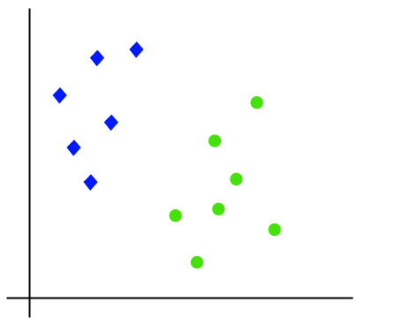
So as it is 2-d space so by just using a straight line, we can easily separate these two classes. But there can be multiple lines that can separate these classes. Consider the below image:
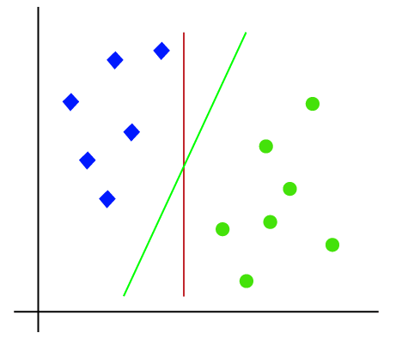
Hence, the SVM algorithm helps to find the best line or decision boundary; this best boundary or region is called as a hyperplane. SVM algorithm finds the closest point of the lines from both the classes. These points are called support vectors. The distance between the vectors and the hyperplane is called as margin. And the goal of SVM is to maximize this margin. The hyperplane with maximum margin is called the optimal hyperplane.
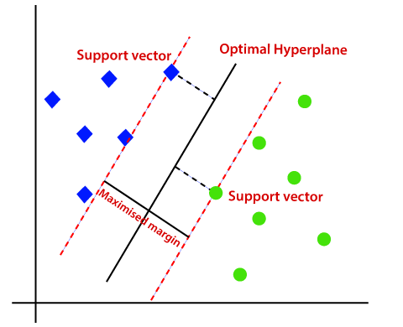
Non-Linear SVM:
If data is linearly arranged, then we can separate it by using a straight line, but for non-linear data, we cannot draw a single straight line. Consider the below image:
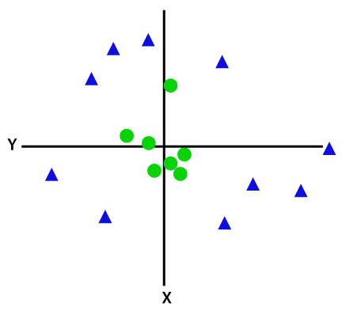
So to separate these data points, we need to add one more dimension. For linear data, we have used two dimensions x and y, so for non-linear data, we will add a third dimension z. It can be calculated as:
z=x² +y²
By adding the third dimension, the sample space will become as below image:
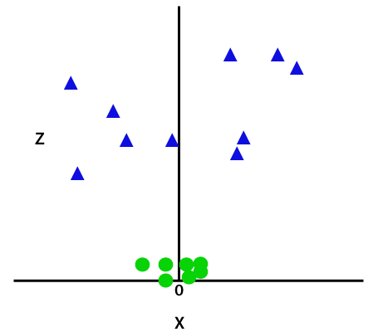
So now, SVM will divide the datasets into classes in the following way. Consider the below image:
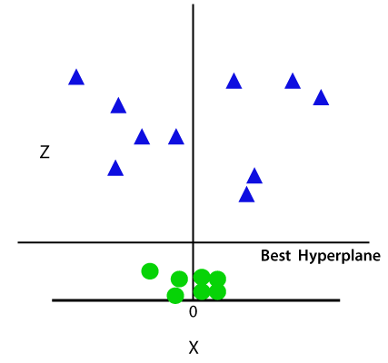
Since we are in 3-d Space, hence it is looking like a plane parallel to the x-axis. If we convert it in 2d space with z=1, then it will become as:
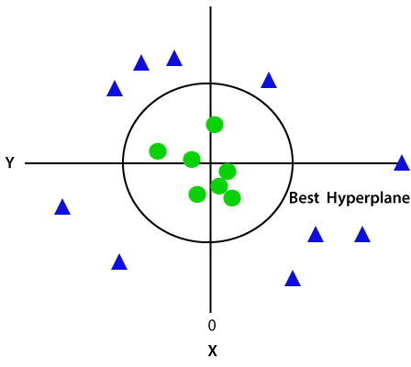
Hence we get a circumference of radius 1 in case of non-linear data.

Naïve Bayes Classifier Algorithm
- Naïve Bayes algorithm is a supervised learning algorithm, which is based on Bayes theorem and used for solving classification problems.
- It is mainly used in text classification that includes a high-dimensional training dataset.
- Naïve Bayes Classifier is one of the simple and most effective Classification algorithms which helps in building the fast machine learning models that can make quick predictions.
- It is a probabilistic classifier, which means it predicts on the basis of the probability of an object.
- Some popular examples of Naïve Bayes Algorithm are spam filtration, Sentimental analysis, and classifying articles.

Why is it called Naïve Bayes?
The Naïve Bayes algorithm is comprised of two words Naïve and Bayes, Which can be described as:
- Naïve: It is called Naïve because it assumes that the occurrence of a certain feature is independent of the occurrence of other features. Such as if the fruit is identified on the bases of color, shape, and taste, then red, spherical, and sweet fruit is recognized as an apple. Hence each feature individually contributes to identify that it is an apple without depending on each other.
- Bayes: It is called Bayes because it depends on the principle of Bayes' Theorem.

Bayes' Theorem:
- Bayes' theorem is also known as Bayes' Rule or Bayes' law, which is used to determine the probability of a hypothesis with prior knowledge. It depends on the conditional probability.
- The formula for Bayes' theorem is given as:
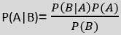
Where,
P(A|B) is Posterior probability: Probability of hypothesis A on the observed event B.
P(B|A) is Likelihood probability: Probability of the evidence given that the probability of a hypothesis is true.
P(A) is Prior Probability: Probability of hypothesis before observing the evidence.
P(B) is Marginal Probability: Probability of Evidence.

Working of Naïve Bayes' Classifier:
Working of Naïve Bayes' Classifier can be understood with the help of the below example:
Suppose we have a dataset of weather conditions and corresponding target variable "Play". So using this dataset we need to decide that whether we should play or not on a particular day according to the weather conditions. So to solve this problem, we need to follow the below steps:
- Convert the given dataset into frequency tables.
- Generate Likelihood table by finding the probabilities of given features.
- Now, use Bayes theorem to calculate the posterior probability.
Problem: If the weather is sunny, then the Player should play or not?
Solution: To solve this, first consider the below dataset:
 | Outlook | Play
0 | Rainy | Yes
1 | Sunny | Yes
2 | Overcast | Yes
3 | Overcast | Yes
4 | Sunny | No
5 | Rainy | Yes
6 | Sunny | Yes
7 | Overcast | Yes
8 | Rainy | No
9 | Sunny | No
10 | Sunny | Yes
11 | Rainy | No
12 | Overcast | Yes
13 | Overcast | Yes
Frequency table for the Weather Conditions:
Weather | Yes | No
Overcast | 5 | 0
Rainy | 2 | 2
Sunny | 3 | 2
Total | 10 | 5
Likelihood table weather condition:
Weather | No | Yes
Overcast | 0 | 5 | 5/14= 0.35
Rainy | 2 | 2 | 4/14=0.29
Sunny | 2 | 3 | 5/14=0.35
All | 4/14=0.29 | 10/14=0.71
Applying Bayes'theorem:
P(Yes|Sunny)= P(Sunny|Yes)*P(Yes)/P(Sunny)
P(Sunny|Yes)= 3/10= 0.3
P(Sunny)= 0.35
P(Yes)=0.71
So P(Yes|Sunny) = 0.3*0.71/0.35= 0.60
P(No|Sunny)= P(Sunny|No)*P(No)/P(Sunny)
P(Sunny|NO)= 2/4=0.5
P(No)= 0.29
P(Sunny)= 0.35
So P(No|Sunny)= 0.5*0.29/0.35 = 0.41
So as we can see from the above calculation that P(Yes|Sunny)>P(No|Sunny)
Hence on a Sunny day, Player can play the game.

Advantages of Naïve Bayes Classifier:
- Naïve Bayes is one of the fast and easy ML algorithms to predict a class of datasets.
- It can be used for Binary as well as Multi-class Classifications.
- It performs well in Multi-class predictions as compared to the other Algorithms.
- It is the most popular choice for text classification problems.

Disadvantages of Naïve Bayes Classifier:
- Naive Bayes assumes that all features are independent or unrelated, so it cannot learn the relationship between features.

Applications of Naïve Bayes Classifier:
- It is used for Credit Scoring.
- It is used in medical data classification.
- It can be used in real-time predictions because Naïve Bayes Classifier is an eager learner.
- It is used in Text classification such as Spam filtering and Sentiment analysis.

Types of Naïve Bayes Model:
There are three types of Naive Bayes Model, which are given below:
- Gaussian: The Gaussian model assumes that features follow a normal distribution. This means if predictors take continuous values instead of discrete, then the model assumes that these values are sampled from the Gaussian distribution.
- Multinomial: The Multinomial Naïve Bayes classifier is used when the data is multinomial distributed. It is primarily used for document classification problems, it means a particular document belongs to which category such as Sports, Politics, education, etc.
The classifier uses the frequency of words for the predictors.
- Bernoulli: The Bernoulli classifier works similar to the Multinomial classifier, but the predictor variables are the independent Booleans variables. Such as if a particular word is present or not in a document. This model is also famous for document classification tasks.

