E-COMMERECE
Class:12 CS
Name: Ankit kc
Date:2026/8/16
Project: Relational database design for ecommerce

INTROD UCTION

This project report presents the development of a relational database system for an E-commerce store. It explains the different stages involved in creating the database, including its planning, design, development, and implementation. The report also highlights the work completed throughout the project and how each step contributed to achieving the result.

ER Diagram
It contains the following tables:
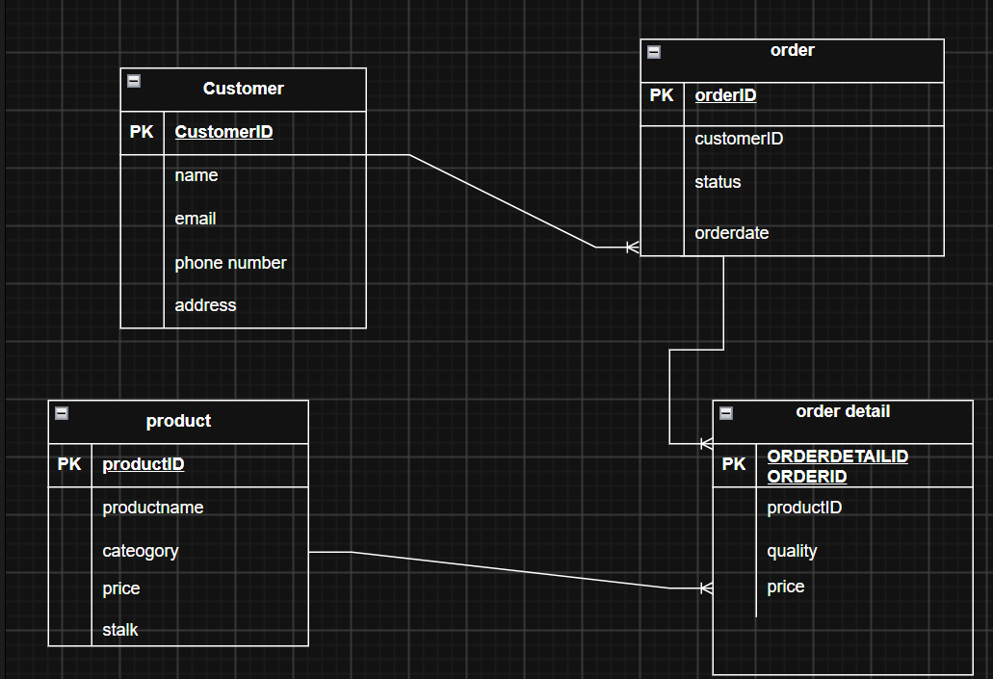

DATABASE IMPLIMENTATION:
MariaDB [(none)]> show databases;
+--------------------------+
| Database |
+--------------------------+
| ecommerce |
| hospitalmanagementsystem |
| information_schema |
| mysql |
| performance_schema |
| phpmyadmin |
| test |
+--------------------------+
7 rows in set (0.001 sec)

MariaDB [(none)]> use ecommerce;
Database changed
MariaDB [ecommerce]> CREATE TABLE customer(
-> customerID INT PRIMARY KEY AUTO_INCREMENT,
-> name VARCHAR(50) NOT NULL,
-> email VARCHAR(30) NOT NULL,
-> phonenumber VARCHAR(20) NOT NULL,
-> address VARCHAR(30) NOT NULL
-> );
Query OK, 0 rows affected (0.041 sec)

MariaDB [ecommerce]> CREATE TABLE product(
-> productID INT PRIMARY KEY AUTO_INCREMENT,
-> productName VARCHAR(50) NOT NULL,
-> category VARCHAR(50),
-> price DECIMAL(10,2) NOT NULL,
-> stock INT NOT NULL
-> );
Query OK, 0 rows affected (0.040 sec)
MariaDB [ecommerce]> CREATE TABLE orders(
-> orderID INT PRIMARY KEY AUTO_INCREMENT,
-> customerID INT,
-> orderdate DATE,
-> status VARCHAR(50),
-> FOREIGN KEY (customerID)
-> REFERENCES customer(customerID)
-> );
Query OK, 0 rows affected (0.070 sec)

MariaDB [ecommerce]> CREATE TABLE order_detail (
-> orderDetailID INT PRIMARY KEY AUTO_INCREMENT,
-> orderID INT,
-> productID INT,
-> quantity INT NOT NULL,
-> unitPrice DECIMAL(10,2),
-> FOREIGN KEY (orderID) REFERENCES orders(orderID),
-> FOREIGN KEY (productID) REFERENCES product(productID)
-> );
Query OK, 0 rows affected (0.073 sec)
DATA INSERTATION:

MariaDB [ecommerce]> INSERT INTO customer (name, email, phonenumber, address) VALUES
-> ('Kiran Poudel', 'kiran.poudel@gmail.com', '9879012345', 'Hetauda'),
-> ('Emma Davis', 'emma.davis@gmail.com', '9880123456', 'Janakpur'),
-> ('Sagar Shrestha', 'sagar.shrestha@gmail.com', '9891234567', 'Nepalgunj'),
-> ('Liam Anderson', 'liam.anderson@gmail.com', '9802345678', 'Dhangadhi'),
-> ('Pratik Joshi', 'pratik.joshi@gmail.com', '9813456789', 'Ilam'),
-> ('Isabella Martin', 'isabella.martin@gmail.com', '9824567890', 'Bharatpur'),
-> ('Roshan Tamang', 'roshan.tamang@gmail.com', '9835678901', 'Tansen'),
-> ('Zoe Taylor', 'zoe.taylor@gmail.com', '9846789012', 'Nagarkot');
Query OK, 8 rows affected (0.030 sec)
Records: 8 Duplicates: 0 Warnings: 0

MariaDB [ecommerce]> INSERT INTO product (productName, category, price, stock) VALUES
-> ('Wireless Mouse', 'Electronics', 1500, 25),
-> ('Mechanical Keyboard', 'Electronics', 4500, 15),
-> ('USB Flash Drive', 'Computer Accessories', 1200, 40),
-> ('Bluetooth Speaker', 'Audio', 3500, 20),
-> ('Laptop Backpack', 'Bags', 2800, 30),
-> ('Water Bottle', 'Accessories', 800, 50),
-> ('Desk Lamp', 'Home & Office', 1800, 18),
-> ('Notebook', 'Stationery', 250, 60);
Query OK, 8 rows affected (0.032 sec)
Records: 8 Duplicates: 0 Warnings: 0

MariaDB [ecommerce]> INSERT INTO orders (customerID,orderdate,status) VALUES
-> (1, '2026-08-01', 'Pending'),
-> (2, '2026-08-02', 'Completed'),
-> (3, '2026-08-03', 'Shipped'),
-> (4, '2026-08-04', 'Pending'),
-> (5, '2026-08-05', 'Completed'),
-> (6, '2026-08-06', 'Cancelled'),
-> (7, '2026-08-07', 'Shipped'),
-> (8, '2026-08-08', 'Processing');
Query OK, 8 rows affected (0.033 sec)
Records: 8 Duplicates: 0 Warnings: 0
MariaDB [ecommerce]> INSERT INTO order_detail (orderID, productID, quantity, unitPrice) VALUES
-> (1, 1, 2, 1500),
-> (2, 3, 1, 1200),
-> (3, 2, 1, 4500),
-> (4, 5, 2, 2800),
-> (5, 4, 1, 3500),
-> (6, 7, 3, 1800),
-> (7, 6, 2, 800),
-> (8, 8, 5, 250);

