E-Commerce Platform: Progress Report

1. Authentication & Security (Login Interface)
- User Registration: Securely hashes passwords and stores user profiles with designated roles (Admin/Customer).
- Role-Based Login: Authenticates credentials and dynamically redirects users to the correct interface based on their database role.

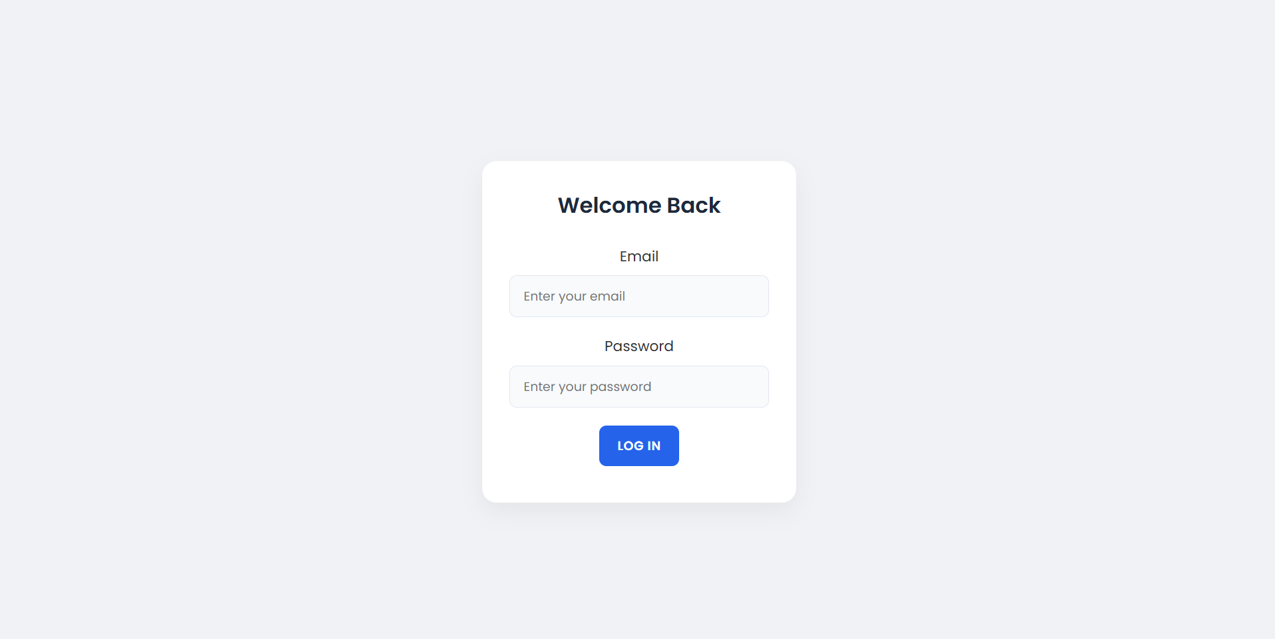

2. Admin Dashboard (Inventory & Analytics)
- Access Control: Verifies administrative privileges on page load and securely handles logouts.
- Real-Time Analytics Banner: Displays Total Revenue, Total Orders, and Low Stock counts calculated via MongoDB aggregation.
- Inventory Data Table: Renders the complete product database in an organized, scrollable tabular format.
- Smart Product Form (Create/Update): A dynamic form that seamlessly switches between adding new inventory and editing existing items.
- One-Click Item Deletion: Permanently removes a product from the database with an instant UI refresh.

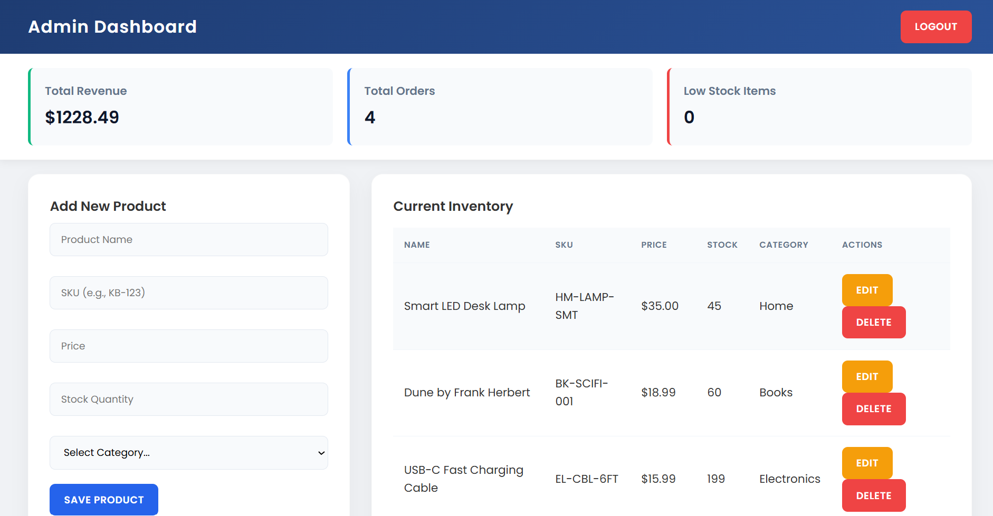

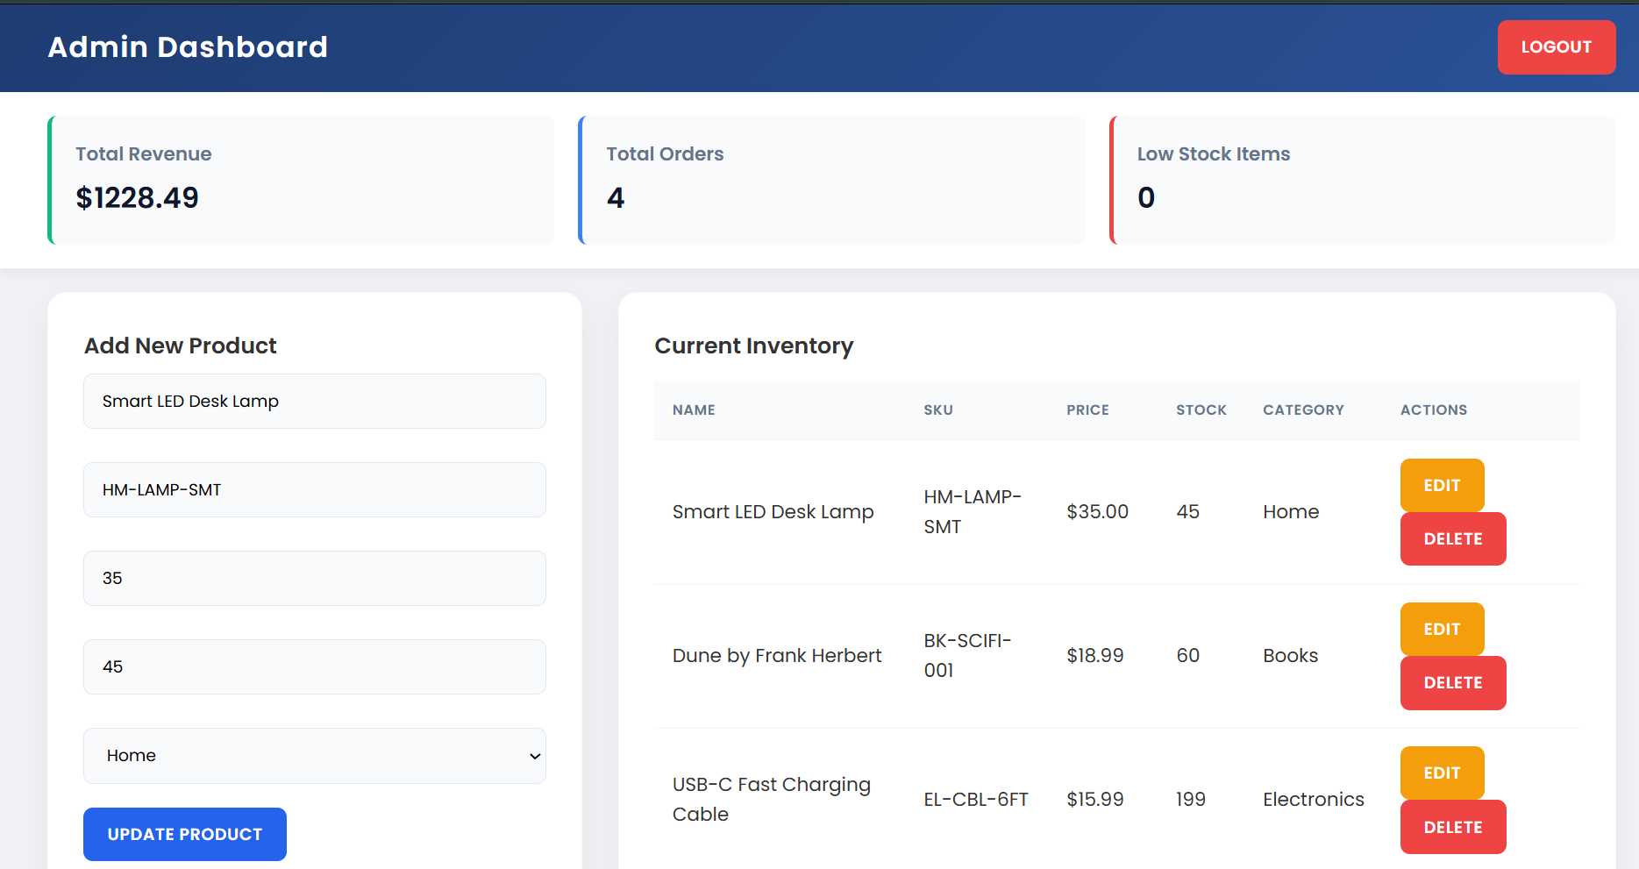

3. Customer Storefront (Shopping Experience)
- Dynamic Product Grid: Displays available inventory as modern product cards indicating price, name, and real-time stock levels.
- Advanced Search & Filtering: Allows filtering by fuzzy text search, category dropdown, and maximum price boundaries.
- Inventory Pagination: Automatically splits large product lists into discrete pages for fast loading and navigation.
- Interactive Shopping Cart: Dynamically tracks selected items, enforces stock limits, and calculates the live order total.
- Cart Item Removal: Enables customers to delete individual items from their active cart prior to checkout.
- Smart Checkout Engine: Submits the order, safely deducts stock quantities in the database, and clears the cart on success.

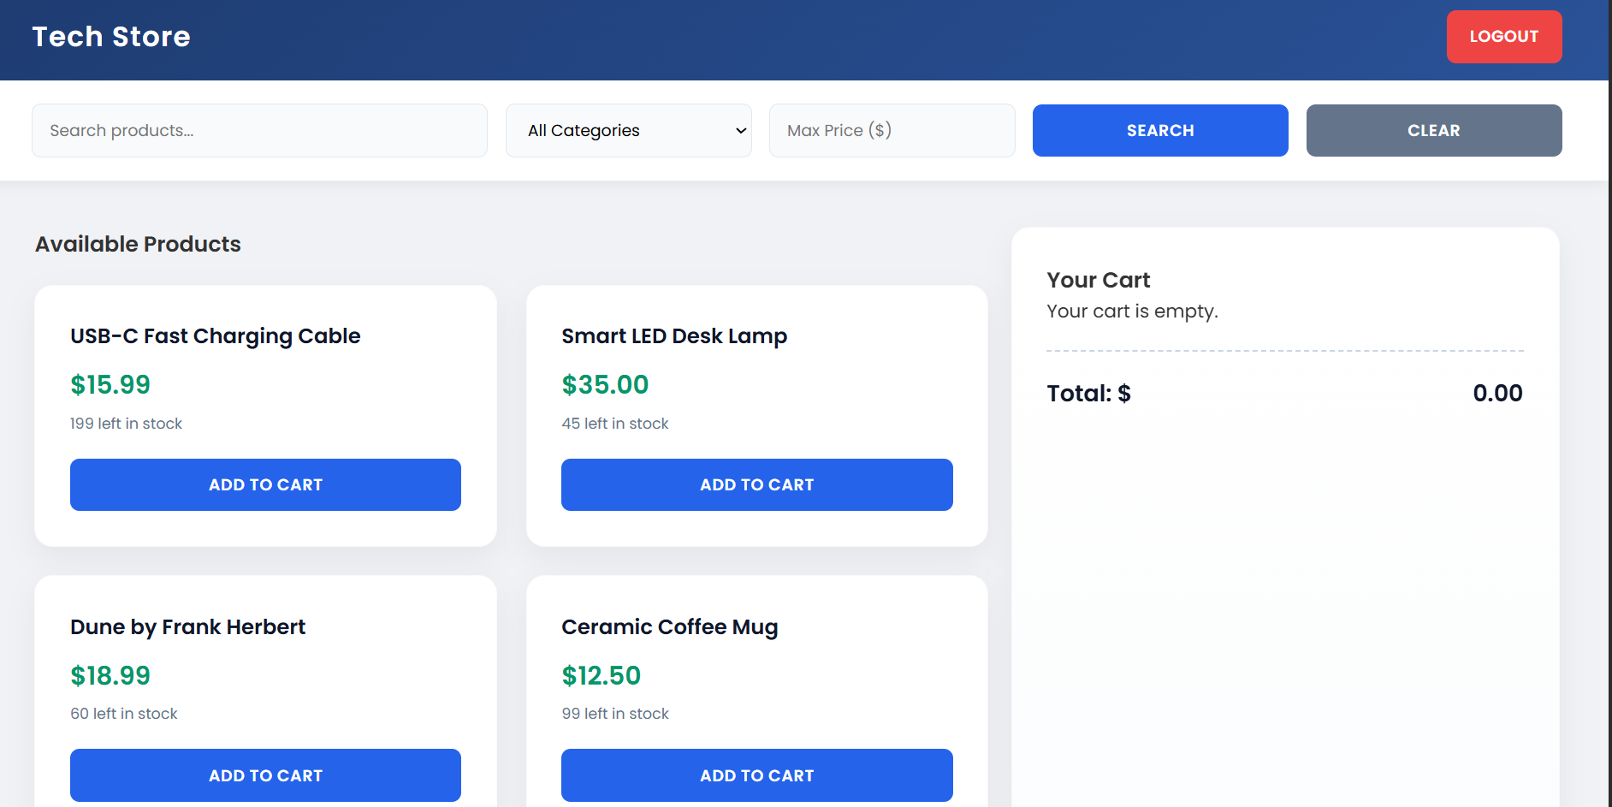
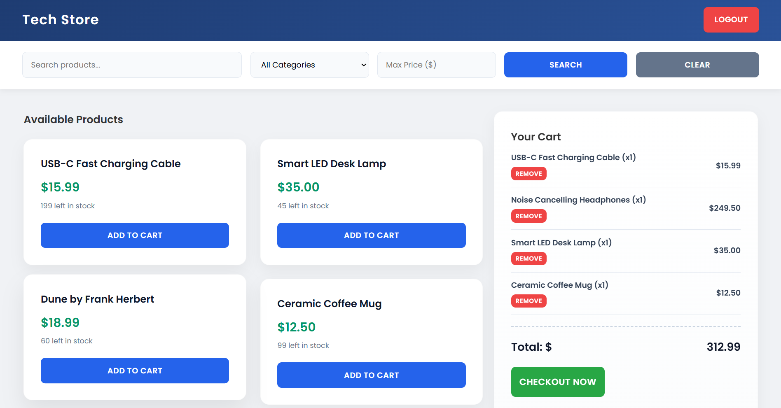

4. Backend Engine & MongoDB Architecture
Relational Database Models: Utilizes strict Mongoose Schemas to logically link Users, Products, and Order arrays.
Atomic Inventory Updates: Uses MongoDB's $inc operator to safely guarantee precise stock decrements during checkout.
Advanced Querying Pipeline: Translates frontend search parameters into complex $regex and $lte/$gte database queries.

