Name:Ankit Kadyan
24BCE8654
Code:
import com.mongodb.client.*;
import com.mongodb.client.model.Filters;
import com.mongodb.client.model.Updates;
import org.bson.Document;

public class Crud {
public static void main(String[] args)
{
MongoClient mongoClient = MongoClients.create("mongodb://localhost:27017");
// Access database
MongoDatabase db = mongoClient.getDatabase("CollegeDB");
MongoCollection<Document> doc=db.getCollection("Students");
//Document std=new Document();
doc.updateOne(Filters.eq("id", 101), Updates.set("cgpa", 9.2) );
System.out.println("Document Updated Successfully");
FindIterable<Document> updatedStudent =doc.find();
System.out.println("\nUpdated Record:");
for (Document di : updatedStudent) {
System.out.println(di.toJson());
}
doc.updateOne(Filters.eq("id",101), Updates.rename("CGPA", "gpa"));
FindIterable<Document> updatedStudent1 =doc.find();
System.out.println("\nUpdated Record:");
for (Document di : updatedStudent1) {
System.out.println(di.toJson());
}
doc.updateOne(Filters.eq("id",101), Updates.unset("gpa"));
FindIterable<Document> updatedStudent2 =doc.find();
System.out.println("\nUpdated Record:");
for (Document di : updatedStudent2) {
System.out.println(di.toJson());
}
}
}
Output:
Document Updated Successfully

Updated Record:
{"_id": {"$oid": "6a2037a09c62576a97d2b6f5"}, "id": 101, "name": "John", "department": "CSE", "Salary": 102222, "cgpa": 9.2}
{"_id": {"$oid": "6a218881cb068d03dc06e1d9"}, "id": 101, "name": "John", "department": "CSE", "cgpa": 8.7, "Salary": 102222}
{"_id": {"$oid": "6a2188b847a91b372f30410f"}, "id": 101, "name": "John", "department": "CSE", "cgpa": 8.7, "Salary": 102222}
{"_id": {"$oid": "6a2188bea1371112ff056892"}, "id": 101, "name": "John", "department": "CSE", "cgpa": 8.7, "Salary": 102222}
{"_id": {"$oid": "6a218a50e82bae49c72b83b6"}, "id": 101, "name": "John", "department": "CSE", "cgpa": 8.7, "Salary": 102222}

Updated Record:
{"_id": {"$oid": "6a2037a09c62576a97d2b6f5"}, "id": 101, "name": "John", "department": "CSE", "Salary": 102222, "gpa": 9.2}
{"_id": {"$oid": "6a218881cb068d03dc06e1d9"}, "id": 101, "name": "John", "department": "CSE", "cgpa": 8.7, "Salary": 102222}
{"_id": {"$oid": "6a2188b847a91b372f30410f"}, "id": 101, "name": "John", "department": "CSE", "cgpa": 8.7, "Salary": 102222}
{"_id": {"$oid": "6a2188bea1371112ff056892"}, "id": 101, "name": "John", "department": "CSE", "cgpa": 8.7, "Salary": 102222}
{"_id": {"$oid": "6a218a50e82bae49c72b83b6"}, "id": 101, "name": "John", "department": "CSE", "cgpa": 8.7, "Salary": 102222}

Updated Record:
{"_id": {"$oid": "6a2037a09c62576a97d2b6f5"}, "id": 101, "name": "John", "department": "CSE", "Salary": 102222}
{"_id": {"$oid": "6a218881cb068d03dc06e1d9"}, "id": 101, "name": "John", "department": "CSE", "cgpa": 8.7, "Salary": 102222}
{"_id": {"$oid": "6a2188b847a91b372f30410f"}, "id": 101, "name": "John", "department": "CSE", "cgpa": 8.7, "Salary": 102222}
{"_id": {"$oid": "6a2188bea1371112ff056892"}, "id": 101, "name": "John", "department": "CSE", "cgpa": 8.7, "Salary": 102222}
{"_id": {"$oid": "6a218a50e82bae49c72b83b6"}, "id": 101, "name": "John", "department": "CSE", "cgpa": 8.7, "Salary": 102222}
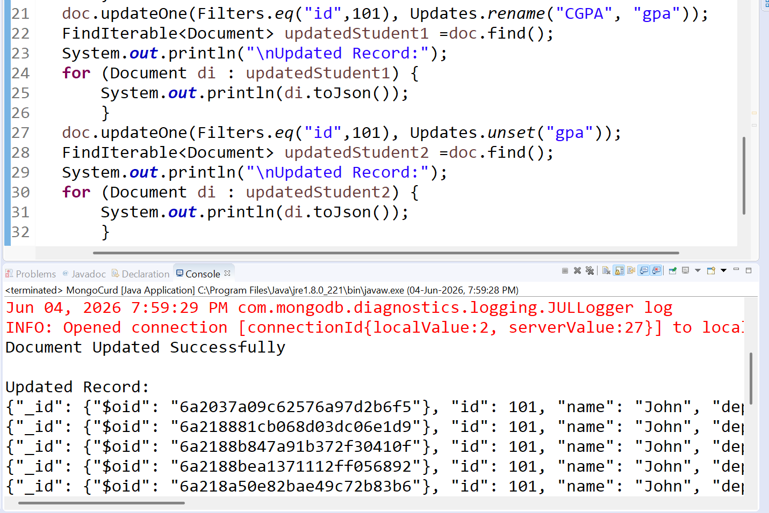SS

