Progress Report
This document provides visual proof of the backend architecture, showcasing successful API endpoint tests via Postman and data integrity verification via MongoDB Compass.

1. Database Integrity (MongoDB Compass)
Visual confirmation of the data stored within the MongoDB database collections.

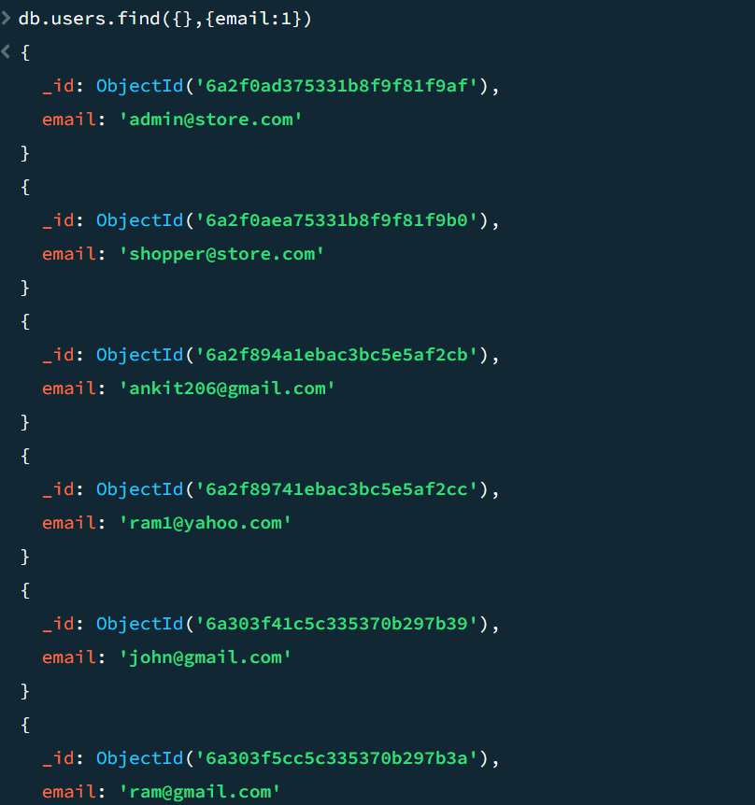
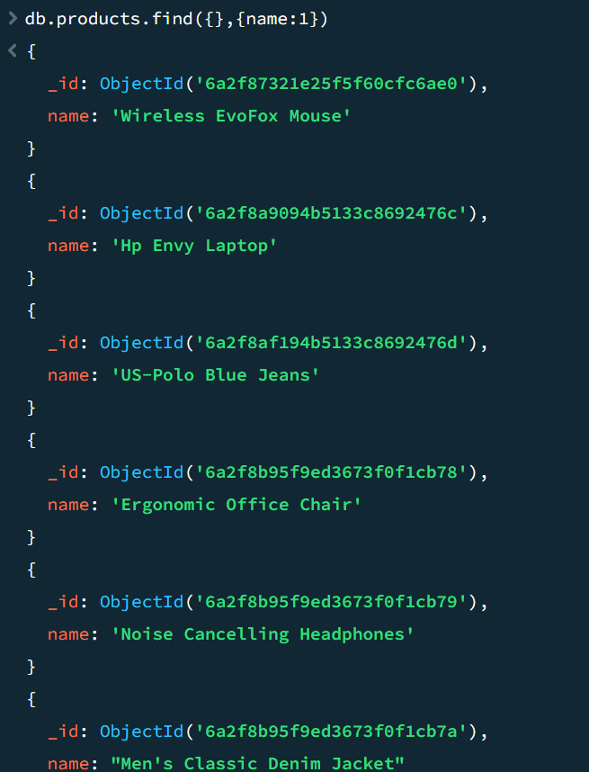

2. Authentication API
Testing the secure login and registration routes.

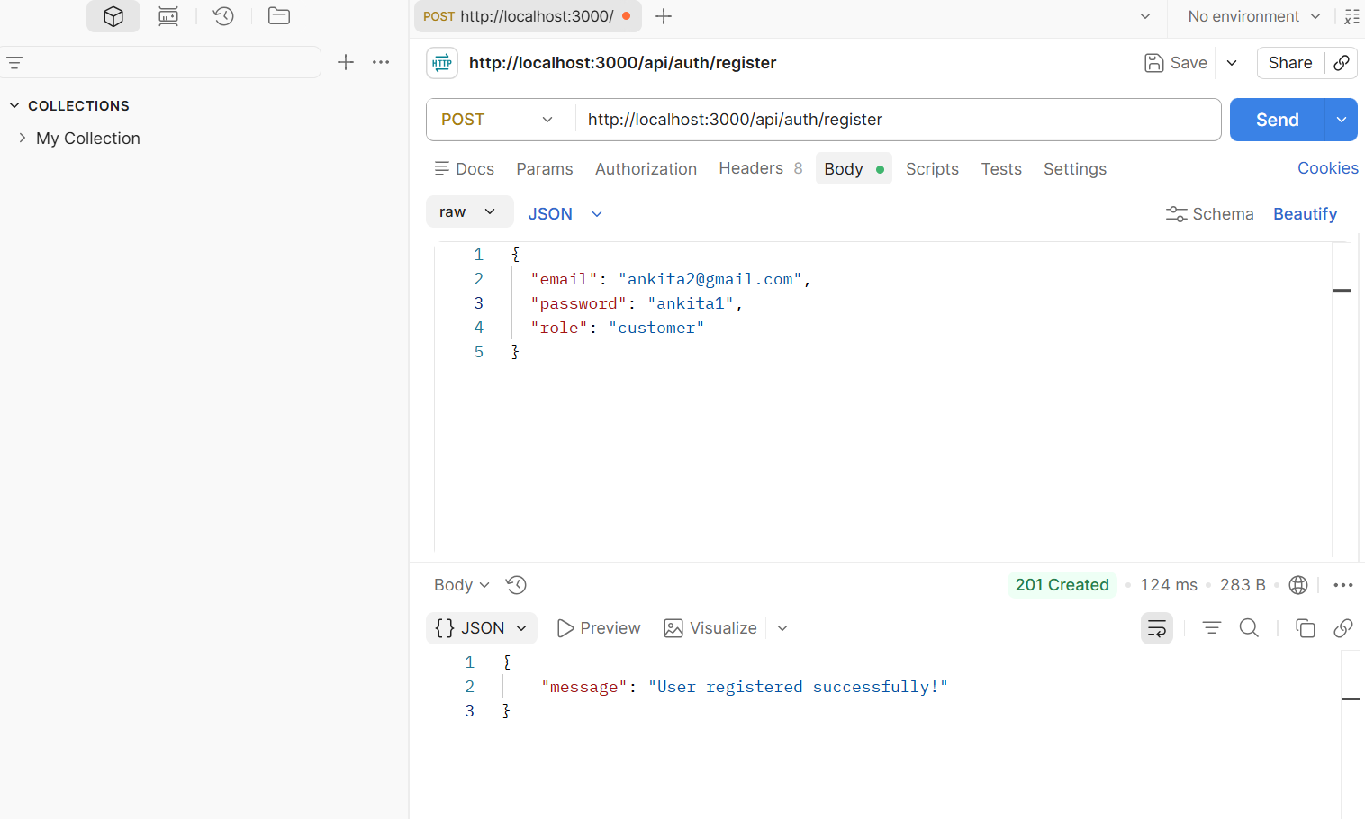

3. Inventory Management API
Testing the CRUD operations for store products.
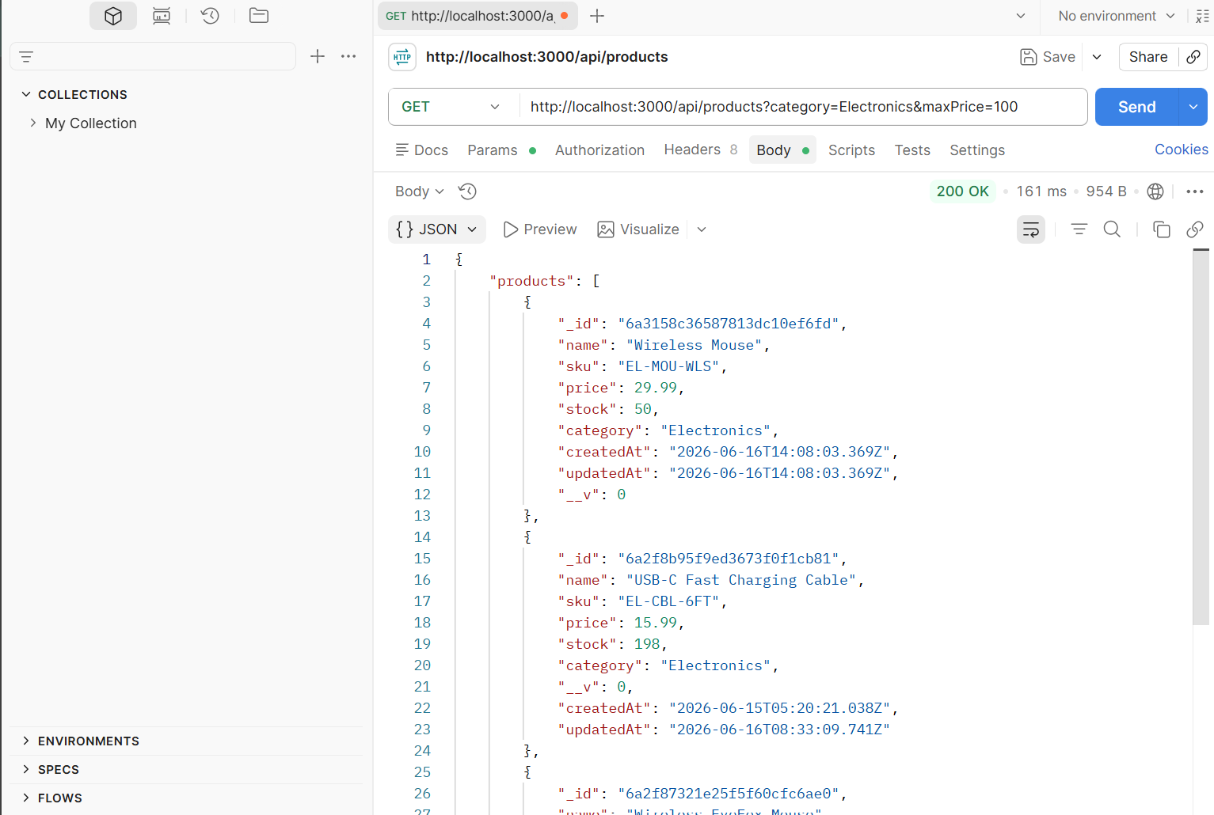

4. Checkout & Orders API
Testing the e-commerce transaction engine using SKUs or Product IDs.

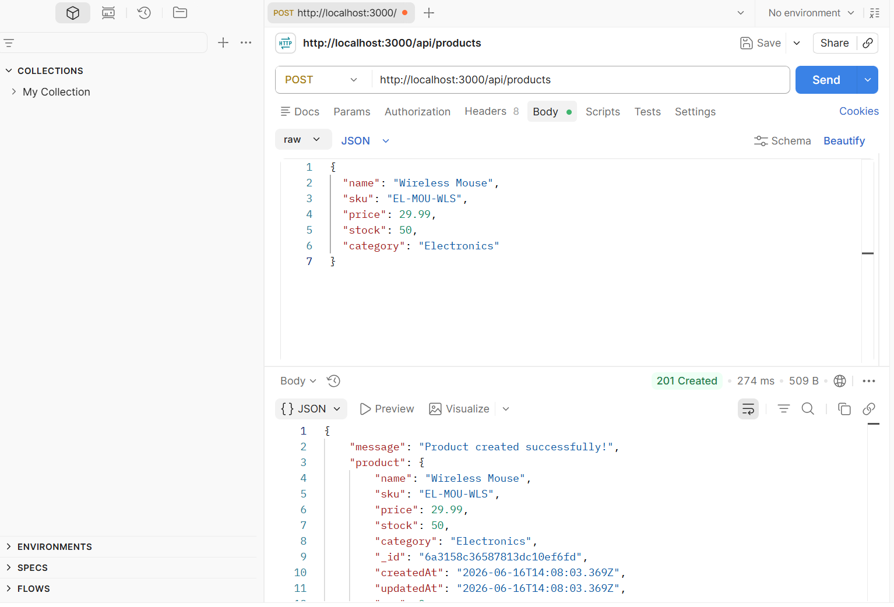

5. Admin Analytics API
Testing the MongoDB Aggregation pipeline for dashboard statistics.

