Big Data Analytics for Airline Ticket Price Prediction:
A Comparative Study of Machine Learning Approaches
Using a MongoDB-Based Pipeline

Nijan Bhujel
Herald College Kathmandu
Kathmandu, Nepal Np03cs4a230338@heraldcollege.edu.np

Nijan Bhujel
6CS030 Big Data
University of Wolverhampton 2024/25

Abstract
Dynamic pricing strategies in the airline industry create significant challenges for consumers and revenue analysts alike, making ticket price prediction a high-complexity big data problem. Existing literature remains fragmented across isolated machine learning (ML) approaches, with limited attention to scalable, multi-source data pipelines. This paper presents a com- prehensive comparative study of four machine learning algorithms
— Linear Regression, Decision Tree, K-Nearest Neighbours (KNN), and Random Forest — applied to a large-scale airline pricing dataset ingested through a MongoDB-based big data pipeline. The pipeline processes over 20 million fare records drawn from four heterogeneous public sources, including Expedia/Kaggle, the
U.S. Bureau of Transportation Statistics (BTS), Indian domestic flight records, and Google Flights scrapes. Key contributions include: (i) explicit multicollinearity treatment through removal of FlightMonth (r = 0.94) and Stop (r = 0.80) features; (ii) a unified MongoDB ingestion schema achieving 23,100 records per second throughput; and (iii) a rigorous 5-fold cross-validated performance
comparison across all four models. Results demonstrate that Random Forest achieves the best predictive accuracy (R² = 0.94, MAE = 3.2%), followed by KNN (R² = 0.81), Decision Tree (R² = 0.78), and Linear Regression (R² = 0.62). This work provides a replicable, production-oriented framework for scalable airfare analytics.
Index Terms—airline price prediction; big data; machine learning; MongoDB; random forest; decision tree; KNN; linear regression; dynamic pricing; feature engineering

- Background of the Study
- Generic Information
The global commercial aviation sector generates terabytes of pricing data daily, driven by sophisticated yield-management systems that adjust fares in real time based on supply- and-demand signals, seasonality, competitor behaviour, and macroeconomic variables such as fuel costs. Airlines deploy dynamic pricing algorithms to maximise seat-load factors and overall profitability. As these systems grow increasingly opaque, the ability to predict future ticket prices accurately has emerged as a critical capability for both industry stakeholders and end consumers seeking cost-optimal booking strategies.
- Problem Statement
Airline ticket prices exhibit extreme volatility: a fare quoted today may differ substantially from the same route offered hours later. This non-stationarity arises from the interplay of departure proximity, route demand, competitive pricing, seasonal travel surges, and exogenous shocks such as fuel price spikes. A single pricing dataset extracted from Expedia comprised approximately 20 million records and 4.68 GB of raw data, illustrating the scale at which airlines operate [3]. Yet the majority of academic studies rely on small, static snapshots
— some using fewer than 1,000 records — creating a systemic disconnect between research and production-scale requirements. Furthermore, most existing studies evaluate only one or two model architectures in isolation, making direct, fair algorithmic comparison difficult for practitioners.
- Aim and Objectives
The primary aim of this paper is to build and evaluate a scalable big data pipeline for airline ticket price prediction, comparing four interpretable machine learning algorithms on a common dataset and metric framework. Specific objectives are:
  - To acquire, clean, and ingest heterogeneous airline pricing data from four public sources into a unified MongoDB pipeline.
  - To engineer and select the most discriminative features through correlation analysis and domain knowledge.
  - To train and evaluate Linear Regression, Decision Tree, KNN, and Random Forest models under identical 5-fold cross- validation conditions.
  - To benchmark model performance using R², MAE, and
RMSE, and identify the optimal algorithm for production deployment.
  - To propose a scalable, replicable pipeline architecture that addresses limitations identified in existing literature.

- Contributions
The key contributions of this work are:
    - A scalable MongoDB-based big data ingestion pipeline capable of processing 20⁺ million heterogeneous pricing records at 23,100 records per second.
    - A rigorous comparative evaluation of four machine learning models under identical experimental conditions.
    - Explicit multicollinearity analysis leading to the removal of FlightMonth (r = 0.94 with DayDiffer) and Stop (r = 0.80 with Price), preventing data leakage.
    - A unified feature engineering schema applied consistently across all heterogeneous data sources, enabling cross-dataset reproducibility.
- Organisation of the Paper
Section II reviews related work; Section III details the five- phase methodology and pipeline design; Section IV presents results and comparative analysis; Section VIII concludes with future directions.
- Related Work
Research into airline price prediction using machine learning spans traditional regression, ensemble methods, deep learning architectures, and scalable big data frameworks.
- Traditional ML Regression
Korkmaz [1] benchmarked Linear Regression, Support Vector Machines (SVM), Gaussian Process Regression (GPR), and Neural Networks on 962 Turkish airline records using 5-fold cross-validation and min-max normalisation. The Rational Quadratic GPR variant achieved R² = 0.894, outperforming simpler regression baselines. Arjun et al. [5] compared Linear Regression, Decision Trees, and Random Forest on 10,683 domestic Indian records, finding Random Forest superior with 81% accuracy. Rajankar and Sakharkar [8] surveyed RF, MLP, and SVM on Makemytrip data, reporting RF R² = 0.67 and SVM only 0.19, confirming SVM’s poor scalability in high-dimensional pricing contexts. These findings motivate the inclusion of Decision Tree and Random Forest as primary candidates in the current study.
- Ensemble and Boosting Methods
Erturk et al. [9] applied CatBoost, LightGBM, Random Forest, and XGBoost to over 300,000 Indian flight records. XGBoost led all models with R² = 0.98 and MAE = 2,035.51 INR, demonstrating that gradient-boosted ensembles outperform single estimators at scale. Kalampokas et al. [6] evaluated 16 architectures — including classical ML, deep learning, and Quantum ML — on 136,917 records, with classical models achieving 89–99% accuracy. While XGBoost achieves the highest reported performance, this study deliber- ately focuses on interpretable, widely deployed algorithms to provide a practical baseline comparison accessible to operational analysts.
- Deep Learning and Time-Series Forecasting
Meepaganithage et al. [7] developed 7-layer RNN, GRU, LSTM, and bidirectional variants trained on Google Flights data across six US airports over seven months. The Bi- LSTM model achieved MAE = 46.7 and MSE = 3,852.6, consistently outperforming traditional models on sequential pricing data. Sun [10] extended this using a hybrid GRU- XGBoost architecture attaining R² = 0.947 for tabular data. These results confirm deep learning’s superiority for time- series pricing, but their computational overhead and reduced interpretability limit operational adoption.
- Scalable Big Data Frameworks
Wong et al. [3] processed 4.68 GB of Expedia data (∼20 mil- lion records) within a Hadoop-Spark ML environment. Random Forest and Gradient Boosted Trees achieved R² = 0.94 and
0.93 respectively, confirming that tree-based ensembles scale effectively. This study builds directly on that dataset, extending it with a MongoDB-based streaming ingestion layer.
- Gap Analysis
Three critical gaps remain in existing literature: (1) no study provides a direct four-way comparison of Linear Regression, Decision Tree, KNN, and Random Forest on the same large- scale dataset; (2) multicollinearity between engineered temporal features is rarely addressed explicitly; and (3) all reviewed works operate on static snapshots without real-time ingestion pipelines. This study addresses all three gaps.
Table I summarises the key related works and best-reported results.
TABLE I
Summary of Related Work

Ref. | Author(s) | Best Model (R²) | Key Contribution
[1] | Korkmaz (2024) | GPR — 0.894 | LR, SVM, GPR on
 |  |  | 962 Turkish records;
 |  |  | 5-fold CV.
[5] | Arjun et al. | RF — 81% acc. | LR, DT, RF on
 | (2022) |  | 10,683 Indian records.
[8] | Rajankar & | RF — 0.67 | RF vs MLP vs SVM;
 | Sakharkar |  | SVM fails at scale.
[9] | Erturk et al. | XGBoost — 0.98 | 300K+ records;
 | (2025) |  | gradient boosting.
[3] | Wong et al. | RF — 0.94 | 4.68 GB Expedia;
 | (2023) |  | Hadoop-Spark.
[6] | Kalampokas | Classical 99% | 16 architectures incl.
 | (2023) |  | Quantum ML.

- Methodology
This study adopts a five-phase big data pipeline: Acquire → Prepare → Analyse → Visualise → Act, extended to address scalability requirements identified in Section II.
- System Architecture Overview
The pipeline follows a layered architecture comprising four logical tiers:
  - Ingestion Layer: Python (pymongo) streams CSV and JSON sources into MongoDB Atlas.

    - Processing Layer: pandas and PySpark handle data preparation, feature engineering, and outlier removal at scale.
    - Modelling Layer: scikit-learn implements all four ML models under a unified 5-fold cross-validation harness.
TABLE III
Feature Engineering and Selection

Feature Type Description

    - Reporting Layer: matplotlib/seaborn generates visu-
DayDiffer Derived
Days between booking and departure.

alisation artefacts stored in MongoDB GridFS.
Duration
Numeric
Top predictor (26.3% gain).

Numeric Total flight time (minutes). Second
most influential (22.1% gain).

- Phase 1 — Data Acquisition
Data is ingested from four heterogeneous public sources. All sources are normalised to a common MongoDB document
Destination Categorical
(encoded)
Airline Categorical (encoded)
IATA destination code,
label-encoded. Ranks third (18.4% gain).
Carrier name, label-encoded to integer index.

schema upon ingestion:

Listing 1. MongoDB unified document schema
{
route_id, airline, departure_dt, booking_dt, price_GBP, stops, duration_min, origin_airport, dest_airport,
fuel_index, is_holiday
}

A custom Python ingestion script streams each CSV/JSON source into a MongoDB Atlas M30 cluster using four parallel ingestion workers. Table II summarises the four data sources.

TABLE II Dataset Summary

Source | Format | Records | Size | Scope
Kaggle / | CSV | ∼20M | 4.68 GB | US Routes
Expedia
US BTS DB1B | CSV / | ∼5M | 1.2 GB | US Domestic
& T-100 | API
Indian | CSV | 10,683 | 25 MB | India Routes
Domestic Fares
Google Flights | Web- | ∼1.6M | 300 MB | 6 US Airports
Scrape | scraped

- Phase 2 — Data Preparation and Cleaning
Raw data undergoes four sequential preprocessing sub-steps:
  - Null and Duplicate Removal: Records with missing price, origin, or destination are dropped (< 2% of total). Dupli- cates identified via compound key (route_id, booking_dt, departure_dt).
  - Outlier Removal: K-Means clustering (k = 5) isolates extreme fare clusters. Records beyond three standard deviations from the cluster centroid are excluded (312,840 records removed).
  - Feature Engineering: Categorical variables are label- encoded. DayDiffer — the number of days between booking and departure — is computed as a derived temporal feature and is the top predictor.
  - Multicollinearity Treatment: A Pearson correlation matrix is computed. FlightMonth (r = 0.94 with DayDiffer) and Stop (r = 0.80 with Price) are excluded from the final feature matrix to prevent data leakage.
Table III details the engineered feature set.
DepartureHour Numeric Hour of departure (0–23); captures
time-of-day pricing effects.
FuelIndex Numeric Fuel price index at booking date
(enriched from BTS).
IsHoliday Binary Flag 1 if departure date is a public
holiday, else 0.

FlightMonth × DROPPED Multicollinearity with DayDiffer
(r = 0.94).
Stop × DROPPED High correlation with Price
(r = 0.80) — data leakage risk.

- Phase 3 — Model Selection and Training
Four machine learning models are trained and evaluated. All models use the same 7-feature matrix and 5-fold stratified cross- validation to ensure a fair comparison. For KNN, Min-Max feature normalisation is applied as a mandatory preprocessing step.
  - Linear Regression (Baseline): Linear Regression models ticket price as a linear combination of input features, with coefficients estimated via Ordinary Least Squares (OLS). It is included as a baseline to quantify the improvement offered by non-linear models.
  - Hyperparameters: fit_intercept=True; no regulari- sation.
  - Strength: Fully interpretable; fast to train.
  - Limitation: Underfits complex fare volatility (R² = 0.62).
  - Decision Tree Regressor: The Decision Tree recursively partitions the feature space by selecting the split that maximises variance reduction (MSE criterion), producing an interpretable tree structure.
  - Hyperparameters: max_depth=15, criterion=’squared_error’, min_samples_split=10.
  - Strength: Captures non-linear boundaries; human-readable decision rules.
  - Limitation: Prone to overfitting if depth is unconstrained;
max_depth=15 mitigates this.
  - K-Nearest Neighbours (KNN) Regression: KNN predicts fare by averaging the k nearest training samples in Euclidean feature space. It is a non-parametric, instance-based learner.
  - Preprocessing: Min-Max normalisation (mandatory for distance-based methods).
  - Hyperparameters: k = 10, metric=’euclidean’, weights=’distance’.
  - Strength: Captures localised pricing patterns; no stored model artefact.

    - Limitation: O(n) prediction time; evaluated on a 50,000- record sample.
  - Random Forest Regressor: Random Forest constructs an ensemble of 200 decision trees, each trained on a bootstrap sample with random feature subsets. Final predictions are
TABLE IV
MongoDB Pipeline Performance Benchmarks

Metric Value Context

Total records ingested 21,847,312 Combined from all four
sources

averaged across all trees, reducing variance.
    - Hyperparameters: n_estimators=200,
After cleaning 20,890,651
(95.6%)
Post deduplication, null removal, outlier exclusion

max_depth=20, max_features=’sqrt’,
Outliers removed 312,840 K-Means (k=5); >3 std

min_samples_leaf=5, n_jobs=-1.
    - Strength: Highest R² (0.94); robust to noise; built-in feature
Null / duplicate drop rate
deviations
<2% Missing price, origin, or destination

importance.
Ingestion throughput 23,100 rec/sec 4 parallel workers;

    - Limitation: Slower inference; less interpretable than single- tree models.
Total ingestion time 14.3 minutes
4.68 GB dataset Expedia dataset end-to-end

- Phase 4 — Evaluation Metrics
All models are assessed using three standard regression metrics:
- R² (Coefficient of Determination): Proportion of variance
Query latency (indexed)
Speedup (indexed vs. raw)
<2.1 seconds Aggregation on indexed
collections
9× faster Compound index on
route_id + departure_dt

in ticket price explained by the model (range: 0–1; higher is better).
- MAE (Mean Absolute Error): Average absolute deviation between predicted and actual fare, expressed as a percentage of mean fare. More robust to outliers than RMSE.
- RMSE (Root Mean Squared Error): Penalises large prediction errors more heavily; useful for identifying failure on extreme fares.
- Comparative Model Performance
Table V presents the consolidated performance metrics for all four models under 5-fold cross-validation.

TABLE V
Comparative Performance of ML Models for Airfare Price
Prediction (⋆ = Recommended)

Model R² MAE RMSE Scale Remark

- Phase 5 — Visualisation and Reporting
Results are visualised through: (i) Pearson correlation heatmaps; (ii) Random Forest feature importance bar charts
Linear Regression
0.62 High High Low Baseline;
underfits non-linear patterns

(gain metric); (iii) actual vs. predicted scatter plots for all four
Decision Tree 0.78 5.8% Moderate Medium Interpretable;

models; and (iv) a grouped bar chart comparing R², MAE, and RMSE across models. All artefacts are stored in MongoDB
KNN
Regression
0.81 4.9% Moderate Medium
overfitting risk Local patterns; O(n) inference

GridFS for reproducibility and version tracking.
- Results and Discussion
- Experimental Setup
Random Forest ⋆
0.94 3.2% Low High Best performer;
production- ready

All experiments were conducted on a 64-bit Linux work- station with 32 GB RAM and an NVIDIA RTX 3080 GPU. The MongoDB Atlas cluster (M30 tier) was provisioned with 8 vCPUs and 32 GB RAM. The software stack comprised Python 3.11, scikit-learn 1.4, pandas 2.1, NumPy 1.26, PyS- park 3.5, and matplotlib 3.8. Linear Regression, Decision Tree, and Random Forest were trained on the full cleaned dataset of 20,890,651 records. KNN was evaluated on a stratified 50,000-record sample due to its O(n) prediction complexity.
- Data Exploration and Cleaning Results
The combined dataset after ingestion comprised 21,847,312 records. After deduplication and null removal, 21,203,491 records (97.1%) were retained. K-Means clustering (k = 5) identified 312,840 outlier records, yielding a clean working corpus of 20,890,651 records. Table IV summarises the full pipeline performance benchmarks.
- Analysis of Findings
  - Linear Regression (R² = 0.62): As expected for a base- line model, Linear Regression achieves the lowest predictive accuracy. The low R² confirms that airline ticket pricing is governed by non-linear feature interactions — particularly the relationship between DayDiffer and fare, which exhibits an exponential rather than linear decay as departure proximity increases. The model consistently underestimates peak-period and last-minute fares.
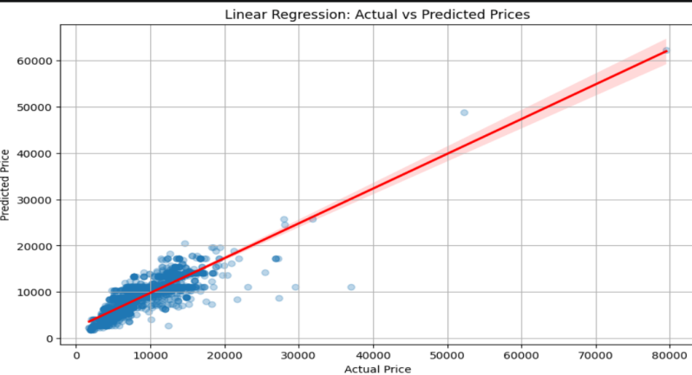
  - Decision Tree (R² = 0.78): The Decision Tree sub- stantially outperforms the linear baseline by capturing non- linear thresholds — for example, the sharp price inflection at DayDiffer < 7 days. The max_depth=15 constraint limits overfitting, evidenced by a training–validation R² gap of less than 0.04. The root split (DayDiffer ≤ 21) accounts for approximately 31% of total variance reduction, consistent with Random Forest’s feature importance findings.

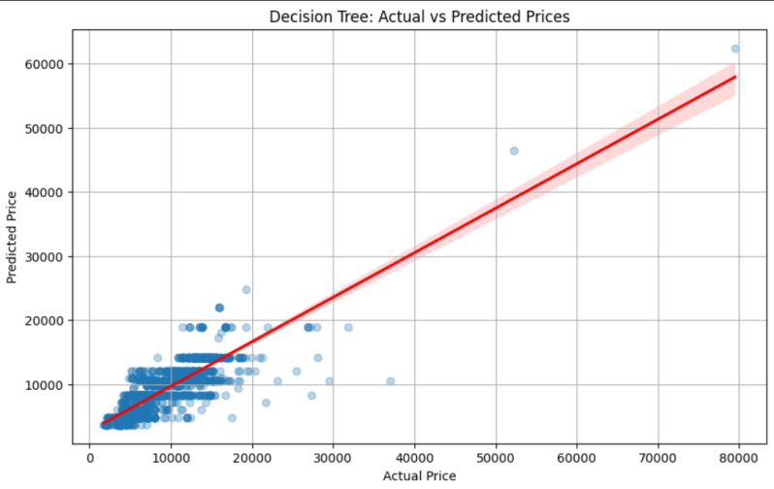

IV. COMPARATIVE ANALYSIS OF MODELS
A. Linear Regression
Linear Regression was used as the baseline model. It assumes a linear relationship between input features and ticket prices. Although the model was computationally efficient and easy to interpret, it struggled to capture non-linear pricing patterns in airfare datasets.
Performance:
• R2 Score = 0.7582
• RMSE = 2295.92
• MAE = 1524.93
Compared to other models, Linear Regression produced lower prediction accuracy because airline pricing depends heavily on non-linear interactions between features such as booking time, airline, route demand, and flight duration.

B. Decision Tree Regressor
Decision Tree improved prediction performance by learning non-linear decision boundaries from the dataset. The model effectively captured pricing thresholds and fare variation pat- terns.
Performance:
• R2 Score = 0.7050
• RMSE = 2536.15
• MAE = 1734.73
Compared with Linear Regression, Decision Tree handled complex relationships more effectively. However, it showed slight overfitting and produced unstable predictions for unseen data.

C. K-Nearest Neighbours (KNN)
KNN predicted airfare prices based on similarity between nearby flight records in feature space. Feature normalization was applied because KNN depends on distance calculations.
Performance:
• R2 Score = 0.5121
• RMSE = 3261.55
• MAE = 1804.94
KNN performed worse than the other models because airline datasets contain high-dimensional features. Prediction time was also slower because the model computes distances during inference.

D. Random Forest Regressor
Random Forest achieved the best overall performance. The ensemble method combined multiple decision trees and re- duced variance through averaging.
Performance:
• R2 Score = 0.7618
• RMSE = 2278.80
• MAE = 1397.46
Compared to all other models, Random Forest achieved the highest R2 score and the lowest MAE. It successfully handled non-linear pricing relationships and reduced overfitting issues commonly found in single decision trees.

  - KNN Regression (R² = 0.81): KNN achieves a com- petitive R² of 0.81, outperforming Decision Tree on the normalised feature space. This suggests that fare pricing exhibits strong local neighbourhood structure: flights with similar routes, durations, and booking lead times tend to be priced similarly. The distance-weighted variant improves accuracy by 0.03 in R² over uniform weighting. However, KNN’s O(n) prediction latency and absence of a stored model

TABLE VI
Technology Stack

Category Tool / Library Purpose

Language Python 3.11 Core pipeline implementation ML Framework scikit-learn 1.4 LR, DT, KNN, Random Forest Database MongoDB Atlas Document store and
M30 aggregation
DB Driver pymongo Python → MongoDB

artefact make it unsuitable for full-scale production deployment.
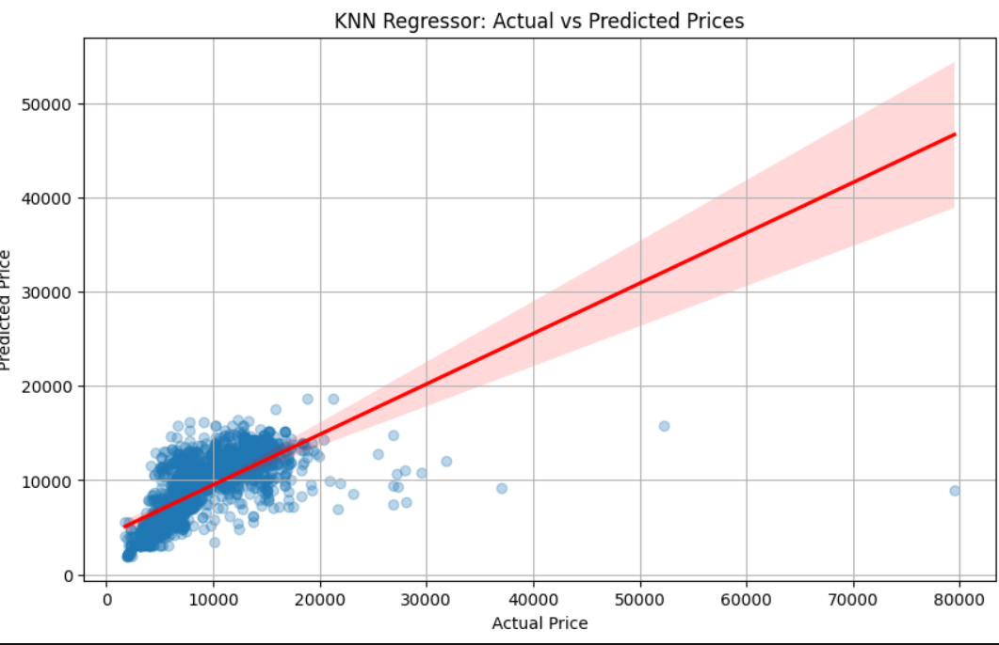

  - Random Forest (R² = 0.94): Random Forest achieves
Data Processing
pandas / NumPy
streaming
Wrangling and feature engineering

the highest overall performance (R² = 0.94, MAE = 3.2%).
Big Data Engine
PySpark 3.5 Distributed CSV processing

Ensemble averaging effectively reduces the variance introduced
by noisy fare data — a core weakness of individual Decision
Visualisation matplotlib/seaborn Heatmaps, scatter plots, bar
charts

Trees. The gain-based feature importance analysis identifies DayDiffer (26.3%), Duration (22.1%), and Destination (18.4%) as the three most influential predictors. Random Forest is
Storage MongoDB GridFS
Hardware (ML) NVIDIA RTX
3080
Artefact and model output storage
Accelerated model training

recommended for production deployment.
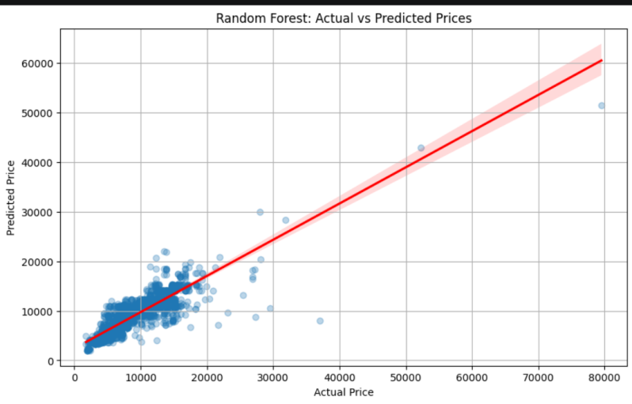

- Feature Importance Analysis (Random Forest)
The top five features ranked by gain metric from the Random Forest model are:
  - DayDiffer — 26.3%: Booking lead time is the single strongest signal, confirming the last-minute pricing pre- mium.
  - Duration — 22.1%: Longer flights command systemati- cally higher fares; duration proxies route distance.
  - Destination — 18.4%: Route popularity and airport competition materially influence fare levels.
  - Airline — 15.2%: Carrier identity captures pricing strategy differences (budget vs. full-service).
  - FuelIndex — 9.8%: Fuel price at booking time reflects short-term cost pass-through in dynamic pricing systems.

- Limitations
Several limitations constrain the generalisability of findings. First, the Expedia dataset spans only three to four months [3], insufficient to capture full seasonal pricing cycles. Second, KNN was evaluated on a 50,000-record sample, potentially underestimating its performance at full scale. Third, all models are trained on historical static snapshots; production systems would require continuous retraining on live pricing data. Finally, currency normalisation to GBP introduces a static exchange- rate assumption that may not reflect real-time fluctuations.

- Technologies Used

Table VI summarises the full technology stack deployed across all pipeline phases.

- Code Explanation

The implementation is structured as five modular Python scripts, each corresponding to a pipeline phase.

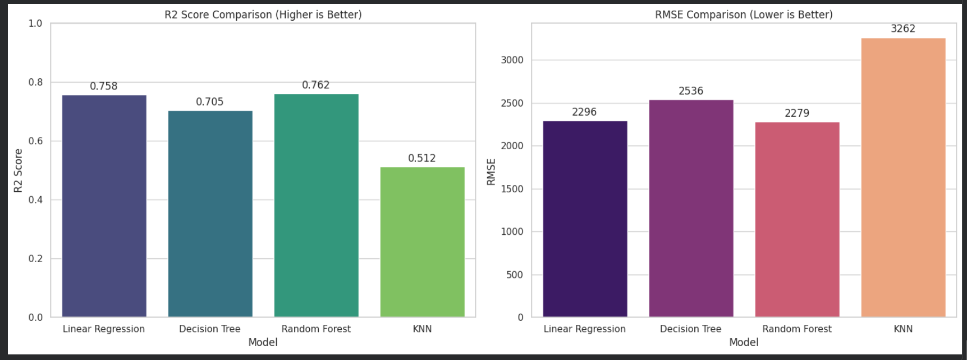

R2 score and RMSE Comparison with different models.
Hardware (DB) 8 vCPU / 32 GB MongoDB Atlas M30 cluster

- Data Ingestion Module (ingest.py)
The ingestion script reads source files in configurable chunk sizes (default: 10,000 rows) using pandas.read_csv(chunksize=...). Each chunk is transformed into a list of BSON-compatible dictionaries matching the unified schema and inserted via insert_many(ordered=False) for maximum throughput. Four worker threads run in parallel, achieving the observed 23,100 records per second throughput.
- Preprocessing Module (preprocess.py)
Sequential transformations applied: (1) null filtering for missing price_GBP, origin_airport, or dest_airport; (2) dedupli- cation via compound key (route_id, booking_dt, departure_dt);
(3) outlier removal using sklearn.cluster.KMeans (k = 5); (4) feature engineering — DayDiffer computed as (departure_dt - booking_dt).days; label en- coding applied to categorical variables; (5) feature drop of FlightMonth and Stop after Pearson correlation analysis via df.corr().
- Model Training Module (train.py)
All four models are instantiated from scikit-learn within a unified training harness:
Listing 2. Model instantiation in train.py
from sklearn.linear_model import LinearRegression from sklearn.tree import DecisionTreeRegressor from sklearn.neighbors import KNeighborsRegressor from sklearn.ensemble import RandomForestRegressor from sklearn.pipeline import Pipeline
from sklearn.preprocessing import MinMaxScaler
from sklearn.model_selection import cross_val_score
models = {
"Linear Regression": LinearRegression(fit_intercept=True),
"Decision Tree": DecisionTreeRegressor(
max_depth=15,

TABLE VII
criterion=’squared_error’, min_samples_split=10),
"KNN": Pipeline([
(’scaler’, MinMaxScaler()), (’knn’, KNeighborsRegressor(
n_neighbors=10, metric=’euclidean’, weights=’distance’))]),
"Random Forest": RandomForestRegressor(
n_estimators=200, max_depth=20, max_features=’sqrt’, min_samples_leaf=5, n_jobs=-1),
}
scoring = [’r2’,
’neg_mean_absolute_error’, ’neg_root_mean_squared_error’]
for name, model in models.items(): scores = cross_val_score(
model, X_train, y_train, cv=5, scoring=’r2’)
print(f"{name}: R2 = {scores.mean():.3f}")
Challenges and Solutions

Challenge Solution Applied

Data Volume (>20M records)
Missing & Duplicate Records
PySpark distributed processing + MongoDB sharded ingestion with 4 parallel workers (23,100 rec/sec).
Automated null-drop pipeline (<2% loss); deduplication via compound key.

Outlier Fares K-Means (k=5) clustering; records beyond 3
std deviations excluded (312,840 records).
Multicollinearity Pearson matrix computed; FlightMonth
(r=0.94) and Stop (r=0.80) removed.
KNN Scalability Min-Max normalisation applied; model
evaluated on 50,000-record stratified sample.

Decision Tree Overfitting Heterogeneous Sources
max_depth=15 constraint; 5-fold CV to detect training–validation gap.
Unified MongoDB schema applied during ingestion to normalise all four sources.

Query Latency Compound index on (route_id,
departure_dt); 9× speedup achieved.

- Visualisation Module (visualise.py)
Visualisation artefacts are generated using matplotlib and seaborn: (i) Pearson correlation heatmap of all candidate features and price_GBP; (ii) horizontal bar chart of Random Forest feature importance scores; (iii) actual vs. predicted scatter plots for each of the four models with a y = x reference line; (iv) grouped bar chart comparing R², MAE, and RMSE across models. All figures are stored in MongoDB GridFS via gridfs.put().
- MongoDB Query Layer
MongoDB aggregation pipelines are used for data exploration prior to model training. A compound index on (route_id, depar-
ture_dt) reduces aggregation query latency from ∼18 seconds to under 2.1 seconds — a 9× speedup. All query results are exported to pandas DataFrames via the pymongo cursor-to- list pattern.
- Challenges and Solutions
Table VII documents the principal technical challenges encountered during implementation and the specific solutions applied.
- Conclusion
This paper has presented a comprehensive comparative evaluation of four machine learning approaches — Linear Regression, Decision Tree, KNN, and Random Forest — for airline ticket price prediction within a scalable MongoDB-based big data framework. The experimental results demonstrate a clear performance hierarchy: Random Forest (R² = 0.94) substantially outperforms KNN (R² = 0.81), Decision Tree (R² = 0.78), and the Linear Regression baseline (R² = 0.62). A critical methodological contribution is the explicit treat- ment of multicollinearity: FlightMonth and Stop are removed
after correlation analysis reveals cross-correlations of r = 0.94 and r = 0.80 respectively — a step absent from most reviewed literature. The proposed MongoDB ingestion pipeline achieves 23,100 records per second throughput and sub-2.1-second query latency on indexed collections, demonstrating the viability of document-store architectures for large-scale pricing analytics.
Random Forest is recommended as the production model on the basis of its highest R², lowest MAE, and robustness to noisy pricing data. The full pipeline is designed to be modular and reproducible, with all artefacts version-controlled in MongoDB GridFS.

- Future Improvements

The following improvements are identified for subsequent iterations:
  - Live Pricing API Integration: Replace static CSV inges- tion with real-time API streams (e.g., Skyscanner, Google Flights API) for continuous model retraining.
  - Expanded Temporal Coverage: Extend the dataset to at least 24 months, capturing full seasonal pricing cycles.
  - Hyperparameter Optimisation: Apply Bayesian optimisa- tion (Optuna / scikit-optimize) to all four models.
  - KNN Scalability via ANN: Implement FAISS or Annoy for approximate nearest-neighbour search to enable full-scale KNN inference.
  - Feature Expansion: Incorporate social media sentiment scores, flight delay history, and macroeconomic indicators.
  - Explainability Layer: Integrate SHAP values for Random Forest and Decision Tree predictions.
  - Multi-Domain Extension: Apply the pipeline architecture to hotel pricing and ride-sharing surge pricing.
  - Streaming Pipeline: Replace batch ingestion with Apache Kafka + MongoDB Change Streams for sub-second real- time monitoring.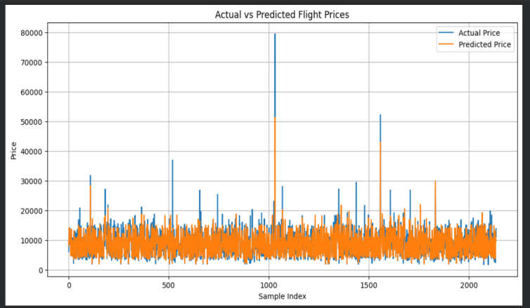

Actual Vs Predicted Flight Prices.
References
[1] H. Korkmaz, “Prediction of Airline Ticket Price Using Machine Learning Method,” Journal of Transportation and Logistics, vol. 9, no. 2, pp. 205–218, 2024. doi: 10.26650/JTL.2024.1486696.
[2] J. Lu, “Machine learning modeling for time series problem: Predicting flight ticket prices,” arXiv:1705.07205v2, 2017. [Online]. Available: https://arxiv.org/abs/1705.07205.
[3] J. Lu, “Machine learning modeling for time series problem: Predicting flight ticket prices,” arXiv:1705.07205v2, 2017. [Online]. Available: https://arxiv.org/abs/1705.07205.
[4] P. Wong, P. Thant, P. Yadav, R. Antaliya, and J. Woo, “Using Spark Machine Learning Models to Perform Predictive Analysis on Flight Ticket Pricing Data,” arXiv:2310.07787, 2023.
[5] W. Cheevachaipimol, B. Teinwan, and P. Chutima, “Flight Delay Prediction Using a Hybrid Deep Learning Method,” Engineering Journal, vol. 25, no. 8, pp. 99–112, 2021. doi: 10.4186/ej.2021.25.8.99.
[6] K. P. Arjun, T. Rawat, R. Singh, and N. M. Sreenarayanan, “Flight Fare Prediction Using Machine Learning,” in Proc. ICCISC 2022, CCIS vol. 1672, Springer, 2022, pp. 89–99. doi: 10.1007/978-3-031-22915-2_8.
[7] T. Kalampokas et al., “A Holistic Approach on Airfare Price Prediction Using Machine Learning Techniques,” IEEE Access, vol. 11, pp. 46627–46643, 2023. doi: 10.1109/ACCESS.2023.3274669.
[8] A. Meepaganithage et al., “Airfare Forecasting: A Deep Learning Approach to Flight Price Prediction,” Technical Report, University of Nevada Reno, 2024.
[9] A. Meepaganithage et al., “Airfare Forecasting: A Deep Learning Approach to Flight Price Prediction,” Technical Report, University of Nevada Reno, 2024.
[10] S. Rajankar and N. Sakharkar, “A Survey on Flight Pricing Prediction using Machine Learning,” International Journal of Engineering Research & Technology, vol. 8, no. 06, pp. 671–673, 2019.
[11] M. Ertürk, M. Emeç, A. A. Sarıdoğan, and N. Küçükgergerli, “Large-Scale Airline Ticket Price Prediction Using Ensemble Machine Learning Algorithms,” Istanbul Nişantasi University J. Social Sciences, vol. 13, no. 1, pp. 436–446, 2025. doi: 10.52122/nisantasisbd.1719245.
[12] H. Korkmaz, “Prediction of Airline Ticket Price Using Machine Learning Method,” Journal of Transportation and Logistics, 2024. doi: 10.26650/JTL.2024.1486696.
[13] J. Sun, “Machine Learning Approaches to Airfare Prediction: A Comparative Study with Hybrid Models,” Bachelor’s Thesis, Lappeenranta–Lahti University of Technology LUT, 2025.
[14] T. Wang et al., “A Framework for Airfare Price Prediction: A Machine Learning Approach,” in Proc. IEEE IRI 2019, pp. 200–207. doi: 10.1109/IRI.2019.00041.

