Microstrip T-Stub S-Parameter Filter: Simulation Report
1. Microstrip T-Stub Filter Topology
The simulated circuit employs a microstrip transmission-line topology designed to function as a distributed bandstop (notch) filter. The core structure consists of a continuous 50 $Ω$ main RF feedline broken into two identical series segments (MS1 and MS2). A third microstrip line (MS3) is connected to the center junction, acting as a shunt open-circuited stub. At microwave frequencies, these physical traces do not behave as simple wires but as distributed parameter networks that manipulate wave propagation based on their physical length and the signal frequency.
2. Substrate Parameters and Their Role
The behavior of the microstrip lines is entirely governed by the defined PCB substrate (Subst1):
- Dielectric Constant (er = 4.5): This dictates the propagation velocity of the electromagnetic wave through the material, defining the effective wavelength ($λ_{eff}$) of the signal.
- Height (h = 0.3937 mm): The dielectric thickness, combined with the trace width ($W=0.787\text{ mm}$), establishes the characteristic impedance of the transmission lines.
- Loss Tangent (tand = 2e-4) and Resistivity (rho = 0.022e-6): These parameters model the real-world dielectric and ohmic conductor losses, contributing to the baseline insertion loss of the filter.
3. The Use of 50 $Ω$ Input and Output Ports
Ports 1 and 2 are strictly configured with a 50 $Ω$ reference impedance, which is the universal standard in RF engineering. Using 50 $Ω$ ports ensures the simulation perfectly matches the characteristic impedance of the microstrip feedlines. This impedance matching eliminates unwanted boundary reflections at the input and output terminals, allowing the simulator to accurately isolate and calculate the forward transmission coefficient ($S_{21}$) of the filter itself.
4. S21 Simulation Graph
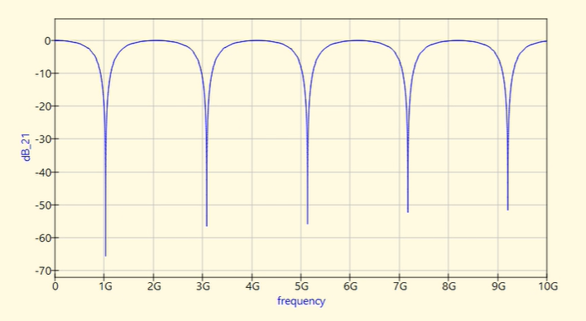

5. Origin of the Attenuation Notches
The resulting S21 graph exhibits periodic, deep attenuation notches at exactly 1 GHz, 3 GHz, 5 GHz, 7 GHz, and 9 GHz. These notches are the direct result of the quarter-wave impedance transformation properties of the shunt open stub (MS3).
At roughly 1 GHz, the physical length of the stub ($L=39.37\text{ mm}$) equals exactly one-quarter of the effective wavelength ($λ/4$). According to transmission line theory, an open circuit at the end of a $λ/4$ line is transformed into a short circuit (zero impedance) at the T-junction. This effective short forces the incident RF signal to reflect entirely back toward Port 1, preventing transmission to Port 2. This phenomenon repeats at every odd multiple of the quarter-wavelength ($3λ/4$, $5λ/4$, etc.), creating the periodic bandstop characteristics seen in the sweep.
6. Conclusion
The S-parameter simulation confirms that the circuit works properly as a microstrip T-stub filter. The RF signal path remains continuous from input to output, and the periodic attenuation notches perfectly align with the expected distributed transmission-line theory, proving the design's effectiveness as a high-frequency notch filter.

