BECE206P Analog Circuits Lab

Name: Ankit Negi

Reg. No.:22BEC1117

**Frequency Response of CS amplifier (Software)**

# AIM: To design and verify the Frequency Response of CS amplifier.

# Software required: Lt spice

# PROCEDURE:

1. Open a new LTspice schematic and create a single stage Common Source Amplifier circuit as provided.
2. Set the input signal amplitude to 10mV

**CIRCUIT DIAGRAM:**

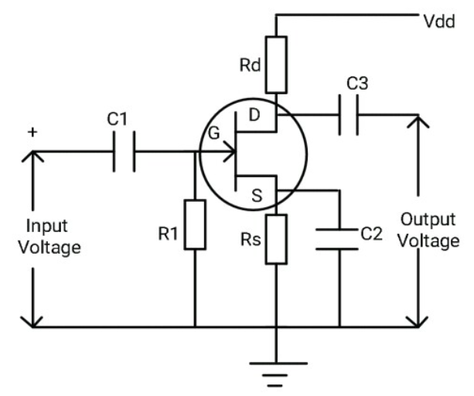

**TASKS:**

1. .op analysis:-

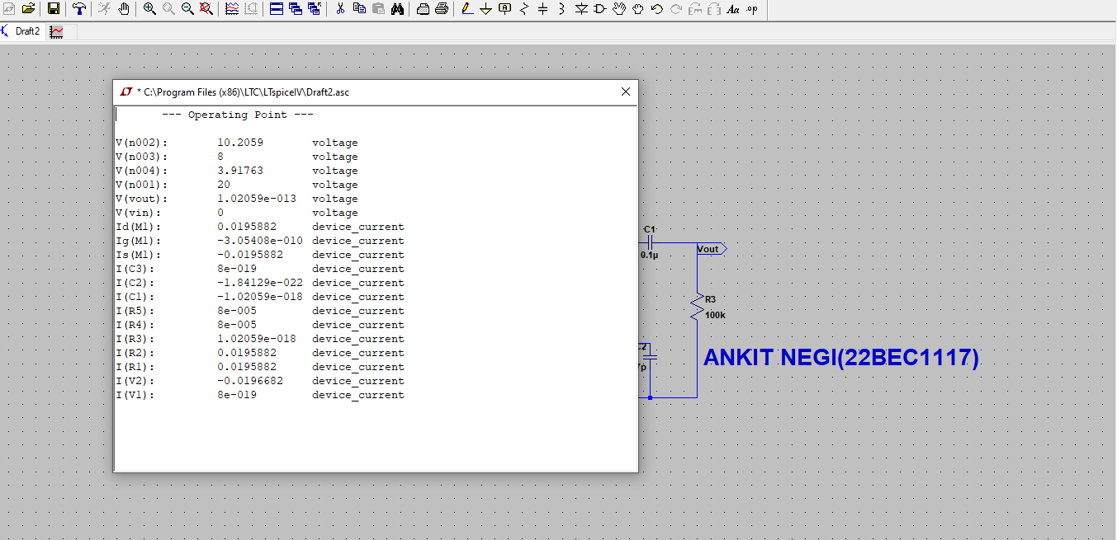

1. .tans analysis:-

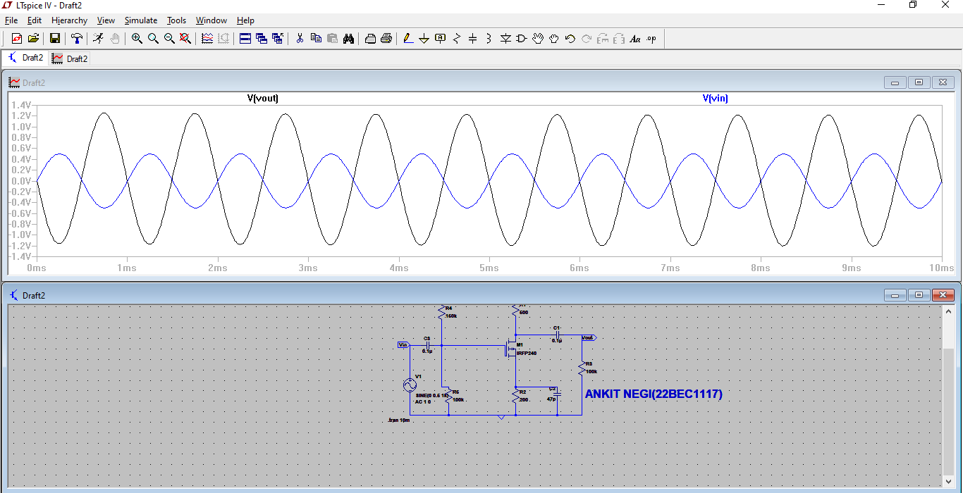

3)ac analysis:-

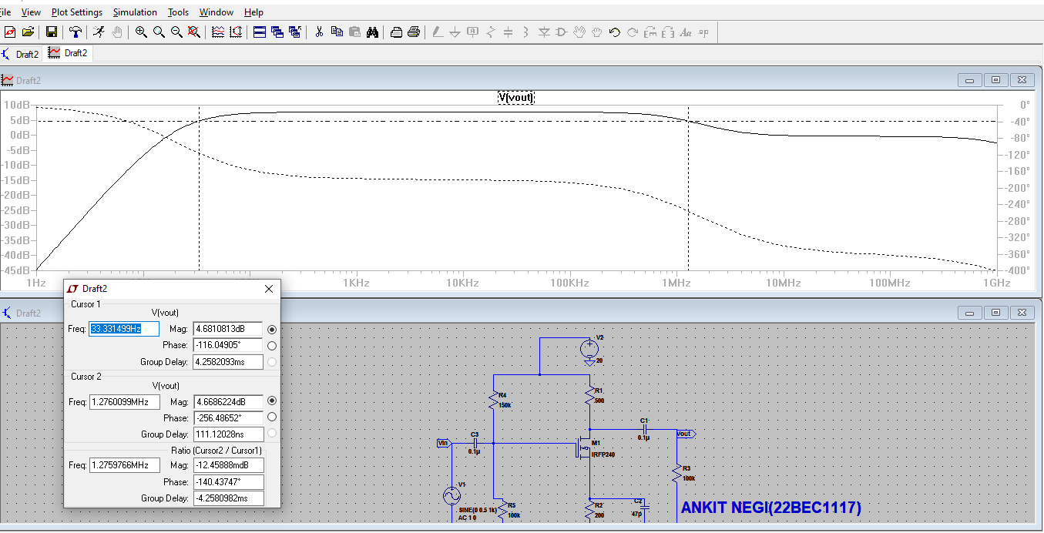

4)multi-stage .op analsis:-

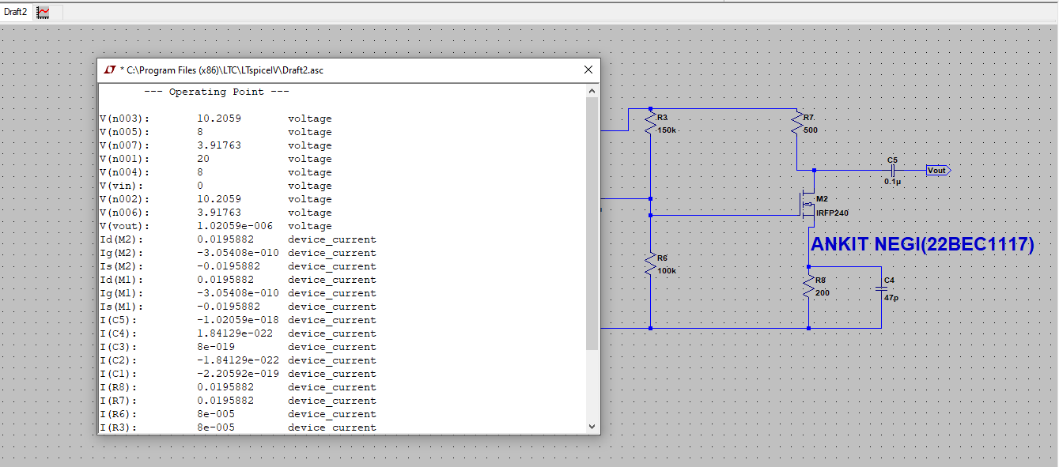

5)multi-stage .trans analysis

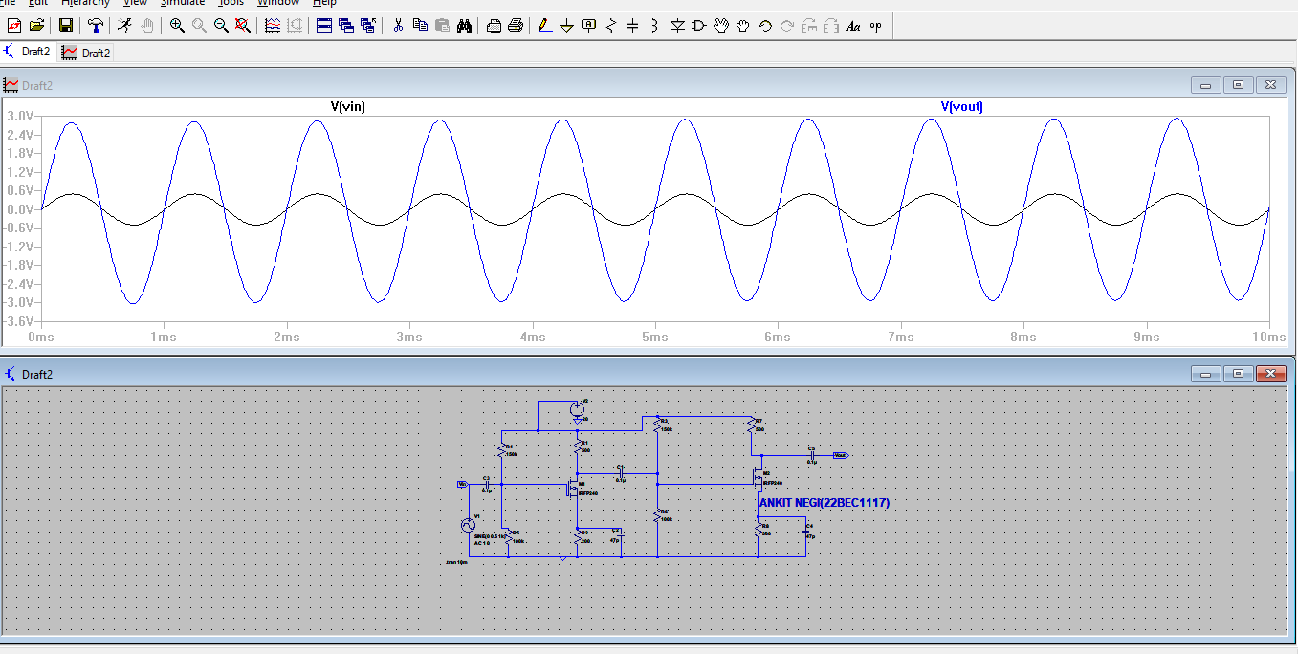

6)multi-stage ac analysis

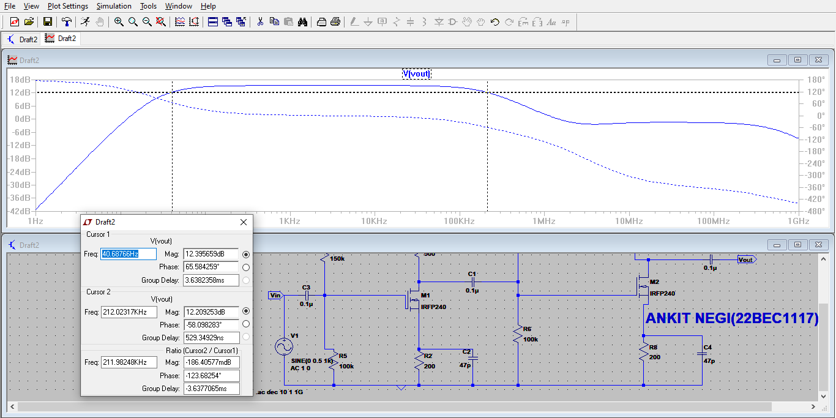

**Inferences:**

The experiment to design and verify the frequency response of a CS amplifier is a systematic process that combines theoretical analysis, practical implementation, and iterative refinement to achieve the desired amplifier performance.

**RESULT:**

We are able to see amplified signal while doing the experiment.