ECE206P Analog Circuits Lab

Name: Ankit Negi

Reg. No.:22BEC1117

**Frequency Response of Diffrential amplifier (Software)**

# AIM: To design and verify the Frequency Response of Diffrential amplifier.

# Software required: Lt spice

# PROCEDURE:

1. Open a new LTspice schematic
2. Open the LTspice circuit file that contains your differential amplifier design.
3. In the circuit window, right-click on the AC voltage source that you will use for your frequency sweep (e.g., a sine wave source).
4. Click on "Advanced" in the pop-up menu. Set the AC amplitude to an appropriate value (e.g., 1V). Set the AC phase to 0 degrees.
5. Ensure the AC magnitude is 1 (this represents a 0 dB reference).
6. Set the Frequency sweep parameters (e.g., start frequency, stop frequency, and number of points).

**Circuit Diagram:**

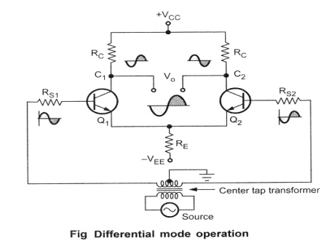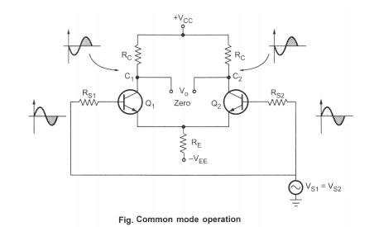

# Tasks :

1-3>Diffrential amplifier:Common Mode.

1).op analysis:-

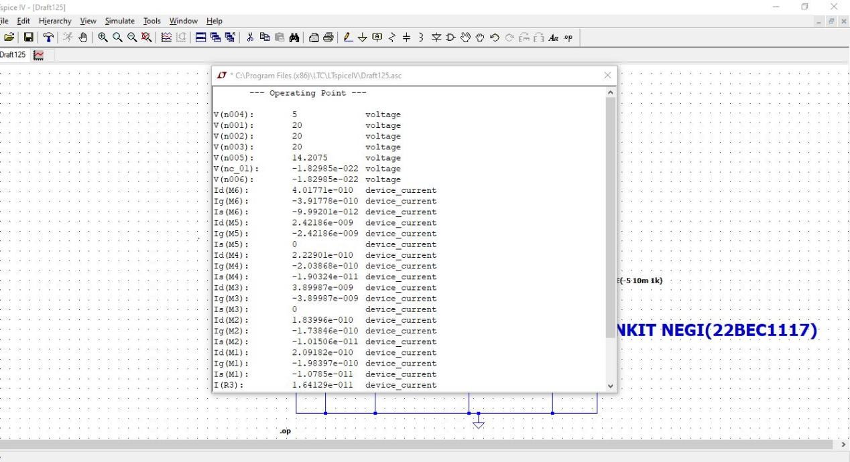

2).tans analysis:-

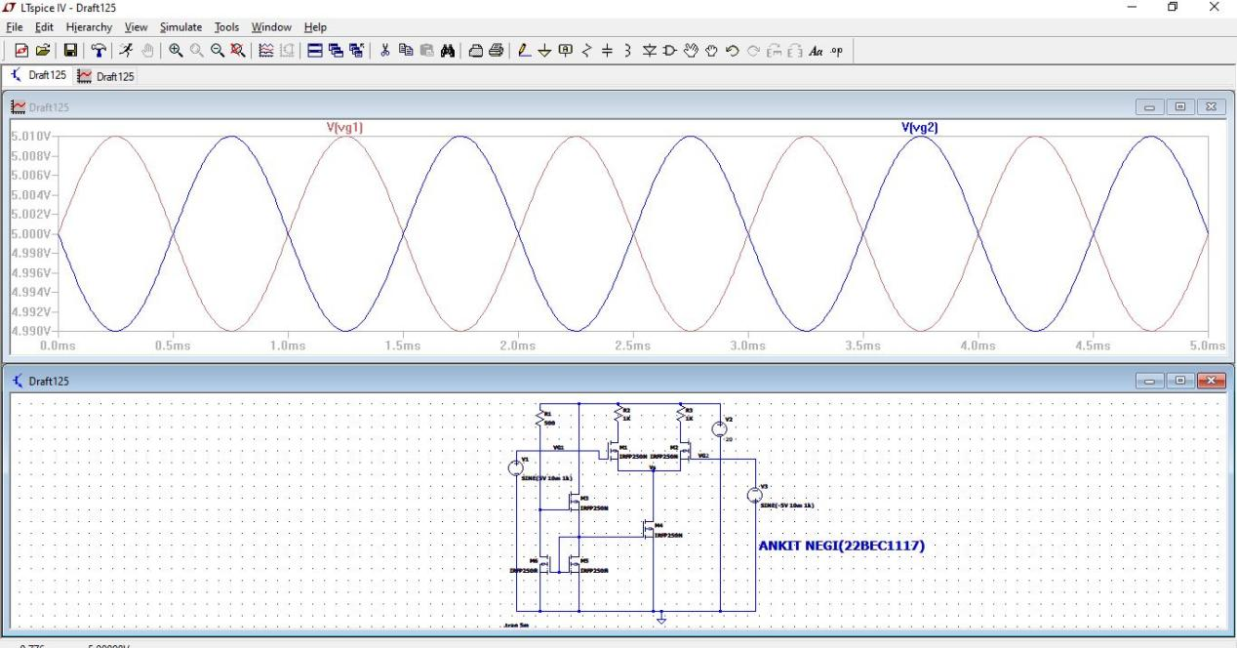

3)ac analysis:-

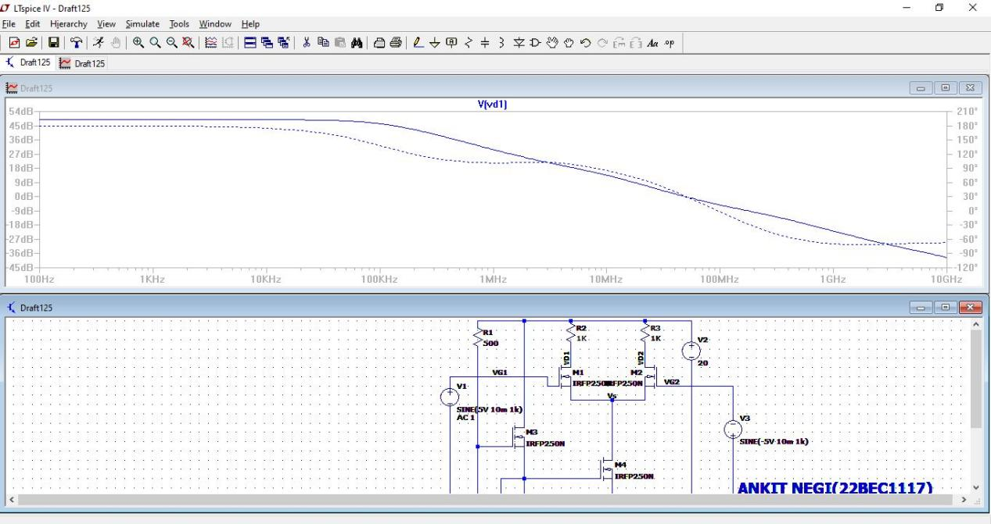

4-6>Diffrential amplifier:Diffrential Mode.

4).op analsis:-

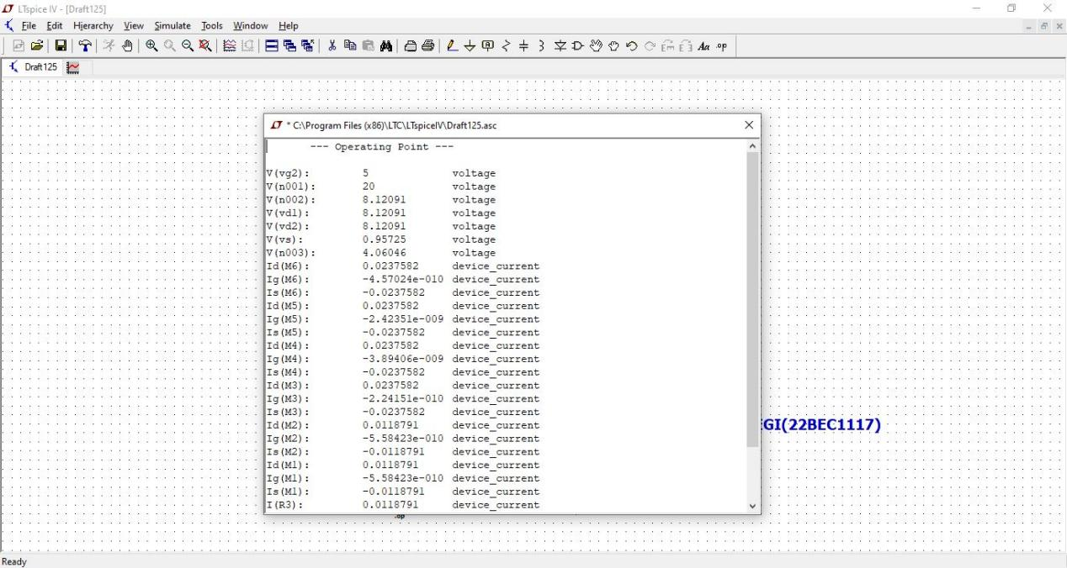

5).trans analysis

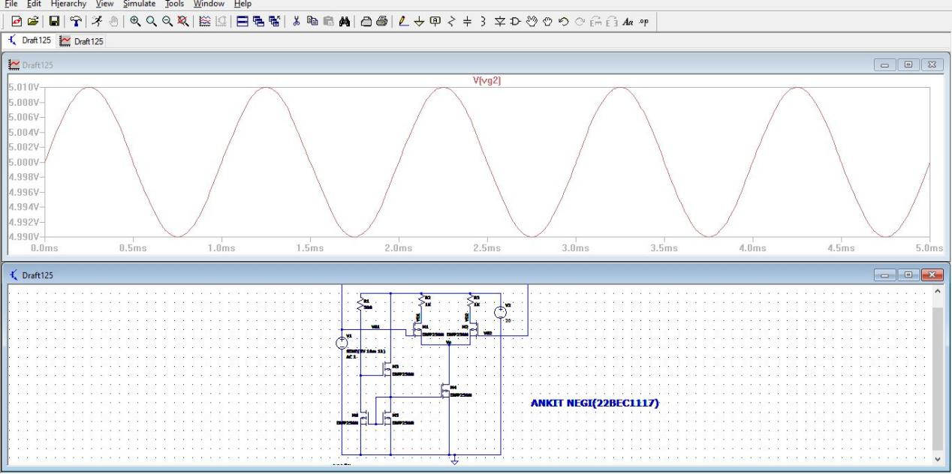

6).ac analysis

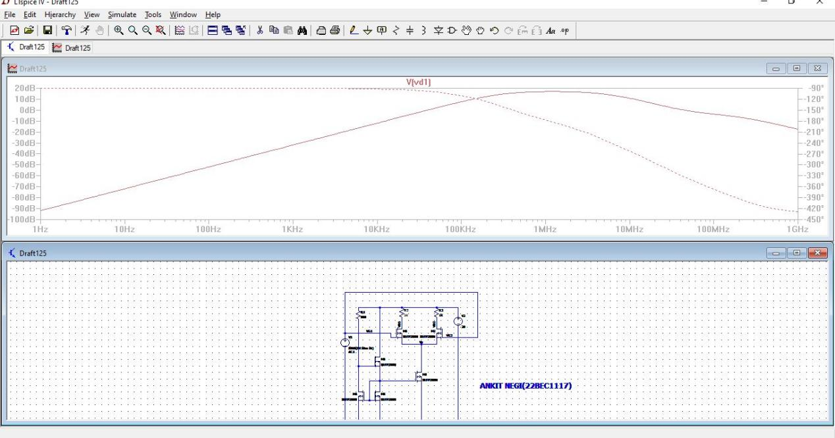

**Inferences:**

You can experimentally determine the frequency response of your differential amplifier circuit using LTspice.

**RESULT:**

We are able to see amplified signal while doing the experiment.