BECE206P Analog Circuits Lab

Name: Ankit Negi
Reg. No.:22BEC1117

Frequency Response of CE amplifier (Software)

AIM: To design and verify the Frequency Response of CE amplifier.

Software required: Lt spice

PROCEDURE:
- Open a new LTspice schematic and create a single stage Common Emitter Amplifier circuit as provided
- Set the input signal amplitude to 10mV

Circuit Diagram:

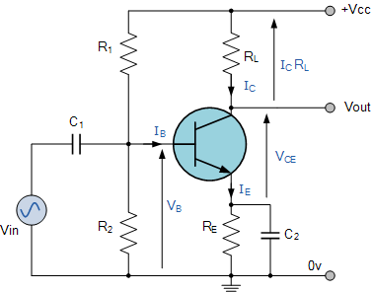

Tasks :

1).op analysis:-
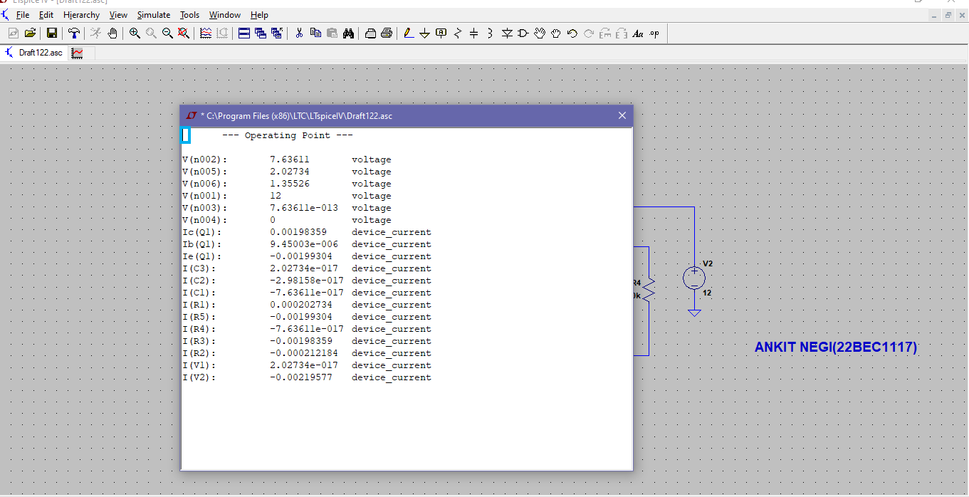

2).tans analysis:-
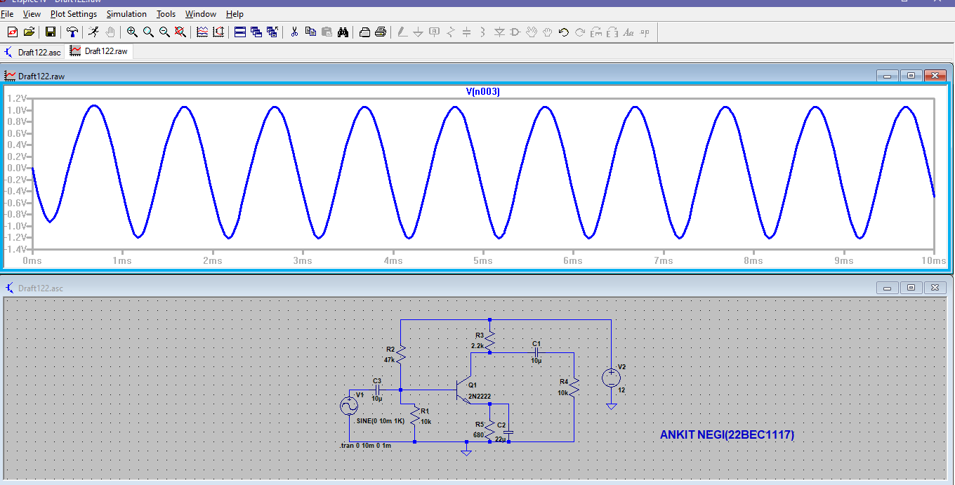

3)ac analysis:-
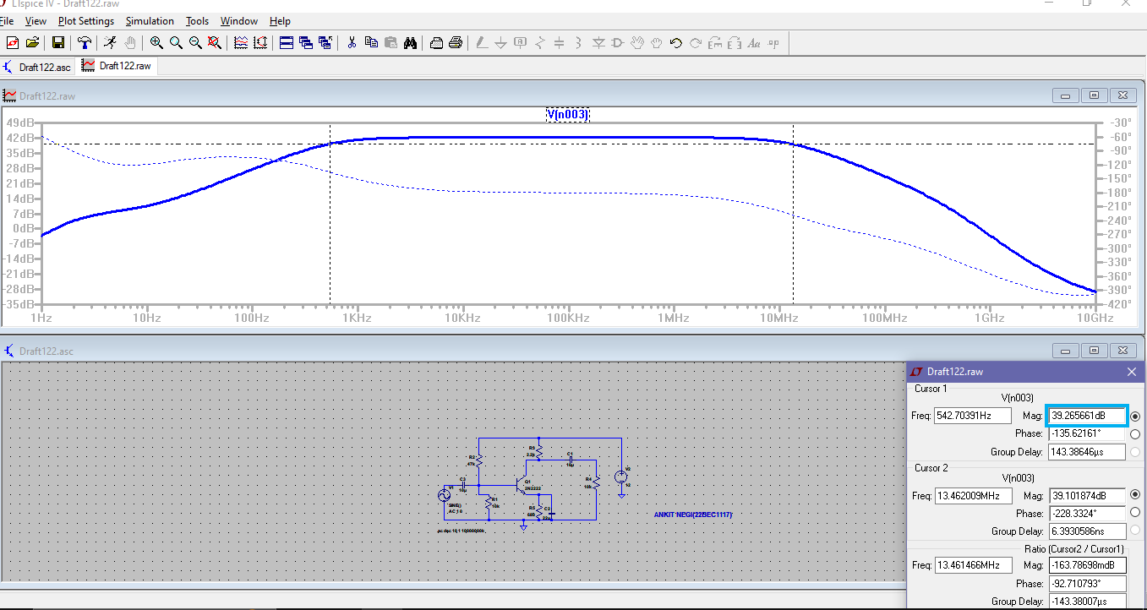

4)multi-stage .op analsis:-
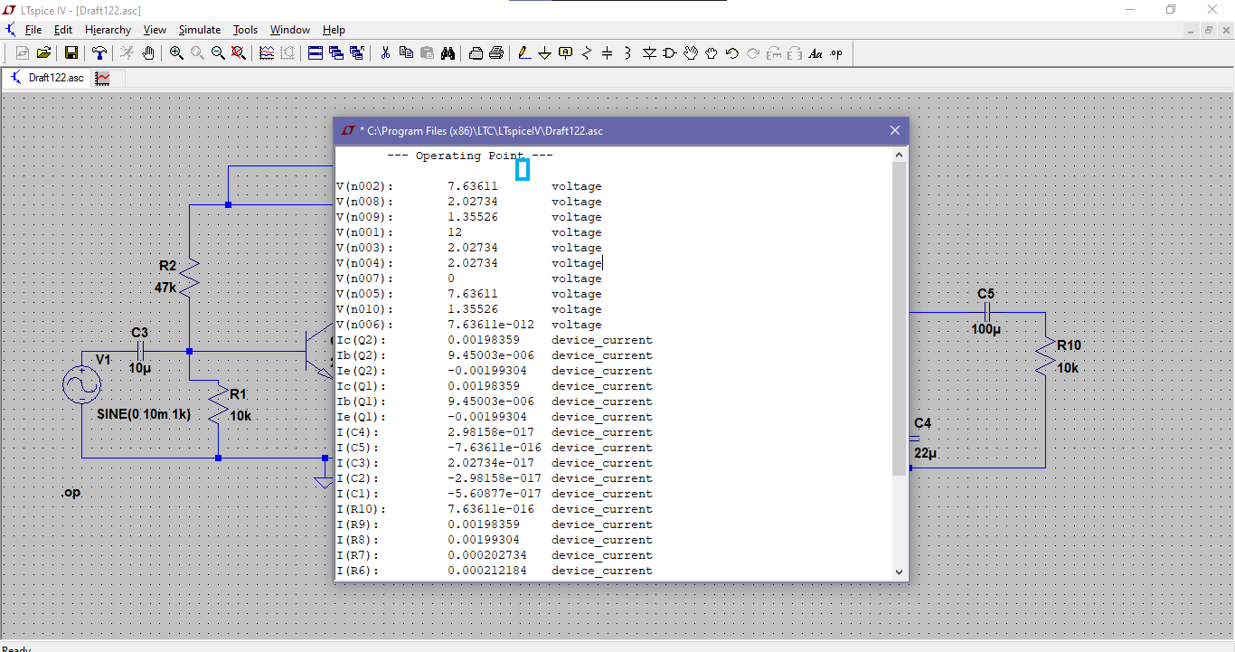

5)multi-stage .trans analysis
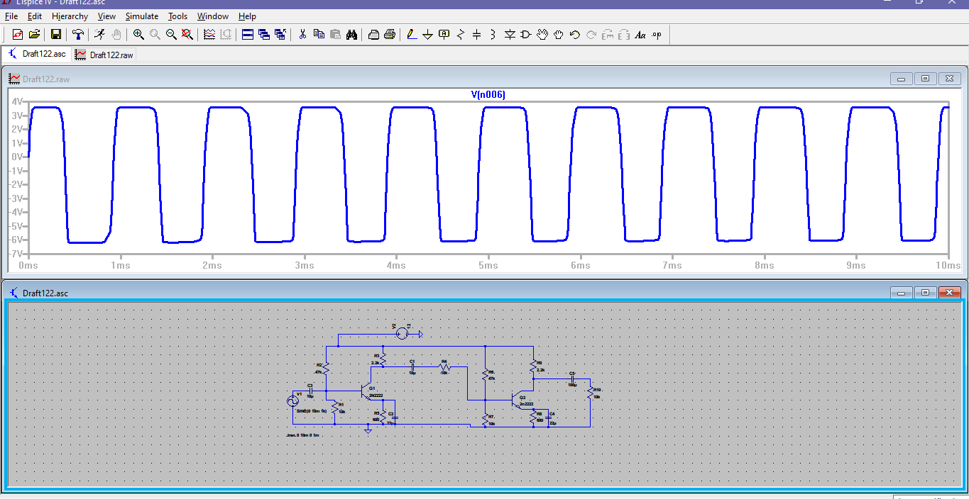

6)multi-stage ac analysis
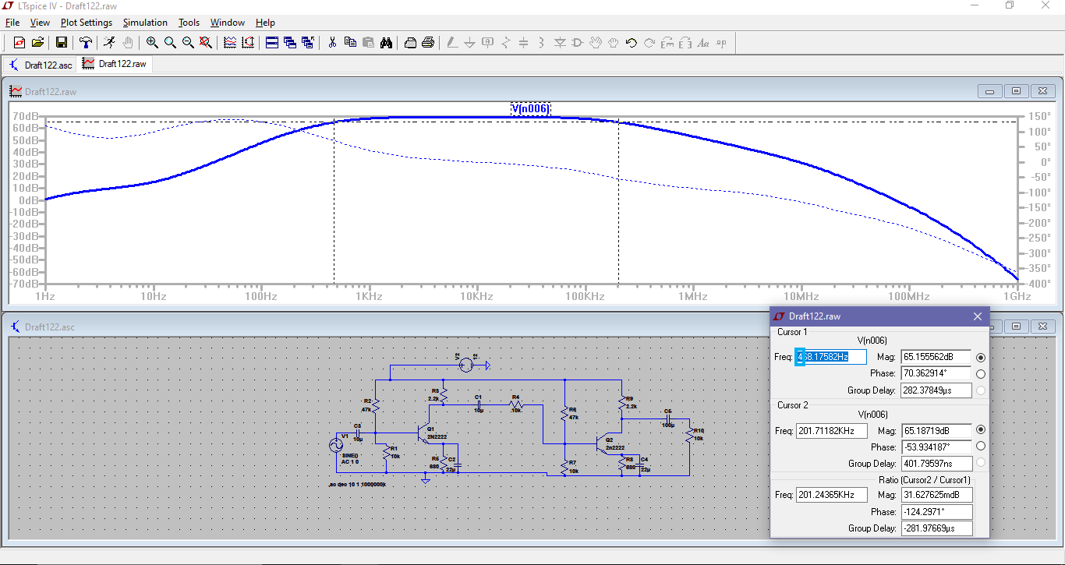

Inferences:
The experiment to design and verify the frequency response of a CE amplifier is a systematic process that combines theoretical analysis, practical implementation, and iterative refinement to achieve the desired amplifier performance.

RESULT:
We are able to see amplified signal while doing the experiment.

