**1)What is Printed Circuit Board Design?**

Printed circuit boards do more than just provide a place to put integrated circuits, they provide a way to create very reliable connections between components that can also be manufactured at very high volume.

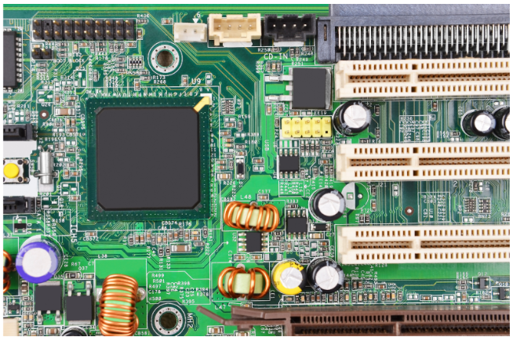

PCBs are truly the backbone of modern electronics.

**2)PCB Design Software**

Altium Designer, KiCad, EasyEDA, and Eagle.

These are used to prepare a design for fabrication and assembly using automated machinery, called computer aided manufacturing (CAM) software.

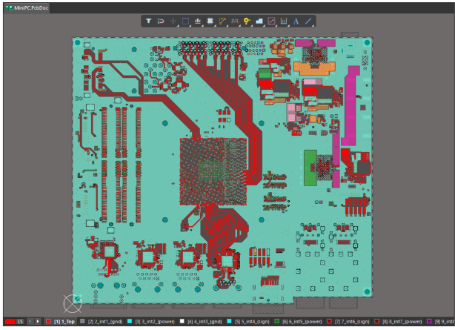

**3)Some Basic Terms**

* **Components:** This can refer to anything that can be soldered onto a PCB. Examples include resistors, capacitors, connectors, and integrated circuits. A component is also an object in a CAD program, and it may refer to a physical feature that is not soldered onto the board.
* **Printed circuit board (PCB or circuit board):** Refers to the bare board design without any of the assembled components.
* **PCB layout:** A CAD drawing showing the location of all elements that will appear on an assembled PCB. This includes all components and copper that will appear on both sides of a PCB.
* **Trace:** A copper connection made between two components in a PCB layout. A trace is sometimes called a “track”.
* **Layers:** All PCBs can have multiple layers, which will include copper connections and components. Internal layers only contain copper, which are only used to make electrical connections. There are two types of layers in any PCB: plane layers and signal layers. A plane layer has a large, uninterrupted copper region that covers the entire layer. A signal layer only contains copper traces that connect the PCB components.
* **Multilayer PCB:** This term refers to any circuit board that has more than two copper layers in total.
* **PCB stackup:** Also called a layer stack, this term refers to the arrangement of layers used to build a bare printed circuit board.
* **Schematic sheets:** Drawings that show how components are connected to each other, similar to a circuit diagram.
* **PCB fabrication:** Refers to the first half of the manufacturing process, where each layer of a bare PCB is fabricated, and copper features are etched on the PCB.
* **PCB assembly (PCBA):** This term has two meanings. It is often used as a noun, referring to a fully assembled PCB. It also refers to the PCB assembly process, where components are soldered onto a bare PCB. In this course, we will normally write “PCBA” for the former, and “PCB assembly” for the latter.
* **PCB laminate:** Also simply called a laminate, this refers to the insulating material used to separate copper layers and build a PCB stackup.

**4)Common PCB Files**

* **Schematic sheets:** Your schematic sheets are like the electrical blueprint for your design. These documents show components, nets, and other information needed to understand the design.
* **Bill of materials:** This document is a list of all components used in the design. It will be used to order components and to aid assembly.
* **PCB layout:** This document shows the physical placement of components and copper connections between them. The PCB layout document will also describe the layer stack used in the design.
* **PCB libraries:** Your libraries store all of the CAD data for your components (schematic symbols, PCB footprints, 3D models, and SPICE subcircuits). Libraries also store procurement information for each component, including MPN, distributor information, a description of each component, quantities of each component, and possible alternative components.

**5)Schematic Sheets**

***A low-voltage power regulator***

**6)PCB Layout**

*3D View Normal View*

**7)Bill of Materials**

A bill of materials is normally exported from your ECAD software as a PDF file or as an Excel file. This file will contain a large table, with each row being an entry for different components in the design.

**8)PCB Libraries**

Data that is common to the above three sets of documents is stored in your PCB libraries.