Carry out a plan autonomously.
Agentic ai sweet spot a clear goal +uncertain path+ multiple steps+ tool- juggling
Goal-directed
Reasoning, action
---- perception (notice what’s going on), reasoning, action, memory

Perception--- how the agent observes the world
Worker agent—an agent focused on a specific task: specialized, predictable ,reusable
Orchestrator agent—coordinates the execution of multi-step plans -tracking,delegating, and adapting as needed
Autonomous does not mean unmanaged.
[[]] agentic- systems that still need your judgment to do their best work, collaborators that can carry out work.
Agentic AI | AI systems that don’t just generate responses but take action toward a goal. These agents perceive inputs, reason about what to do, act on those plans, and sometimes remember past interactions.
Steps:: task is given agent find the intent perceive environment create a plan- take actions
Distillation—use a trained LLM to train a smaller model for a specific application
Traceability??
A tool is just a python function (or API) that is packaged in a way the LLM can understand and call when needed.
Ways to create tools::
- Using @tool decorator
- Using StructuredTool & Pydantic – input follows a structured schema
- Using BaseTool class- abstract base class for all tools in LangChain.
Toolkit- bundle of related tools that serve a common purpose
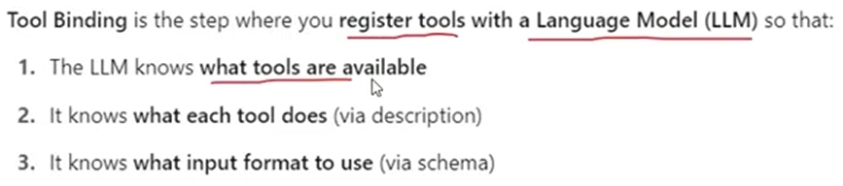
The LLM does not actually run the tool.
LangChain's InjectedToolArg, its purpose is to have an argument supplied by your application/code rather than by the LLM.
Type Annotations
Typed Dictionary- defined explicitly what the data structures are, this is not available in normal python dict.
Elements
State- a shared data structure that holds the current information or context of the entire application. Analogy- whiteboard in a meeting room
Nodes- individual functions that perform specific tasks. Analogy- Assembly line stations
Graph- maps out how different nodes are connected and executed.
Edges- connections between nodes that determine the flow of execution.
Tools- specialized functions that nodes can utilize to perform specific tasks
Nodes are part of the graph structure, while tools are functionalities used within nodes.
ToolNode- main job is to run a tool. Connects the tool’s output back into the State, so other nodes can use that information.
StateGraph- class used to build and compile the graph structure. It defines the structure and flow of the workflow.

