Gen AI- 1) user perspective 2) builder perspective
Lang Chain::open-source framework that helps in building LLM based applications
Components of lang chain:-
- Models
- Prompts
- Chains
- Memory
- Indexes
- Agents--Agents combine language models with tools to create systems that can reason about tasks, decide which tools to use, and iteratively work towards solutions.
Models are the core interfaces through which you interact with AI models(language and embedding[semantic search])
Think of chains as assembly lines for LLM calls.
Indexes connect your application to external knowledge—like pdfs, databases, websites etc. it is a combination of 4 things::_-1) document loader 2) text splitter 3) vector store
4) retrievers

LLM api calls are stateless.=>LLMs do not retain information from past interactions.
Some types of memory::
• ConversationBufferMemory – stores full chat history
• ConversationSummaryMemory – summarized memory
ConversationBufferWindowMemory- store last n interactions
Language models
- LLM—text intext out
- Chat models—message based

HuggingFace- Repositary of open source LLMs
LangChain provide abstractions that:
- Simplify loading data from sources
- Templatize llm prompts
- Parse LLM ouput
- Add contextual memory to interactions
LLM types::
- Completion – pass in string and LLM returns text semantically extends the string
- Chat-oriented: pass in a conversation between user and AI and get sematic completion or answers based on it
Prompt templates=allows specific format and context placeholders when generating text, maintains consistency
Static vs dynamic prompt user has more control in static
A static prompt is fixed — it does not change based on user input or context.
A dynamic prompt changes based on user input, variables, or context.
Why use PromptTemplate over f strings?
- Default validation (validate the no. of inputs)
- Reusable (save as JSON file)
- LangChain Ecosystem
Types of messages in Langchain::
- System-The system message is usually passed in as the first of a sequence of input messages.
- Human
- AI
A message placeholder acts like a slot in your prompt where multiple messages (not just one string) can be injected at runtime.
MessagesPlaceholder → expects a list of messages
ConversationBufferMemory → provides that list

User Input → Prompt
↑
MessagesPlaceholder
↑
ConversationBufferMemory
↓
Updated after response

With_structured_output()- 1) pydantic 2) typed dict. 3) JSON_schema
“Difference between Output Parser and Structured Output?”
👉 Say:
- Output parsers post-process LLM text
- Structured output controls LLM generation itself
- Structured output is more reliable and modern
Pydantic- data validation and data parsing library
Json_shema=working with different languages in a project,
Ex- backend: python, frontend: javascript
With_structured_output(method=json format or function calling)
Chains::
- Simple
- Sequential
- Parallel
- Conditional

RunnableLambda wraps a normal Python function so it can be used in a chain.
RunnableBranch is like an if–else statement for chains.
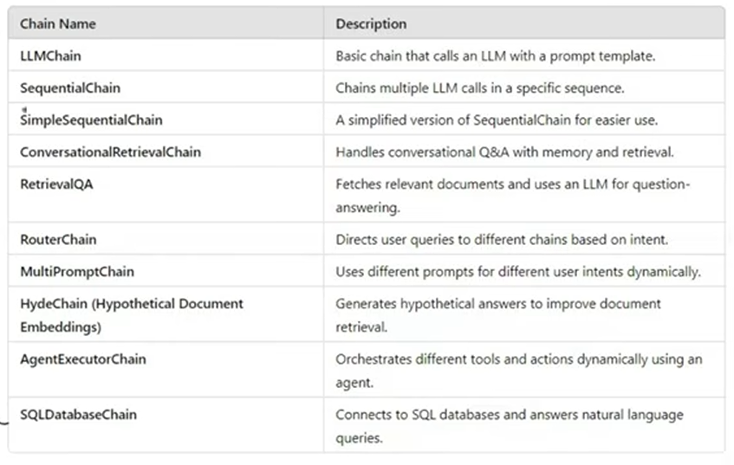
  - Task specific runnables- core langchain components that have been converted into runnables
  - Primitives runnables- orchestrate, structuring execution logic in AI workflows
Ex- RunnableSequence, RunnableParalllel, RunnablePassthrough-returns the input as output, RunnableLambda- middleware b/w different AI components,
In chain there are one or more steps, that takes input and return results. And actually those steps are runnables.
Runnable allows you to chain components using | operator:
LCEL- LangChain Expression language
- Load- load full document
- Lazy load- fetch the document when needed, best for large documents

