Base Models- : Lack some domain knowledge
LLM: Lacks current knowledge
WHY DO WE NEED TO AUGMENT LLMs?
- LLMs are difficult to control
- The LLM may underperform in your task
- Context windows are limited—Attention mechanisms, models struggle to “remember” information in large contexts needle in a haystack
- Knowledge gaps: Models can’t provide information beyond their training cut-off date
- Hallucinations: Outputs may be incorrect or ungrounded in reality.
- Lack of sources: which is necessary in many applications, such as search
How RAG solves these problems?
- Integrates external knowledge sources (e.g. databases, documents, APIs)
- Ensures answers are more accurate, up to date and grounded.
- More developer control. Allows for targeted customization without retraining the model.
RAG- a mechanism that embeds documents that an LLM can retrieve and then add as context to its initial prompt and answer a question.
2 dimensions to enhance LLM: model and context optimization
- Chain of thoughts technique for Prompts—break the task down into steps
|Zero shot prompting- model is asked to perform the task without any examples or prior context.
||Few shot prompt- model is given examples of outputs before being ask to generate a new one
- Chaining—chain complex prompts for improved performance
Fine- Tuning: (Limitations)
- Requires substantial labelled data for the fine tuning task
- Fine- tuned models may overfit to specific data, losing general purpose utility.
- Time and cost intensive, especially if the base model frequently updates.

When to use fine- tuning:
- If the task requires repeated, high- precision outputs
- If the general- purpose LLM consistently struggles with domain specific language.

You don’t touch the model with RAGs. It’s really a technique that is put on top of the model.
Embedding to embed the documents from Knowledge Base into lower dimensional representations. If the representation is too small, you will lose information, if it’s too big, you will add latency. It’s a trade-off.
Store those representations into a database called a vector database.
Retrieval Find relevant documents (based on embedding distance)
Augmentation add retrieved data to the user query.
Embeddings are the bridge between raw text and semantic search.
In a typical RAG pipeline, you:
- Take documents (PDFs, notes, web pages, etc.)
- Split them into chunks
- Convert each chunk into an embedding vector (a list of numbers)
- Store these in a vector database
- When a user asks a question:
  - Convert the question into an embedding
  - Find the most similar chunks
  - Send those chunks to the LLM for answering

To improve RAG (so that it works well with large documents):
- Chunking: on top of the embedding of the full document store a chapter level vector. That slows to be more precise with the sourcing.
- HyDE (Hypothetical Document Embeddings):
Problem: User query does not look like your documents.
Solution: Use the user query to generate a fake hallucinated document and then embed that documents and then it to the vector in the vector database.
AI Agent:
- Prompts
- Context Management- Core Memory, Archival Memory
- Tools
the core idea behind RAG (Retrieval-Augmented Generation) — how an LLM answers questions using information from your documents:
Key Idea
👉 LLM is not retrieving
👉 LLM is only generating based on given context

Retrieval is done by:
- Vector search
- Similarity matching

MCP- system in middle that make it simpler for LLM to communicate with the end point, agent to agent communication, allows the agent to go back and forth.
Eval- the process of measuring how well a model performs on specific tasks.
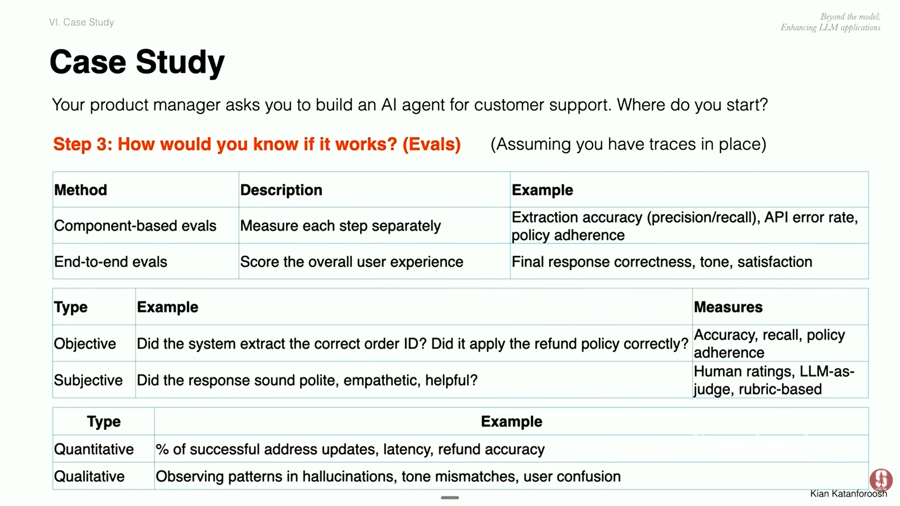

RAG = semantic retrieval, NOT computation engine.
❌ Weak at:
- Aggregations (sum, avg)
- Exact filtering
- SQL-like queries
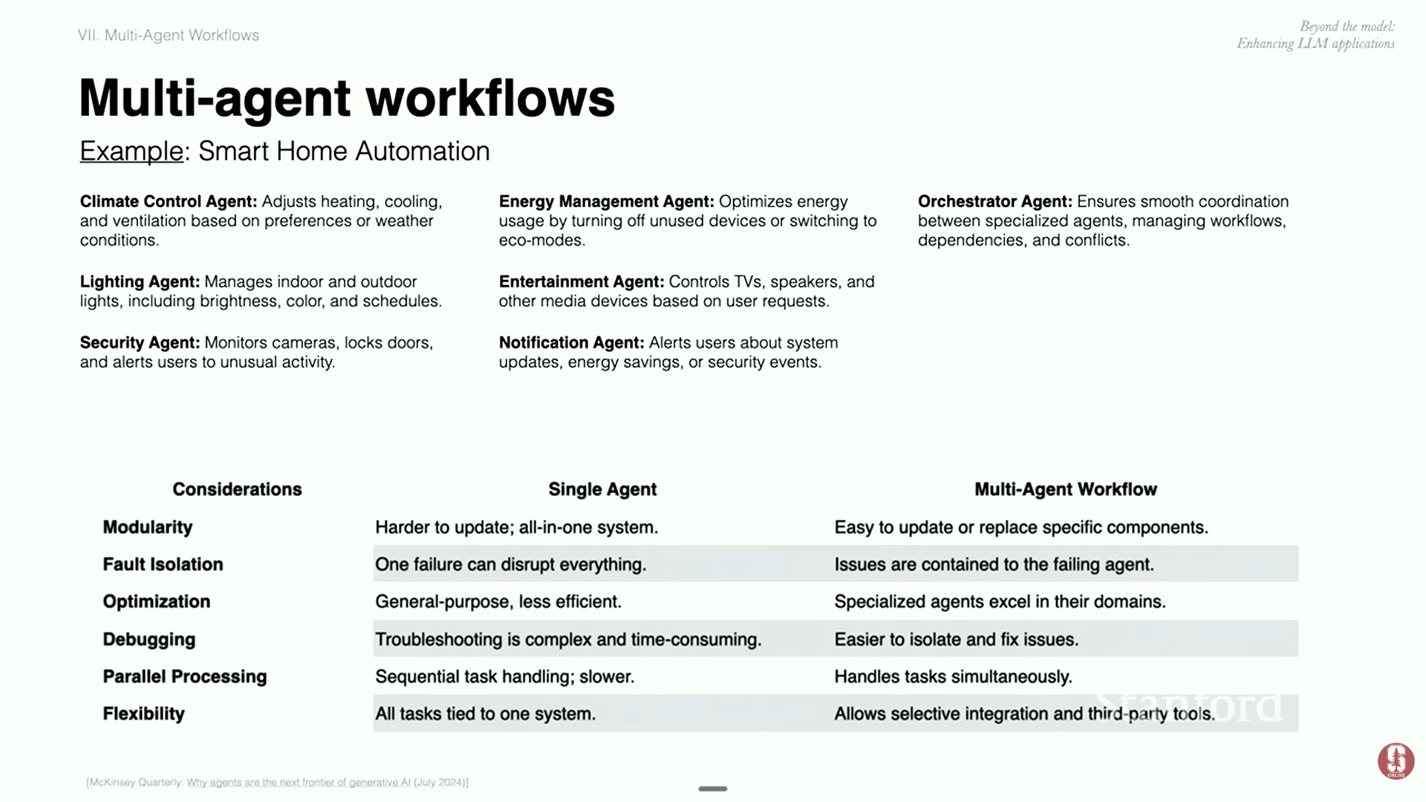
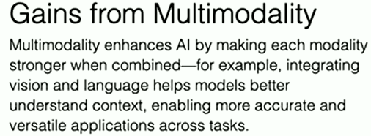
Multiple Methods in Harmony:: Future of AI
STEPS:
  - Indexing
  - Retrieval
  - Generation
Private data(documents) are indexed such that they can be retrieved based upon some heuristics relative to an input like a question
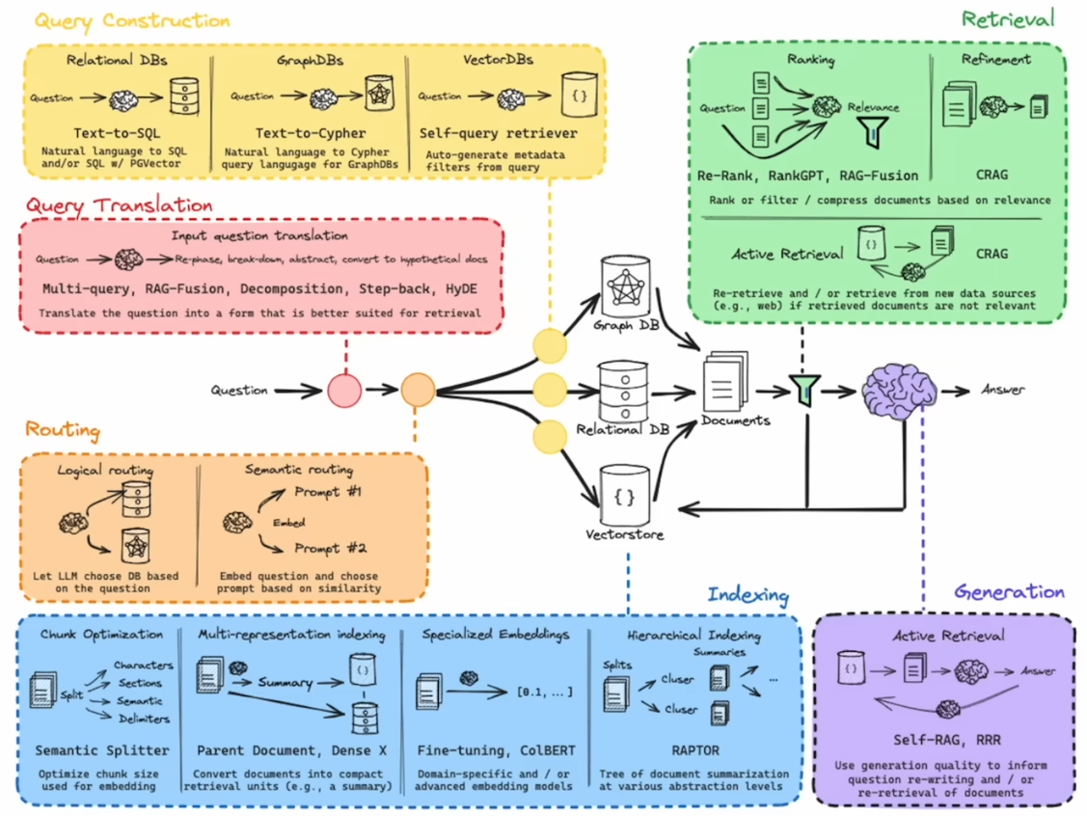
Query Translation- take question from a user and modify it in some way to make it better suited for retrieval from indexes
Routing- to the right place for retrieval
Query Construction- taking natural language and converting it into the DSL necessary for whatever data source you want to work with
Why embeddings are needed in RAG
LLMs don’t search documents directly like Google.
Instead, they:
- Convert query → embedding
- Compare with stored document embeddings
- Retrieve most similar chunks
- Generate answer using retrieved text
👉 This enables:
- Semantic search (meaning-based, not keyword-based)
- Fast retrieval
- Better accuracy
The index performs a similarity search and returns splits that are relevant to the question
• Embedding = convert text → numbers
• Indexing = arrange those numbers for quick lookup
Without indexing:
👉 You compare query with ALL vectors → very slow
With indexing:
👉 You use smart structures to find nearest vectors quickly
Indexing does NOT depend on query
Instead:
- Documents are pre-organized in vector space
- Query is “placed” into that same space
- Then we find closest points
👉 Indexing = organizing document embeddings
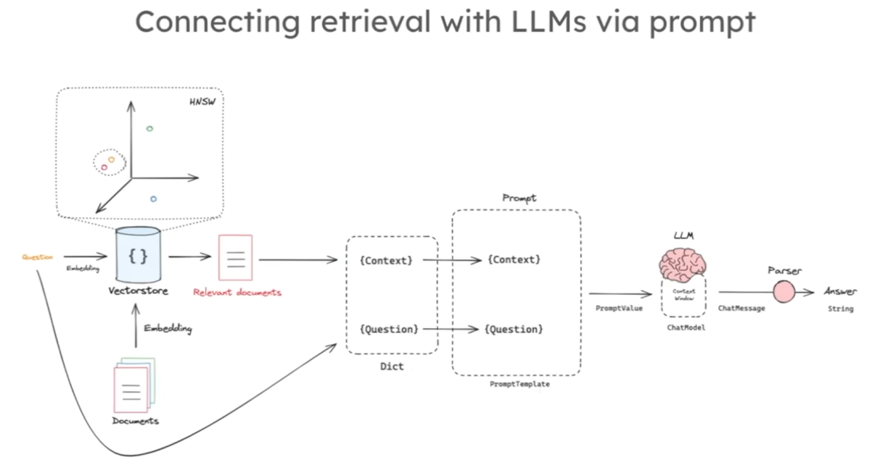

Text splitters break large documents into smaller chunks before embedding.
Why?
- LLM context limits
- Better retrieval accuracy
- Avoid losing meaning
- So what splitting actually does
- ✔ Increases semantic precision
✔ Reduces noise in embeddings
✔ Improves top-k retrieval quality
✔ Helps LLM get focused context
🔹 Full RAG Pipeline (Big Picture)
Data Sources → Loading → Splitting → Embedding → Indexing → Storage
↓
User Query → Query Embedding → Retrieval → Context → LLM → Answer

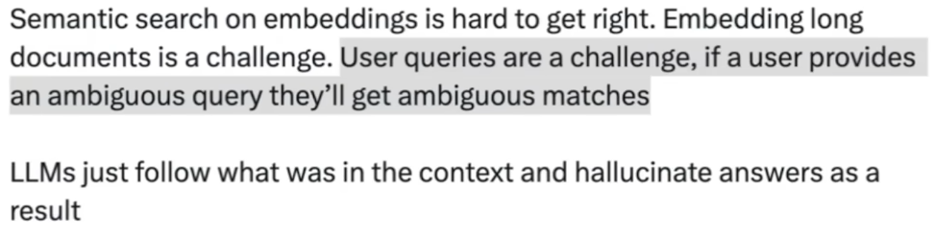
Query Translation:
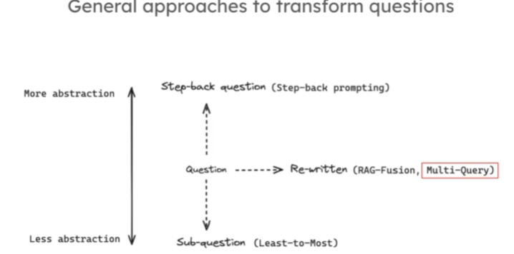

Multi- Query: Transform a question into multiple perspectives
RAG- Fusion: Improve search, produce consolidated ranking,
Ranking step of our retrieved documents – reciprocal rank fusion
Reciprocal Rank Fusion (RRF)
For each document $d$:
$$\text{Score}(d)=\sum_{i=1}^{n}{\frac{1}{k+{\text{rank}}_{i}(d)}}$$
Where:
- $n$= number of queries
- ${\text{rank}}_{i}(d)$= rank of document in query $i$
- $k$= smoothing constant (usually ~60)
Why RRF uses rank (not score)
Because:
- Different queries → different score scales
- Ranks are comparable across queries

🔹 Why add constant k?
$$\frac{1}{k+\text{rank}}$$
👉 Smooths the effect:
- Prevents rank 1 from dominating too much
- Makes contributions more balanced

🔹 One-line takeaway
Rank = position in retrieval results; RRF combines ranks across queries to reward documents that appear frequently and higher.
Decomposition:
- Least to Most: decompose problem into sub-problems, solve sequentially
We convert a problem $P$ into sub-problems:
$$P→\{P_{1},P_{2},P_{3},...,P_{n}\}$$
Then solve sequentially:
$$A_{1}=f(P_{1}) \\ A_{2}=f(P_{2},A_{1}) \\ A_{3}=f(P_{3},A_{1},A_{2})$$
...
$$A_{n}=f(P_{n},A_{1},A_{2},...,A_{n-1})$$
👉 Each step depends on previous answers.
Example
Problem:
“John has 3 apples. He buys 2 more, then gives 1 away. How many left?”
Least-to-Most:
- How many apples after buying? → 3 + 2 = 5
- After giving 1 away? → 5 - 1 = 4
👉 Final answer = 4

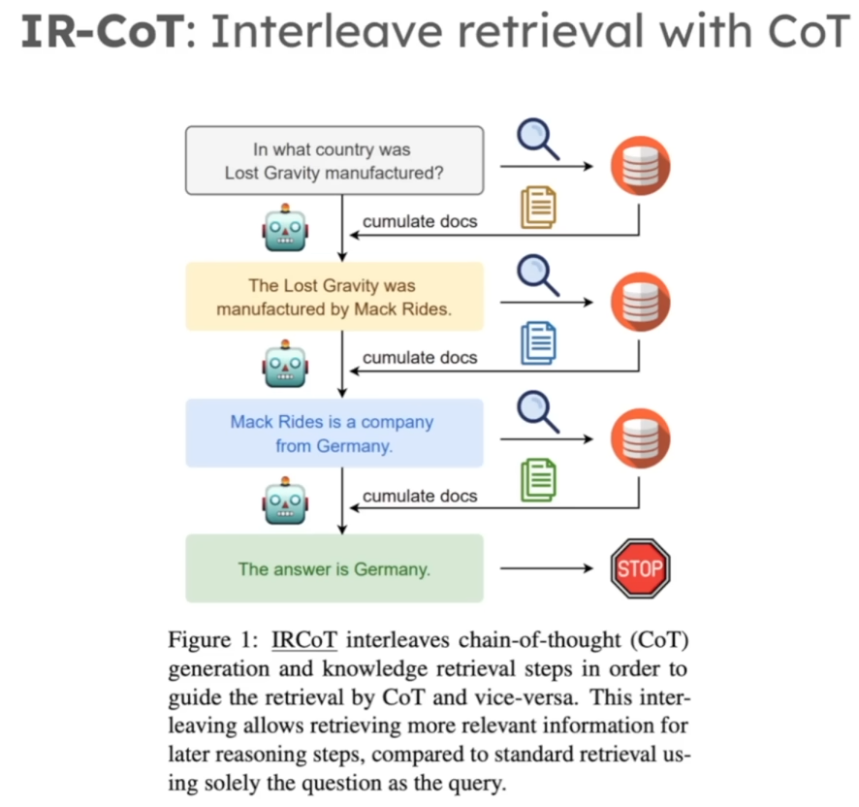
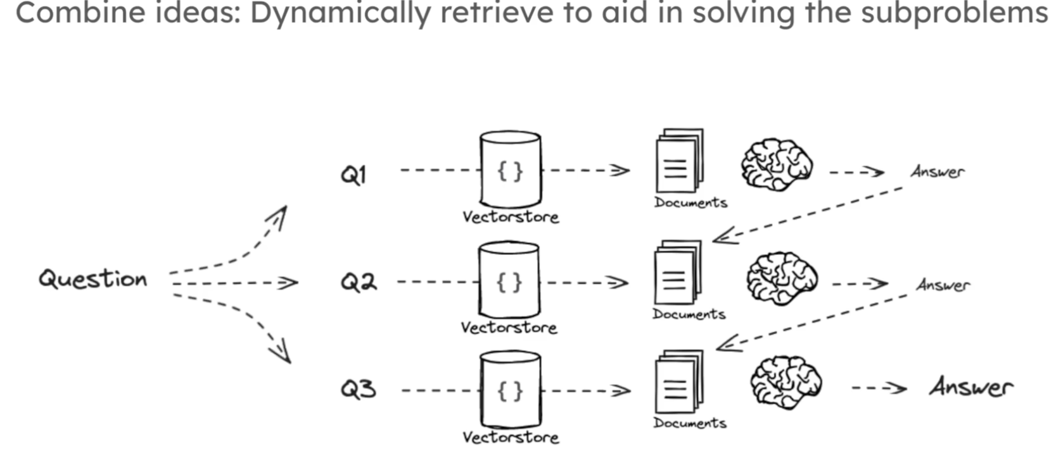
IR-CoT (Iterative Retrieval Chain-of-Thought)
👉 “Think → retrieve info → think again → repeat”
- Start reasoning:
$$C_{1}=f(P)$$
- Retrieve relevant info:
$$D_{1}=R(C_{1})$$
- Update reasoning:
$$C_{2}=f(P,D_{1})$$
- Repeat:
$$C_{t+1}=f(P,D_{t})$$
👉 Dynamic loop
Difference Table:
Feature | Least-to-Most | IR-CoT
Structure | Sequential | Iterative loop
Decomposition | Explicit | Implicit
Retrieval | ❌ No | ✅ Yes
Use case | Math, logic | Open-domain QA
Flexibility | Low | High
Error handling | Weak (propagation) | Strong (can recover)

Step-back
Few shot prompt to produce more abstract step-back question
HyDE
HyDE RAG Flow
- User query
- LLM generates hypothetical answer/document
- Convert that document → embedding
- Search vector DB
- Retrieve better context
- Final answer generation
👉 So instead of searching with weak query, we search with a rich, context-filled pseudo-document
Why HyDE Works (Core Insight)
👉 Problem:
- Query = short (e.g., “vitamin D recovery”)
- Documents = long, detailed paragraphs
👉 Solution:
- Hypothetical doc = similar style + vocabulary as real docs
- So embedding space me closer match milta hai

Routing the question to the right source
Logical Routing- LLM for classification
Semantic Routing- Choose prompt based upon the similarity

Query Construction
Taking natural language question and converting it into particular domain specific language
• Query Construction = Writing a better question
• Query Translation = Translating that question into a language the system understands
User Query
↓
Query Construction (expand/improve)
↓
Query Translation (to embedding / SQL / DSL)
↓
Retriever
Query Structuring
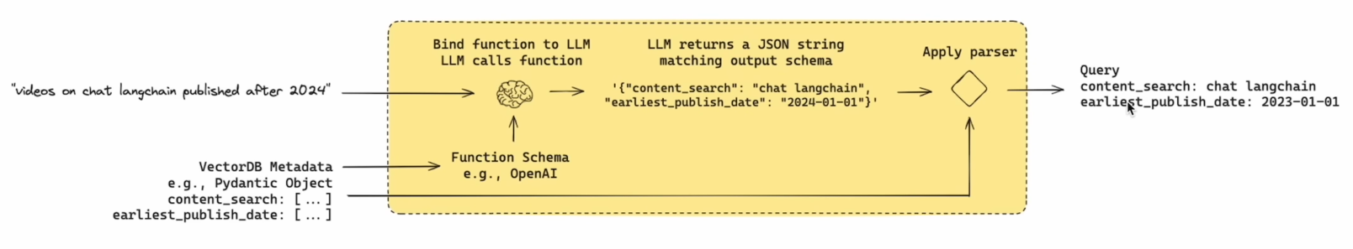
Indexing
Multi -Representation: Proposition Indexing-use LLM to distil it or make it like a crisper summary that’s better optimized for retrieval
What is Proposition Indexing?
Instead of embedding/indexing the whole paragraph or chunk, we:
- Extract propositions (atomic facts)
- Embed each proposition individually
- Store them in a vector database
Example:
Document:
“Apple released the iPhone 15 in 2023. It has a USB-C port and improved camera.”
Propositions:
- Apple released iPhone 15 in 2023
- iPhone 15 has a USB-C port
- iPhone 15 has an improved camera
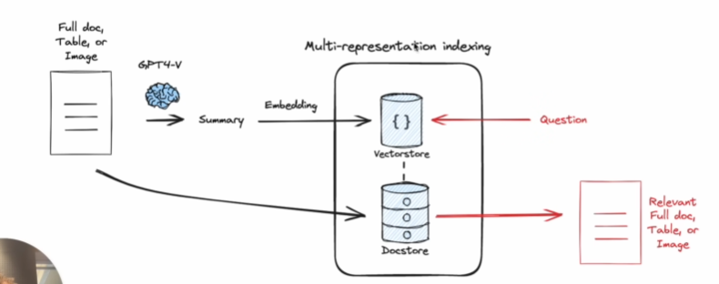
Why This Design is Powerful
✅ 1. Efficient Search
- Searching summaries is faster than full docs
✅ 2. Better Matching
- Summaries remove noise
- Focus on key meaning
✅ 3. Full Context Retained
- Final answer uses full document
- No information loss

Why Embeddings are Used in RAG
In RAG, embeddings enable semantic search instead of keyword search.
Without embeddings:
- Search = keyword matching (exact words)
With embeddings:
- Search = meaning matching (even if words differ)
Indexing (RAPTOR)- HIERARCHICAL INDEXING
Consolidate information (Clusters) across documents or chunks
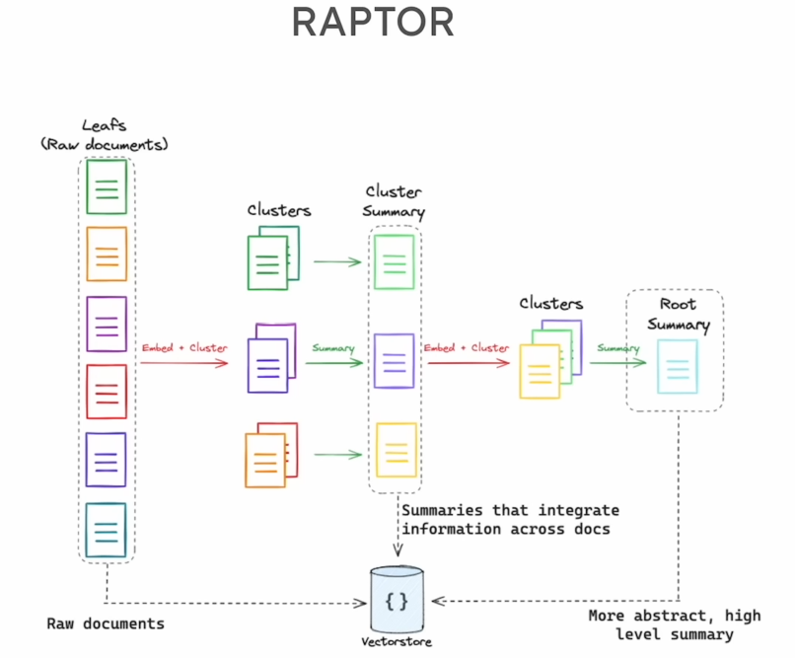
Higher level questions would be more similar in semantic search to these higher level summary chunks as it required information across the board(from different documents)
Lower level questions will retrieve these more lower level chunks
RAPTOR: Recursive Abstractive Processing for Tree- Organized Retrieval
- The leafs are a set of starting documents
- Leafs are embedded and clustered
- Clusters are then summarized into higher level(more abstract) consolidation of information across similar documents.
This process is done recursively, resulting in a “tree” going from raw docs(leafs) to more abstract summaries.
Indexing (ColBERT) (Contextualized Late Interaction over BERT)
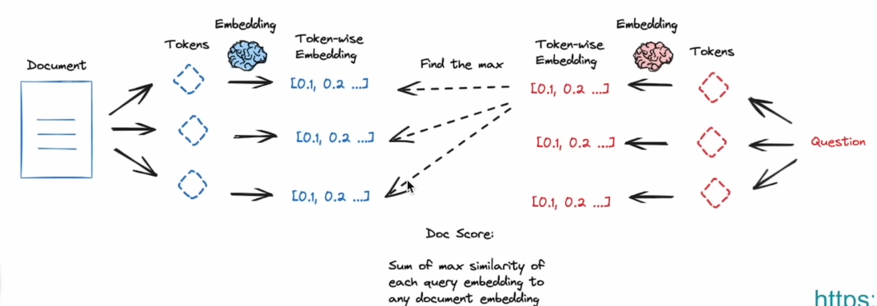
Active RAG: LLM decides when and what to retrieve based upon retrieval and /or generation.
State Machine—let the llm choose b/w different steps but specify all the transitions that are available.
CRAG-: corrective-RAG, an approach for active RAG
  - Correct documents
- If at least one document exceeds the threshold for relevance, then it proceeds to generation
- Before generation, it performs knowledge refinement.
- This partitions the document into “knowledge strips”
- It grades each strip, and filters out irrelevant ones.
  - Ambiguous or incorrect documents
- If all documents fall below the relevance threshold or if the grader is unsure, then the framework seeks an additional datasource.
- It will use web search to supplement retrieval.
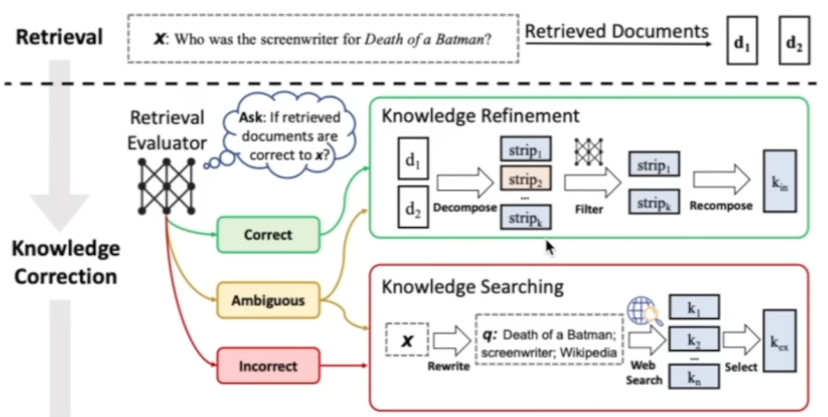
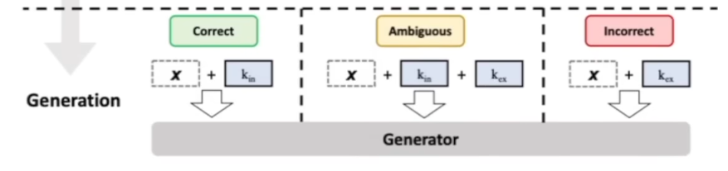
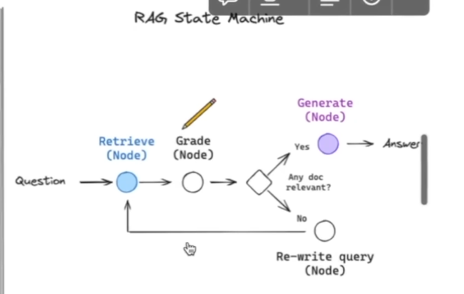

Adaptive RAG(Flow engineering)-check relevance documents, check whether or not the answer contains hallucinations
Query Analysis- process of taking an input question and modifying to optimize retrieval
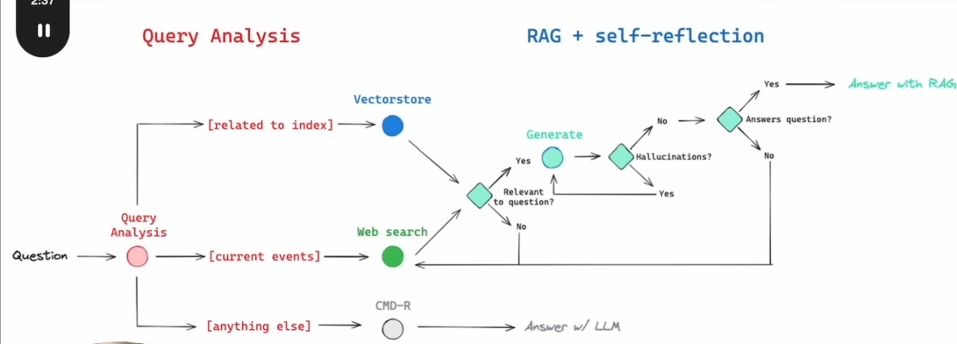
Command R-
Agents vs LangGraph:
- Agent: More flexible, less reliable-> larger LLM(CMD+ R plus)
- LangGraph: Less flexible, more reliable-> Smaller LLM(CMD+R)
If thousands of pages can be stuff into context window of LLM , why do need a retrieval system?
Retrieval is not guaranteed , reasoning is harder than retrieval
Smaller context => better retrieval
LLMs don’t equally “pay attention” to all tokens.
- They focus more on:
  - Beginning
  - End
- Middle content gets diluted
This is called:
👉 Lost in the Middle
Retrieval helps by:
- Injecting relevant + semantically matched evidence
- Often with ranking + scoring
So:
RAG = guided grounding
Large context = unstructured dump
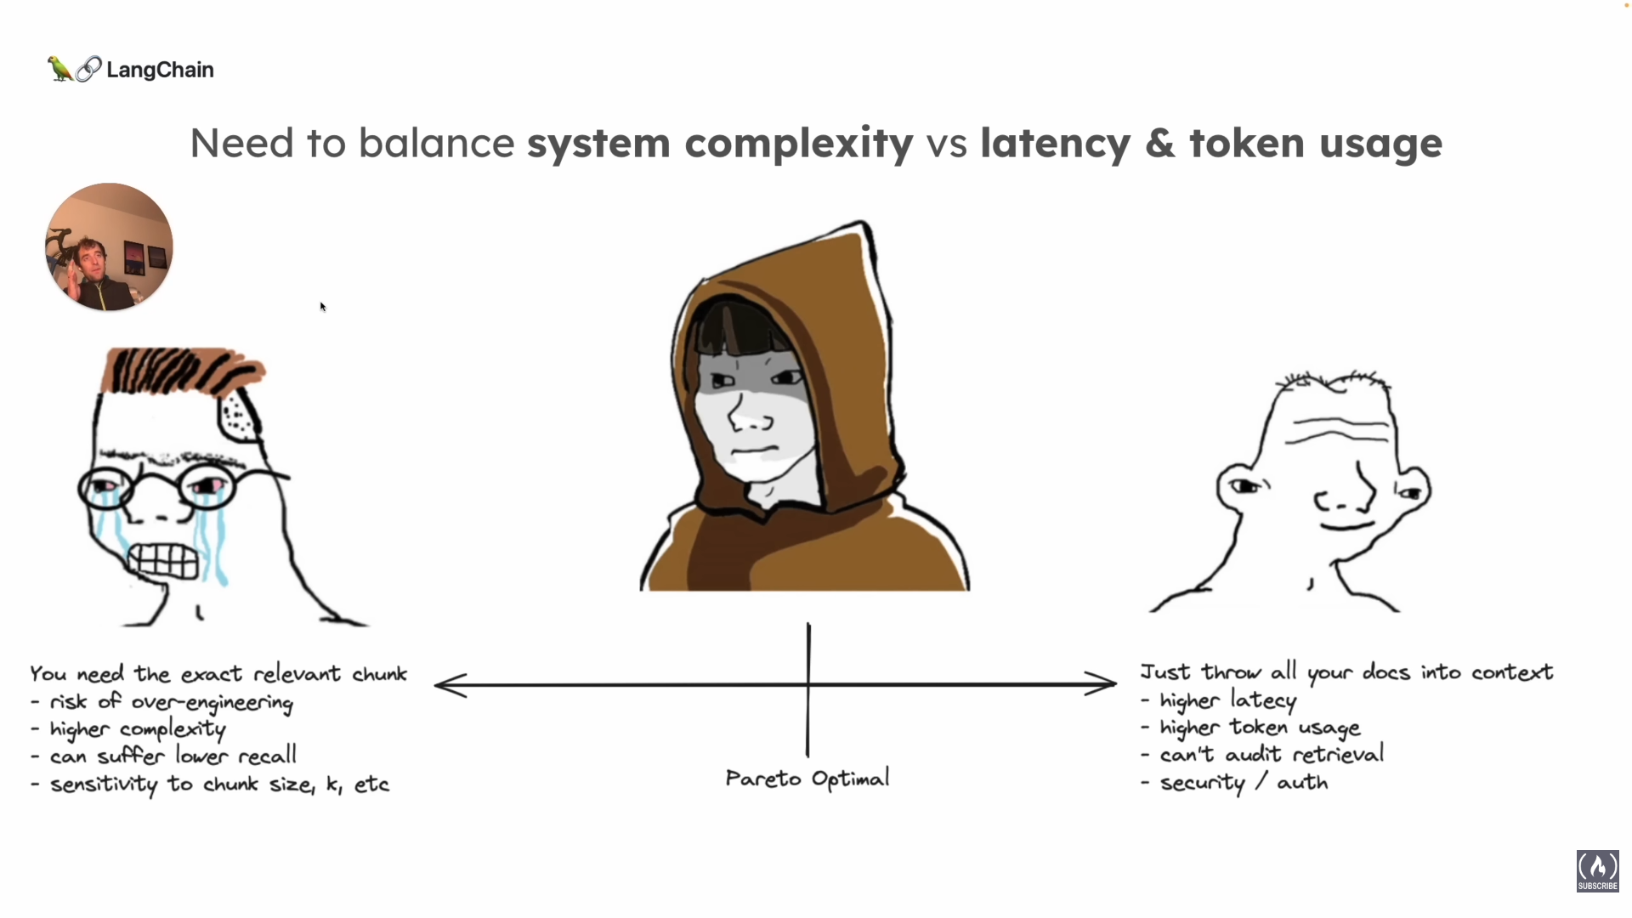

Text Structure based text splitting
Document Structured Based- for special kind of documents like codes
Semantic meaning based

Vector Stores- a system designed to store and retrieve data represented as numerical vectors.
Challenges:
    - Generate embedding vectors
    - Storage
    - Intelligent semantic search
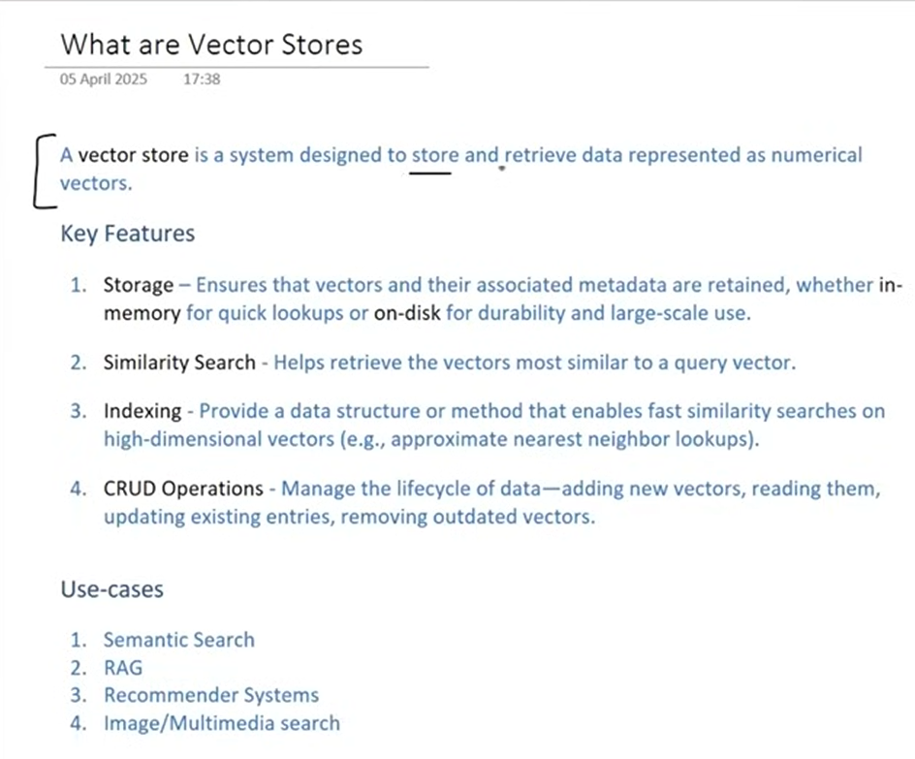
- Chunking decides what pieces of information you're going to retrieve.
- Embedding converts those pieces into vectors.
- Indexing algorithm organizes those vectors for fast retrieval.
Relational databases are not great at storing and retrieving vectors
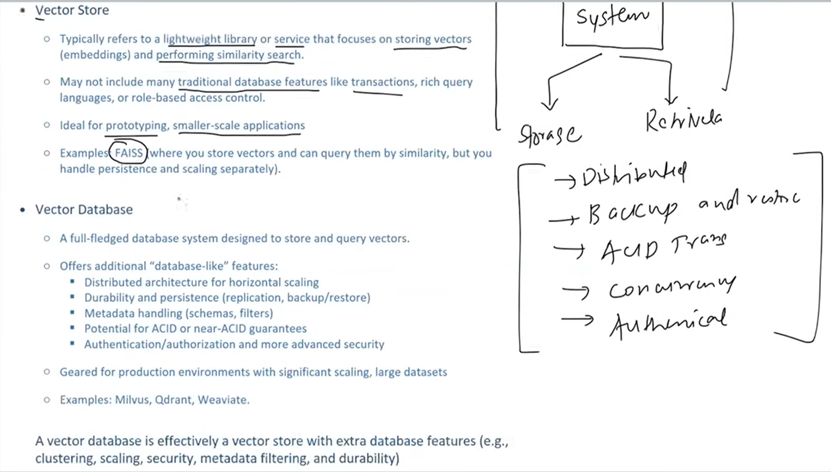
Retrievers based on retrieval mechanism:
Maximal Marginal Relevance (MMR)-
“How can we pick results that are not only relevant to the query but also different from each other?”
It is an information retrieval algorithm designed to reduce redundancy in the retrieved results while maintaining high relevance to the query.
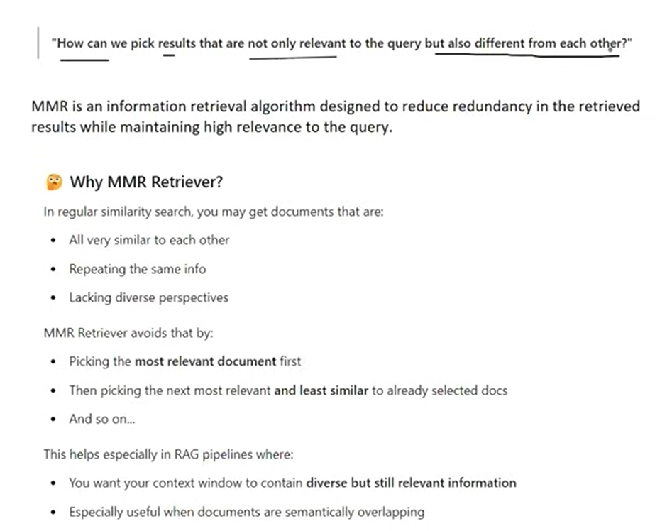
Search_type= ”mmr”
Multi- Query Retriever
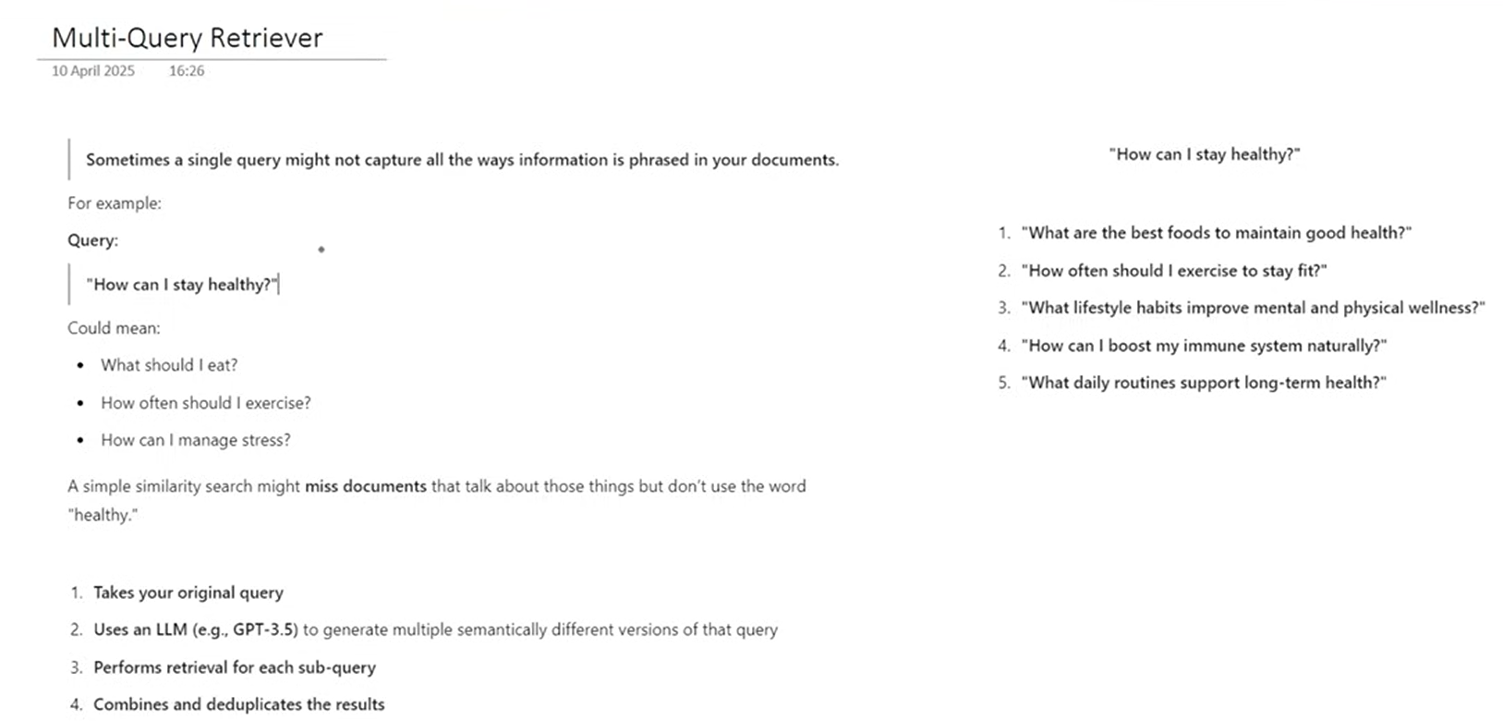

Contextual Compression Retriever
