1. Create Database

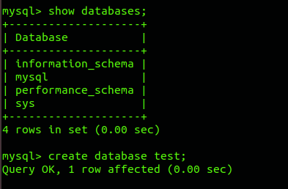

1. Design Schema

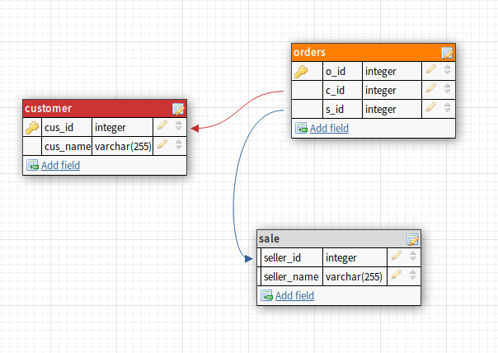

1. Create tables

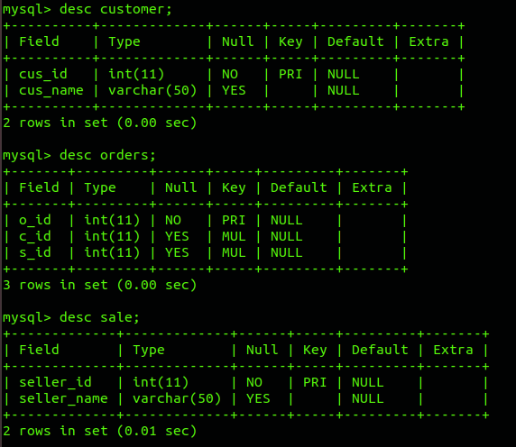

1. Insert sample data

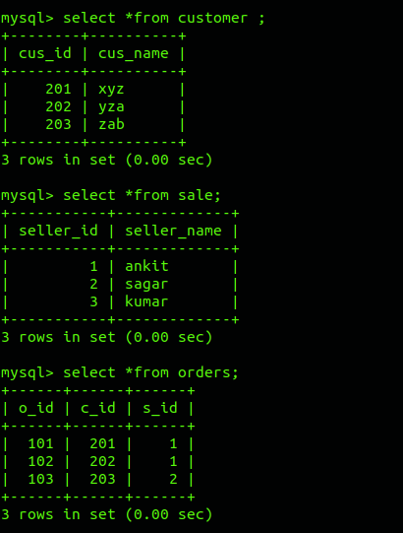

1. Find the sales person have multiple orders.
2. Find the all sales person details along with order details

select sale.seller_id, sale.seller_name, orders.o_id from orders inner join sale on orders.s_id=sale.seller_id;

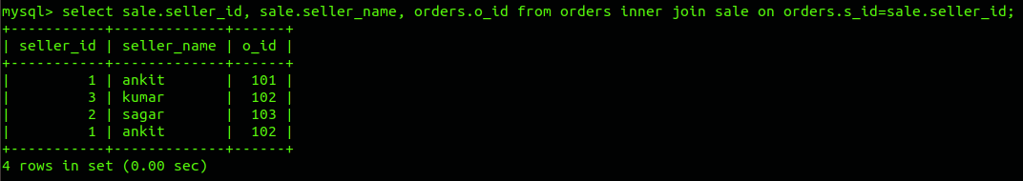

1. Create index

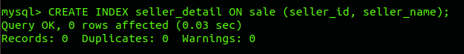

1. How to show index on a table

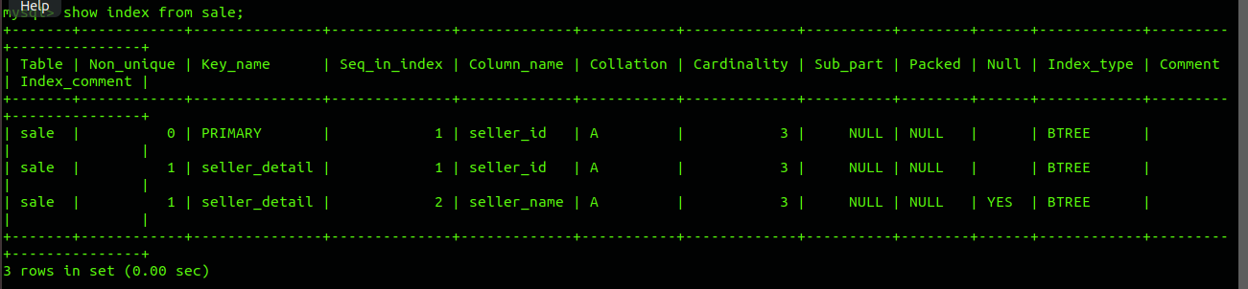

1. Find the order number, sale person name, along with the customer to whom that order belongs to

SELECT customer.cus_name, orders.o_id, seller_name

FROM ((orders

INNER JOIN customer ON orders.c_id = customer.cus_id)

INNER JOIN sale ON orders.s_id = sale.seller_id);

