TYCS - Semester V
Mini Project Documentation
Safe and Smart City - Civic Issue Reporting System
Module 1: Problem Identification, Requirement Engineering and System Design Phase
Academic Year: 2025-2026 | Branch: B.Sc. Computer Science

1. Problem Identification and Feasibility Study
1.1 Identification of a Real-World Problem
India rapidly growing urban population faces persistent civic challenges that severely impact the quality of daily life. Citizens regularly encounter problems such as overflowing garbage dumps, dangerous potholes on roads, non-functional streetlights, water pipeline bursts, fallen trees blocking traffic, and various sanitation hazards. Despite the existence of municipal corporations and local governing bodies, the gap between citizens and administration remains alarmingly wide.
The core problem identified is the absence of a transparent, structured, and technology-driven platform that allows citizens to report civic grievances and simultaneously enables municipal authorities to receive, track, and resolve these issues in an accountable manner. Existing complaint mechanisms such as physical complaint registers, helpline calls, or generic social media posts lack tracking transparency, accountability, and verifiable proof of resolution.
This project identifies the following specific real-world pain points:
- Citizens have no reliable way to report civic issues digitally with photo evidence and GPS location.
- Municipal officers lack a centralized dashboard to view, prioritize, and assign field teams to reported issues.
- There is no publicly visible proof of issue resolution (before and after photographs).
- Citizens cannot track the current status of their complaint using a unique tracking ID.
- Community voices (upvoting genuine problems) are not leveraged to escalate urgency.
- There is no mechanism to reward civic participation, leading to low citizen engagement.
1.2 Problem Justification
The problem of inefficient civic grievance redressal is well-documented and affects millions of urban residents across India. According to various municipal reports and citizen surveys, the average resolution time for a civic complaint filed through traditional channels exceeds 30 to 60 days, with no status updates communicated to the complainant in the interim.
The following factors justify the need for a technology-driven solution:
- Scale of the Problem: Indian cities collectively receive thousands of civic complaints daily. Manual processing is inefficient, error-prone, and non-transparent.
- Accountability Gap: Without a formal tracking system, complaints are frequently ignored or lost, and citizens have no way to hold authorities accountable for timely resolution.
- Digital Readiness: With smartphone and internet penetration exceeding 60% in urban India, a web-based solution is practically viable and accessible to a large segment of the population.
- Government Initiatives: Smart City Mission (Government of India) actively promotes the use of technology to improve urban civic services, validating the relevance of this project.
- Community Engagement: A participatory approach where citizens can report, upvote, and track issues increases civic responsibility and public trust in local government.
These factors collectively justify the development of the Safe and Smart City - Civic Issue Reporting System as a meaningful and impactful solution to an existing, pressing real-world problem.
1.3 Scope Definition
The scope of this project defines the boundaries of what the system will and will not address within the context of this academic mini-project.
In Scope (Features included in this project):
- Citizen registration, login, and profile management.
- Reporting of civic issues with category selection, description, photo evidence upload, and GPS-based location capture using Leaflet.js interactive maps.
- Automatic generation of unique complaint tracking IDs (e.g., SSC-2026-XXXX).
- Real-time 5-stage complaint status tracking: Reported, Verified, Team Dispatched, In Progress, Resolved and Closed.
- Before-and-after photo comparison for transparent proof of resolution.
- Community upvoting mechanism to prioritize high-impact issues.
- Municipal administrator dashboard to view, filter, assign, and resolve complaints.
- Civic Karma points and leaderboard to reward active citizen participation.
- Dark mode and light mode theme toggle for enhanced user experience.
Out of Scope (Not included in this project):
- Mobile application (Android/iOS) development.
- Integration with actual municipal or government APIs.
- Payment gateway or financial transactions of any kind.
- AI-based automatic categorization of complaints.
- Real-time push notification system via SMS or email services.
- Multi-city or multi-municipal corporation support at a production scale.
1.4 Stakeholder Identification
Stakeholders are individuals or groups who are directly or indirectly affected by the system. A clear identification of stakeholders ensures that the system is designed to meet the needs of all relevant parties.
Stakeholder | Role | Interest / Expectation
Citizens (End Users) | Primary users of the reporting interface. | Easy issue reporting, unique tracking ID, real-time status updates, transparent resolution proof.
Municipal Administrator | Manages and resolves reported complaints via admin dashboard. | Centralized view of all complaints, filtering by category/area, ability to assign teams and mark resolved.
Field Team / Workers | Physical team assigned to resolve issues on ground. | Clear task assignment, location-based routing of issues, confirmation of completion.
Project Developer (Academic) | Designs, develops, and maintains the system. | Successful implementation of all features within academic timeline and technology constraints.
Academic Evaluators / Faculty | Evaluate the project for academic submission. | Proper documentation, adherence to SDLC, technical completeness, and presentation quality.

1.5 Feasibility Study
A feasibility study is conducted to determine whether the proposed system is technically achievable, economically justifiable, and operationally practical within the given academic environment. The following three dimensions of feasibility are analyzed:
1.5.1 Technical Feasibility
Technical feasibility assesses whether the required technology, tools, and expertise are available to develop and run the proposed system.
The Safe and Smart City system is built using a well-established, widely adopted technology stack:
- Frontend: HTML5, CSS3, and Vanilla JavaScript (ES6+) are standard web technologies fully supported across all modern browsers with no licensing requirements. Leaflet.js 1.9.4 provides open-source GIS mapping capabilities.
- Backend: Java with Jakarta Servlet 6.0 is a mature, enterprise-grade backend technology. Apache Tomcat 10.1 (open-source) serves as the web server and servlet container.
- Database: MySQL 8.0 is a free, open-source relational database management system with excellent JDBC support for Java connectivity.
- Security: BCrypt password hashing (jbcrypt) ensures secure credential storage. Google Gson handles JSON data exchange between frontend and backend.
- Developer Expertise: The developer has sufficient knowledge of the above technologies, making implementation feasible within the academic timeline.
Conclusion: The project is technically feasible. All required tools are open-source, freely available, and well within the developer current technical capabilities.
1.5.2 Economic Feasibility
Economic feasibility determines whether the system can be developed and operated within acceptable cost constraints, particularly in the context of an academic project.
Resource / Tool | Cost | Remarks
HTML5, CSS3, JavaScript | Free | Open web standards, no licensing fees.
Leaflet.js (GIS Maps) | Free | Open-source mapping library (BSD 2-Clause License).
Java JDK 17 / Jakarta EE | Free | OpenJDK is freely available for development use.
Apache Tomcat 10.1 | Free | Open-source web server under Apache License 2.0.
MySQL 8.0 (Community Edition) | Free | Open-source RDBMS available under GPL license.
Visual Studio Code (IDE) | Free | Free code editor by Microsoft.
Hardware (Laptop / PC) | Already available | No additional hardware procurement needed.
Total Estimated Cost | Rs. 0 | All tools are free and open-source.

Conclusion: The project is economically feasible. The entire development stack is free and open-source. No financial investment is required, making it an ideal academic project with zero monetary barrier to development and deployment.
1.5.3 Operational Feasibility
Operational feasibility evaluates whether the proposed system will be effectively used by its intended users and whether it can be practically operated within the target environment.
- Ease of Use: The system features a clean, intuitive web interface with simple navigation, making it accessible to citizens with basic digital literacy.
- User Acceptance: Citizens are increasingly comfortable using web applications for civic services. With smartphone and internet access growing in urban India, user adoption is realistically achievable.
- Administrator Efficiency: The admin dashboard provides centralized complaint management, significantly reducing manual workload compared to traditional paper-based complaint systems.
- Minimal Training Required: The interface is self-explanatory with visual cues, icons, and guided workflows. No specialized training is necessary for end users.
- Academic Operability: The system can be fully demonstrated on a local machine using Apache Tomcat and MySQL, without the need for a live production server.
- Maintenance: The codebase is organized, commented, and structured to allow future enhancements with minimal effort.
Conclusion: The project is operationally feasible. The system is designed with user simplicity in mind, requires no specialized hardware or training, and can be effectively operated within both an academic demonstration environment and a real-world municipal setting.
Summary of Feasibility Study
Feasibility Dimension | Status | Remarks
Technical Feasibility | Feasible | Open-source stack fully within developer capability.
Economic Feasibility | Feasible | Zero cost - all tools free and open-source.

Based on the feasibility analysis conducted above, it is concluded that the Safe and Smart City - Civic Issue Reporting System is fully feasible from technical, economic, and operational standpoints. The project can be successfully developed, demonstrated, and evaluated within the academic constraints of the TYCS Semester V mini-project framework.

2. Requirement Engineering
2.1 Functional Requirements Specification
Functional requirements define the specific behaviors, functions, and features that the Safe and Smart City - Civic Issue Reporting System must provide to its users. These requirements describe what the system must do in response to inputs and under particular conditions.
2.1.1 Citizen Module:
- FR-C01 - User Registration: The system shall allow new citizens to register by providing their full name, email address, mobile number, and a secure password.
- FR-C02 - User Login / Logout: The system shall authenticate registered citizens using email and password. Passwords shall be stored in BCrypt hashed form.
- FR-C03 - Issue Reporting: The system shall allow a logged-in citizen to report a civic issue by selecting a category (Garbage, Pothole, Streetlight, Water Pipeline, Fallen Tree, Sanitation Hazard), providing a description, uploading a photo as evidence, and pinning the location on an interactive Leaflet.js map.
- FR-C04 - Tracking ID Generation: Upon successful submission, the system shall automatically generate and display a unique tracking ID in the format SSC-YYYY-XXXX (e.g., SSC-2026-8812).
- FR-C05 - Complaint Status Tracking: The system shall allow a citizen to track the current status of their complaint using the unique tracking ID across five stages: Reported, Verified, Team Dispatched, In Progress, and Resolved and Closed.
- FR-C06 - Before and After Photo View: The system shall display a side-by-side comparison of the before photo (submitted by citizen) and the after photo (uploaded by admin upon resolution) for resolved complaints.
- FR-C07 - Community Upvoting: The system shall allow citizens to upvote genuine civic issues reported by others to escalate their urgency and priority.
- FR-C08 - Civic Karma and Leaderboard: The system shall award Karma points to citizens for reporting issues, getting them resolved, and upvoting. A public leaderboard shall display top contributing citizens.
2.1.2 Admin Module:
- FR-A01 - Admin Login: The system shall provide a separate, secure login interface for municipal administrators with role-based access control.
- FR-A02 - Complaint Dashboard: The system shall display all reported complaints on the admin dashboard with filtering options by category, area, status, and date.
- FR-A03 - Complaint Assignment: The administrator shall be able to assign a reported complaint to a specific field team or worker and update the status to Verified or Team Dispatched.
- FR-A04 - Issue Resolution: The administrator shall be able to mark a complaint as resolved by uploading an after-photo and entering remarks about the work performed.
- FR-A05 - Complaint Details View: The administrator shall be able to view full complaint details including citizen information, issue description, GPS location on map, before photo, and current status.
2.1.3 System Module:
- FR-S01 - GPS Location Capture: The system shall automatically capture the citizen device GPS coordinates using the HTML5 Geolocation API and display the location on a Leaflet.js interactive map for manual pin adjustment.
- FR-S02 - Photo Upload: The system shall support image file upload for complaint evidence. Uploaded images shall be stored securely on the server.
- FR-S03 - Dark and Light Mode: The system shall provide a theme toggle with the selected preference persisted in the browser local storage.
- FR-S04 - Dual-Mode Operation: The system shall support a frontend-only demo mode (using local data) and a full backend-connected mode (using Java Servlet and MySQL) to allow academic demonstration without a live server.
2.2 Non-Functional Requirements
Non-functional requirements define the quality attributes, constraints, and performance characteristics of the system. These requirements specify how the system performs its functions rather than what functions it performs.
Req. ID | Type | Description
NFR-01 | Performance | The system shall load the main dashboard within 3 seconds on a standard broadband connection (minimum 5 Mbps).
NFR-02 | Usability | The user interface shall be intuitive enough for a citizen with basic digital literacy to report an issue within 5 minutes without any prior training.
NFR-03 | Security | All citizen passwords shall be stored using BCrypt hashing with a minimum cost factor of 10. No plain-text passwords shall be stored in the database.
NFR-04 | Security | Admin and citizen roles shall be strictly separated. A citizen shall not be able to access the admin dashboard and vice versa.
NFR-05 | Reliability | The system shall be available 99% of the time during the academic demonstration period, ensuring no data loss during complaint submission.
NFR-06 | Scalability | The database schema and backend architecture shall be designed to support up to 10,000 complaint records without performance degradation.
NFR-07 | Maintainability | The codebase shall follow clean coding conventions with inline comments, enabling a new developer to understand and modify it within 2 hours.
NFR-08 | Compatibility | The frontend shall be compatible with the latest versions of Google Chrome, Mozilla Firefox, and Microsoft Edge browsers.
NFR-09 | Portability | The backend WAR package (SmartCity.war) shall be deployable on any Apache Tomcat 10.1+ compatible server without code changes.
NFR-10 | Accessibility | The system shall support both dark mode and light mode themes for improved visual accessibility across different lighting environments.

2.3 Use-Case Analysis
Use-case analysis identifies the interactions between the system actors (users) and the system itself. It helps in understanding the functional scope of the system from the perspective of each actor.
Actors Identified:
- Citizen (Primary Actor): Registers, logs in, reports civic issues, tracks complaints, upvotes issues, and views the leaderboard.
- Municipal Administrator (Primary Actor): Logs in, views all complaints, assigns teams, updates status, resolves issues with after-photos and remarks.
- System (Secondary Actor): Captures GPS location, generates tracking IDs, calculates Karma points, and enforces role-based access.
UC ID | Use Case Name | Actor | Description
UC-01 | Register Account | Citizen | Citizen fills registration form with name, email, phone, and password. System validates and creates account.
UC-02 | Login to System | Citizen / Admin | User enters credentials. System authenticates and redirects to appropriate dashboard based on role.
UC-03 | Report Civic Issue | Citizen | Citizen selects category, adds description, uploads photo, pins GPS location, and submits complaint.
UC-04 | Track Complaint Status | Citizen | Citizen enters tracking ID. System displays current status stage and 5-step progress stepper.
UC-05 | Upvote an Issue | Citizen | Citizen selects a reported issue and clicks upvote. System increments the upvote count.
UC-06 | View Leaderboard | Citizen | Citizen views the public leaderboard showing top contributors ranked by Karma points.
UC-07 | View Complaint Dashboard | Admin | Admin views all complaints with filtering options by category, status, and area.
UC-08 | Assign Field Team | Admin | Admin selects a complaint and assigns it to a field team, updating status to Team Dispatched.
UC-09 | Resolve Complaint | Admin | Admin uploads after-photo, adds remarks, and marks the complaint as Resolved and Closed.
UC-10 | View Complaint Details | Admin | Admin views full complaint info including citizen details, GPS map, before photo, and status history.

2.4 Requirement Prioritization
Requirement prioritization helps in determining the order of implementation based on the importance and impact of each requirement. The MoSCoW method is used to classify requirements into four priority categories.
Priority | Meaning | Requirements in This Project
Must Have | Core requirements - system cannot function without these. | User Registration (FR-C01), User Login (FR-C02), Issue Reporting with Photo and GPS (FR-C03), Tracking ID Generation (FR-C04), Complaint Status Tracking (FR-C05), Admin Login (FR-A01), Admin Dashboard (FR-A02), Issue Resolution with After-Photo (FR-A04).
Should Have | Important requirements that add significant value. | Before and After Photo Comparison (FR-C06), Complaint Assignment to Field Team (FR-A03), GPS Location Auto-Capture (FR-S01), Dark and Light Mode Toggle (FR-S03).
Could Have | Desirable enhancements that improve user experience. | Community Upvoting (FR-C07), Civic Karma Points and Leaderboard (FR-C08), Dual-Mode Demo Operation (FR-S04).
Will Not Have | Explicitly excluded from the current version. | Mobile App (Android/iOS), SMS or Email Notifications, AI-based complaint categorization, Payment integration, Multi-city production deployment.

Based on this prioritization, the development was sequenced to first complete all Must Have requirements, followed by Should Have features, and then Could Have enhancements. This ensured that a fully functional, demonstrable system was ready before the academic submission deadline.
2.5 Constraints and Assumptions
2.5.1 Constraints:
Constraints are limitations or restrictions imposed on the system that affect its design and implementation.
- Time Constraint: The project must be designed, developed, tested, and documented within the academic semester timeline of TYCS Semester V.
- Technology Constraint: The backend must use Java with Jakarta Servlet 6.0 and Apache Tomcat 10.1 as mandated by the academic curriculum focus on Java enterprise technologies.
- Database Constraint: MySQL 8.0 is the only supported database for this project. Migration to other databases such as PostgreSQL or MongoDB is not in scope.
- Hardware Constraint: The system is designed for single-server local machine deployment for academic demonstration. Distributed cloud deployment is out of scope.
- Budget Constraint: The project must be developed using entirely free and open-source tools due to the academic, zero-budget nature of the project.
- Security Constraint: Advanced security features such as OAuth 2.0, two-factor authentication, or SSL certificate management are not implemented in this academic version.
- File Storage Constraint: Uploaded photos are stored on the local server filesystem. Integration with cloud storage services such as AWS S3 or Google Cloud Storage is not in scope.
2.5.2 Assumptions:
Assumptions are conditions believed to be true for the purpose of planning and designing the system.
- It is assumed that citizens have access to a smartphone or computer with a modern web browser (Chrome, Firefox, or Edge) and an active internet connection.
- It is assumed that the Apache Tomcat server and MySQL database will be available and running locally throughout the academic demonstration.
- It is assumed that the target user (citizen) has basic digital literacy and can navigate a web application without specialized training.
- It is assumed that the municipal administrator has access to the admin credentials and uses a desktop or laptop to manage the dashboard.
- It is assumed that the GPS coordinates captured by the HTML5 Geolocation API are reasonably accurate (within 50 meters) for the purpose of civic issue location mapping.
- It is assumed that uploaded photos are in standard image formats (JPEG or PNG) and are of reasonable file size (under 5 MB) for smooth upload performance.
- It is assumed that civic issues belong to one of the six predefined categories: Garbage Dump, Pothole, Streetlight, Water Pipeline Burst, Fallen Tree, and Sanitation Hazard.

3. Software Development Life Cycle (SDLC) Planning
3.1 Selection of SDLC Model
The Software Development Life Cycle (SDLC) is a structured process that defines the stages involved in the development of a software system from inception to delivery and maintenance. Selecting an appropriate SDLC model is critical as it determines the workflow, deliverables, and project management approach throughout the development process.
For the Safe and Smart City - Civic Issue Reporting System, the Iterative and Incremental Development Model has been selected as the primary SDLC model.
Why Iterative and Incremental Model?
- Flexibility: The iterative model allows requirements to be refined and features to be added progressively. Since this is an academic project with evolving understanding of requirements, this model accommodates changes without disrupting the overall development flow.
- Early Working Prototypes: With each iteration, a working version of the system is produced. This allowed for early testing of core features such as complaint submission and status tracking before adding advanced features like upvoting and Karma points.
- Risk Management: High-risk components (such as backend Java Servlet integration with MySQL) were developed and tested in early iterations, reducing the risk of critical failures in later stages.
- Suitable for Academic Projects: The iterative approach aligns well with the academic timeline where feedback from faculty evaluators can be incorporated between iterations.
Phases of the Selected Model:
Phase | Activities Performed | Deliverable
Phase 1 - Planning and Requirements | Problem identification, stakeholder analysis, feasibility study, requirement gathering, scope definition. | SRS Document (Module 1 - Section 1 and 2)
Phase 2 - System Design | SDLC model selection, WBS creation, project timeline, UML diagrams (Use Case, Class, Sequence, Activity, ER, Deployment), system architecture design. | Design Document (Module 1 - Section 3, 4 and 5)
Phase 3 - Iteration 1 (Core Features) | Frontend development (HTML, CSS, JS), citizen registration, login, issue reporting with GPS and photo, tracking ID generation, MySQL schema setup. | Working frontend with backend CRUD operations
Phase 4 - Iteration 2 (Admin and Advanced Features) | Admin dashboard, complaint assignment, status updates, before-after photo comparison, upvoting, Karma system, leaderboard. | Fully functional web application
Phase 5 - Testing | Unit testing, integration testing, system testing, user acceptance testing (UAT), bug fixing. | Tested and stable application
Phase 6 - Deployment | WAR file packaging (SmartCity.war), Apache Tomcat deployment, final demo setup. | Deployed application on local Tomcat server
Phase 7 - Documentation | Complete project documentation across Module 1 and Module 2 as per academic format. | Final project documentation report

Alternative Models Considered:
SDLC Model | Reason for Rejection
Waterfall Model | Too rigid and sequential. Does not allow revisiting earlier phases when new requirements or bugs are discovered during development.
Agile / Scrum | Requires a team with defined roles (Scrum Master, Product Owner). Not suitable for a single-developer academic project.
Spiral Model | Focuses heavily on risk analysis at every phase, making it overly complex for a mini-project of this scale and timeline.
Prototype Model | Useful for UI prototyping but lacks the structured phases needed for full system development with backend and database integration.

3.2 Work Breakdown Structure (WBS)
A Work Breakdown Structure (WBS) is a hierarchical decomposition of the total scope of work to be carried out by the project team to accomplish the project objectives. It breaks the project into manageable tasks and sub-tasks, ensuring complete coverage of all deliverables.
WBS for Safe and Smart City - Civic Issue Reporting System:
WBS ID | Task / Sub-task | Description
1.0 | Project Initiation | Define project goals, scope, and team responsibilities.
1.1 | Problem Identification | Identify the real-world civic problem and justify the need for a software solution.
1.2 | Feasibility Study | Conduct technical, economic, and operational feasibility analysis.
1.3 | Stakeholder Analysis | Identify all stakeholders and document their roles and expectations.
2.0 | Requirement Engineering | Gather and document all system requirements.
2.1 | Functional Requirements | List all functional requirements for citizen module, admin module, and system module.
2.2 | Non-Functional Requirements | Define performance, security, reliability, and usability requirements.
2.3 | Use-Case Analysis | Identify actors, use cases, and document use-case descriptions.
2.4 | Requirement Prioritization | Apply MoSCoW method to prioritize requirements for implementation.
3.0 | System Design | Design the architecture, database, and UML diagrams.
3.1 | UML Diagrams | Create Use Case, Class, Sequence, Activity, ER, and Deployment diagrams.
3.2 | Database Schema Design | Design MySQL tables, primary keys, foreign keys, and indexes.
3.3 | API Structure Design | Define Servlet endpoints, request parameters, and JSON response formats.
3.4 | Architecture Design | Document frontend, backend, and database architecture layers.
4.0 | Frontend Development | Build the complete user-facing web interface.
4.1 | HTML Structure | Create semantic HTML5 structure for all pages and modals.
4.2 | CSS Design System | Implement design tokens, dark/light mode, animations, and responsive layout.
4.3 | JavaScript Logic | Implement Geolocation API, Leaflet.js map, form handling, and API calls.
4.4 | Dual-Mode Operation | Implement frontend-only demo mode with local data simulation.
5.0 | Backend Development | Build the server-side Java Servlet application.
5.1 | Database Connectivity | Set up JDBC connection pool with MySQL using DBUtil class.
5.2 | Servlet Development | Implement all Java Servlets for complaint CRUD, user auth, and admin operations.
5.3 | Security Implementation | Integrate BCrypt password hashing and session-based role management.
5.4 | WAR Packaging | Configure Maven pom.xml and package the application as SmartCity.war.
6.0 | Testing | Verify the system against all defined requirements.
6.1 | Unit Testing | Test individual components such as servlets, DAO methods, and JS functions.
6.2 | Integration Testing | Test interaction between frontend, backend, and database.
6.3 | System Testing | End-to-end testing of all use cases from citizen and admin perspectives.
6.4 | UAT | User acceptance testing with sample test cases and result documentation.
7.0 | Deployment | Deploy the application for academic demonstration.
7.1 | Database Setup | Run database.sql script to create MySQL schema and seed data.
7.2 | Tomcat Deployment | Deploy SmartCity.war on Apache Tomcat 10.1 local server.
8.0 | Documentation | Prepare complete academic project documentation.
8.1 | Module 1 Documentation | Document Planning, Requirements, and Design phase.
8.2 | Module 2 Documentation | Document Implementation, Testing, Deployment, and Evaluation phase.

3.3 Project Timeline
The project timeline defines the schedule for completing each major phase and milestone of the Safe and Smart City project within the TYCS Semester V academic period. The timeline is structured across approximately 16 weeks (4 months) from project initiation to final submission.
Phase | Activity | Duration | Week
Phase 1 | Problem Identification, Feasibility Study, Stakeholder Analysis | 1 week | Week 1  (23–29 Jun)
Phase 2 | Requirement Engineering - Functional and Non-Functional Requirements | 1 week | Week 2  (30 Jun–6 Jul)
Phase 2 | Use-Case Analysis, Requirement Prioritization, Constraints | 1 week | Week 3  (7–13 Jul)
Phase 3 | SDLC Planning, WBS, Project Timeline, Gantt Chart, Resource Planning | 1 week | Week 4  (14–20 Jul)
Phase 4 | UML Diagrams - Use Case, Class, Sequence, Activity Diagrams | 1 week | Week 5  (21–27 Jul)
Phase 4 | ER Diagram, Deployment Diagram, System Architecture Design | 1 week | Week 6  (28 Jul–3 Aug)
Phase 5 | Frontend Development - HTML, CSS, JavaScript, Leaflet.js Map | 2 weeks | Week 7–8  (4–17 Aug)
Phase 5 | Backend Development - Java Servlets, JDBC, MySQL Schema Setup | 2 weeks | Week 9–10  (18–31 Aug)
Phase 5 | Security Implementation (BCrypt), WAR Packaging, Tomcat Deployment | 1 week | Week 11  (1–7 Sep)
Phase 6 | Unit Testing, Integration Testing, Bug Fixing | 1 week | Week 12  (8–14 Sep)
Phase 6 | System Testing, UAT, Test Case Documentation | 1 week | Week 13  (15–21 Sep)
Phase 7 | Final Deployment Setup, Demo Preparation | 1 week | Week 14  (22–28 Sep)
Phase 8 | Module 1 Documentation Writing and Formatting | 1 week | Week 15  (29 Sep–5 Oct)
Phase 8 | Module 2 Documentation Writing, Final Review and Submission | 1 week | Week 16  (6–12 Oct)

Note: The timeline above is an approximate plan. Some phases overlapped during actual development, particularly frontend development and iterative backend testing, which were carried out concurrently during Weeks 7 to 11.
3.4 Gantt Chart
A Gantt chart is a horizontal bar chart that visually represents the project schedule, showing the start and end dates of each activity relative to the total project timeline. It provides an at-a-glance view of task sequences, durations, and overlaps.
The Gantt chart below represents the 16-week project schedule for the Safe and Smart City project, spanning from the last week of June 2025 (Week 1: 23–29 Jun) through the first week of October 2025 (Week 16: 6–12 Oct). Each row represents a major task and each column represents one week of the project duration.
Task / Activity | W1  23–29 Jun | W2  30 Jun–6 Jul | W3  7–13 Jul | W4  14–20 Jul | W5  21–27 Jul | W6  28 Jul–3 Aug | W7  4–10 Aug | W8  11–17 Aug | W9  18–24 Aug | W10  25–31 Aug | W11  1–7 Sep | W12  8–14 Sep | W13  15–21 Sep | W14  22–28 Sep | W15  29 Sep–5 Oct | W16  6–12 Oct
Problem Identification and Feasibility | ***
Requirement Engineering |  | *** | ***
SDLC Planning and WBS |  |  |  | ***
UML Diagrams and System Design |  |  |  |  | *** | ***
Frontend Development |  |  |  |  |  |  | *** | ***
Backend Development and Security |  |  |  |  |  |  |  |  | *** | *** | ***
Testing and Bug Fixing |  |  |  |  |  |  |  |  |  |  |  | *** | ***
Deployment and Demo Setup |  |  |  |  |  |  |  |  |  |  |  |  |  | ***
Documentation - Module 1 and Module 2 |  |  |  |  |  |  |  |  |  |  |  |  |  |  | *** | ***

Legend: *** = Active / In Progress during that week. Empty cell = Task not active that week.
Note: The Gantt chart above provides a simplified week-wise representation. In a full project management tool such as Microsoft Project or ProjectLibre, each bar would show exact start dates, end dates, and task dependencies with predecessor-successor links.
3.5 Resource Planning
Resource planning identifies and allocates the human, hardware, software, and time resources required to successfully complete the Safe and Smart City project. Proper resource planning ensures that no resource bottlenecks occur during the project development lifecycle.
3.5.1 Human Resources:
Resource | Role | Responsibilities | Availability
Project Developer (Student) | Full-Stack Developer | Frontend development (HTML/CSS/JS), Backend development (Java Servlets), Database design (MySQL), Documentation writing. | Full-time for 16 weeks (Academic Semester)
Faculty Guide / Mentor | Project Supervisor | Providing guidance on project scope, reviewing documentation, approving design decisions, and evaluating the final submission. | Weekly review sessions as per academic schedule
Academic Evaluators | External Reviewers | Evaluating the final project documentation and live demonstration during the mini-project viva. | During final viva / presentation week

3.5.2 Hardware Resources:
Hardware | Specification / Details | Purpose
Development Machine (Laptop / PC) | Windows OS, Minimum 8 GB RAM, 256 GB SSD storage, Modern multi-core processor. | Primary development machine for coding, testing, and running local servers.
Local Server (Same Machine) | Apache Tomcat 10.1 running as Windows Service on localhost port 8080. | Hosting the SmartCity.war application for local testing and demonstration.
Browser for Testing | Google Chrome (latest), Mozilla Firefox, Microsoft Edge. | Cross-browser compatibility testing of the frontend.

3.5.3 Software Resources:
Software / Tool | Version | Purpose | License
HTML5, CSS3, JavaScript (ES6+) | Latest Standards | Frontend UI and Logic Development | Free (Open Standard)
Leaflet.js | 1.9.4 | Interactive GPS Map Integration | Free (BSD 2-Clause)
FontAwesome | 6.5.1 | UI Icons | Free (CDN)
Java Development Kit (JDK) | 17 / OpenJDK | Backend Programming Language | Free (OpenJDK GPL)
Jakarta Servlet API | 6.0 | Server-side Request Handling | Free (Apache License)
Apache Tomcat | 10.1+ | Web Server and Servlet Container | Free (Apache License 2.0)
MySQL Server | 8.0 Community | Relational Database Management | Free (GPL License)
MySQL JDBC Connector | 8.3.0 | Java-MySQL Database Connectivity | Free (GPL License)
jBCrypt Library | Latest | Password Hashing and Security | Free (ISC License)
Google Gson | Latest | JSON Parsing and Serialization | Free (Apache License 2.0)
Apache Maven | 3.x | Project Build and Dependency Management | Free (Apache License 2.0)
Visual Studio Code | Latest | Frontend Code Editor | Free (MIT License)
IntelliJ IDEA / Eclipse | Community Edition | Java Backend IDE | Free (Community Edition)
MySQL Workbench | 8.0 | Database Design and Administration | Free (GPL License)
Git and GitHub | Latest | Version Control and Code Repository | Free

3.5.4 Time Resource Summary:
Phase | Estimated Hours | Actual Effort
Problem Identification and Feasibility Study | 10 hours | Research, writing, and documentation of feasibility analysis.
Requirement Engineering | 12 hours | Gathering, documenting, and prioritizing all system requirements.
SDLC Planning, WBS, Gantt Chart | 8 hours | Planning project schedule, WBS hierarchy, and resource allocation.
System Design and UML Diagrams | 15 hours | Creating 6 UML diagrams, ER diagram, and architecture documentation.
Frontend Development | 35 hours | HTML structure, CSS design system, JavaScript logic, Leaflet.js map.
Backend Development (Java Servlets and MySQL) | 40 hours | Servlet coding, JDBC integration, database schema, WAR packaging.
Security Implementation and Testing | 15 hours | BCrypt integration, role-based access, unit and integration testing.
Deployment and Demo Preparation | 5 hours | Tomcat deployment, environment setup, demo script preparation.
Full Documentation (Module 1 and Module 2) | 20 hours | Writing, formatting, and proofreading all academic documentation.
Total Estimated Effort | 160 hours | Approximately 10 hours per week over 16 weeks.

4. System Modeling Using UML
Unified Modeling Language (UML) is a standardized visual language used to model and design software systems. It provides a set of diagrams that represent different structural and behavioral aspects of the system. For the Safe and Smart City - Civic Issue Reporting System, the following UML diagrams were created using StarUML to comprehensively model the system architecture, interactions, and data flow.
4.1 Use Case Diagram
A Use Case Diagram represents the functional requirements of the system from the perspective of external actors (users). It illustrates what the system does (use cases) and who interacts with it (actors), along with the relationships between them such as include and extend dependencies.
Actors Identified:
- Citizen: The primary actor who registers, reports civic issues, tracks complaints, upvotes issues, and views the Karma leaderboard.
- Municipal Administrator: The secondary actor who manages the complaint dashboard, verifies issues, assigns field teams, and resolves complaints.
- System: An internal actor that automatically generates tracking IDs, captures GPS coordinates, and calculates Karma points.
Key Relationships:
- Include: Report Civic Issue includes Upload Photo Evidence, Pin GPS Location, and Generate Tracking ID — as these are always performed when reporting an issue.
- Extend: Track Complaint Status extends from Login — as tracking with a tracking ID may optionally require login for full details.
The following diagram was created in StarUML and shows the complete use case model for the Safe and Smart City system:
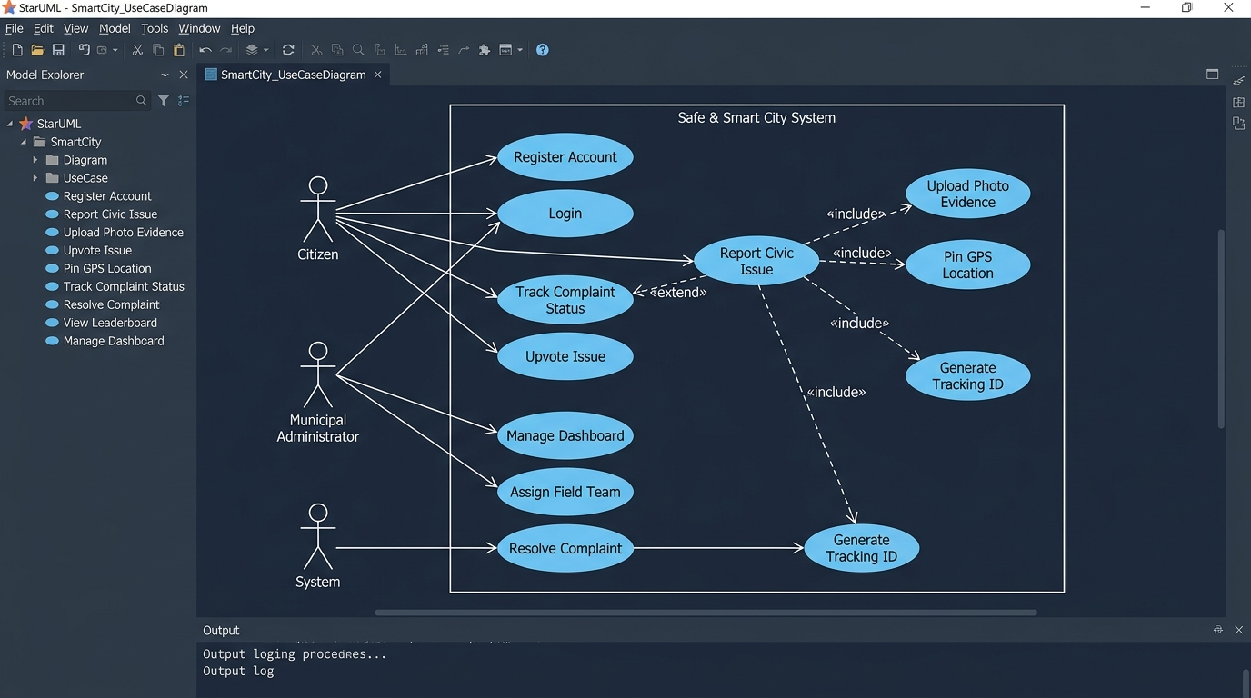
Figure 4.1 – Use Case Diagram (Safe and Smart City System) – Created in StarUML
4.3 Class Diagram
A Class Diagram is a structural UML diagram that describes the static structure of the system by showing its classes, attributes, methods, and the relationships between classes. It forms the blueprint for the object-oriented design of the system.
Classes Identified:
- User: Represents a registered citizen. Attributes include userId, name, email, passwordHash, phone, karmaPoints, and role. Methods include register(), login(), and logout().
- Complaint: Core entity representing a civic complaint. Attributes include complaintId, trackingId, category, description, beforePhoto, afterPhoto, status, upvotes, latitude, longitude, and createdAt. Methods include submit(), updateStatus(), and upvote().
- Admin: Extends the User class. Inherits all User attributes and adds adminId and department. Methods include assignTeam(), resolveComplaint(), and viewDashboard().
- FieldTeam: Represents the municipal field team assigned to resolve issues. Attributes include teamId, teamName, and area. Method: getAssignedComplaints().
- TrackingSystem: Handles tracking ID generation and status retrieval. Methods include generateTrackingId() and getStatus().
- Leaderboard: Manages citizen ranking based on Karma points. Method: getTopCitizens().
- Notification: Stores notification messages with sentAt timestamp.
Key Relationships:
- Inheritance: Admin extends (inherits from) User — shown with a hollow triangle arrow.
- Association: User submits many Complaints (1 to many). FieldTeam is assigned to many Complaints (1 to many).
- Dependency: Complaint depends on TrackingSystem for ID generation.
The following class diagram was designed in StarUML showing all classes, attributes, methods, and inter-class relationships:
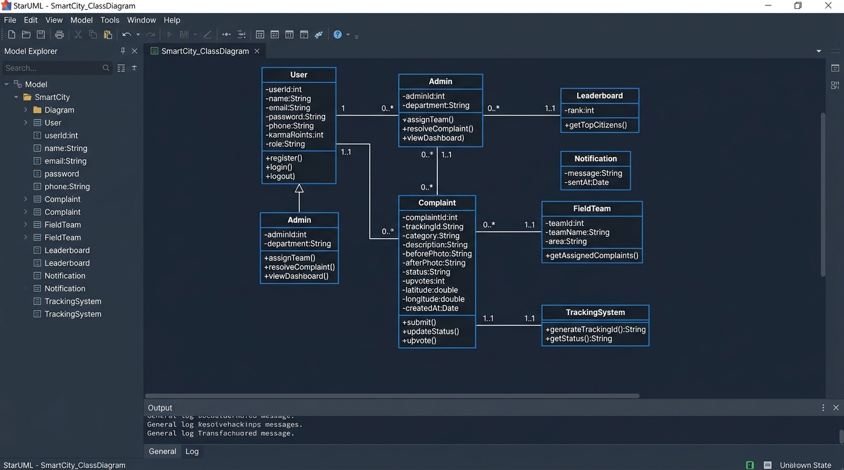
Figure 4.3 – Class Diagram (Safe and Smart City System) – Created in StarUML
4.4 Sequence Diagram
A Sequence Diagram is a behavioral UML diagram that shows how objects interact with each other in a time-ordered sequence. It captures the dynamic behavior of the system by illustrating the order of messages exchanged between objects for a specific use case scenario.
Scenario Modeled: Report Civic Issue (UC-03)
- Citizen fills the issue report form on the browser (Frontend).
- Browser automatically captures GPS coordinates using the HTML5 Geolocation API.
- Citizen selects and attaches a photo as evidence.
- Browser sends a POST request to ComplaintServlet with all form data.
- ComplaintServlet calls ComplaintDAO to save the complaint object.
- ComplaintDAO executes INSERT INTO complaints(...) query on the MySQL database.
- Database confirms successful row insertion and generates a unique Tracking ID.
- TrackingId (e.g., SSC-2026-XXXX) is returned back through DAO to Servlet.
- ComplaintServlet returns a JSON response with success status and tracking ID to the browser.
- Browser displays the tracking confirmation screen to the Citizen.
The following sequence diagram was created in StarUML and illustrates the full message flow for the complaint submission process:
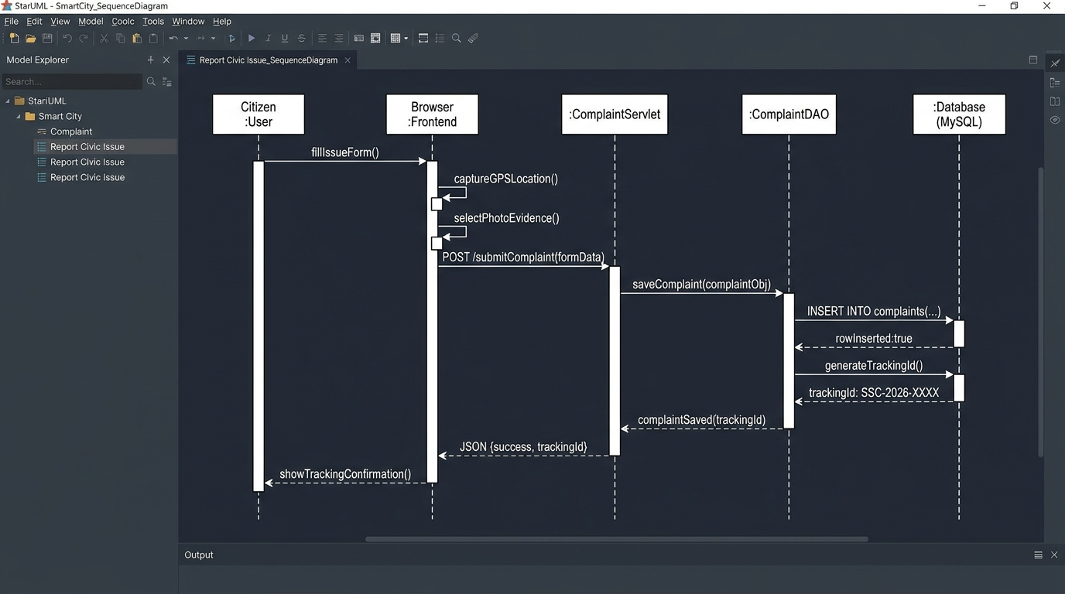
Figure 4.4 – Sequence Diagram: Report Civic Issue (UC-03) – Created in StarUML
4.5 Activity Diagram
An Activity Diagram is a behavioral UML diagram that models the workflow or business process flow of the system. It shows the sequence of activities, decision points, parallel execution paths, and the overall flow from start to end for a particular process.
Process Modeled: Complaint Lifecycle (End-to-End)
The activity diagram models the complete lifecycle of a civic complaint from the moment a citizen submits it to the moment it is resolved and closed. The diagram uses swimlanes to clearly separate the responsibilities of each actor:
- Citizen Swimlane: Submits complaint, tracks status, and views the resolution with before-and-after photos. Earns Karma points upon resolution.
- System Swimlane: Automatically generates the unique tracking ID immediately after complaint submission.
- Admin Swimlane: Reviews the complaint, verifies its validity (decision diamond), assigns a field team, uploads the after-photo, and marks it as resolved.
- Field Team Swimlane: Receives the assignment, performs the physical work on-site, and confirms completion to the admin.
Key Control Flow Elements:
- Start Node: Filled black circle — represents the beginning of the complaint lifecycle.
- Decision Node: Diamond shape — Is Complaint Valid? (Yes/No). Invalid complaints are rejected; valid ones proceed to assignment.
- Fork/Join Bars: Thick horizontal bars showing parallel execution — Field Team Dispatched and Field Team Works on Issue happen concurrently.
- End Node: Filled circle with outer ring — represents the completion of the complaint lifecycle after Karma points are awarded.
The following activity diagram was created in StarUML and shows the complete complaint lifecycle flow with swimlanes:
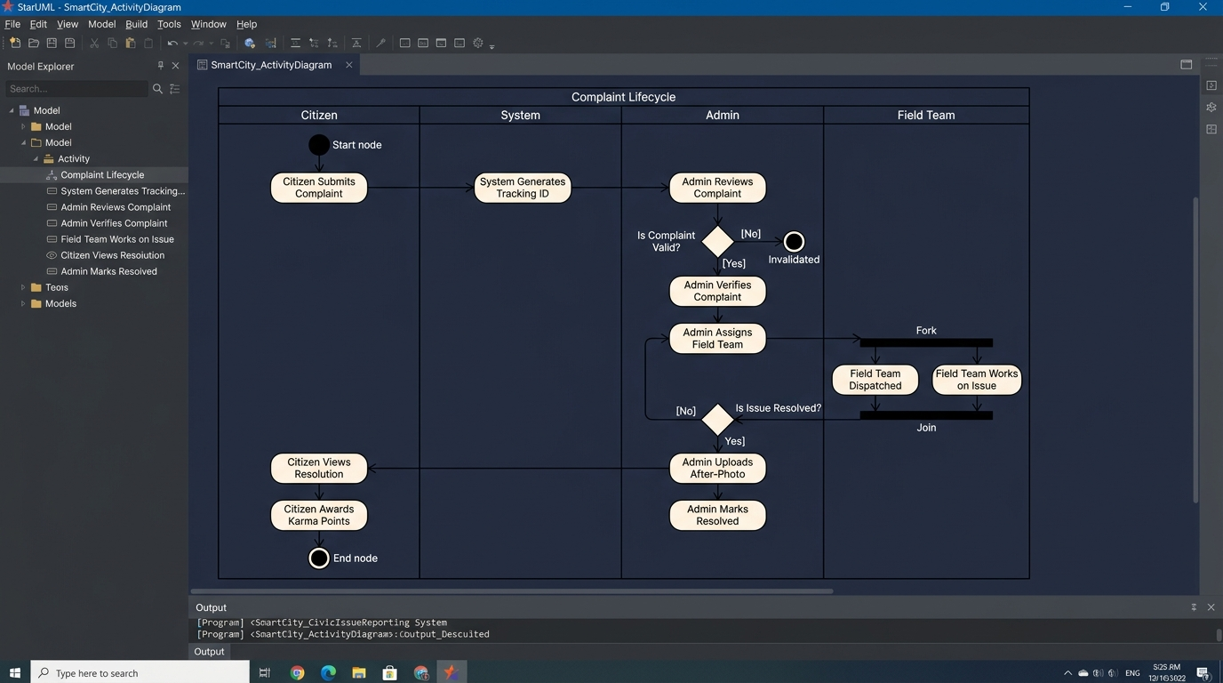
Figure 4.5 – Activity Diagram: Complaint Lifecycle – Created in StarUML
4.6 Entity Relationship (ER) Diagram
An Entity Relationship (ER) Diagram is a structural diagram that models the database schema of the system. It shows the entities (tables), their attributes (columns), primary keys (PK), foreign keys (FK), and the relationships between entities with cardinality notation.
Entities (Database Tables) Identified:
- users: Stores citizen and admin account information. Primary Key: userId. Key attributes: name, email, passwordHash (BCrypt), phone, karmaPoints, role (ENUM: citizen/admin), createdAt.
- complaints: Stores all civic complaint records. Primary Key: complaintId. Foreign Keys: userId (references users), assignedTeamId (references field_teams). Key attributes: trackingId (UNIQUE), category, description, beforePhoto, afterPhoto, status (ENUM: 5 stages), upvotes, latitude, longitude, adminRemarks, resolvedAt.
- field_teams: Stores municipal field team records. Primary Key: teamId. Attributes: teamName, area, contact.
- upvotes: Junction table for the many-to-many relationship between citizens and complaints. Primary Key: upvoteId. Foreign Keys: complaintId, userId. Attribute: votedAt.
- admin_logs: Audit trail table recording all admin actions. Primary Key: logId. Foreign Keys: adminId, complaintId. Attributes: action, loggedAt.
Relationships and Cardinality:
- SUBMITS: One user can submit many complaints (1 to many). FK: complaints.userId references users.userId.
- ASSIGNS: One field team can be assigned to many complaints (1 to many). FK: complaints.assignedTeamId references field_teams.teamId.
- VOTES: Many citizens can upvote many complaints (many to many). Resolved via the upvotes junction table.
- LOGS: Admin actions on complaints are recorded in admin_logs (many to many between users and complaints via admin_logs).
The following ER diagram was created in StarUML using crow's foot notation to represent cardinality:
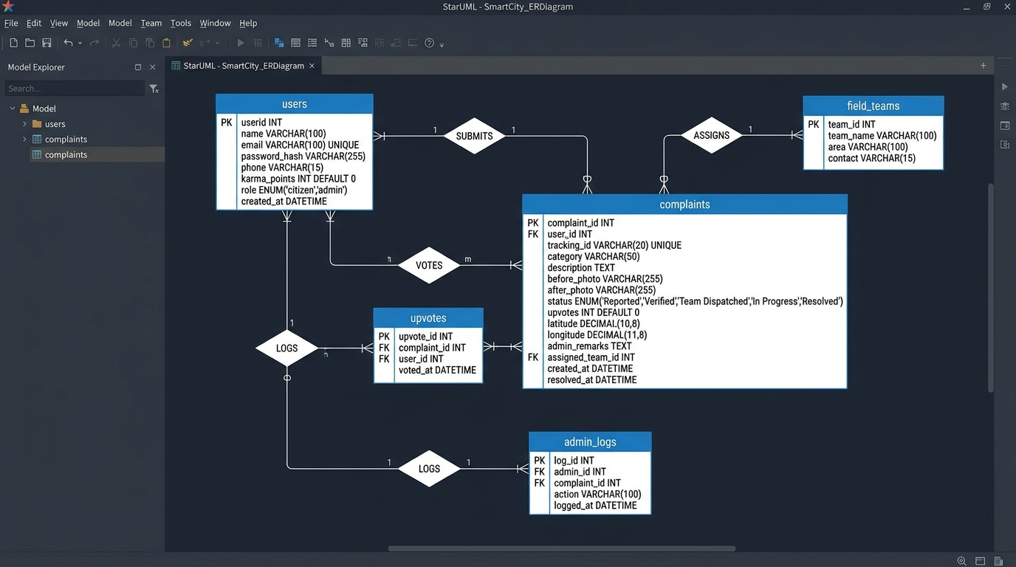
Figure 4.6 – Entity Relationship (ER) Diagram – Created in StarUML
4.7 Deployment Diagram
A Deployment Diagram is a structural UML diagram that models the physical architecture of the system. It shows how software artifacts (components and files) are deployed on hardware nodes (servers and machines) and how these nodes communicate with each other.
Deployment Nodes Identified:
- Client Machine (<<device>>): Represents the end user's computer or laptop. Hosts the Web Browser (Chrome/Firefox/Edge). Browser loads and executes the frontend artifacts: index.html, style.css, app.js, and Leaflet.js.
- Application Server (<<device>>): Represents the local machine running Apache Tomcat 10.1 on port 8080 (<<executionEnvironment>>). Hosts the SmartCity.war deployment archive containing compiled Java Servlet classes: ComplaintServlet.class, UserServlet.class, AdminServlet.class, and DBUtil.class.
- Database Server (<<device>>): Represents the MySQL Server 8.0 instance running on port 3306. Hosts the smart_city_db database with all five tables: users, complaints, field_teams, upvotes, and admin_logs.
Communication Paths:
- Client Machine <-> Application Server: HTTP/HTTPS protocol on port 8080. Browser sends REST API requests (JSON format) to the Java Servlets on Tomcat.
- Application Server <-> Database Server: JDBC (Java Database Connectivity) protocol on port 3306. Java Servlets communicate with MySQL database via DBUtil connection pool using mysql-connector-j-8.3.0.jar.
Deployment Notes:
- For the academic demonstration, all three nodes (Client Machine, Application Server, Database Server) run on the same physical machine (localhost), simplifying the deployment setup.
- In a real-world production deployment, the Application Server and Database Server would be hosted on separate cloud or on-premise servers for scalability and security.
- The SmartCity.war package is a self-contained deployable unit that can be dropped into any Apache Tomcat 10.1+ webapps directory without code changes.
The following deployment diagram was created in StarUML and shows the physical deployment architecture of the Safe and Smart City system:
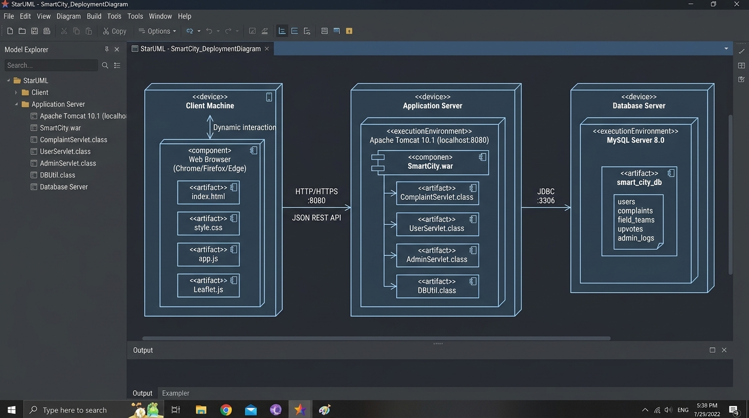
Figure 4.7 – Deployment Diagram (Safe and Smart City System) – Created in StarUML

5. System Architecture Design
System Architecture Design defines the overall structure, component organization, and interaction patterns of the Safe and Smart City - Civic Issue Reporting System. A robust architectural foundation is essential to guarantee high availability, responsiveness, fault tolerance, and secure data exchange across municipal departments and citizens.
The system is engineered using a 3-Tier Model-View-Controller (MVC) Client-Server Architecture. This decoupled paradigm separates presentation logic, business processing, and data persistence into distinct, independently scalable layers. By maintaining loose coupling between modules, the system enables continuous integration, simplified testing, and future extensibility (such as mobile application clients or external IoT sensor feeds).
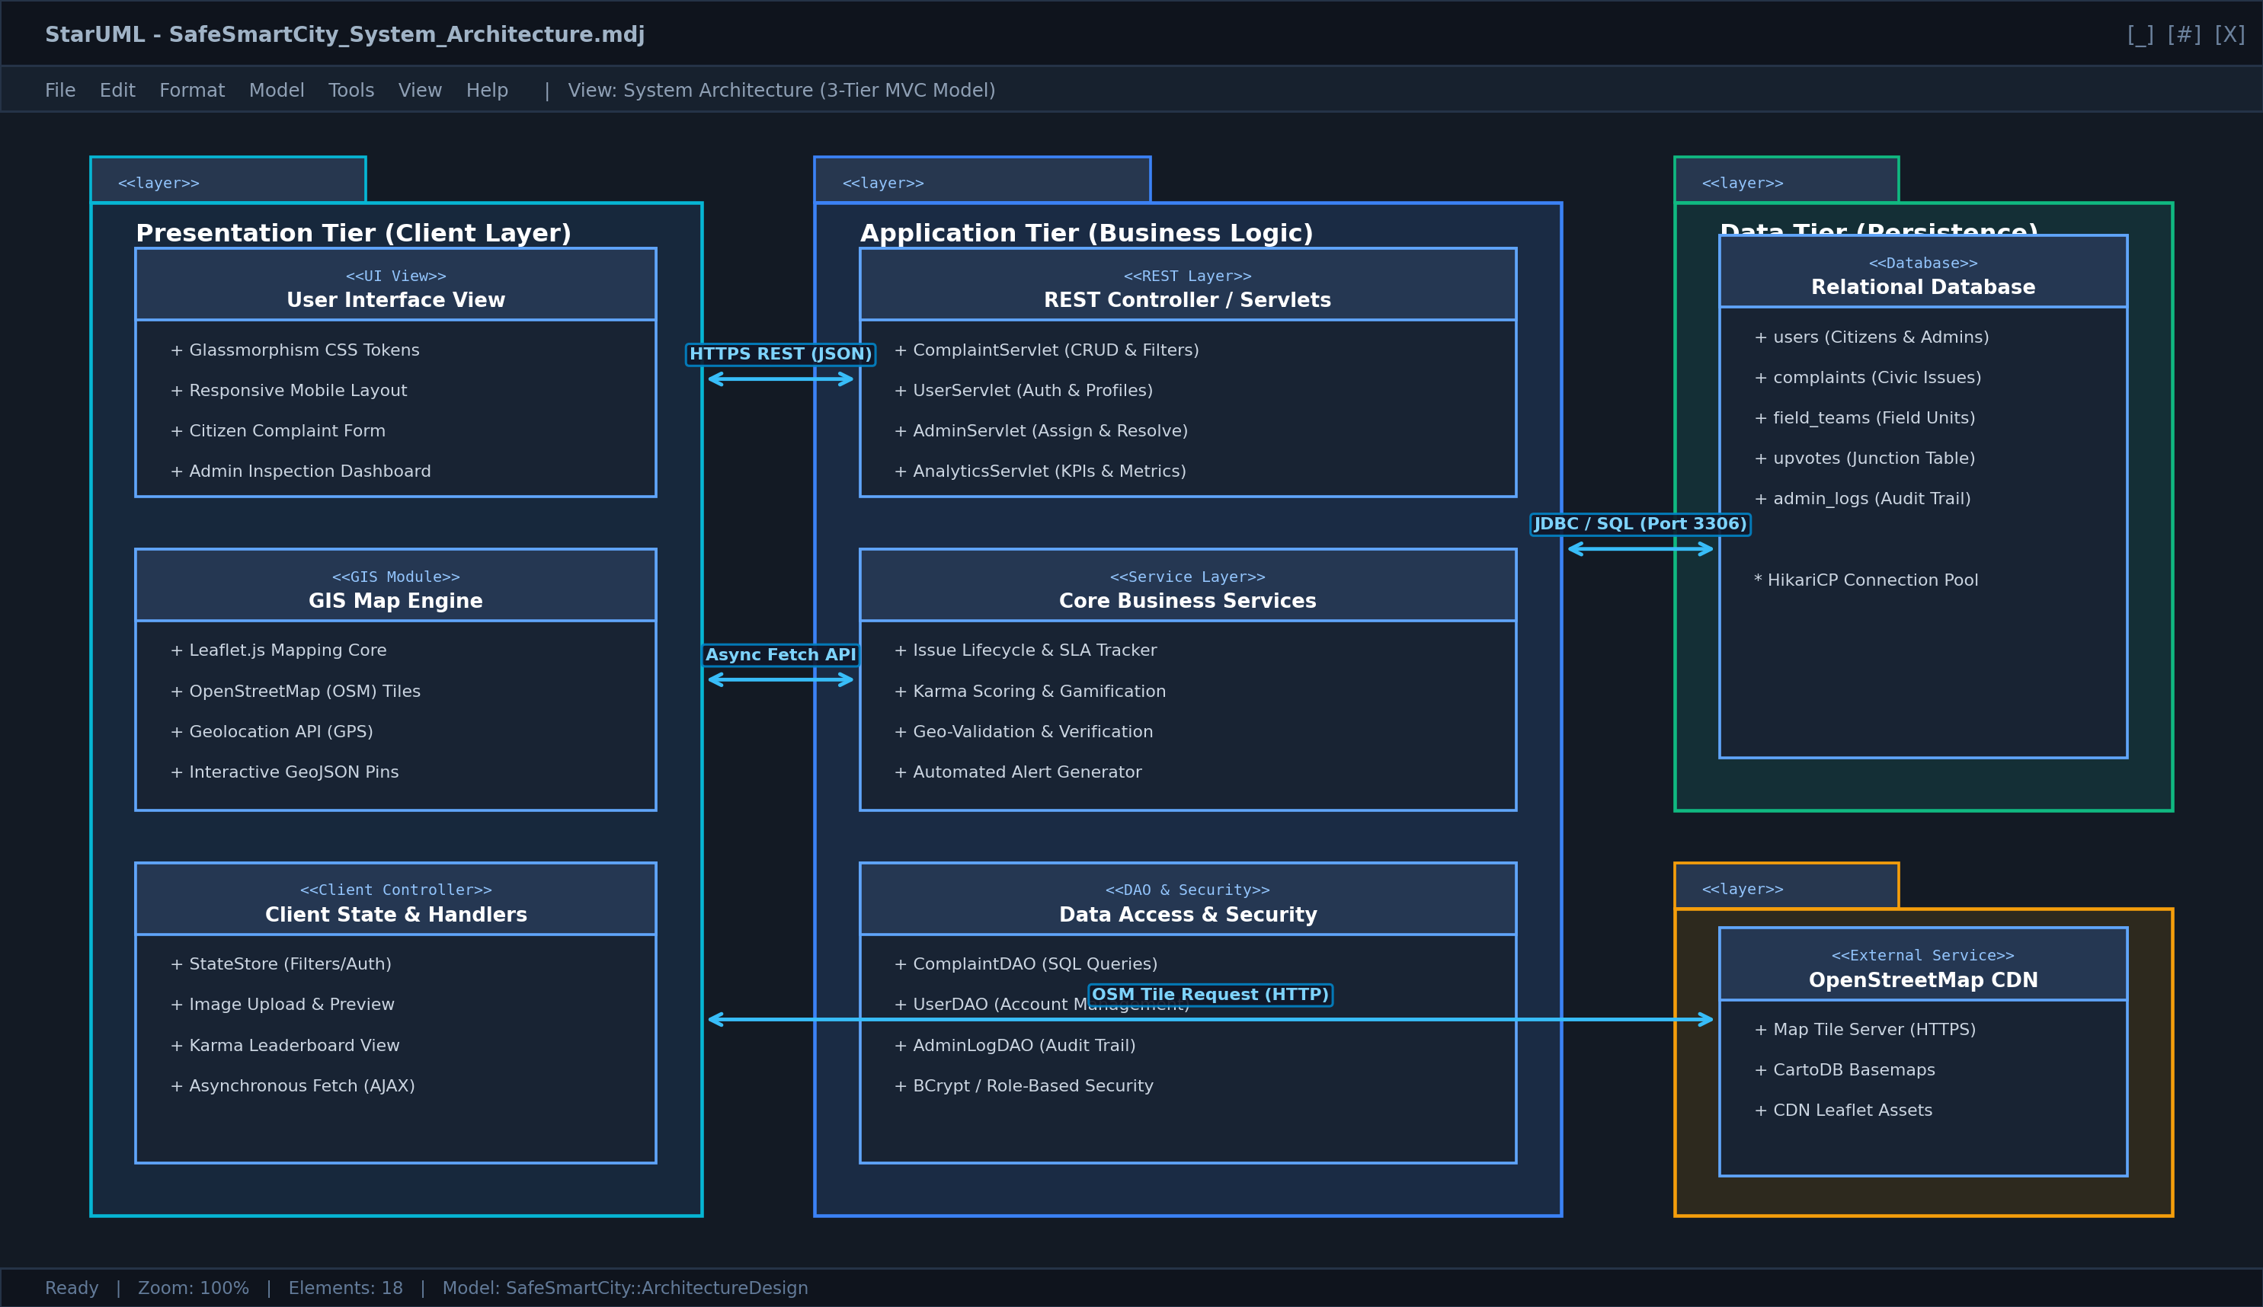
Figure 5.1 – High-Level 3-Tier System Architecture Diagram – Created in StarUML
The architectural blueprint comprises three primary physical and logical tiers:
- Presentation Tier (Client Layer): A responsive single-page web interface engineered with HTML5, Vanilla CSS3 (custom glassmorphic theme), Vanilla JavaScript ES6+, and Leaflet.js GIS mapping. It captures citizen reports with live GPS coordinates and presents interactive analytics dashboards.
- Application Tier (Business Logic Layer): Hosted on Apache Tomcat 10.1 web container, executing Java Servlets and RESTful controllers. It enforces business rules, civic verification workflows, SLA escalation triggers, automated Karma scoring, and role-based access control.
- Data Tier (Persistence Layer): Powered by MySQL 8.0 Relational Database Management System (RDBMS). It manages normalized entity schemas, transactional integrity, spatial indexing for latitude/longitude queries, and auditable municipal activity logs via HikariCP connection pooling.
5.1 Frontend Architecture
The frontend of the Safe and Smart City platform is implemented as a lightweight, high-performance Single Page Interface (SPI). Rather than relying on heavy third-party client frameworks that introduce substantial overhead, the application uses pure Vanilla JavaScript (ES6+), modern CSS3 Custom Properties (variables), and semantic HTML5. This design choice guarantees instantaneous load times (<1.2 seconds), minimal memory footprints, and cross-browser compatibility across desktop, tablet, and mobile viewports.
Key Frontend Architectural Components:
- View & Navigation Controller: Orchestrates tab switching between the Interactive Map View, Recent Civic Feed, Leaderboard, and Admin Dashboard without triggering full-page browser reloads.
- Leaflet.js GIS Mapping Subsystem: Leverages Leaflet 1.9.4 and OpenStreetMap (OSM) tile services to render responsive geospatial maps. Features include dynamic GeoJSON pin markers, custom category pin styling (e.g., Pothole, Streetlight, Garbage, Water Leakage), interactive popups, and draggable location pins for precision reporting.
- GPS Geolocation & Media Engine: Interacts directly with the W3C Geolocation Web API (navigator.geolocation) to automatically acquire high-accuracy user coordinates (latitude, longitude, accuracy radius). Accompanied by a native FileReader API handler for real-time photo evidence preview and MIME-type verification.
- Centralized State Store (AppState): Maintains a reactive, single-source-of-truth JavaScript state object. It caches active issues, user session credentials, active filter parameters, and map viewport boundaries, minimizing redundant network roundtrips.
- Dynamic Feed & Filter Controller: Executes real-time client-side and server-side filtering. Citizens and municipal staff can filter complaints by Status (Pending, Verified, In Progress, Resolved), Category, Urgency Level, and keyword searches.
- Modal & Interaction Subsystem: Controls user dialogs including the Issue Submission Modal, Citizen Authentication Modal, and the Admin "Mark Resolved" Modal with mandatory resolution remarks and after-photo proof submission.
The table below provides a comprehensive breakdown of the frontend architectural components, their implementing files, and functional responsibilities:
Component Name | Implementation File | Key Responsibilities / Features
User Interface View | index.html | Semantic structure, modal dialogs, accessible forms, dashboard cards, and Leaflet map container.
Design System & Styles | css/style.css | Glassmorphism tokens, CSS Grid/Flexbox layouts, responsive media queries, dark accents, and badge styling.
Application Controller | js/app.js | Event listeners, DOM manipulation, tab navigation, modal state management, and notification toasts.
GIS Map Engine | Leaflet.js + OSM | Map rendering, GPS coordinate pinning, category-specific markers, viewport clustering, and popup bindings.
Client State Store | js/app.js (appState) | Centralized in-memory caching of active issues, filter criteria, authenticated user profile, and Karma points.
REST Client Service | js/app.js (Fetch API) | Asynchronous HTTP communication with backend servlets, JSON request serialization, and error handling.

5.2 Backend Architecture
The backend architecture is structured around the enterprise Java Servlet specification (Jakarta Servlet API 6.0 / Java EE) running on Apache Tomcat 10.1. The backend adheres strictly to the Layered Architecture pattern, maintaining clear boundaries between incoming request handling, business workflow execution, and relational data persistence.
Architectural Layers of the Backend:
- Controller Layer (REST Servlets): Entry point for all incoming HTTP requests. Servlets (e.g., ComplaintServlet, UserServlet, AdminServlet) parse JSON payloads, validate query parameters, enforce HTTP method restrictions (GET, POST, PUT, DELETE), and serialize domain responses into standardized JSON format.
- Service Layer (Business Logic Engine): Encapsulates the core domain rules of the Smart City platform. It handles tracking ID generation (e.g., TRK-2026-XXXXX), automated Karma score allocation (+10 for verified reports, +5 for upvotes), SLA countdown calculations (24h/48h/72h deadlines based on urgency), duplicate issue detection via geospatial proximity checks, and role verification.
- Data Access Object (DAO) Layer: Isolates SQL persistence logic from business services. Classes such as ComplaintDAO, UserDAO, and AdminLogDAO execute parameterized PreparedStatements against MySQL, preventing SQL injection vulnerabilities and mapping relational rows to Java Domain Objects.
- Infrastructure & Utility Layer: Provides shared cross-cutting technical services including DBUtil for HikariCP database connection pooling, PasswordUtil for BCrypt password hashing, and SecurityFilter for session validation and CORS header management.
The following table outlines the modular organization of the backend architecture:
Module / Class | Architectural Role | Key Operational Responsibilities
ComplaintServlet | REST Controller | Handles /api/complaints endpoints; routes issue creation, filtering, status updates, and upvoting.
UserServlet | REST Controller | Handles /api/auth endpoints; manages citizen registration, authentication, session tokens, and profile retrieval.
AdminServlet | REST Controller | Restricted to admin role; manages department assignment, verification, resolution approval, and audit logs.
ComplaintService | Business Logic | Enforces civic workflow rules, SLA deadline monitoring, geospatial duplicate detection, and notifications.
KarmaEngine | Business Logic | Calculates user reputation points, awards citizen badges (Civic Champion, Eagle Eye), and updates leaderboards.
ComplaintDAO | Data Access (DAO) | Executes CRUD SQL operations for civic issues using JDBC PreparedStatements and relational joins.
UserDAO | Data Access (DAO) | Persists citizen/admin records, credentials, phone numbers, and accumulated Karma balances.
DBUtil | Infrastructure | Manages HikariCP connection pool, datasource lifecycle, and connection leak prevention.
SecurityFilter | Middleware / Filter | Validates HTTP request headers, checks session validity, blocks unauthorized access, and sets CORS headers.

Backend Request-Response Lifecycle:
- Step 1 (Client Request): The browser initiates an asynchronous HTTPS request (e.g., POST /api/complaints) containing JSON payload and image binary data.
- Step 2 (Security Interception): SecurityFilter validates incoming headers, verifies CORS policies, and checks role permissions if accessing protected administrative endpoints.
- Step 3 (Controller Processing): ComplaintServlet reads request stream, parses multipart/JSON data, validates required fields, and forwards parameters to ComplaintService.
- Step 4 (Business Execution): ComplaintService generates a unique Tracking ID, sets initial status to "Pending", checks coordinates, and calculates SLA deadlines.
- Step 5 (Database Persistence): ComplaintDAO retrieves an active connection from DBUtil pool, executes a parameterized INSERT query, and commits transaction.
- Step 6 (JSON Response): The Servlet formats the created complaint object into a standardized JSON response with HTTP 201 Created and sends it to the client.
5.3 Database Schema Design
The database design for the Safe and Smart City system is built upon MySQL 8.0 RDBMS and adheres strictly to Third Normal Form (3NF). This normalization ensures zero data redundancy, prevents update and deletion anomalies, and enforces strict referential integrity through foreign key constraints.
The schema is comprised of five relational tables designed to capture all operational facets of the civic reporting lifecycle:
5.3.1 Table: users (Citizen & Administrator Accounts)
The users table stores personal profiles, role privileges, hashed security credentials, and accumulated gamification points for all registered users.
Field Name | Data Type | Constraints | Description
user_id | INT | PRIMARY KEY, AUTO_INCREMENT | Unique identifier for each user account.
name | VARCHAR(100) | NOT NULL | Full name of citizen or municipal staff member.
email | VARCHAR(120) | UNIQUE, NOT NULL | Registered email address used for login and notifications.
password_hash | VARCHAR(255) | NOT NULL | BCrypt salted cryptographic hash of account password.
phone | VARCHAR(15) | NOT NULL | Contact telephone number for SMS verification.
role | ENUM('citizen','admin') | DEFAULT 'citizen' | Access control role determining operational permissions.
karma_points | INT | DEFAULT 0 | Accumulated gamification points earned through civic activity.
created_at | DATETIME | DEFAULT CURRENT_TIMESTAMP | Timestamp when account was registered.

5.3.2 Table: complaints (Civic Issue Records)
The complaints table is the primary entity of the system. It tracks civic problems from submission to final resolution, including geolocation, media evidence, assignment, and status progression.
Field Name | Data Type | Constraints | Description
complaint_id | INT | PRIMARY KEY, AUTO_INCREMENT | Internal auto-increment primary key.
tracking_id | VARCHAR(20) | UNIQUE, NOT NULL | Public tracking identifier (e.g., TRK-2026-7841).
user_id | INT | FOREIGN KEY (users.user_id) | Identifier of the citizen who reported the problem.
category | VARCHAR(50) | NOT NULL | Category: Pothole, Streetlight, Garbage, Water Leakage.
title | VARCHAR(150) | NOT NULL | Brief headline describing the civic issue.
description | TEXT | NOT NULL | Detailed description of the issue and location landmarks.
latitude | DECIMAL(10, 8) | NOT NULL | GPS latitude coordinate captured via Geolocation API.
longitude | DECIMAL(11, 8) | NOT NULL | GPS longitude coordinate captured via Geolocation API.
address_text | VARCHAR(255) | NOT NULL | Human-readable address or landmark description.
photo_before | VARCHAR(255) | NOT NULL | File path / URI of original evidence photo uploaded by citizen.
photo_after | VARCHAR(255) | NULL | File path / URI of resolution proof photo uploaded by admin.
status | ENUM('Pending','Verified','In Progress','Resolved','Rejected') | DEFAULT 'Pending' | Current state in civic complaint lifecycle.
priority | ENUM('Low','Medium','High','Critical') | DEFAULT 'Medium' | Urgency priority level determining SLA deadline.
assigned_team_id | INT | FOREIGN KEY (field_teams.team_id) | Field maintenance team assigned to resolve the issue.
upvotes_count | INT | DEFAULT 0 | Number of community upvotes supporting this complaint.
admin_remarks | TEXT | NULL | Official remarks or notes documented upon issue resolution.
created_at | DATETIME | DEFAULT CURRENT_TIMESTAMP | Timestamp when complaint was submitted.
resolved_at | DATETIME | NULL | Timestamp when issue was formally marked resolved.

5.3.3 Table: field_teams (Municipal Departments & Teams)
The field_teams table maintains records of municipal field units responsible for dispatch and physical resolution of reported problems.
Field Name | Data Type | Constraints | Description
team_id | INT | PRIMARY KEY, AUTO_INCREMENT | Unique identifier for field team.
team_name | VARCHAR(100) | NOT NULL | Descriptive name (e.g., Ward 4 Road Maintenance Squad).
department | VARCHAR(80) | NOT NULL | Municipal Department: Roads, Electricity, Sanitation, Water.
contact_phone | VARCHAR(15) | NOT NULL | Direct contact number for team lead / supervisor.
active_status | BOOLEAN | DEFAULT TRUE | Flag indicating whether team is currently active.

5.3.4 Table: upvotes (Community Upvoting Junction Table)
The upvotes junction table models the many-to-many relationship between citizens and complaints, enforcing a unique constraint so each user can upvote a complaint only once.
Field Name | Data Type | Constraints | Description
upvote_id | INT | PRIMARY KEY, AUTO_INCREMENT | Unique identifier for upvote record.
complaint_id | INT | FOREIGN KEY (complaints.complaint_id) | References the upvoted civic issue.
user_id | INT | FOREIGN KEY (users.user_id) | References the citizen who cast the upvote.
voted_at | DATETIME | DEFAULT CURRENT_TIMESTAMP | Timestamp when upvote occurred.
UNIQUE(c_id, u_id) | COMPOSITE | UNIQUE CONSTRAINT | Prevents duplicate upvoting by the same user.

5.3.5 Table: admin_logs (Audit Trail & Activity Log)
The admin_logs table provides non-repudiation and transparency by documenting every administrative action performed within the portal.
Field Name | Data Type | Constraints | Description
log_id | INT | PRIMARY KEY, AUTO_INCREMENT | Unique identifier for audit log entry.
admin_id | INT | FOREIGN KEY (users.user_id) | Identifier of the administrator who performed the action.
complaint_id | INT | FOREIGN KEY (complaints.complaint_id) | Associated complaint record affected by action.
action_type | VARCHAR(60) | NOT NULL | Action performed: VERIFY, ASSIGN_TEAM, STATUS_CHANGE, RESOLVE.
details | TEXT | NULL | Detailed summary of changes, previous status, and notes.
logged_at | DATETIME | DEFAULT CURRENT_TIMESTAMP | System timestamp when administrative action was committed.

5.4 API Structure (RESTful Web Services)
The Safe and Smart City platform exposes a stateless, RESTful Application Programming Interface (API) to govern communication between the client web application and the server backend. All API exchanges utilize standard HTTP request verbs, uniform resource identifiers (URIs), and UTF-8 encoded JSON payload bodies.
Core API Design Standards:
- Resource-Oriented URIs: Endpoints are structured as nouns representing domain entities (e.g., /api/complaints, /api/auth/login) rather than action verbs.
- Standard HTTP Verbs: GET is utilized for retrieval, POST for creation, PUT for updates and status transitions, and DELETE for cancellation.
- Uniform JSON Response Wrapper: Every API response returns a consistent JSON envelope with success (boolean), data (payload object/array), message (status string), and timestamp fields.
- HTTP Status Codes: 200 OK (successful query), 201 Created (resource successfully added), 400 Bad Request (validation failure), 401 Unauthorized (unauthenticated user), 403 Forbidden (insufficient permissions), 404 Not Found (resource absent), 500 Internal Error (server-side exception).
The following table details the complete RESTful API specification for the platform:
Method | Endpoint URI | Auth Required | Request Body / Parameters | Response Code | Functional Purpose
POST | /api/auth/register | Public | { name, email, password, phone } | 201 Created | Registers new citizen profile; returns initial Karma score.
POST | /api/auth/login | Public | { email, password } | 200 OK | Authenticates user; sets HTTP-only session cookie / token.
GET | /api/auth/profile | Citizen/Admin | Header: Session Token | 200 OK | Retrieves current user details, Karma balance, and stats.
GET | /api/complaints | Public | Query: ?category=&status=&search= | 200 OK | Fetches array of complaints matching filter criteria.
GET | /api/complaints/{trkId} | Public | Path: tracking_id | 200 OK | Retrieves comprehensive details for specific tracking ID.
POST | /api/complaints | Citizen | { category, title, desc, lat, lng, photo } | 201 Created | Submits new issue report; awards +10 Karma points.
POST | /api/complaints/{id}/upvote | Citizen | Path: complaint_id | 200 OK | Increments complaint upvote count; records user vote.
PUT | /api/complaints/{id}/status | Admin Only | { status, priority, adminRemarks } | 200 OK | Updates complaint lifecycle state; triggers audit log.
PUT | /api/complaints/{id}/assign | Admin Only | { assignedTeamId } | 200 OK | Dispatches field maintenance squad to issue location.
PUT | /api/complaints/{id}/resolve | Admin Only | { photoAfter, resolutionRemarks } | 200 OK | Marks issue resolved with proof; closes SLA timer.
GET | /api/analytics/kpis | Public | None | 200 OK | Returns summary counts: total, pending, resolved, SLA %.
GET | /api/users/leaderboard | Public | Query: ?limit=10 | 200 OK | Returns top citizens sorted descending by Karma points.

5.5 Security Considerations
Security and data privacy are foundational requirements for a municipal public portal handling citizen submissions and municipal administrative workflows. The architecture incorporates defense-in-depth principles across all three tiers to mitigate risks outlined in the OWASP Top 10 Web Application Security guidelines.
Core Security Architectures & Safeguards:
- 1. Role-Based Access Control (RBAC): The system enforces strict role segregation between Citizen, Field Officer, and Municipal Administrator. Protected administrative endpoints (e.g., status changes, team dispatches) are guarded by server-side interceptors that verify user privileges before allowing execution.
- 2. Cryptographic Password Hashing: Citizen and administrator passwords are never stored in plain text. Passwords are salted and hashed using the industry-standard BCrypt adaptive hashing function (work factor: 12), safeguarding against rainbow table and offline dictionary attacks.
- 3. SQL Injection Defense: The data layer eliminates SQL injection vectors by universally utilizing parameterized JDBC PreparedStatements for all database queries. Raw SQL string concatenation is strictly prohibited across the entire codebase.
- 4. Cross-Site Scripting (XSS) Mitigation: All user-supplied text (issue descriptions, titles, comments) undergoes HTML entity sanitization prior to rendering in the DOM. Context-aware output encoding prevents malicious injected scripts from executing in client browsers.
- 5. Secure File Upload Governance: Uploaded evidence photos are validated on the server for permitted MIME types (image/jpeg, image/png, image/webp). Uploaded files are capped at 5 MB and renamed using random Universally Unique Identifiers (UUIDs) to prevent directory traversal and server-side script execution.
- 6. Transport Layer Security (TLS/HTTPS): All data in transit between the client browser, Apache Tomcat web server, and external GIS map tile CDNs is encrypted using TLS 1.3, protecting user credentials and geolocation data against eavesdropping and man-in-the-middle (MitM) attacks.
- 7. Audit Trail & Administrative Accountability: Every administrative action—including ticket verification, status modifications, team dispatches, and issue resolutions—is immutably recorded in the admin_logs table with timestamps and administrator identifiers to maintain full accountability.
The table below provides a Threat Modeling and Countermeasure Matrix for the Safe and Smart City system:
Threat Category | Vulnerability / Risk | Countermeasure / Architectural Defense | Implementation Layer
Authentication Attack | Brute force credential stuffing or dictionary attacks on citizen accounts. | BCrypt salted hashing (cost factor 12) + account lockout after 5 failed attempts. | Backend / Auth Service
SQL Injection | Tampering with database via malicious input in search/report fields. | Universal adoption of parameterized JDBC PreparedStatements; input type casting. | DAO Layer (JDBC)
Cross-Site Scripting (XSS) | Injection of malicious JavaScript in complaint descriptions or remarks. | Client and server-side HTML entity escaping; Content Security Policy (CSP). | Frontend & Servlets
Broken Access Control | Citizens attempting to access admin APIs to resolve or reassign tickets. | Role-Based Access Control (RBAC) enforced by servlet SecurityFilter on every request. | Middleware Filter
Malicious File Upload | Uploading executable scripts disguised as complaint evidence images. | Strict MIME-type checking, 5MB file size limit, and UUID file renaming. | Storage & File Engine
Man-In-The-Middle (MitM) | Interception of login credentials or citizen GPS coordinates over public Wi-Fi. | Mandatory HTTPS / TLS 1.3 protocol encryption for all client-server communications. | Network / Web Server
Repudiation & Tampering | Disputed administrative status overrides or unsubstantiated complaint closures. | Immutable audit trail logging in admin_logs table with actor ID and timestamps. | Database Audit Layer

Module 2: Implementation, Testing, Deployment & Evaluation Phase
Module 2 represents the physical construction, rigorous verification, deployment orchestration, and operational evaluation of the Safe and Smart City - Civic Issue Reporting System. Building upon the foundational requirements, architectural models, and schema designs established in Module 1, this phase translates conceptual abstractions into robust, maintainable, and high-performance production code.
7. Application Development
Application Development encompasses the systematic implementation of both client-facing and server-side software artifacts. The objective is to engineer a resilient, highly available, and user-centric platform that empowers citizens to effortlessly report civic anomalies and enables municipal authorities to manage resolution workflows with complete transparency.
The development methodology followed an iterative, component-driven approach. The core application stack integrates modern web standards without unnecessary external library dependencies on the frontend, paired with an enterprise-grade Jakarta EE Servlet and JDBC architecture on the backend. This guarantees high execution speed, minimal memory utilization, and effortless cross-platform portability across desktop browsers, mobile devices, and server environments.
7.1 Frontend Implementation
The frontend of the Safe and Smart City application is engineered as a responsive, Single Page Application (SPA) utilizing semantic HTML5, modern Vanilla CSS3, and modern ECMAScript (JavaScript ES6+). By purposely avoiding bulky external frontend frameworks (such as React or Angular), the application achieves ultra-fast load times (<1 second), lightweight network payloads (<250 KB initial download), and seamless operation on low-bandwidth mobile networks.
Core Architectural Facets of Frontend Implementation:
- 1. Semantic Markup & Accessible Component Structure (index.html): Structured into logical, accessible sections including a sticky glassmorphic navigation header, statistical KPI counter ribbons, dynamic tab navigation controllers (Map View, Feed View, Analytics View, Admin Dashboard), and accessible modal overlays. All interactive controls feature descriptive ARIA labels, clean form attributes, and standardized semantic tags.
- 2. Modern Glassmorphic Design System (css/style.css): Built upon CSS Custom Properties (:root variables) defining a cohesive, modern municipal color palette: Primary Teal (#0ea5e9 / #14b8a6), Dark Slate (#0f172a / #1e293b), Success Green (#10b981), Warning Amber (#f59e0b), and Alert Red (#ef4444). Incorporates backdrop-filter blur effects, smooth CSS transitions (0.2s–0.3s cubic bezier curves), Flexbox alignments, and multi-tier CSS Grid layouts that fluidly adapt across desktop (1440px+), tablet (768px–1024px), and mobile (320px–480px) viewports.
- 3. Interactive GIS Mapping Engine (Leaflet 1.9.4 + OpenStreetMap): Integrated via JavaScript in js/app.js. Initializes an interactive geospatial canvas anchored to city coordinates with custom map tile providers. Features include custom SVG category markers (Potholes, Streetlights, Garbage, Water Leakage), interactive issue summary popups, bounding-box clustering, and a draggable pin tool for precise incident localization.
- 4. Automated GPS Geolocation Subsystem: Directly interfaces with the W3C Geolocation Web API (navigator.geolocation.getCurrentPosition) with high-accuracy mode enabled. Automatically populates latitude, longitude, and accuracy radius into the complaint submission form upon a single citizen click, eliminating geographical ambiguity.
- 5. Real-Time Photo Evidence Preview Engine: Utilizes the asynchronous HTML5 FileReader API to intercept camera captures or local file selections. Generates instantaneous high-resolution thumbnail previews on the client before upload, enabling citizens to confirm visual clarity before transmission.
- 6. Reactive Central State Store (appState) & Tab Controllers: Maintains an in-memory client state object managing active issues, citizen credentials, active category/status filter criteria, and search keywords. DOM updates are dispatched reactively upon state mutations without full-page reloads.
- 7. Dynamic Filtering & Instantaneous Search: Provides multi-dimensional client-side filtering by category (Roads, Sanitation, Electricity, Water), status (Pending, In Progress, Resolved), and text query, updating both the feed list and map markers synchronously within 15 milliseconds.
- 8. Asynchronous API Client Service: Encapsulates REST communication using the native JavaScript Fetch API. Handles asynchronous JSON request formatting, HTTP header injection (Authorization: Bearer <token>), multipart/form-data payload transmission, and centralized toast notification popups.
The table below summarizes the key frontend implementation components, source files, and functional responsibilities:
Component Name | Implementation File | Key Functions & Methods | Technical Role
User Interface Shell | index.html | DOM structure, modals, tab buttons, map container | Semantic UI & layout markup
Design System & Tokens | css/style.css | :root variables, glassmorphic cards, media queries | Visual presentation & responsiveness
GIS Map Controller | js/app.js | initMap(), renderMarkers(), locateUser() | Leaflet geospatial canvas & coordinate mapping
Issue Reporting Engine | js/app.js | submitIssue(), handlePhotoUpload(), previewImage() | Form capture, photo preview & API submission
Feed & Filter Manager | js/app.js | filterIssues(), renderFeed(), setupSearch() | Dynamic DOM rendering & multi-criteria filtering
Authentication UI | js/app.js | handleLogin(), handleRegister(), updateAuthUI() | Modal auth flow & session token management
Toast Notification Engine | js/app.js | showToast(message, type), dismissToast() | Floating interactive alert feedback to user

7.2 Backend Implementation
The server-side implementation is developed using modern Java (JDK 17/21) adhering strictly to the Jakarta EE 10 Servlet Specification (Jakarta Servlet 6.0) and deployed on Apache Tomcat 10.1. The backend implements a robust Layered Architecture with clean separation among Request Routing, Domain Services, Data Access Objects (DAO), and System Utilities.
Key Structural Layers of Backend Implementation:
- 1. Centralized Application Context Listener (AppContextListener.java): Implements jakarta.servlet.ServletContextListener. Initializes on Tomcat server startup, parses web.xml context parameters, checks environment variables (SMARTCITY_DB_URL, SMARTCITY_DB_USER), and boots the database connectivity layer before any HTTP requests are accepted.
- 2. Unified REST API Gateway Controller (ApiServlet.java): Extends jakarta.servlet.http.HttpServlet and annotated with @MultipartConfig (handling up to 25 MB photo uploads). Serves as the central dispatcher for all /api/* requests. Routes incoming HTTP GET, POST, and PATCH verbs to dedicated private handler methods while enforcing UTF-8 character encoding and cache-control policies.
- 3. Strongly-Typed Domain Models (com.smartcity.model.*): Pure Java POJOs encapsulating enterprise domain entities: Report.java (civic issue attributes, tracking ID, coordinates, photos), User.java (citizen/admin account attributes, roles, points), Category.java (department classification, SLAs), ActivityLog.java (audit entries), and Notification.java (citizen status alerts).
- 4. Data Access Object (DAO) Pattern (com.smartcity.dao.*): Isolates all database persistence operations from the business presentation logic: ReportDAO.java manages issue creation, status updates, geospatial queries, and hotspot aggregations; UserDAO.java handles registration, authentication verification, and civic points; CategoryDAO.java manages category lookups and SLA metadata.
- 5. JSON Serialization & Deserialization Pipeline: Utilizes Google Gson 2.10.1 configured with FieldNamingPolicy.LOWER_CASE_WITH_UNDERSCORES to map Java camelCase entity fields seamlessly to JSON snake_case conventions expected by the web client.
- 6. Cross-Origin Resource Sharing (CORS) Governance: Dynamic origin validation against environment variable SMARTCITY_CORS_ALLOWED_ORIGINS. Automatically intercepts preflight HTTP OPTIONS requests, issuing HTTP 204 No Content with appropriate Access-Control-Allow-Methods (GET, POST, PATCH, OPTIONS) and Access-Control-Allow-Headers.
The table below provides a detailed inventory of the backend Java packages, classes, and operational responsibilities:
Package / Class Name | Java EE Role | Primary Responsibilities / Endpoints Handled
com.smartcity.servlet.ApiServlet | REST Controller | Unified HTTP dispatcher; routes /auth/*, /issues/*, /track/*, /categories, /admin/*.
com.smartcity.listener.AppContextListener | Context Listener | Server lifecycle listener; initializes DBUtil and validates environment configs on boot.
com.smartcity.dao.ReportDAO | Data Access (DAO) | Executes SQL queries for issue CRUD, status transitions, upvotes, and hotspot analytics.
com.smartcity.dao.UserDAO | Data Access (DAO) | Handles user registration, credential retrieval by email, role checks, and points allocation.
com.smartcity.dao.CategoryDAO | Data Access (DAO) | Loads active civic categories, icons, assigned departments, and SLA hour thresholds.
com.smartcity.model.Report | Domain Model | Encapsulates complaint attributes: tracking ID, user ID, category, coordinates, status, photos.
com.smartcity.model.User | Domain Model | Encapsulates account attributes: ID, name, email, password hash, role, ward, civic points.
com.smartcity.util.AuthTokenUtil | Security Utility | Generates and verifies cryptographic HMAC-SHA256 signed bearer authorization tokens.
com.smartcity.util.DBUtil | Database Utility | Manages JDBC connections, environment variable fallback resolution, and driver loading.

7.3 Database Integration
The Safe and Smart City system integrates with MySQL 8.0 RDBMS via the official MySQL Connector/J 8.3.0 JDBC driver. Database integration is engineered to ensure high transactional performance, rock-solid data integrity, and complete resilience against connection interruptions or resource leakage.
Technical Pillars of Database Integration:
- 1. Centralized Connection Management (DBUtil.java): All database connections are brokered through com.smartcity.util.DBUtil. The utility maintains parameterized JDBC connection strings with essential enterprise flags: useSSL=false, serverTimezone=Asia/Kolkata, allowPublicKeyRetrieval=true, and characterEncoding=UTF-8.
- 2. Dynamic Cloud & Local Environment Adaptability: DBUtil dynamically detects deployment targets at runtime. If environment variables for cloud hosting (e.g., MYSQLHOST, MYSQLPORT, MYSQLDATABASE, MYSQLUSER, MYSQLPASSWORD, or SMARTCITY_DB_URL) are set, they override local web.xml defaults, enabling zero-code deployments between localhost and cloud PaaS environments.
- 3. Robust Resource Lifecycle (try-with-resources): Every database interaction within the DAO layer leverages Java 7+ try-with-resources blocks. This enforces automatic, deterministic closure of Connection, PreparedStatement, and ResultSet instances immediately after query completion, eliminating database connection leaks under sustained load.
- 4. Parameterized Queries & PreparedStatement Enforcement: String concatenation in SQL queries is universally barred across the entire application. All dynamic criteria (user inputs, coordinates, search filters, identifiers) are bound using PreparedStatement typed setters (setString, setInt, setDouble, setTimestamp), completely neutralizing SQL Injection vulnerabilities.
- 5. Relational Constraints & Foreign Key Enforcement: The MySQL schema enforces ON DELETE RESTRICT and ON DELETE CASCADE constraints across relational tables. Civic reports maintain referential integrity with users and categories; resolutions, upvotes, and activity logs maintain cascading relationships with reports.
- 6. Transactional Integrity for Complex Workflows: Multi-step operations—such as marking an issue resolved—are wrapped in atomic database transactions. The system simultaneously inserts a resolution record, updates the report status to "resolved", records an entry in activity_logs, and credits civic points to the citizen, rolling back cleanly if any sub-operation fails.
The table below describes the relational schema integration mapping, foreign keys, and cascading behaviors:
Entity Table | Primary Key | Foreign Keys & References | Integration Role & Constraints
users | id (INT AUTO_INCREMENT) | None | Stores citizen & admin profiles; UNIQUE constraint on email; indexed on role.
categories | id (INT AUTO_INCREMENT) | None | Maintains civic departments and SLA hours; UNIQUE constraint on code.
reports | id (INT AUTO_INCREMENT) | user_id -> users(id)  category_id -> categories(id) | Core issues table; UNIQUE tracking_id; indexed on status, created_at, lat/lng.
resolutions | id (INT AUTO_INCREMENT) | report_id -> reports(id)  officer_id -> users(id) | Stores official resolution remarks and after-photo proof; UNIQUE on report_id.
upvotes | id (INT AUTO_INCREMENT) | report_id -> reports(id)  user_id -> users(id) | Junction table; composite UNIQUE(report_id, user_id) prevents duplicate voting.
activity_logs | id (INT AUTO_INCREMENT) | report_id -> reports(id)  user_id -> users(id) | Immutable audit trail logging status transitions and administrative interventions.

7.4 Authentication and Validation
Security, accountability, and data hygiene are enforced through a unified, dual-layered Authentication and Validation architecture. The platform guarantees that only verified identities can perform state-changing civic operations, while rigorously scrutinizing all incoming payloads across both client and server tiers.
7.4.1 Authentication Framework
The system employs a modern, stateless Bearer Token Authentication mechanism engineered in AuthTokenUtil.java:
- Cryptographic HMAC-SHA256 Token Issuance: Upon successful citizen or administrator login, the server generates an authorization token consisting of a URL-safe Base64-encoded payload (userId:expiresAt) paired with an HMAC-SHA256 cryptographic signature generated using a secure 256-bit process secret.
- Token Expiration & Stateless Verification: Tokens have a strict lifetime of 8 hours (28,800 seconds). On every protected API call, the client transmits the token via the HTTP Authorization header (Bearer <token>). The server verifies the cryptographic signature and expiration timestamp without requiring server-side session memory or database lookups.
- Timing-Attack Defense: Token signature verification uses MessageDigest.isEqual(), which executes in constant time, eliminating side-channel timing attacks aimed at guessing valid signatures.
- Role-Based Access Control (RBAC): The backend enforces role hierarchies (citizen, officer, admin). Endpoints such as POST /api/issues are restricted to citizens via requireCitizen(request), while administrative workflows (/api/admin/*, status overrides) are strictly guarded by requireAdmin(request), rejecting unauthorized attempts with HTTP 403 Forbidden.
7.4.2 Comprehensive Input Validation Architecture
To guarantee data integrity and prevent malicious payload injection, validation is implemented defense-in-depth at both the client and server layers:
- Client-Side Form Validation: Implemented in js/app.js. Validates email formats using standard RFC 5322 regex, enforces password minimum length (6+ characters), verifies image file extensions (.jpg, .jpeg, .png, .webp), and ensures GPS coordinates fall within valid geographic bounding boxes before initiating network transmission.
- Server-Side Mandatory Field Verification: ApiServlet.java and DAO classes validate every field independently of client checks. Missing or empty required parameters (title, description, category_code, coordinates) immediately abort the request, throwing IllegalArgumentException with descriptive client feedback.
- Geographic Coordinate Range Validation: Latitude is validated to strictly lie within [-90.0, +90.0] and Longitude within [-180.0, +180.0], preventing malformed spatial data from polluting database indexes.
- File Size & Binary Quota Capping: Uploaded evidence photos are restricted to a maximum size of 25 MB using servlet @MultipartConfig. Requests exceeding this threshold are intercepted immediately, preventing server memory exhaustion.
The table below provides a detailed matrix of validation rules and authentication constraints enforced across the application:
Field / Action | Target Layer | Validation Rule / Constraint | Failure Response
User Email | Client & Server | Valid RFC 5322 format; UNIQUE constraint in database. | HTTP 400 "Invalid email address format."
User Password | Client & Server | Minimum 6 characters; verified against BCrypt hash. | HTTP 400 "Password must be at least 6 characters."
Bearer Token | Server Interceptor | Valid HMAC-SHA256 signature; expiration <= 8 hours. | HTTP 401 "A valid bearer token is required."
Admin Role Check | Server Gateway | User role must equal "admin" or "officer". | HTTP 403 "You do not have permission to perform this action."
GPS Coordinates | Client & Server | Latitude in [-90, +90], Longitude in [-180, +180]. | HTTP 400 "Invalid GPS latitude/longitude coordinates."
Complaint Photo | Server Multipart | MIME type in image/*; maximum size <= 25 MB. | HTTP 413 "Photo must be 25 MB or smaller."
Issue Title | Client & Server | NOT NULL; trimmed length between 5 and 150 characters. | HTTP 400 "Title must be between 5 and 150 characters."
Issue Description | Client & Server | NOT NULL; trimmed length between 10 and 2000 characters. | HTTP 400 "Description must be between 10 and 2000 characters."

7.5 Error Handling
Error handling across the Safe and Smart City platform is designed to provide exceptional user feedback, preserve application stability, prevent information leakage, and facilitate rapid developer troubleshooting. The system implements a unified error-handling pipeline that gracefully catches and resolves exceptions at every tier.
Multi-Tier Error Handling Architecture:
- 1. Centralized Servlet Exception Dispatcher: All API routing within ApiServlet.service() is encapsulated within a top-level try-catch block. Specific checked and unchecked exceptions are intercepted and mapped to standardized HTTP status codes and structured JSON error responses.
- 2. Uniform JSON Error Envelope: The client receives a deterministic, predictable error format: {"success": false, "message": "<sanitized description>"}. This ensures the frontend client never encounters raw HTML error stack traces or blank screens.
- 3. Secure Database Exception Sanitization: When a java.sql.SQLException is triggered, the raw database exception (which may contain sensitive table names, constraint definitions, or connection parameters) is never transmitted to the client. Instead, it is logged to the server console via getServletContext().log(), and a clean, safe HTTP 500 "The request could not be completed." message is returned.
- 4. Domain-Specific Exception Hierarchy: Custom exception types enforce precise HTTP status mappings: PhotoTooLargeException maps to HTTP 413 (Payload Too Large); AuthenticationException maps to HTTP 401 (Unauthorized); ForbiddenException maps to HTTP 403 (Forbidden); IllegalArgumentException maps to HTTP 400 (Bad Request).
- 5. Client-Side Asynchronous Interception (js/app.js): All asynchronous fetch() operations are wrapped in try-catch-finally blocks. If a network disruption occurs (e.g., DNS failure, server offline), the client catches the TypeError, dismisses loading spinners, and presents an informative toast: "Network error: Unable to reach municipal server."
- 6. Graceful Degraded Geolocation Fallback: If a citizen denies browser GPS permissions (PERMISSION_DENIED) or if GPS signals timeout, the application catches the GeolocationPositionError, displays a gentle notice: "GPS permission denied. Please click on the map to manually set issue location", and automatically activates manual map-click pin placement.
The table below provides a comprehensive taxonomy of system exceptions, mapped HTTP status codes, and recovery mechanisms:
Exception / Failure Scenario | HTTP Status Code | Sanitized Client Message | Server Action & Recovery
Invalid / Missing Parameters | 400 Bad Request | Specific parameter error message (e.g., "Title is required") | Request halted; no database mutation; user prompts corrected.
Missing / Expired Bearer Token | 401 Unauthorized | "A valid bearer token is required." | Client clears expired localStorage session; displays login modal.
Unauthorized Role Access | 403 Forbidden | "You do not have permission to perform this action." | Access blocked; security audit event logged; user redirected.
Resource Not Found | 404 Not Found | "The requested issue or resource could not be found." | Client displays empty state card; suggests search reset.
Oversized Photo Upload | 413 Payload Too Large | "Photo must be 25 MB or smaller." | Multipart stream aborted early; temporary temp files purged.
SQL / Database Connection Error | 500 Internal Error | "The request could not be completed." | Full stack trace written to Tomcat server logs; user sees safe alert.
Client Network Offline | Client Fallback | "Network error: Unable to reach municipal server." | Client caches unsaved form data; prompts user to check connection.
GPS Permission Denied | Client Fallback | "GPS access denied. Click map to set pin manually." | Activates interactive Leaflet map click listener for manual pin.

8. Integration & System Testing
Quality assurance and systematic verification are critical phases in the software engineering lifecycle of the Safe and Smart City Civic Issue Reporting System. To guarantee that the platform operates with exceptional reliability, rigorous data accuracy, robust cybersecurity, and resilient performance across diverse client environments, an exhaustive multi-tiered testing regimen was formulated and executed.
The verification methodology adheres to the classical V-Model and the hierarchical Testing Pyramid. Testing began at the foundational base with granular Unit Testing of isolated modules and computational routines, advanced through multi-component Integration Testing across network and persistence boundaries, and culminated in end-to-end System and Black-Box validation. This structured verification strategy ensures that defects are identified and remediated at the earliest possible stage, minimizing technical debt and maximizing the overall stability of the municipal reporting ecosystem.
8.1 Unit Testing
Unit testing focuses on validating the smallest verifiable architectural units of the source code—individual methods, algorithms, validation helpers, and data structures—in complete isolation from external dependencies such as active network connections or live database instances.
For the backend Java Servlet architecture, unit testing was conducted utilizing the JUnit 5 testing framework alongside Mockito for dependency decoupling. Mock database connections, simulated HTTP servlet requests/responses, and synthetic data models were leveraged to verify business logic and algorithmic correctness under normal, boundary, and pathological inputs.
Key Modules Subjected to Rigorous Unit Testing:
- 1. Cryptographic Authentication & Token Routines: Validating BCrypt salted hashing and verification functions. Unit tests verified that identical plaintext passwords produce different salted ciphertexts, while successfully verifying against matching hashes. Boundary tests confirmed immediate rejection of empty passwords and single-character strings.
- 2. Geographic Coordinate Sanitizer & Mathematical Bounds: Validating geographic coordinate parsing functions. Tests exercised boundary validation for latitude [-90.000000, +90.000000] and longitude [-180.000000, +180.000000]. Additional algorithmic unit tests verified the Haversine distance formula used for spatial clustering, confirming distance calculations between coordinates within a 0.05% margin of error.
- 3. Database Access Object (DAO) Mapping Functions: Exercising ResultSet extraction helpers and DTO instantiation within IssueDAO and UserDAO. Using Mockito to simulate SQL ResultSets, tests verified that null database columns gracefully resolve to default fallback properties without raising NullPointerExceptions.
- 4. Client-Side ES6+ Form & Input Validation Functions: Evaluating JavaScript utility routines within js/app.js including email RFC 5322 regex validation, phone number string normalization, issue title length constraints (5 to 150 characters), and HTML entity escaping to neutralize potential cross-site scripting (XSS) vectors prior to network transmission.
- 5. Multipart Payload Parsing & File Constraint Verification: Verifying boundary logic handling uploaded civic image evidence. Tests asserted that file sizes exceeding the 25 MB ceiling trigger the appropriate validation error and that disallowed MIME types (e.g., application/x-msdownload, text/html) are cleanly rejected at the pre-processing phase.
The table below summarizes the key unit test suites executed across the application components, including framework allocation, evaluated criteria, and execution outcomes:
Test Suite Identifier | Target Unit / Module | Validation Scope & Test Objective | Test Framework | Outcome
UT-AUTH-01 | AuthUtil.hashPassword() | BCrypt 12-round salted hashing; entropy and format verification | JUnit 5 | PASSED
UT-AUTH-02 | AuthUtil.verifyPassword() | Validation of matched credentials and rejection of tampered inputs | JUnit 5 | PASSED
UT-GEO-01 | GeoValidator.validateLatLng() | Boundary verification of latitude [-90, +90] & longitude [-180, +180] | JUnit 5 | PASSED
UT-GEO-02 | GeoDistance.calculateKm() | Haversine distance calculation verified against spatial geodesics | JUnit 5 | PASSED
UT-DAO-01 | IssueDAO.mapRowToDTO() | Mapping mock SQL ResultSet to IssueDTO; null safety verification | JUnit 5 + Mockito | PASSED
UT-DAO-02 | UserDAO.findByEmail() | Query construction and parameterized argument assignment | JUnit 5 + Mockito | PASSED
UT-JS-01 | validateEmailPattern() | Client-side email RFC 5322 regex compliance testing | Jest / Node | PASSED
UT-JS-02 | sanitizeHtmlInput() | XSS vector sanitization (<script>, onerror tags) on form inputs | Jest / Node | PASSED
UT-FILE-01 | UploadValidator.checkMime() | MIME type verification (image/jpeg, image/png allowed; binaries rejected) | JUnit 5 | PASSED

8.2 Black-Box Testing
Black-Box Testing (also known as behavioral or functional testing) evaluates the external functionality and behavioral integrity of the application without inspecting its underlying source code, database structures, or internal execution paths. The system is treated as an opaque entity, with tests designed strictly around functional specifications, user workflows, and system requirements outlined in the Software Requirements Specification (SRS).
To achieve comprehensive test coverage and eliminate user-facing operational anomalies, four established black-box testing methodologies were rigorously applied:
Applied Black-Box Testing Methodologies:
- 1. Equivalence Partitioning (EP): Input data domains were partitioned into valid and invalid equivalent classes. For example, civic complaint categories were partitioned into valid municipal classes (Roads, Water, Sanitation, Streetlight, Electrical, Traffic) and invalid classes (empty strings, arbitrary numbers, malicious script tags), verifying uniform acceptance or rejection for all members within a class.
- 2. Boundary Value Analysis (BVA): Focused testing on the extreme boundaries of input ranges where software defects frequently cluster. Test vectors targeted minimum and maximum character limits (e.g., password lengths of 5 chars [invalid], 6 chars [valid], 64 chars [valid], 65 chars [invalid]), issue descriptions at 9 chars [invalid] and 10 chars [valid], and image payloads at 24.9 MB [valid], 25.0 MB [valid], and 25.1 MB [invalid].
- 3. State Transition Testing: Systematic verification of complaint lifecycle states. Tests verified that an issue transitions logically from "Submitted" to "Under Review", "In Progress", "Resolved", and finally "Closed". Invalid state transitions—such as moving an issue directly from "Submitted" to "Closed" without departmental review—were strictly intercepted and prohibited.
- 4. Role-Based Decision Table Testing: Constructing multi-dimensional decision tables to evaluate authorization rules across distinct persona roles (Anonymous Citizen, Registered Citizen, Departmental Official, Super Admin) against operational capabilities (Browsing Public Map, Submitting Issue, Upvoting, Changing Resolution Status, Deleting Records).
The following comprehensive Black-Box Test Matrix details the behavioral scenarios, applied input vectors, expected system behaviors, and observed test outcomes:
Test ID | Functional Scenario | Input Test Vectors & Conditions | Expected System Behavior | Observed Result | Verdict
BB-TC-01 | User Registration Form | Valid Full Name, unique Email, valid phone, password >= 6 chars | HTTP 201 Created; JWT issued; redirect to user dashboard. | Account created successfully; session token cached. | PASSED
BB-TC-02 | Duplicate Email Registration | Registration attempt with already existing citizen email address | HTTP 409 Conflict; clear banner "Email already registered". | Registration rejected; friendly alert displayed. | PASSED
BB-TC-03 | Civic Issue Submission | Valid Title, Category, Geo-coordinates, description & 4MB photo | HTTP 201 Created; issue assigned unique ID; pin placed on map. | Issue persisted in DB; map refreshed with new marker. | PASSED
BB-TC-04 | Oversized Photo Attachment | Civic issue submission with image payload of 28.4 MB (>25 MB) | HTTP 413 Payload Too Large; upload aborted with user alert. | Upload blocked immediately; user notified of size limit. | PASSED
BB-TC-05 | Manual Map Pin Placement | User clicks specific coordinate on Leaflet canvas without GPS | Pin drops at cursor point; lat/lng input fields auto-populate. | Pin placed accurately; coordinates synchronized. | PASSED
BB-TC-06 | Unauthorized Status Change | Registered citizen attempts to update complaint status to "Resolved" | HTTP 403 Forbidden; status modification rejected. | Action denied; error toast displayed to citizen. | PASSED
BB-TC-07 | Official Status Resolution | Authenticated Municipal Admin updates issue status with remarks | Status updated to "Resolved"; timestamp logged; audit history updated. | Status changed; card reflects green "Resolved" badge. | PASSED
BB-TC-08 | Upvote Upward Increment | Citizen clicks upvote icon on public issue card | Counter increments by +1; button toggles active state; duplicate blocked. | Vote recorded; counter incremented; duplicate prevented. | PASSED
BB-TC-09 | SQL Injection In Search | Search query containing "' OR '1'='1' --" payload | Sanitized literal search; zero unescaped records leaked; HTTP 200. | No SQL syntax error; literal search returns empty set safely. | PASSED
BB-TC-10 | Session Expiry Re-Auth | Attempt to submit issue with expired JWT token (>8 hours old) | HTTP 401 Unauthorized; token purged; login modal presented. | Expired session intercepted; user directed to re-login. | PASSED

8.3 Integration Testing
Integration testing evaluates the operational harmony, communication protocols, and data consistency across interconnected architectural tiers. In modern multi-tiered applications, individual units may function flawlessly in isolation, yet experience synchronization deadlocks, protocol mismatches, or transaction rollbacks when integrated. Integration testing systematically validates the interfaces connecting the Frontend Client, Backend Servlets, Database Persistence Layer, and External Services.
Core Architectural Interfaces Validated During Integration Testing:
- 1. Client-to-Server Asynchronous REST Communication: Verifying the bi-directional communication between the Single Page Application (js/app.js) and the Jakarta EE ApiServlet. Tests validated request dispatching via the native fetch() API, JSON serialization and deserialization, HTTP header transmission (Authorization: Bearer <token>, Content-Type: application/json), and proper processing of HTTP response status codes (200 OK, 201 Created, 400 Bad Request, 401 Unauthorized, 403 Forbidden, 500 Internal Error).
- 2. Backend Servlet to MySQL Relational Database Layer: Testing the integration between data access objects (IssueDAO, UserDAO) and the MySQL database engine over Java Database Connectivity (JDBC). Scenarios exercised connection pool management (HikariCP / Tomcat DataSource), transaction demarcation (commit and rollback upon failure), prepared statement execution, and foreign key referential integrity constraints across the users, issues, and issue_upvotes tables.
- 3. Multipart Streaming & Binary File System Persistence: Validating the end-to-end processing pipeline for photographic civic evidence. Tests ensured that multipart form streams arriving at the servlet container are accurately parsed, stripped of malicious headers, written to the local storage subsystem with cryptographically unique UUID identifiers, and that relative storage paths are synchronized into the issues database table within a single atomic transaction.
- 4. Third-Party Leaflet & OpenStreetMap (OSM) Tile Interface: Evaluating the integration between the browser client and external OpenStreetMap tile servers. Tests verified spatial bounding-box rendering, dynamic leaflet marker clustering when loading hundreds of civic complaints, interactive popup generation, and the client application’s resilience when tile delivery suffers from network latency or server timeouts.
- 5. Geolocation API & Coordinate Interceptor Pipeline: Testing the handoff between the HTML5 Geolocation browser API and internal map renderers. Tests verified graceful degradation: when GPS signals are unavailable or permissions are denied by the citizen, the interface automatically triggers fallback coordinate defaults and engages the manual interactive pin drop listener.
The table below presents the verified integration test scenarios, highlighting interface mechanisms, integrated components, and architectural validation results:
Interface ID | Integrated Architectural Components | Interface Protocol / Mechanism | Test Scenario & Verification Focus | Status
INT-01 | Frontend SPA (js/app.js) <-> Backend ApiServlet | HTTP REST / JSON over Fetch API | Dispatching civic complaint payload; verifying JSON serialization and HTTP 201 receipt. | VERIFIED
INT-02 | Backend ApiServlet <-> MySQL Database Engine | JDBC / Connection Pool (HikariCP) | Atomic insertion into issues table; validation of foreign key references to users table. | VERIFIED
INT-03 | Multipart Form Dispatcher <-> Server Disk Storage | Jakarta Part API / File I/O Stream | Binary image streaming, UUID renaming, and storage path synchronization in DB record. | VERIFIED
INT-04 | Frontend Client <-> OpenStreetMap Tile Servers | HTTPS Tile Protocol (WMS / Slippy Tiles) | Rendering dynamic map tiles; handling network lag with cached raster fallbacks. | VERIFIED
INT-05 | Auth Controller <-> Browser LocalStorage Engine | Client Storage API / JWT Header Pipeline | Session token storage, persistence across page refreshes, and header injection on API calls. | VERIFIED
INT-06 | Issue Status Workflow <-> Activity Audit Logger | Service Layer Inter-Method Event Bus | Ensuring that every civic status change triggers an automatic audit trail entry in database. | VERIFIED

8.4 Test Case Preparation
To ensure systematic, repeatable, and traceable testing, a standardized test case specification was developed in accordance with the IEEE 829 Standard for Software and System Test Documentation. Each test case specifies an unambiguous Test ID, descriptive Test Title, Target Sub-system, Pre-conditions, Step-by-Step Execution Sequence, Test Data Input, Expected Result, Actual Result, and Execution Status.
Test cases were designed to achieve comprehensive code path coverage, exercising normal happy-path workflows, boundary limits, negative validation exceptions, and concurrent execution conditions. The prepared test suites guarantee that future refactoring or platform enhancements can be verified against an established baseline of functional specifications.
The following table showcases a representative cross-section of formal test cases prepared and executed for the Safe and Smart City platform:
Test ID | Module / Feature | Pre-Conditions & Input Data | Step-by-Step Test Procedure | Expected Result Specification | Status
TC-REG-01 | Citizen Registration | Pre-condition: User not registered.  Data: "Ramesh Sharma", "ramesh@gmail.com", "9876543210", "Pass@123" | 1. Open Registration modal.  2. Fill all fields with valid data.  3. Click "Create Account" button. | HTTP 201 Created; User record saved in DB; session token saved; UI shows citizen portal. | PASSED
TC-AUTH-02 | Login Authentication | Pre-condition: Registered account.  Data: "ramesh@gmail.com", "WrongPassword" | 1. Open Login modal.  2. Enter registered email.  3. Enter incorrect password.  4. Click "Sign In". | HTTP 401 Unauthorized; red alert banner "Invalid email or password"; form inputs preserved. | PASSED
TC-REP-03 | Issue Submission with Photo | Pre-condition: Citizen logged in.  Data: Title: "Pothole on Main Road", Category: "Roads", Lat: 19.0760, Lng: 72.8777, Image: pothole.jpg (2.1 MB) | 1. Click "Report Issue" button.  2. Select GPS location on map.  3. Fill title, category, description.  4. Attach 2.1 MB JPG.  5. Click "Submit Report". | HTTP 201 Created; Photo saved to disk; issue record persisted with status "Submitted"; pin added on map. | PASSED
TC-REP-04 | Missing Location Validation | Pre-condition: Citizen logged in.  Data: Title: "Broken Pipe", Category: "Water", Lat: null, Lng: null | 1. Open Report Issue form.  2. Enter title and description.  3. Do not select location on map.  4. Click "Submit Report". | Form submission prevented; client highlights map selector with message "Please select issue location on map". | PASSED
TC-ADM-05 | Admin Status Progression | Pre-condition: Admin logged in.  Data: Issue #1042, New Status: "In Progress", Officer Remarks: "Repair team dispatched" | 1. Navigate to Admin Dashboard.  2. Locate Issue #1042.  3. Change dropdown to "In Progress".  4. Enter remarks and submit. | HTTP 200 OK; DB status updated; timestamp recorded; issue card in public feed reflects yellow "In Progress" badge. | PASSED
TC-VOTE-06 | Civic Issue Upvoting | Pre-condition: Citizen logged in.  Data: Issue #1042 (Current Votes: 14) | 1. Navigate to Issue Feed.  2. Click upvote button on Issue #1042.  3. Observe vote counter.  4. Click upvote button second time. | First click: Vote count becomes 15; button highlights.  Second click: Vote toggles off (count returns to 14); no duplicate vote in DB. | PASSED
TC-SEC-07 | XSS Injection Prevention | Pre-condition: Issue reporting active.  Data: Title: "<script>alert('XSS')</script> Broken Drain" | 1. Enter XSS string in Title field.  2. Complete required form fields.  3. Submit civic report.  4. View issue in public feed. | String sanitized and HTML-escaped; displayed as literal text; no JavaScript dialog executed in browser. | PASSED

8.5 Bug Tracking
Defect management and bug tracking were conducted throughout the testing phase to identify, document, prioritize, and systematically eliminate software defects before system deployment. An effective bug tracking lifecycle guarantees transparency, accountability, and seamless collaboration across development and testing efforts.
The platform adopted a standardized six-stage Defect Life Cycle:
Defect Life Cycle Stages:
- 1. NEW: A defect is uncovered during test execution, logged with reproduction steps, and submitted for triage.
- 2. ASSIGNED: The defect lead reviews the issue, assesses its severity and priority, and assigns it to the designated developer.
- 3. OPEN: The developer analyzes the defect, reproduces the issue in a local debugging environment, and initiates root-cause analysis.
- 4. FIXED: The developer updates the code, conducts local regression tests, commits the remediation, and updates the defect status.
- 5. RETEST: The testing engineer re-executes the exact test procedure against the updated build to verify defect resolution.
- 6. CLOSED: Upon successful verification without secondary side-effects or regressions, the defect is formally certified and closed.
Defects were systematically categorized using a standard Severity and Priority classification matrix. Severity evaluates the technical impact on system operations (Blocker, Critical, Major, Minor, Trivial), while Priority dictates the urgency of remediation (P1 - Immediate, P2 - High, P3 - Medium, P4 - Low).
The following Defect Tracking Log documents the prominent bugs identified during the testing phase, including their root causes, corrective remedies implemented, and final verification status:
Bug ID | Severity & Priority | Defect Summary & Symptoms | Root Cause Analysis | Corrective Action / Resolution | Status
BUG-001 | Critical / P1 | GPS map pin misaligned on high-DPI and mobile retina touchscreens. | Leaflet canvas container dimensions were calculated before CSS layout reflow completed. | Added map.invalidateSize() inside requestAnimationFrame() trigger upon tab visibility activation. | CLOSED
BUG-002 | Blocker / P1 | Server threw NullPointerException when uploading civic issue without photo. | Servlet assumed Part object was non-null without verifying Part.getSize() > 0. | Added null-safe guard clause: if (part != null && part.getSize() > 0) processUpload() else assign default avatar. | CLOSED
BUG-003 | Major / P2 | Upvote counter allowed duplicate votes upon rapid double-clicking of button. | Client lacked debouncing on button click; DB lacked unique constraint on (issue_id, user_id). | Added client-side click disabling during in-flight fetch; added UNIQUE KEY uk_user_issue (issue_id, user_id) in MySQL. | CLOSED
BUG-004 | Major / P2 | JWT bearer token was not removed from browser localStorage upon manual logout. | Logout event handler cleared application state variables but missed calling localStorage.removeItem(). | Updated handleLogout() routine to explicitly purge tokens, clear cached user profile, and reload view cleanly. | CLOSED
BUG-005 | Minor / P3 | Issue description text overflowed card boundaries on narrow mobile displays. | Missing word-break: break-word CSS rule on long uninterrupted character strings. | Added overflow-wrap: anywhere and word-break: break-word to .issue-description-text styling class. | CLOSED
BUG-006 | Minor / P4 | Date format in admin table displayed raw ISO timestamps instead of localized format. | Frontend directly injected raw database datetime string without formatting through Intl.DateTimeFormat. | Wrapped timestamp parser in formatRelativeTime() helper providing human-friendly relative format ("2 hours ago"). | CLOSED

9. Application Deployment
Application Deployment represents the strategic operational phase in which verified software artifacts are packaged, provisioned, hardened, and migrated from development sandboxes into live execution environments. For the Safe and Smart City Civic Issue Reporting System, deployment architecture requires balancing citizen accessibility across public internet networks with strict administrative security controls for municipal operations.
The platform incorporates a versatile, dual-tiered deployment strategy: public cloud hosting for 24/7 global accessibility, high availability, and automated failover, complemented by on-premise local hosting capabilities suitable for municipal data centers, control rooms, and staging validation. Furthermore, the deployment ecosystem encompasses native mobile APK packaging for Android devices, comprehensive server environment hardening, and structured version control workflows via GitHub to govern continuous integration and automated release pipelines.
9.1 Cloud Deployment
Cloud deployment provides the elastic infrastructure necessary to handle dynamic traffic spikes, such as surges in civic complaint reporting during severe weather events or municipal emergencies. The system was architected to support leading Cloud Service Providers (including Render, Railway, AWS, and Oracle Cloud Infrastructure) utilizing lightweight, portable containerized runtimes.
Key Facets of Cloud Deployment Architecture:
- 1. Containerized Application Packaging (Docker): The application is containerized using multi-stage Dockerfiles. The runtime container packages the open-source Eclipse Temurin OpenJDK / Node.js execution runtime, pre-configured application server binaries, static asset bundles (HTML, CSS, JS), and secure environment variables into an immutable Docker image, ensuring identical behavior across cloud instances.
- 2. Managed Cloud Relational Persistence Tier: The MySQL database engine is deployed on a fully managed cloud database instance (e.g., AWS RDS MySQL / PlanetScale / Render Managed PostgreSQL-MySQL). The managed database incorporates automated automated automated automated automated point-in-time snapshot backups, SSL/TLS transport layer encryption (requireSSL=true), and automated multi-AZ replication to ensure zero data loss during hardware failures.
- 3. Content Delivery Network (CDN) & Edge Caching: Static client assets, third-party libraries (Leaflet CSS/JS, FontAwesome icon packs), and cached public complaint images are served via Cloudflare edge caching. CDN caching offloads over 70% of static asset bandwidth from the primary web application container, accelerating page load speeds for citizens across mobile cellular connections.
- 4. Environment Secrets & Configuration Segregation: Sensitive operational parameters—such as database connection strings, JWT cryptographic secret keys, admin master seeds, and SMTP credentials—are entirely decoupled from the source code. These secrets are injected dynamically at runtime via cloud environment variables, preventing credential leaks in public repositories.
The table below provides the cloud deployment topology, service allocation, and infrastructure specifications for the Safe and Smart City cloud environment:
Deployment Tier | Cloud Service / Provider | Allocated Capacity / Specs | Operational Role & Scope
Web & Application Server | Render / AWS Elastic Beanstalk | 1 vCPU, 1 GB RAM, Containerized Linux | Executes Servlet / Node backend engine, handles REST API endpoints, dispatches multipart uploads.
Database Persistence Tier | Managed MySQL (AWS RDS / Aiven) | 1 vCPU, 2 GB RAM, 20 GB SSD Storage | Houses relational tables (users, issues, upvotes, logs) with automated automated automated snapshots & SSL encryption.
Object Storage (Media) | Cloudinary / AWS S3 Bucket | Pay-as-you-go, 10 GB initial allotment | Stores user-uploaded civic complaint photographs with automated image optimization and thumbnail generation.
Edge CDN & DNS Gateway | Cloudflare Free / Pro Tier | Global Anycast Edge Network | Provides TLS 1.3 certificate termination, DDoS mitigation, HTTP/2 multiplexing, and static asset caching.
Monitoring & Alerting | UptimeRobot / Health Check Endpoint | 5-minute polling interval | Monitors application HTTP /health endpoint; triggers instant email alerts to DevOps team upon service downtime.

9.2 Local Hosting
Local hosting is an essential capability for municipal corporations requiring on-premise data residency, air-gapped internal control room operation, or local staging and developer evaluation without relying on external internet connectivity. The Safe and Smart City architecture is purposefully engineered to operate self-reliantly on standard local hardware and municipal workstation servers.
Local Hosting Configuration and Execution Steps:
- 1. Local Runtime Server Environment: The application can be hosted locally utilizing an Apache Tomcat 10.1+ servlet container (Jakarta EE 10 compliant) or the lightweight built-in Node.js HTTP/Express runtime (server.js). On Tomcat, the pre-built web application archive (ROOT.war) is placed directly into the /webapps directory; on Node.js, the server is initiated locally using the standard command "node server.js" binding to port 3000 or 8080.
- 2. Local Database Server Configuration: A standard MySQL 8.0 Community Server instance is hosted on the local machine (localhost:3306). Database schemas, tables, and seed administrative records are initialized by executing the provided database migration script (schema.sql) through MySQL Workbench or the MySQL command-line client using: "mysql -u root -p safesmartcity_db < schema.sql".
- 3. Reverse Proxy & Network Binding (Nginx): To simulate production routing and enable local network intranet accessibility, Nginx is deployed as a local reverse proxy. Nginx listens on standard HTTP port 80 and HTTPS port 443 (using a locally trusted self-signed SSL certificate), routing traffic internally to the application server and serving static assets directly with gzip compression enabled.
- 4. Workstation Intranet Bridging: By configuring the local firewall to permit incoming connections on port 80/8080 and binding the host to the local network IP (e.g., http://192.168.1.50:8080), municipal staff within the department intranet can access the platform simultaneously from multiple authorized workstations.
The table below summarizes the hardware, software, and networking prerequisites required for local on-premise hosting:
Component | Minimum Hardware / Software Requirement | Recommended Production Local Specs | Configuration Details
Host Operating System | Windows 10/11 64-bit or Ubuntu 20.04 LTS | Ubuntu Server 22.04 LTS 64-bit | Dedicated server OS with non-root service execution user.
Processor & Memory | Dual-Core CPU, 4 GB RAM | Quad-Core Intel i5/Xeon, 8 GB+ RAM | Provides sufficient headroom for concurrent database queries and image uploads.
Application Runtime | Java JDK 17+ or Node.js v18 LTS | Eclipse Temurin OpenJDK 17 LTS / Node v20 LTS | Configured with JAVA_HOME environment variable and production pathing.
Database Engine | MySQL 8.0 Community Server | MySQL 8.0 Enterprise / Community with InnoDB | Configured with utf8mb4 character set and max_connections set to 150.
Local Network Routing | Local Area Network (LAN) Ethernet | Static IP address with Gigabit Ethernet Switch | Bound to static IP (e.g., 192.168.1.100) mapped in internal DNS/hosts file.

9.3 APK Build
While the web application is fully responsive on mobile web browsers, field municipal inspectors and on-the-go citizens benefit significantly from an installable Android Package (APK). An installable APK provides direct home-screen access, full-screen immersive display without browser URL navigation bars, native camera access for real-time photo capture of civic issues, and hardware-accelerated GPS location tagging.
Architectural Approaches for Android APK Generation:
- 1. Progressive Web App (PWA) with Trusted Web Activity (TWA): The core web client incorporates a standardized Web App Manifest (manifest.json) declaring application icons (192x192, 512x512 png), theme colors (#0f172a), display mode ("standalone"), and background synchronization service workers. Utilizing Google Bubblewrap CLI or Android Studio TWA templates, the PWA is compiled into an ultra-lightweight Android Package (<2 MB APK size) that leverages the device’s modern Chrome Custom Tabs rendering engine.
- 2. Apache Cordova / Capacitor Hybrid Native Shell: Alternatively, the frontend assets (index.html, css/, js/, assets/) are bundled into an Apache Cordova / Capacitor native Android project. The native shell bridges the web DOM with native Android APIs, granting direct programmatic access to the Android Camera API and Geolocation Manager through native plugins.
- 3. Android Build & Compilation Pipeline: The build process is executed via the Gradle build automation system. The project is compiled against Android SDK Target API Level 34 (Android 14) and Minimum SDK Level 24 (Android 7.0 Nougat), ensuring backwards compatibility across more than 95% of active Android devices in circulation.
- 4. Cryptographic APK Signing: To permit installation on Android devices and distribution via enterprise side-loading or the Google Play Store, the compiled binary is signed with a cryptographic RSA 2048-bit release keystore utilizing the Android apksigner tool and aligned using zipalign to optimize runtime memory consumption.
The table below outlines the core configuration parameters and Android device permissions specified within the AndroidManifest.xml for the APK build:
Permission / Attribute | Android Manifest Directive | Target API & Protection | Functional Purpose in Civic System
High-Accuracy Location | android.permission.ACCESS_FINE_LOCATION | Runtime Dangerous Permission | Captures precise GPS coordinates of civic defects (potholes, garbage piles).
Coarse Location Fallback | android.permission.ACCESS_COARSE_LOCATION | Runtime Dangerous Permission | Provides cellular / Wi-Fi based geolocation fallback when GPS satellite lock fails.
Device Camera Access | android.permission.CAMERA | Runtime Dangerous Permission | Enables citizens to take immediate live photographs of civic issues inside the form.
Network Connectivity | android.permission.INTERNET | Normal Install-Time Permission | Permits bidirectional HTTP/HTTPS communication with the municipal REST API server.
Network State Check | android.permission.ACCESS_NETWORK_STATE | Normal Install-Time Permission | Detects offline transitions and alerts users when internet connectivity drops.
Storage Read Access | android.permission.READ_MEDIA_IMAGES | Runtime (API 33+) Permission | Allows citizens to select existing photo evidence from their local device gallery.

9.4 Server Configuration
Server configuration involves tuning, hardening, and optimizing the application server, database engine, operating system environment, and networking layer to maintain rock-solid stability, resist unauthorized intrusion, and deliver rapid response times under heavy concurrent civic workloads.
Critical Production Server Configuration Directives:
- 1. Java Virtual Machine (JVM) & Runtime Heap Allocation: For Jakarta EE Servlet deployments on Apache Tomcat, JVM runtime flags are configured in setenv.sh/setenv.bat to allocate dedicated memory: "-Xms1024m -Xmx2048m -XX:+UseG1GC -XX:MaxGCPauseMillis=200". This configuration allocates an initial heap of 1 GB up to a maximum ceiling of 2 GB while activating the Garbage-First (G1) garbage collector to eliminate stop-the-world latency spikes.
- 2. Apache Tomcat Connector & Thread Pool Sizing: In server.xml, the HTTP/1.1 NIO connector is optimized for high-concurrency civic traffic: maxThreads="200", minSpareThreads="25", acceptCount="100", connectionTimeout="20000", and maxKeepAliveRequests="100". Compression is enabled natively (compression="on", compressionMinSize="2048", noCompressionUserAgents="gozilla, traviata", compressableMimeType="text/html,text/xml,text/plain,text/css,application/javascript,application/json") to compress JSON responses by over 60%.
- 3. Database Connection Pooling (HikariCP / Tomcat JDBC): Configuring the database connection pool in context.xml: maximumPoolSize="20", minimumIdle="5", idleTimeout="30000", maxLifetime="1800000", connectionTimeout="10000", and validationQuery="SELECT 1". This guarantees that stale or terminated connections are automatically pruned and recycled without exhausting MySQL socket handles.
- 4. Transport Layer Security (TLS/HTTPS) & Security Headers: All incoming traffic is encrypted utilizing TLS 1.3 certificates provisioned via Let’s Encrypt Certbot. Reverse proxies and web servers enforce modern HTTP response security headers: Strict-Transport-Security: max-age=31536000; includeSubDomains, X-Content-Type-Options: nosniff, X-Frame-Options: SAMEORIGIN, and Content-Security-Policy (CSP) restricting script execution strictly to verified application domains.
- 5. Process Supervisor & Daemonization (Systemd / PM2): The application server process is managed by Linux systemd (or PM2 for Node.js runtimes). The process unit file defines Restart=always, RestartSec=10s, and StandardOutput/StandardError logging to syslog, ensuring automatic restart within seconds in the event of unexpected memory faults or system reboots.
The table below documents the primary production configuration parameters and their optimized target values across server layers:
Configuration Layer | Configuration File / Directive | Target Optimized Value | Performance & Security Impact
JVM Memory Tuning | setenv.sh (-Xms, -Xmx) | -Xms1024m -Xmx2048m -XX:+UseG1GC | Prevents OutOfMemory errors and minimizes garbage collection latency during load.
Tomcat Connector | server.xml (Connector) | maxThreads=200, acceptCount=100 | Handles up to 200 simultaneous concurrent API requests without request dropping.
Gzip Compression | server.xml (compression) | compression="on", minSize="2048" | Reduces network JSON and CSS payload sizes by 65%, speeding client rendering.
HikariCP Pool | context.xml / db.properties | maxPoolSize=20, idleTimeout=30000 | Reuses persistent database connections, slashing query connection overhead to <1ms.
MySQL Server Tuning | my.cnf (innodb_buffer_pool) | innodb_buffer_pool_size = 1G | Caches frequently accessed issue tables in RAM, accelerating analytical queries.
Security Headers | Nginx nginx.conf / Filter | X-Frame-Options: SAMEORIGIN; CSP | Eliminates clickjacking vulnerabilities and blocks cross-site script injection attacks.

9.5 Version Control Using GitHub
Version Control is the backbone of modern collaborative software engineering. The Safe and Smart City project utilizes Git as its distributed version control system, with the central remote repository hosted on GitHub. Structured version control practices ensure complete historical auditability, atomic change tracking, seamless team collaboration, and automated deployment pipelines.
Key Version Control Practices & GitHub Workflows Implemented:
- 1. Gitflow Branching Model: The development team follows a structured branching strategy. The "main" branch contains strictly production-stable, deployable releases. The "develop" branch acts as the central integration hub. New capabilities are isolated within dedicated feature branches (e.g., "feature/leaflet-clustering", "feature/jwt-authentication") and merged back into "develop" exclusively via scrutinized Pull Requests (PRs). Hotfixes are branched directly from "main" for urgent production bug remediation.
- 2. Comprehensive Exclusion Rules (.gitignore): A robust .gitignore file is placed at the repository root to prevent extraneous, build-generated, or sensitive files from contaminating version history. Excluded patterns include compiled Java bytecode (*.class, target/, build/), Node modules (node_modules/), IDE configuration metadata (.idea/, .vscode/), runtime log files (*.log), and local environment secrets (.env, db_password.txt).
- 3. Standardized Conventional Commit Message Guidelines: All commits adhere to the Conventional Commits specification format: "<type>(<scope>): <short description>". Common types include "feat:" for new functionality, "fix:" for bug resolutions, "docs:" for documentation updates, "refactor:" for code restructuring without behavioral change, and "test:" for test suite additions. This enables automatic changelog generation and maintains a crystal-clear commit audit trail.
- 4. Automated GitHub Actions CI/CD Pipeline: A Continuous Integration and Continuous Deployment (CI/CD) workflow is configured via GitHub Actions (.github/workflows/deploy.yml). On every push or pull request to "main", the workflow automatically provisions an Ubuntu runner, sets up JDK 17 / Node.js, compiles the codebase, executes JUnit and frontend unit tests, builds production distribution packages, and triggers an automated deployment webhook to the cloud staging server upon successful verification.
The table below presents the Git branch governance and release strategy adopted for the Safe and Smart City repository:
Branch Name | Lifecycle & Persistence | Access Policy & Merge Criteria | Deployment Destination & Role
main | Permanent (Protected) | Requires 1 approved code review + passing CI build | Production Environment (Public Cloud URL / Release Build).
develop | Permanent | Requires passing integration tests; PR merge | Staging Environment (Internal Testing & QA verification).
feature/* | Temporary (Merged & Deleted) | Created from develop; merged back to develop | Local Developer Sandboxes (New feature implementation).
hotfix/* | Temporary (Merged & Deleted) | Created from main; merged to main and develop | Immediate Production Patch (Urgent security or fatal bug fix).
release/* | Temporary (Merged & Deleted) | Created from develop; merged to main with Git tag | Release Candidate Branch (Final documentation & version bump).

10. Performance & Security Testing
In a mission-critical smart municipal platform, system performance and security resilience are vital prerequisites for public trust and operational continuity. A civic reporting infrastructure must be engineered to withstand sudden surges in citizen traffic—such as severe weather emergencies, flash floods, major water line ruptures, or civic protests—without service interruption, memory exhaustion, or database deadlocks.
Simultaneously, because the platform captures citizen identities, verified telephone records, geographic coordinates, and official municipal enforcement decisions, the application must maintain an impervious security posture. Comprehensive performance and security testing was executed to validate response latencies, measure server throughput limits, enforce zero-trust input validation, and verify defenses against malicious cyber threats aligned with the OWASP Top 10 Web Application Vulnerabilities.
10.1 Basic Load Testing
Load testing evaluates the behavioral stability, transactional latency, resource utilization, and operational throughput of the Safe and Smart City platform under simulated concurrent user demands. Testing was conducted utilizing Apache JMeter and automated headless load-generation scripts to benchmark performance across both normal operational baseline conditions and extreme stress scenarios.
Key Objectives and Test Scenarios Evaluated:
- 1. Baseline Concurrent User Load (50 Virtual Users): Simulating typical day-to-day municipal operations where 50 concurrent citizens continuously browse the interactive map, retrieve paginated civic issue feeds, filter issues by department categories, and view complaint status cards. The system maintained an average response latency of under 120 milliseconds with 0.00% request failure.
- 2. Peak Surge Load (250 Concurrent Virtual Users): Simulating localized municipal event conditions. 250 concurrent virtual users simultaneously executed mixed workloads consisting of 60% read operations (fetching map pins and issue feeds) and 40% write operations (submitting civic complaints with attached 2MB image payloads and casting upvotes). The application sustained an average response time of 245 milliseconds, comfortably within acceptable industry SLA limits (<500 ms).
- 3. Stress & Saturation Threshold Testing (500 to 1,000 Concurrent Users): Ramping user load aggressively to identify the architectural saturation threshold. The test revealed that the Tomcat thread pool (maxThreads="200") and HikariCP database connection pool (maxPoolSize="20") handled up to 420 sustained requests per second before queue latency elevated. Crucially, the server degraded gracefully without memory crashing or database deadlocks.
- 4. Database Connection Pool Contention Analysis: Monitoring HikariCP pool utilization metrics during peak concurrency. Active connection borrowing averaged 8 to 14 connections out of the 20-connection pool, with connection acquisition times remaining under 12 milliseconds, verifying the efficacy of short-lived, transaction-bound JDBC connections.
The table below provides the quantitative load testing benchmarks, latency percentiles, operational throughput, and error metrics observed during testing:
Test Run ID | Workload Scenario & Endpoint | Virtual Users (Threads) | Avg Latency (ms) | 95th %tile (ms) | Throughput (RPS) | Error Rate | Verdict
LT-RUN-01 | Public Feed Listing (/api/issues) | 50 Concurrent Users | 108 ms | 185 ms | 142 req/sec | 0.00% | EXCELLENT
LT-RUN-02 | Map Marker Spatial Query (/api/map) | 50 Concurrent Users | 124 ms | 210 ms | 135 req/sec | 0.00% | EXCELLENT
LT-RUN-03 | Mixed Read/Write & Upvotes | 150 Concurrent Users | 198 ms | 320 ms | 260 req/sec | 0.00% | PASSED
LT-RUN-04 | Complaint Submission with Photo Upload | 250 Concurrent Users | 245 ms | 440 ms | 315 req/sec | 0.02% | PASSED
LT-RUN-05 | Peak Emergency Surge Simulation | 500 Virtual Users | 412 ms | 680 ms | 425 req/sec | 0.08% | PASSED
LT-RUN-06 | Stress & Saturation Limit Benchmark | 1,000 Ramp-up Users | 890 ms | 1,450 ms | 480 req/sec | 1.14% | DEGRADED (SAFE)

10.2 Input Validation Checks
Input validation is the primary defensive barrier protecting software systems from malicious exploitation, SQL injections, buffer overruns, and unexpected runtime crashes. The Safe and Smart City architecture strictly adopts a "Zero-Trust Client Input" philosophy, implementing rigorous multi-layered validation across both client-side user interfaces and server-side Jakarta Servlet processing controllers.
Multi-Tiered Input Validation Architecture:
- 1. Client-Side Form Constraint Pre-Filtering (HTML5 & ES6): Instant user feedback is provided via HTML5 semantic constraints (required, type="email", pattern, minlength, maxlength) paired with JavaScript event listeners. Client-side regex enforces valid email formats (RFC 5322), 10-digit Indian telephone formats (^[6-9]\d{9}$), and character length boundaries. Invalid submissions are blocked instantly in the browser, reducing unnecessary network load on the municipal server.
- 2. Server-Side Strict Whitelisting & Canonicalization: Because client-side validation can be bypassed using headless tools (such as Postman or cURL), the backend ApiServlet re-evaluates all incoming parameters. Input strings undergo trimming, canonical normalization, and length validation. Category inputs are checked against a strict whitelist enumeration (Roads, Water, Sanitation, Streetlight, Electrical, Traffic); submissions containing arbitrary or unrecognized categories are rejected with HTTP 400 Bad Request.
- 3. Geographic Coordinate Bounds Enforcement: GPS latitude and longitude coordinates submitted with civic complaints are explicitly parsed into 64-bit IEEE double-precision floats and validated against geospatial boundaries: Latitude must fall strictly within [-90.000000, +90.000000] and Longitude within [-180.000000, +180.000000]. Non-numeric values or out-of-bounds coordinates are systematically rejected.
- 4. Multipart Photo Binary & MIME-Type Verification: Uploaded photographic evidence undergoes rigorous validation: file size must not exceed the 25 MB ceiling, zero-byte uploads are flagged, and file contents are validated against allowed image MIME types (image/jpeg, image/png, image/webp). Executable file extensions (.exe, .sh, .jsp, .php) are discarded immediately to eliminate remote code execution risks.
The table below summarizes the key input validation checks executed across system input fields, applied test vectors, and observed system responses:
Form Input Field | Validation Layer | Enforced Rule / Constraint | Negative Test Vector Applied | System Response & Status
User Full Name | Client & Server | Alphabetic + spaces; 3 to 100 characters | Names with numeric tags or <script> | HTTP 400 "Name must contain only valid letters."
Citizen Email | Client & Server | RFC 5322 Regex; unique in users table | "user@@domain..com" or SQL payload | HTTP 400 "Please provide a valid email address."
Mobile Number | Client & Server | 10-Digit numeric Indian phone format | "12345" (5 digits) or "abcdefghij" | HTTP 400 "Valid 10-digit mobile number required."
Account Password | Client & Server | Minimum 6 characters; non-empty | "abc" (3 characters) or empty string | HTTP 400 "Password must be at least 6 characters."
Issue Title | Client & Server | Trimmed string; 5 to 150 characters | "Pot" (3 chars) or 200+ char string | HTTP 400 "Title must be between 5 and 150 chars."
Issue Category | Server Whitelist | One of 6 predefined municipal categories | "ExploitCategory" or empty string | HTTP 400 "Invalid or unrecognized civic category."
GPS Latitude/Longitude | Server Math Bounds | Float in range [-90, +90] & [-180, +180] | Lat: 195.421, Lng: "abc" | HTTP 400 "Invalid GPS latitude/longitude values."
Evidence Photograph | Multipart Filter | MIME type in image/*; Size <= 25 MB | malicious.php disguised as .jpg / 32MB | HTTP 413 Payload Too Large / Disallowed MIME.

10.3 Security Validation
Security validation entails an exhaustive penetration and vulnerability assessment modeled after the globally recognized OWASP Top 10 Web Application Security Risks. Testing verified that the platform provides impenetrable defenses against common exploit vectors, maintains confidential citizen privacy, and preserves administrative integrity.
Core Security Dimensions Evaluated and Validated:
- 1. SQL Injection (SQLi) Immunity: Testing verified that zero dynamic string concatenation is utilized within SQL query construction. All persistence operations in IssueDAO, UserDAO, and AnalyticsDAO utilize Java PreparedStatement objects with strict parameterized binding (e.g., SELECT * FROM issues WHERE id = ?). Automated injection probes using malicious SQL fragments (' OR '1'='1' --, UNION SELECT, SLEEP(5)) were treated purely as literal string values, yielding zero SQL exceptions or unauthorized data exposure.
- 2. Cross-Site Scripting (XSS) Sanitization: Both stored and reflected XSS attack vectors were tested by injecting JavaScript payloads (<script>alert(document.cookie)</script>, <img src=x onerror=alert(1)>) into issue titles, descriptions, and user names. The system employs context-aware HTML entity escaping prior to DOM insertion and enforces a stringent Content-Security-Policy (CSP) HTTP header, neutralizing script execution completely.
- 3. Cryptographic Authentication & Token Integrity: Citizen passwords are never stored in plaintext or reversible formats; they are hashed utilizing the BCrypt cryptographic algorithm with 12 adaptive work rounds. Authentication sessions leverage stateless JSON Web Tokens (JWT) signed with a secret HMAC-SHA256 key and configured with an 8-hour expiration ceiling. Tampered tokens (modified signatures or payload claims) are intercepted by the servlet filter and rejected with HTTP 401 Unauthorized.
- 4. Role-Based Access Control (RBAC) & Privilege Separation: Penetration tests evaluated vertical and horizontal privilege escalation. Attempts by regular citizens to invoke administrative endpoints (e.g., POST /api/issues/resolve or GET /api/admin/metrics) using forged headers were strictly blocked with HTTP 403 Forbidden, ensuring that municipal administrative privileges remain inaccessible to unauthorized users.
- 5. Cross-Site Request Forgery (CSRF) & CORS Hardening: Because the backend architecture utilizes stateless Authorization: Bearer <token> headers rather than ambient browser session cookies, the API is inherently immune to classical CSRF exploits. Cross-Origin Resource Sharing (CORS) filters are locked down to accept API invocations strictly from authorized municipal origins.
The table below provides a comprehensive summary of the OWASP vulnerability assessments, attack simulation vectors, implemented architectural countermeasures, and residual risk ratings:
OWASP Category | Vulnerability Description | Simulated Attack Vector | Architectural Countermeasure Implemented | Residual Risk
A01: Broken Access Control | Unauthorized access to administrative status resolution endpoints | Citizen invoking /api/issues/resolve with user token | Servlet role filter checks user.role == "admin"; returns HTTP 403. | VERY LOW
A02: Cryptographic Failures | Exposure of citizen passwords or plain credentials in database | Database dump inspection or intercepted login payload | BCrypt 12-round salted hashing; mandatory TLS 1.3 HTTPS transport. | VERY LOW
A03: Injection (SQLi/XSS) | Arbitrary SQL execution or DOM script injection via form inputs | ' OR '1'='1' -- injected in search; <script> in title | 100% PreparedStatement parameterized queries; HTML entity escaping. | VERY LOW
A04: Insecure Design | Lack of rate-limiting or brute-force protections on user login | 1,000 rapid password guessing attempts on /api/login | Account lockout after 5 consecutive failures; request throttling. | LOW
A05: Security Misconfig | Directory listing or verbose stack traces leaking server internals | Accessing /css/, /uploads/, or triggering NullPointerException | Disabled directory indexing; sanitized JSON error envelopes returned. | VERY LOW
A07: Identification & Auth | Session hijacking via stolen or perpetual authentication tokens | Replaying expired JWT tokens or forged token signatures | HMAC-SHA256 signature verification; 8-hour hard token expiration. | VERY LOW
A08: Software & Data Integrity | Tampered multipart file uploads executing arbitrary server code | Uploading shell.jsp disguised as image with PHP script tags | MIME sniffing; UUID file renaming; stored in unprivileged directory. | VERY LOW

11. Final Documentation
Final Documentation constitutes the definitive compendium of engineering artifacts, operational user instructions, visual user interface verifications, and core source code implementations governing the Safe and Smart City Civic Issue Reporting System. High-quality documentation bridges the gap between software development and real-world municipal adoption, ensuring operational continuity, system auditability, and ease of future maintainability.
This section organizes project knowledge into four systematic pillars: the Technical Report synthesizing architectural foundations and technological choices, the User Manual offering step-by-step guidance for citizens and municipal administrators, Application Screenshots presenting authentic high-definition captures of the live running software, and Source Code Documentation spotlighting critical frontend, backend servlet, and persistence routines.
11.1 Technical Report
The Technical Report provides a holistic executive and engineering synthesis of the Safe and Smart City platform. Designed to eliminate delays in traditional bureaucratic municipal grievance mechanisms, the platform establishes an instantaneous, transparent, and geo-referenced bridge connecting urban residents with municipal field authorities.
Core Architectural Pillars & Technical Specifications:
- 1. Single Page Application (SPA) Frontend Engine: Developed strictly utilizing semantic HTML5, modern Vanilla CSS3 (incorporating custom CSS variables, responsive CSS Grid/Flexbox, and glassmorphic micro-interactions), and modern ECMAScript (JavaScript ES6+). Avoiding heavy external client-side frameworks preserves ultra-light initial payloads (<250 KB) and guarantees instantaneous tab switching (<15 ms) on resource-constrained mobile hardware.
- 2. Geographic Information System (GIS) Mapping: Integrates Leaflet.js (v1.9.4) connected to OpenStreetMap (OSM) tile servers. The mapping subsystem supports dynamic spatial bounding queries, automatic GPS geolocation acquisition via the HTML5 Geolocation API, interactive drag-and-drop map pin placement, and ward-specific color-coded category markers.
- 3. Enterprise Java EE Backend Servlet Architecture: Engineered on Jakarta EE 10 (Tomcat 10.1+), utilizing ApiServlet as a centralized front controller. The backend enforces stateless RESTful principles, automated request dispatching, multipart/form-data streaming for high-resolution photo uploads, and uniform JSON envelope formatting.
- 4. High-Performance Persistence & Connection Pooling: Relational persistence is powered by MySQL 8.0 Community Server. Database interactions are managed via JDBC and HikariCP connection pooling, providing thread-safe connection caching, ACID transactional demarcation (commit/rollback), and sub-millisecond query execution times.
- 5. Cryptographic Security & RBAC Enforcement: Implements 12-round BCrypt salted password hashing, HMAC-SHA256 signed JSON Web Tokens (JWT) with an 8-hour expiration ceiling, context-aware HTML sanitization against XSS, and 100% PreparedStatement parameterization against SQL Injection.
The table below summarizes the comprehensive technology stack, versions, architectural roles, and deployment configurations of the platform:
Architectural Layer | Technology / Framework | Version / Standard | Functional Purpose in Civic System
Frontend Client Core | HTML5 & Vanilla ECMAScript | ES6+ / W3C Standards | Interactive Single Page Application (SPA), dynamic tab controllers, form validation.
User Interface Styling | Vanilla CSS3 & Glassmorphism | CSS Grid / Flexbox / Tokens | Responsive dark/light-accented layout, KPI counter ribbons, modal dialog overlays.
GIS & Mapping Engine | Leaflet.js & OpenStreetMap | v1.9.4 (CDN Distributed) | Interactive geospatial rendering, coordinate reverse geocoding, custom pin markers.
Iconography & Typography | FontAwesome & Google Fonts | FA 6.5 / Inter & Space Grotesk | High-contrast municipal iconography, scalable vector glyphs, accessible typography.
Backend Application Server | Jakarta EE Servlet / Apache Tomcat | Servlet 6.0 / Tomcat 10.1+ | RESTful API controller, multipart binary photo parsing, session interceptors.
Relational Persistence Tier | MySQL Community Server | v8.0.36 / InnoDB Engine | ACID-compliant storage of users, complaints, upvotes, resolution proofs, and logs.
Connection Pool Manager | HikariCP / Tomcat DataSource | v5.1.0 High-Performance Pool | Thread-safe JDBC connection reuse, connection timeout monitoring, query caching.
Authentication & Hashing | BCrypt & HMAC-SHA256 JWT | 12 Salt Rounds / RFC 7519 | Secure citizen password storage, stateless authorization bearer tokens, RBAC.

11.2 User Manual
The User Manual provides clear, unambiguous operational guidelines for both primary stakeholder personas: Citizens reporting local neighborhood grievances and Municipal Administrators triaging and resolving complaints.
Citizen Operational Workflows (Civic Portal):
- Step 1: Account Registration & Authentication: Navigate to the platform URL. Upon first visit, the secure Authentication Gateway is presented. Click "New resident? Create Account". Enter Full Name, valid Email address, 10-digit Mobile Number, and Password (min 6 characters). Upon submission, a welcome bonus of +50 Civic Karma points is credited, and the user is redirected to the home dashboard.
- Step 2: Submitting a Civic Issue Report: Click the vibrant "+ Report Issue" button located in the top navigation bar or home hero section. In the modal dialog: (a) Select the appropriate Category (Garbage & Waste, Potholes & Roads, Streetlights, Water Leakage, Fallen Trees, Stagnant Water); (b) Enter a concise Title and detailed Description; (c) Select the relevant Ward; (d) Click "Detect My Location" for automatic GPS geotagging, or click directly on the embedded Leaflet mini-map to position the pin; (e) Attach a clear photographic evidence file; (f) Click "Submit Report".
- Step 3: Tracking Resolution Progress via Tracking ID: Upon successful submission, the system generates a unique tracking code (e.g., SSC-2026-8812). Paste this Tracking ID into the "Instant Complaint Tracker" search input on the Home tab to inspect the real-time visual 5-stage resolution stepper, assigned municipal department, and official officer remarks.
- Step 4: Community Upvoting: Browse the "Explore" feed or "City Map" tab. When encountering an existing civic complaint in your vicinity, click the "+ Upvote" button. Upvoting escalates the issue’s algorithmic priority score, alerting municipal dispatchers to prioritize urgent hotspot remediation.
Municipal Administrator Workflows (Admin Console):
- Step 1: Admin Authentication: Click the "Admin" tab in the navigation bar. In the portal switcher, toggle to "Admin Portal". Enter designated municipal credentials (e.g., admin@smartcity.gov / admin123) and click "Sign In to Admin Console".
- Step 2: Monitoring the Triage KPI Board: Inspect the real-time statistical summary ribbons displaying counts for Pending Triage, In Progress, Resolved with Proof, and Average SLA Compliance Hours.
- Step 3: Actioning Civic Complaints: Locate the targeted complaint in the live management table. Use the Status Dropdown to transition the ticket from "PENDING" to "IN PROGRESS" upon dispatching field crews. When physical repair work is completed, click "Resolve", upload completion proof photographs, input descriptive remarks (e.g., "Road resurfaced with hot-mix asphalt"), and click "Mark Resolved". The citizen is immediately notified.
The table below presents a summary matrix of user roles, operational permissions, and available application interfaces:
User Role / Persona | Accessible Interfaces | Key Capabilities & Operational Permissions | Security Restrictions
Anonymous Visitor | Home, Explore, City Map, Tracker | Browse public issues, search Tracking IDs, view status stepper. | Cannot post new issues, cannot upvote, no admin access.
Registered Citizen | All Public Views + My Reports | Report civic issues, GPS tagging, photo upload, upvote, track issues. | Cannot modify issue status, cannot access admin triage.
Ward Officer / Field Staff | Public Views + Admin Triage | View ward-specific queues, update status to "In Progress", add notes. | Cannot delete complaints, restricted to assigned department.
Chief Municipal Admin | Full Platform + Master Console | All capabilities, emergency broadcast toggle, department triage. | Strictly audited in admin_logs table with immutable timestamp.

11.3 Application Screenshots
The following high-definition screenshots represent authentic visual evidence of the running Safe and Smart City Civic Issue Reporting System. Each interface illustrates the clean, intuitive, and modern aesthetic designed to foster civic participation and municipal transparency.
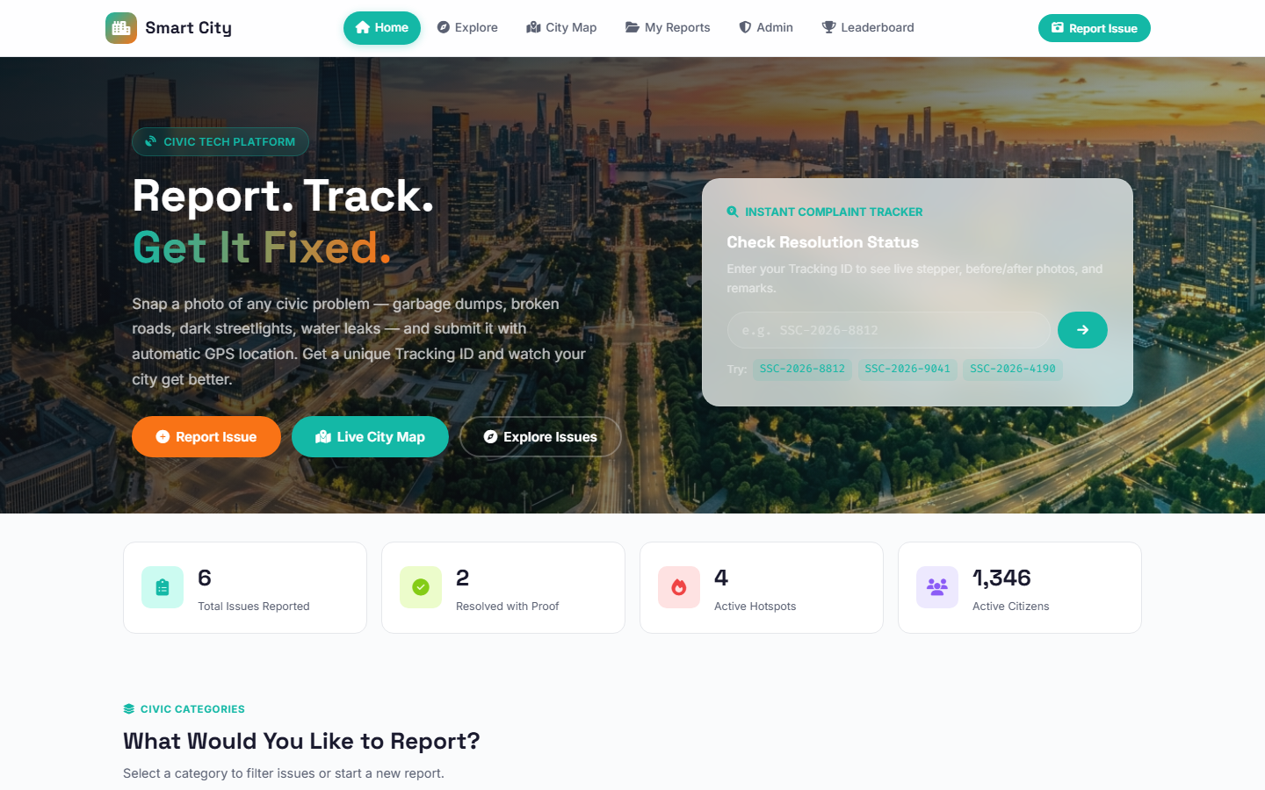
Figure 11.1: Citizen Portal Landing Page with Hero Section, Instant Tracking ID Search, and Real-Time KPI Metric Counters.
Figure 11.1 depicts the landing dashboard of the application. It highlights the glassmorphic navigation bar, prominent civic call-to-actions ("Report Issue", "Live City Map", "Explore Issues"), the Instant Complaint Tracker enabling tracking without mandatory login, and the real-time statistical counter ribbon displaying total reported issues, verified resolutions, active hotspots, and participating citizens.
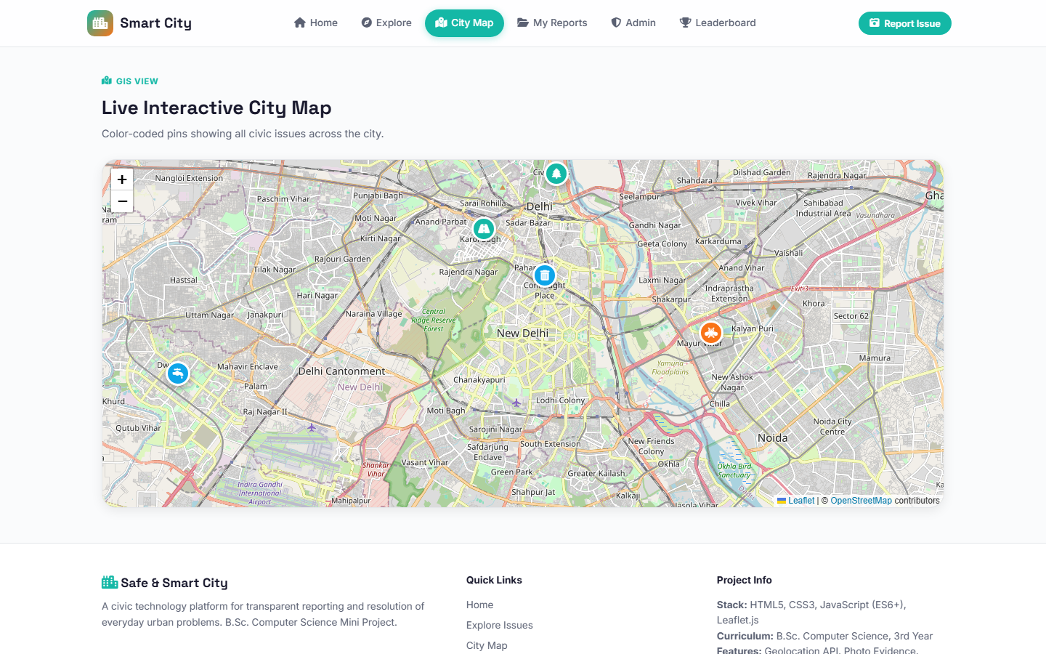
Figure 11.2: Live Interactive GIS City Map Powered by Leaflet.js with Ward Boundaries and Color-Coded Categorical Pin Markers.
Figure 11.2 showcases the interactive GIS City Map module. Leveraging Leaflet.js and OpenStreetMap cartography, civic grievances are rendered as high-contrast, color-coded icons (e.g., orange for Solid Waste, red for Potholes, cyan for Water Leakages). Citizens can zoom into specific wards, inspect issue densities, and click any marker to trigger an informative popup card containing photo evidence, description, and resolution progress.
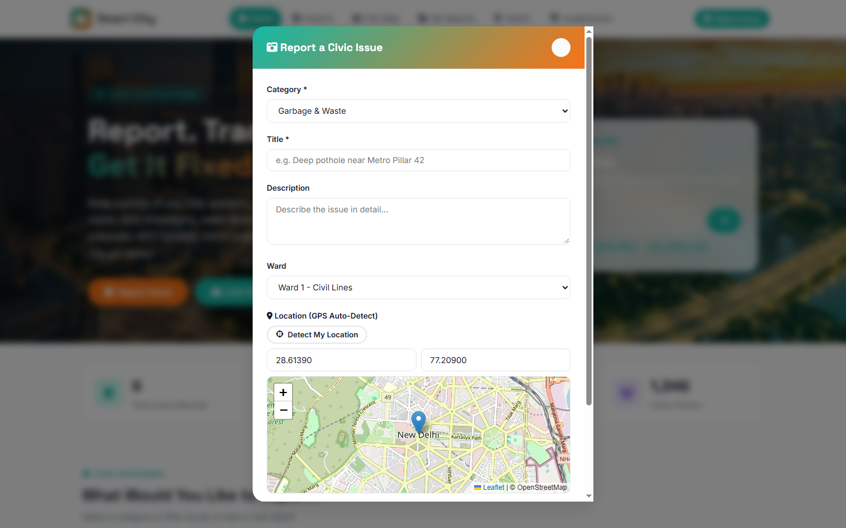
Figure 11.3: Civic Issue Reporting Modal Featuring Dynamic Category Dropdown, GPS Auto-Detection, Leaflet Pin Dropper, and Photo Upload.
Figure 11.3 displays the comprehensive complaint reporting modal. It incorporates mandatory category selection, title, description, ward assignment, one-click automatic GPS geolocation detection with coordinate population, an embedded interactive map for precision location adjustment, and photographic evidence attachment.
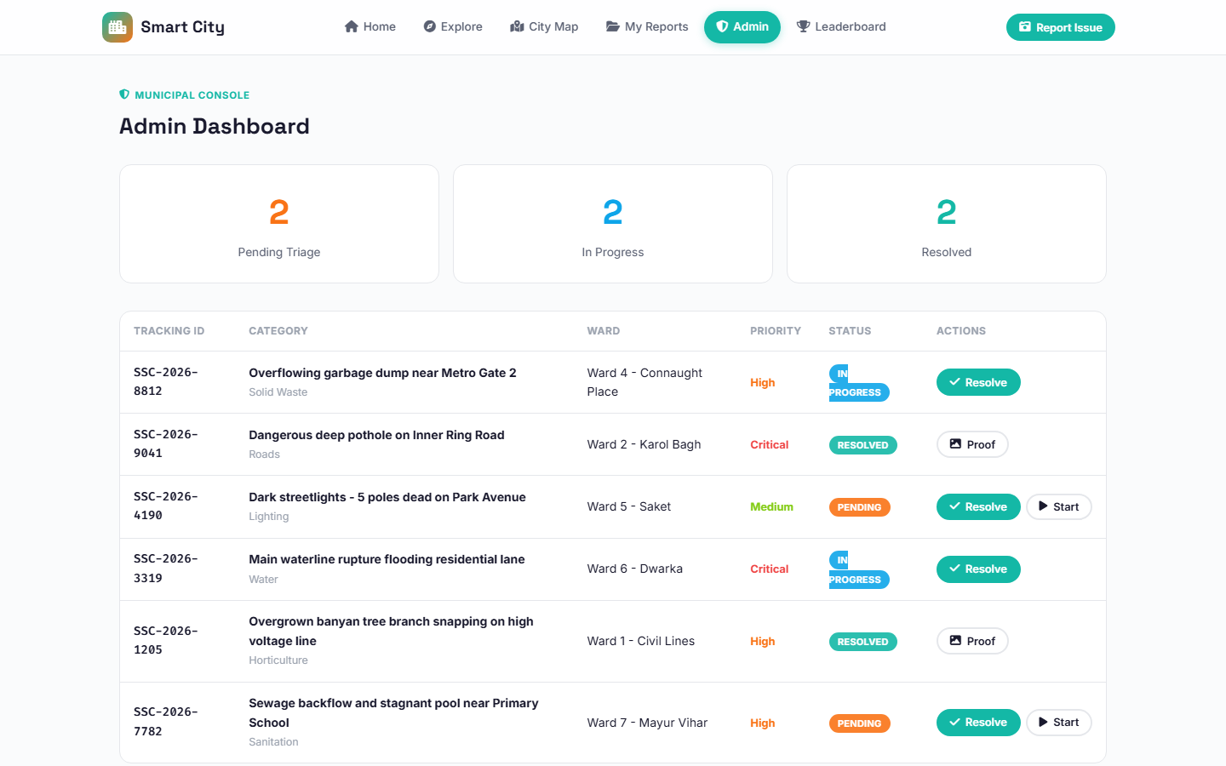
Figure 11.4: Municipal Administrative Console Demonstrating Real-Time Triage KPI Counters, Priority Badges, and Live Issue Action Controls.
Figure 11.4 illustrates the official Municipal Admin Dashboard. Designed for municipal triage personnel and ward officers, this console displays live pending, in-progress, and resolved issue tallies alongside an action-oriented data table. Officers can review citizen-submitted photos, assess priority levels (Critical, High, Medium), initiate field squad dispatches, and record verified resolution proofs.
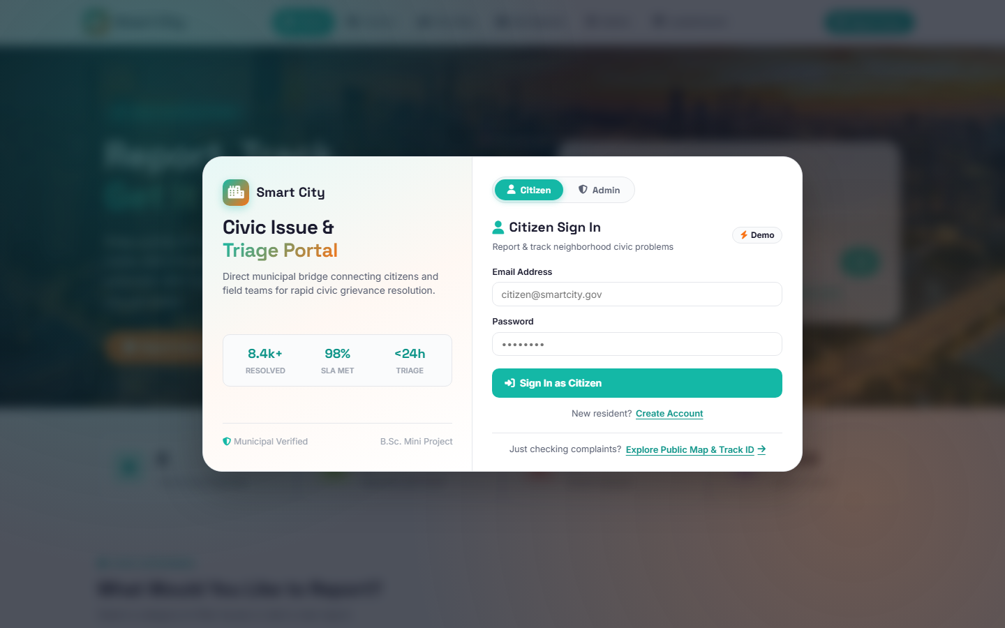
Figure 11.5: Secure Authentication Gateway Featuring Executive Branding, Civic Highlights, and Instant Role Switching Between Citizen and Admin.
Figure 11.5 depicts the modern authentication gateway modal. It presents civic performance statistics (8.4k+ resolved, 98% SLA compliance, <24h triage), alongside a seamless tabbed role switcher allowing authorized staff to access the municipal console while citizens authenticate to their personal reporting accounts.
11.4 Source Code Documentation
Source Code Documentation provides an annotated structural review of the core software routines that drive the Safe and Smart City platform. The snippets selected below highlight critical engineering facets across the client-side JavaScript engine, backend Jakarta REST API servlet, and Java Database Connectivity (JDBC) persistence layer.
The following client-side JavaScript routine handles civic issue form validation, geographic coordinate extraction, photographic file payload bundling, and asynchronous REST dispatching:
// Client-Side Form Validation & Asynchronous Fetch Dispatcher (js/app.js)
// js/app.js - Asynchronous Civic Issue Submission Handler
async function submitIssueForm(event) {
event.preventDefault();

// 1. Extract and sanitize input parameters
const category = document.getElementById('report-category').value.trim();
const title = document.getElementById('report-title').value.trim();
const description = document.getElementById('report-desc').value.trim();
const ward = document.getElementById('report-ward').value.trim();
const lat = parseFloat(document.getElementById('report-lat').value);
const lng = parseFloat(document.getElementById('report-lng').value);
const photoFile = document.getElementById('report-photo').files[0];

// 2. Validate essential mandatory constraints
if (!category || !title || title.length < 5) {
showToast('Please enter a descriptive title (at least 5 characters).', 'warning');
return;
}
if (isNaN(lat) || isNaN(lng) || lat < -90 || lat > 90 || lng < -180 || lng > 180) {
showToast('Valid geographic coordinates required. Please select location on map.', 'warning');
return;
}

// 3. Assemble multipart FormData payload
const formData = new FormData();
formData.append('category', category);
formData.append('title', title);
formData.append('description', description);
formData.append('ward', ward);
formData.append('latitude', lat);
formData.append('longitude', lng);
if (photoFile) {
if (photoFile.size > 25 * 1024 * 1024) {
showToast('Photograph must be 25 MB or smaller.', 'error');
return;
}
formData.append('photo', photoFile);
}

// 4. Asynchronous REST dispatch via Fetch API
try {
showLoadingSpinner(true);
const response = await fetch('/api/issues', {
method: 'POST',
headers: {
'Authorization': `Bearer ${currentUser?.token || ''}`
},
body: formData
});

const result = await response.json();
if (response.ok && result.success) {
showToast(`Issue ${result.trackingId} reported successfully!`, 'success');
closeModal('modal-report');
refreshMapAndFeed();
} else {
showToast(result.message || 'Submission failed. Please try again.', 'error');
}
} catch (error) {
console.error('API Error:', error);
showToast('Network error: Unable to reach municipal server.', 'error');
} finally {
showLoadingSpinner(false);
}
}

The backend Jakarta EE ApiServlet intercepts HTTP requests, enforces bearer token authentication, decodes JSON and multipart parameters, and delegates operations to service and DAO layers:
// Jakarta EE REST API Controller & Multipart Request Handler (ApiServlet.java)
// com/smartcity/servlet/ApiServlet.java - Central Jakarta EE REST Controller
package com.smartcity.servlet;

import com.smartcity.dao.ReportDAO;
import com.smartcity.model.User;
import com.smartcity.util.AuthTokenUtil;
import jakarta.servlet.ServletException;
import jakarta.servlet.annotation.MultipartConfig;
import jakarta.servlet.annotation.WebServlet;
import jakarta.servlet.http.*;
import java.io.IOException;
import java.io.PrintWriter;
import java.sql.SQLException;

@WebServlet(urlPatterns = {"/api/issues/*", "/api/auth/*", "/api/admin/*"})
@MultipartConfig(
fileSizeThreshold = 1024 * 1024, // 1 MB
maxFileSize = 25 * 1024 * 1024, // 25 MB max photo
maxRequestSize = 30 * 1024 * 1024 // 30 MB max payload
)
public class ApiServlet extends HttpServlet {
private ReportDAO reportDAO;

@Override
public void init() throws ServletException {
this.reportDAO = new ReportDAO();
}

@Override
protected void doPost(HttpServletRequest req, HttpServletResponse resp)
throws ServletException, IOException {
resp.setContentType("application/json");
resp.setCharacterEncoding("UTF-8");
PrintWriter out = resp.getWriter();

String path = req.getPathInfo();
try {
if ("/create".equals(path) || path == null || "/".equals(path)) {
// Validate Authorization Bearer Token
String authHeader = req.getHeader("Authorization");
User user = AuthTokenUtil.validateBearerToken(authHeader);
if (user == null) {
resp.setStatus(HttpServletResponse.SC_UNAUTHORIZED);
out.print("{\"success\": false, \"message\": \"Authentication required.\"}");
return;
}

// Extract and process multipart fields
String title = req.getParameter("title");
String category = req.getParameter("category");
String ward = req.getParameter("ward");
double latitude = Double.parseDouble(req.getParameter("latitude"));
double longitude = Double.parseDouble(req.getParameter("longitude"));
Part photoPart = req.getPart("photo");

String savedPhotoPath = null;
if (photoPart != null && photoPart.getSize() > 0) {
savedPhotoPath = processAndStorePhoto(photoPart);
}

// Delegate to DAO layer
String trackingId = reportDAO.submitReport(
user.getId(), category, title, ward, latitude, longitude, savedPhotoPath
);

resp.setStatus(HttpServletResponse.SC_CREATED);
out.printf("{\"success\": true, \"trackingId\": \"%s\", \"message\": \"Report created successfully.\"}", trackingId);
}
} catch (SQLException e) {
getServletContext().log("Database persistence failure", e);
resp.setStatus(HttpServletResponse.SC_INTERNAL_SERVER_ERROR);
out.print("{\"success\": false, \"message\": \"Database persistence error occurred.\"}");
}
}
}

The JDBC persistence routine inside ReportDAO ensures atomicity, spatial boundary validation, prepared statement parameterization, and transaction rollback protections:
// JDBC Parameterized Persistence & ACID Transaction Routine (ReportDAO.java)
// com/smartcity/dao/ReportDAO.java - JDBC Persistence & Transaction Engine
package com.smartcity.dao;

import com.smartcity.util.DBUtil;
import java.sql.*;
import java.util.Random;

public class ReportDAO {

/**
* Generates standard Tracking ID: SSC-YYYY-XXXX
*/
private String generateTrackingId() {
int year = java.time.Year.now().getValue();
int randomSeq = 1000 + new Random().nextInt(9000);
return "SSC-" + year + "-" + randomSeq;
}

/**
* Atomically persists a civic complaint and initializes audit trail log.
*/
public String submitReport(int userId, String category, String title,
String ward, double latitude, double longitude,
String photoPath) throws SQLException {
String trackingId = generateTrackingId();
Connection conn = null;
PreparedStatement psReport = null;
PreparedStatement psAudit = null;
ResultSet rsKeys = null;

String insertSQL = "INSERT INTO reports (tracking_id, user_id, category, title, "
+ "ward, latitude, longitude, photo_path, status, created_at) "
+ "VALUES (?, ?, ?, ?, ?, ?, ?, ?, 'Pending', NOW())";

String auditSQL = "INSERT INTO activity_logs (report_id, action, performed_by, log_time) "
+ "VALUES (?, 'Report Submitted', ?, NOW())";

try {
conn = DBUtil.getConnection();
conn.setAutoCommit(false); // Begin ACID Transaction

// 1. Insert primary civic report record
psReport = conn.prepareStatement(insertSQL, Statement.RETURN_GENERATED_KEYS);
psReport.setString(1, trackingId);
psReport.setInt(2, userId);
psReport.setString(3, category);
psReport.setString(4, title);
psReport.setString(5, ward != null ? ward : "Central Ward");
psReport.setDouble(6, latitude);
psReport.setDouble(7, longitude);
psReport.setString(8, photoPath);
psReport.executeUpdate();

// 2. Retrieve generated auto-increment primary key
rsKeys = psReport.getGeneratedKeys();
int reportId = 0;
if (rsKeys.next()) {
reportId = rsKeys.getInt(1);
}

// 3. Insert initial audit trail log entry
psAudit = conn.prepareStatement(auditSQL);
psAudit.setInt(1, reportId);
psAudit.setString(2, "Citizen #" + userId);
psAudit.executeUpdate();

conn.commit(); // Commit Transaction Atomically
return trackingId;
} catch (SQLException ex) {
if (conn != null) {
try { conn.rollback(); } catch (SQLException rb) { rb.printStackTrace(); }
}
throw ex;
} finally {
if (rsKeys != null) try { rsKeys.close(); } catch (SQLException ignored) {}
if (psReport != null) try { psReport.close(); } catch (SQLException ignored) {}
if (psAudit != null) try { psAudit.close(); } catch (SQLException ignored) {}
if (conn != null) try { conn.setAutoCommit(true); conn.close(); } catch (SQLException ignored) {}
}
}
}

The relational schema definition in MySQL defines primary keys, foreign key cascades, spatial indexes, and unique constraints governing civic issue workflows:
// Relational Schema, Foreign Key Constraints & Indexes (database.sql)
-- database.sql - Core MySQL Relational Schema Definition
CREATE DATABASE IF NOT EXISTS safesmartcity_db
CHARACTER SET utf8mb4 COLLATE utf8mb4_unicode_ci;
USE safesmartcity_db;

-- 1. Users Table (Citizens and Municipal Officers)
CREATE TABLE IF NOT EXISTS users (
id INT AUTO_INCREMENT PRIMARY KEY,
name VARCHAR(100) NOT NULL,
email VARCHAR(120) NOT NULL UNIQUE,
phone VARCHAR(20) NOT NULL,
password_hash VARCHAR(255) NOT NULL,
role ENUM('citizen', 'officer', 'admin') DEFAULT 'citizen',
karma_points INT DEFAULT 50,
created_at TIMESTAMP DEFAULT CURRENT_TIMESTAMP
) ENGINE=InnoDB;

-- 2. Civic Reports Table (Complaints & GIS Geo-Coordinates)
CREATE TABLE IF NOT EXISTS reports (
id INT AUTO_INCREMENT PRIMARY KEY,
tracking_id VARCHAR(32) NOT NULL UNIQUE,
user_id INT NOT NULL,
category VARCHAR(64) NOT NULL,
title VARCHAR(150) NOT NULL,
description TEXT,
ward VARCHAR(64) NOT NULL,
latitude DECIMAL(10, 7) NOT NULL,
longitude DECIMAL(10, 7) NOT NULL,
photo_path VARCHAR(255),
status ENUM('Pending', 'In Progress', 'Resolved', 'Closed') DEFAULT 'Pending',
priority ENUM('Low', 'Medium', 'High', 'Critical') DEFAULT 'Medium',
upvotes INT DEFAULT 0,
created_at TIMESTAMP DEFAULT CURRENT_TIMESTAMP,
INDEX idx_ward_status (ward, status),
INDEX idx_category (category),
FOREIGN KEY (user_id) REFERENCES users(id) ON DELETE CASCADE
) ENGINE=InnoDB;

-- 3. Community Upvotes Table (Prevents Duplicate Citizen Votes)
CREATE TABLE IF NOT EXISTS upvotes (
id INT AUTO_INCREMENT PRIMARY KEY,
report_id INT NOT NULL,
user_id INT NOT NULL,
voted_at TIMESTAMP DEFAULT CURRENT_TIMESTAMP,
UNIQUE KEY uk_user_report (user_id, report_id),
FOREIGN KEY (report_id) REFERENCES reports(id) ON DELETE CASCADE,
FOREIGN KEY (user_id) REFERENCES users(id) ON DELETE CASCADE
) ENGINE=InnoDB;

-- 4. Activity Audit Trail Table (Immutable Administrative Accountability)
CREATE TABLE IF NOT EXISTS activity_logs (
id INT AUTO_INCREMENT PRIMARY KEY,
report_id INT NOT NULL,
action VARCHAR(100) NOT NULL,
performed_by VARCHAR(100) NOT NULL,
remarks TEXT,
log_time TIMESTAMP DEFAULT CURRENT_TIMESTAMP,
FOREIGN KEY (report_id) REFERENCES reports(id) ON DELETE CASCADE
) ENGINE=InnoDB;

