BHARATI VIDYAPEETH (DEEMED TO BE UNIVERSITY)
COLLEGE OF ENGINEERING, PUNE – 411043
A PROJECT BASED LEARNING
CASE STUDY REPORT ON
MERAGHAR – HOUSE PRICE PREDICTION SYSTEM
(Machine-Learning Based Property Price Estimation for Indian Cities)
Submitted by
Name | PRN | Roll No.
Ankit Akash | 2414110181 | 01
For the course: Data Warehousing and Mining
Submitted To Course Coordinator
Dr. Rohini Khalkar
B. Tech Computer Engineering (Sem V)
2026–27

DEPARTMENT OF COMPUTER ENGINEERING
Bharati Vidyapeeth (Deemed to be University)
College of Engineering, Pune – 411043

CERTIFICATE
This is to certify that the project report entitled “MeraGhar – House Price Prediction System – Case Study” is a bonafide work carried out by Ankit Akash (01) in partial fulfilment of the requirements for the award of the degree of B. Tech in Computer Engineering during the academic year 2026–27. The work has been completed under my guidance and supervision. To the best of my knowledge, the work presented in this report has not been submitted, either in whole or in part, to any other university or institution for the award of any degree or diploma.
Date:
Dr. Rohini Khalkar Dr. Sandeep Vanjale
Internal Guide Head of Department
Dept. of Computer Engineering Dept. of Computer Engineering

ACKNOWLEDGEMENT
I express my sincere gratitude to Dr. Rajesh Prasad, Principal of Bharati Vidyapeeth (Deemed to be University), College of Engineering, Pune, for providing the facilities and academic environment required for completing this project.
I am deeply thankful to Dr. Sandeep Vanjale, Head of the Department of Computer Engineering, for valuable guidance and encouragement throughout the project work. I extend my heartfelt gratitude to my project guide and course coordinator, Dr. Rohini Khalkar, for continuous guidance, constructive suggestions, technical support, and motivation during every stage of the project.
I also thank all faculty members, friends, and family members who supported me during the development and documentation of the MeraGhar House Price Prediction System. Finally, I thank my institution for providing an opportunity to undertake this project and apply concepts of data warehousing, data mining, machine learning, and data visualization in a practical real-estate application.
Ankit Akash
TABLE OF CONTENTS
CERTIFICATE 2
ACKNOWLEDGEMENT 3
ABSTRACT 6
1. INTRODUCTION 7
1.1 Background 7
1.2 Problem Statement 7
1.3 Objectives 7
1.4 Scope 8
1.5 Need for the System 8
1.6 Project at a Glance 8
1.7 Organization of the Report 9
2. LITERATURE SURVEY 10
2.1 Introduction 10
2.2 Hedonic Pricing and Property Valuation 10
2.3 Machine Learning for House-Price Prediction 10
2.4 Data Warehousing and Dimensional Modelling 10
2.5 Model Evaluation Measures 10
2.6 Research Gap 11
3. REQUIREMENT ANALYSIS AND FEASIBILITY STUDY 12
3.1 Existing System 12
3.2 Proposed System 12
3.3 Functional Requirements 12
3.4 Non-Functional Requirements 13
3.5 Dataset Description 13
3.6 Feasibility Study 14
3.7 Use-Case Description 14
4. SYSTEM DESIGN 16
4.1 System Architecture 16
4.2 Data-Flow Description 16
4.3 Data Warehouse Design 17
4.4 User-Interface Design 19
4.5 KPI and Analytics Design 19
5. METHODOLOGY AND IMPLEMENTATION 20
5.1 Development Methodology 20
5.2 Data Collection 20
5.3 Data Preprocessing 20
5.4 Analytics Workflow 21
5.5 Algorithm Description 21
5.6 Modules of the System 22
5.7 Technology Stack 22
5.8 Feature List 23
5.9 Implementation Details 23
6. TESTING AND RESULTS 28
6.1 Testing Strategy 28
6.2 Test Cases 28
6.3 Evaluation Metrics 29
6.4 Results and Discussion 29
6.5 Key Findings 37
6.6 Recommendations for Improvement 38
6.7 Result Evaluation Areas 38
6.8 Learning Outcomes 39
7. CONCLUSION AND FUTURE SCOPE 40
7.1 Conclusion 40
7.2 Limitations 40
7.3 Future Scope 40
REFERENCES 42

ABSTRACT
Buying or selling a home is the largest financial decision most families make, yet estimating a fair price is difficult. A property’s value depends on its city, locality, built-up area, age, amenities and many other attributes, and buyers usually rely on broker opinions or on browsing listing portals one by one. MeraGhar – House Price Prediction System is a web-based machine-learning and data-analysis prototype built to address this problem for five Indian metropolitan cities.
The system is built with Python, Flask, pandas and scikit-learn. It is trained on a dataset of 1,000 residential properties from 5 cities (Mumbai, Delhi, Bengaluru, Pune and Chennai) and 25 localities, described by 12 input attributes (city, locality, bedrooms, bathrooms, living area, floors, year built, parking, facing, lift, furnishing and garden) and one target, the price in Indian rupees. A single training script cleans the data, applies median imputation, standardisation and one-hot encoding inside a scikit-learn pipeline, trains five regression algorithms (Linear Regression, Decision Tree, Random Forest, Extra Trees and Gradient Boosting) on an 80/20 split, compares them using R², MAE and RMSE, and automatically saves the best model. Extra Trees was selected with R² = 0.9997, MAE = ₹1.76 lakh and RMSE = ₹2.42 lakh on the 200 held-out properties.
The web application offers seven pages: a price estimator with server-side input validation, a project dashboard, a dataset explorer, a data-preprocessing report, a data-visualization page, a model-comparison page and an about page. This case study documents the project end to end: requirement analysis, layered architecture, a conceptual star-schema data-warehouse design, algorithm descriptions, implementation, testing, and a critical evaluation of the results. The evaluation goes beyond the headline score. It shows that living area alone has a correlation of 0.95 with price, that only living area and city carry measurable predictive weight (all other features have a permutation importance of about zero), and that a one-line “price = rate × area” baseline fitted separately for every city reaches R² = 0.9999 – a strong indication that the supplied dataset is synthetic and that the near-perfect scores demonstrate the machine-learning workflow rather than accuracy on real property markets. The report closes with limitations and a roadmap for improvement.
The source code is available at https://github.com/Ankit45Akash/MeraGhar.
Keywords: House price prediction, machine learning, regression, Extra Trees, scikit-learn, Flask, data preprocessing, data warehousing, data mining, star schema, real-estate analytics, data visualization.

1. INTRODUCTION

1.1 Background
Residential real estate in India’s metropolitan cities is characterised by very large price differences. A flat of the same size can cost nearly half as much in Chennai as in Mumbai, and prices also vary from locality to locality within a city. Information is scattered across listing portals, brokers and word of mouth, so an ordinary buyer or seller has no quick, consistent way to judge whether an asking price is reasonable.
Classical valuation theory treats a house as a bundle of attributes – location, size, age and amenities – each of which contributes to its price (the “hedonic pricing” idea). Machine-learning regression models learn this relationship automatically from past data: given the attributes of a new property, they return an estimated price. A web interface makes such a model usable by non-technical people. MeraGhar (Hindi for “my home”) combines both ideas: a trained regression model, an interactive estimator and a set of dashboards that expose the data, the preprocessing and the model comparison behind the estimate.

1.2 Problem Statement
Buyers, sellers and small agents need a quick estimate of a property’s price, but available information is fragmented, subjective and difficult to interpret. Raw property data contains location, area, room counts, age and amenities, yet it is rarely analysed beyond simple averages, and the reasons behind a price remain hidden.
The central problem addressed by this project is: How can a web-based system learn from a property dataset, compare several regression algorithms objectively, and give users an instant, validated price estimate together with transparent evidence about the data and the model behind it?

1.3 Objectives
- To develop a web application that estimates the price of a residential property from 12 user-supplied attributes.
- To organise property data (location, size, age, amenities and price) into a structure suitable for analysis and multi-dimensional reporting (data-warehouse view).
- To preprocess the data – validation, missing-value handling, scaling and categorical encoding – inside a reproducible machine-learning pipeline.
- To train and compare five regression algorithms using R², MAE and RMSE, and to select and store the best model automatically.
- To validate every user input on the server so that out-of-range or invalid values never reach the model.
- To provide a dashboard, dataset explorer, preprocessing report and visualization page that make the data and the model transparent.
- To evaluate the results critically, including which features really drive the prediction and what the scores do and do not prove.
- To demonstrate data-warehousing and data-mining concepts of the course (Data Warehousing and Mining) in a realistic real-estate setting.

1.4 Scope
The system is an academic analytical prototype. It focuses on exploring a property dataset, comparing regression models and producing an indicative price estimate. It is not a certified valuation tool and does not replace professional valuers, registered sale-deed prices or bank valuation reports.
- Property data for five cities (Mumbai, Delhi, Bengaluru, Pune, Chennai) and 25 localities, stored in a single CSV file.
- A price estimator with 12 inputs, input validation and a result page that shows the estimate in Indian rupees.
- Training, comparison and persistence of five regression models through a single script (train_model.py).
- Seven web pages: estimator, dashboard, dataset explorer, data preprocessing, data visualization, model comparison and about.
- A conceptual star-schema design for historical, multi-dimensional analysis if transaction-level data becomes available.

1.5 Need for the System
A home buyer in a metropolitan city faces an information problem: the asking price rarely comes with an explanation. A data-driven estimator gives an independent reference point within milliseconds, helps users compare the same property across cities, and shows which attributes matter. For students and analysts, the project also serves as a compact, reproducible example of a complete data-mining workflow – from raw CSV to a deployed prediction service – with every step visible in the interface.

1.6 Project at a Glance
Table 1: Project summary
Item | Details
Project title | MeraGhar – House Price Prediction System
Application name | MeraGhar – House Price Analytics
Source code | https://github.com/Ankit45Akash/MeraGhar (branch: main)
Deployment | Flask application served with Gunicorn (Procfile: web: gunicorn app:app) – deployable on any Python platform-as-a-service
Dataset | indian_house_prices.csv – 1,000 properties, 5 cities, 25 localities, 12 input attributes + price
Algorithms compared | Linear Regression, Decision Tree, Random Forest, Extra Trees, Gradient Boosting
Selected model | Extra Trees (150 trees, max depth 16, min leaf 3)
Headline results | R² 0.9997 · MAE ₹1.76 lakh · RMSE ₹2.42 lakh · MAPE 1.10% (200 test properties)
Technology | Python, Flask, pandas, scikit-learn, joblib, HTML/CSS/JavaScript, Chart.js
Course | Data Warehousing and Mining, B.Tech Computer Engineering (Sem V)

1.7 Organization of the Report
Chapter 1 introduces the project. Chapter 2 presents the literature survey. Chapter 3 discusses requirements, the dataset and feasibility. Chapter 4 explains the system design, including architecture, data flow and the warehouse schema. Chapter 5 describes the methodology, algorithms and implementation. Chapter 6 presents testing, results and a critical analysis with graphs. Chapter 7 concludes the case study and outlines limitations and future scope.

2. LITERATURE SURVEY

2.1 Introduction
Property price estimation sits at the intersection of economics, statistics and machine learning. The concepts relevant to this project are hedonic pricing, regression analysis, tree-based ensemble learning, model evaluation, data warehousing and visual analytics.

2.2 Hedonic Pricing and Property Valuation
Rosen (1974) formalised hedonic pricing: the price of a differentiated product such as a house is explained by the prices of its characteristics – location, size, number of rooms, age and amenities. Almost all statistical house-price models, including this project, follow this idea: choose a set of attributes, learn how each contributes to price, and use the learned relationship to value a new property. Traditional hedonic models are linear; modern machine-learning models can capture interactions, for example that an extra square foot is worth much more in Mumbai than in Chennai.

2.3 Machine Learning for House-Price Prediction
Park and Bae (2015) applied machine-learning methods to housing data and showed that data-driven models can match or outperform simple statistical baselines when the right attributes are available. Since then, ensembles of decision trees have become the standard choice for tabular property data because they handle mixed numeric and categorical attributes, need little tuning and are robust to scale differences.
Linear regression models the target as a weighted sum of predictors and is easy to interpret, but it cannot represent interactions unless they are added by hand. Decision trees (Breiman et al., 1984) split the data into regions with similar prices; they capture non-linearity but a single tree is unstable. Random Forests (Breiman, 2001) average many trees trained on bootstrap samples to reduce variance. Extremely Randomised Trees, or Extra Trees (Geurts, Ernst and Wehenkel, 2006), go one step further by choosing split thresholds at random, which further reduces variance and training time. Gradient Boosting (Friedman, 2001) builds shallow trees one after another, each correcting the errors of the previous ones. All five are available in scikit-learn (Pedregosa et al., 2011) and are compared in this project.

2.4 Data Warehousing and Dimensional Modelling
A data warehouse integrates historical data from operational sources into a structure optimised for analysis. Kimball and Ross recommend dimensional modelling: a central fact table of numeric measures surrounded by descriptive dimension tables. This star schema supports fast aggregation and consistent drill-down. In this project the schema is used as a conceptual model for the property data (Section 4.3), and the dashboard and visualization pages perform the corresponding OLAP-style aggregations: roll-up by city, drill-down to locality, and slicing by area band, furnishing or age.

2.5 Model Evaluation Measures
Regression models are evaluated with the coefficient of determination R², the mean absolute error (MAE) and the root mean squared error (RMSE). R² reports the share of price variance explained by the model, MAE gives the average error in rupees, and RMSE penalises large errors more strongly. Because a score measured on the training data is optimistic, models must be evaluated on records they have not seen – here a held-out 20% test set. A high score must still be read against a simple baseline and against the realism of the data.
Table 2: Comparative analysis of the regression techniques used
Technique | Idea | Strength | Limitation
Linear Regression | Weighted sum of predictors | Transparent, fast, no tuning | Cannot model interactions (e.g. city × area) unless engineered
Decision Tree | Recursive splits into price regions | Non-linear, readable rules | Unstable; one tree overfits or underfits easily
Random Forest | Average of many bootstrap trees | Low variance, robust, little tuning | Larger model; less interpretable
Extra Trees | Average of trees with random split points | Very low variance, fast, smooth fits | Large model file; random splits can blur sharp effects
Gradient Boosting | Sequence of shallow trees fixing errors | Often very accurate on tabular data | Needs tuning; slower to train; sensitive to settings

2.6 Research Gap
Many house-price projects stop at a notebook that reports one score for one model. Listing portals show prices but not the reasoning behind them. A student- or manager-friendly solution should (i) run a fair comparison of several algorithms, (ii) expose the data quality and preprocessing steps, (iii) validate user input before prediction, and (iv) state honestly what the score proves. This project addresses the gap with an end-to-end web application that keeps the training script, the saved model, the dashboards and a critical evaluation connected.

3. REQUIREMENT ANALYSIS AND FEASIBILITY STUDY

3.1 Existing System
Today a person who wants to know the price of a property typically browses listing portals, asks brokers, or compares a few similar flats manually. This creates several limitations: asking prices are subjective and negotiable, comparisons across cities take a long time, the influence of individual attributes is not visible, and there is no consistent way to check an estimate against data.

3.2 Proposed System
The proposed system provides a single web interface where the user enters 12 attributes of a property and instantly receives a model-based price estimate in rupees. Behind the estimator, a training script compares five regression algorithms on a property dataset and stores the best one. Supporting pages show the dataset, the data-quality report, the visual analysis and the model comparison, so that the estimate can be understood and questioned.

3.3 Functional Requirements
Table 3: Functional requirements
ID | Functional requirement
FR-01 | The system shall load in a web browser without any installation.
FR-02 | The system shall provide an estimator form with 12 inputs: city, locality, bedrooms, bathrooms, living area, floors, year built, parking, facing, lift, furnishing and garden.
FR-03 | The system shall validate inputs on the server: allowed categories, locality present in the dataset, and numeric ranges (bedrooms 1–5, bathrooms 1–4, area 300–5,000 sq ft, floors 1–3, year 1950–2025, parking 0–3).
FR-04 | The system shall return the estimated price in INR together with the model name and a summary of the inputs.
FR-05 | The system shall show a clear error message and HTTP 400 status for invalid input without crashing.
FR-06 | The system shall provide a dashboard with record count, mean and median price, number of cities, selected model, records-by-city and average-price-by-city charts and the algorithm comparison.
FR-07 | The system shall provide a dataset explorer that lists up to the first 100 records with a search box.
FR-08 | The system shall provide a preprocessing report showing records, columns, missing cells, duplicate rows, data types and numeric/categorical columns.
FR-09 | The system shall provide a visualization page with price by city, area vs price, price by bedrooms, price distribution, price by furnishing and price by property age.
FR-10 | The system shall provide a model-comparison page showing R², MAE and RMSE for all five algorithms and flagging the selected model.
FR-11 | The training script shall train all algorithms on the same split, select the best model by R² (MAE breaks ties) and save the model and the comparison results.
FR-12 | The system shall provide an about page describing the objective, workflow, technology and limitations.

3.4 Non-Functional Requirements
Table 4: Non-functional requirements
ID | Non-functional requirement
NFR-01 | The interface should be simple enough for users without data-science training.
NFR-02 | A single prediction should return in well under a second (measured: about 15 ms for the model call).
NFR-03 | Numbers shown on the dashboard, comparison page and result page must be consistent because all read the same dataset and result files.
NFR-04 | The code should be modular so that algorithms, features or pages can be added or replaced.
NFR-05 | User inputs should not be stored; production use needs HTTPS, authentication and a non-debug server.
NFR-06 | The layout should be responsive on desktop and mobile screens.
NFR-07 | The training pipeline should be reproducible (fixed random seed, same split every run).
NFR-08 | Charts and tables should be readable with sufficient contrast and clear labels.

3.5 Dataset Description
The dataset indian_house_prices.csv contains 1,000 residential properties from five cities – Pune (207), Chennai (205), Mumbai (201), Bengaluru (197) and Delhi (190) – spread over 25 localities (five per city, for example Andheri, Bandra and Powai in Mumbai, or Baner, Aundh and Kothrud in Pune). Each record has 12 input attributes and the target price. The file has no missing cells and no duplicate rows (verified by the preprocessing page).
Table 5: Attribute dictionary of the dataset
Attribute | Type | Meaning | Values / range in data
city | Categorical | City of the property | Mumbai, Delhi, Bengaluru, Chennai, Pune
locality | Categorical | Neighbourhood within the city | 25 localities (5 per city)
bedrooms | Integer | Number of bedrooms | 1 – 5
bathrooms | Integer | Number of bathrooms | 1 – 4
sqft_living | Integer | Living (built-up) area in square feet | 300 – 4,999 (mean 2,643)
floors | Integer | Number of floors | 1 – 3
year_built | Integer | Year of construction | 1950 – 2025 (mean 1987)
parking | Integer | Number of parking spaces | 0 – 3
facing | Categorical | Direction the property faces | North, South, East, West
lift | Categorical | Lift available | Yes / No
furnishing | Categorical | Furnishing status | Furnished, Semi-Furnished, Unfurnished
garden | Categorical | Garden available | Yes / No
price | Integer (target) | Property price in Indian rupees | ₹28.72 lakh – ₹6.01 crore (mean ₹2.54 crore)

Table 6: Price statistics of the dataset (₹)
Statistic | Value | Statistic | Value
Records | 1,000 | Standard deviation | 1,35,12,259 (₹1.35 crore)
Mean price | 2,53,68,365 (₹2.54 crore) | Minimum price | 28,72,000 (₹28.72 lakh)
Median price | 2,49,38,000 (₹2.49 crore) | Maximum price | 6,00,56,000 (₹6.01 crore)

The mean and median are close, so the price distribution is fairly symmetric (Section 6.4.3). The dataset is balanced across cities (190–207 records each), which means that city-wise comparisons are not distorted by sample size.

3.6 Feasibility Study
Technical feasibility: Python, Flask, pandas and scikit-learn are mature open-source tools. Training five models on 1,000 records takes seconds on an ordinary laptop, and a prediction takes milliseconds, so no special hardware is needed.
Economic feasibility: The prototype uses only free and open-source software and a free-tier-capable deployment model (a Procfile for Gunicorn), so development and hosting costs are negligible for academic use.
Operational feasibility: The estimator is a single form with drop-downs and number fields; users need no technical knowledge. The supporting pages are read-only.
Schedule feasibility: The work was done in phases – requirements, data analysis, training pipeline, web interface, visual pages, testing and documentation – within one semester (the repository history shows the initial version on 7 October 2026 and the extended website and dashboard on 10 October 2026).

3.7 Use-Case Description
The primary actor is the user (a buyer, seller or agent). The user opens the application, enters the property details and submits the form to receive an estimate. The user may also open the dashboard, dataset explorer and visualization pages to understand the data. Secondary actors are the administrator / data scientist, who replaces the dataset and re-runs train_model.py to retrain the model, and the evaluator (for example a teacher), who reads the preprocessing and model-comparison pages.
Table 7: Main use cases
Use case | Actor | Outcome
Estimate property price | User | Validated inputs are scored by the saved model; the price is shown in ₹
Handle invalid input | User | A clear error message is shown with HTTP 400; no prediction is made
Explore the dataset | User / Evaluator | First 100 records can be searched and inspected
Inspect data quality | Evaluator | Missing cells, duplicates, data types and preprocessing steps are reported
View visual analysis | User / Evaluator | Charts of price by city, bedrooms, furnishing, area and age
Compare algorithms | Evaluator | R², MAE and RMSE of five models; the selected model is flagged
Retrain the model | Administrator | train_model.py trains all models, saves the best model and the comparison JSON

4. SYSTEM DESIGN

4.1 System Architecture
MeraGhar uses a layered architecture. The presentation layer consists of Jinja2 HTML templates styled with CSS and enhanced with JavaScript and Chart.js: the estimator form, result page, dashboard, dataset explorer, preprocessing report, visualization page, model-comparison page and about page. The application layer is the Flask application (app.py), which defines the routes, validates user input, loads the dataset and the saved model package, and prepares the data passed to each template. The machine-learning layer is a scikit-learn pipeline that imputes, scales and encodes the inputs and feeds them to the selected regressor; it is produced by the training script. The data layer holds the CSV dataset, the serialised model (house_price_model.pkl) and the comparison results (model_comparison.json).
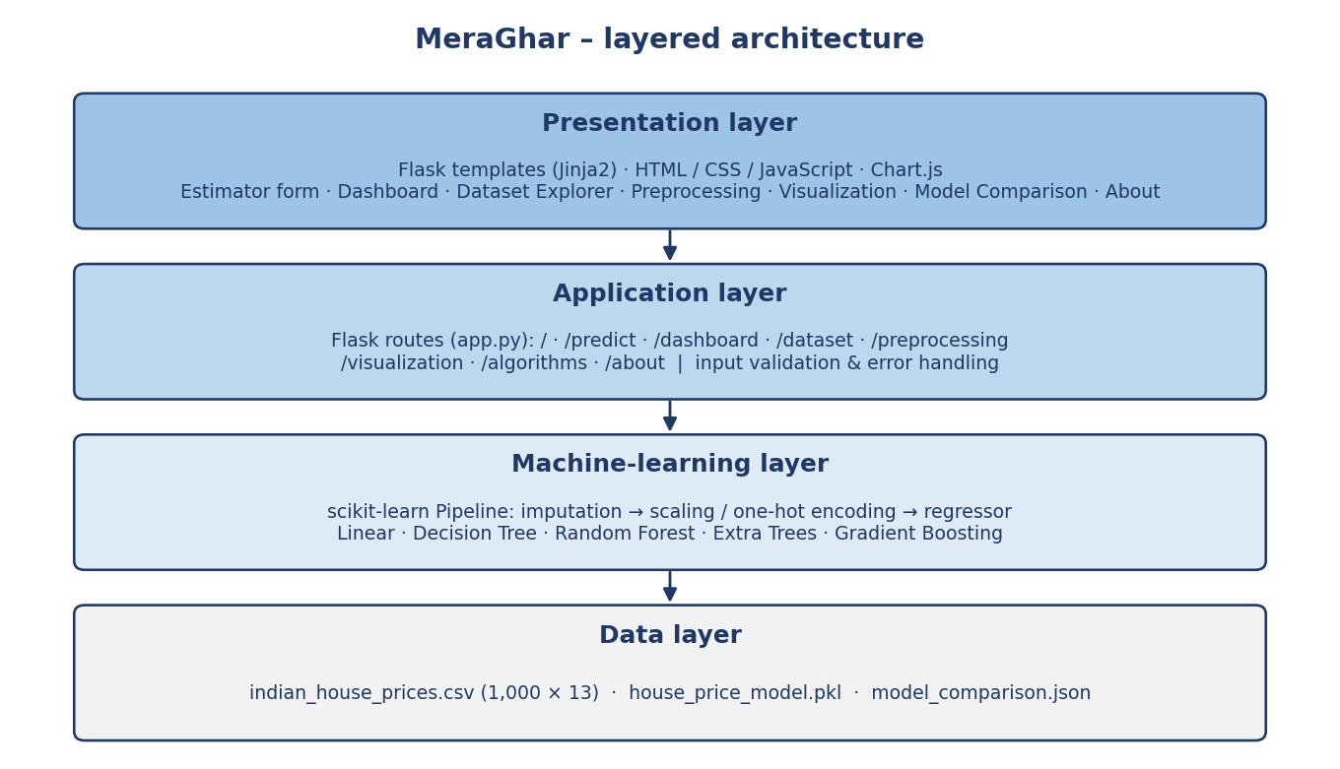
Figure 4.1: Layered system architecture of MeraGhar

4.2 Data-Flow Description
Training and prediction are deliberately separated. During training, train_model.py reads the CSV, validates the required columns, cleans the target, splits the records 80/20, fits the five pipelines, evaluates them and saves the best one. During prediction, the Flask application loads the saved package once at start-up; for every form submission it validates the inputs, builds a one-row DataFrame and calls the pipeline to obtain the price.
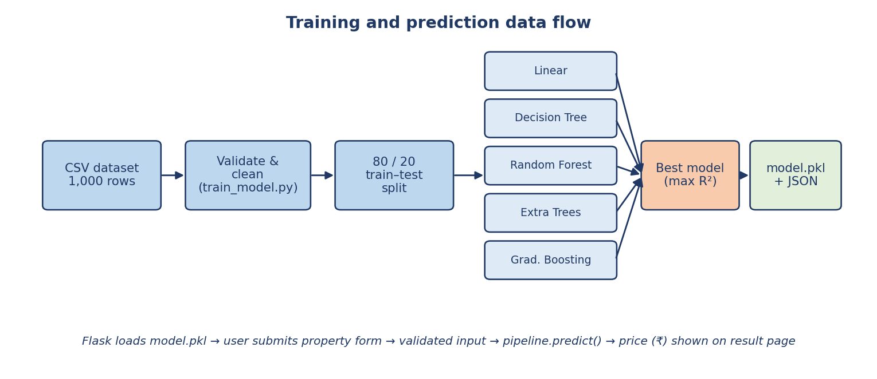
Figure 4.2: Training and prediction data-flow diagram
- Run train_model.py: load indian_house_prices.csv and verify that all 12 feature columns and the price column exist.
- Convert numeric columns to numbers (invalid cells become missing), drop rows without a positive price and treat blank category strings as missing.
- Split the data 80% / 20% with random_state = 42 (800 training and 200 test properties).
- Build one pipeline per algorithm: numeric features → median imputation → standardisation; categorical features → most-frequent imputation → one-hot encoding; then the regressor.
- Fit each pipeline on the training set and compute R², MAE and RMSE on the test set.
- Select the model with the highest R² (lowest MAE breaks ties) and save it with its metrics to house_price_model.pkl; save all results to model_comparison.json.
- Start the Flask app. The estimator validates inputs, calls the saved pipeline and shows the price; the other pages read the dataset and the JSON file.

4.3 Data Warehouse Design
A star schema is suitable for property analysis because it organises measurable events around descriptive dimensions. MeraGhar itself works on a flat CSV file, but its attributes map naturally to the conceptual warehouse below. If transaction or listing history becomes available, the same design would allow trend analysis by date, locality and property type.
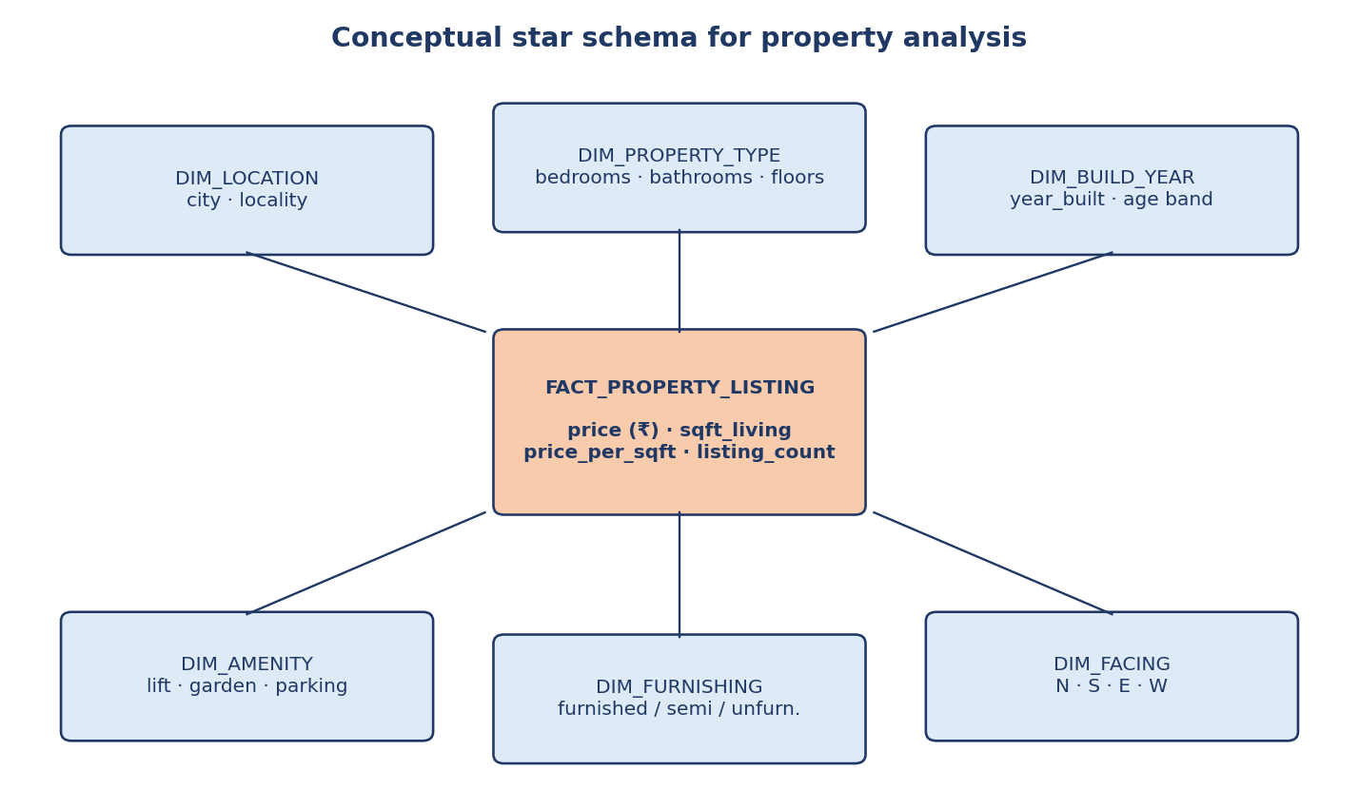
Figure 4.3: Conceptual star schema for property analysis
Table 8: Property fact table (conceptual)
Fact / attribute | Description
listing_id | Unique identifier of the fact row (one property listing)
location_id, property_type_id, build_year_id, amenity_id, furnishing_id, facing_id | Foreign keys to the dimension tables
price | Property price in INR (the measure to be predicted and aggregated)
sqft_living | Living area in square feet
price_per_sqft | Derived measure: price / sqft_living
listing_count | Count measure (1 per row) for counts and averages

Table 9: Dimension tables (conceptual)
Dimension | Example attributes | Hierarchy
Location | city, locality | City → Locality
Property type | bedrooms, bathrooms, floors | Bedrooms → Bathrooms
Build year | year_built, age band (0–5, 6–15, 16–30, over 30 years) | Year → Age band
Amenity | lift, garden, parking spaces | –
Furnishing | Furnished, Semi-Furnished, Unfurnished | –
Facing | North, South, East, West | –

The application and the analysis in Chapter 6 already perform OLAP-style operations on the flat file, which links the project directly to the course syllabus (Table 10).
Table 10: OLAP operations performed on the flat file
OLAP operation | Realisation in MeraGhar
Roll-up | Average and median price aggregated from property level to city level (dashboard and visualization pages)
Drill-down | From city to locality averages (Figure 6.7) and from all properties to living-area bands (Figure 6.11)
Slice | Price for one value of a dimension, e.g. furnishing = Furnished or garden = Yes
Dice | Living-area band and city together (scatter plot, Figure 6.8)
Pivot | City × living-area table of predicted prices (Table 21, Section 6.4.8)

4.4 User-Interface Design
The interface is a server-rendered website with a light, card-based design. The home page contains a hero section and the estimator form; the other pages share a dark-green sidebar with the entries Dashboard, Dataset Explorer, Data Preprocessing, Data Visualization, Model Comparison, Price Estimator and About Project. Each page opens with a short description, summary cards and then the detailed table or chart.
- Estimator (home page): 12 inputs (drop-downs for city, locality, floors, parking, facing, lift, furnishing and garden; number fields for bedrooms, bathrooms, living area and year built); submitting sends a POST request to /predict.
- Result page: the estimate in large type, a card for each entered property detail and the name of the model that produced the value.
- Dashboard: four summary cards (records, mean price, median price, cities), records-by-city and average-price-by-city charts, the algorithm comparison table and a data-limitation notice.
- Dataset explorer: a searchable table of the first 100 records.
- Data preprocessing: counts of records, columns, missing cells and duplicates, a missing-value table, data types and the preprocessing steps.
- Data visualization: six charts (price by city, living area vs price, price by bedrooms, price distribution, price by furnishing and price by property age).
- Model comparison: R², MAE and RMSE for every algorithm and an explanation of the metrics.

4.5 KPI and Analytics Design
The dashboard reports dataset-level indicators (record count, mean price, median price, number of cities) and model-level indicators (R², MAE, RMSE). In this report additional indicators are derived to interpret the results. The main formulas are listed below.
Price per sq ft = Price / sqft_living
R² = 1 − SS_res / SS_tot
MAE = (1/n) Σ |yᵢ − ŷᵢ| RMSE = √[(1/n) Σ (yᵢ − ŷᵢ)²]
MAPE = (100/n) Σ |yᵢ − ŷᵢ| / yᵢ Error eᵢ = ŷᵢ − yᵢ
Standardisation: z = (x − μ) / σ One-hot: category → 0/1 indicator columns
Permutation importance of feature j = R²(original) − R²(feature j shuffled)

5. METHODOLOGY AND IMPLEMENTATION

5.1 Development Methodology
The project followed an incremental methodology. The training script, the prediction route and each informational page were developed and checked as separate units before being combined, which made it possible to verify calculations and data flow step by step. The repository history reflects this: an initial commit with the predictor, followed by an update that added the dashboard and the analysis pages.
- Requirement gathering and definition of the prediction target and evaluation measures.
- Study of house-price modelling and the regression algorithms available in scikit-learn.
- Dataset collection and inspection (shape, types, missing values, duplicates).
- Design of the preprocessing pipeline and the model-comparison procedure.
- Implementation of train_model.py and persistence of the best model.
- Development of the Flask application, input validation and the estimator pages.
- Development of the dashboard, dataset explorer, preprocessing, visualization and comparison pages.
- Testing, retraining checks and critical evaluation of the results.
- Version control on GitHub, packaging for deployment (requirements.txt, Procfile) and documentation.

5.2 Data Collection
The analysis uses the file Dataset/indian_house_prices.csv with 1,000 records and 13 columns (Table 5). The file is a prepared dataset, not a live feed from a listing portal; Section 6.4.7 shows that its prices follow a very regular pattern and should be treated as demonstration data.

5.3 Data Preprocessing
Preprocessing happens in two places: validation and cleaning when the data is loaded, and transformation inside the scikit-learn pipeline so that exactly the same steps are applied during training and prediction.
- Validate that all 12 feature columns and the target column exist; otherwise training stops with a clear message listing the missing columns.
- Convert numeric fields (bedrooms, bathrooms, sqft_living, floors, year_built, parking, price) with pandas to_numeric; unreadable cells become missing values.
- Drop rows without a usable target and rows whose price is not positive; require at least 20 valid records.
- Replace blank category strings with missing values so that they can be imputed.
- Numeric features: median imputation followed by standardisation (zero mean, unit variance).
- Categorical features: most-frequent imputation followed by one-hot encoding with handle_unknown = “ignore”, so an unseen category never crashes the model.
- Split into 800 training and 200 test records using random_state = 42 for reproducibility.
On the supplied file the data-quality check finds 0 missing cells and 0 duplicate rows, so imputation is a safeguard rather than an active step. The training script does not remove duplicates automatically; the preprocessing page reports their number instead.
numeric_pipeline = Pipeline([
("imputer", SimpleImputer(strategy="median")),
("scaler", StandardScaler()),
])
categorical_pipeline = Pipeline([
("imputer", SimpleImputer(strategy="most_frequent")),
("encoder", OneHotEncoder(handle_unknown="ignore")),
])
preprocessor = ColumnTransformer([
("numeric", numeric_pipeline, NUMERIC_FEATURES),
("categorical", categorical_pipeline, CATEGORICAL_FEATURES),
])
Listing 5.1: Preprocessing pipeline in train_model.py

5.4 Analytics Workflow
After preprocessing, each algorithm is wrapped in a Pipeline (preprocessor + regressor), fitted on the training set and evaluated on the test set with R², MAE and RMSE. The results are collected into one list, the best model is chosen and both the model package and a JSON summary are written to disk. Because all pages read the same files, the dashboard, the comparison page and the result page always agree.

5.5 Algorithm Description
The five regression algorithms are compared on identical data and identical splits. Their settings are given in Table 11.
Table 11: Algorithms and hyper-parameters (all with random_state = 42 where applicable)
Algorithm | scikit-learn class | Key parameters | Principle
Linear Regression | LinearRegression | defaults | Least-squares fit of a weighted sum of the encoded features
Decision Tree | DecisionTreeRegressor | max_depth = 8, min_samples_leaf = 4 | Single tree of if-then splits; leaf = mean price
Random Forest | RandomForestRegressor | 150 trees, max_depth = 16, min_samples_leaf = 3 | Average of trees fitted on bootstrap samples with best splits
Extra Trees | ExtraTreesRegressor | 150 trees, max_depth = 16, min_samples_leaf = 3 | Average of trees with randomly chosen split thresholds
Gradient Boosting | GradientBoostingRegressor | 120 stages, learning_rate = 0.05, max_depth = 2 | Shallow trees added sequentially to correct residual errors

5.5.1 Best-model selection
The model with the highest test R² is selected; if two models tie, the one with the lower MAE wins. The selected pipeline is stored together with the feature list, the metrics of all models, the currency (INR) and the scikit-learn version in house_price_model.pkl. The application loads this package once when it starts.

5.5.2 Prediction and input validation
When the user submits the form, the /predict route reads the 12 values, converts the numbers and then checks that every categorical value is in the allowed list, that the locality exists in the dataset and that each numeric value lies in its permitted range. Only then is a one-row DataFrame passed to the pipeline. A non-positive output is rejected as invalid. Any error returns the result page with the message and HTTP status 400.
NUMERIC_LIMITS = {
"bedrooms": (1, 5), "bathrooms": (1, 4), "sqft_living": (300, 5000),
"floors": (1, 3), "year_built": (1950, 2025), "parking": (0, 3),
}
for column, (minimum, maximum) in NUMERIC_LIMITS.items():
if not minimum <= input_data[column] <= maximum:
raise ValueError(f"{column} must be between {minimum} and {maximum}.")
prediction = float(model.predict(pd.DataFrame([input_data]))[0])
Listing 5.2: Range validation and prediction in app.py

5.6 Modules of the System
Table 12: Modules
Module | File | Responsibility
Model training | train_model.py | Load, validate and clean data; split; train and compare five algorithms; save the best model and results
Web application | app.py | Routes, input validation, model loading, data preparation for each page
Price estimator | templates/index.html, result.html | Input form, result display and error display
Dashboard | templates/dashboard.html | Summary cards, city charts, algorithm table
Dataset explorer | templates/dataset.html | Searchable table of the first 100 records
Data preprocessing | templates/preprocessing.html | Data-quality report and preprocessing steps
Data visualization | templates/visualization.html | Six Chart.js charts built from the dataset
Model comparison | templates/algorithms.html | R², MAE, RMSE of all algorithms and metric explanation
About | templates/about.html | Objective, workflow, technology and limitations
Data and model store | Dataset/, *.pkl, *.json | Dataset, trained model package, comparison results

5.7 Technology Stack
Table 13: Technology stack
Layer | Technology / implementation | Purpose
Language | Python 3 | Training script and web back end
Web framework | Flask with Jinja2 templates | Routing, validation and page rendering
Data processing | pandas, NumPy | Loading, cleaning and aggregating the dataset
Machine learning | scikit-learn (Pipeline, ColumnTransformer, regressors), joblib | Preprocessing, training, evaluation and model persistence
Front end | HTML, CSS (responsive card layout), JavaScript | Interface, search box and interactions
Visualization | Chart.js (loaded from a CDN) | Bar and distribution charts on the dashboard and visualization pages
Deployment | Gunicorn with a Procfile (web: gunicorn app:app) | Production-style server for PaaS hosting
Version control | Git and GitHub | Source-code management
Dependencies | requirements.txt: Flask, pandas, scikit-learn, joblib, gunicorn | Reproducible environment

5.8 Feature List
Table 14: Feature list
Feature | Description
Instant price estimate | 12 inputs → price in ₹ in about 15 ms for the model call
Server-side validation | Allowed categories, dataset localities and numeric ranges; HTTP 400 with a clear message
Automatic model selection | Five algorithms compared; best R² saved (MAE breaks ties)
Dashboard | Record count, mean, median, cities, records and average price by city, algorithm table
Dataset explorer | First 100 records with live search
Preprocessing report | Missing cells, duplicates, data types, numeric and categorical columns, pipeline steps
Data visualization | Six charts: city, area, bedrooms, distribution, furnishing, age
Model comparison | R², MAE, RMSE per algorithm and an explanation of each metric
Transparency notes | Every analytical page states that scores on synthetic data do not prove real-market accuracy

5.9 Implementation Details
The interface is built from reusable page templates that share one stylesheet. The application is started with a single command and serves eight URLs: / (estimator), /predict (POST), /dashboard, /dataset, /preprocessing, /visualization, /algorithms and /about. The following screenshots were taken from the application running on the project code. The source code is available at https://github.com/Ankit45Akash/MeraGhar.

Figure 5.1: Home page with the hero section and navigation
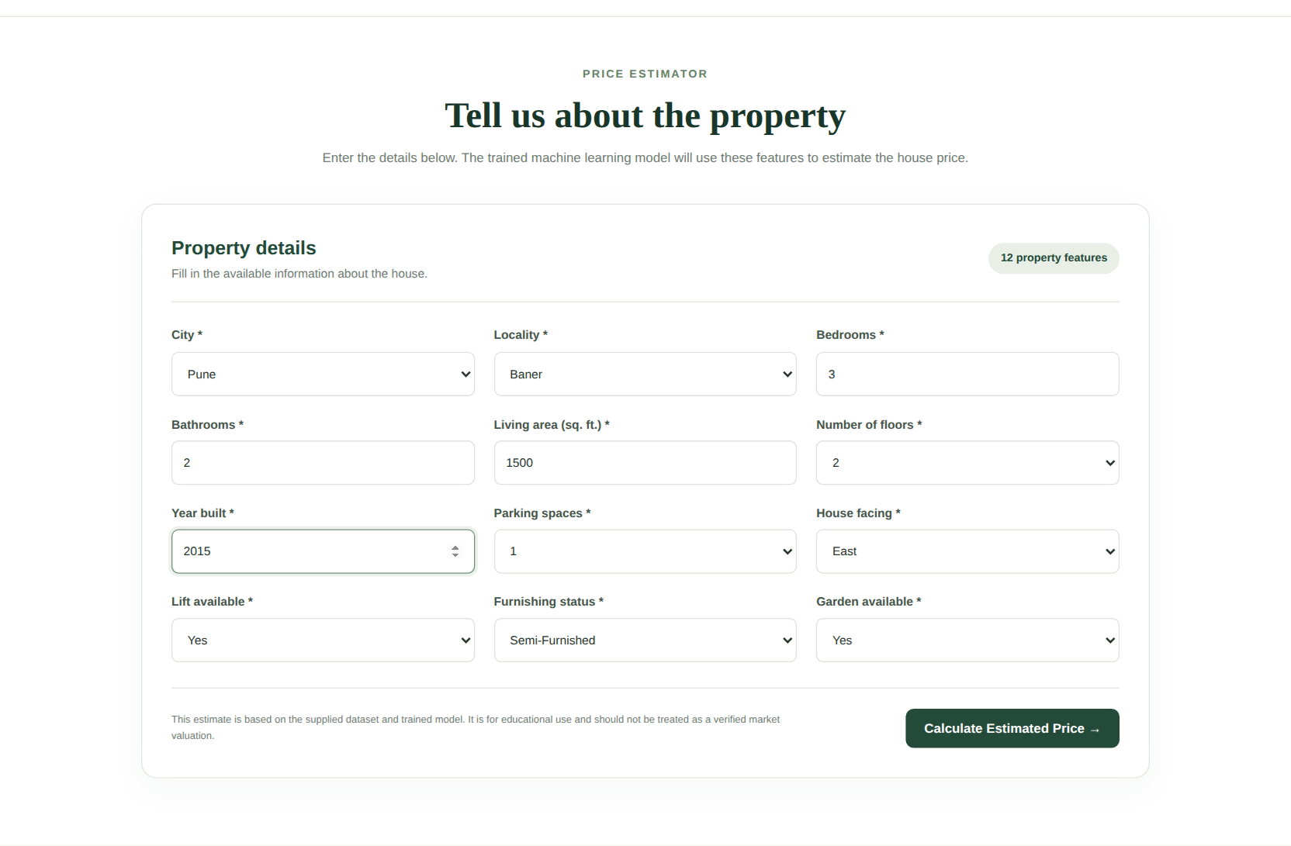
Figure 5.2: Estimator form filled with a sample property (Pune, Baner, 3 bedrooms, 1,500 sq ft)
Reading Figure 5.2. The user chooses the city and locality and enters the numeric and categorical attributes. All fields are mandatory, and the server re-validates them even if the browser checks pass.
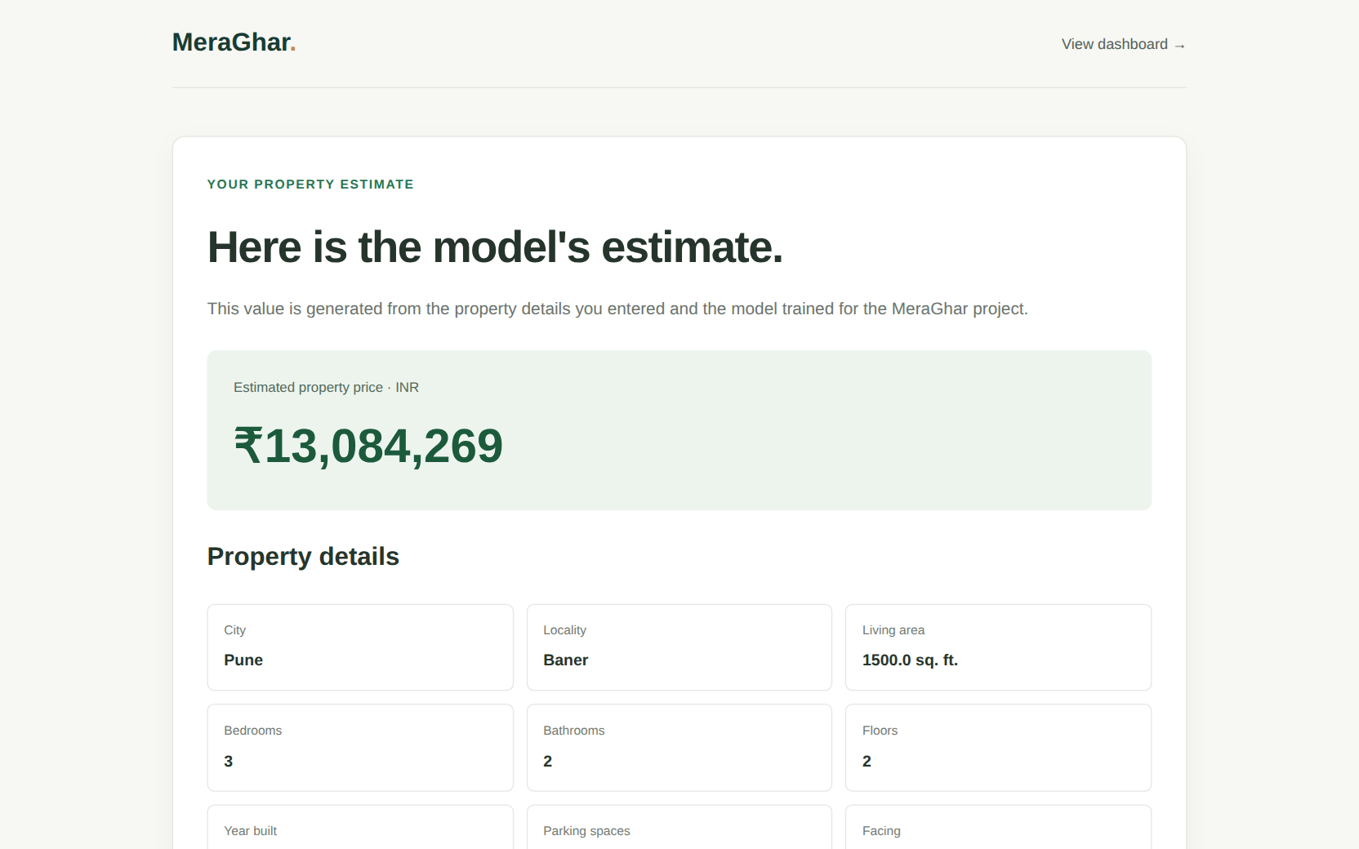
Figure 5.3: Result page showing the estimated price of ₹13,084,269 with the entered details
Reading Figure 5.3. For the sample property the model returns ₹13,084,269 (about ₹1.31 crore). Dividing by the 1,500 sq ft area gives ₹8,723 per sq ft, which agrees with the Pune average of ₹8,694 per sq ft in the data (Section 6.4.3).
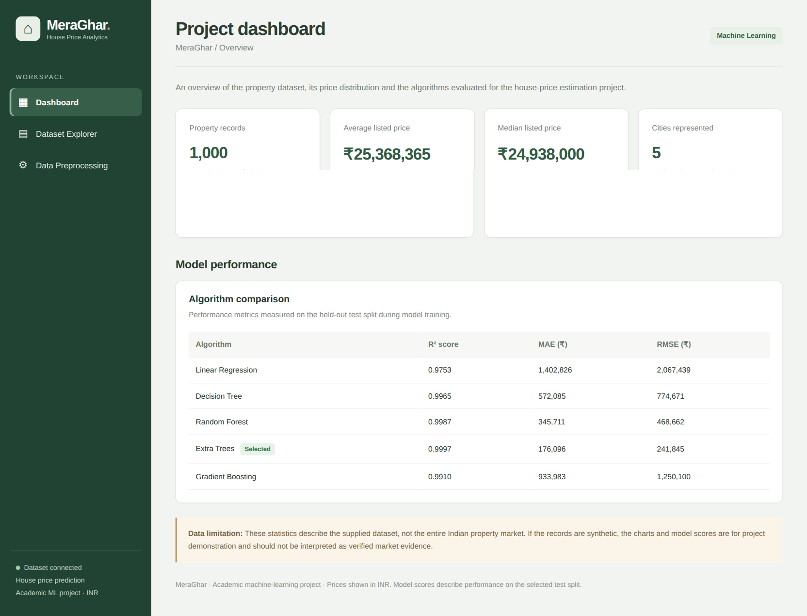
Figure 5.4: Dashboard – summary cards and algorithm comparison (chart canvases omitted in this capture)
Reading Figure 5.4. The four cards show 1,000 records, a mean price of ₹25,368,365, a median of ₹24,938,000 and 5 cities. The table lists the five algorithms and flags Extra Trees as “Selected”. The records-by-city and average-price-by-city charts, which Chart.js draws in the browser, are reproduced from the same data in Figure 6.5 and Table 19.
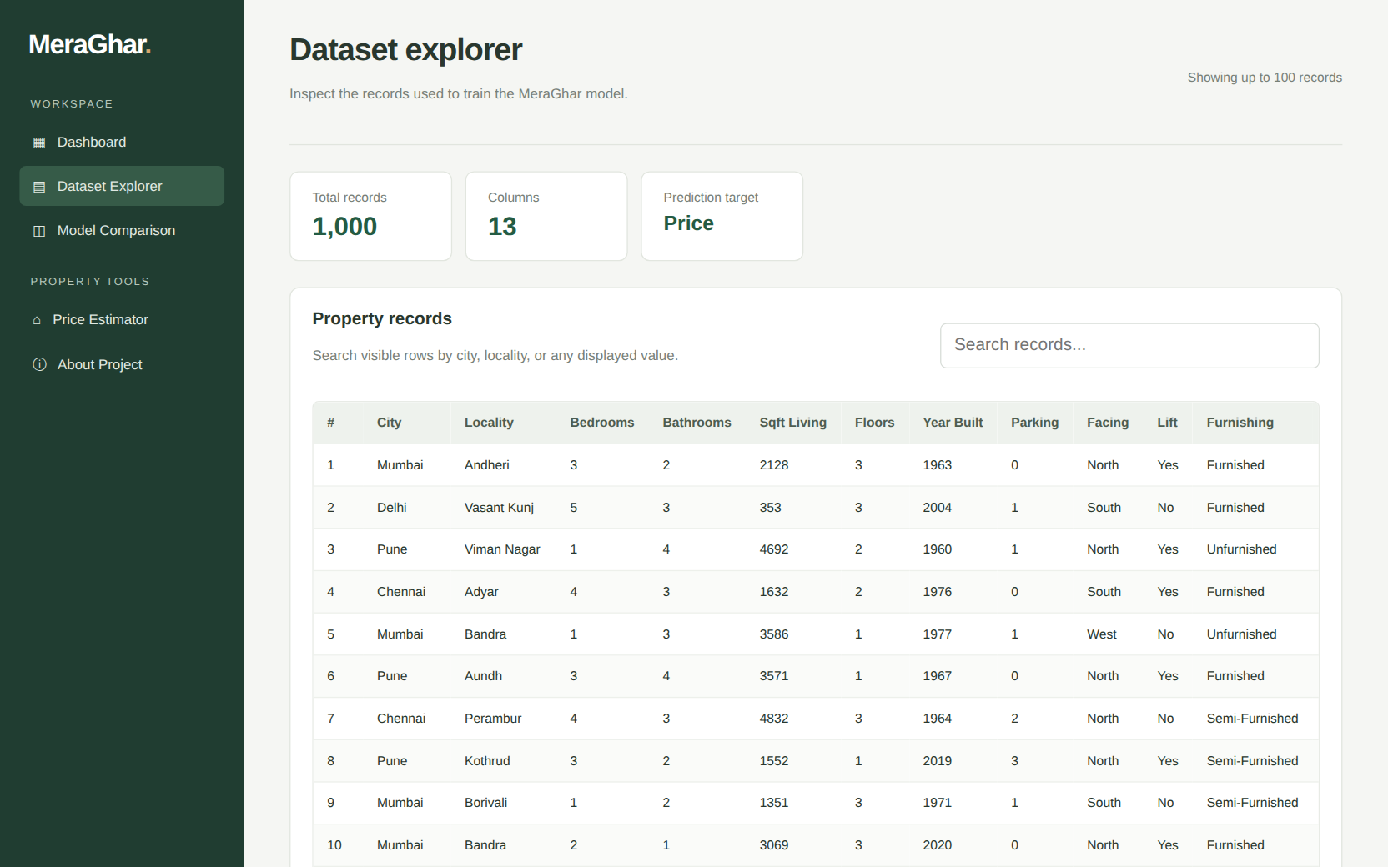
Figure 5.5: Dataset explorer with the searchable property table
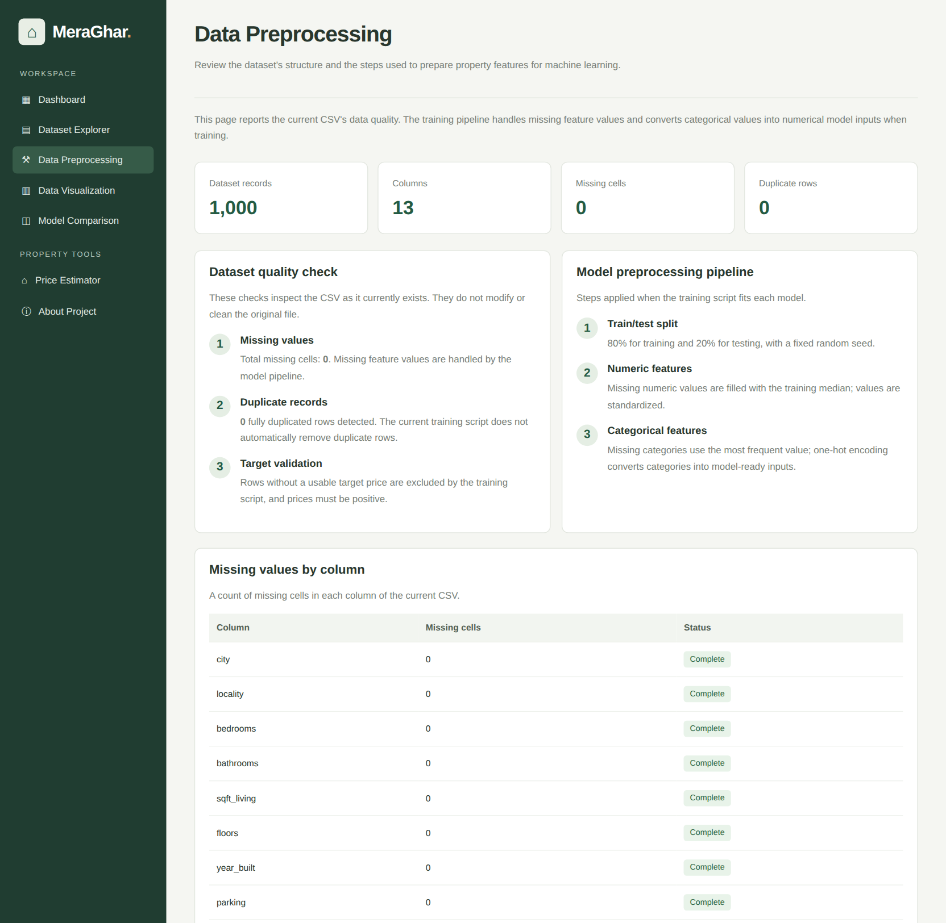
Figure 5.6: Data-preprocessing report (record counts, quality checks and pipeline steps)
Reading Figure 5.6. The report confirms 1,000 records, 13 columns, 0 missing cells and 0 duplicate rows, lists the three pipeline steps and shows that the CSV file itself is left unchanged – imputing, scaling and encoding are performed inside each fitted model.
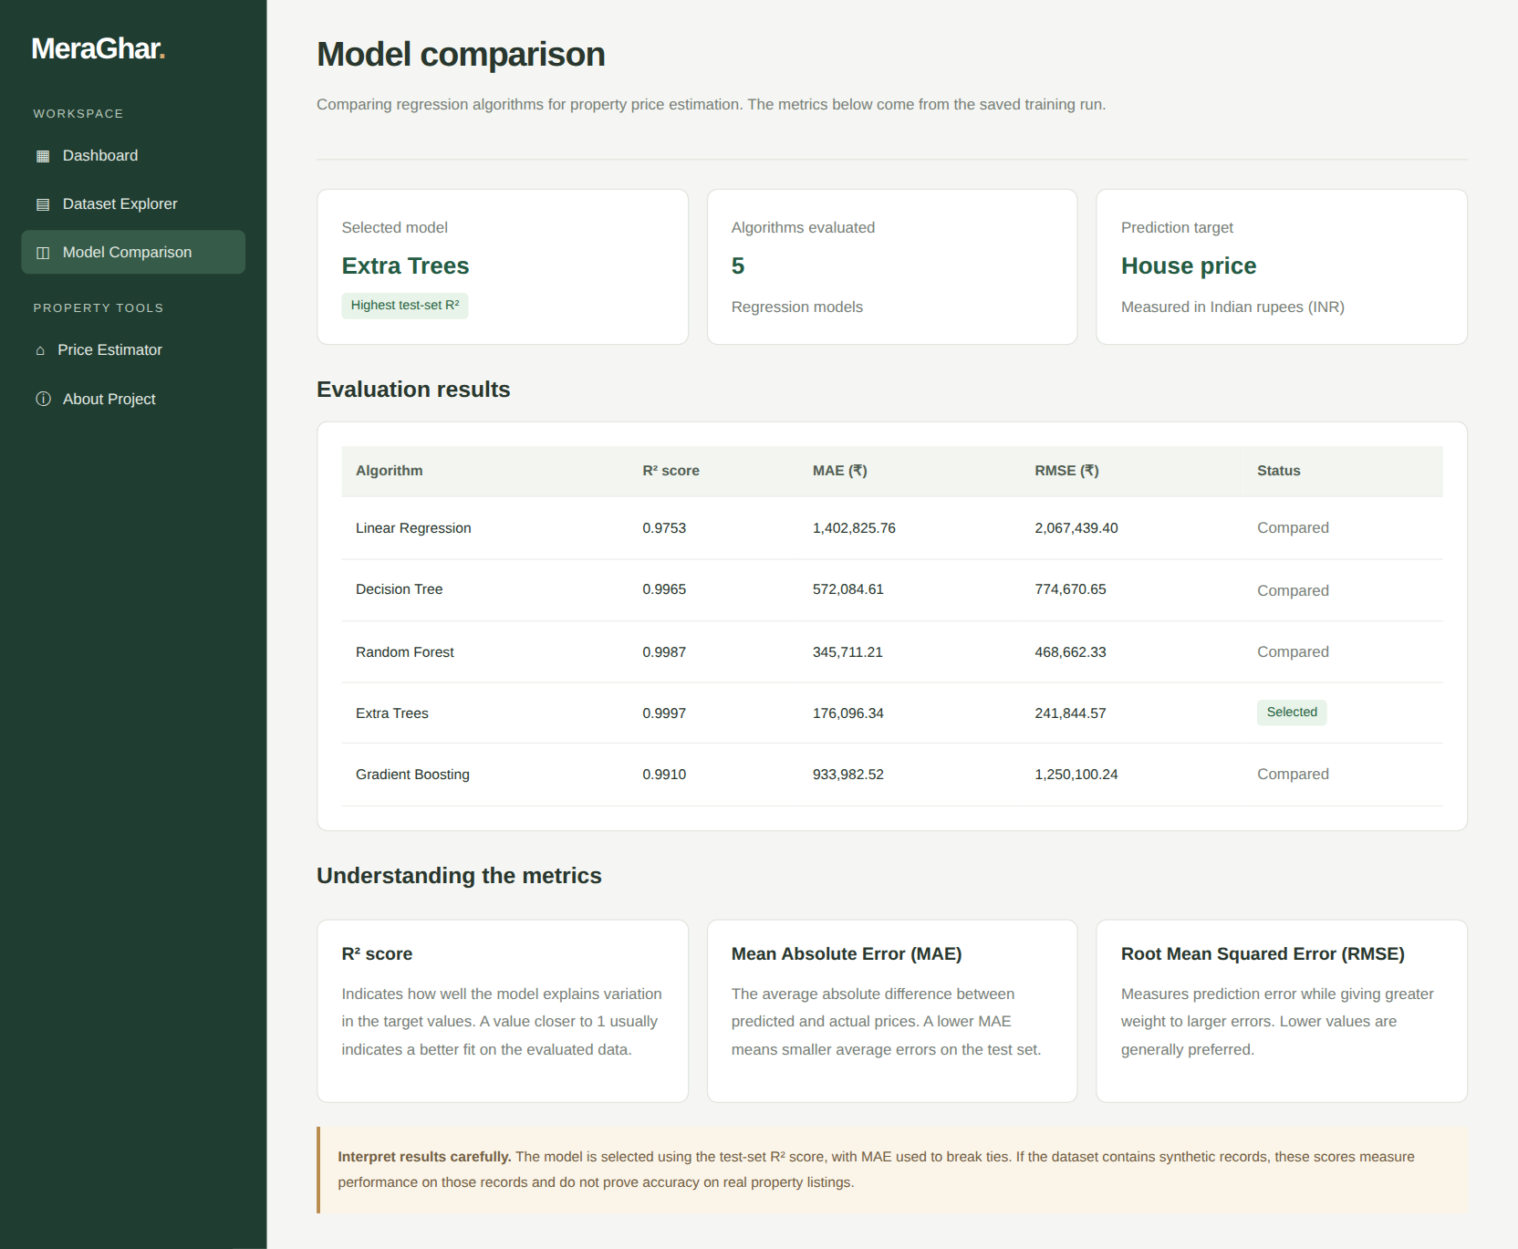
Figure 5.7: Model-comparison page with R², MAE and RMSE of the five algorithms

6. TESTING AND RESULTS

6.1 Testing Strategy
The system was evaluated through functional testing of every page and route, input-validation testing with valid and invalid values, reproducibility testing of the training script, and calculation verification of the displayed metrics. The functional and validation tests were executed against the project code with Flask’s test client in October 2026; the training results were verified by re-running train_model.py, which reproduced the stored metrics exactly. Supplementary checks that are not part of the project code – five-fold cross-validation, a per-city linear baseline and permutation importance – were run for this report to interpret the results and are labelled as such.

6.2 Test Cases
Table 15: Test cases and observed results
ID | Scenario | Input / action | Expected result | Status
TC-01 | Load pages | GET /, /dashboard, /dataset, /preprocessing, /visualization, /algorithms, /about | All seven pages return HTTP 200 | Pass (executed)
TC-02 | Valid prediction | Pune, Baner, 3 bed, 2 bath, 1,500 sq ft, 2 floors, 2015, 1 parking, East, lift, semi-furnished, garden | HTTP 200; price ₹13,084,269 shown | Pass (executed)
TC-03 | Invalid city | city = Jaipur | HTTP 400 with “valid city” message | Pass (executed)
TC-04 | Unknown locality | locality = Nowhere | HTTP 400; locality must be from dataset | Pass (executed)
TC-05 | Area too large | sqft_living = 9,000 | HTTP 400; range message | Pass (executed)
TC-06 | Area too small | sqft_living = 100 | HTTP 400; range message | Pass (executed)
TC-07 | Non-numeric input | bedrooms = abc | HTTP 400; no crash | Pass (executed)
TC-08 | Year out of range | year_built = 1800 | HTTP 400; range message | Pass (executed)
TC-09 | Invalid category | facing = Up | HTTP 400; valid facing message | Pass (executed)
TC-10 | Empty submission | POST /predict with no data | HTTP 400; no crash | Pass (executed)
TC-11 | Retraining | python train_model.py | Same R², MAE, RMSE as stored in model_comparison.json; Extra Trees selected | Pass (executed)
TC-12 | City–locality mismatch | city = Pune, locality = Andheri (a Mumbai locality) | Ideally rejected as inconsistent | Gap found: accepted (HTTP 200)
TC-13 | Responsive layout | Open on a phone-width screen | Layout remains usable (CSS media queries are present) | To be verified manually

Twelve of the thirteen cases were executed and eleven of those passed. TC-12 exposed a validation gap: the application checks that the city is valid and that the locality exists somewhere in the dataset, but it does not check that the locality belongs to the selected city, so impossible combinations are scored without warning. This is listed as a limitation and as an improvement (Section 6.6).

6.3 Evaluation Metrics
Each model is judged with three measures computed on the 200 held-out test properties:
- R² (coefficient of determination): share of the variance in price explained by the model; 1.0 is a perfect fit.
- MAE (mean absolute error): average absolute difference between predicted and actual price, in rupees.
- RMSE (root mean squared error): like MAE but squares errors first, so a few large mistakes weigh more.
For interpretation, the report also uses MAPE (mean absolute percentage error), the share of predictions within 5% of the true price, and a simple baseline.

6.4 Results and Discussion

6.4.1 Overall scorecard
Table 16 and Figure 6.1 summarise the results stored by the training script. All five models explain more than 97% of the price variance; Extra Trees is best on every measure and is therefore the model saved for prediction.
Table 16: Model comparison on the 200 test properties (as stored in model_comparison.json)
Algorithm | R² | MAE (₹) | RMSE (₹) | Status
Linear Regression | 0.9753 | 14,02,826 | 20,67,439 | Compared
Decision Tree | 0.9965 | 5,72,085 | 7,74,671 | Compared
Random Forest | 0.9987 | 3,45,711 | 4,68,662 | Compared
Extra Trees | 0.9997 | 1,76,096 | 2,41,845 | Selected
Gradient Boosting | 0.9910 | 9,33,983 | 12,50,100 | Compared

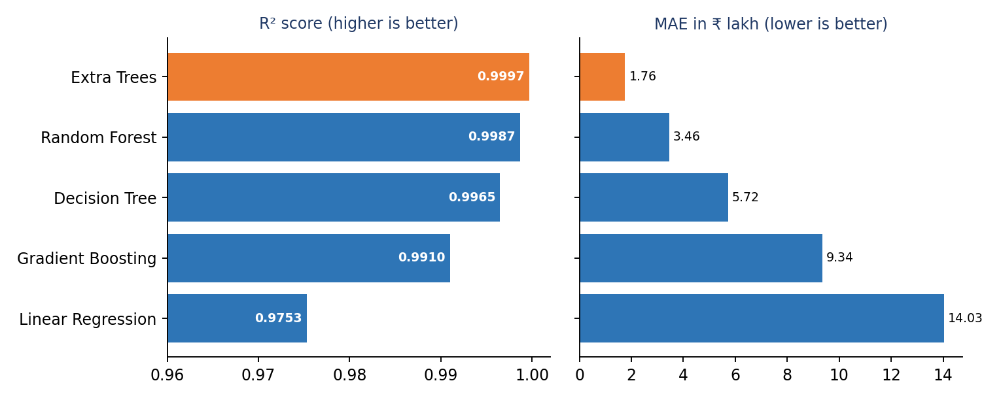
Figure 6.1: R² and MAE of the five algorithms (selected model highlighted)
The ranking by error is Extra Trees (MAE ₹1.76 lakh) < Random Forest (₹3.46 lakh) < Decision Tree (₹5.72 lakh) < Gradient Boosting (₹9.34 lakh) < Linear Regression (₹14.03 lakh). Extra Trees’ MAE is about 8 times smaller than that of Linear Regression, even though the R² values (0.9997 and 0.9753) look close – a reminder that R² saturates near 1 and that MAE in rupees is the more informative measure here. A supplementary five-fold cross-validation gave the same ranking (Table 17), so the choice of Extra Trees does not depend on one lucky split.
Table 17: Supplementary check – train R² and five-fold cross-validated R² (run for this report)
Algorithm | Train R² | Test R² (80/20) | 5-fold CV R² (mean ± sd)
Linear Regression | 0.9821 | 0.9753 | 0.9793 ± 0.0022
Decision Tree | 0.9985 | 0.9965 | 0.9968 ± 0.0006
Random Forest | 0.9997 | 0.9987 | 0.9987 ± 0.0004
Extra Trees | 0.9999 | 0.9997 | 0.9997 ± 0.0002
Gradient Boosting | 0.9956 | 0.9910 | 0.9932 ± 0.0012

The gap between train and test R² is below 0.007 for every model, so there is no sign of overfitting; the very small standard deviations show that the scores are stable across folds.

6.4.2 Accuracy of the selected model (Extra Trees)
Figure 6.2 plots predicted against actual prices for the 200 test properties. The points lie almost exactly on the diagonal. Figure 6.3 shows the distribution of the prediction errors.
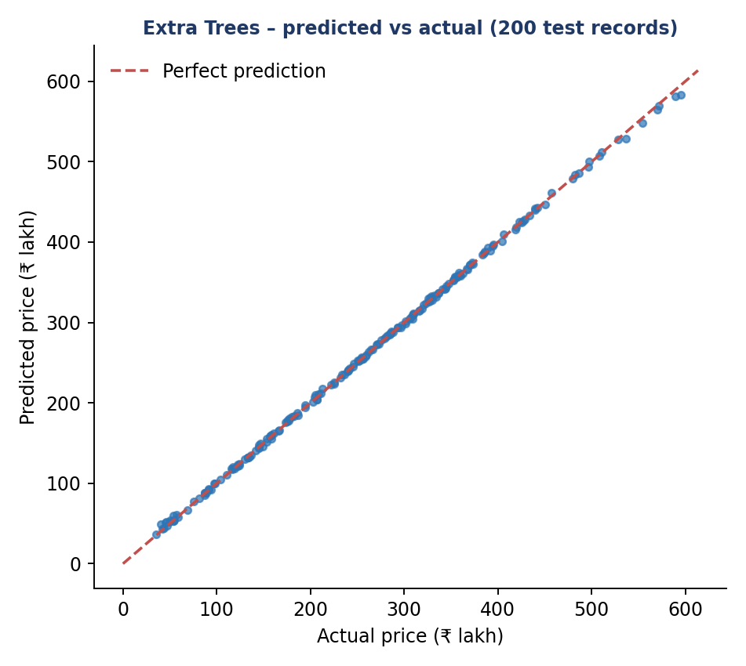
Figure 6.2: Predicted vs actual price for the 200 test properties
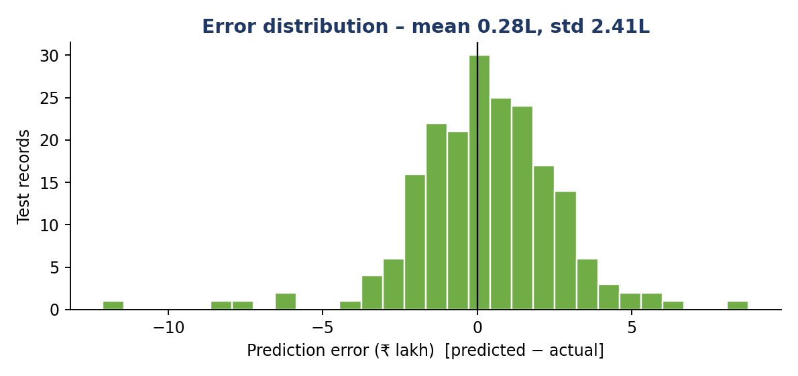
Figure 6.3: Distribution of prediction errors (predicted − actual)
Table 18: Error profile of Extra Trees on the test set
Measure | Value | Meaning
MAE | ₹1.76 lakh | Average absolute error
RMSE | ₹2.42 lakh | Typical error, large mistakes weighted more
MAPE | 1.10% | Average error relative to the true price
Mean error | +₹0.28 lakh | Very slight over-prediction on average
Standard deviation of error | ₹2.41 lakh | Spread of the errors around the mean
Largest absolute error | ₹12.13 lakh | Worst single property
Within 5% of true price | 97.0% of properties | Share of predictions with relative error under 5%
Within ₹10 lakh | 99.5% of properties | Share of predictions with absolute error under ₹10 lakh

6.4.3 Price patterns in the data
Figure 6.4 shows the distribution of prices. The values range from ₹28.72 lakh to ₹6.01 crore with a mean of ₹2.54 crore and a median of ₹2.49 crore; the distribution is broad and roughly symmetric rather than strongly skewed, which is unusual for real property data, where a few very expensive homes normally create a long right tail.
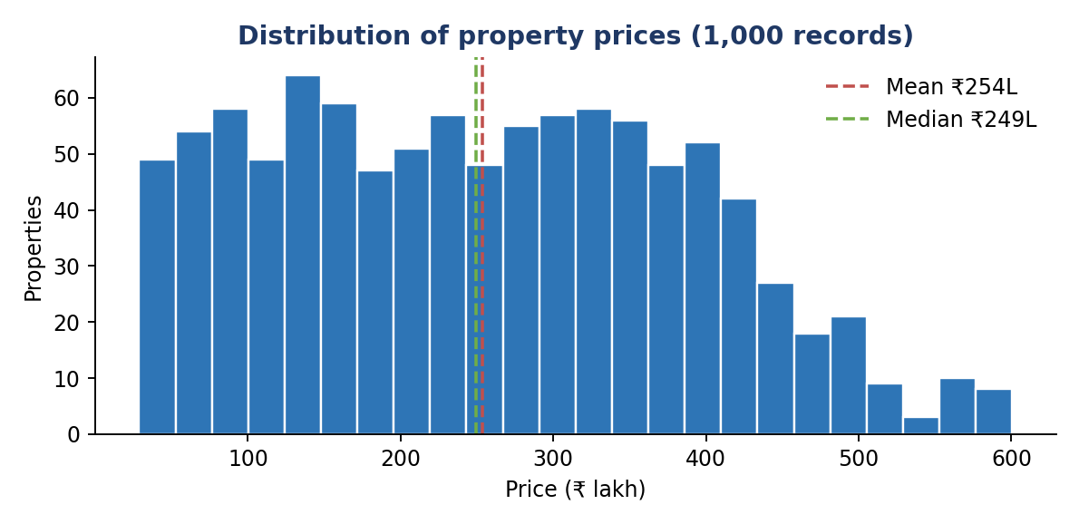
Figure 6.4: Distribution of property prices
Prices differ clearly by city (Figure 6.5). Mumbai is the most expensive (mean ₹3.15 crore), followed by Delhi (₹2.61 crore), Bengaluru (₹2.49 crore), Pune (₹2.34 crore) and Chennai (₹2.12 crore). Mumbai’s mean is about 49% higher than Chennai’s. Because the dataset is balanced across cities, this difference is not an artefact of sample size.
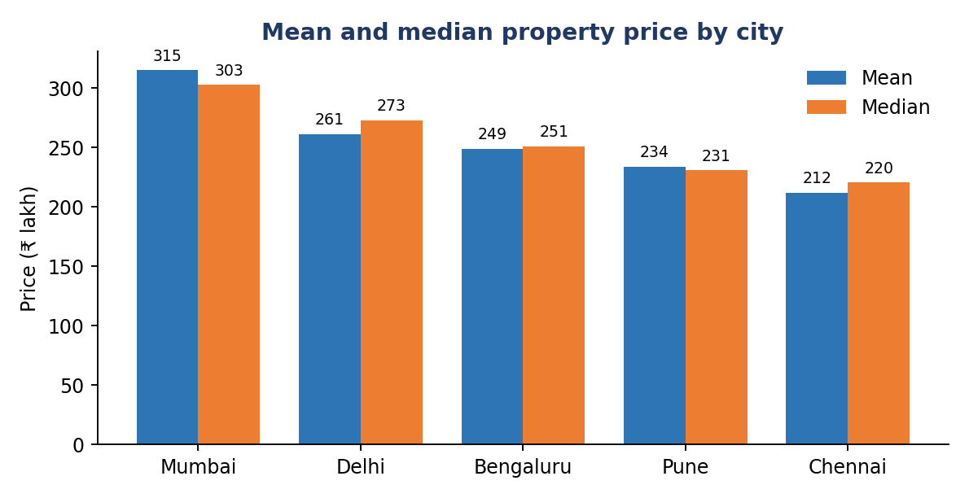
Figure 6.5: Mean and median price by city (₹ lakh)
Table 19: City-level summary
City | Records | Mean price (₹) | Median price (₹) | Price per sq ft (₹)
Mumbai | 201 | 3,14,84,199 | 3,02,68,000 | 12,209
Delhi | 190 | 2,61,06,184 | 2,72,60,000 | 10,232
Bengaluru | 197 | 2,48,70,198 | 2,51,03,000 | 9,215
Pune | 207 | 2,33,72,396 | 2,30,68,500 | 8,694
Chennai | 205 | 2,11,82,200 | 2,20,44,000 | 8,197

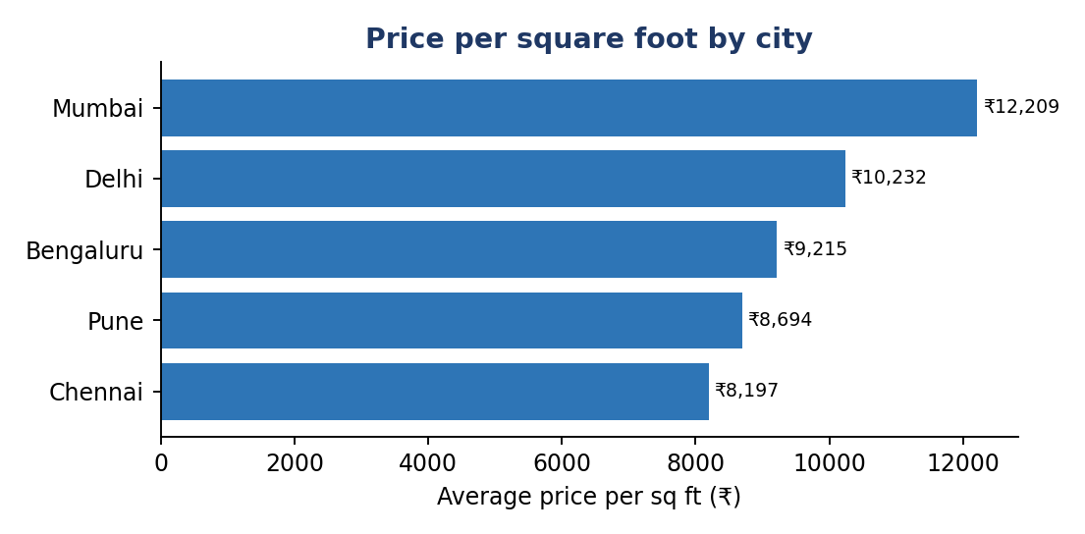
Figure 6.6: Average price per square foot by city
Price per square foot gives the cleanest comparison between cities: ₹12,209 in Mumbai against ₹8,197 in Chennai. Locality averages (Figure 6.7) are dominated by the city they belong to – all five Mumbai localities (Bandra ₹3.35 crore, Borivali ₹3.21 crore, Andheri ₹3.10 crore, Powai ₹3.03 crore, Juhu ₹2.99 crore) lie above every Chennai locality (from T Nagar ₹1.94 crore to Anna Nagar ₹2.19 crore). Once city and area are known, locality adds almost nothing (Section 6.4.5).
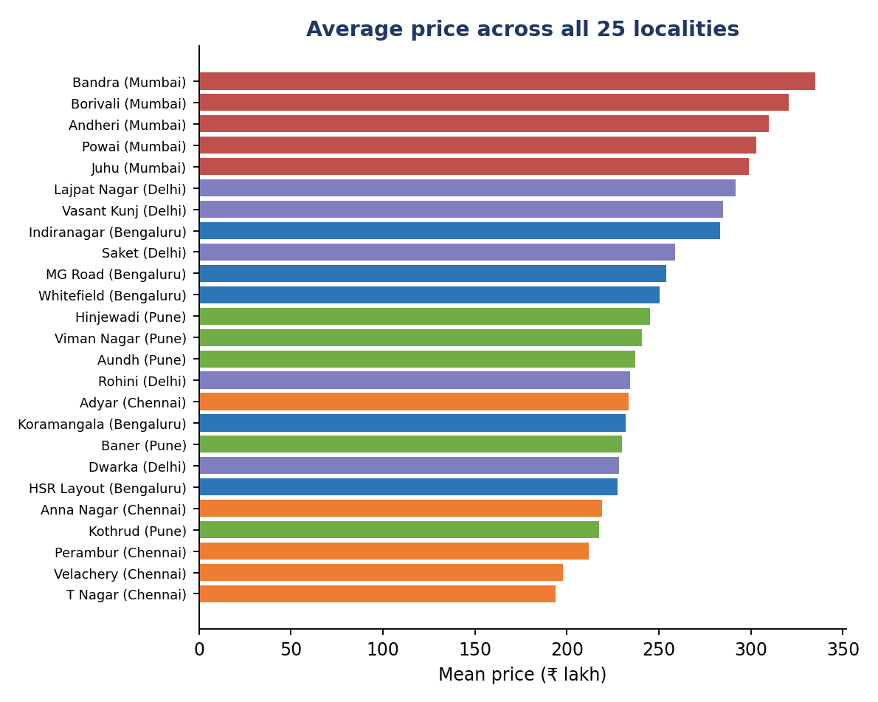
Figure 6.7: Average price of the 25 localities, coloured by city

6.4.4 What drives the price?
Living area is by far the strongest driver. Figure 6.8 shows an almost perfectly straight line for each city, and the lines are ordered by city price level.
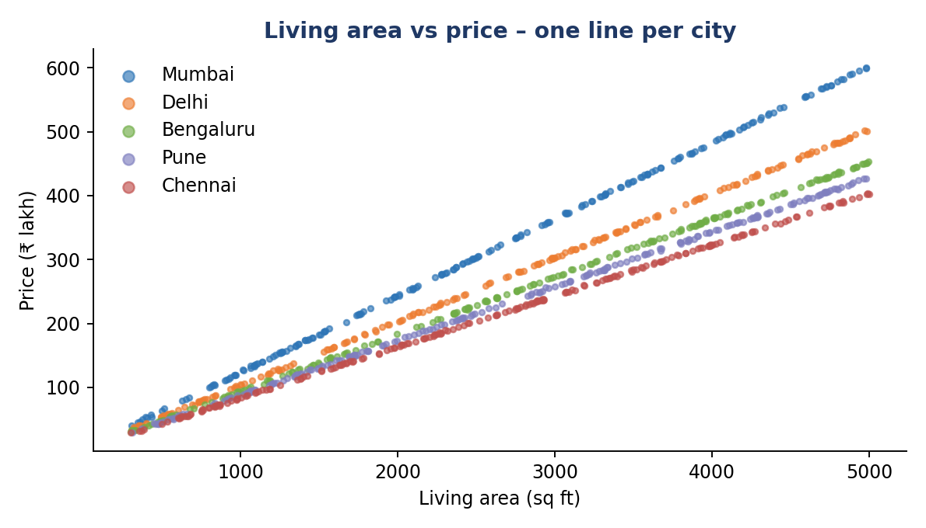
Figure 6.8: Living area vs price for all 1,000 properties, coloured by city
The correlation matrix (Figure 6.9) confirms this: price has a correlation of 0.951 with living area, while bedrooms (0.025), bathrooms (−0.028), floors (0.038), year built (0.030) and parking (0.021) are essentially uncorrelated with price. In a real market one would expect more bedrooms, newer construction and more parking to raise the price at a given area.
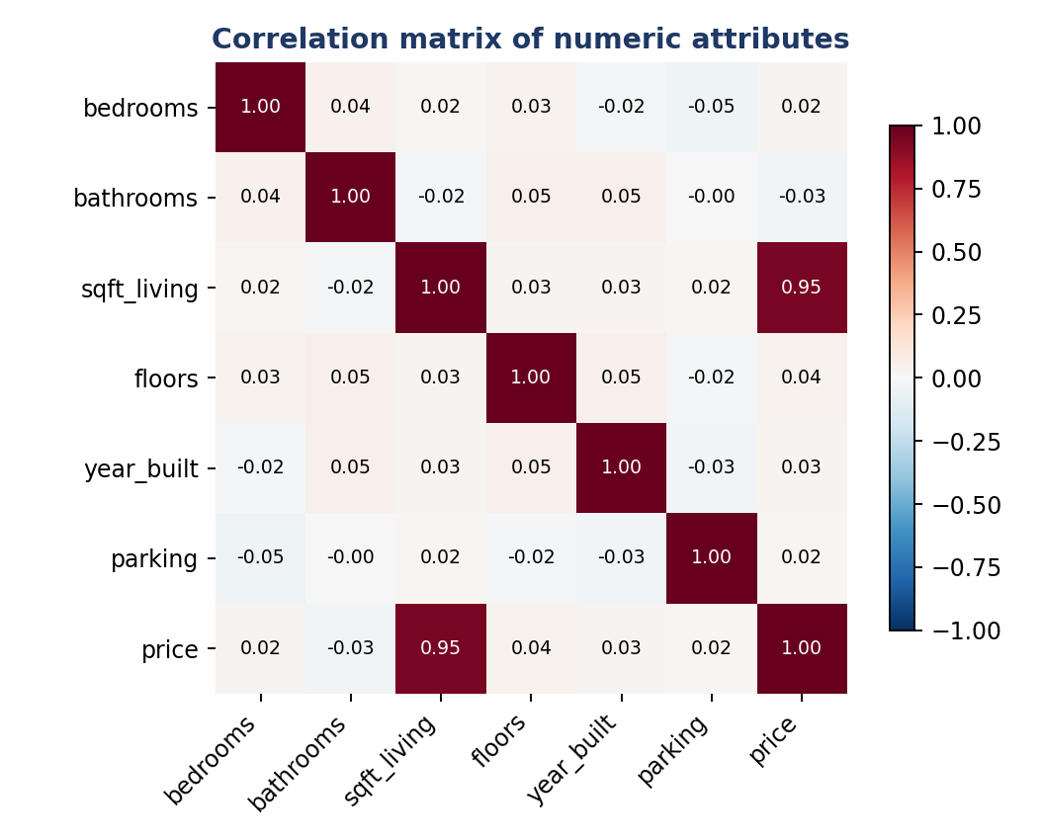
Figure 6.9: Correlation matrix of numeric attributes
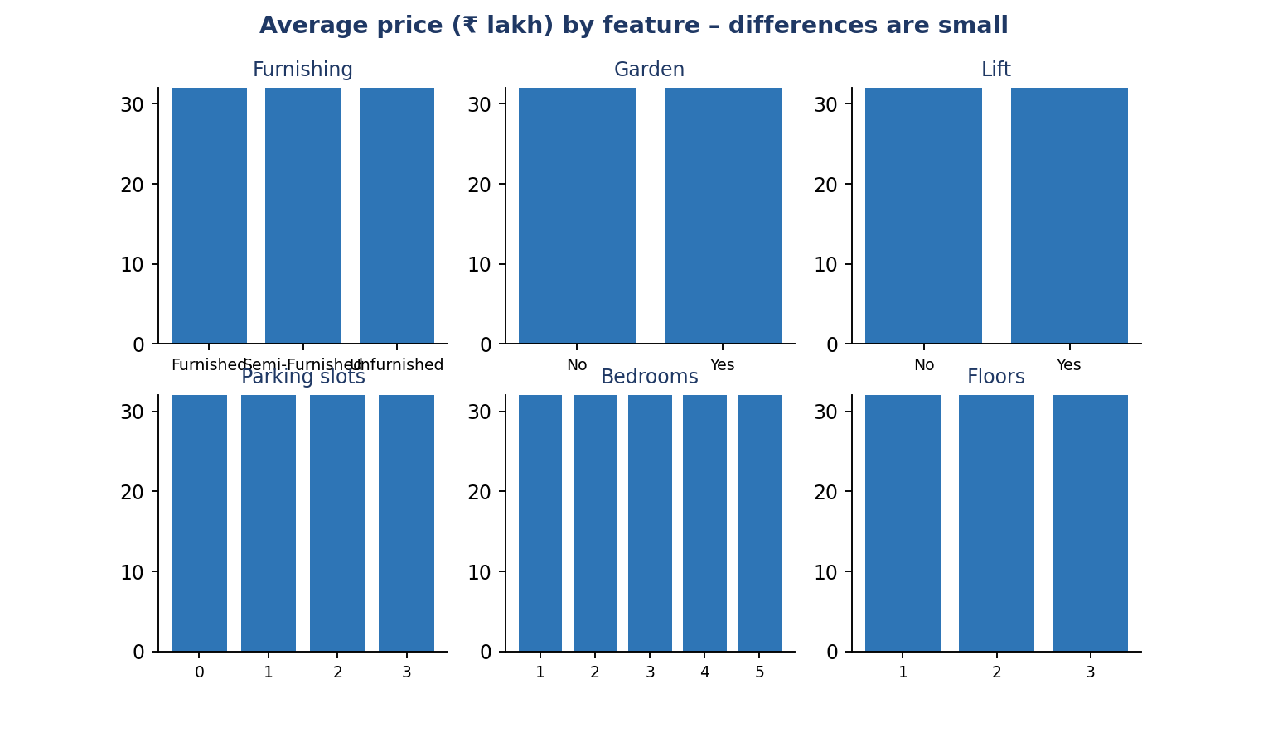
Figure 6.10: Average price (₹ lakh) by furnishing, garden, lift, parking, bedrooms and floors
Figure 6.10 shows that the average price barely changes across these features. For example, properties with a garden average ₹2.58 crore against ₹2.50 crore without, and furnished, semi-furnished and unfurnished homes average ₹2.54, ₹2.61 and ₹2.46 crore. These small differences are consistent with random variation in city and area mix rather than with a true amenity premium.
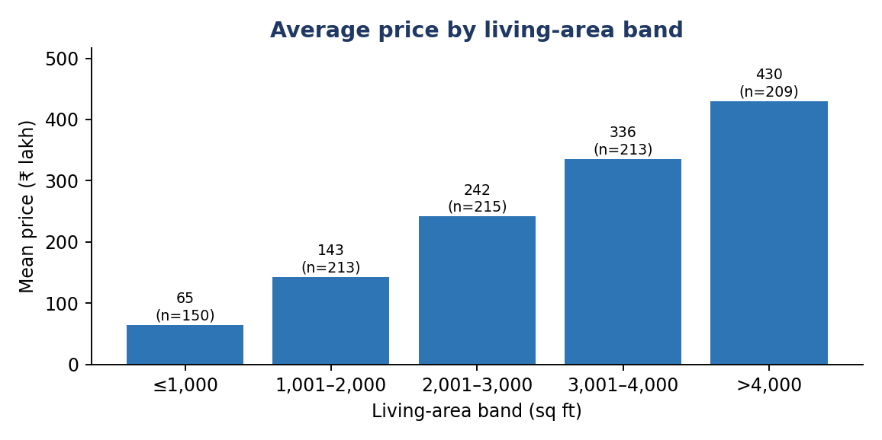
Figure 6.11: Average price by living-area band
By contrast, the average price rises steadily with area: ₹64.9 lakh for homes up to 1,000 sq ft, ₹1.43 crore for 1,001–2,000 sq ft, ₹2.42 crore, ₹3.36 crore and ₹4.30 crore for the larger bands – roughly ₹9 lakh for every additional 100 sq ft on average (Figure 6.11).

6.4.5 Feature importance
To find out what the selected model actually uses, permutation importance was computed on the test set: each feature in turn is shuffled and the drop in R² is recorded. Figure 6.12 shows that living area (drop of 1.86 in R²) and city (0.21) are the only features that matter. For bedrooms, bathrooms, floors, year built, parking, facing, lift, furnishing, garden and locality the drop is 0.000 to three decimals – shuffling them does not change the predictions in any measurable way.
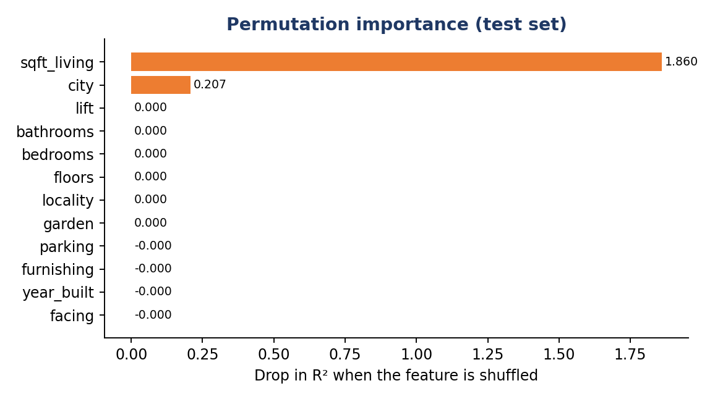
Figure 6.12: Permutation importance of the 12 input features (supplementary analysis)
This explains why the estimator’s output barely reacts to most inputs. Holding a Pune (Kothrud) flat of 1,800 sq ft fixed and changing only the number of bedrooms from 1 to 5, the predicted price moves between ₹157.0 and ₹158.0 lakh – a spread of under 1%.

6.4.6 Error analysis by city
The prediction error is not the same in every city (Table 20). Mumbai has the largest absolute error (MAE ₹2.72 lakh) – about twice that of the other four cities (₹1.38–1.54 lakh) – because the same percentage error corresponds to more rupees on higher prices.
Table 20: Mean absolute error by city on the test set (₹ lakh)
City | Pune | Chennai | Delhi | Bengaluru | Mumbai
MAE (₹ lakh) | 1.38 | 1.45 | 1.46 | 1.54 | 2.72

6.4.7 Is the dataset realistic? A critical check
The scores in Table 16 are exceptionally high for house-price data. Real listings carry noise from negotiation, condition, floor, view and builder reputation, so scores this close to 1.0 would be surprising on genuine market data. Three observations suggest that this dataset is synthetic:
- Within each city the correlation between living area and price is 1.000 (to three decimals) – price is essentially “rate × area”. The coefficient of variation of price per square foot inside a city is only 1.8–2.6%.
- Bedrooms, bathrooms, floors, building age, parking, facing, lift, furnishing and garden – all of which influence real prices – have no measurable effect (Sections 6.4.4 and 6.4.5).
- A deliberately simple baseline – a separate straight line of price against area for each city, fitted on the same training records – achieves R² = 0.9999 and MAE = ₹0.75 lakh on the same test records, better than the selected Extra Trees model (R² 0.9997, MAE ₹1.76 lakh).
The third point also explains the model ranking. Plain Linear Regression scores lowest (R² 0.9753) not because the relationship is complicated, but because one global line cannot represent that the price per square foot is different in every city – an interaction between city and area. Tree-based models learn this interaction automatically, and Extra Trees’ random split points give a smooth approximation of the straight lines, which is why it wins among the five algorithms. It should therefore be read as the best of the five tested algorithms on this dataset, not as evidence of accuracy on real market data. The project’s own About and Model Comparison pages state the same caution.

6.4.8 Model response curves
Figure 6.13 shows what the deployed model returns for the same property (3 bedrooms, 2 bathrooms, 2 floors, built 2010, one parking space, East facing, lift, semi-furnished, garden) in five cities as the living area grows. Prices rise almost linearly, and the city decides the slope. Table 21 gives three points on the curves.
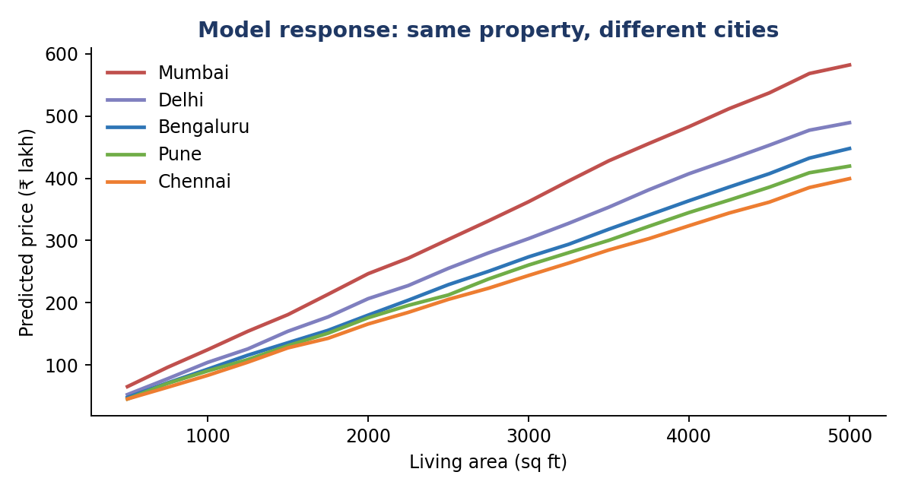
Figure 6.13: Predicted price vs living area for the same property in five cities
Table 21: Predicted price (₹ lakh) of the same property in different cities
City (locality used) | 500 sq ft | 2,000 sq ft | 3,500 sq ft
Mumbai (Andheri) | 65.3 | 246.7 | 428.0
Delhi (Dwarka) | 52.5 | 206.6 | 353.5
Bengaluru (Koramangala) | 48.0 | 180.2 | 318.1
Pune (Kothrud) | 45.4 | 175.9 | 300.3
Chennai (Adyar) | 45.5 | 165.9 | 284.8

At 3,500 sq ft the same property is estimated at ₹4.28 crore in Mumbai and ₹2.85 crore in Chennai – a difference of about 50%, in line with the price-per-square-foot gap in Table 19.

6.5 Key Findings
- MeraGhar turns a 1,000-record property file into a working estimator, a data-quality report, visual analysis and an objective five-model comparison, all consistent with one another.
- Extra Trees is the best of the five algorithms (R² 0.9997, MAE ₹1.76 lakh, RMSE ₹2.42 lakh, MAPE 1.10%); 97% of test predictions are within 5% of the true price, and cross-validation confirms the ranking.
- Linear Regression is the weakest (R² 0.9753, MAE ₹14.03 lakh) because it cannot model the city × area interaction; tree ensembles can.
- Living area (correlation 0.95) and city explain essentially all of the price variation; every other feature has a permutation importance of about zero.
- Prices differ strongly by city: Mumbai costs ₹12,209 per sq ft against ₹8,197 in Chennai, about 49% more.
- A per-city straight-line baseline (R² 0.9999) beats the selected model, which together with the perfectly linear structure indicates that the dataset is synthetic; the scores demonstrate the workflow, not real-market accuracy.
- Server-side validation rejects invalid values (all 8 invalid-input tests passed), but the city–locality consistency check is missing.

6.6 Recommendations for Improvement
Table 22: Observed limitation and suggested improvement
Observation | Suggested improvement | Expected benefit
Dataset appears synthetic (price ≈ rate × area) | Replace or augment with real listings (e.g. portal exports or registered sale data) with noise, more cities and time stamps | Scores that reflect real-market performance; meaningful effect of bedrooms, age and amenities
Locality is not checked against the selected city (TC-12) | Filter the locality list by city in the form and validate the pair on the server | No impossible combinations are scored
Single 80/20 split used for model selection | Use k-fold cross-validation inside train_model.py and report mean ± standard deviation | More reliable model choice
Only a single point estimate is shown | Show a prediction interval (e.g. from tree variance or quantile models) | Users see the uncertainty of the estimate
Model file tied to one scikit-learn version; requirements not pinned | Pin library versions in requirements.txt and store the version check in the app | Reproducible deployment
Chart.js loaded from a CDN; Flask debug mode enabled in app.py | Serve Chart.js locally; run with debug off under Gunicorn | Works offline and is safer in production
No explanation of an individual estimate | Add feature-contribution or SHAP-style explanation on the result page | Transparency for the user
No historical data | Add listing dates and build the star schema as a real warehouse | Trend analysis and price forecasting

6.7 Result Evaluation Areas
Table 23: Result evaluation areas
Evaluation area | Verification approach | Expected contribution
Page availability | Request all seven pages (TC-01) | Confirms that the application runs end to end
Metric reproducibility | Re-run train_model.py and compare with model_comparison.json (TC-11) | Confirms that the reported scores are reproducible
Input validation | Send invalid categories, ranges and text (TC-03 to TC-10) | Confirms that bad data never reaches the model
Model stability | Five-fold cross-validation and train/test comparison (Table 17) | Confirms that Extra Trees is not a lucky split or an overfit
Feature relevance | Permutation importance and correlation matrix | Shows which inputs actually drive the estimate
Data realism | Per-city linear baseline and price-per-sq-ft spread | Shows how far the scores can be trusted
Responsive design | Open on varied screen widths (TC-13) | Supports accessibility; still to be verified

6.8 Learning Outcomes
- Building a complete machine-learning workflow – data checks, pipeline, model comparison, persistence and deployment – and serving it through a web application.
- Understanding why preprocessing belongs inside the pipeline so that training and prediction use identical transformations.
- Recognising that a very high score has to be interpreted against a simple baseline and against the realism of the data (R² 0.9997 versus a straight-line baseline of 0.9999).
- Learning why tree ensembles outperform plain linear regression when interactions such as city × area exist.
- Applying data-warehousing ideas – dimensional modelling and OLAP-style roll-up, drill-down and slice – to a real-estate dataset.
- Appreciating the importance of server-side validation and of testing for logical gaps such as mismatched city and locality.

7. CONCLUSION AND FUTURE SCOPE

7.1 Conclusion
MeraGhar – House Price Prediction System was developed as a web-based machine-learning prototype that estimates the price of a residential property in five Indian cities from 12 attributes. The training script compares five regression algorithms in a reproducible scikit-learn pipeline and automatically stores the best one – Extra Trees, with R² = 0.9997 and a mean absolute error of ₹1.76 lakh on 200 held-out properties. The Flask application validates every input, returns an estimate in about 15 milliseconds and is complemented by a dashboard, dataset explorer, preprocessing report, visualization page and model-comparison page.
The case study demonstrates core data-warehousing and data-mining principles: structured analytical data, dimensional modelling, data cleaning and transformation, supervised learning, and metric-based evaluation. The critical analysis shows that tool output must be read carefully. The excellent scores are explained by a dataset whose price is almost exactly “city rate × living area”; a simple per-city straight line is as good as the best model, and ten of the twelve inputs have no measurable influence. The project therefore succeeds as a demonstration of the complete workflow, while real-market accuracy would require real listing data.
The source code is available at https://github.com/Ankit45Akash/MeraGhar. Before operational use, the system should be trained on verified market data and strengthened with a city–locality consistency check, authentication, HTTPS, pinned dependencies, monitoring and a non-debug production server.

7.2 Limitations
- The dataset appears synthetic and contains only 1,000 records from five cities; the scores do not establish accuracy on real property listings.
- Only living area and city influence the estimate; bedrooms, age, amenities and locality have no measurable effect, which would not hold in a real market.
- The locality is not validated against the selected city, so impossible combinations are accepted (TC-12).
- Model selection uses a single 80/20 split; cross-validation was only run as a supplementary check.
- The application returns a single number without a confidence interval or explanation.
- The saved model is tied to the scikit-learn version used for training, and library versions are not pinned.
- Duplicate rows are reported but not removed by the training script (none exist in the current file).
- Flask runs with debug mode in app.py and there is no authentication, logging or rate limiting; this is acceptable for a classroom demo only.
- No time dimension: the system cannot model price trends or inflation.

7.3 Future Scope
- Train on real listing and registration data with more cities, localities, property types and listing dates.
- Add cross-validated hyper-parameter tuning (grid or random search) and additional models such as XGBoost or LightGBM.
- Show prediction intervals and per-estimate explanations (feature contributions) on the result page.
- Filter localities by the chosen city and validate the pair on the server.
- Build the star schema as a real data warehouse with a date dimension and scheduled loads, and add OLAP-style drill-down dashboards.
- Add price-trend forecasting, a “compare two properties” view and a map-based locality explorer.
- Provide a REST API and a mobile-friendly progressive web app.
- Add user accounts, saved searches, audit logging and secure deployment (HTTPS, environment-based configuration).
- Automate retraining and drift monitoring when new data arrives.

REFERENCES
- J. Han, M. Kamber and J. Pei, Data Mining: Concepts and Techniques, 3rd ed., Morgan Kaufmann.
- R. Kimball and M. Ross, The Data Warehouse Toolkit: The Definitive Guide to Dimensional Modeling, Wiley.
- S. Rosen, “Hedonic prices and implicit markets: product differentiation in pure competition,” Journal of Political Economy, vol. 82, no. 1, pp. 34–55, 1974.
- B. Park and J. K. Bae, “Using machine learning algorithms for housing price prediction: the case of Fairfax County, Virginia housing data,” Expert Systems with Applications, vol. 42, no. 6, pp. 2928–2934, 2015.
- L. Breiman, J. Friedman, R. Olshen and C. Stone, Classification and Regression Trees, Wadsworth, 1984.
- L. Breiman, “Random forests,” Machine Learning, vol. 45, no. 1, pp. 5–32, 2001.
- P. Geurts, D. Ernst and L. Wehenkel, “Extremely randomized trees,” Machine Learning, vol. 63, no. 1, pp. 3–42, 2006.
- J. H. Friedman, “Greedy function approximation: a gradient boosting machine,” Annals of Statistics, vol. 29, no. 5, pp. 1189–1232, 2001.
- F. Pedregosa et al., “Scikit-learn: machine learning in Python,” Journal of Machine Learning Research, vol. 12, pp. 2825–2830, 2011.
- M. Grinberg, Flask Web Development, 2nd ed., O’Reilly Media.
- MeraGhar – House Price Prediction System, source-code repository, https://github.com/Ankit45Akash/MeraGhar, accessed October 10, 2026.

