**How To run the Project**

1. First, you have to download the XAMPP software which will serve as the host for our project.

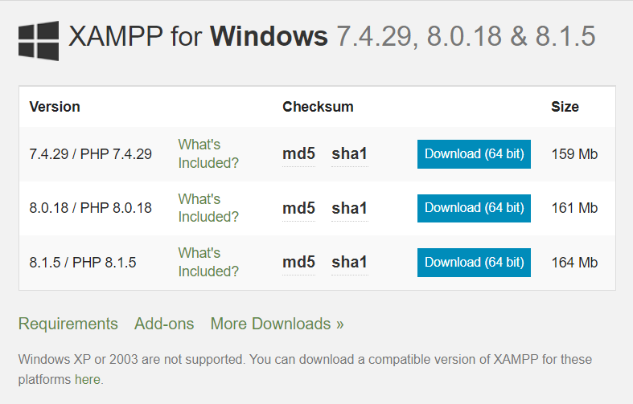

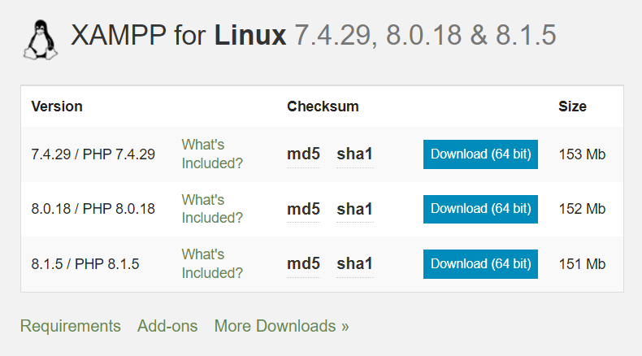

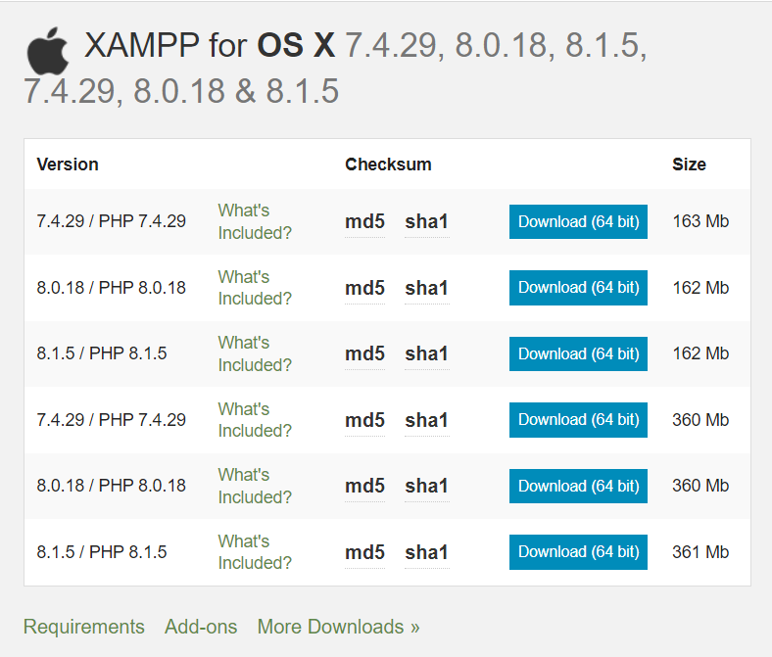

Download the software according to your system from the site <https://www.apachefriends.org/download.html>

1. Now you have to install the XAMPP software on your system.
2. Then you have to download and unzip the folder named Project_Data-main,containing the code for the project.
3. Now you have to open the xampp folder. Inside the folder go to a folder named htdocs and place your unzipped file there.
4. Now you have to run the xampp app on your system and start the Apache and MySql modules.

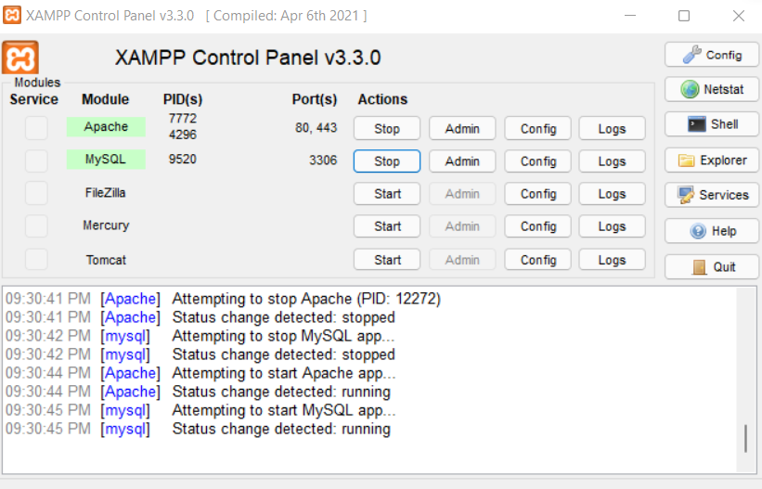

1. For the next step go to your web browser and type <http://localhost/phpmyadmin/>
2. Click on New and create a database named tour.

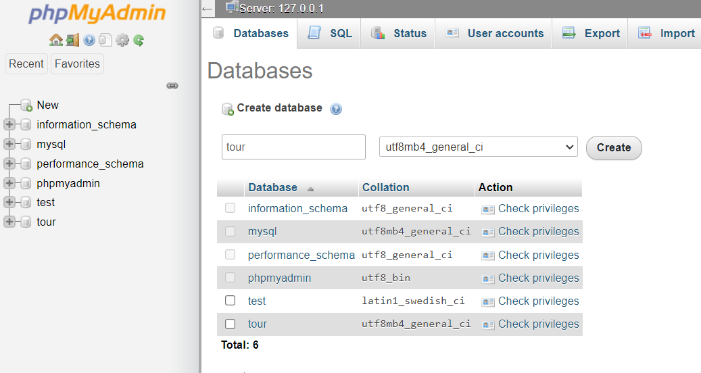

1. Click on the database and go to import and import tour.sql from Project_Data-main to the database.

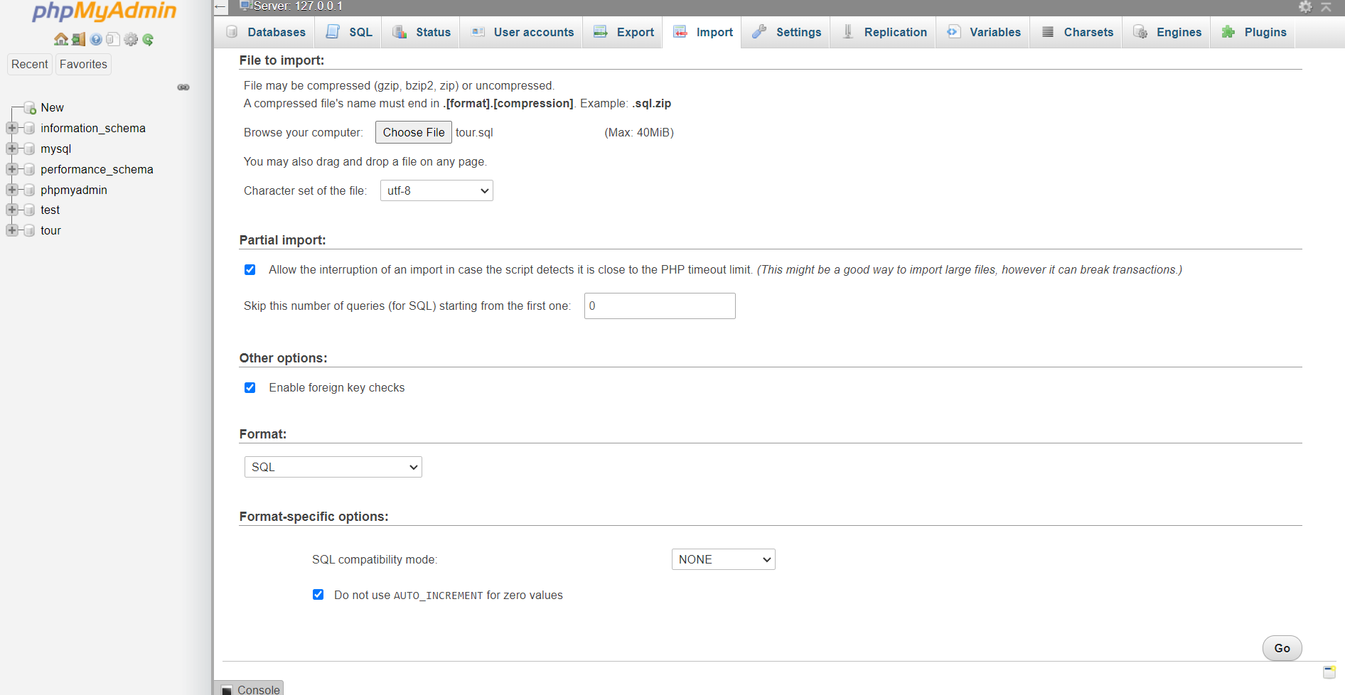

1. After clicking on go, open new tab in your browser and type <http://localhost/Project_Data-main/index.php> and you will be able to access the project.