**Demo Website**

*<!*DOCTYPE html*>*

*<*html lang="en"*>*

*<*head*>*

*<*meta charset="UTF-8"*>*

*<*meta name="viewport" content="width=device-width, initial-scale=1.0"*>*

*<*title*>*Document*</*title*>*

*<*style*>*

        body{

            margin: 0px;

            padding: 0px;

        }

       #header{

        height: 80px;

        background-color: rgb(46, 248, 120);

        text-align: center;

       }

       a{

        margin-inline-start: 20px;

        text-decoration: none;

        color: black;

       }

       #body{

        height: 150px;

        width: 400px;

        box-shadow: 1px 1px 0px 0px;

        padding: 10px;

        border-radius: 10px;

        background-color: rgb(253, 253, 255);

    }

    #all{

        background-color: rgb(195, 195, 210);

        display: grid;

        grid-template-columns: 5fr 5fr;

        gap: 30px;

        padding: 20px;

       }

       #footer{

        background-color: rgb(21, 19, 19);

        color: aliceblue;

        height: 50px;

        text-align: center;

        margin-bottom: 0px;

        padding-top: 3px;

       }

*</*style*>*

*</*head*>*

*<*body*>*

*<*div id="header"*>*

*<*h2*>*Welcome To Our Website Task*</*h2*>*

*<*nav*>*

*<*a href=""*>*Home*</*a*>*

*<*a href=""*>*About*</*a*>*

*<*a href=""*>*Contact*</*a*>*

*</*nav*>*

*</*div*>*

*<*div id="all"*>*

*<*div id="body"*>*

*<*h3*>*About CSS*</*h3*>*

*<*p*>*Cascading Style Sheets(CSS) allow you to style and layout your webpages, adding, spacing and more.*</*p*>*

*</*div*>*

*<*div id="body"*>*

*<*h3*>*Box Model*</*h3*>*

*<*p*>*The CSS box model describe the rectangular boxes generated for elements. It include margins, border, padding and the actual content.*</*p*>*

*</*div*>*

*<*div id="body"*>*

*<*h3*>*Responsive design*</*h3*>*

*<*p*>*  ensure your webpages looks great on all devices from desktops to mobile phones.*</*p*>*

*</*div*>*

*</*div*>*

*<*div id="footer"*>*

*<*p*>*Created by [Ankit Kumar Singh] Follow us on *<*span style="color: rgb(46, 248, 120); cursor: pointer;"*>* Instagram | Twitter | Linkedin*</*span*></*p*>*

*</*div*>*

*</*body*>*

*</*html*>*

**Output**

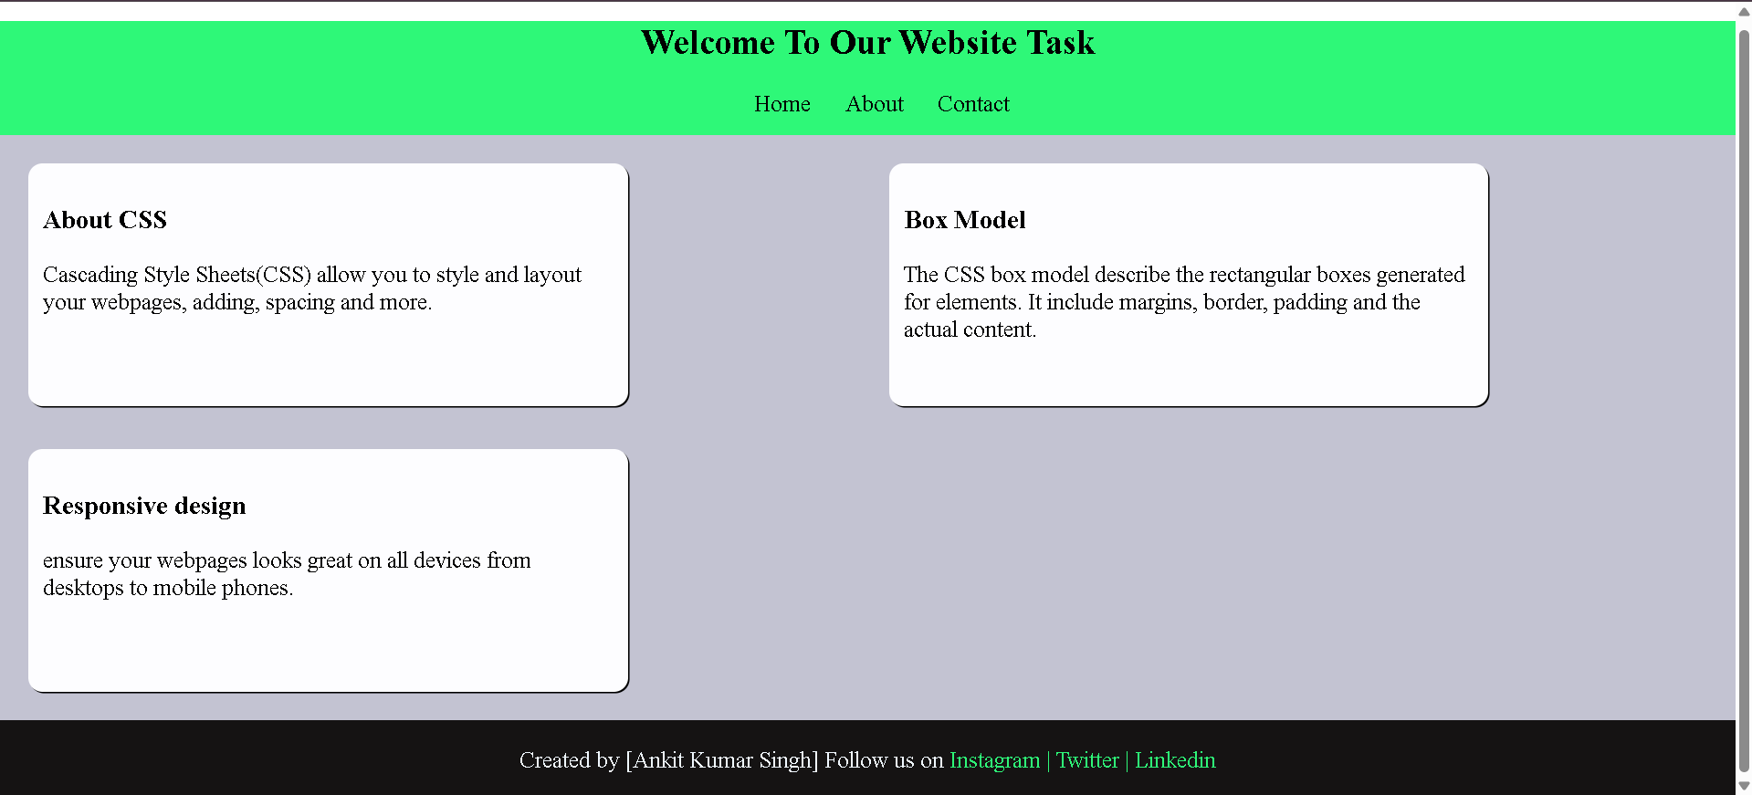

**Github**

