Warehouse Stock Inventory System:
Agile Software Project Management & System Design Report

Ankit Katwal (Team Lead & Lead Software Architect)
Sabrin Manandhar (Scrum Master & QA Lead)
Shivam Khadka (DevOps Lead & Systems Engineer)
Department of Computer Science & Information Technology
International American University (IAU)
CSE 220: Principles of Software Engineering
Professor Gaman Aryal
August 17, 2026

Warehouse Stock Inventory System:
Agile Software Project Management & System Design Report
1. Executive Summary and Project Background
The Warehouse Stock Inventory System is an enterprise software solution engineered to modernize manual warehouse operations through structured automation, real-time inventory level tracking, barcode item registration, order fulfillment routing, automated vendor replenishment, and immutable transaction audit logging. Manual record-keeping in logistics facilities often causes stock discrepancies, delayed dispatch times, and misplaced items (Sommerville, 2021). Our software engineering team designed an object-oriented, multi-tier system to digitize inventory intake and dispatch fulfillment while providing managers with real-time stock visibility.
In accordance with the CSE 220 course syllabus, this project simulates a real-world enterprise software development lifecycle without raw source code implementation. The project uses Trello for visual Agile sprint coordination, Excel for detailed scheduling and test matrices, and GitHub for document version control and team collaboration. The project scope covers requirement elicitation, stakeholder analysis, domain modeling with Unified Modeling Language (UML) diagrams, simulated design-phase test validation across 40 test cases, and Agile sprint scheduling.
2. Team Roles and Responsibilities Matrix
To ensure efficient collaboration and clear accountability across the project lifecycle, our group divided project responsibilities into specialized Agile engineering roles. Table 1 details the division of responsibilities among all three team members.
Table 1
Team Member Roles, Titles, and Primary Project Responsibilities
Team Member | Agile Role & Title | Primary Responsibilities
Ankit Katwal | Team Lead & Lead Software Architect (Product Owner) | Lead system architectural modeling; authored UML Use Case and Class diagrams; established core functional requirements; directed Sprint 1 backlog prioritization.
Sabrin Manandhar | Scrum Master & Senior QA Lead (Quality Assurance Specialist) | Facilitated daily standups and sprint planning; managed sprint board progression; authored master 40-case test matrix; evaluated defect logs and test execution reports.
Shivam Khadka | Senior Systems Engineer & DevOps Lead (Configuration Manager) | Configured GitHub version control repository; established Git branching workflows; authored UML Sequence and Activity diagrams; managed technical documentation consistency.
3. System Requirements and Stakeholder Analysis
Requirements engineering establishes the functional scope and operational constraints required for successful system delivery (Pressman & Maxim, 2020). Our team identified three primary operational stakeholder groups: Warehouse Clerks (operational staff handling item scanning, shipment intake, and physical dispatches), Inventory Managers (supervisors tracking stock levels, safety thresholds, and vendor purchase orders), and Warehouse Auditors (compliance officers verifying transaction ledgers). Table 2 summarizes stakeholder engagement across the project lifecycle.
Table 2
Stakeholder Analysis and Organizational Engagement Matrix
Stakeholder Group | Primary Interest / Goals | Influence on Project | Involvement Level
Warehouse Clerks | Fast, accurate scanning and dispatch tools suited for active warehouse floor operations. | High: daily end users of core operational workflows. | Direct: primary UI and usability feedback consumers.
Inventory Managers | Real-time stock visibility and reliable automated threshold alerts for inventory control. | High: set safety thresholds and approve replenishment purchase orders. | Direct: define core business rules and approval logic.
Warehouse Auditors | Tamper-proof, immutable transaction logs for audit compliance and inventory governance. | Medium: define compliance and data retention guidelines. | Periodic: review audit logs and transaction traceability.
External Suppliers | Standardized electronic purchase orders and timely shipment dispatch confirmations. | Medium: external API integration endpoints and delivery schedules. | Indirect: receive purchase orders via supplier gateway.
Functional Requirements
The system implements 10 core functional requirements:
FR-01 (User Authentication): The system shall authenticate warehouse personnel via username/email and password, enforcing role-based access control (RBAC).
FR-02 (Stock Intake): The system shall record incoming inventory against active Purchase Orders, supporting partial intake with automated backorder logging.
FR-03 (Barcode Scanning): The system shall parse standard SKU barcodes and QR codes from handheld scanners to retrieve item data within 500ms.
FR-04 (Availability Check): The system shall verify real-time stock levels and prevent checkout requests exceeding on-hand warehouse quantities.
FR-05 (Low-Stock Watchlist): The system shall allow managers to flag critical SKUs and trigger automated alerts when stock falls below set safety thresholds.
FR-06 (Priority Queue): The system shall allow clerks to assign priority tags (Urgent, Standard, Low) to fulfillment orders for prioritized picking.
FR-07 (Atomic Reservation): The system shall lock and reserve stock units during picking to prevent race conditions and duplicate order allocation.
FR-08 (Supplier Replenishment): The system shall generate electronic replenishment Purchase Orders when safety stock levels are breached.
FR-09 (Dispatch Documentation): The system shall format and print itemized dispatch packing slips upon order completion.
FR-10 (Audit Logging): The system shall record every inventory change into an append-only, immutable transaction ledger.
Non-Functional Requirements
System performance and operational quality are governed by five non-functional requirements:
NFR-01 (Performance): Real-time stock lookup and barcode queries shall respond in less than 500 milliseconds under 100 concurrent requests.
NFR-02 (Availability): The core inventory database service shall maintain 99.9% uptime during operational warehouse shifts.
NFR-03 (Security): User passwords shall be securely hashed using Argon2id or bcrypt with unique cryptographic salts, and API communications shall use TLS 1.3 encryption.
NFR-04 (Data Integrity): Inventory updates shall comply with strict ACID transactional guarantees to prevent inventory discrepancies.
NFR-05 (Usability): Handheld scanning UI interfaces shall support high-contrast visual display and minimal tap navigation for rapid warehouse floor use.
4. Agile Project Management and Sprint Execution
Our team adopted the Agile Scrum framework to manage system delivery. Scrum encourages iterative progress, active collaboration, and regular inspection of work artifacts (Beck et al., 2001). We used Trello as our visual Kanban and Sprint management platform. We created a Product Backlog consisting of 10 User Stories, estimated story points using the Fibonacci sequence (1, 2, 3, 5, 8), assigned priority rankings (High, Medium, Low), and allocated tasks across team members.
Table 3
Agile Product Backlog, Story Point Estimation, and Active Sprint Status
ID | User Story Description | Points | Priority | Assigned Lead | Status
WMS-01 | As a Warehouse Clerk, I want to log in securely so I can access my shift dashboard. | 2 | High | Ankit Katwal | Done (Sprint 1)
WMS-02 | As a Warehouse Clerk, I want to register incoming stock shipments against active purchase orders. | 5 | High | Shivam Khadka | QA & Review
WMS-03 | As a Warehouse Clerk, I want to scan item barcodes so I can quickly retrieve product data. | 3 | High | Ankit Katwal | In Progress
WMS-04 | As a Warehouse Clerk, I want the system to check stock availability in real-time. | 3 | High | Sabrin Manandhar | In Progress
WMS-05 | As an Inventory Manager, I want to add items to a low-stock watchlist for threshold alerts. | 3 | Medium | Sabrin Manandhar | Sprint 2 Backlog
WMS-06 | As a Warehouse Clerk, I want to apply priority tags to urgent stock requests. | 2 | Medium | Ankit Katwal | Sprint 2 Backlog
WMS-07 | As the System, I want to lock and reserve allocated stock to prevent duplicate orders. | 5 | High | Shivam Khadka | Sprint 2 Backlog
WMS-08 | As an Inventory Manager, I want to transmit automated reorder purchase orders to suppliers. | 5 | Medium | Shivam Khadka | Product Backlog
WMS-09 | As a Warehouse Clerk, I want to generate and print itemized dispatch notes. | 3 | High | Sabrin Manandhar | Product Backlog
WMS-10 | As an Auditor, I want to review immutable transaction logs of all stock movements. | 3 | Low | Ankit Katwal | Product Backlog
Table 3 reflects the sprint lifecycle status across our active backlog, matching the live Trello Kanban board snapshot shown in Figure 1. Sprint 1 focused on delivering foundational operational capabilities: User Authentication (WMS-01), Stock Intake (WMS-02), Barcode Scanning (WMS-03), and Stock Level Checking (WMS-04), representing 13 total Story Points. In addition, team-level documentation and architectural modeling tickets (DOC-01 and UML-01) were completed during Sprint 1. The team conducted weekly sprint reviews to evaluate deliverables against acceptance criteria.
Figure 1
Agile Trello Sprint Board with Story Point Estimates and Task Workflow
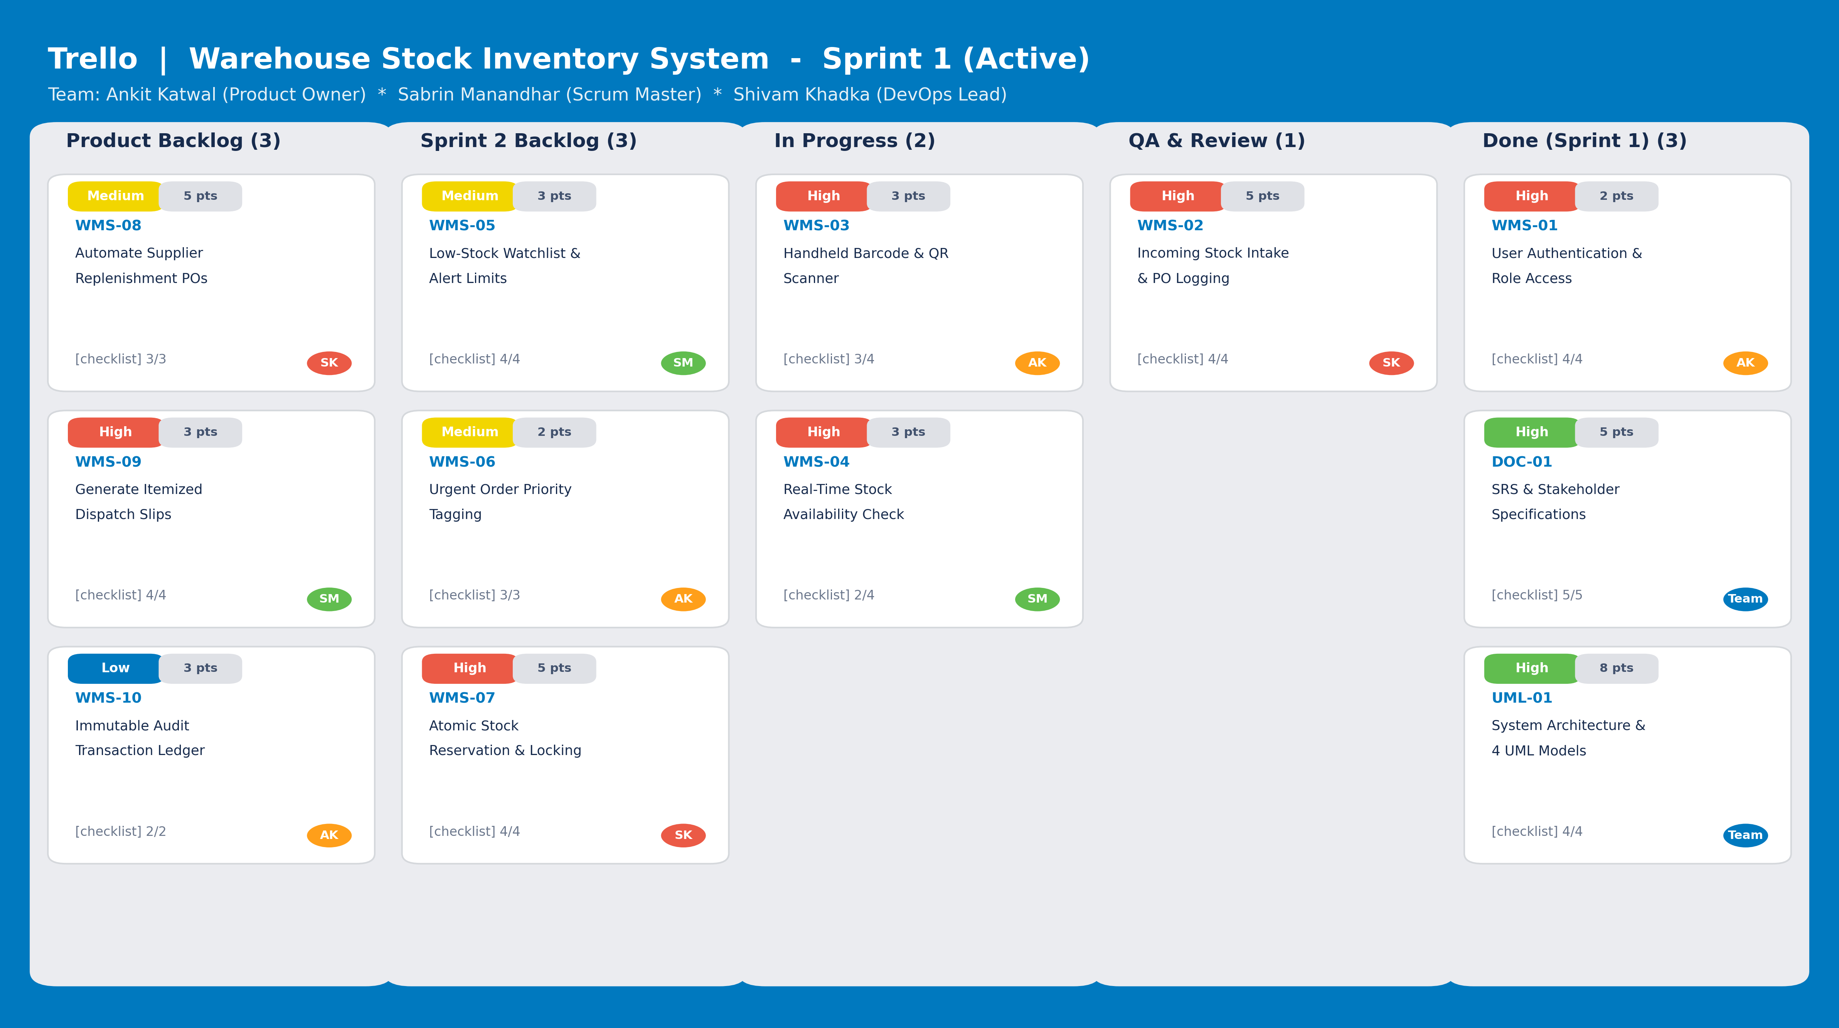
Figure 1 illustrates our active Trello Kanban Sprint Board for the Warehouse Stock Inventory System. The board is structured into five distinct workflow swimlanes: Product Backlog, Sprint 2 Backlog, In Progress, QA & Review, and Done (Sprint 1). Each user story is assigned a Fibonacci story point weight, priority tag, assigned team member avatar, and checklist verification counter to ensure complete visibility across all sprint activities.
Sprint Timeline, Work Breakdown, and Gantt Chart
In addition to visual board tracking, our engineering team constructed a formal Agile sprint planning model (Planning_WMS.xlsx) to calculate work package durations, team lead allocations, and critical path milestones across the eight-week development lifecycle (56 calendar days). Each sprint activity is governed by discrete start dates, expected working durations, completion dates, and a calculated refined calendar duration using the formula: Refined Duration = (End Date - Start Date) + 1.
Our four-sprint delivery roadmap was scheduled across an exact 8-week timeline (July 1, 2026 to August 25, 2026):
Sprint 1 (Foundations): Weeks 1 to 2 (July 1 to July 14, 2026): Project kickoff, stakeholder requirements elicitation, and foundational core sprint (WMS-01 to WMS-04, DOC-01, UML-01).
Sprint 2 (Inventory Control): Weeks 3 to 4 (July 15 to July 28, 2026): Advanced inventory control, low-stock watchlist, priority queue sorting, and atomic stock locking (WMS-05 to WMS-07).
Sprint 3 (Logistics & Integration): Weeks 5 to 6 (July 29 to August 11, 2026): External supplier gateway coordination, thermal dispatch note printing, and audit logging (WMS-08 to WMS-10).
Sprint 4 (QA & Final Deployment): Weeks 7 to 8 (August 12 to August 25, 2026): Master test matrix design verification (40 test cases), defect logging, documentation finalization, and deployment readiness review.
Figure 2
Eight-Week Agile Delivery Roadmap and Sprint Milestone Gantt Chart
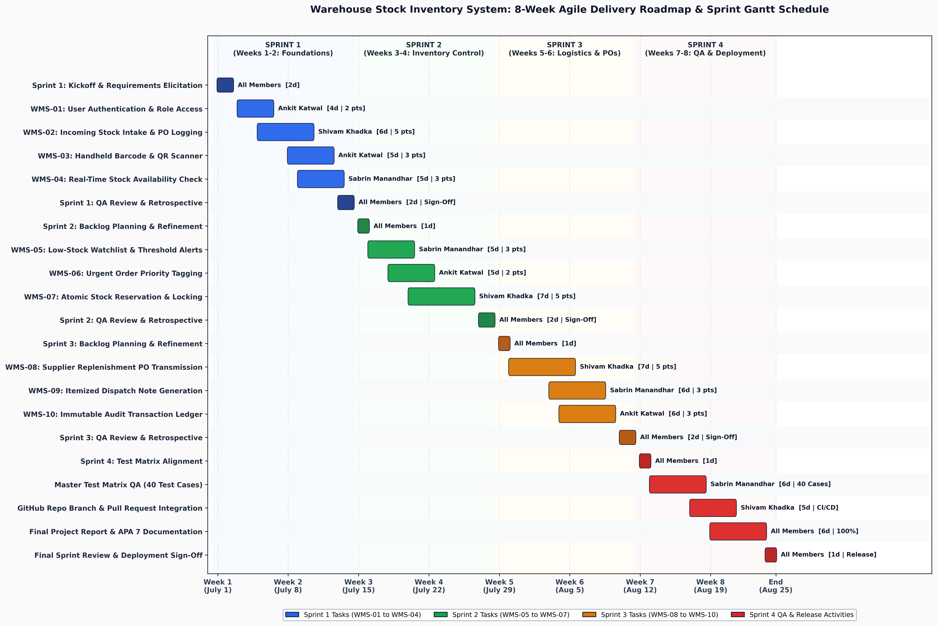
Figure 2 presents our project delivery Gantt Chart spanning an eight-week lifecycle divided across four distinct sprints (July 1 to August 25, 2026). The chart delineates work package durations, team lead allocations, and critical path milestones derived from our Planning_WMS.xlsx sprint schedule model.
5. UML System Architectural Design
To provide clear architectural documentation, our team developed four complementary Unified Modeling Language (UML) models following standard software engineering modeling conventions (Sommerville, 2021). These models describe user interactions, temporal message sequences, operational workflow logic, and object-oriented structural domain entities.
5.1 Expanded Use Case Model (Multi-Actor Architecture)
The Expanded Use Case Diagram (Figure 3) models system functional boundaries across three distinct actors: Warehouse Clerk (initiates authentication, intake, barcode scanning, manual adjustments, stock checks, and dispatch processing), Inventory Manager (maintains low-stock watchlists, coordinates supplier replenishment, and generates audit reports), and Supplier Gateway (receives purchase order transmissions and confirms replenishment deliveries). Generalization relationships connect Barcode Scanning and Manual Adjustments into the Update Inventory Records use case. An <<include>> dependency connects Process Outbound Stock Request to Update Inventory Records and Generate Dispatch Note, while an <<extend>> relationship connects Apply Priority Tag for urgent shipments.
Figure 3
Expanded Use Case Diagram for Warehouse Stock Inventory System
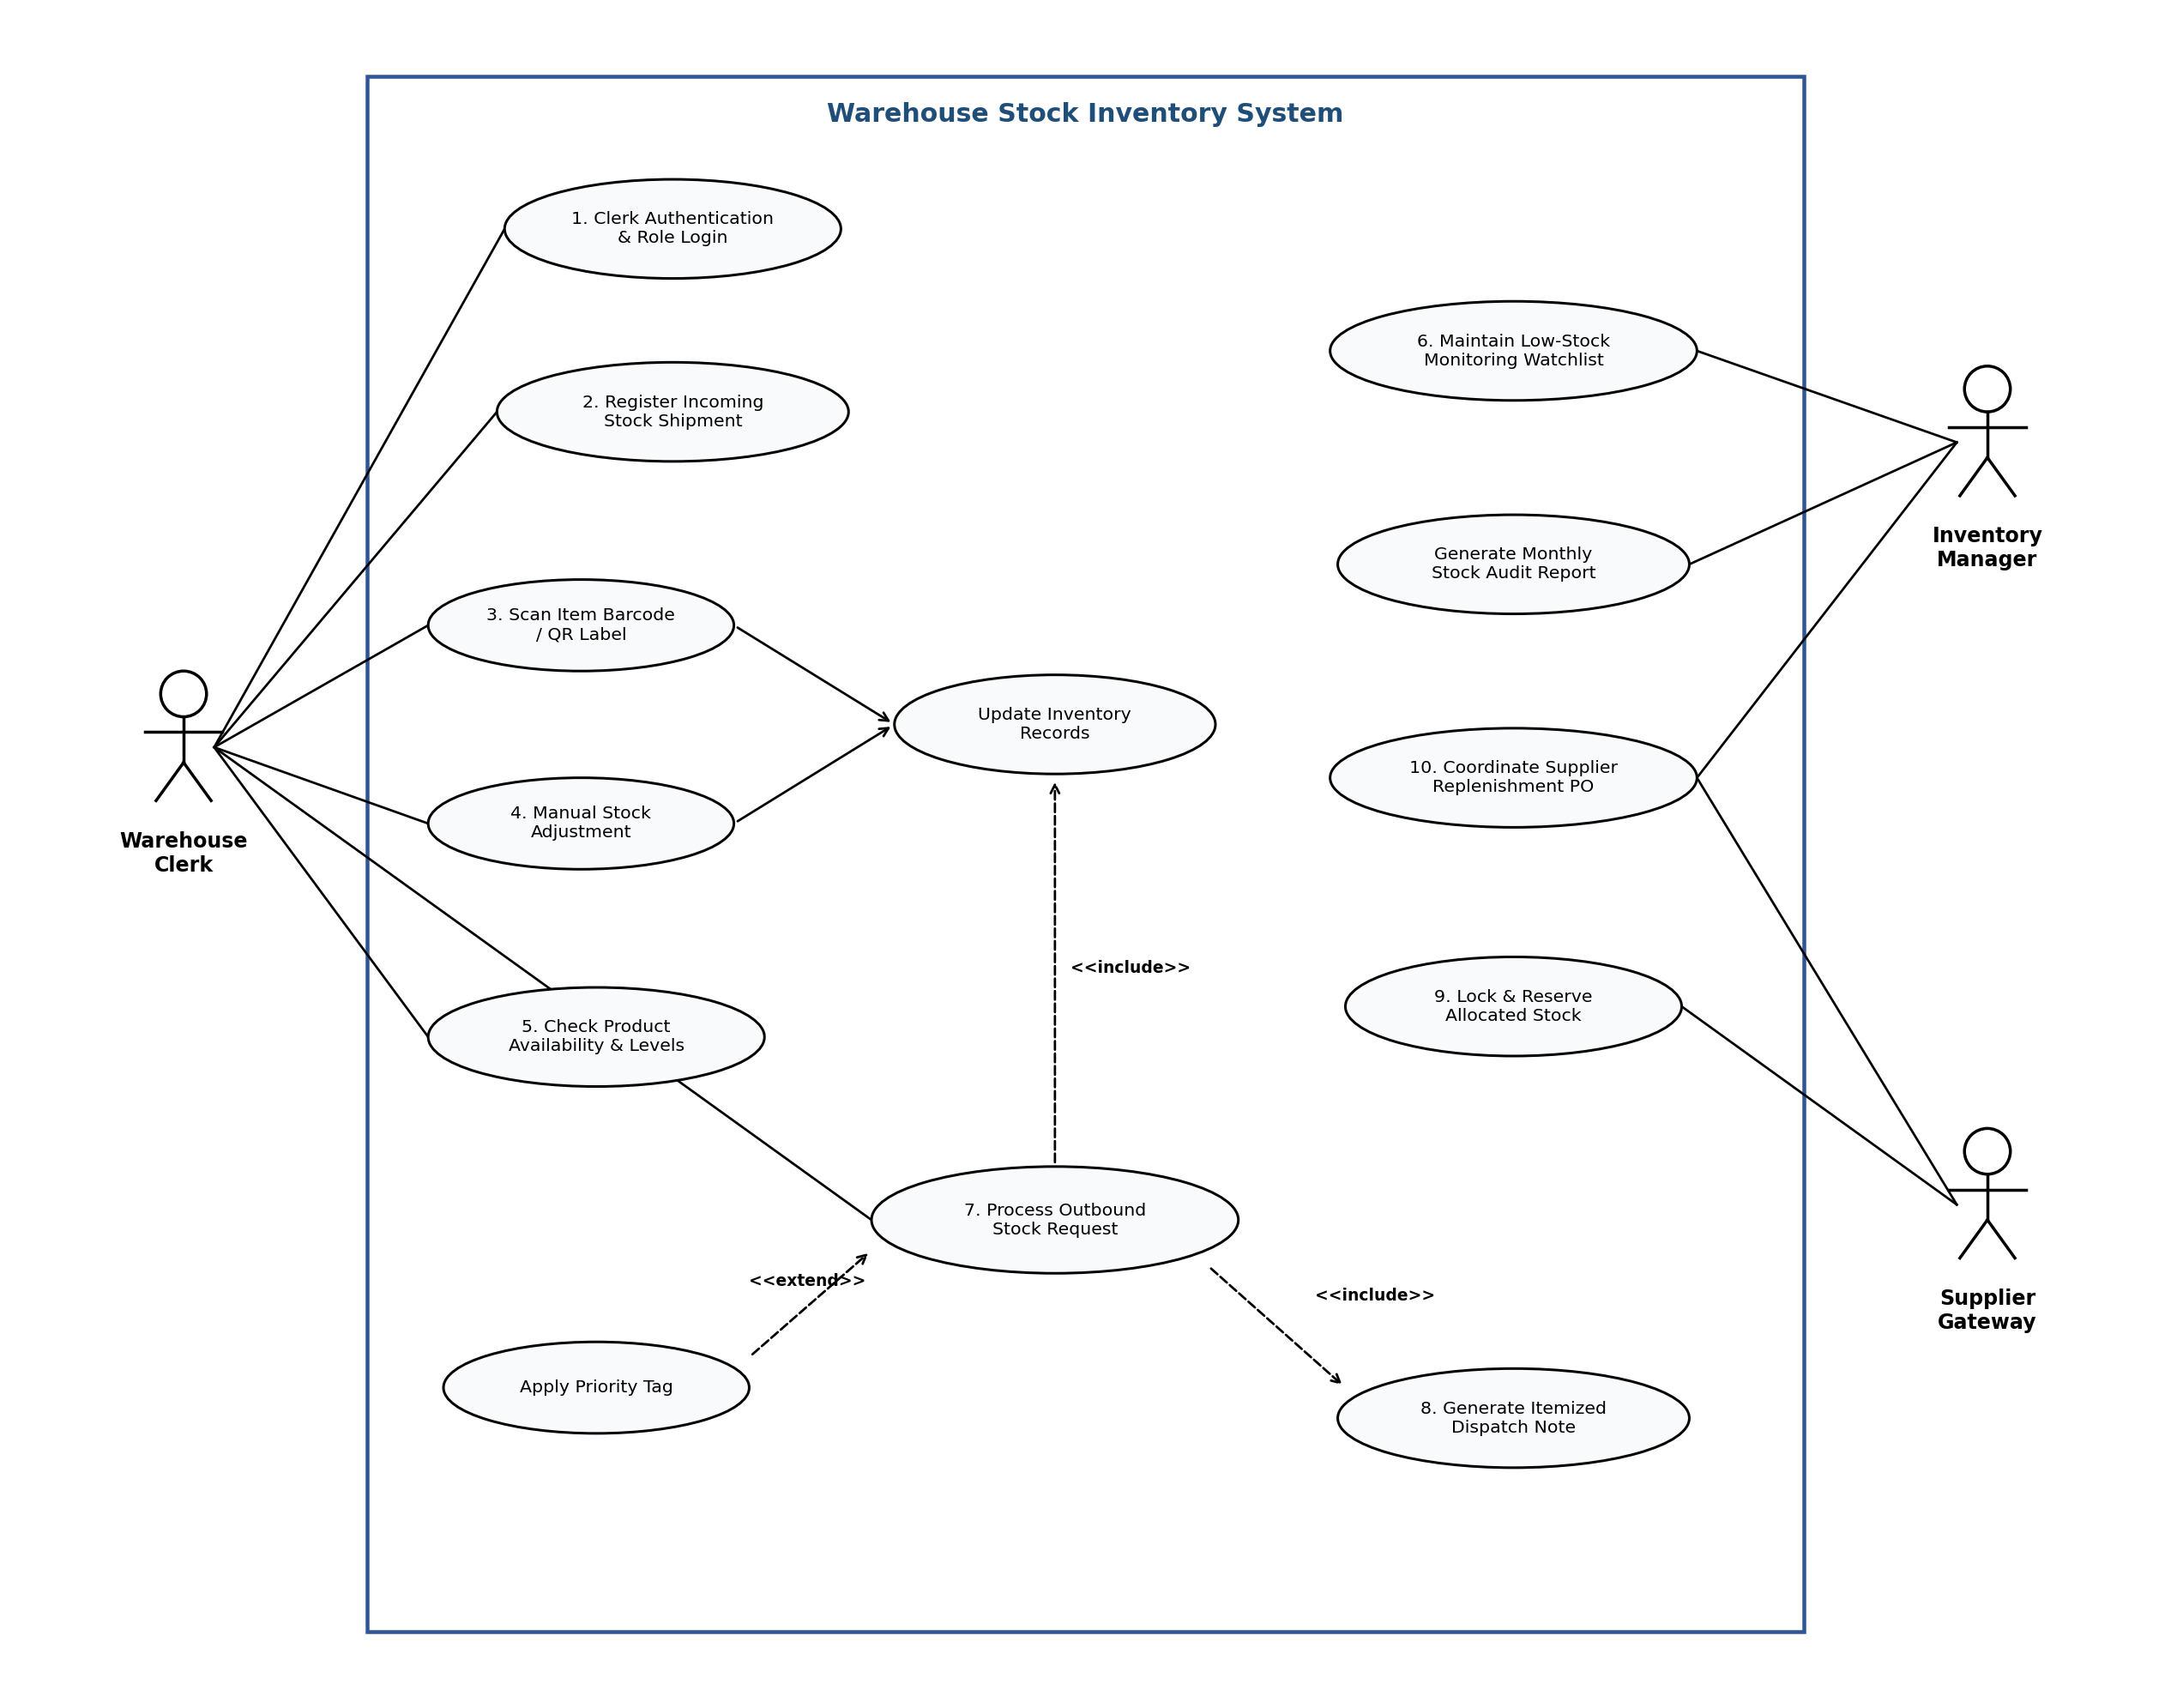
Figure 3 illustrates all functional system use cases and interactions across the Warehouse Clerk, Inventory Manager, and Supplier Gateway actors, incorporating standard <<include>> and <<extend>> UML relationships.
5.2 Sequence Model (Authentication & Role Validation)
The Sequence Diagram (Figure 4) illustrates the synchronous message exchange across five system participants: Warehouse Clerk (actor), :LoginPage (boundary UI), :LoginController (control layer), :LoginService (domain service), and :LoginRepository (persistence layer). The interaction begins when the clerk inputs credentials via submitCredentials(username, password). The LoginPage invokes login(username, password) on the LoginController, which delegates credential evaluation to the LoginService via verifyCredentials(username, password). The LoginService queries the LoginRepository using fetchUserDetails(username), which retrieves the stored userRecord.
Upon verifying password hash matches, the LoginService returns authStatus to the LoginController, which passes validationResult back to the LoginPage. An alt (alternative) interaction fragment models the two conditional execution paths: if result == true (Valid Credentials), the system redirects the clerk to the operational warehouse dashboard with a valid sessionToken; if result == false (Invalid Credentials), the LoginPage displays an 'Invalid Credentials' error notification. Explicit object destruction markers (X) indicate the termination of lifelines upon interaction completion.
Figure 4
Sequence Diagram for User Authentication and Session Verification
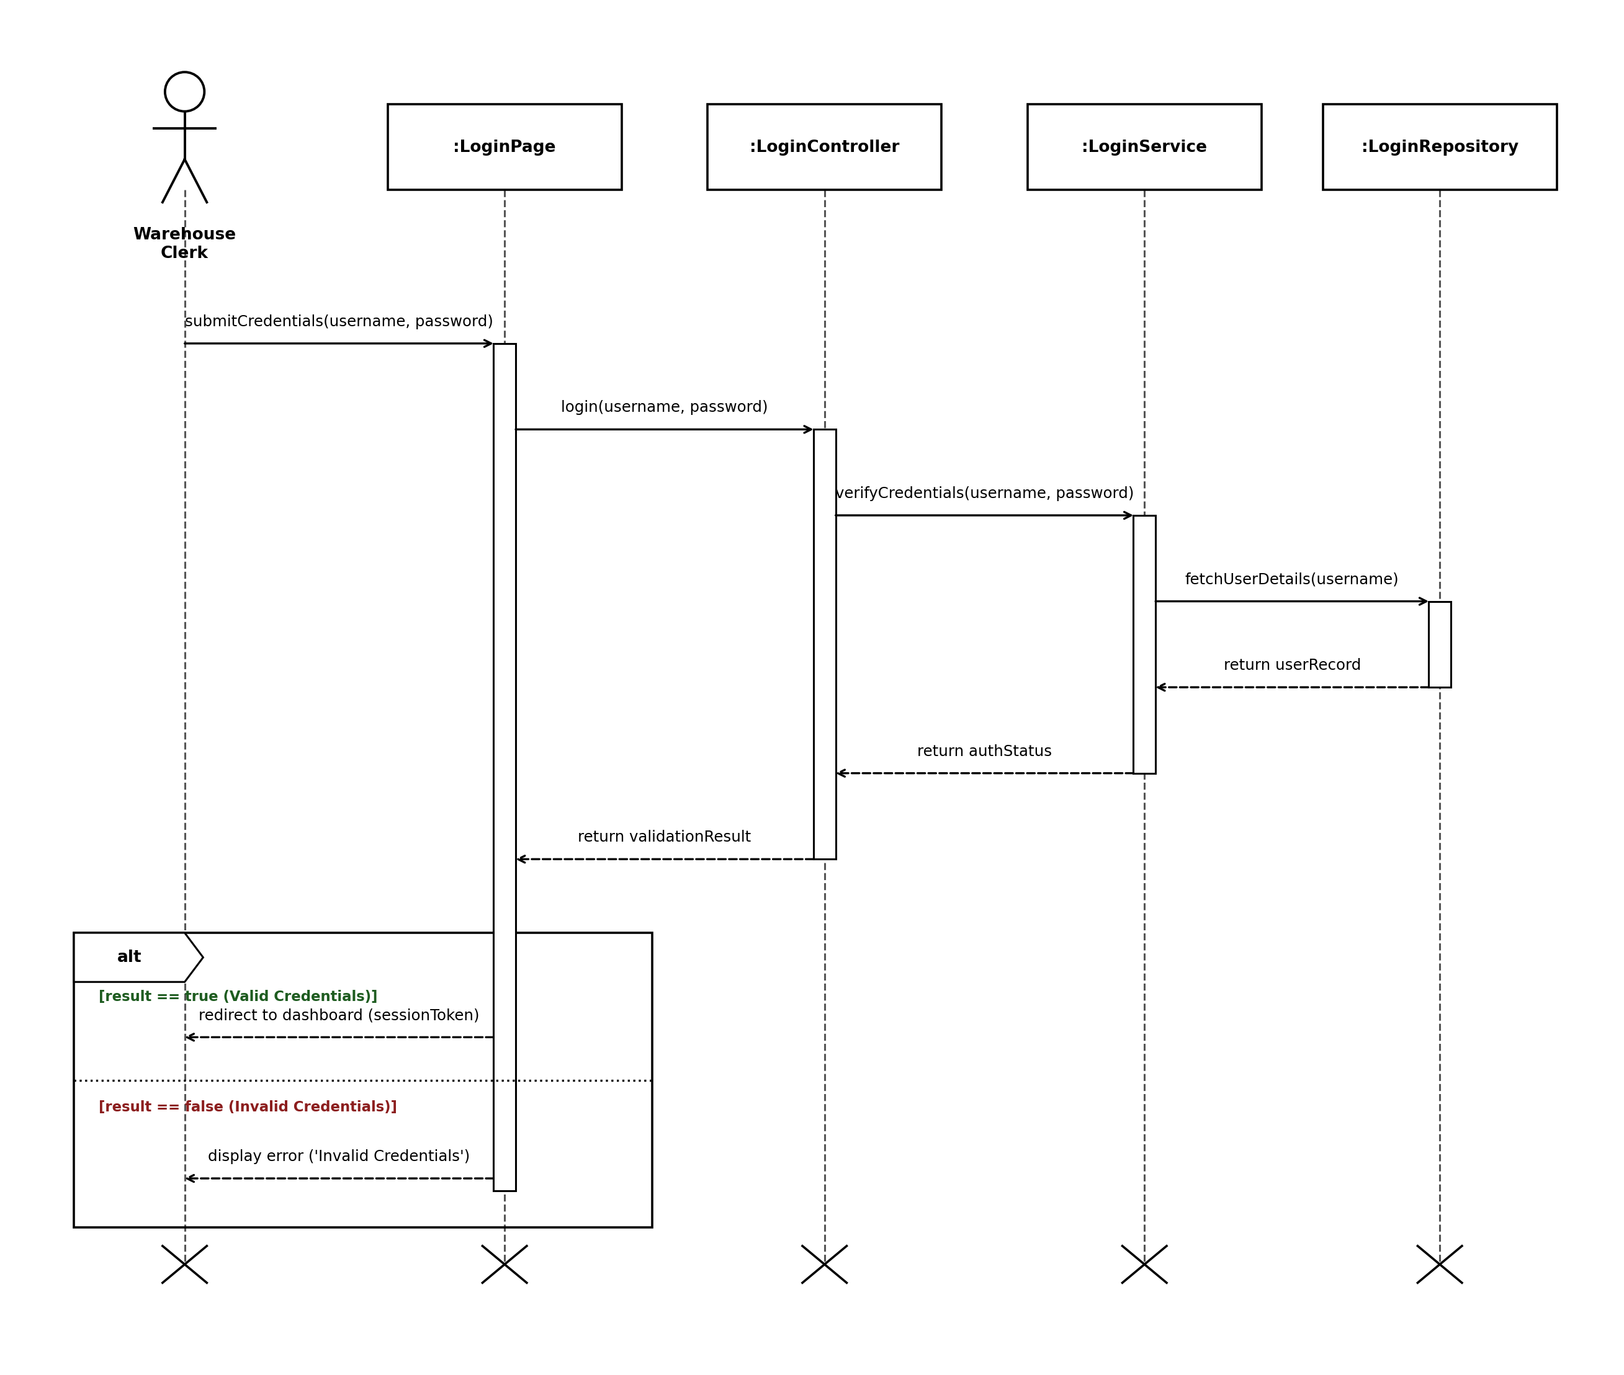
Figure 4 models the sequence of method calls across presentation, controller, service, and persistence layers during user login, detailing the conditional alt execution paths for valid and invalid credentials.
5.3 Activity Model (Outbound Stock Fulfillment Workflow)
The Activity Diagram (Figure 5) models the end-to-end operational workflow of outbound stock fulfillment across three dedicated swimlanes: Warehouse Clerk (Floor Operations), Inventory Management System (Core Processing & Database), and Dispatch & Logistics Hub (Shipping & Freight Transport). The process begins in the clerk swimlane when an outbound stock request is received and reviewed. Control transitions across swimlanes to the Inventory Management System to query the database and check real-time stock availability. A decision diamond evaluates whether stock is available: if stock is insufficient ([No / Insufficient]), the system logs the shortage, sends an out-of-stock alert, and terminates at an activity stop node.
If stock is available ([Yes / Available]), control transitions back to the clerk swimlane to scan item barcodes and physically pick units from the assigned warehouse bin. Upon submitting the completed dispatch form, the Inventory System executes an atomic stock deduction, generates the itemized dispatch note, and records the transaction into the immutable audit ledger. Control then transitions to the Logistics Hub swimlane, where logistics personnel verify parcel weight, affix courier shipping labels, and handover the parcel to the transport carrier before reaching the final activity node.
Figure 5
Activity Diagram for Outbound Stock Fulfillment Workflow Across 3 Swimlanes
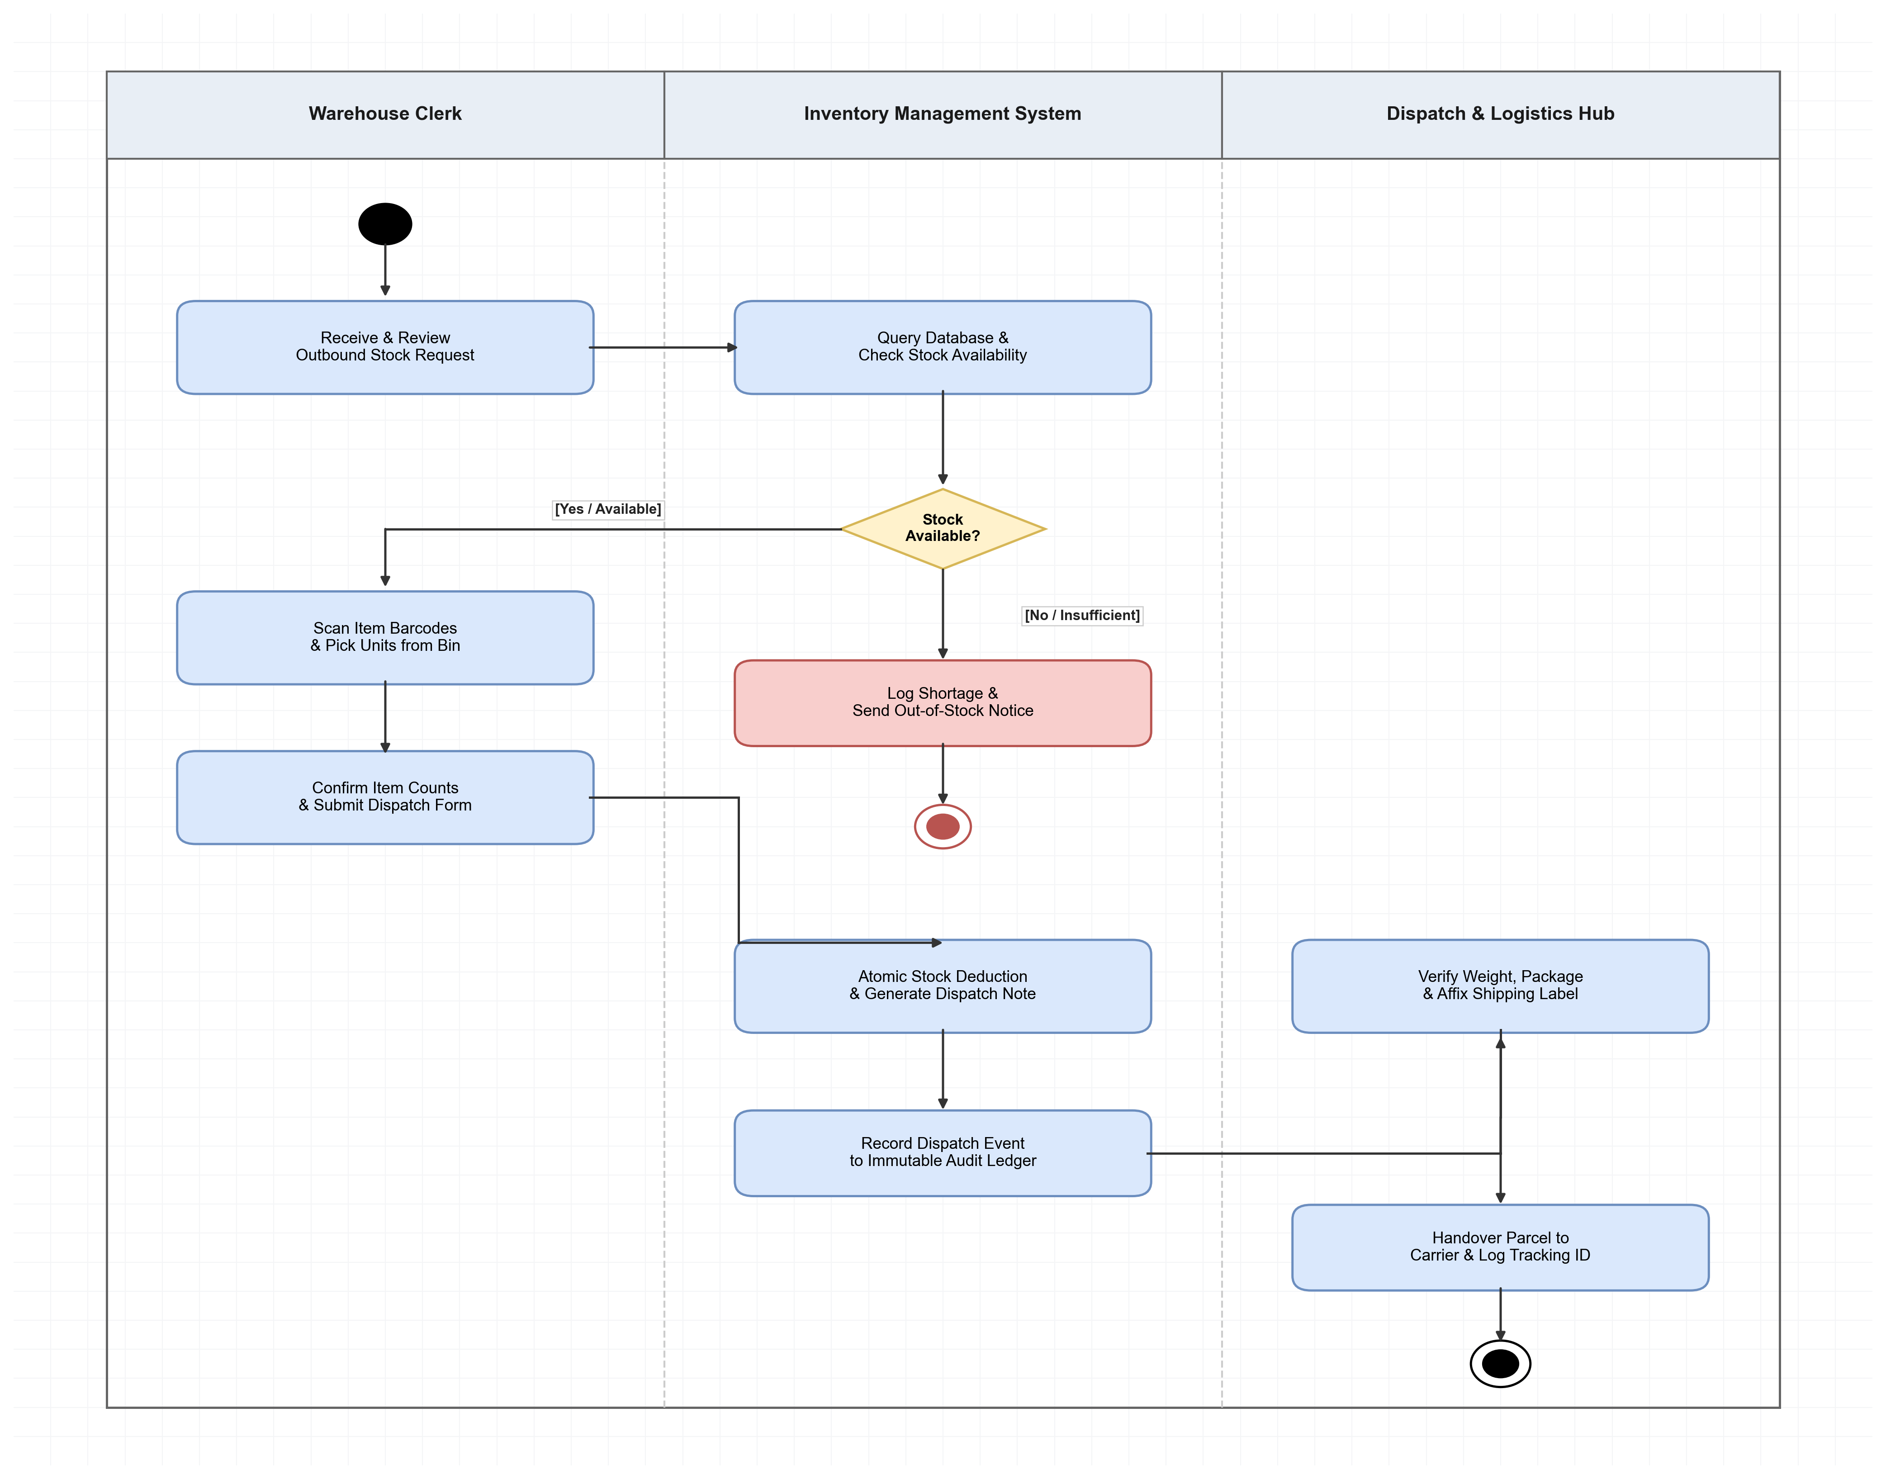
Figure 5 illustrates the complete outbound stock request fulfillment process modeled in standard Draw.io notation across three swimlanes, highlighting initial nodes, decision branches, atomic inventory updates, and final handover states.
5.4 Multi-Tier Class Model (Domain Entity Architecture)
The Class Diagram (Figure 6) defines the structural domain entities, visibility markers, and association multiplicities within the Warehouse Stock Inventory System modeled in Draw.io. The model establishes an abstract base class User (encapsulating userID, fullName, email, role, and passwordHash), which generalizes into WarehouseClerk (storing shift and scannerID) and InventoryManager (storing department and approvalLimit). This eliminates duplicate attribute definitions and provides clean role specialization.
Physical inventory is authoritatively managed by InventoryItem (capturing itemID, binLocation, qtyOnHand, safetyThreshold, and isLocked), which maintains a 1-to-1 association with Product (capturing productID, skuBarcode, name, category, and unitPrice). A WarehouseClerk initiates StockRequests (0..*), each aggregating one or more RequestItems (1..*). Furthermore, completed StockRequests generate exactly one DispatchNote (1), while all inventory quantity adjustments across intake, dispatch, and safety restocks are decoupled and recorded into an append-only StockTransaction (0..*) ledger for tamper-proof audit governance (FR-10).
Figure 6
Multi-Tier Class Diagram for Domain Entities and Multiplicity Relationships
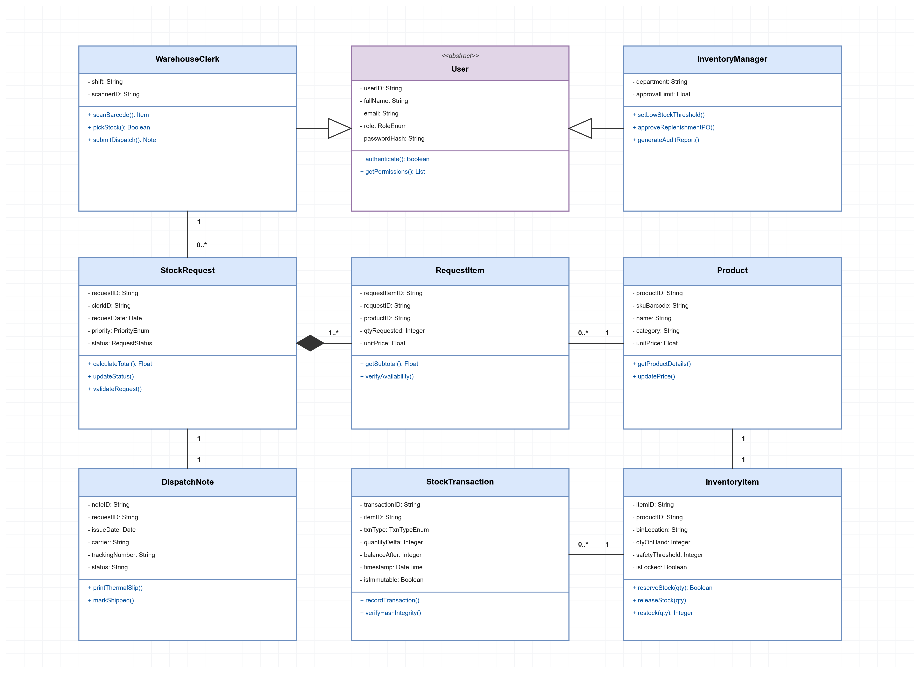
Figure 6 defines the structural domain model modeled in Draw.io, detailing attribute specifications, inheritance structures, visibility markers, and cardinality relationships across all nine system entity classes.
6. Software Testing and Quality Assurance Plan
To verify system design stability, our team constructed and executed a comprehensive design-phase test matrix comprising 40 test cases mapped across our 10 User Stories (4 test cases per story: 2 positive validation cases and 2 targeted negative boundary cases). In accordance with software engineering testing principles (Myers et al., 2012; Jorgensen & DeVries, 2021), verification systematically evaluated four testing levels: Unit Testing, Integration Testing, System Testing, and User Acceptance Testing (UAT). Table 4 provides an itemized summary of test execution results across all 10 user stories.
Table 4
Software Test Execution Summary Across 10 User Stories
Story ID | Feature Area Under Test | Passed Cases | Failed Cases | Pass Rate
WMS-01 | User Authentication & Role Access | 3 | 1 | 75%
WMS-02 | Incoming Stock Intake & Backorder | 3 | 1 | 75%
WMS-03 | Handheld Barcode & QR Lookup | 3 | 1 | 75%
WMS-04 | Real-Time Stock Availability Check | 3 | 1 | 75%
WMS-05 | Manager Low-Stock Watchlist | 3 | 1 | 75%
WMS-06 | Priority Stock Request Tagging | 3 | 1 | 75%
WMS-07 | Atomic Stock Reservation & Locking | 3 | 1 | 75%
WMS-08 | Supplier API Replenishment PO | 3 | 1 | 75%
WMS-09 | Thermal Dispatch Note Generation | 3 | 1 | 75%
WMS-10 | Immutable Audit Transaction Logging | 3 | 1 | 75%
Across the 40 test cases evaluated in Testing.xlsx, 30 test cases passed successfully (75% pass rate), while 10 test cases revealed simulated design defects (25% defect rate). Rather than generic input faults, detailed root-cause analysis of the 10 failed cases (TC-WMS-01-04 through TC-WMS-10-04) identified six distinct software engineering defect categories:
1. Input Field Validation Defect (TC-WMS-01-04): Blank login submission displayed generic 'Invalid credentials' rather than triggering required-field validation prompts.
2. Boundary Negative Quantity Fault (TC-WMS-02-04): Negative intake values triggered unhandled system exceptions rather than gracefully rejecting negative quantities.
3. External Service Timeout Handling (TC-WMS-03-04): Scanning unregistered foreign barcodes caused internal server timeouts instead of returning standard HTTP 404/not-found notices.
4. Lifecycle State Constraint Defect (TC-WMS-04-04): Discontinued products were incorrectly evaluated as available in stock lookups.
5. Entity Integrity & Concurrency Faults (TC-WMS-05-04 & TC-WMS-07-04): Duplicate items were permitted on low-stock watchlists, and stock reservations succeeded on locked warehouse bins.
6. Hardware Fault & Immutability Violations (TC-WMS-06-04, 08-04, 09-04, 10-04): Priority tags could be applied to closed requests, zero-quantity purchase orders were transmitted, print jobs reported success while printers were offline, and historical transaction timestamps could be modified.
These 10 failed test cases establish a prioritized defect backlog for remediation during Phase 2 sprint iterations. The complete master test matrix spreadsheet containing all 40 test cases, execution steps, expected results, and actual outputs is maintained in Testing.xlsx and accessible via our live team spreadsheet link:
Master Test Matrix Link: https://docs.google.com/spreadsheets/d/1mdZHp1IVuzcRRwkW0LrXoaDRFCk_5oth/edit?usp=drive_link&ouid=108925449514102250579&rtpof=true&sd=true
7. GitHub Version Control and Repository Management
Software configuration management was conducted using GitHub to maintain full traceability of all engineering artifacts (Chacon & Straub, 2020). Our team organized the repository into four dedicated directories:
- /requirements: Contains functional specifications, stakeholder matrices, and user story definitions.
- /design: Contains high-resolution UML diagram exports (Use Case, Sequence, Activity, Class).
- /testing: Stores the master 40-case testing matrix spreadsheet (Testing.xlsx) and QA reports.
- /project_management: Contains Trello sprint board exports, story point estimation sheets, sprint scheduling workbooks (Planning_WMS.xlsx), and meeting minutes.
We enforced a Git feature-branch workflow. Direct commits to the 'main' branch were restricted. Team members created dedicated feature branches (such as 'feature/wms-01-auth' and 'feature/wms-02-stock-intake') for individual work packages. Merging required formal Pull Requests with peer review, ensuring that all artifacts were verified before integration into the baseline release. [Evidence Note: Team repository commits, branch logs, and merged Pull Requests are recorded within the warehouse-stock-inventory-system project repository].
8. Team Reflections on Agile Project Management Tools
Collaborating on this simulated software project provided valuable insights into Agile project management and tool integration. Using Trello gave our team clear visual transparency into sprint progress. The visual movement of cards across swimlanes helped identify work-in-progress bottlenecks early, ensuring that no team member was overloaded during active sprints.
Simultaneously, GitHub provided version control and document integrity. Linking Trello ticket IDs (such as WMS-01) directly to GitHub commit messages and pull request descriptions bridged the gap between project planning and version-controlled deliverable management. Overall, combining Trello and GitHub demonstrated how modern software teams maintain alignment, enforce quality gates, and manage complex systems collaboratively.
9. Conclusion and Future System Enhancements
In conclusion, the Warehouse Stock Inventory System project successfully demonstrated the practical application of software engineering principles, Agile project management, and object-oriented architectural modeling. By combining stakeholder analysis, UML design models, a 40-case test matrix, and disciplined GitHub version control, our team established a complete software specification ready for production implementation.
For Phase 2 production deployment, our team recommends two major technical enhancements: first, integrating Internet of Things (IoT) RFID sensors on warehouse shelving for real-time, automated bin level synchronization; and second, deploying predictive machine learning algorithms to forecast seasonal demand fluctuations and dynamically optimize reorder points.

References
Beck, K., Beedle, M., van Bennekum, A., Cockburn, A., Cunningham, W., Fowler, M., Grenning, J., Highsmith, J., Hunt, A., Jeffries, R., Kern, J., Marick, B., Martin, R. C., Mellor, S., Schwaber, K., & Sutherland, J. (2001). Manifesto for Agile software development. Agile Alliance. https://agilemanifesto.org/
Chacon, S., & Straub, B. (2020). Pro Git (2nd ed.). Apress.
Jorgensen, P. C., & DeVries, B. (2021). Software testing: A craftsman's approach (5th ed.). CRC Press.
Myers, G. J., Sandler, C., & Badgett, T. (2012). The art of software testing (3rd ed.). John Wiley & Sons.
Pressman, R. S., & Maxim, B. R. (2020). Software engineering: A practitioner's approach (9th ed.). McGraw-Hill Education.
Sommerville, I. (2021). Software engineering (10th ed.). Pearson.

