**OpenCV Experiments**

*Robotics Lab I Lab Work*

**B.Tech in Mechatronics**

*Submitted by*

**Ankit Aggarwal**

(Reg. No. – 200929036)

Batch: A1

**Department of Mechatronics**



**December 2021**

|  |  |  |  |  |
| --- | --- | --- | --- | --- |
| **Contents** | | | | |
|  | | | | |
| **Experiment 1** | | | **Colour Detection using OpenCV** | **3-5** |
|  | **1.1** | Aim | | 3 |
|  | **1.2** | Problem Statement | | 3 |
|  | **1.3** | Theory | | 3 |
|  | **1.4** | Procedure | | 3 |
|  | **1.5** | Code | | 3-5 |
|  | **1.6** | Results | | 5 |
|  | **1.7** | Conclusion | | 5 |
|  | | | | |
| **Experiment 2** | | | **Shape Detection using OpenCV** | **6-8** |
|  | **2.1** | Aim | | 6 |
|  | **2.2** | Problem Statement | | 6 |
|  | **2.3** | Theory | | 6 |
|  | **2.4** | Procedure | | 6 |
|  | **2.5** | Code | | 6-7 |
|  | **2.6** | Results | | 8 |
|  | **2.7** | Conclusion | | 8 |
|  | | | | |
| **Experiment 3** | | | **Biscuit Quality Detection using OpenCV** | **9-11** |
|  | **3.1** | Aim | | 9 |
|  | **3.2** | Problem Statement | | 9 |
|  | **3.3** | Theory | | 9 |
|  | **3.4** | Procedure | | 9 |
|  | **3.5** | Code | | 9-10 |
|  | **3.6** | Results | | 11 |
|  | **3.7** | Conclusion | | 11 |
|  | | | | |
| **REFERENCES** | | | | **12** |

# Experiment 1 - Colour Detection using OpenCV

## Aim

To identify and classify objects based on colour using HSV values.

## Problem Statement

Classify the following images based on colour

## Theory

Colour detection is performed based on the HSV Colour Scale. The HSV (Hue Saturation Value) scale provides a numerical readout of an image that corresponds to the colour names contained therein. These scale values are used to create a range for each colour and the results are classified into the appropriate colour names. For instance, the lower limit for Blue is (100,180,245) and the upper limit is (100,220,245).

The Computer Vision library has dedicated functions such as cv2.cvtColor for colour detection. These functions are used in conjunction with NumPy to accurately perform colour detection of the given images.

## Procedure

* Read the given image using cv2.read and show it in a window titled ‘image’ using cv2.imshow.
* Scale the image as required and find its dimensions.
* Resize the image to its new dimensions using cv2.resize.
* Define a mouse event to return HSV values upon mouse click.
* Use the returned values to define ranges for the given colours.
* Set a reference area in each image to assess colour.
* Average out HSV values of all pixels in the given reference area using NumPy.
* Compare with the previously set ranges for each colour.
* Print the colour onto the image using cv2.putText.

## Code

import cv2

print(cv2.__version__)

import cv2

import numpy as np

image=cv2.imread('C:/Users/MAHE/Documents/OpenCV_200929036/GS.png')

cv2.imshow("image", image)

cv2.waitKey(0)

cv2.destroyAllWindows()

scale_percent = 100

width = int(image.shape[1] * scale_percent / 100)

height = int(image.shape[0] * scale_percent / 100)

dim = (width, height)

print(dim)

# resize image

img = cv2.resize(image, dim, interpolation = cv2.INTER_AREA)

cv2.imshow("image", img)

cv2.waitKey(0)

cv2.destroyAllWindows()

def mouse(event,x,y,flags,param):

if event==cv2.EVENT_LBUTTONDOWN:

h=hsv[y,x,0]

s=hsv[y,x,1]

v=hsv[y,x,2]

print("H:",h)

print("S:",s)

print("V:",v)

cv2.namedWindow('mouse')

cv2.setMouseCallback('mouse',mouse)

hsv=cv2.cvtColor(image,cv2.COLOR_BGR2HSV)

cv2.imshow("mouse", hsv)

cv2.waitKey(0)

cv2.destroyAllWindows()

blueLower=(100,180,245)

blueUpper=(110,220,255)

greenLower=(64,60,190)

greenUpper=(74,70,210)

whiteLower=(0,0,245)

whiteUpper=(10,10,255)

refPt=[(width//2-25, height//2-25),(width//2+25, height//2+25)]

roi = img[refPt[0][1]:refPt[1][1], refPt[0][0]:refPt[1][0]]

cv2.imshow("ROI", roi)

cv2.waitKey(0)

cv2.destroyAllWindows()

hsv=cv2.cvtColor(roi,cv2.COLOR_BGR2HSV)

havg= np.average(hsv, axis=0)

h_avg = np.average(havg, axis=0)

print(h_avg)

x = img.ravel()[0]

y = img.ravel()[1]

if (h_avg[0]>=np.array(blueLower[0])) and (h_avg[0]<=np.array(blueUpper[0])) and (h_avg[1]>=np.array(blueLower[1])) and (h_avg[1]<=np.array(blueUpper[1])) and (h_avg[2]>=np.array(blueLower[2])) and (h_avg[2]<=np.array(blueUpper[2])):

print("Color is Blue")

cv2.putText(img, "Blue", (x-25, y-25), cv2.FONT_HERSHEY_COMPLEX, 0.5, (0, 255, 0))

elif (h_avg[0]>=np.array(greenLower[0])) and (h_avg[0]<=np.array(greenUpper[0])) and (h_avg[1]>=np.array(greenLower[1])) and (h_avg[1]<=np.array(greenUpper[1])) and (h_avg[2]>=np.array(greenLower[2])) and (h_avg[2]<=np.array(greenUpper[2])):

print("Color is Green")

cv2.putText(img, "Green", (x-25, y-25), cv2.FONT_HERSHEY_COMPLEX, 0.5, (0, 255, 0))

elif (h_avg[0]>=np.array(whiteLower[0])) and (h_avg[0]<=np.array(whiteUpper[0])) and (h_avg[1]>=np.array(whiteLower[1])) and (h_avg[1]<=np.array(whiteUpper[1])) and (h_avg[2]>=np.array(whiteLower[2])) and (h_avg[2]<=np.array(whiteUpper[2])):

print("Color is White")

cv2.putText(img, "White", (x-25, y-25), cv2.FONT_HERSHEY_COMPLEX, 0.5, (0, 255, 0))

else:

print("Color is not Blue, Green or White.")

cv2.imshow('colours', img)

cv2.waitKey(0)

cv2.destroyAllWindows()

## Results

Figure 1 - Image detected as Green Figure 2 - Image detected as Blue

## Conclusion

The given images were classified based on their colour. The name of the colour was also printed on the image.

# Experiment 2 - Shape Detection using OpenCV

## Aim

To identify and classify objects based on shape using suitable algorithms.

## Problem Statement

Classify the following images based on shape

## Theory

Shape Detection is performed based on edge and contour detection. The image is read as a matrix and edges are detected based on points of high magnitude change in saturation values. This process is known as thresholding. The edges are then checked for continuity, to detect edges and corners of a shape.

The Computer Vision Library has dedicated functions such as cv2.thresholding for shape detection. These functions are used in conjunction with other functions like cv2.GaussianBlur and cv2.cvtColor for maximizing accuracy in shape detection.

## Procedure

* Read the given image using cv2.read and show it in a window titled ‘image’ using cv2.imshow.
* To improve accuracy of edge detection the following steps are taken:
  + Blur the image using Gaussian Blur [cv2.GaussianBlur]
  + Convert the image into grayscale [cv2.cvtColor]
* Perform edge detection using thresholding [cv2.threshold]
* Find contours from the detected edges [cv2.findContours]
* For each of the contours determined in the image, determine the shape of the polygons present in the image [cv2.approxPolyDP]
* Draw the determined image onto the input image [cv2.drawContours]
* Based on the detected contours, count number of edges and classify into a shape.
* Print the name of the shape onto the image [cv2.putText]

## Code

import cv2

print(cv2.__version__)

import numpy as np

import cv2

img = cv2.imread('C:/Users/MAHE/Documents/OpenCV_200929036/YC.png')

cv2.imshow("img",img)

height, width = img.shape[:2]

cv2.waitKey(0)

cv2.destroyAllWindows()

Blur=cv2.GaussianBlur(img, (1,1), 0)

cv2.imshow("Blur",Blur)

cv2.waitKey(0)

cv2.destroyAllWindows()

Gray=cv2.cvtColor(Blur,cv2.COLOR_BGR2GRAY)

cv2.imshow("Gray",Gray)

cv2.waitKey(0)

cv2.destroyAllWindows()

ret,thresh=cv2.threshold(Gray,0,255,cv2.THRESH_BINARY_INV+cv2.THRESH_OTSU)

cv2.imshow('thresh', thresh)

cv2.waitKey(0)

cv2.destroyAllWindows()

contours , hierarchy = cv2.findContours(thresh, cv2.RETR_TREE, cv2.CHAIN_APPROX_NONE)

print(len(contours))

for contour in contours:

approx = cv2.approxPolyDP(contour, 0.01* cv2.arcLength(contour, True), True)

cv2.drawContours(img, [approx], 0, (255, 0, 0), 2)

x = approx.ravel()[0]

y = approx.ravel()[1]

edge = str(len(approx))

if len(approx) == 3:

cv2.putText(img, "Triangle", (x-25, y-25), cv2.FONT_HERSHEY_COMPLEX, 0.5, (0, 255, 0))

cv2.putText(img, edge, (x-60, y-60), cv2.FONT_HERSHEY_COMPLEX, 0.5, (0, 255, 0))

elif len(approx) == 4:

x, y , w, h = cv2.boundingRect(approx)

aspectRatio = float(w)/h

print(aspectRatio)

if aspectRatio >= 0.95 and aspectRatio <= 1.05:

cv2.putText(img, "square", (x-25, y-25), cv2.FONT_HERSHEY_COMPLEX, 0.5, (0, 255, 0))

cv2.putText(img, edge, (x-60, y-60), cv2.FONT_HERSHEY_COMPLEX, 0.5, (0, 255, 0))

else:

cv2.putText(img, "rectangle", (x-25, y-25), cv2.FONT_HERSHEY_COMPLEX, 0.5, (0, 255, 0))

cv2.putText(img, edge, (x-60, y-60), cv2.FONT_HERSHEY_COMPLEX, 0.5, (0, 255, 0))

elif len(approx) == 5:

cv2.putText(img, "pentagon", (x-25, y-25), cv2.FONT_HERSHEY_COMPLEX, 0.5, (0, 255, 0))

cv2.putText(img, edge, (x-60, y-60), cv2.FONT_HERSHEY_COMPLEX, 0.5, (0, 255, 0))

else:

cv2.putText(img, "circle", (x-25, y-25), cv2.FONT_HERSHEY_COMPLEX, 0.5, (0, 255, 0))

cv2.putText(img, edge, (x-60, y-60), cv2.FONT_HERSHEY_COMPLEX, 0.5, (0, 255, 0))

cv2.imshow('shapes', img)

cv2.waitKey(0)

cv2.destroyAllWindows()

## Results

Figure 3 - Image detected as a Circle Figure 4 - Image detected as a Rectangle

Figure 5 - Image detected as a Triangle Figure 6 - Image detected as a Square

## Conclusion

The given images were classified based on their shape. The name of the shape and number of edges detected were also printed on the image.

# Experiment 3 - Biscuit Quality Detection using OpenCV

## Aim

To determine the quality of biscuits from images based on suitable algorithms.

## Problem Statement

Determine the quality of the biscuits using the following images.

## Theory

Industries would require several quality inspection applications. One such application has been demonstrated for food industries. The quality of the biscuits must be checked and classified as broken or not broken.

Quality Detection will be performed as a combination of colour, edge and shape detection. The area encompassed by the detected contours will be evaluated to determine the size of the shape detected. If the size is large enough it will be considered as a piece of the biscuit. If multiple pieces are detected, the biscuit will be classified as Broken. If only one long, continuous edge is detected, the biscuit will be classified as Good Quality.

Functions such as cv2.contourArea and cv2.arclength along with dedicated functions for colour and edge detection will be used from the Computer Vision Library, in conjunction with NumPy to perform accurate biscuit quality detection.

## Procedure

* Read the given image using cv2.read and show it in a window titled ‘image’ using cv2.imshow.
* Define a mouse event to return HSV values upon mouse click.
* Use the returned values to define ranges for the colour Red.
* Create a 3x3 matrix of ones and dilate it. [np.ones, cv2.dilate]
* Perform thresholding operation to detect edges. [cv2.inRange]
* Find contours based on detected edges [cv2.findContours]
* Analyse the area values encompassed by contours [cv2.contourArea]
* Analyse the length of contours detected [cv2.arcLength]
* Based on above parameters, classify biscuit as Broken or Good Quality.
* Print the result and contours found onto the input image. [cv2.putText]

## Code

import cv2

import numpy as np

image=cv2.imread('C:/Users/MAHE/Documents/OpenCV_200929036/Biscuit/2.jpg')

cv2.imshow("image", image)

cv2.waitKey(0)

cv2.destroyAllWindows()

def mouse(event,x,y,flags,param):

if event==cv2.EVENT_LBUTTONDOWN:

h=hsv[y,x,0]

s=hsv[y,x,1]

v=hsv[y,x,2]

print("H:",h)

print("S:",s)

print("V:",v)

cv2.namedWindow('mouse')

cv2.setMouseCallback('mouse',mouse)

hsv=cv2.cvtColor(image,cv2.COLOR_BGR2HSV)

cv2.imshow("mouse", hsv)

cv2.waitKey(0)

cv2.destroyAllWindows()

redLower=(0,150,50)

redUpper=(20,200,200)

mask=cv2.inRange(hsv,redLower,redUpper)

cv2.imshow("mask",mask)

cv2.waitKey(0)

cv2.destroyAllWindows()

kernel=np.ones((3,3),np.uint8)

mask=cv2.dilate(mask,kernel,iterations=1)

contours,heirarchy=cv2.findContours(mask,cv2.RETR_EXTERNAL,cv2.CHAIN_APPROX_NONE)

cv2.imshow("dilate",mask)

cv2.waitKey(0)

cv2.destroyAllWindows()

print("Number of contours found="+str(len(contours)))

for c in contours:

area = cv2.contourArea(c)

perimeter = cv2.arcLength(c, True)

((x,y),radius)= cv2.minEnclosingCircle(c)

if (area>500):

cv2.drawContours(image,[c],-1,(255,0,0),5)

print("Area.{},Perimeter.{}".format(area,perimeter))

print("number of contours:{}".format(len(contours)))

if(perimeter>2100):

string="broken"

else:

string="good quality"

cv2.putText(image,string, (50,50), cv2.FONT_HERSHEY_COMPLEX,2,(0,0,255), 2)

cv2.imshow("contour",image)

cv2.waitKey(0)

cv2.destroyAllWindows()

## Results

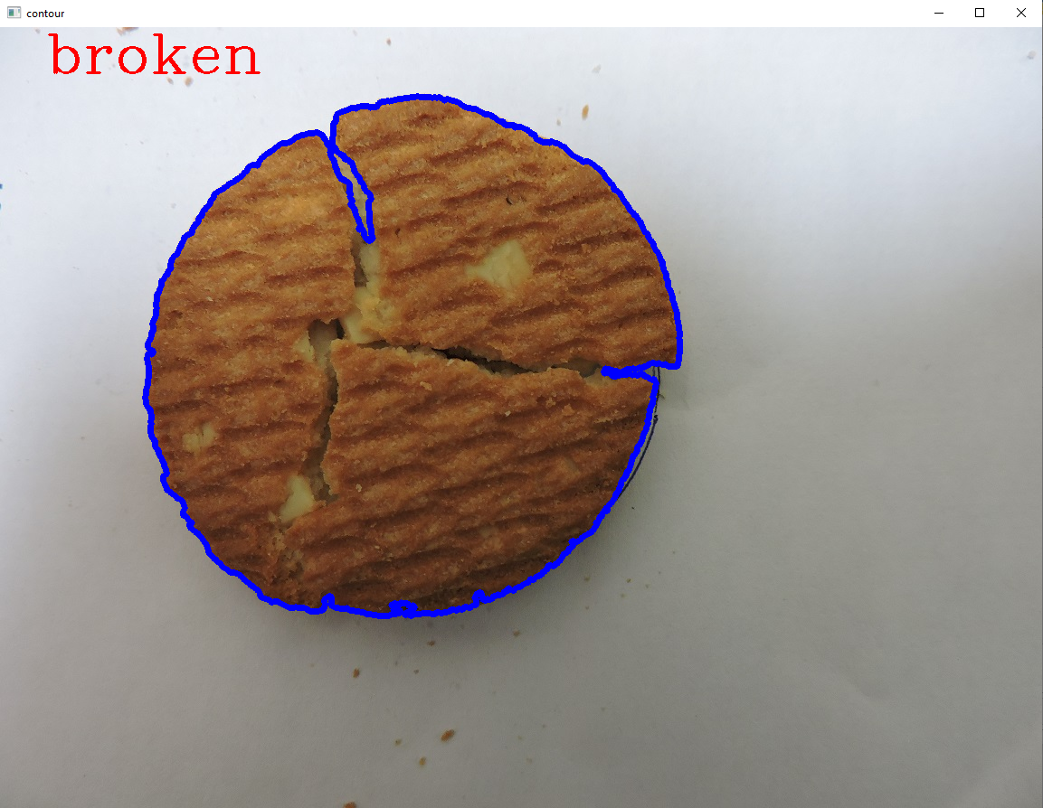

Figure 7 - Biscuit detected as Good Quality Figure 8 - Biscuit detected as Broken

## Conclusion

The biscuits in the given image were classified into Broken and Good Quality. The results were also printed onto the images along with the detected contours.

# References

* [OpenCV: OpenCV modules](https://docs.opencv.org/3.4/index.html)
* [First Principles of Computer Vision - YouTube](https://www.youtube.com/channel/UCf0WB91t8Ky6AuYcQV0CcLw)
* Robotics I Lab Manual – 3rd Semester