16662 Robot Autonomy – Homework 1
Ankit Aggarwal (ankitagg)

Submission for Q3

Plot for Static Whiteboard
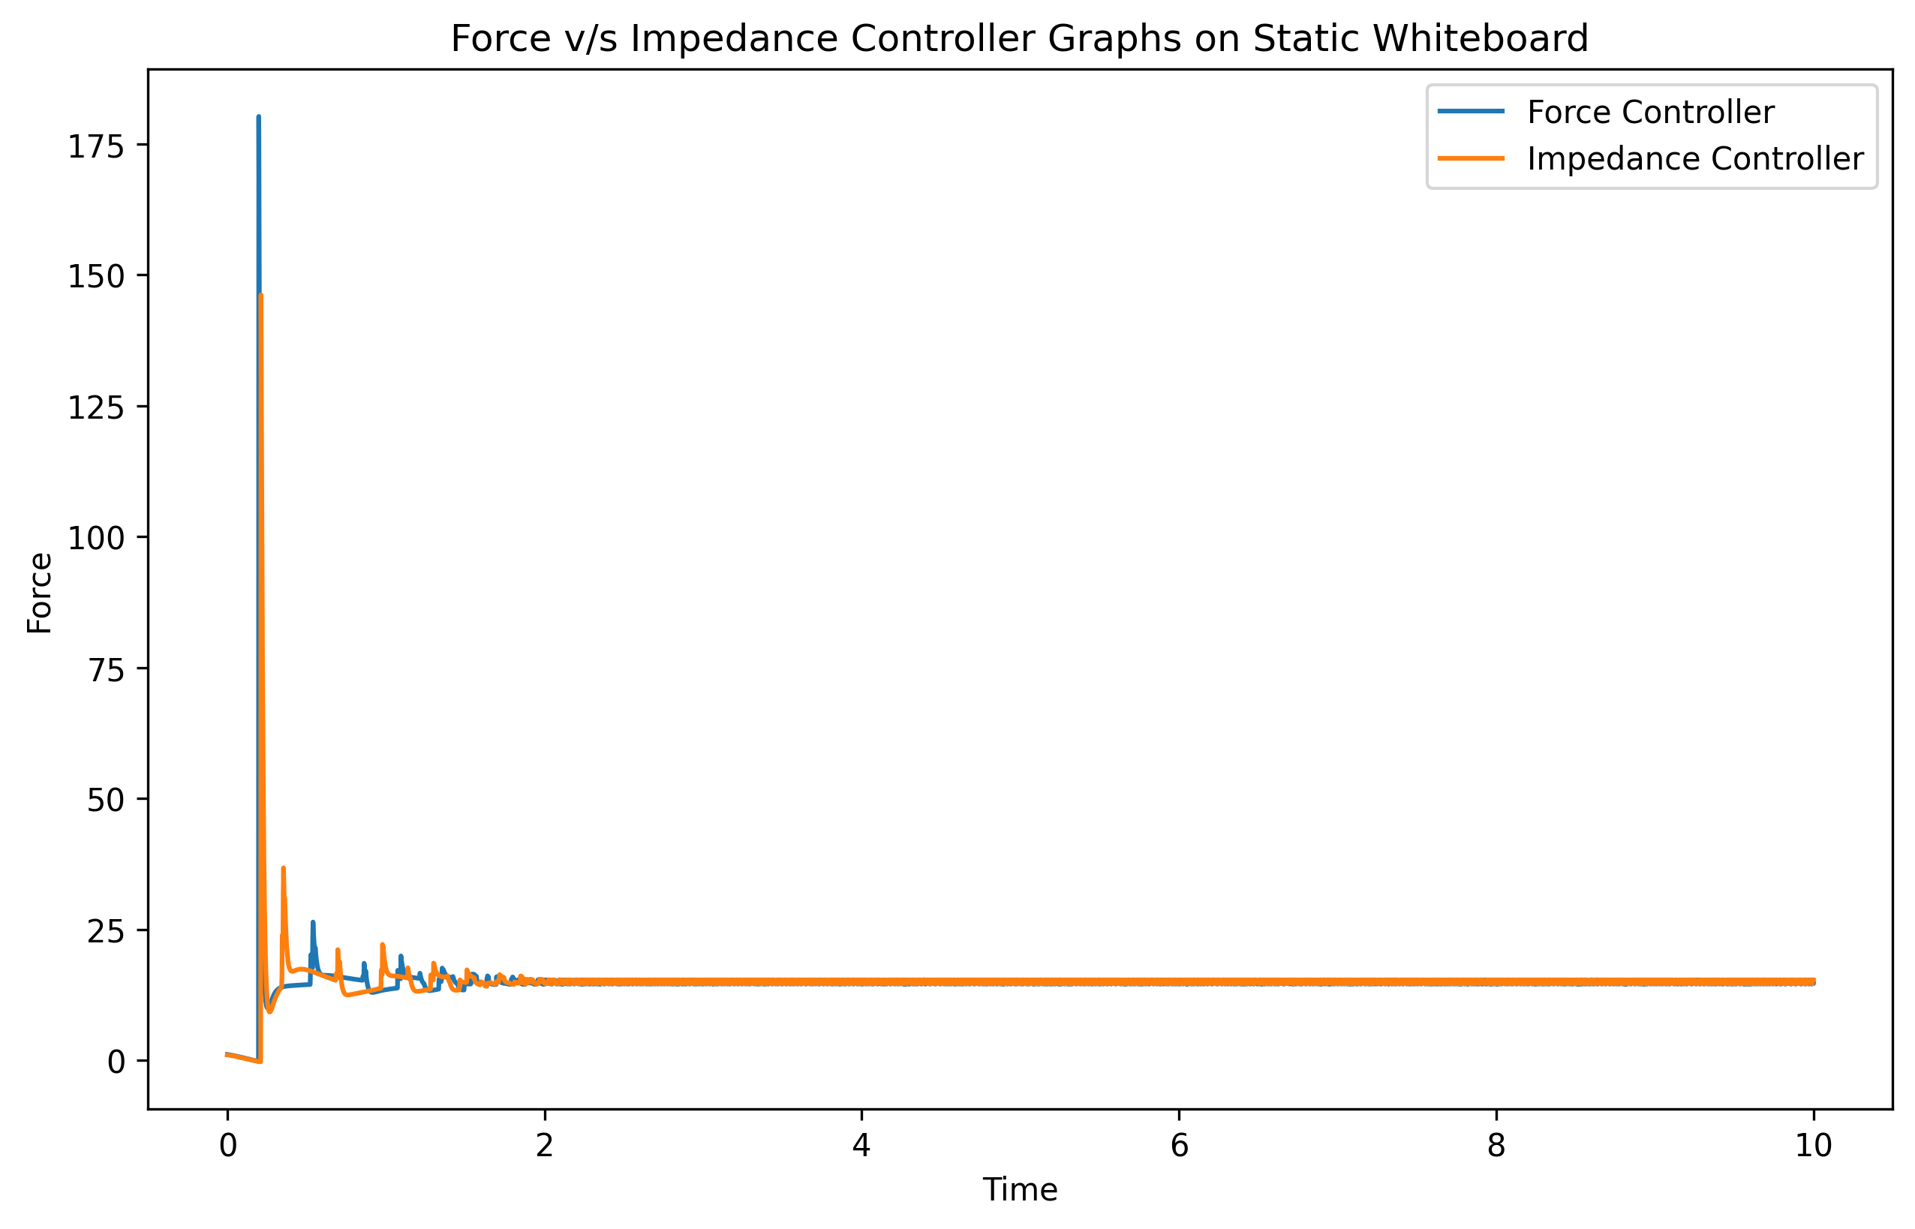
Zoomed in:
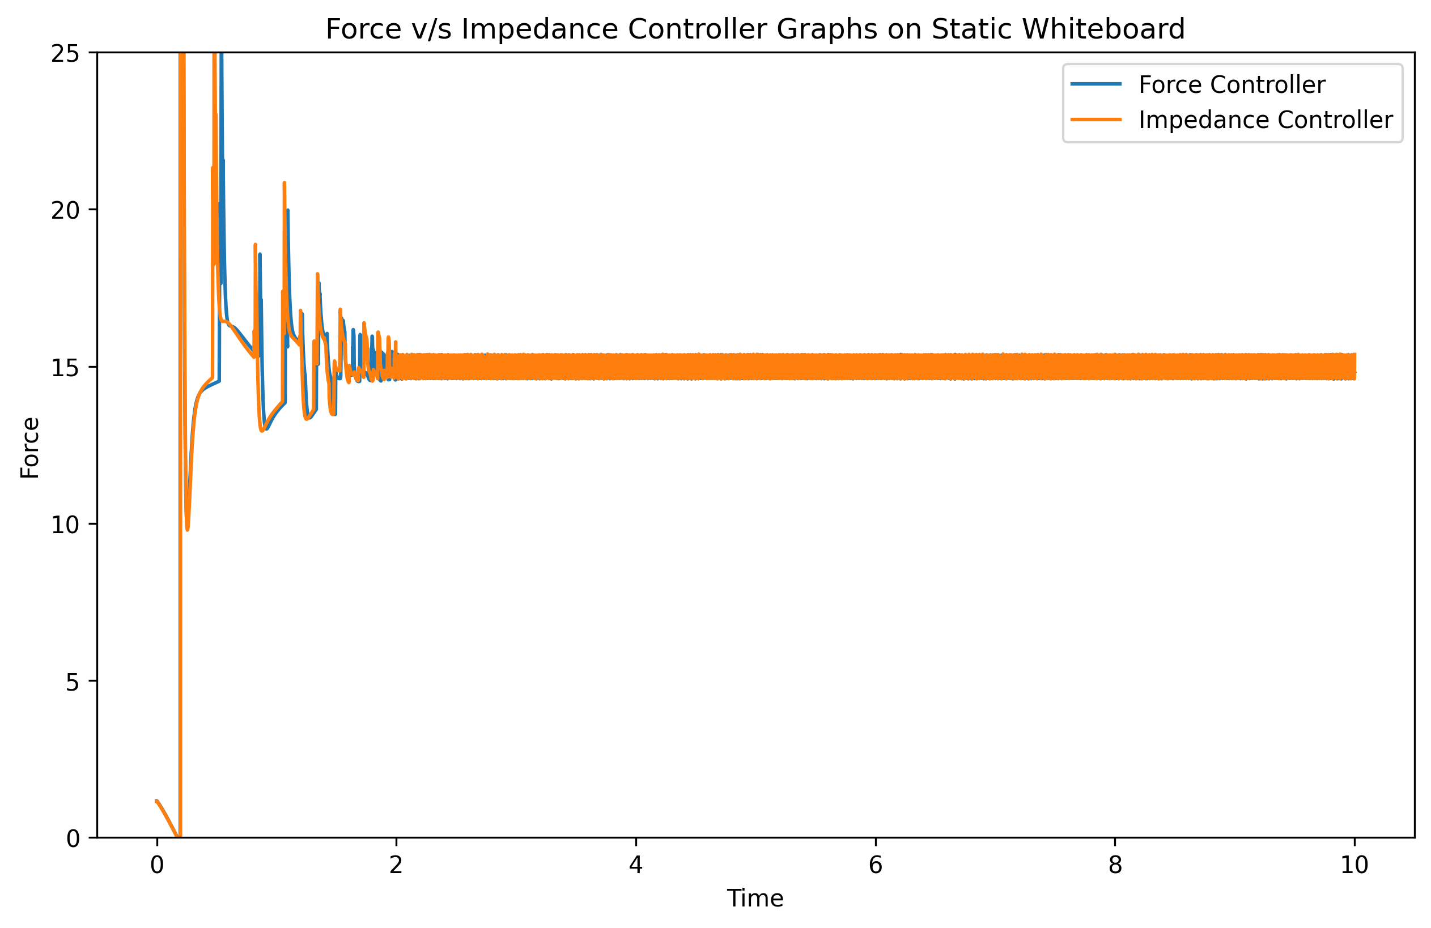

Plot for Moving Whiteboard
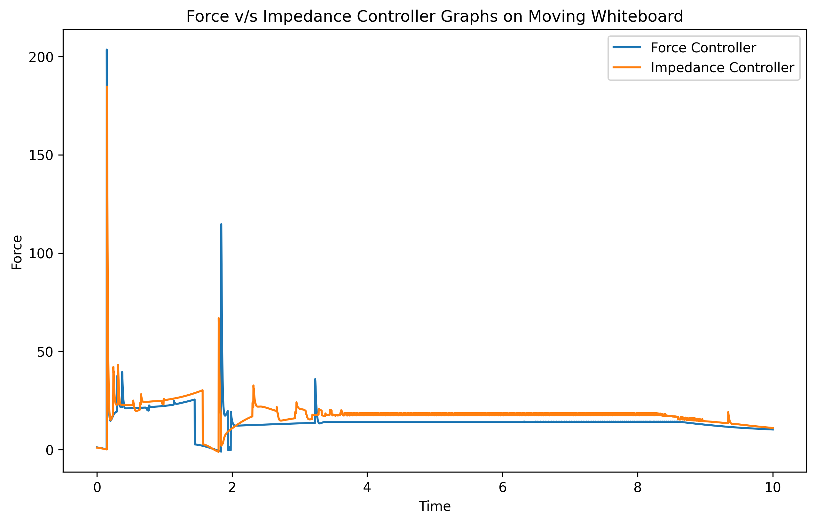
Zoomed in:
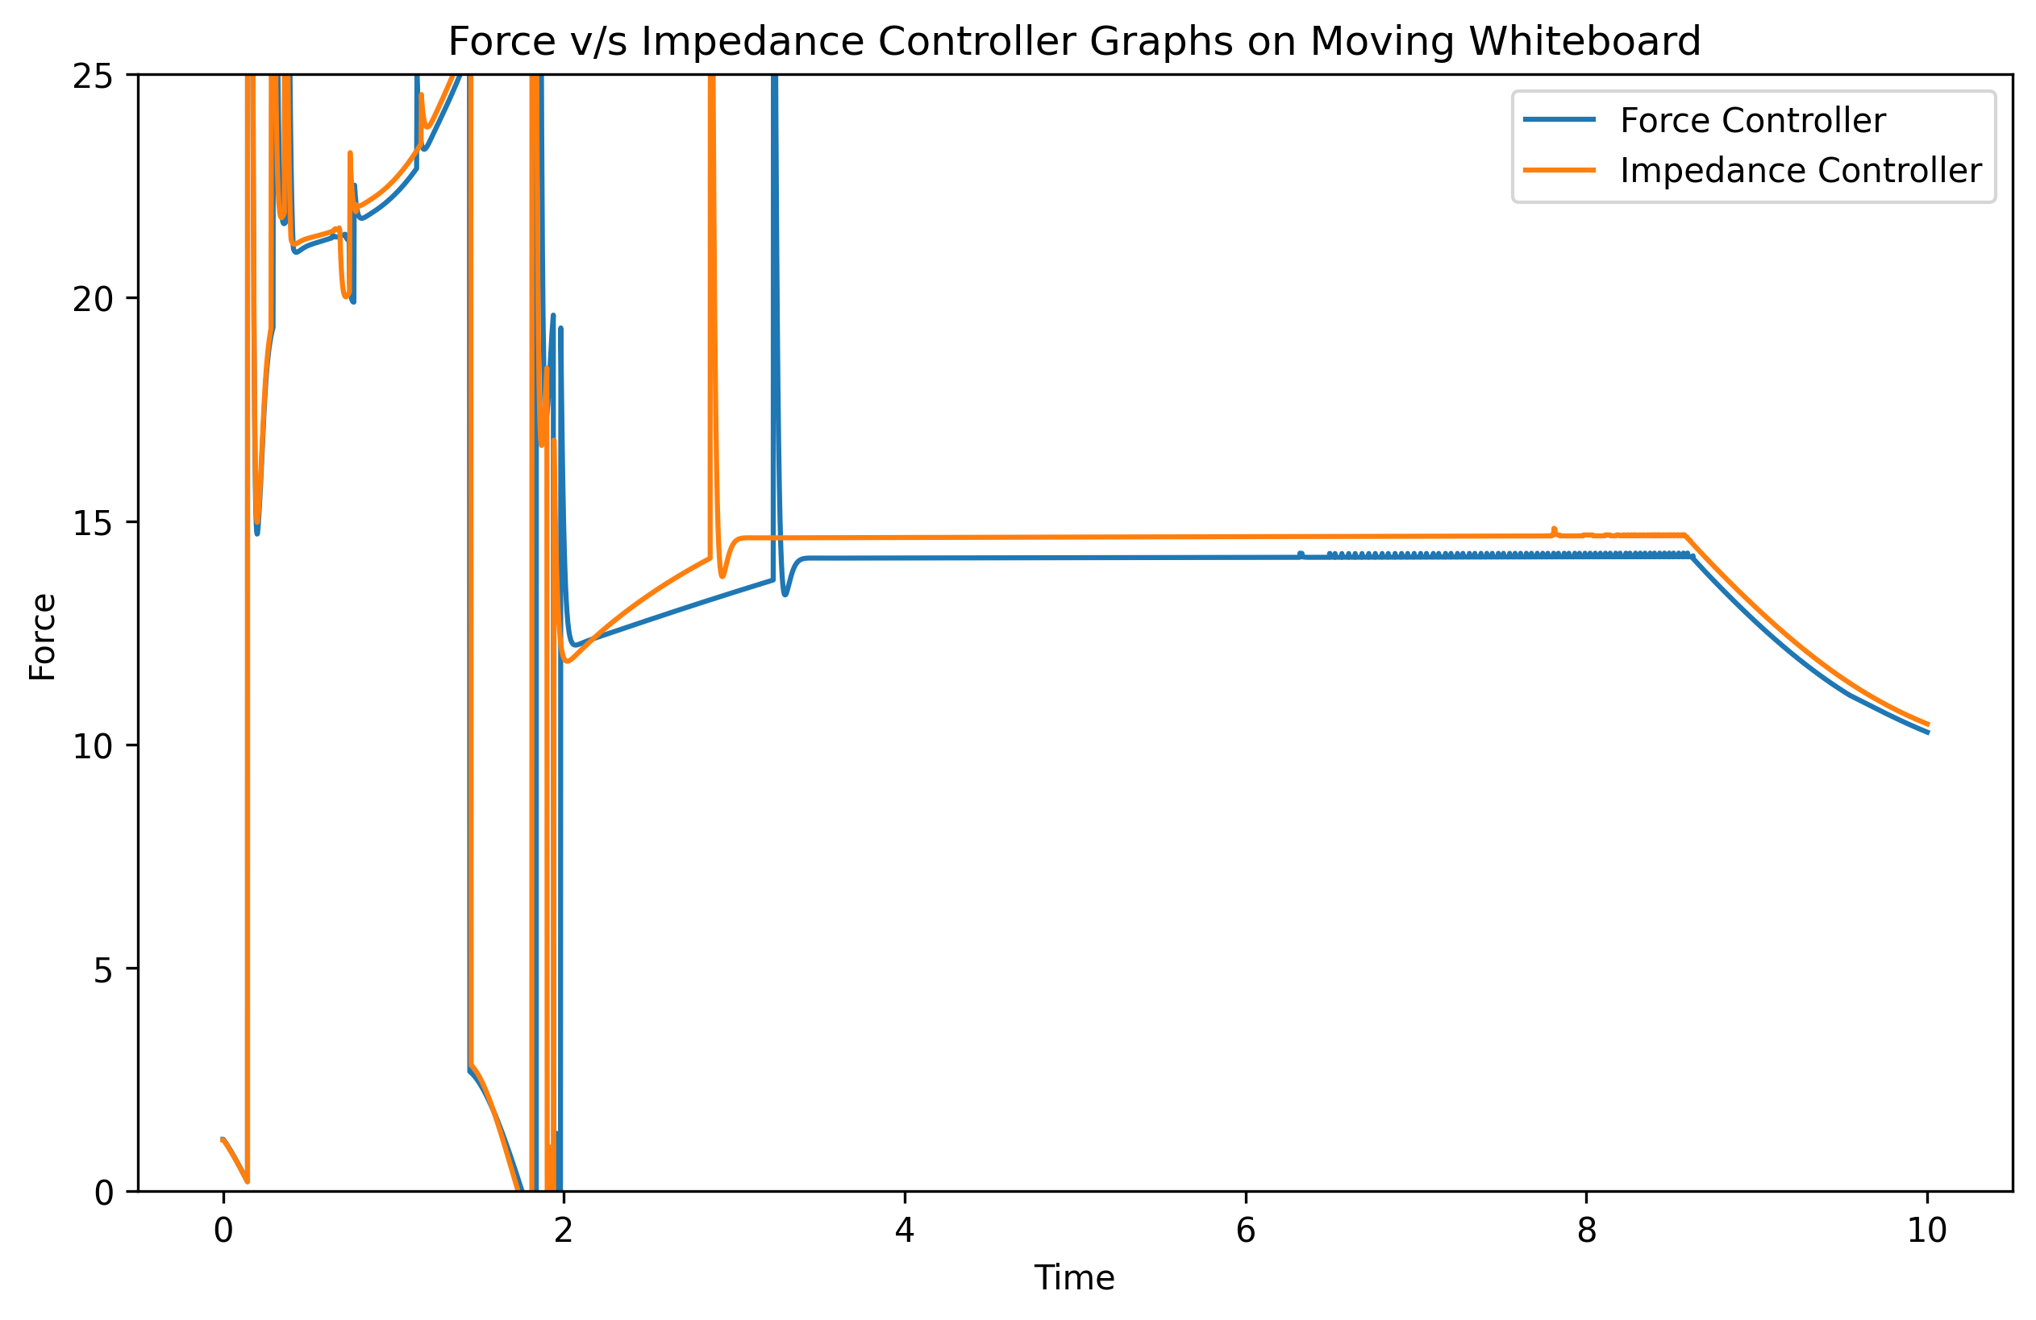

Screenshot of Robot at Maximum Amplitude
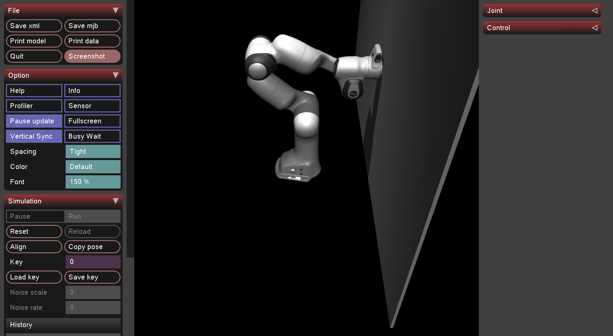

Explanation for difference in behavior of the force and impedance controllers
Impedance controllers resist sudden spikes/drops in force to help smooth out motion and eliminate jerks.

Submission for Q4

End Effector Poses
Q1
Joints:
[0.0, 0.0, 0.0, 0.0, 0.0, 0.0, 0.0]
computed FK ee position
[ 8.80000000e-02 -8.93992163e-18 9.26000000e-01]
computed FK ee rotation
[[ 1.0000000e+00 0.0000000e+00 0.0000000e+00]
[ 0.0000000e+00 -1.0000000e+00 -1.2246468e-16]
[ 0.0000000e+00 1.2246468e-16 -1.0000000e+00]]

Q2
Joints:
[0, 0, -0.7853981633974483, -0.2617993877991494, 0.3490658503988659, 0.2617993877991494, -1.3089969389957472]
computed FK ee position
[ 0.15710277 -0.10259332 0.93602711]
computed FK ee rotation
[[ 0.64935398 0.75871099 0.05193309]
[ 0.7552124 -0.65137389 0.07325497]
[ 0.08940721 -0.00834789 -0.99596017]]

Q3
Joints:
[0, 0, 0.5235987755982988, -1.0471975511965976, -1.1344640137963142, 0.7853981633974483, 0.0]
computed FK ee position
[0.40136375 0.08742801 0.85526363]
computed FK ee rotation
[[ 0.98015816 -0.18113365 -0.08050201]
[-0.17410263 -0.5925751 -0.78647507]
[ 0.09475362 0.78488557 -0.61235316]]

Final Joint Angles for moving the end effector to R_{g} and t_{g}
Iterations for Convergence: 469
Error 9.284698282135374e-07 0.00010577967311055332
Computed IK angles [-1.381117 0.50327976 1.52171772 -1.88583765 -2.85264866 2.71926329
-0.77118883]

To verify, I computed H using the FK function
H_computed: [[-9.69874012e-06 8.45002582e-07 1.00000000e+00 6.00000067e-01]
[-2.95517988e-06 1.00000000e+00 -8.45031243e-07 1.44289493e-09]
[-1.00000000e+00 -2.95518807e-06 -9.69873762e-06 5.00000010e-01]
[ 0.00000000e+00 0.00000000e+00 0.00000000e+00 1.00000000e+00]]

Screenshot Corresponding to the computed Joint Positions
