Robot Autonomy – Homework 2
Ankit Aggarwal – ankitagg@

Cuboid Collision Detection
Test Case | Origin (m) | Orientation (rad) | Dimensions (m) | Result
1 | (0,1,0) | (0,0,0) | (0.8,0.8,0.8) | False
2 | (1.5,-1.5,0) | (1,0,1.5) | (1,3,3) | False
3 | (0,0,-1) | (0,0,0) | (2,3,1) | True
4 | (3,0,0) | (0,0,0) | (3,1,1) | True
5 | (-1,0,-2) | (0.5,0,0.4) | (2,0.7,2) | True
6 | (1.8,0.5,1.5) | (-0.2,0.5,0) | (1,3,1) | False
7 | (0,-1.2,0.4) | (0,0.785,0.785) | (1,1,1) | True
8 | (-0.8,0,-0.5) | (0,0,0.2) | (1,0.5,0.5) | True

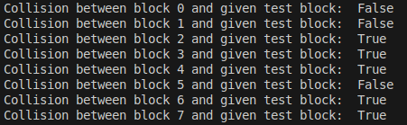

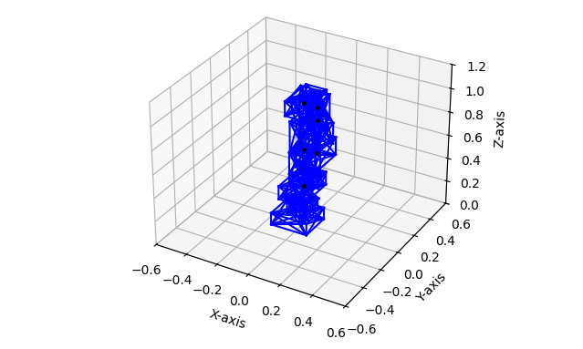
Bounding Boxes

RRT Motion Planning
RRT Connect with Goal Bias
goal_bias = 0.1
step_size = 0.3

Number of Steps without Shortening = 31
Number of Steps with Shortening = 3

Outputs:
Without Path Shortening: https://youtu.be/c2BA_O1wWkw
With Path Shortening: https://youtu.be/0emJ8ssZack

PRM Motion Planning
Vertices = 1500
Neighbours defined as L2 Norm < 2 radians.
Time taken to generate PRM: 122.94546556472778
Plan Found = Plan: [1333, 31, 1293, 1166]

Executed Output: https://youtu.be/gqURleVxb4U

