Robot Autonomy – Homework 3
Ankit Aggarwal - ankitagg@

2. Propositional States and Actions
The three actions are given as:

Action 1: Move to Pantry
Description: The robot can move to a pantry if it is in the kitchen
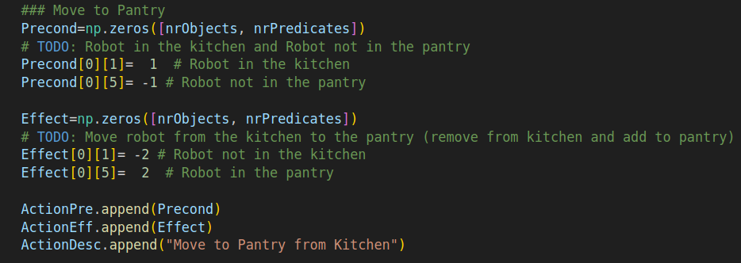

Action 2: Move to Kitchen
Description: The robot can move to the kitchen if it is in the pantry
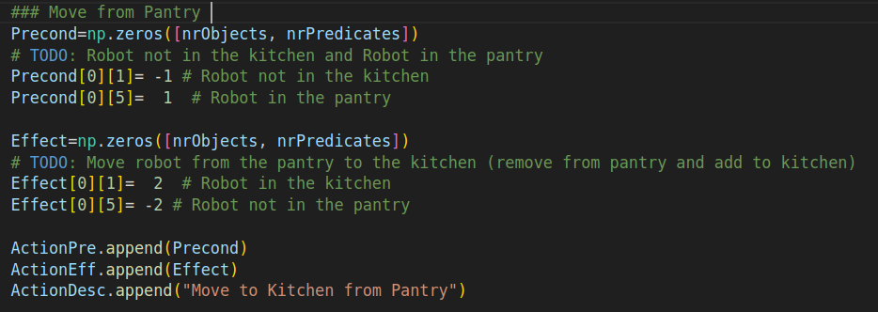

Action 3: Cut Fruit
Description: The robot can cut fruit if the robot, knife, and fruit are in the kitchen and the fruit has not been cut.
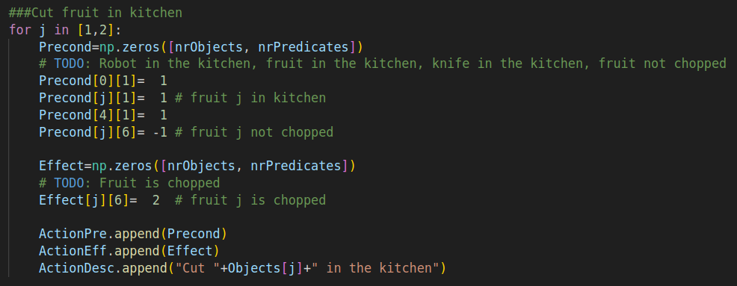

3. Discrete Search
Searching for a plan from the initial state to a goal state.

Djisktra Search
Number of vertices/states explored = 5894
Length of Plan = 16

Screenshot of the final plan
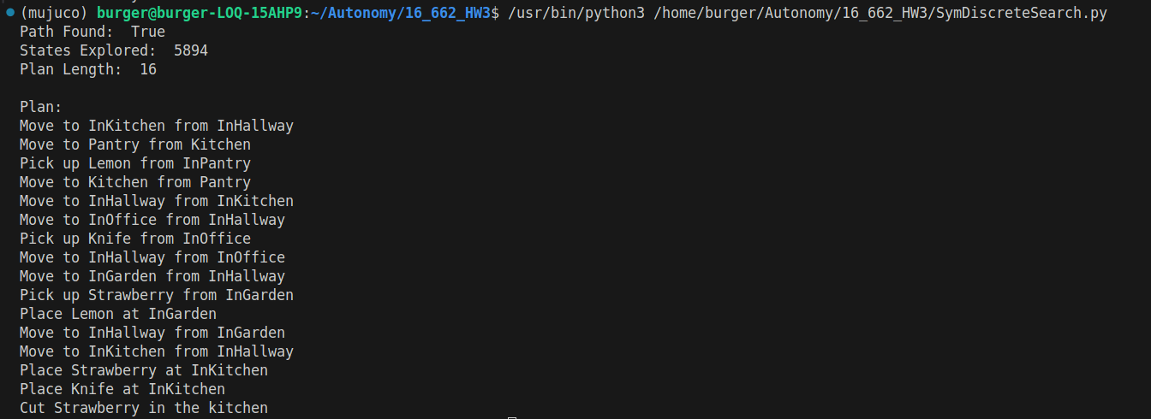

A* Search
Number of vertices/states explored = 2005
Length of Plan = 16

Screenshot of the Final Plan
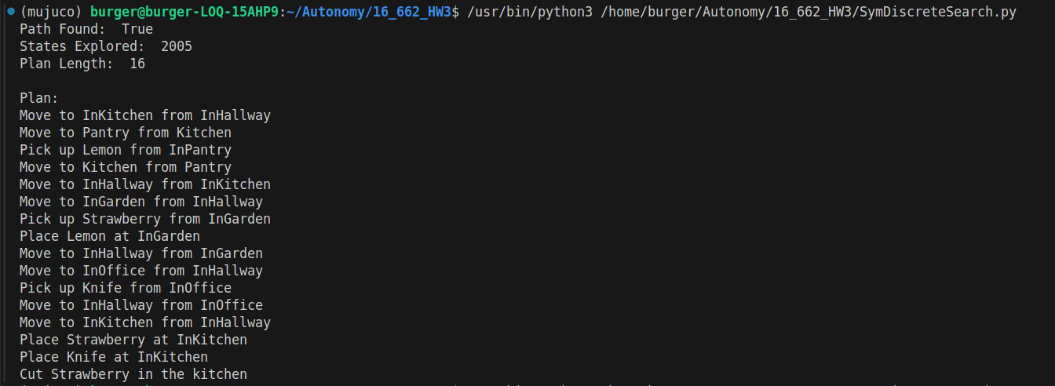

Cost Function Snippet
