CAPSTONE PROJECT REPORT
Make the Computer Draw a Box
Nand to Tetris – I (ETCCNT301)
School of Engineering & Technology
K.R. Mangalam University
Student Name: Ankit Kumar Pandey
University Roll Number: 2501350030
Personal Number K: 30
GitHub Repository: [PASTE YOUR REPOSITORY URL HERE]

1. Box Dimensions
The box dimensions are calculated using my university roll number, where K = 30.
- Starting row = K = 30
- Height = 20 rows
- Width = 16 × ((K mod 4) + 1)
- Width = 16 × ((30 mod 4) + 1) = 48 pixels
Therefore, the program draws a rectangular box of 48 pixels in width and 20 rows in height, starting from screen row 30.
The starting screen memory address is:
SCREEN + (32 × 30) = 16384 + 960 = 17344
3. Implementation
Part A – HDL Implementation
Implemented and tested the CPU, Memory, and Computer using the Nand2Tetris Hardware Simulator.
Part B – Hack Assembler
Developed a Python-based two-pass assembler (assembler.py) that converts Hack assembly programs into 16-bit machine instructions. It supports labels, variables, predefined symbols, and generates a symbol table containing user-defined labels and variables.
Part C – Box Program
Created Box.asm to draw a black rectangular box when a keyboard key is pressed and clear it when no key is pressed. The program writes -1 to three screen memory words per row to draw the box and 0 to clear it. It processes 20 rows and advances the screen pointer by 32 words for each new row.
4. Testing and Screenshots
The following tests and outputs were checked during the capstone implementation.
Figure 1: Memory and CPU Test
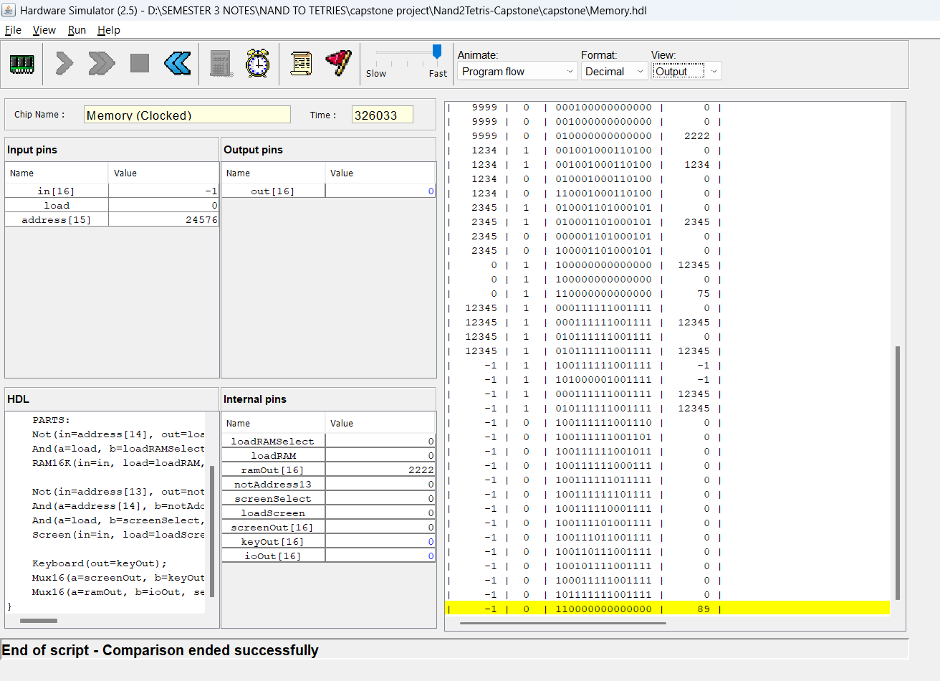
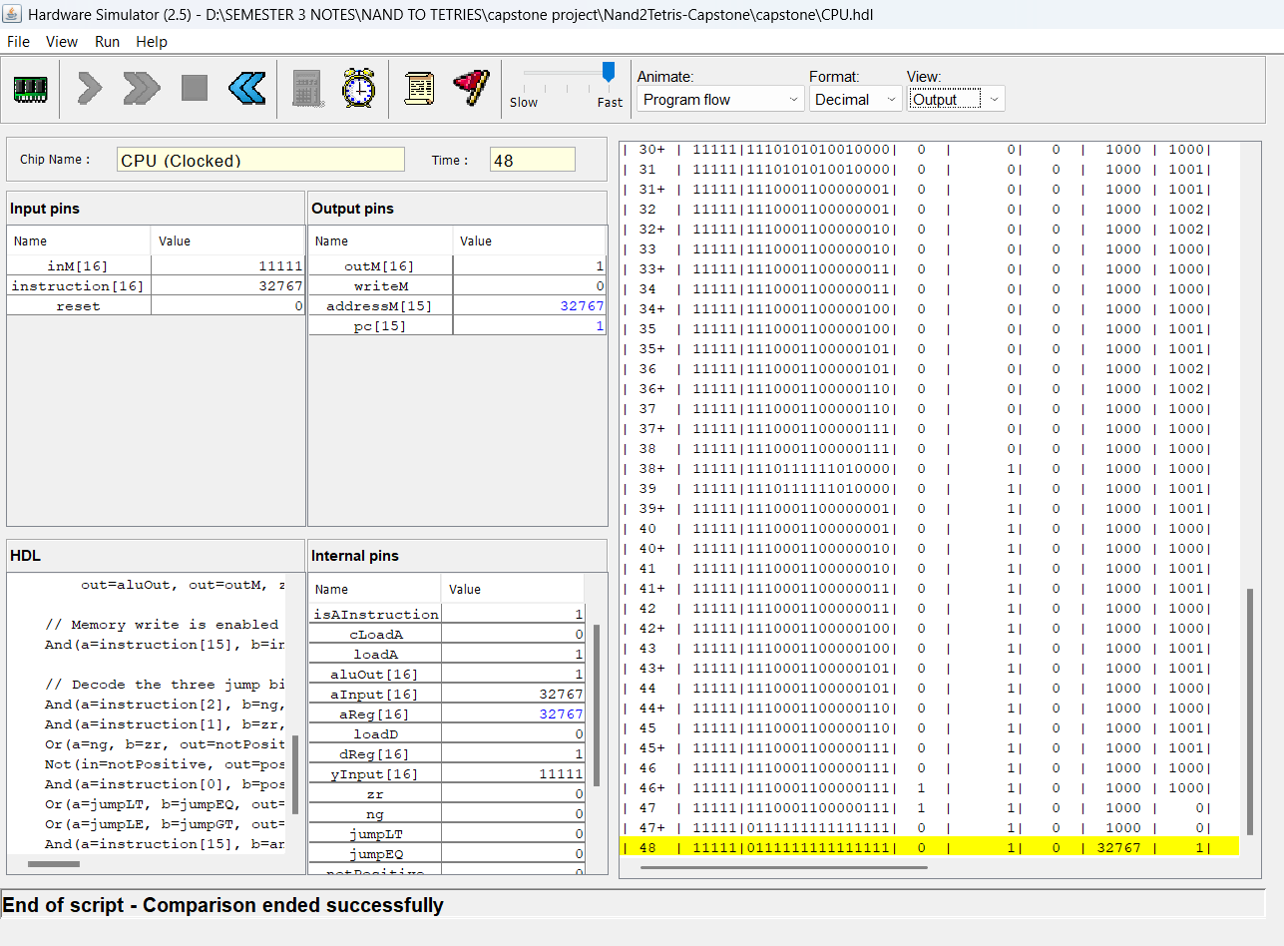
Figure 2: Computer Test
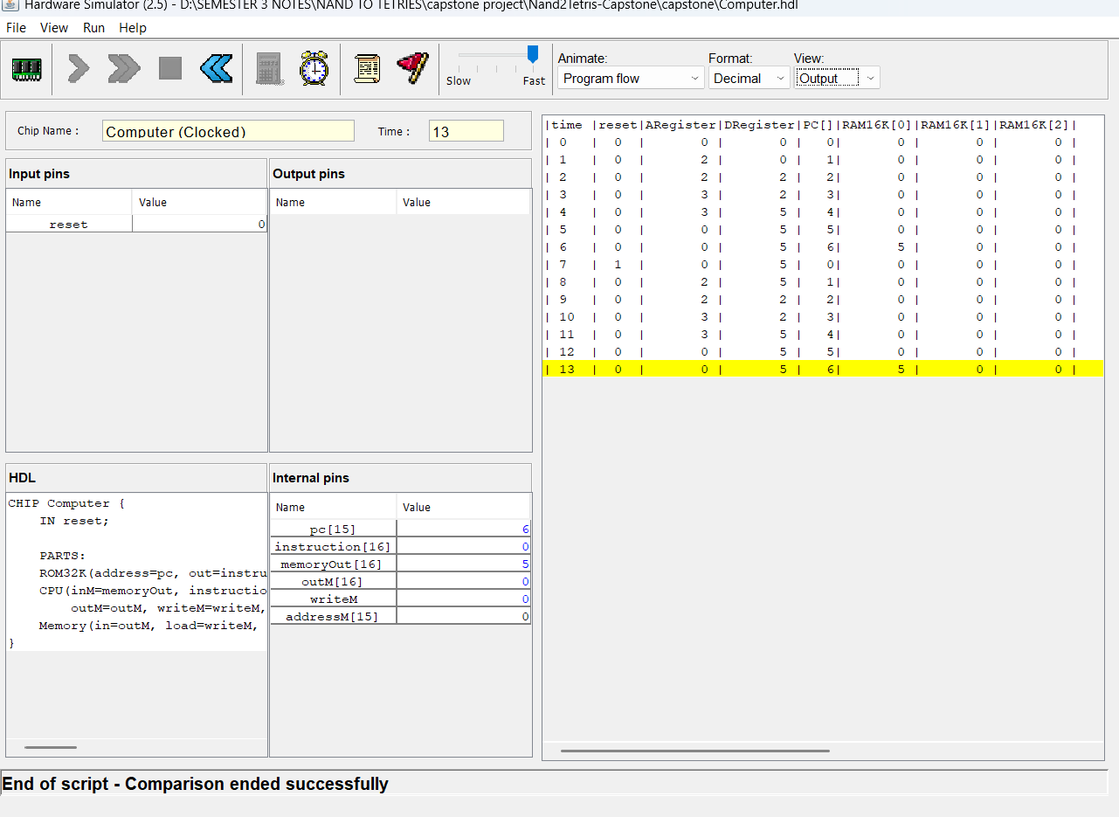
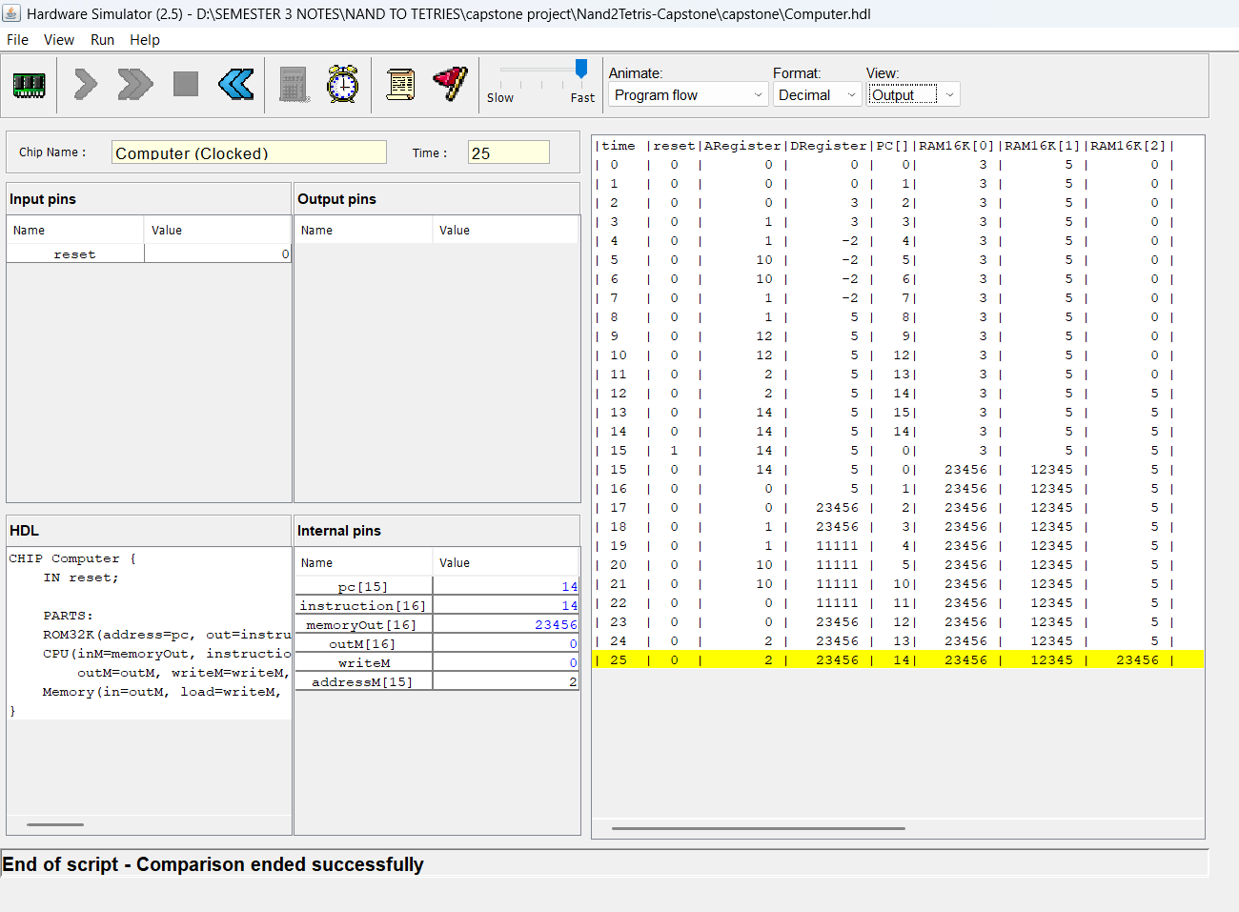
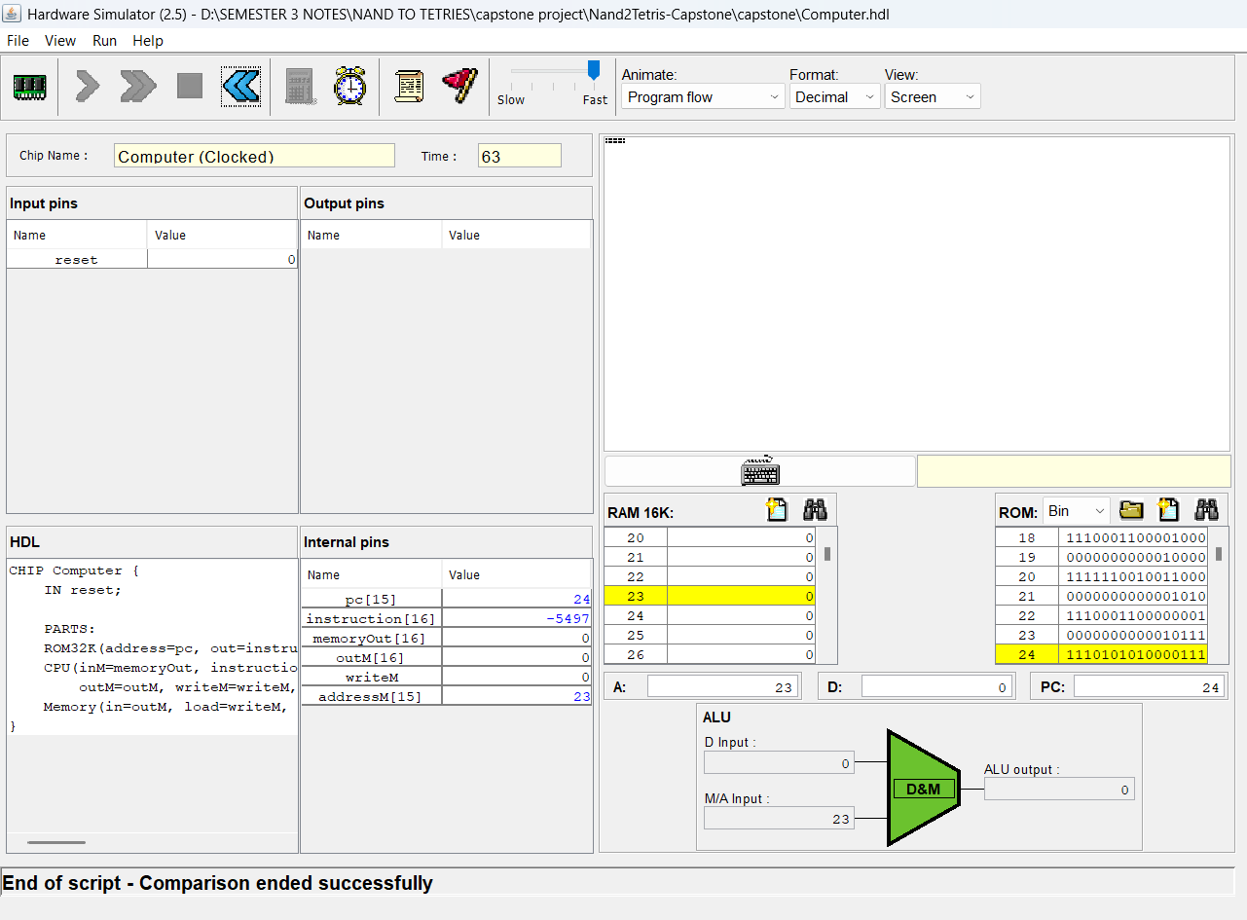
Figure 3: Python Assembler Execution
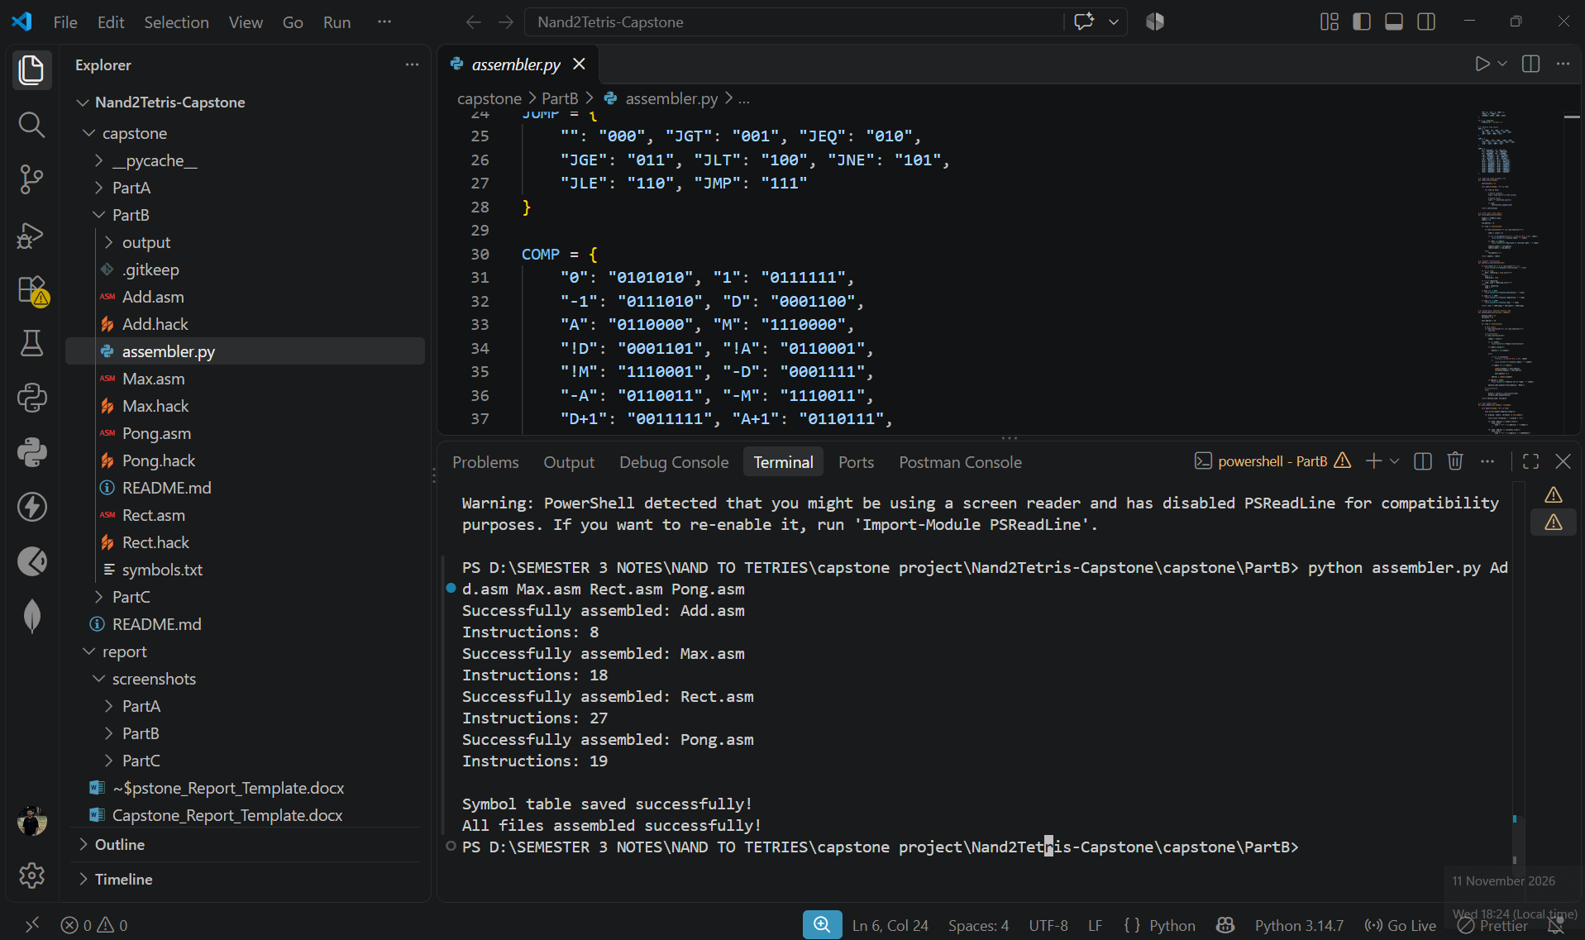

Figure 4: Box Program Assembly
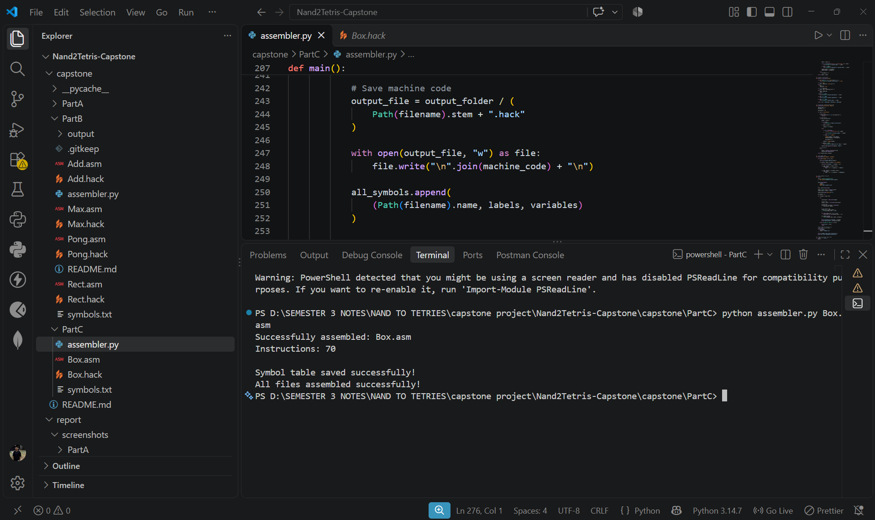
Figure 5: Final Box Output in CPU Emulator
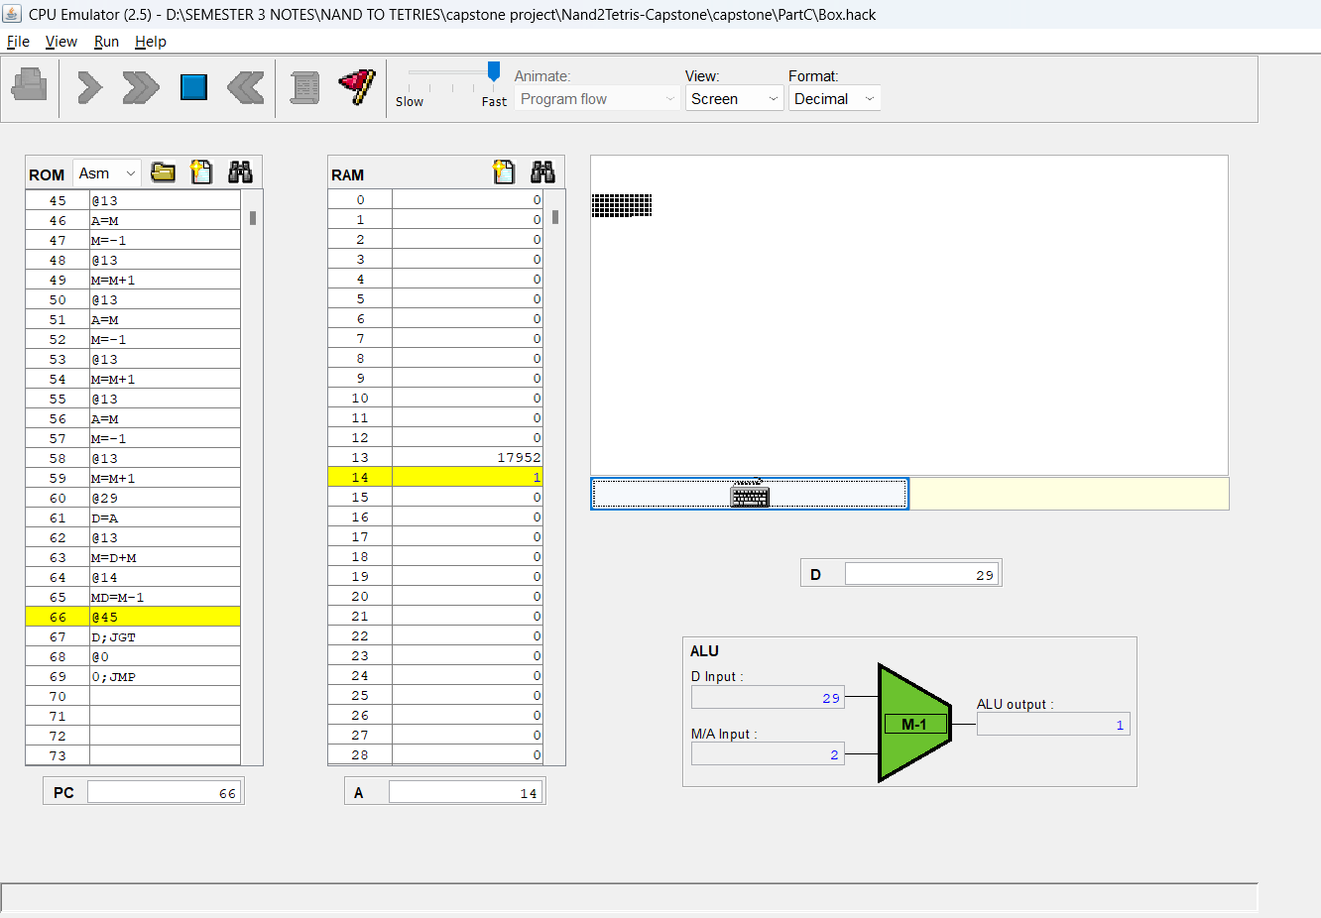

Figure 6: Box Cleared After Key Release
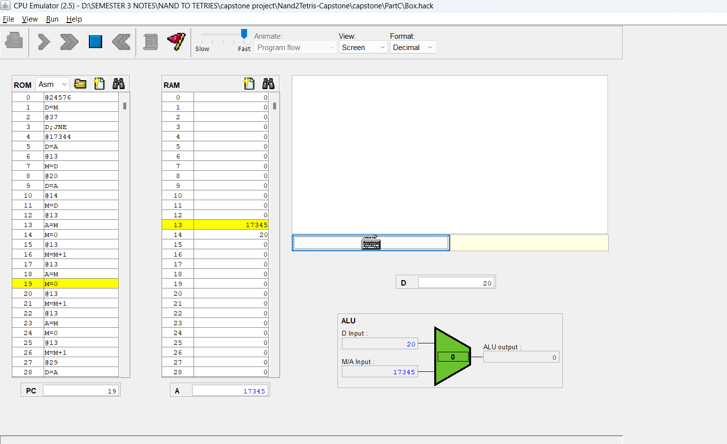
5. Mistake Fixed
During the development of the Box.asm program, I initially needed to correct the screen pointer calculation for moving from one row to the next. A Hack screen row contains 32 words, whereas my box uses only 3 words per row. After writing these 3 words, the pointer must advance by another 29 words to reach the beginning of the next row. I corrected the pointer update by adding 29 and tested the program again in the CPU Emulator. This ensured that the box was drawn across the correct 20 screen rows without incorrectly shifting the next row's starting position.
6. Submission Details
- GitHub Repository: [Insert your GitHub repository link]
- Submitted Files: HDL files, assembler.py, Box.asm, Box.hack, and symbols.txt.
- Report: This document contains the implementation summary, test evidence, final box output, and one mistake fixed.

