---First programme, printing help world

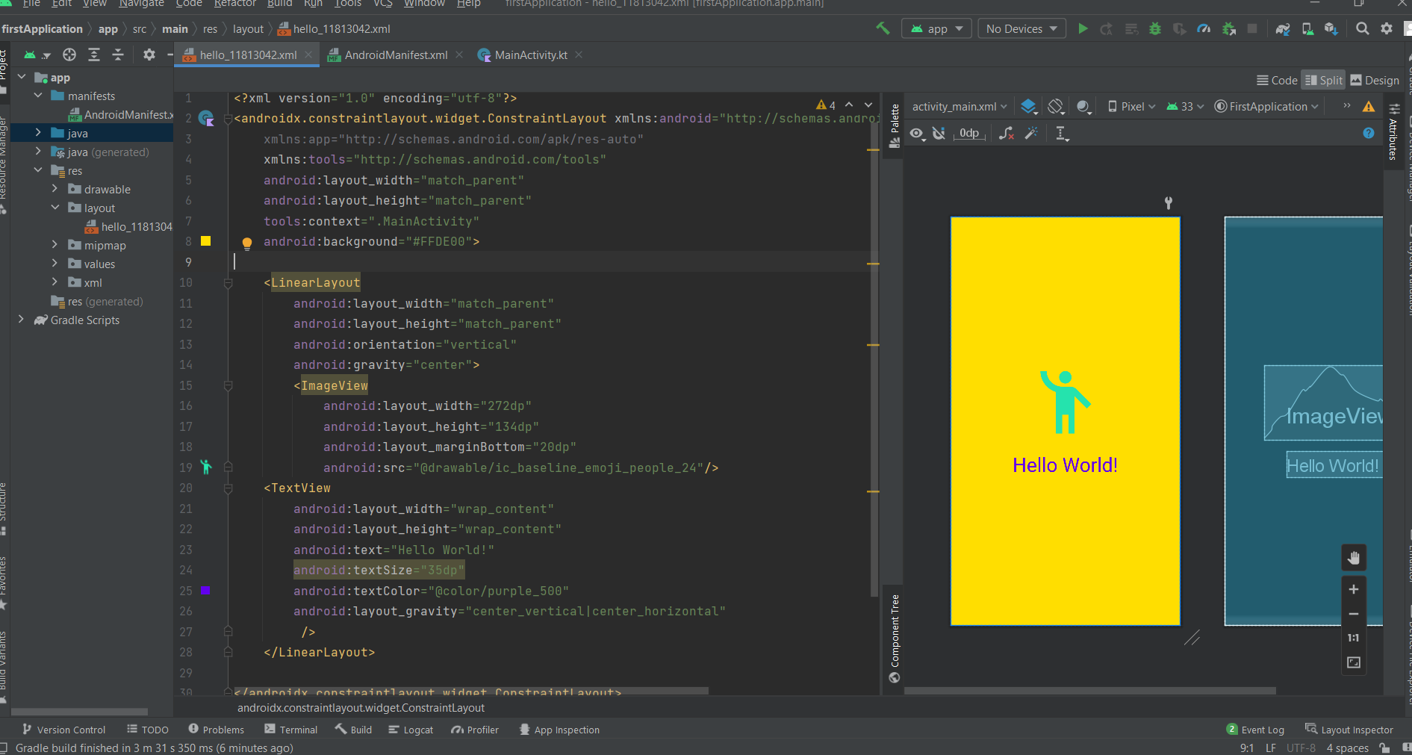

Kotlin file code—

package com.example.firstapplication  
  
import androidx.appcompat.app.AppCompatActivity  
import android.os.Bundle  
  
class MainActivity : AppCompatActivity() {  
 override fun onCreate(savedInstanceState: Bundle?) {  
 super.onCreate(savedInstanceState)  
 setContentView(R.layout.*hello_11813042*)  
 }  
}

Xml file code—

<?xml version="1.0" encoding="utf-8"?>  
<androidx.constraintlayout.widget.ConstraintLayout xmlns:android="http://schemas.android.com/apk/res/android"  
 xmlns:app="http://schemas.android.com/apk/res-auto"  
 xmlns:tools="http://schemas.android.com/tools"  
 android:layout_width="match_parent"  
 android:layout_height="match_parent"  
 tools:context=".MainActivity"  
 android:background="#FFDE00">  
  
 <LinearLayout  
 android:layout_width="match_parent"  
 android:layout_height="match_parent"  
 android:orientation="vertical"  
 android:gravity="center">  
 <ImageView  
 android:layout_width="272dp"  
 android:layout_height="134dp"  
 android:layout_marginBottom="20dp"  
 android:src="@drawable/ic_baseline_emoji_people_24"/>  
 <TextView  
 android:layout_width="wrap_content"  
 android:layout_height="wrap_content"  
 android:text="Hello World!"  
 android:textSize="35dp"  
 android:textColor="@color/purple_500"  
 android:layout_gravity="center_vertical|center_horizontal"  
 />  
 </LinearLayout>  
  
</androidx.constraintlayout.widget.ConstraintLayout>