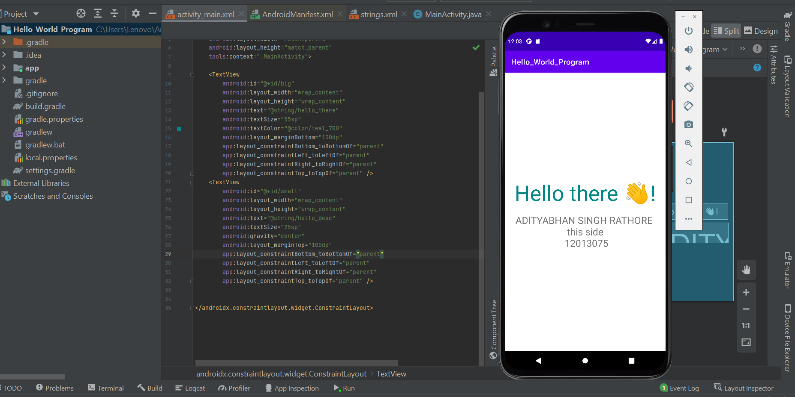

**activity_main.xml**

<?xml version="1.0" encoding="utf-8"?>  
<androidx.constraintlayout.widget.ConstraintLayout xmlns:android="http://schemas.android.com/apk/res/android"  
 xmlns:app="http://schemas.android.com/apk/res-auto"  
 xmlns:tools="http://schemas.android.com/tools"  
 android:layout_width="match_parent"  
 android:layout_height="match_parent"  
 tools:context=".MainActivity">  
  
 <TextView  
 android:id="@+id/big"  
 android:layout_width="wrap_content"  
 android:layout_height="wrap_content"  
 android:text="@string/hello_there"  
 android:textSize="55sp"  
 android:textColor="@color/teal_700"  
 android:layout_marginBottom="100dp"  
 app:layout_constraintBottom_toBottomOf="parent"  
 app:layout_constraintLeft_toLeftOf="parent"  
 app:layout_constraintRight_toRightOf="parent"  
 app:layout_constraintTop_toTopOf="parent" />  
 <TextView  
 android:id="@+id/small"  
 android:layout_width="wrap_content"  
 android:layout_height="wrap_content"  
 android:text="@string/hello_desc"  
 android:textSize="25sp"  
 android:gravity="center"  
 android:layout_marginTop="100dp"  
 app:layout_constraintBottom_toBottomOf="parent"  
 app:layout_constraintLeft_toLeftOf="parent"  
 app:layout_constraintRight_toRightOf="parent"  
 app:layout_constraintTop_toTopOf="parent" />  
  
  
</androidx.constraintlayout.widget.ConstraintLayout>

**strings.xml**

<resources>  
 <string name="app_name">Hello_World_Program</string>  
 <string name="hello_there">Hello there 👋!</string>  
 <string name="hello_desc">ADITYABHAN SINGH RATHORE \nthis side\n 12013075</string>  
</resources>