Name : Akansha Arora

Roll no:12013096

Section: ITA03

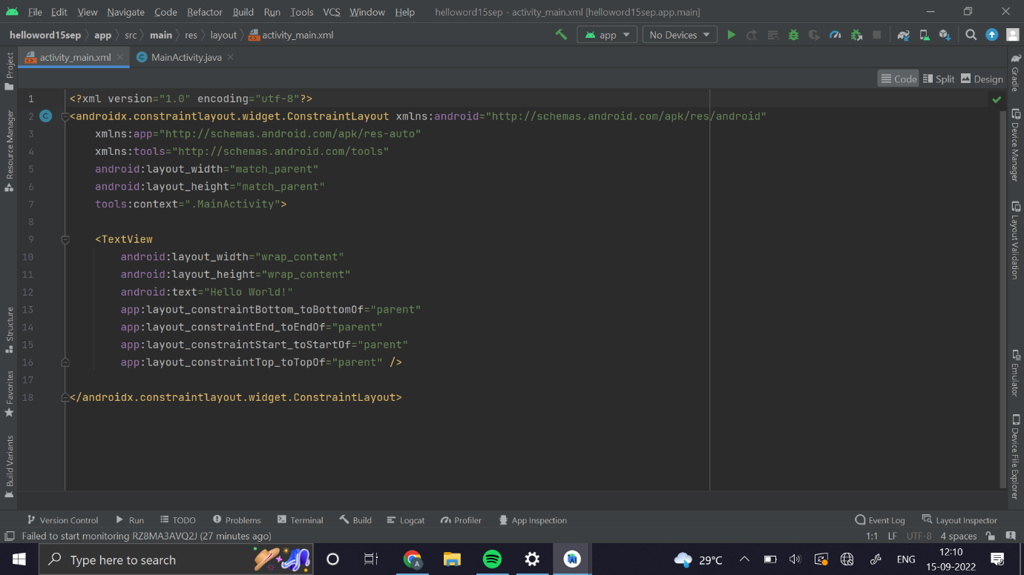

OUTPUT

