**LAB-01**

**To Create “Hello World” Widget in an Android App**

**XML File: -**

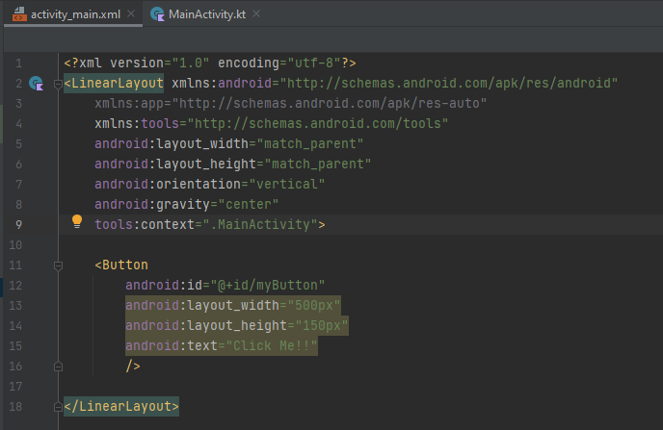

**MainActivity.kt file: -**

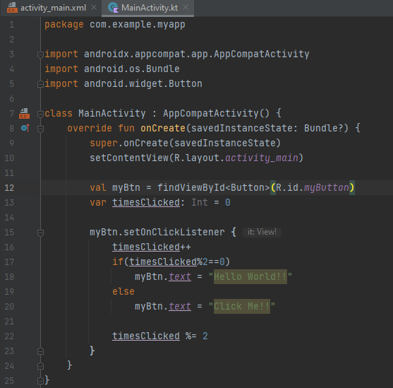

**Output: -**

