

Index

1. **Web Page using HTML tags: (a) Background colour (b) Font (c) Bold/italic (d) Big/Small (e) h1, h2 (f) Marquee (g) Ordered/Unordered Lists**
2. **Created a Employee table and apply Various table handling operations on it using HTML.**
3. **Implement the concept of frames in a Web page.**
4. **Home Page of our institute and insert images in it**
5. **Prepare your CV and link it on Web Page.**
6. **Created a Web Page and use various sound effects/animations in it.**

Experiment no: 1

**Web Page using HTML tags: (a) Background colour (b) Font (c) Bold/italic (d) Big/Small (e) h1, h2 (f) Marquee (g) Ordered/Unordered Lists**

<!DOCTYPE html>

<html>

<head>

<title>First Page</title>

<style type="text/css">

body{

background-color: black;

color: white;

}

.para{

font-size: 23px;

float: right;

width: 900px;

}

.image{

width: 400px;

float: right;

}

li{

padding: 10px;

}

.mark{

background-color: red;

padding: 8px;

font-size: 19px;

color: white;

font-family: sans-serif;

}

</style>

</head>

<body>

<marquee class="mark" width="100%" direction="left" scrollamount="12" ><b>Shree APJ Abdul Kalam</b></marquee>

<p class="para">

<font size="6" color="red"><b><i><span>A.P.J Abdul kalam</span></i></b></font>,in full Avul Pakir Jainulabdeen Abdul Kalam,(born on October 15,1931,RAMESWARAM,India-died july 27,2015 Shillong),Indian scientist and politician who played a leading role in the development of India’s missile and nuclear weapons programs.

<img src="images/1.png" class="image">

He was president of India from 2002 to 2007.Kalam earned a degree in aeronautical engineering from the Madras Institute of Technology and in 1958 joined the Defence Research and Development Organisation (DRDO).In 1969 he moved to the Indian Space Research Organisation, where he was project director of the SLV-III, the first satellite launch vehicle that was both designed and produced in India. Rejoining DRDO in 1982, Kalam planned the program that produced a number of successful missiles, which helped earn him the nickname “Missile Man.” Among those successes was Agni, India’s first intermediate-range ballistic missile, which incorporated aspects of the SLV-III and was launched in 1989.From 1992 to 1997 Kalam was scientific adviser to the defense minister, and he later served as principal scientific adviser (1999–2001) to the government with the rank of cabinet minister. His prominent role in the country’s 1998 nuclear weapons tests solidified India as a nuclear power and established Kalam as a national hero, although the tests caused great concern in the international community. In 1998 Kalam put forward a countrywide plan called Technology Vision 2020, which he described as a road map for transforming India from a less-developed to a developed society in 20 years. The plan called for, among other measures, increasing agricultural productivity, emphasizing technology as a vehicle for economic growth, and widening access to health care and education.

</p>

<font color="red" face="arial"><h1>Some Quotes by APJ Sir...</h1></font>

<ul>

<li>"You have to dream before your dreams can come true."</li>

<li>"If you want to shine like a sun, first burn like a sun"</li>

<li>"All of us do not have equal talent. But, all of us have an equal opportunity to develop our talents."</li>

<li>"Man needs difficulties in life because they are necessary to enjoy success."</li>

<li>"Don’t take rest after your first victory because if you fail in second, more lips are waiting to say that your first victory was just luck."</li>

</ul>

</body>

</html>

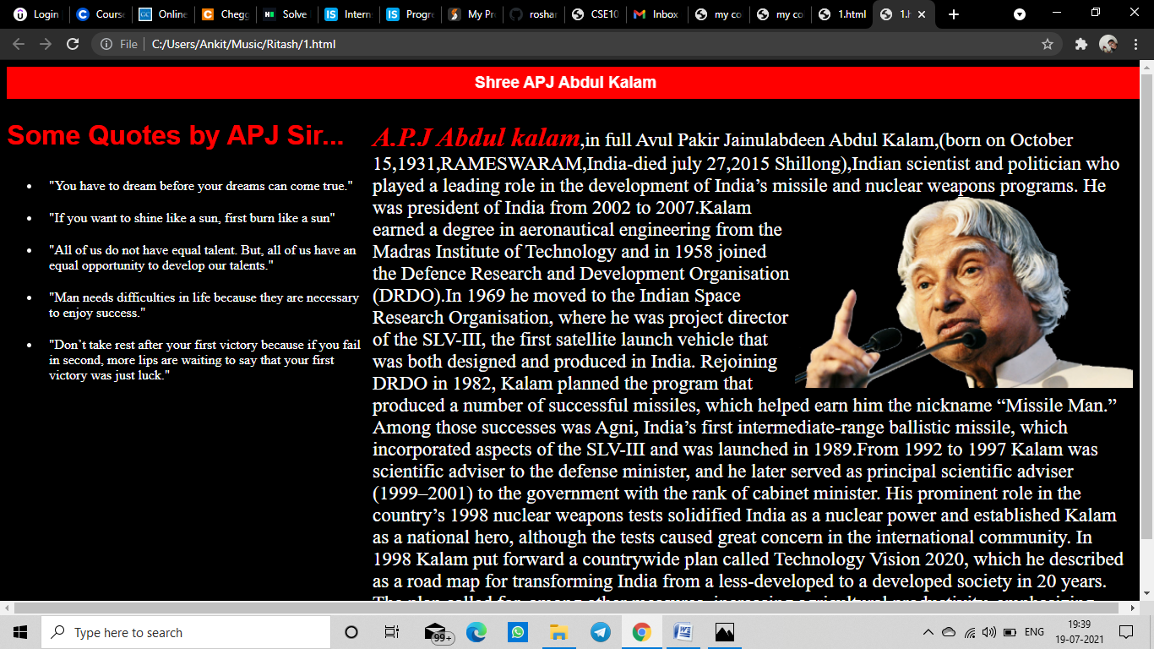

Experiment no: 2

**Created a Employee table and apply Various table handling operations on it using HTML**

<!DOCTYPE html>

<html>

<head>

<title>Employee Table</title>

</head>

<style type="text/css">

html,body{

margin:0;

height: 100%;

background: linear-gradient(to bottom right,red,yellow);

background-repeat: no-repeat;

background-size: cover;

width: 100%;

}

.quote{

position: relative;

letter-spacing: 1px;

margin-bottom: -40px;

animation: text 3s infinite;

color: floralwhite;

}

@keyframes text{

0%{

margin-bottom: -40px;

}

30%{

letter-spacing: 3px;

margin-bottom: -40px;

}

85%{

letter-spacing: 1.8px;

margin-bottom: -40px;

}

}

table {

width:50%;

margin-left: auto;

margin-right: auto;

margin-top: 100px;

}

table, th, td {

border: 1px solid black;

border-collapse: collapse;

}

th, td {

padding: 15px;

text-align: left;

}

#t01 tr:nth-child(even) {

background-color: #eee;

}

#t01 tr:nth-child(odd) {

background-color: #fff;

}

#t01 th {

background-color: black;

color: white;

}

</style>

<body>

<h2 class="quote" style="text-align: center;">Employee Table</h2>

<table id="t01">

<tr>

<th>Eid</th>

<th>Name</th>

<th>Age</th>

<th>Designation</th>

<th>Salary(in INR)</th>

</tr>

<tr>

<td>1</td>

<td>Berlin</td>

<td>30</td>

<td>Assistant Professor</td>

<td>30000</td>

</tr>

<tr>

<td>2</td>

<td>Tokyo</td>

<td>25</td>

<td>Associate Professor</td>

<td>35000</td>

</tr>

<tr>

<td>3</td>

<td>Helsinki</td>

<td>23</td>

<td>Manager</td>

<td>20000</td>

</tr>

<tr>

<td>4</td>

<td>Rio</td>

<td>43</td>

<td>Professor</td>

<td>50000</td>

</tr>

<tr>

<td>5</td>

<td>Nairobi</td>

<td>28</td>

<td>Supervisor</td>

<td>28000</td>

</tr>

</table>

</body>

</html>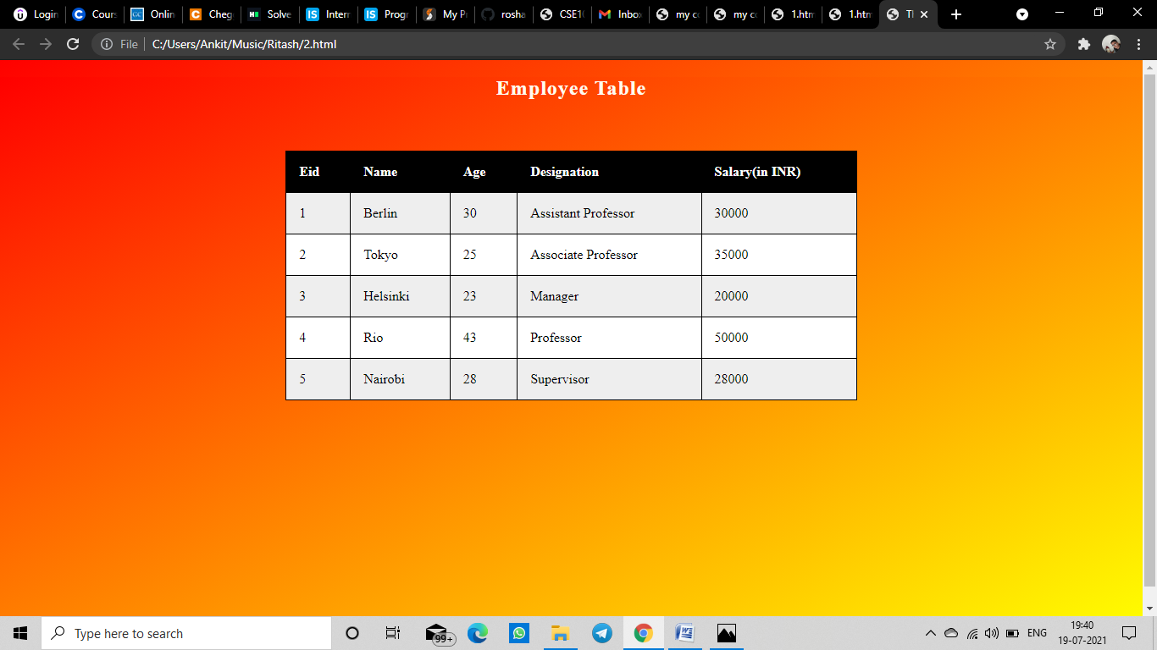

Experiment no: 3

**Implement the concept of frames in a Web page.**

<!DOCTYPE html>

<html>

<head>

<title>Iframe</title>

<style type="text/css">

<link rel="preconnect" href="https://fonts.googleapis.com">

<link rel="preconnect" href="https://fonts.gstatic.com" crossorigin>

<link href="https://fonts.googleapis.com/css2?family=Source+Sans+Pro&display=swap" rel="stylesheet">

html{

background-color: black;

}

.main{

width: 100%;

height: 100%;

display: flex;

}

body{

background-color: antiquewhite ;

}

.header{

position: relative;

color: green;

letter-spacing: 1px;

margin-bottom: -40px;

animation: text 3s infinite;

}

h1{

text-align: center;

}

.para{

margin-top: 30px;

width: 60%;

float: left;

border: 2px solid black;

background: linear-gradient(to bottom right,orange,red);

}

.parag{

color: beige;

padding: 40px;

font-size: 21px;

font-family: 'Source Sans Pro', sans-serif;

}

.ifra{

margin-left: 50px;

float: left;

width: 35%;

height: 480px;

}

iframe{

height: 100%;

width: 100%;

}

@keyframes text{

0%{

margin-bottom: -40px;

}

30%{

letter-spacing: 3px;

margin-bottom: -40px;

}

85%{

letter-spacing: 1.8px;

margin-bottom: -40px;

}

}

</style>

</head>

<body >

<div class="main">

<div class="para">

<div>

<h1 style="text-align: center;">Dayanand College</h1>

</div>

<p class="parag" >Dayanand College, Hisar welcomes you and bids you to become a member of our mission for excellence with us does not only mean

academic achievement. This it does, but it has other elements also, like social responsibility and personal nobility.

Dayanand College may not take you to the sky, but it promises to show you the sky and the path to the sky also. Here,

you will take one of the many steps you will need to know the world, to explore the earth and to reach the sky. Equally

important with us is to inculcate in you the spirit of love and sympathy, the spirit of happiness and fulfillment. Love

the world to fulfill yourself and sympathize with the lesser to spread happiness. Think of yourself but do not be forgetful of others also.

Here, in this college, you may not become the great you want to be, but here you will learn the need to be the great you must be.

Greatness is a product of honesty and nobility. Greatness is fertilized by love and understanding.

Here you should learn to attach yourself to great causes, to good missions, to noble visions. Here,

you should get your key to success and happiness and fulfillment.</p>

</div>

<div class="ifra">

<div>

<h1>Read more here....</h1>

</div>

<iframe src="https://www.dnc.ac.in/" title="iframe example">

</iframe>

</div>

</div>

</body>

</html>

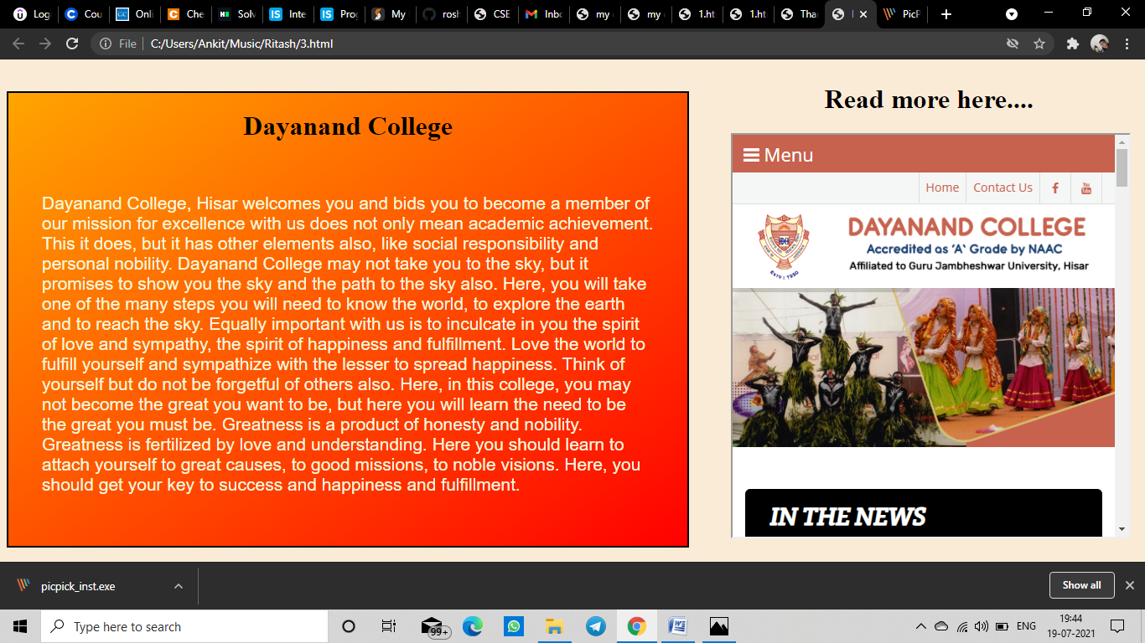

Experiment no: 4

**Home Page of our institute and insert images in it**

<!DOCTYPE html>

<html lang="en">

<head>

<title>my college</title>

<meta charset="UTF-8">

<meta name="viewport" content="width=device-width, initial-scale=1">

<link rel="stylesheet" href="https://maxcdn.bootstrapcdn.com/bootstrap/4.0.0/css/bootstrap.min.css" integrity="sha384-Gn5384xqQ1aoWXA+058RXPxPg6fy4IWvTNh0E263XmFcJlSAwiGgFAW/dAiS6JXm" crossorigin="anonymous">

<script src="https://code.jquery.com/jquery-3.2.1.slim.min.js" integrity="sha384-KJ3o2DKtIkvYIK3UENzmM7KCkRr/rE9/Qpg6aAZGJwFDMVNA/GpGFF93hXpG5KkN" crossorigin="anonymous"></script>

<script src="https://cdnjs.cloudflare.com/ajax/libs/popper.js/1.12.9/umd/popper.min.js" integrity="sha384-ApNbgh9B+Y1QKtv3Rn7W3mgPxhU9K/ScQsAP7hUibX39j7fakFPskvXusvfa0b4Q" crossorigin="anonymous"></script>

<script src="https://maxcdn.bootstrapcdn.com/bootstrap/4.0.0/js/bootstrap.min.js" integrity="sha384-JZR6Spejh4U02d8jOt6vLEHfe/JQGiRRSQQxSfFWpi1MquVdAyjUar5+76PVCmYl" crossorigin="anonymous"></script>

<style>

* {

box-sizing: border-box;

}

body {

font-family: Arial, Helvetica, sans-serif;

margin: 0;

}

/* Style the header */

.header {

padding: 80px;

text-align: center;

background: #1abc9c;

color: white;

}

/* Increase the font size of the h1 element */

.header h1 {

font-size: 40px;

}

/* Style the navigation bar links */

.navbar a {

float: left;

color: white;

text-align: center;

padding: 8px 50px;

text-decoration: none;

}

/* Change color on hover */

.navbar a:hover {

background-color: #ddd;

color: black;

}

.carousel-inner{

border: 2px solid black;

}

.caru{

display: flex;

justify-content: center;

align-items: center;

background-color: lavenderblush;

height: 450px;

margin-top: 0;

}

.link{

text-decoration: none;

color: black;

font-size: 18px;

border: 2px solid crimson;

padding: 16px 80px;

text-align: center;

width: 100%;

}

.link:hover{

background: crimson;

color: white;

}

/* Column container */

.row {

display: flex;

flex-wrap: wrap;

}

/* Create two unequal columns that sits next to each other */

/* Sidebar/left column */

.side {

flex: 30%;

background-color: #f1f1f1;

padding: 20px;

}

/* Main column */

.main {

flex: 70%;

background-color: white;

padding: 20px;

}

/* Fake image, just for this example */

.fakeimg {

width: 100%;

padding: 10px;

}

/* Responsive layout - when the screen is less than 700px wide, make the two columns stack on top of each other instead of next to each other */

@media screen and (max-width: 700px) {

.row {

flex-direction: column;

}

}

/* Responsive layout - when the screen is less than 400px wide, make the navigation links stack on top of each other instead of next to each other */

@media screen and (max-width: 400px) {

.navbar a {

float: none;

width:100%;

}

}

</style>

</head>

<body>

<nav class="navbar navbar-expand-lg navbar-dark bg-dark">

<a class="navbar-brand" href="#"><img src="https://dnc.ac.in/templates/dnc/images/logo.png" width="35"></a>

<button class="navbar-toggler" type="button" data-toggle="collapse" data-target="#navbarSupportedContent" aria-controls="navbarSupportedContent" aria-expanded="false" aria-label="Toggle navigation">

<span class="navbar-toggler-icon"></span>

</button>

<div class="collapse navbar-collapse" id="navbarSupportedContent">

<ul class="navbar-nav mr-auto">

<li class="nav-item active">

<a class="nav-link" href="#">Home<span class="sr-only">(current)</span></a>

</li>

<li class="nav-item active">

<a class="nav-link" href="#">Academics</a>

</li>

<li class="nav-item active">

<a class="nav-link" href="#">Student Corner</a>

</li>

<li class="nav-item dropdown">

<a class="nav-link dropdown-toggle" href="#" id="navbarDropdown" role="button" data-toggle="dropdown" aria-haspopup="true" aria-expanded="false">

Courses

</a>

<div class="dropdown-menu" aria-labelledby="navbarDropdown">

<a class="dropdown-item text-dark" href="#">B.SC</a>

<a class="dropdown-item text-dark" href="#">BBA</a>

<a class="dropdown-item text-dark" href="#">BCA</a>

<div class="dropdown-divider"></div>

<a class="dropdown-item text-dark" href="#">OTHERS</a>

</div>

</li>

</ul>

<form class="form-inline my-2 my-lg-0">

<input class="form-control mr-sm-2" type="search" placeholder="Search" aria-label="Search">

<button class="btn btn-outline-success my-2 my-sm-0" type="submit">Search</button>

</form>

</div>

</nav>

<div style="color:white;text-align: center;background-color: lightcoral;border-bottom: 2px solid white;">

<h2 >DAYANAND COLLEGE</h2>

<h3 style="color: blue;">Accrediated as 'A' Grade by NAAC</h3>

<p>Affliated to Guru Jambeshwar University</p>

</div>

<div class="caru">

<div id="carouselExampleIndicators" class="w-50 carousel slide" data-ride="carousel">

<ol class="carousel-indicators">

<li data-target="#carouselExampleIndicators" data-slide-to="0" class="active"></li>

<li data-target="#carouselExampleIndicators" data-slide-to="1"></li>

<li data-target="#carouselExampleIndicators" data-slide-to="2"></li>

</ol>

<div class="carousel-inner">

<div class="carousel-item active">

<img class="mx-auto d-block w-100" src="images/1.jfif" alt="First slide">

</div>

<div class="carousel-item">

<img class="mx-auto d-block w-100" src="images/4.jfif" alt="Second slide">

</div>

<div class="carousel-item">

<img class="mx-auto d-block w-100" src="images/3.jfif" alt="Third slide">

</div>

</div>

<a class="carousel-control-prev" href="#carouselExampleIndicators" role="button" data-slide="prev">

<span class="carousel-control-prev-icon" aria-hidden="true"></span>

<span class="sr-only">Previous</span>

</a>

<a class="carousel-control-next" href="#carouselExampleIndicators" role="button" data-slide="next">

<span class="carousel-control-next-icon" aria-hidden="true"></span>

<span class="sr-only">Next</span>

</a>

</div>

</div>

<! -- Section -->

<div class="row">

<div class="side">

<h2>From The Desk of Principal</h2>

<div class="fakeimg" style="height:200px;"><img src="images/6.jpg" style="height: 180px;width: 200px;margin-left: 30px;" alt="Trulli"></div>

<p>Quality in teaching must be built through a ‘Pull Mechanism’ as merely providing a ‘Push Mechanism’ we cannot ensure quality.

Thus it would be very critical for the education system to foster an environment that builds a pull to enforce quality in

education rather than a push. Warm greetings from the Principal, Dayanand College, Hisar, a premier educational institution of

quality and excellence. The academic year 2016-17 has been a momentous & significant landmark in the journey of Dayanand College

since National Assessment & Accreditation Council (NAAC) in its second cycle of evaluation awarded Grade A to the college.

The recognition of Dayanand College as an exceptional temple of learning brings tremendous sense of responsibility that

inspires us to strive continuously to always scale new heights.</p>

<h3>Institute at a Glance</h3>

<p>Important links.</p>

<div class="fakeimg" style="height:60px;"><a href="files/1.pdf" class="link">Fees Structure</a></div><br>

<div class="fakeimg" style="height:60px;"><a href="files/2.pdf" class="link">COC Handbook</a></div><br>

<div class="fakeimg" style="height:60px;"><a href="files/3.pdf" class="link">Course wise seat</a></div><br>

</div>

<div class="main">

<h2>ABOUT US</h2>

<div class="fakeimg" style="height:200px;background-image: url('images/5.jpg');background-repeat: no-repeat;background-size: cover;"></div>

<p>

Dayanand College, Hisar is a 65 yearsc old, Re-Accredited as ’A’ Grade institution by NAAC, Bengaluru in November 2016. The temple of learning is a nursery of higher education. The college owes its existence to the vision and missionary zeal of Lala Gian Chand Mahajan (later venerated as Swami Munishwaranand) who was a teacher by profession, a social crusader by inclination, and a saint by temperament. Swamiji was helped in his crusade by a galaxy of philanthropists and missionaries. The college is a multi-faculty, co-educational government-aided institution affiliated to Guru Jambheshwar University of Science & Technology, Hisar. Founded in the historical city of Hisar in 1950, the college was taken over by the DAV College Managing Committee, New Delhi in 1962.

The emergence of this seat of learning marked a new era in this educationally and culturally obscure land even after independence. It was a dust bowl, a dry, dreary and dismal darkness. The opening of a college here was thus like creating oasis in the desert.

The college is situated on two campuses, occupying a total land area of about 28 acres out of which 4 acres of land is for the college complex and 24 acres of land is harnessed for creating facilities like hostels, staff quarters and sports ground and indoor sports complex</p>

<br>

<h2>MISSION AND VISION</h2>

<div class="fakeimg" style="height:200px;"><img src="images/6.jfif" style="width: 100%;height: 200px;"></div>

<br>

<p>Dayanand College, Hisar welcomes you and bids you to become a member of our mission for excellence with us does not only mean

academic achievement. This it does, but it has other elements also, like social responsibility and personal nobility.

Dayanand College may not take you to the sky, but it promises to show you the sky and the path to the sky also. Here,

you will take one of the many steps you will need to know the world, to explore the earth and to reach the sky. Equally

important with us is to inculcate in you the spirit of love and sympathy, the spirit of happiness and fulfillment. Love

the world to fulfill yourself and sympathize with the lesser to spread happiness. Think of yourself but do not be forgetful of others also.

Here, in this college, you may not become the great you want to be, but here you will learn the need to be the great you must be.

Greatness is a product of honesty and nobility. Greatness is fertilized by love and understanding.

Here you should learn to attach yourself to great causes, to good missions, to noble visions. Here,

you should get your key to success and happiness and fulfillment.</p>

</div>

</div>

</body>

</html>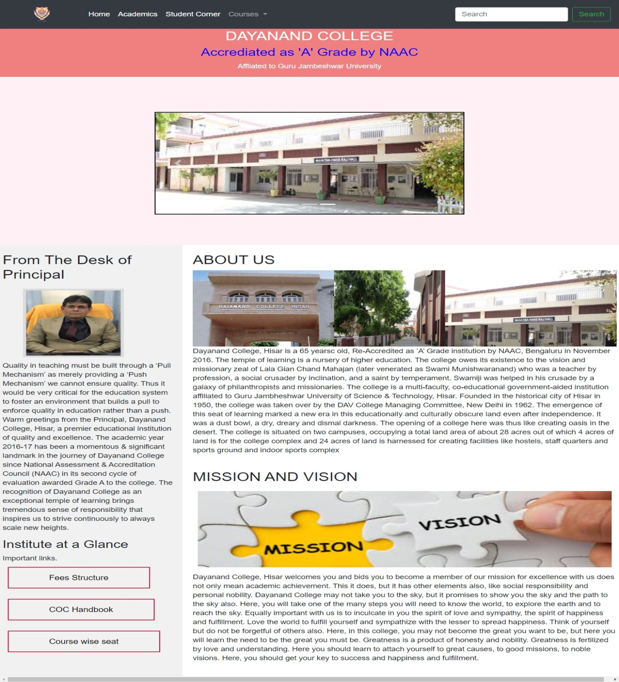

Experiment no: 5

**Prepare your CV and link it on Web Page.**

<!DOCTYPE html>

<html>

<head>

<title>CV</title>

<style type="text/css">

body{

background-color: turquoise;

}

.link{

text-decoration: none;

color: black;

font-size: 18px;

border: 2px solid crimson;

padding: 16px 50px;

text-align: center;

margin-left:600px;

}

.link:hover{

background: crimson;

color: white;

}

h1{

text-align: center;

color: crimson;

}

</style>

</head>

<body>

<h1 >CV Linking</h1>

<br>

<div style="margin-top: 200px;">

<a href="files/res.pdf" class="link">Resume</a>

</div>

</body>

</html>

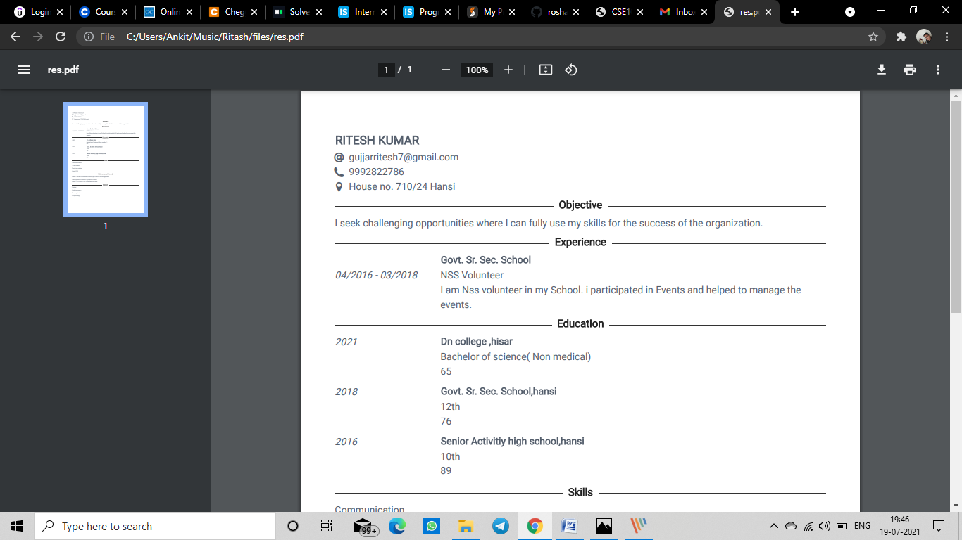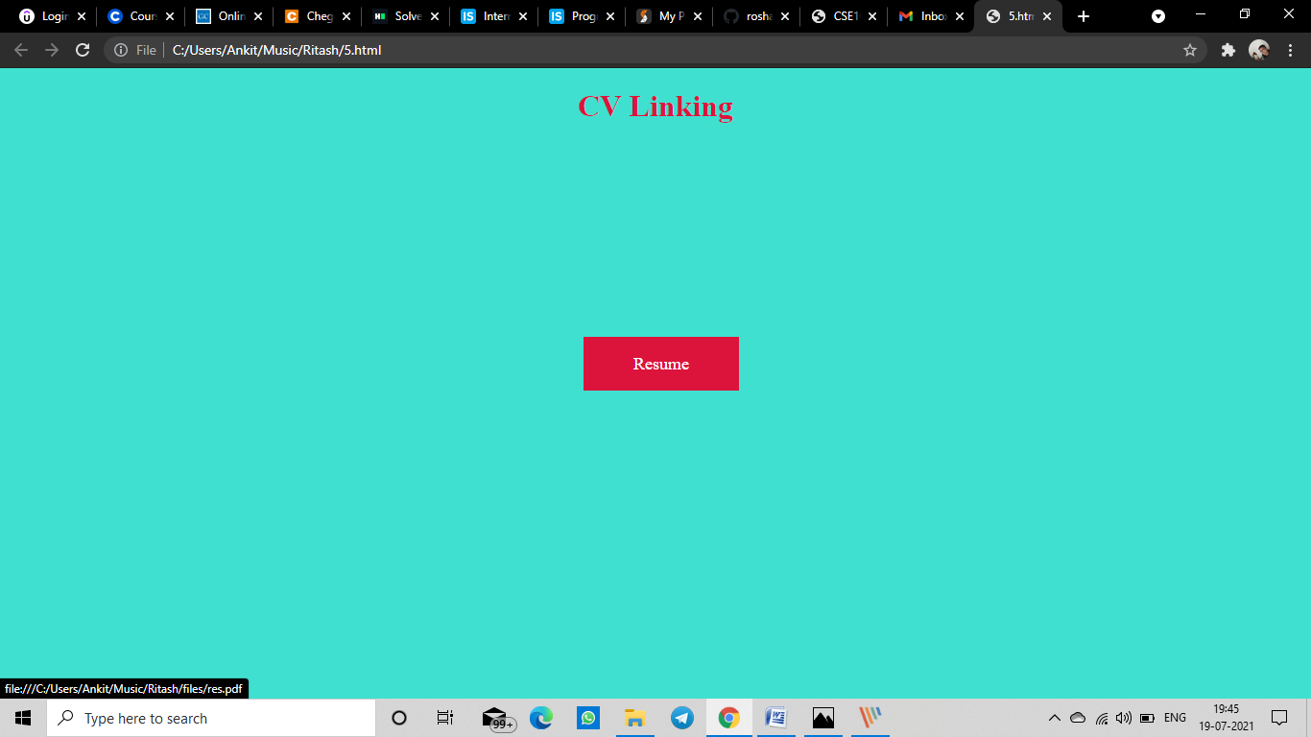

Experiment no: 6

**Created a Web Page and use various sound effects/animations in it.**

<html>

<head>

<title>Audio and Animation</title>

<link rel="stylesheet" href="https://cdnjs.cloudflare.com/ajax/libs/animate.css/4.1.1/animate.min.css"

/>

<style type="text/css">

html,body{

max-width: 100%;

overflow-x: hidden;

}

</style>

</head>

<body style="background-image: url('images/8.jfif');background-repeat: no-repeat;background-size: cover;background-position: fixed;">

<div>

<h1 style="color: violet;text-align: center;" class="animate__animated animate__pulse animate__infinite ">Speeches</h1>

</div>

<div>

<div style="height: 300px;text-align: center;">

<img src="images/3.png" id="myImage">

</div>

</div>

<div>

<audio style="margin:10px 500px;" src="audio/1.mp3"

controls

onplay="playAnimation()"

onpause="pauseAnimation()"

>

</div>

<div>

<audio style="margin:10px 500px;" src="audio/2.mp3"

controls

onplay="playAnimation()"

onpause="pauseAnimation()"

>

</div>

<div>

<audio style="margin:10px 500px;" src="audio/3.mp3"

controls

onplay="playAnimation()"

onpause="pauseAnimation()"

>

</div>

<script>

var selectImg=document.getElementById("myImage");

function playAnimation(){

selectImg.src="images/2.gif";

}

function pauseAnimation(){

selectImg.src="images/3.png";

}

</script>

</body>

</html> 