SNA ASSIGNMENT
Cascade formation
Name: Ankit Dimri
Roll No.: 17BCS004

The folling code simulates the formation of cascades in Karate club network with varing seed nodes and threshlod values, demonstrating the role of seed nodes and threshhold in fomation of cascades.
Complete cascade is a cascade formed when all nodes of the network become a part of the cascade.
Incomplete cascade is formed when only a partial number of nodes of the network take part in the cascade.
GitHub: https://github.com/AnkitDimri/Social-Network-Analysis/tree/master/cascade
Source code:
© Ankit Dimri

library (igraph) # header file

cascade <- function (graph, frmt, threshold) {

G = read_graph (graph, format = frmt)
V (G)$accepted = "B"
G = color (G)
plot (G, vertex.color = V (G)$color)

G = seeder (G)
G = color (G)
plot (G, vertex.color = V (G)$color)

G = seeder (G)
G = color (G)
plot (G, vertex.color = V (G)$color)

# start cascading
G = spread (G, threshold)

while (G$change == T) {
G = color (G)
plot (G, vertex.color = V (G)$color)
G = spread (G, threshold)
if (length (V (G) [V (G)$accepted == "A"]) == length (V (G))) {
G = color (G)
plot (G, vertex.color = V (G)$color)
break
}
}

size = length (V (G) [V (G)$accepted == "A"])
cat ("\nCascade size is", size, "out of", length (V (G)), "nodes\n")

}

seeder <- function (lg) {

r = runif (1, 1, length (V (lg)) + 1)
r = floor (r)

V (lg)$accepted [r] = "A"

return (lg)
}

color <- function (lg) {

V (lg)$color = ifelse (V (lg)$accepted == "A", "green", "orange")

return (lg)
}

spread <- function (lg, t) {

a = c ()
for (i in 1:length (V (lg)))
if (V(lg) [i]$accepted == "A")
a = c (a, V (lg) [i])

u = c ()
n = c ()
for (i in 1:length (a)) {
n = neighbors (lg, a [i])
u = union (u, n)
}

for (i in 1:length (a))
u = u [ u != a [i]]

s = c ()
flag = 0
print (u)
for (i in 1:length (u)) {
n = neighbors (lg, u [i])
count = 0

for (j in 1:length (n))
if (V (lg) [n [j]]$accepted == "A")
count = count + 1
if (count / length (n) >= t) {
s = c (s, u [i])
flag = 1
}
}

V (lg) [s]$accepted = "A"
if (flag)
lg$change = T
else
lg$change = F

return (lg)
}

cascade ("../karate.gml", "gml", 0.3)

Various cases have been attached, with all stages of changes given numerically. In the ZIP folder under karate_2_seed directory

Case 1:
2 Random seeds, threshold value = 0.3
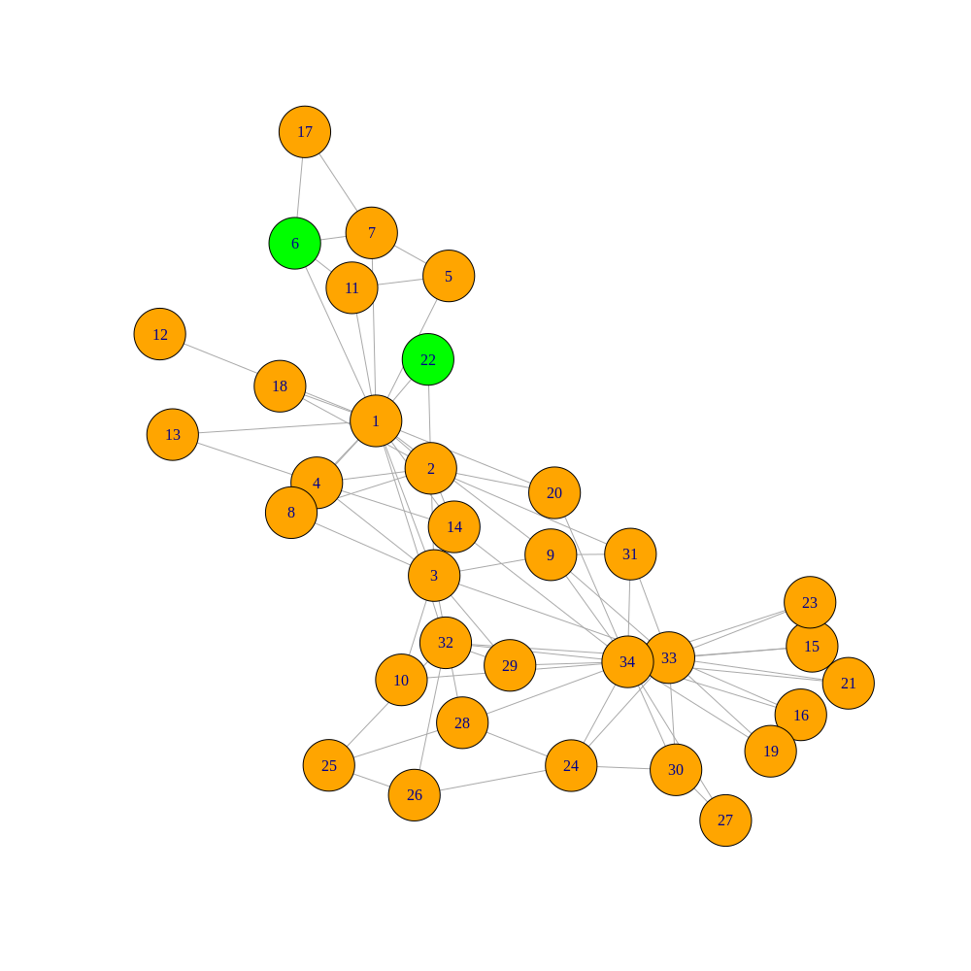
initialization:

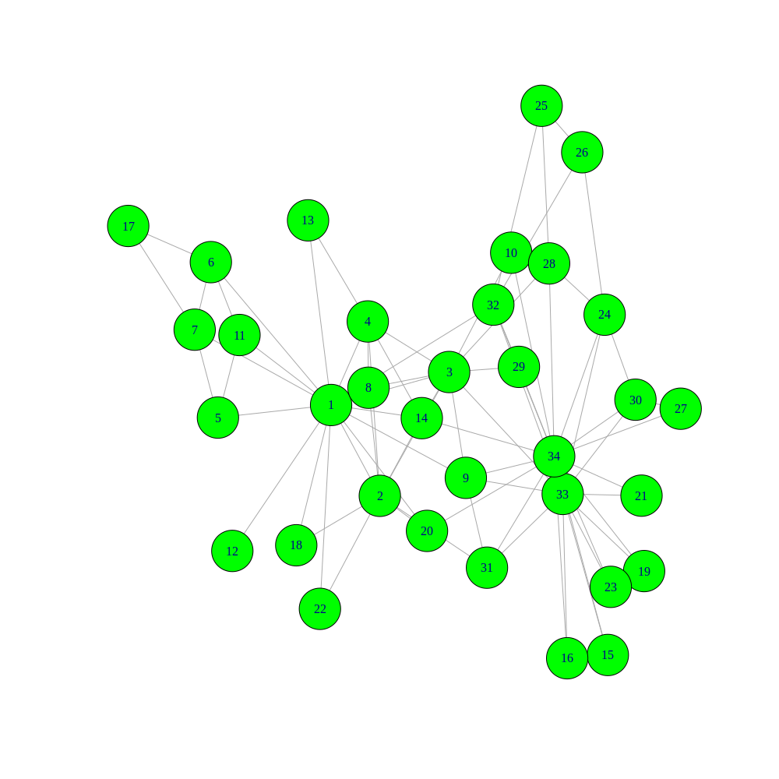
end of cascade:

Led to complete cascade, cascade size = 34 out of 34
Case 2:
2 Random seeds, threshold value = 0.3
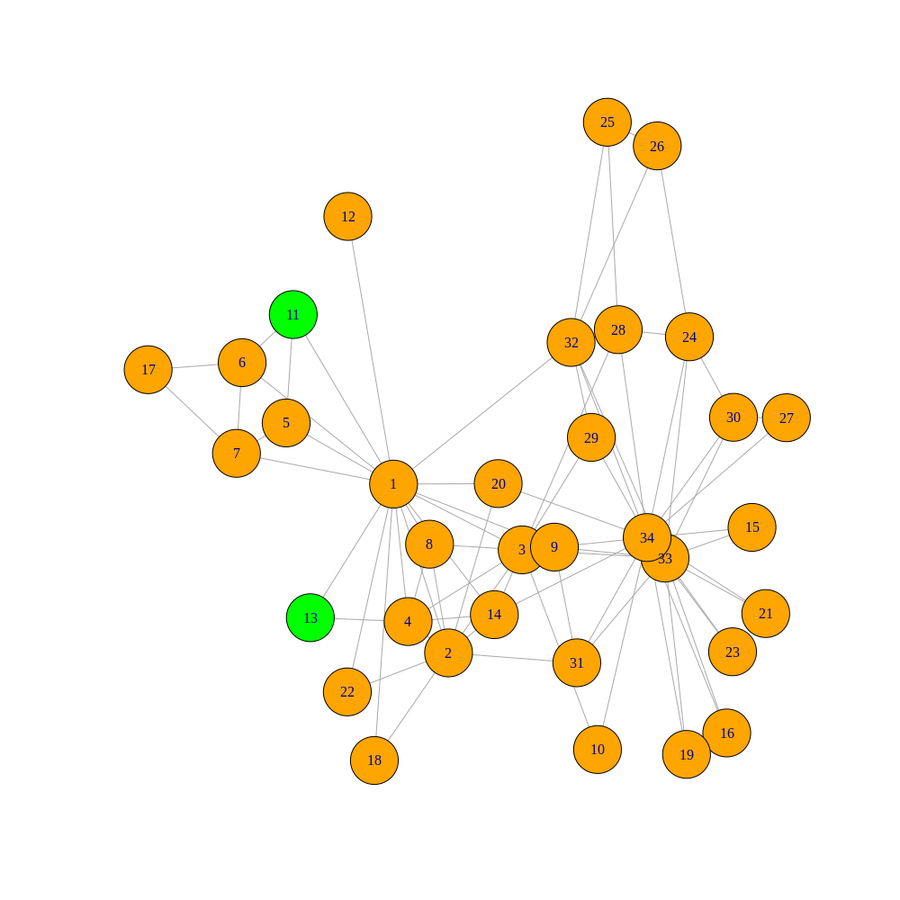
Initialization:

End of Cascade:
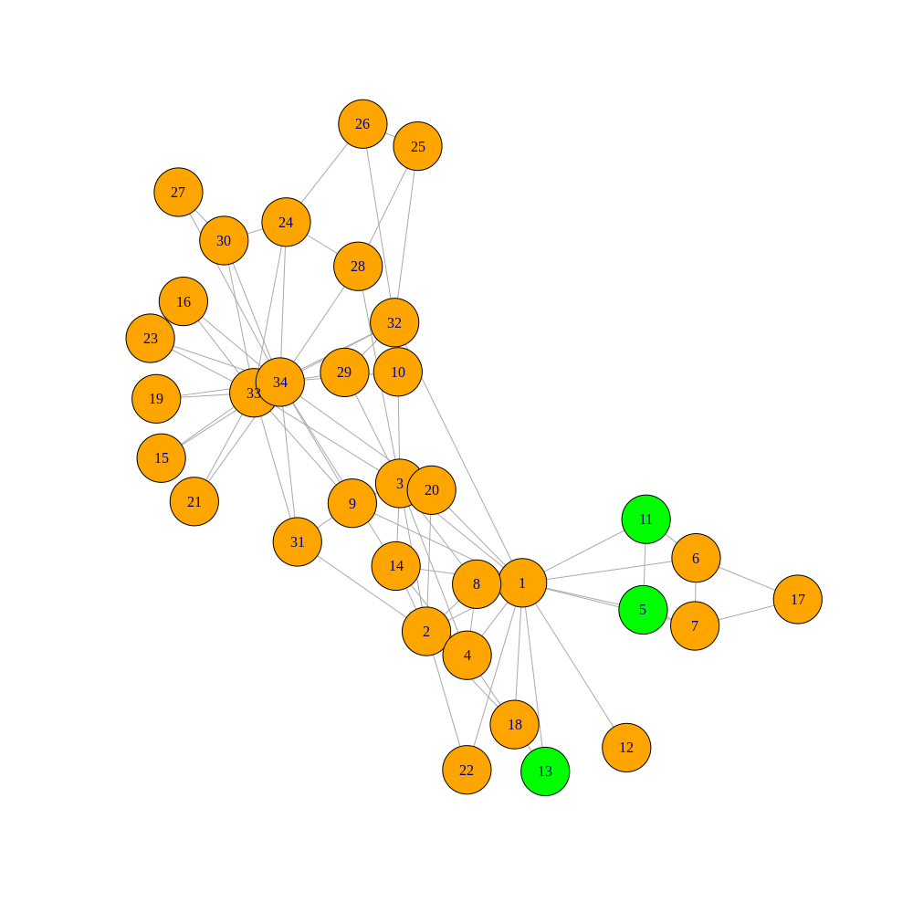
Led to Incomplete Cascade. Cascade size is 3 out of 34 nodes

Threfore the two cases show the impact of seed nodes on the formation of cascades and also shows complete and incomplete cascade.

Special cases:
1. Second Highest Degree node taken as seed node and threshold value as 0.3
Intial:
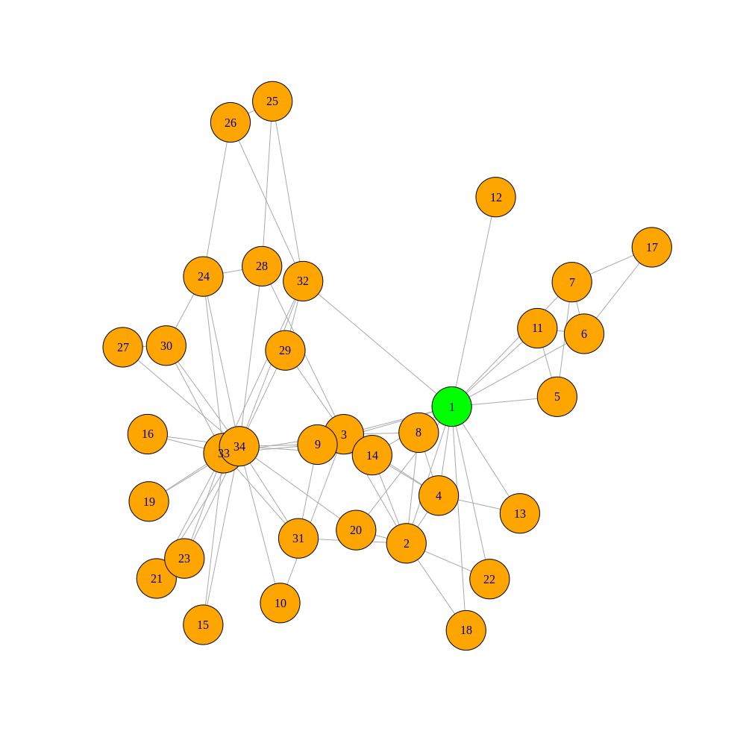

Final:
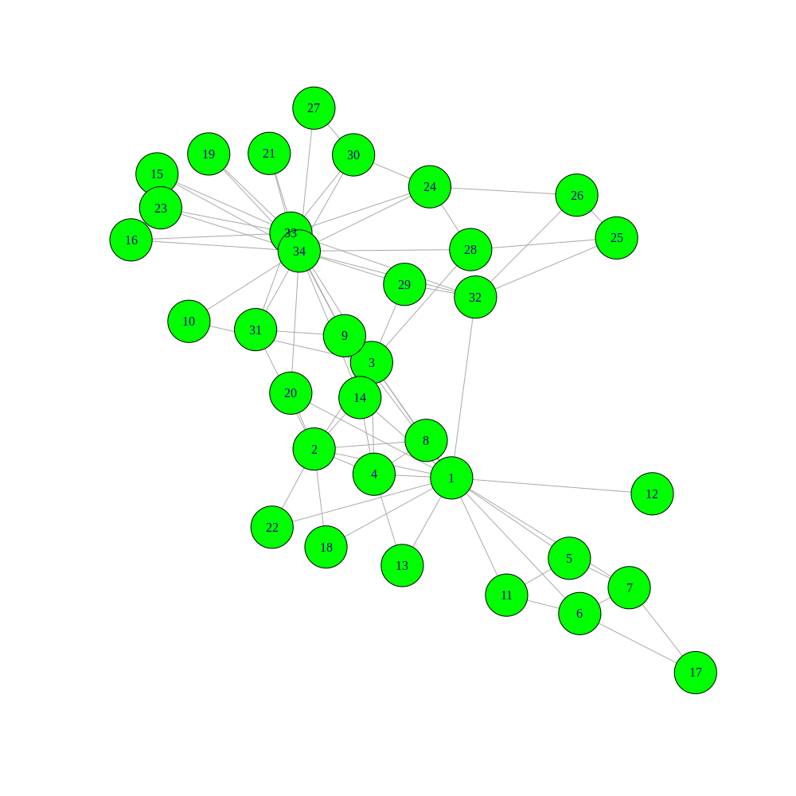

Led to complete cascade. Cascade size is 34 out of 34 nodes
2. Second Highest Degree node taken as seed node and threshold value as 0.3
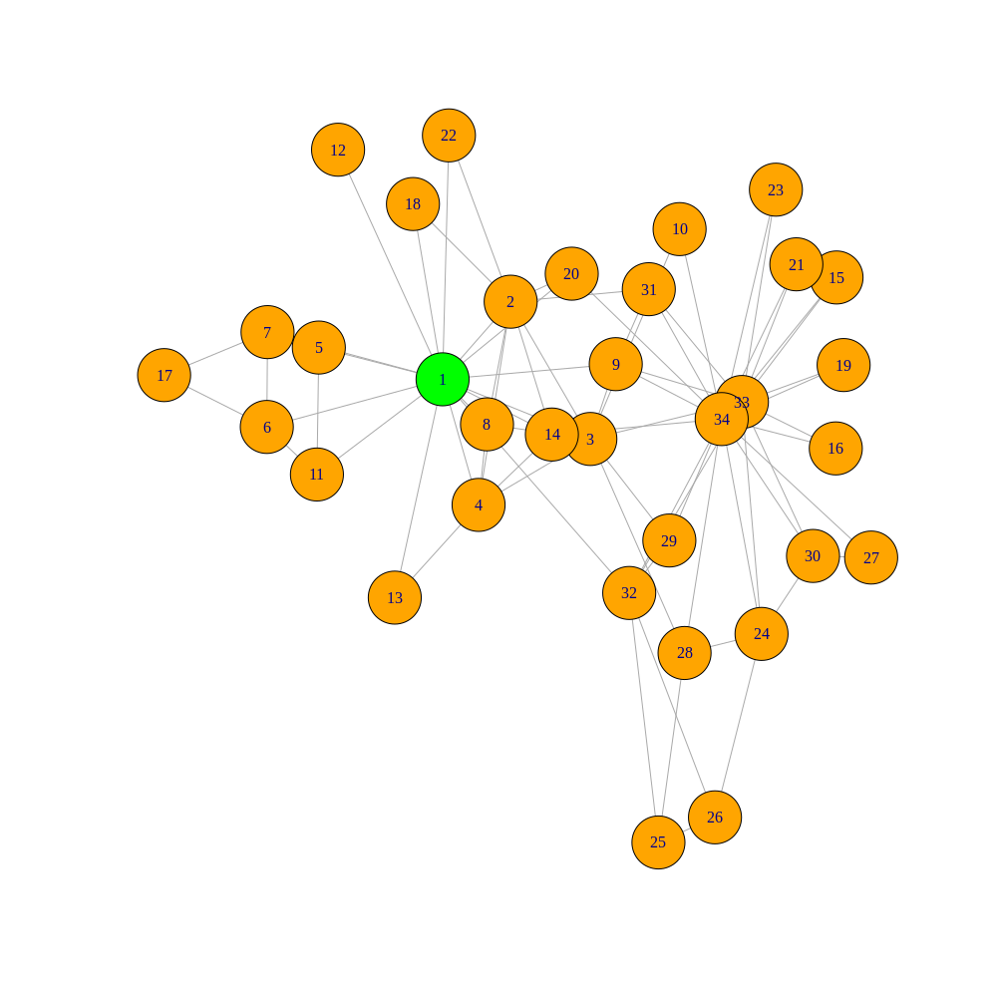
Intial:

Final:
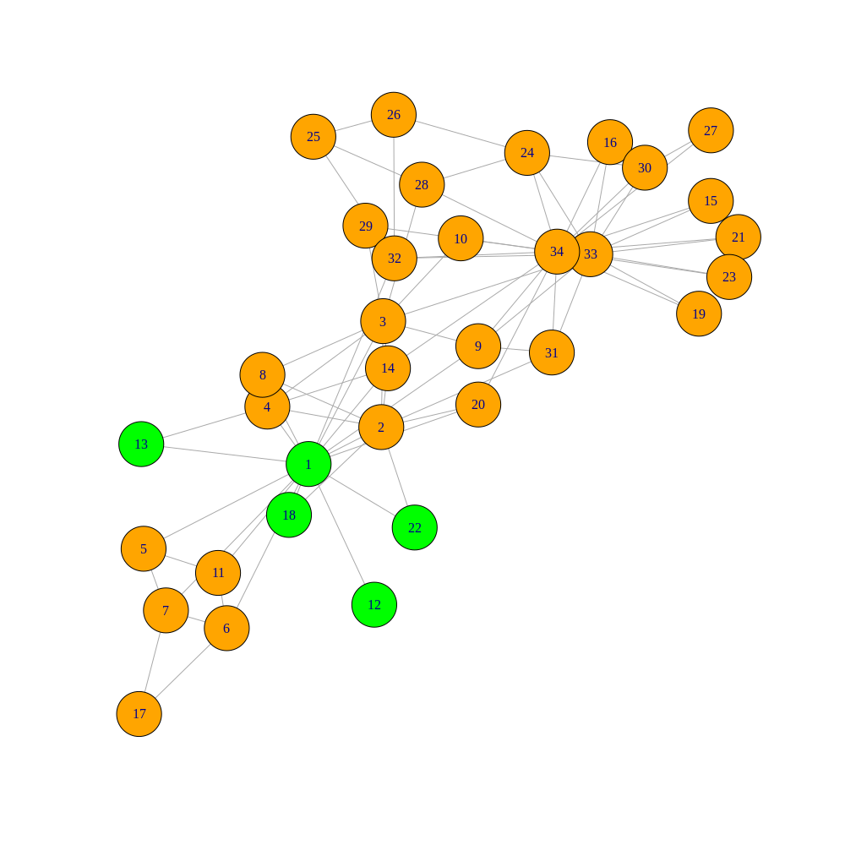

Led to incomplete cascade. Cascade size is 5 out of 34 nodes

3. Highest Degree node taken as seed node and threshold value as 0.4
intial:
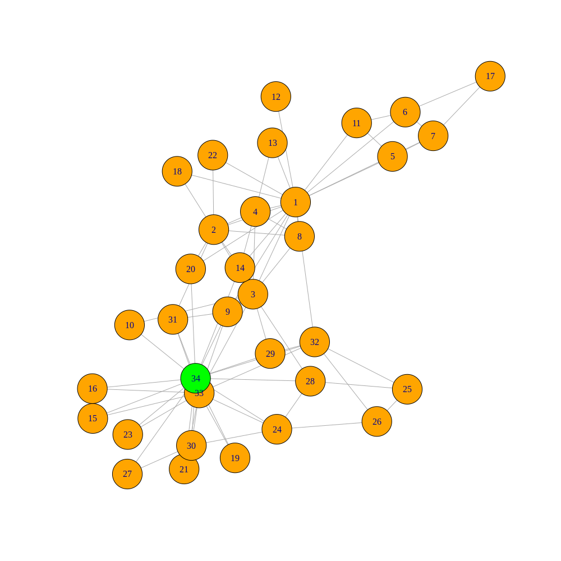

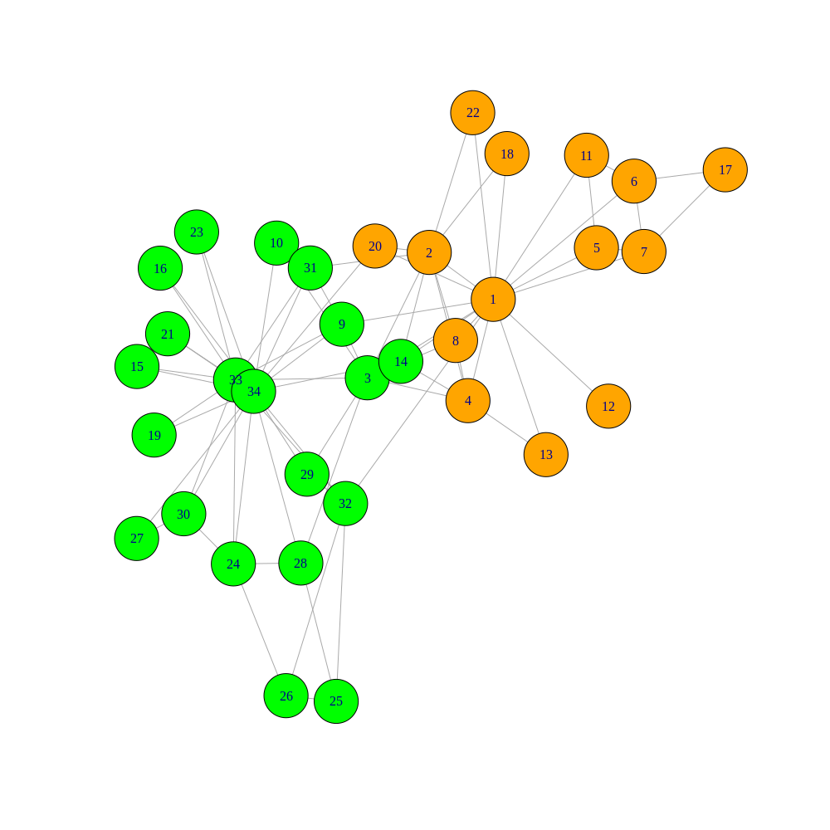
final:

Incomplete cascade (complete with threshold value at 0.3), Cascade size is 20 nodes out of 34.
Hence these cases demostrate the different cascade scenarios with different parameters.

