SNA ASSIGNMENT
Community Detection using Edge Betweeness

R code:

library (igraph)
find_community <- function (G) {
g = G
com = components (g)$no

while (com == 1) {

cat ("Number of components: ", com, "\n")
ebt = edge_betweenness (g)
g = g - E(g) [which.max (ebt)]
com = components (g)$no
}

cat ("Number of components: ", com, "\n")

com1 = groups (components (g)) [1]
com2 = groups (components (g)) [2]
comps = c(c(com1), c(com2))

return (comps)
}

show_communities <- function (G) {

comps = find_community (G)

c1 = as.integer (comps$`1`)
c2 = as.integer (comps$`2`)
print (c1)
print (c2)

V(G)$color = ifelse (V(G)%in% c2, "green", "blue")
plot (G, color = V(G)$color, vertex.size = 8)
}

# For Karate club network
G = read_graph ("~/ankit/Github/Social-Network-Analysis/karate.gml", format = "gml")
show_communities (G)

# For dolphin network
G = read.csv("~/ankit/Github/Social-Network-Analysis/dolphin.csv")
G = graph_from_data_frame (G, directed = FALSE)
show_communities (G)

GitHub Link: https://github.com/AnkitDimri/Social-Network-Analysis/tree/master/betweeness

1. Community detection in Karate club network:
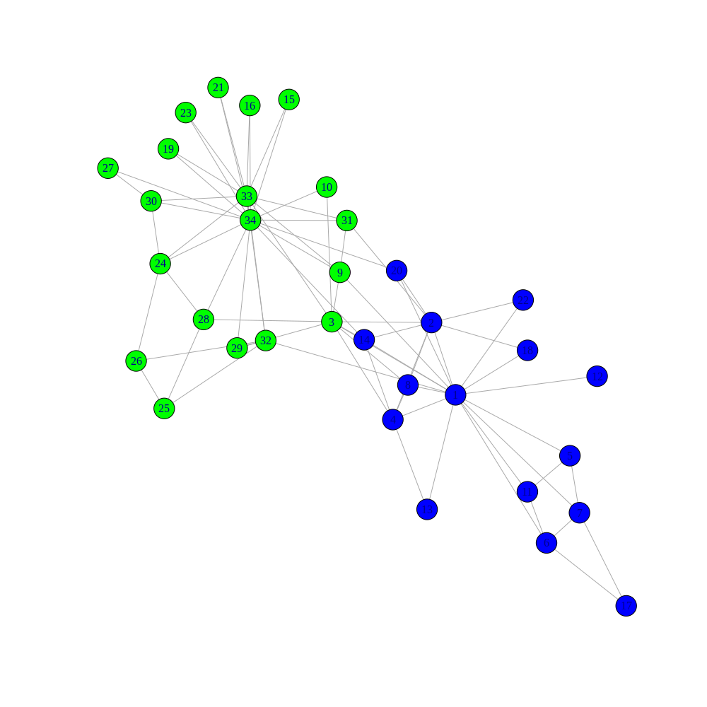
2. Community detetction in Dolphin network:
