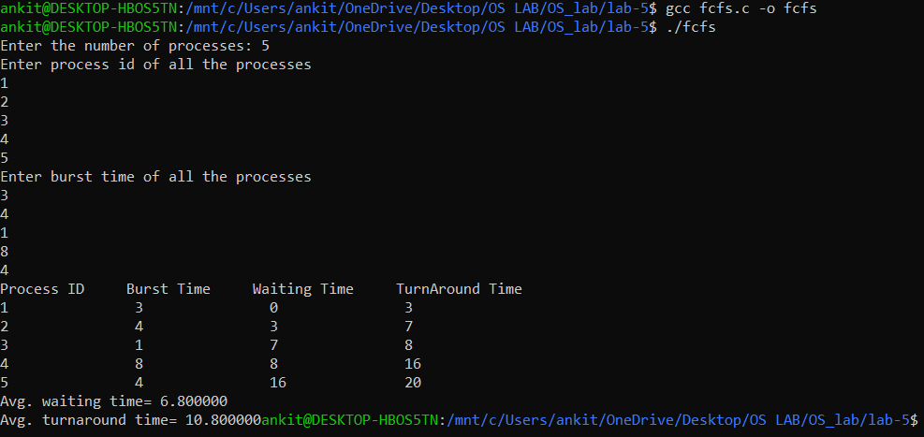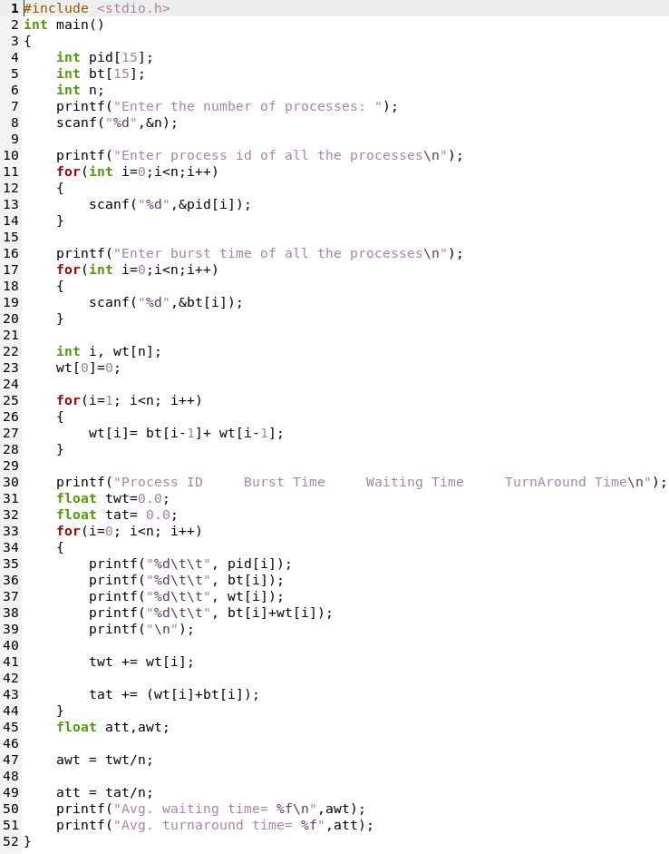Q: Write a C program for First Come First Serve Scheduling Algorithm.

OUTPUT