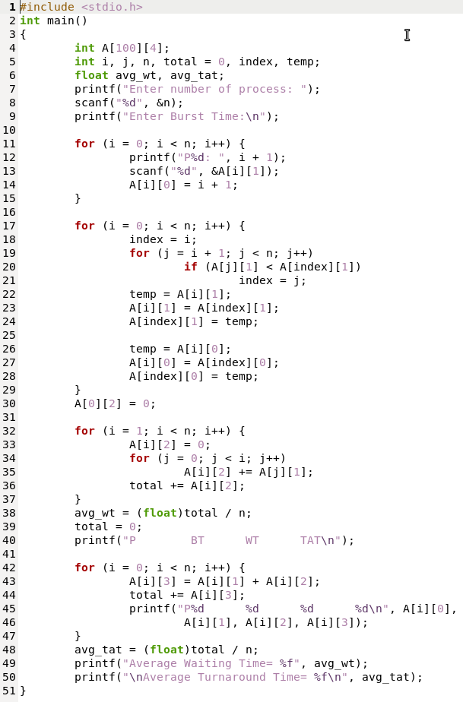Q: Write a C Program for Shortest Job First Scheduling Algorithm.

OUTPUT