LAB-07

Q1: Write a C Program to implement Priority Scheduling assuming non pre-emptive processes and same arrival time for all processes and calculate average waiting time and average turn around time.

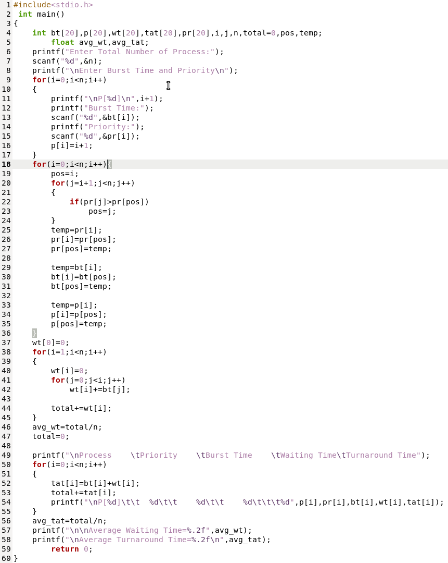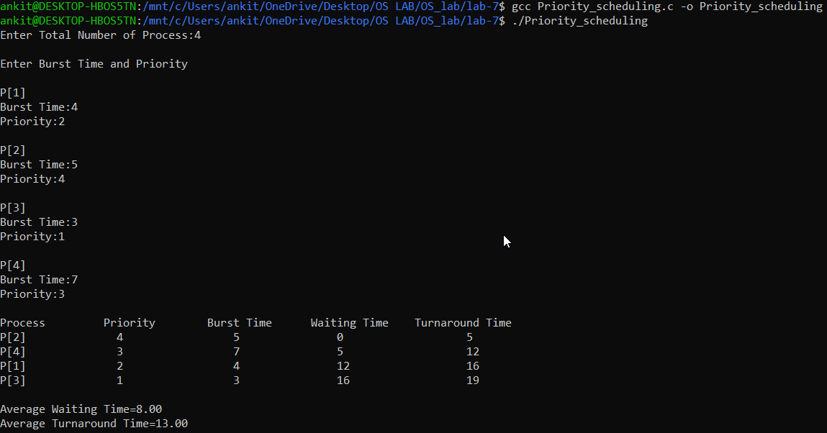

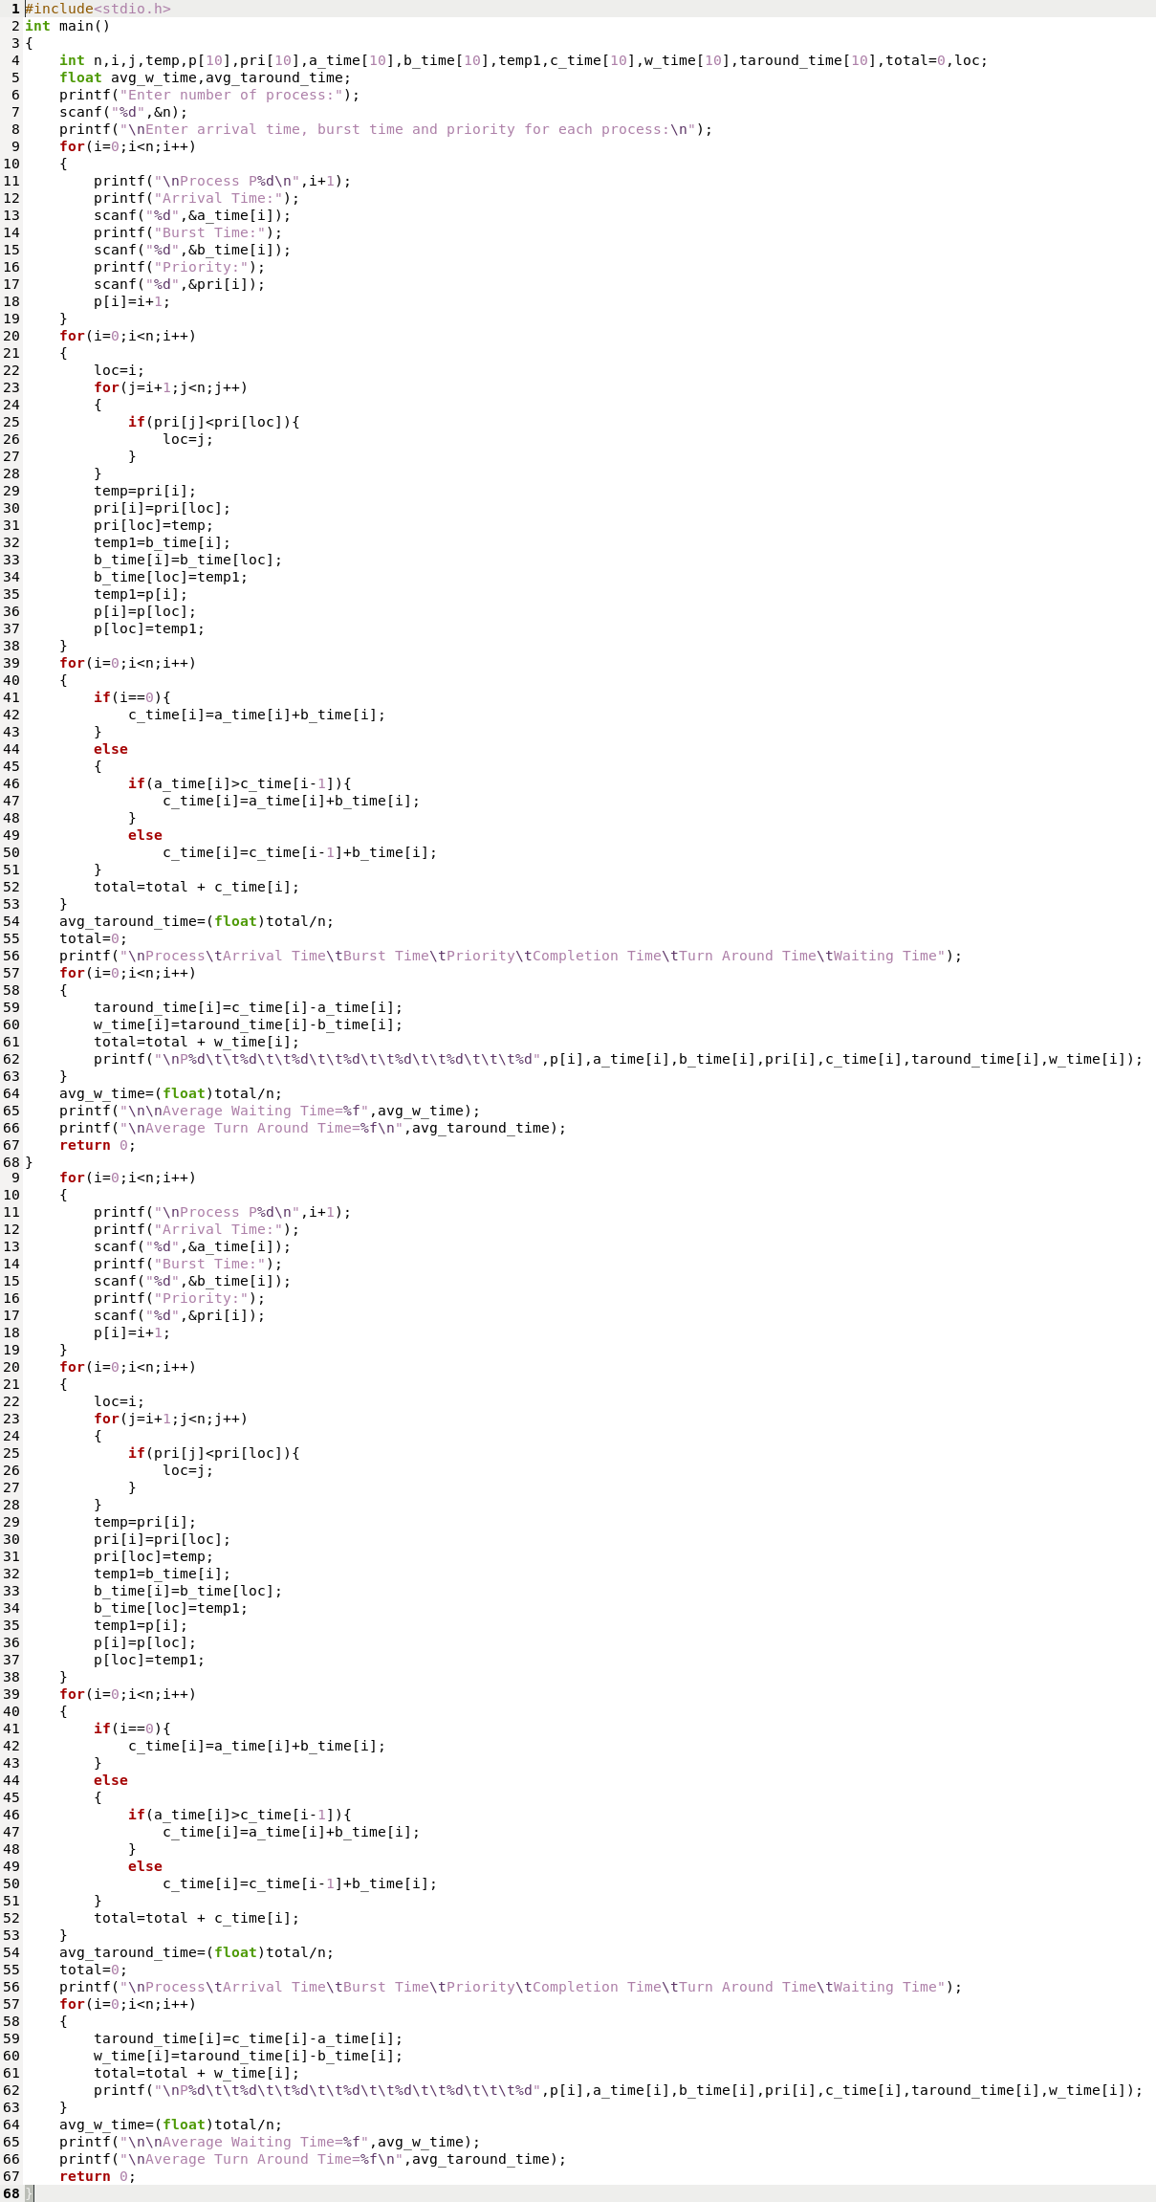Q2: Write a C Program to implement Priority Scheduling assuming pre-emptive processes with different arrival times for all processes and calculate average waiting time and average turn around time.

