LAB-9

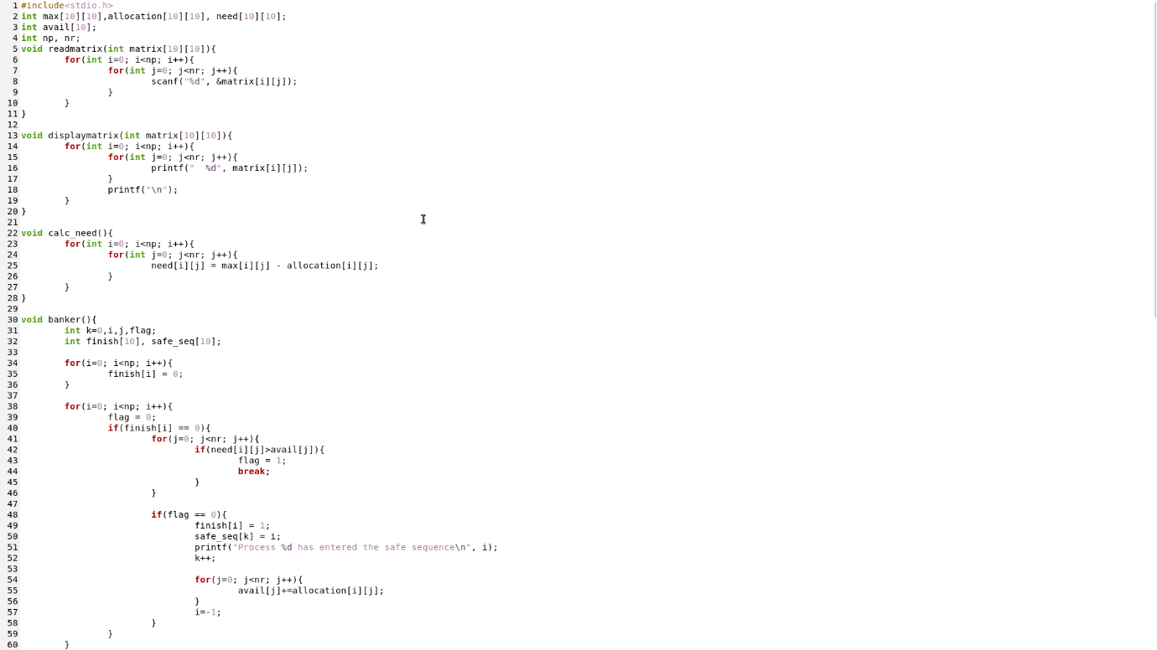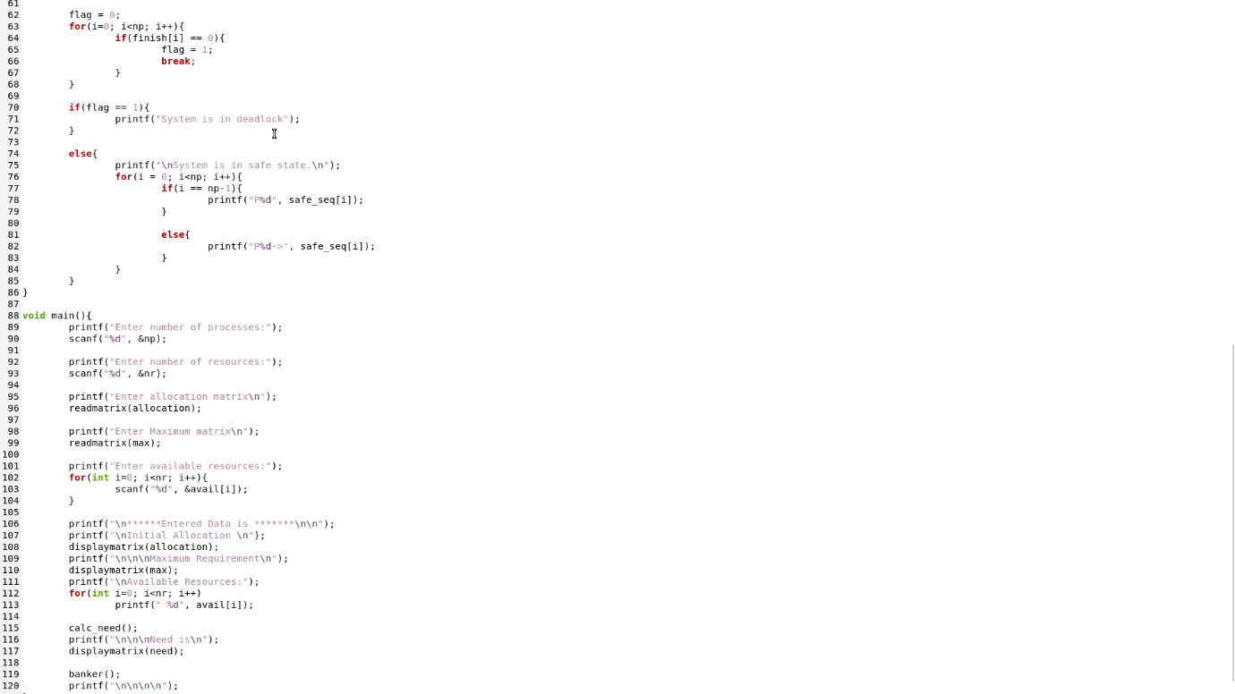Q1 Write a C program to implement Banker’s Algorithm.

Q2 Write a C Program to implement Producer Consumer Problem.

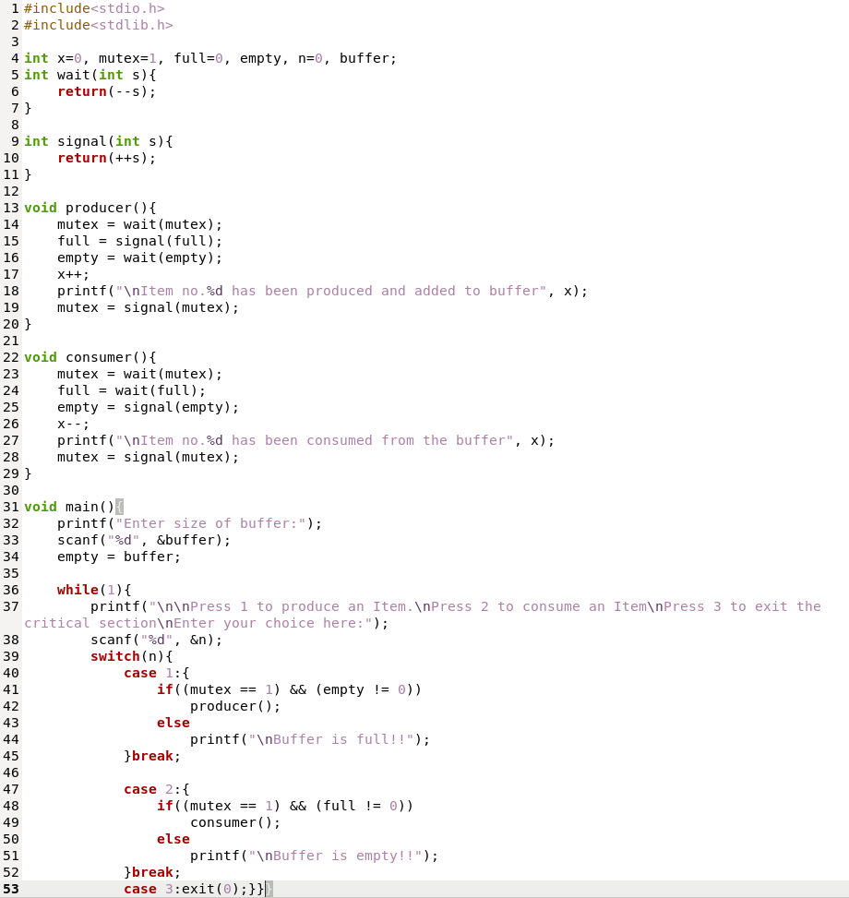

Q3Write a C program to implement FIFO page replacement algorithm.

