Q. How do you assign a task to someone in Jira? Demonstrate.

A.

Step 1: Open a JIRA Project. Either create a new JIRA project or open an existing one.

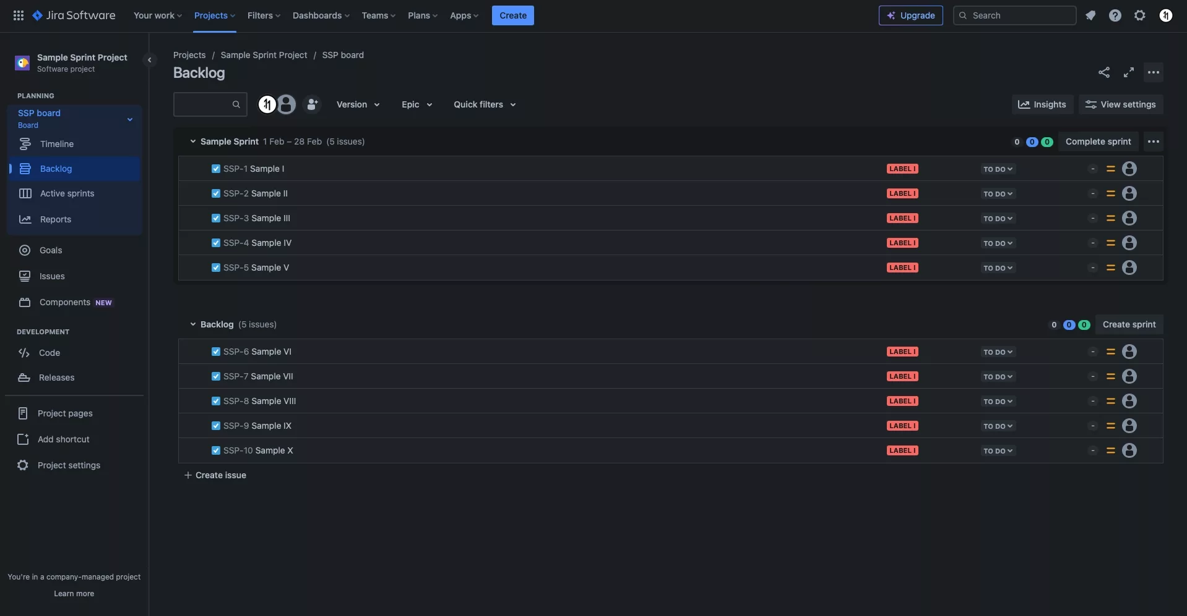

Step 2: + Create Issue. At the bottom of the Backlog, click + Create issue.

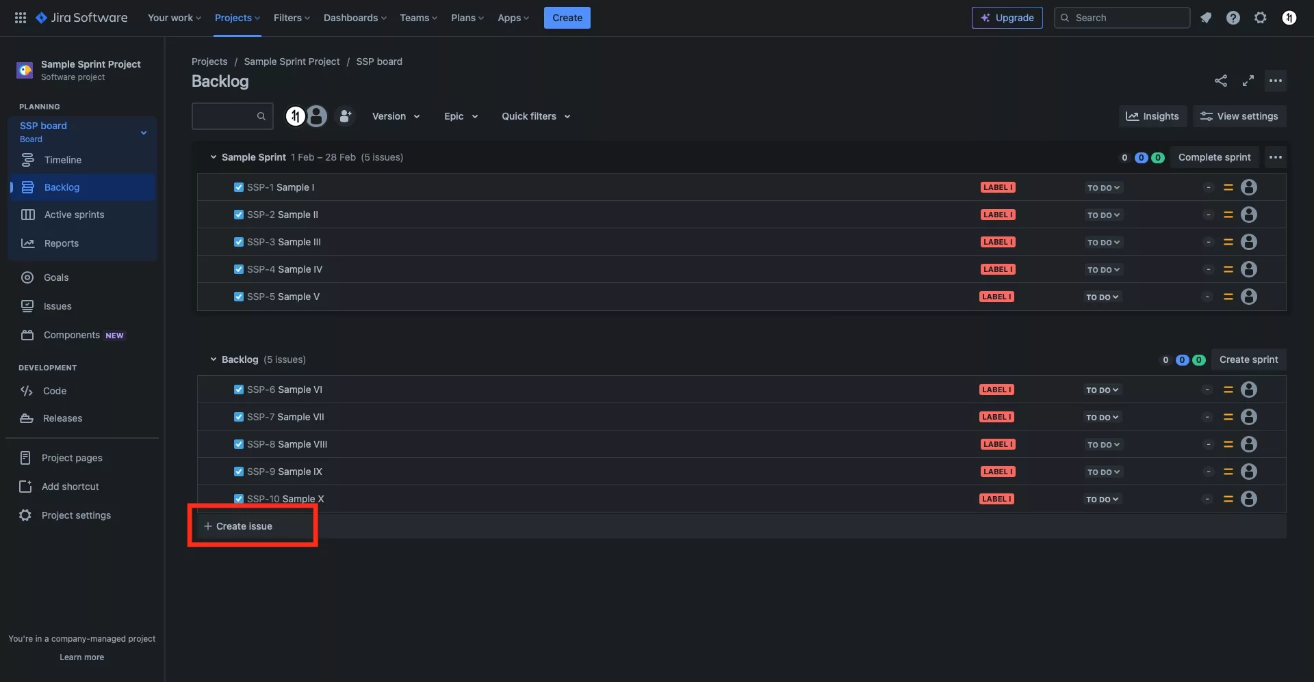

Step 3: Create the Task. Enter the name of the Task and press Enter.

Make sure that the blue task icon is active on the ticket that is being generated, if it is not, select the dropdown to open up a menu that allows you convert the issue into a task.

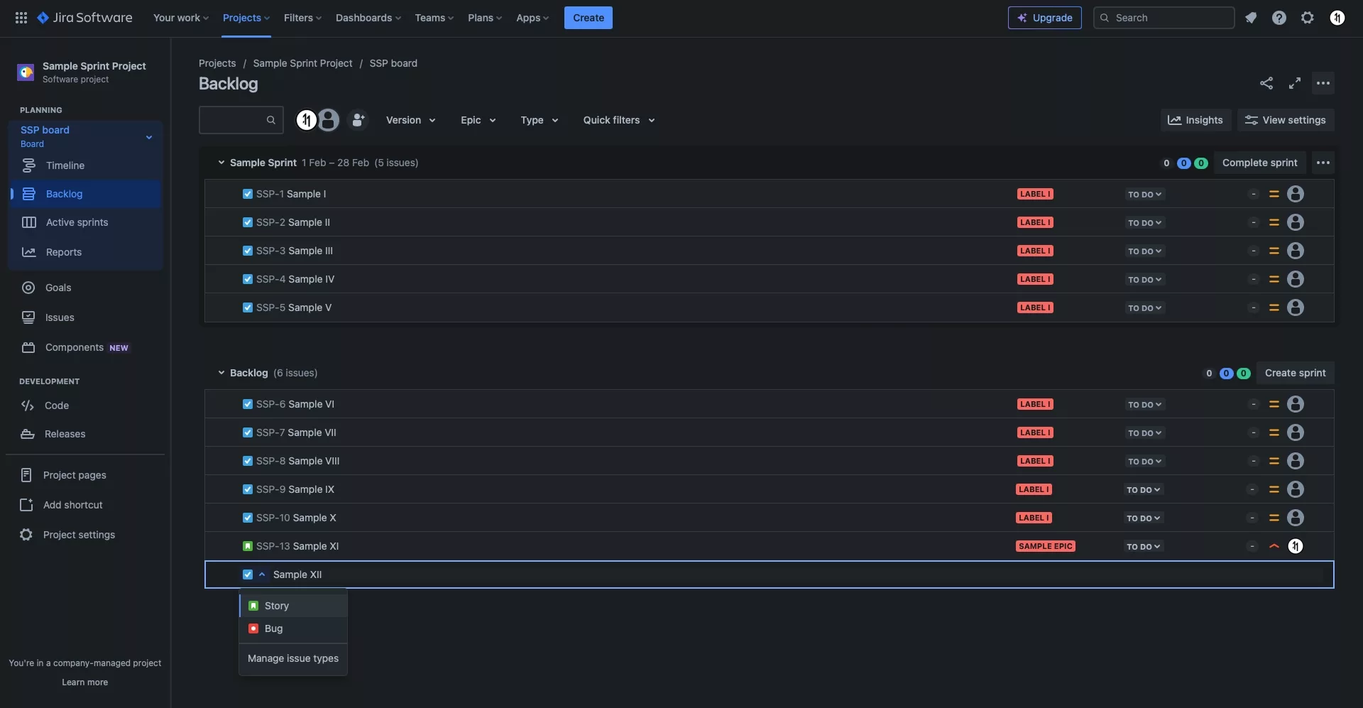

Step 4: Edit the Issue.

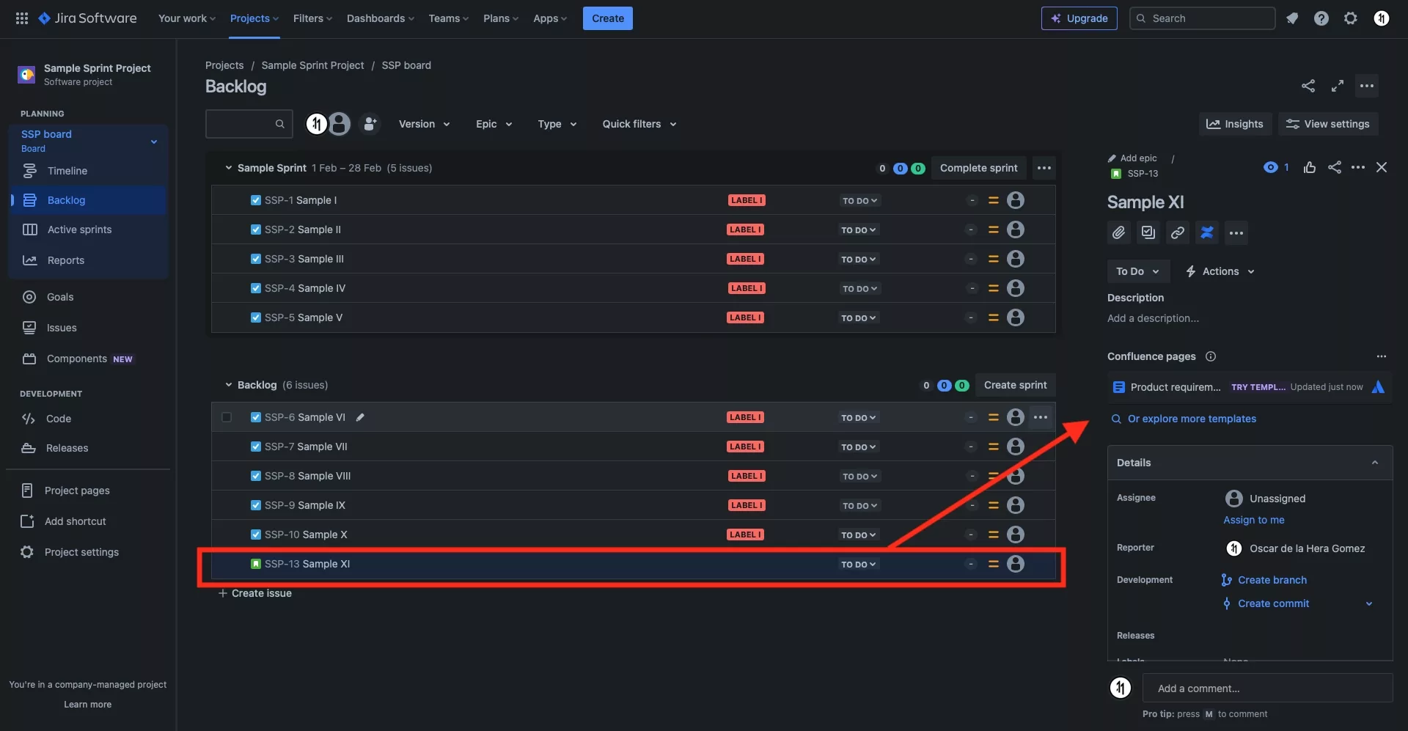

Step 5: Edit the Assignee. Scroll to the Details section and select the Assignee field.

Select the person that will execute the issue.

Scroll to the Details section and select the Assignee field.
Select the person that will execute the issue.