Marketing & Operations Strategy Business Report

{COMPANY NAME}

This report proposes to discuss the prospectus marketing and operations strategies that may be

utilised by {COMPANY NAME} in order to deliver sustainable customer value to consumers

Within Specified Industry market.

This sustainable customer value is delivered in an attempt to ensure the safety of market share, and increase the profitability and revenue of the existing Organisation.

This report will also investigate {COMPANY NAME} ability to introduce a new product into the current Portfolio of products already being offered, and how the current, Business practices, and marketing strategies will best suit the introduction of this new Product, whilst still supporting the existing product range.

{COMPANY NAME} {A1} Count of feq set list {Bi} is individual freq item set list

1.1 Objectives

The overall objectives of this report are to:

Conduct an evaluation of the existing market strategies being undertaken by {COMPANY NAME}

Investigate the impact and mechanisms for introducing a new product or Combination of Products into the existing

product portfolio, in order to appeal to both new and current consumers

Explain how the various marketing and operational strategies formulated by the

organisation can work together to ensure a successful introduction, planning,

implementation, and monitoring of the new product

Establish the extent to which both the existing marketing and operational activities,

and those proposed by the launch of the new product, will provide sustainable

customer value in the long term

2 ANALYSIS

2.1 The Current Situation

2.1. With the Analysis conducted , We have found that ,there are {A1} Combinations of frequent items currently sold under retail by a wide variety of customers. Frequent item set are the combinations that a customer has likely combined and bought the products together , This points to a certain trend that arises from the habits of the current cluster of consumers for which the research had been conducted. These Results provide us a variety of insights and chances to increase the revenue of the current store/outlet.

Basis on these Results, Strategic marketing ideas/plans have been chalked up , as well as basis of analysis and everything supporting it in the background has been attached and provided in the last.

The Frequent Item Combinations are {B1}

{B2}

{B3}

2.2 Recognised Risks

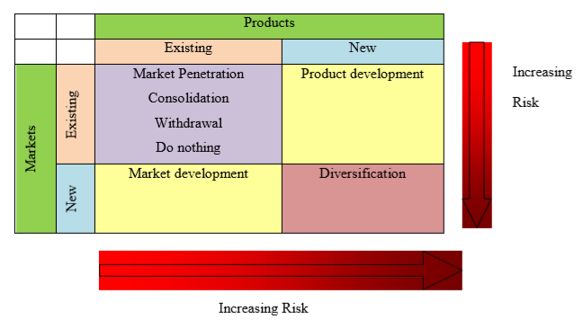

As is evident from the above matrix, the strategy of market development through

diversification involves a high level of risk due to the fact that it involves introducing a new

product to a new market. With this in mind, {COMPANY NAME} will have to ensure

that adequate market research is conducted in order to minimise the risks associated with

entering a new market, and ensure that the product is sold at the right price, in the right

places, and in the correct quantities.

2.3 Proposed marketing plan

In order to improve the lives of current consumers, and influence consumers to purchase

products from the {Company Name} retail outlets and increasing revenue based on the habits of the consumers, following marketing strategies have been brought together.

For B{i} I <= Count of freq datasets print this segment for each

1. COMBINATIONAL PACKAGING AND PRICING:
2. PHYSICAL ENVIRONMENT & PLACEMENT:
3. ENTRY/EXIT SALE STRATEGIES IN THE STORE
4. REPEAT CUSTOMER DISCOUNTS AND PROMOTIONS
5. PRODUCT SAMPLING BY PHYSICAL PROMOTION
6. UPSELLING PRODUCTS BY STAFF
7. PLAYING WITH PRICE POINTS OF ESSENTIAL ITEMS VS NON ESSESNTIALS
8. REPACKAGING (DEPENDEANT ON QUANTATIVE COMBINATION OF PRODUCT SALE)
9. CUSTOMER LOYALTY BONUS ON PURCHASE OF
10. PROMOTIONS IN STRATEGIC PHYSICAL POINTS OF STORE
11. CROSS PROMOTIONS BETWEEN ITEMS OF {B1..Bi}
12. POSSIBLE FLAVOUR COMBINATIONS (NEW PRODUCT)

2.4 Control – How do we keep track of progress?

It is essential to keep a track of data and billing information after implementing a marketing scheme or a strategy to keep a check on which strategy is best used and delivers the best results. The data should be collected continuously. Sales figures and changes in market share proportions also need to be closely monitored in order to assess those marketing activities that are proving successful, and those which are having a negative effect on the overall product image and consumer demand.

2.5 Strategic integration of marketing and operations

Marketing and promotions need to ensure that there is sufficient demand stimulated by the

various campaigns in order to support the production levels being maintained by the

operations department. Communication between the marketing and operations department is

of paramount importance in order to ensure that the correct production capacity is made

available in order to meet demand levels and avoid a production deficit – which can leave

consumers wanting, and a production surplus – where stock is left unsold and requires

storage or perishes over time.

3.0 CONCLUSION

A lot of marketing strategies provided are realistically possible and will/may provide the revenue boost and it is clearly based on client’s habits, Although some habits may occur co-incidentally.

So with simple business growth tactics, The Returned results would reap benefits in a manner to increase revenue or to decrease the time to come up with marketing solutions as this document provides generic options.

4.0 Back Calculations and supporting documentation for analysis

Create Table for relevant freq item list with support ,lift, confidence