**Installation/Operation Manual for Photoacoustic Imaging Simulations using NIRFAST and kWave MATLAB toolboxes**

**About this Manual**

**Purpose**

This document provides detailed instructions regarding the installation and operation of the NIRFAST optics and k-Wave acoustics toolboxes (MATLAB), for the purpose of simulating photoacoustic (PA) imaging.

**Related Documentation**

A working knowledge and an up-to-date installation of MATLAB, particularly matrix/array operations, is presumed. Extensive documentation regarding MATLAB programming and its built-in functions/toolboxes can be found at <https://www.mathworks.com/help/matlab/>.

**1) Installation**

**1.1) NIRFAST Toolbox**

The NIRFAST toolbox can be installed at <http://www.dartmouth.edu/~nir/nirfast/>. For the purposes of US+PA simulations, **only** the “NIRFAST-Matlab” installation is required. This manual is based on the latest release, version 9.1 – released 3/28/2018.

If newer releases of NIRFAST-Matlab are made available, and this manual has not yet been accordingly updated, all prior versions of the toolbox can be found at <https://github.com/nirfast-admin/NIRFAST/releases>.

Unzip the download file and extracting to a desired location. In MATLAB, add the NIRFAST folder **and** all subfolders to the MATLAB path. Detailed instructions for doing so can be found here: <https://www.mathworks.com/help/matlab/matlab_env/add-remove-or-reorder-folders-on-the-search-path.html>.

**Important:** The NIRFAST folder has multiple subfolders, remember to add the subfolders to the path as well.

**1.2) k-Wave Toolbox**

The k-Wave toolbox can be installed at <http://www.k-wave.org/download.php>. After unzipping the file, detailed installation instructions can either be found in the readme.txt file, or at <http://www.k-wave.org/installation.php>.

**2) Using the toolboxes**

**2.0) Basic Sequence of Events**

There are 7 steps needed to simulate a PA image using the NIRFAST and k-Wave toolboxes:

|  |  |  |
| --- | --- | --- |
| **Step** | **Script** | |
| 1. Creating a bitmap to represent the in-silico tissue phantom being imaged. | N/A | |
| 2. Creating an optical absorber, source, and detector mesh. | Built-in “nirfast” command | |
| 3. Defining the optical absorber characteristics, based on the tissue phantom. | phantom_optical_characteristics.m | |
| 4. Simulate the light propagation and calculate the fluence and subsequent pressure (generated from PA effect) for each absorber. | PA_forward_solver.m | |
| 5. Defining the acoustic characteristics of the tissue phantom.  6. Simulate the propagation of the resultant pressure wavefronts from the PA effect.  7. Forming the PA image | PA_phantom_acoustic_characteristics.m  PA_back_solver.m  Beamforming_code.m |
|  |  |
|  |  |
|  |  |
|  |  |
|  |  |
|  |  |
|  |  |

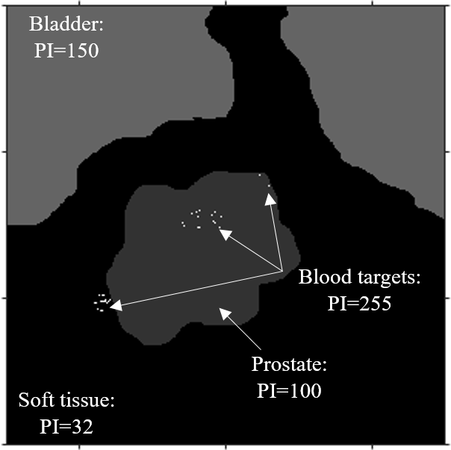**2.1) Creating the tissue phantom bitmap**

Creating the in-silico tissue phantom bitmap is the first step in simulating PA imaging.

The bitmap has two purposes:

1. Define the geometry of the in-silico tissue phantom.
2. Labelling the specific tissues in the phantom by assigning a specific pixel intensity to each tissue type. These intensity labels will be used later to identify each of the constituent tissues as well as define their optical characteristics.

The image on the left shows a 600x600 8-bit prostate phantom bitmap. In it, the geometry of the tissue types is defined ( bladder at top, prostate roughly central, etc.), as well as the associated intensity labels (prostate intensity = 100, bladder intensity = 150, etc.).

1.) Sample 8-bit prostate phantom bitmap, made in MS Paint

The bitmap can be created in any image design software (MS Paint, Adobe Illustrator/Photoshop, etc.). The example bitmap shown on the previous page was made with MS Paint.

**2.2) Creating the optical mesh**

The next step in the entire simulation process is creating the optical mesh using NIRFAST.

In the MATLAB command window, enter the command, “nirfast”, exactly as shown (no quotation marks).

After, the mesh creator window will pop-up. Follow the steps shown below.

Save to file location, as a .rpt file

Make sure the size of the mesh (in mm) corresponds to the size of the bitmap (in px). Ex: 600x600 bitmap corresponds to 60x60 (mm) mesh. Node distance of .1 mm results in 600x600 nodes, thus one node/absorber corresponds to one pixel.

The mesh size can be a scale factor of the bitmap size, as long as the node distance value allows for 1 node/absorber for each pixel.

Define the locations and number of optical sources (red), in (x y) format.

Define the locations and number of optical detectors (blue), in (x y) format.

Will get 8 rpt files:

The .rpt files contain the default spatial and optical characteristics of all the absorbers in the mesh. Each absorber’s location, chromophore concentration, scattering amplitude and scattering power is defined.

Each absorber has a defined concentration of each of the chromophores (ex: 40% HbO, 10% deoxyHb, 50% Water). Based on the chromophore concentration distribution of the absorber, its scattering amplitude and power are also defined. While NIRFAST can pre-define these values, for most phantoms, it will be necessary for the user to redefine both the chromophores, and their concentrations for each absorber.

NIRFAST has 6 default chromophores: HbO, deoxyHb, water, lipids, LuTex, and GDtex. It is important to note that these are only the default chromophores. While any of these pre-defined chromophores can be used if needed, they can also be used as placeholders for the tissue classes in the tissue phantom. The optical mesh is created using any number/combination of these default chromophores, corresponding to the number of tissue classes in the tissue sample. If 3 tissue types are defined in a tissue phantom (ex: bone, skin, soft tissue), any combination of 3 of the default chromophores can be chosen as placeholders. In the next 2 sections, defining the real tissue classes and their respective optical characteristics will be covered.

In addition to defining the characteristics of each absorber, the wavelength array must also be defined. The wavelength array provides the optical source wavelengths. In the above example, only 800 nm is used/defined. The default scripts provided in this repository do not currently support a multiwavelength simulation.

**2.3) Defining the optical absorber characteristics**

Using, “phantom_optical_characteristics.m”, the user shall define the optical absorber characteristics of the phantom.

In the previous section, creating the optical mesh with the default chromophores was covered. There are two steps to defining the true characteristics of the phantom.

The first step involves defining a background chromophore. Ideally, this will be the most prominent tissue in the phantom. For example, in the example bitmap shown previously, soft tissue was chosen as the background chromophore.

First, the optical mesh and the tissue bitmap are loaded. Then, for the entire mesh, every absorber is defined as having the optical characteristics of the background tissue/chromophore. This includes scattering amplitude/power, concentration, refractive index, and speed of light.

The resulting mesh is entirely uniform and is saved as a separate mesh from the original, titled “mesh_back”. While it may seem redundant to create the background mesh, it will be used as a correction factor in the pressure calculations resulting from the simulated photoacoustic effect.

The next step involves creating an optical mesh based on all the tissue types in the phantom. Using the pixel intensity tags of each of the tissue types, the corresponding absorber to each pixel will be defined with the tissue type’s characteristics. For example; if pixel (50, 50) is bladder, absorber (200,200) will be defined as entirely having the optical characteristics of bladder. This will be done for every pixel/absorber, and the new detailed mesh will be saved, separately from previous two, titled “mesh_anom”.

Note: optical characteristics for each tissue type will have to come from literature

**2.4) Simulate the light propagation**

In PA_forward_solver.m, the forward propagation of the optical source is simulated.

Using the previously defined background and foreground meshes (“mesh_back”, “mesh_anom”) and the optical source wavelength, the script performs finite element method (FEM) optical scattering simulation. Using the previously defined optical absorbers, the fluence properties of each are calculated. Then, the resultant pressure/acoustic characteristics of each absorber are calculated, based on the PA effect.

The resultant nodal and scattered pressure data from the PA effect are saved, to be used in the acoustic back propagation simulation script later.

**2.4) Defining optical characteristics of the phantom**

In PA_phantom_acoustics_characteristics.m, the acoustic characteristics of the phantom are defined. This includes the density map and the sound speed map of the phantom. These acoustic characteristics will define how the pressure wavefront generated by the PA affect will travel through the phantom.

Being that PA imaging is commonly combined with an ultrasound image of the same region, the code repository also includes standalone scripts for ultrasound imaging simulation. Those scripts include a detailed operation manual for the acoustics characteristics script. Please see “Ultrasound_simulation_codes/US_simulation_guide.docx” for said manual.

If being used in a combined US+PA format, the user should keep all acoustic characteristics the same for the phantom in the PA codes and the ultrasound codes.

**2.6) Simulate the propagation of the resultant pressure wavefronts**

In PA_backsolver, the travel of the pressure wavefront generated due to the PA effect is simulated. Using the density and sound speed maps previously generated, the wavefronts acoustic behavior in the phantom is modelled. The resultant acoustic data from the detectors is stored, to be used in creating the final image.

**2.7) Forming the photoacoustic image**

In Beamforming_code.m, the acoustic data from the detectors is used to create the final photoacoustic image.