AtmoSense AI
(Smart Environmental Health Intelligence)

A Minor Project Report
Submitted in partial fulfillment of requirement of the
Degree of
BACHELOR OF TECHNOLOGY in COMPUTER SCIENCE & ENGINEERING
BY

Piyush Solanki (EN23CS304044)
Mayank Sahu (EN23CS304037)
Piyush Pal (EN23CS304044)

Under the Guidance of
Prof. Vishal Sharma
Prof. Suyog Munshi

Department of Computer Science & Engineering
Faculty of Engineering
MEDICAPS UNIVERSITY, INDORE- 453331
APRIL-2026

Chapter 1
Introduction

1.1 Introduction
Environmental tracking and personal health management play a critical role in modern daily routines. Every day, individuals and athletes across various regions execute complex outdoor activities that require understanding changing weather patterns, air quality indices, and their direct physiological impacts. Managing personal health in extreme conditions, predicting hydration needs, and assessing lung recovery times manually is both time-consuming and repetitive, particularly when dealing with rapidly fluctuating environmental variables.
AtmoSense AI is an AI-powered environmental health intelligence ecosystem designed to address these challenges. The system intelligently analyzes real-time meteorological data, air quality metrics, and user-specific physiological intent to automatically generate context-aware health heuristics using advanced predictive algorithms. By integrating environmental data directly into a unified interactive dashboard, AtmoSense AI eliminates the need to switch between multiple weather and health apps, thereby improving decision-making efficiency and reducing health risks.
The system is built using a modern, robust technology stack: Node.js and Express for core backend execution and API orchestration, a modular React.js interface with Tailwind CSS for frontend interaction, and a highly resilient AI prediction engine for intelligent impact calculation. AtmoSense AI is deployed as a full-stack web application, enabling users to seamlessly track AQI, predict heat stress, and receive customized safety recommendations directly within their browser in a secure manner.

1.2 Literature Review
Recent advancements in Data Analytics and Health Informatics have enabled the development of automated systems capable of not just displaying weather data, but reasoning through complex physiological logic. Models such as the Rothfusz regression for Heat Index and generalized lung recovery heuristics have demonstrated remarkable capabilities in understanding human thermoregulation and respiratory stress.
Several weather tracking tools have been developed to assist users in managing outdoor activities. Applications like AccuWeather and AQICN introduced predictive forecasting and air quality tracking. However, these features offer limited personalization; they exist in isolated data silos and suffer from the "interpretation gap." They generate numerical data, but still require the user to manually calculate hydration needs, assess safety limits, and adjust workout intensity.
Studies in the domain of environmental health highlight the growing need for context-sensitive, autonomous health predictions rather than passive data dashboards. The reliance on standalone weather APIs also presents significant vulnerabilities, as users frequently encounter downtime or lack localized data during intensive outdoor planning.
AtmoSense AI builds upon this body of work by offering a truly integrated health platform that combines advanced capabilities through a proprietary AI Prediction Engine. This approach overcomes the key limitations of existing tools—specifically, their lack of personalized health heuristics, susceptibility to API failures, and poor synthesis of combined weather and pollution data.

1.3 Objectives
To develop an AI-powered environmental intelligence platform that helps users efficiently plan outdoor activities with minimal health risks. To significantly reduce the cognitive effort required to interpret complex weather and AQI data by automating the calculation process using advanced predictive algorithms. To integrate the health prediction feature directly into a unified dashboard, ensuring seamless usage without switching between disparate health and weather applications. To design a highly resilient backend architecture that automatically falls back to intelligent mock data to prevent downtime caused by external API limits. To build a scalable and maintainable modular MERN stack application that can securely interface with external REST APIs like OpenWeatherMap and WAQI. To allow users to customize their physiological profiles (e.g., Asthma sensitivity) and automate daily health planning autonomously.

1.4 Significance
The significance of AtmoSense AI lies in its ability to transform the way individuals interact with their immediate environment. Outdoor activities and personal health management remain foundational to human well-being, and the burden of manually interpreting AQI risks and heat indices has become a major source of health hazards.
AtmoSense AI addresses this challenge by providing an intelligent system that acts as a proactive health partner. This reduces the cognitive effort required to cross-reference multiple data sources, minimizes exposure to dangerous pollutants, and helps maintain a safe physiological state during complex physical activities.
Furthermore, by operating as a seamless web platform, AtmoSense AI integrates non-intrusively into the user's existing daily routine, making it accessible securely from any device. The system's fallback capability makes it uniquely reliable for uninterrupted health planning.

1.5 Research Design / Methodology
Requirement Analysis: Identifying the functional and non-functional requirements of the system through an analysis of user friction points (data silos, lack of personalization, manual health calculations).
System Design: Designing the overall modular MERN architecture, data flow, API orchestration mechanisms, fallback logic, and glassmorphism-styled UI/UX of the React frontend.
Implementation: Developing the core logic using Node.js and Express, integrating external REST APIs for environmental data gathering, utilizing specialized heuristics (e.g., Rothfusz regression) for health impact calculation, and connecting MongoDB for prediction logging.
Testing: Conducting unit testing of the heuristic prediction engine, integration testing of the OpenWeatherMap and WAQI APIs, and simulated network failure testing to validate the mock data fallback logic.
Deployment: Packaging the project for local execution, ensuring .env security isolation, and running the application within the user's standard browser environment. The system follows a decoupled architecture where the React frontend communicates dynamically with the Node backend, which securely interfaces with remote data APIs to generate health insights.

1.6 Source of Data
The primary source of data for AtmoSense AI is the real-time environmental APIs accessed dynamically. The backend fetches meteorological data (temperature, humidity, wind) and air quality metrics (PM2.5, PM10, NO2) to generate context.
For the prediction module, internal heuristics are gathered dynamically via established physiological models (e.g., National Weather Service Heat Index equations). No external personal datasets are used for model training, as the system relies entirely on zero-shot inference from algorithmic rules via the prediction engine.
Official documentation and technical references used during development include the React Official Documentation, Node.js API Guidelines, Mongoose SDK Documentation, Tailwind CSS specs, and the REST API references for OpenWeatherMap and WAQI.

1.7 Chapter Scheme
The report is organized into the following chapters:
• Chapter 1 – Introduction: Presents the background, literature review, objectives, significance, methodology, and chapter organization of the project.
• Chapter 2 – Requirements Specification: Details the functional and non-functional requirements, user characteristics, hardware specifications, constraints, and dependencies of the system.
• Chapter 3 – Design: Describes the system architecture, data flow diagrams, activity diagrams, class diagrams, ER diagrams, sequence diagrams, and database/local storage design.
• Chapter 4 – Implementation, Testing, and Maintenance: Covers the technologies used, heuristic predictive strategies, fallback testing, installation procedures, and end-user instructions.
• Chapter 5 – Results and Discussions: Presents the React user interface, module descriptions, and system snapshots with brief explanations of the core features.
• Chapter 6 – Summary and Conclusions: Summarizes the work done and presents conclusions drawn from the AtmoSense AI project.
• Chapter 7 – Future Scope: Outlines the potential enhancements, mobile support, and future directions for the AtmoSense AI system.

Chapter 2
Requirements Specification

2.1 User Characteristics
Health-Conscious Individuals and Athletes: Professionals and hobbyists who manage rigorous outdoor routines, execute physical workouts, and require precision regarding environmental limits. They require the system to instantly analyze complex atmospheric data and output seamless physiological parameters like precise hydration requirements and body temperature elevations.
Medical Patients and Sensitive Demographics: Users responsible for maintaining their respiratory health, such as asthmatics. They rely on the system to autonomously monitor pollutant spikes (PM2.5, PM10) and aggressively calculate lung recovery times, ensuring they avoid hazardous outdoor exposure.
General Public and Commuters: Users who require robust daily productivity and safety automation. They depend on the system to parse current meteorological conditions to generate structured safety recommendations, assisting with routine schedule planning around peak heat indices.
Tech Enthusiasts and Developers: Individuals seeking to interact with a modern MERN application, explore its glassmorphism UI, and appreciate the underlying API fallback intelligence. They utilize the platform's robust backend to observe how asynchronous JavaScript orchestration efficiently resolves parallel data streams.

2.2 Functional Requirements
REQ-1: The system shall provide a unified, highly modular, React-based dashboard interface via the frontend module, allowing users to select from distinct operational features like prediction and air quality tracking without leaving the single-page application.
REQ-2: The system shall implement a proprietary 'Mock Data Fallback' mechanism. If the primary external APIs (e.g., OpenWeatherMap or WAQI) encounter an HTTP 429 Rate Limit or HTTP 403 Access Denied error, the system must automatically and transparently failover to an internal intelligent data generator.
REQ-3: The system shall possess deep HTTP integration, utilizing Node.js and Axios modules to safely execute parallel GET requests, normalize incoming JSON payloads, and manage asynchronous data streams efficiently.
REQ-4: The system (Prediction Engine module) shall read the normalized weather and AQI structures, and apply heuristic, algorithmic equations (such as the Rothfusz regression) directly to the data to resolve runtime health impact calculations.
REQ-5: The system (Backend module) shall dynamically detect incoming POST requests containing user profiles, initialize a Mongoose schema, push to MongoDB Atlas via secured connection strings, and orchestrate REST API responses for the frontend.
REQ-6: The system shall extract specific environmental variables (Temperature, PM2.5, Humidity) dynamically, feeding the extracted values to the internal algorithms for immediate processing of hydration and lung recovery times.
REQ-7: The system shall aggregate data by parsing REST APIs, generating a highly personalized, visual safety recommendation dashboard tailored specifically to the user's defined physical activity and health sensitivity.
REQ-8: The system shall process complex datasets and utilize UI libraries like Recharts to generate structured bar charts, which are subsequently rendered flawlessly on the Air Quality dashboard page.
REQ-9: The system shall persist state strictly via MongoDB, while storing encrypted API credentials within a .env file locally, ensuring zero exposure of sensitive keys to the client-side browser.

2.3 Dependencies
Core Language: JavaScript (ES6+) / Node.js 18 or higher. The entire backend core and React frontend strictly rely on the Node runtime environment and V8 JavaScript engine.
External Application Programming Interfaces (APIs): The system's logical reasoning depends heavily on external API endpoints, specifically the OpenWeatherMap Current Weather API and the World Air Quality Index (WAQI) JSON API.
Backend Modules: The system extensively uses built-in and third-party Node.js libraries such as Express.js for routing, Cors for cross-origin policy management, and dotenv to natively bind to local environment variables securely.
Database Libraries: Mongoose ODM is strictly required for modeling application data and interacting with the MongoDB cluster. The 'mongodb-memory-server' is also utilized as a dependency for local, in-memory database testing and fallback operations.
Frontend UI Libraries: React.js and Vite are necessary for DOM manipulation and bundling. Tailwind CSS is required for utility-first styling. Framer Motion is essential for fluid component animations, and Lucide React is required for scalable vector icon rendering.
Data Processing Libraries: Axios is necessary for executing HTTP requests and manipulating JSON payloads efficiently from the backend server to the external providers.

2.4 Performance Requirements
• The API orchestration layer must detect external API rate limits or failures, intercept the exception, and successfully route the request to the Mock Data generator within 500 milliseconds to prevent user-facing latency.
• System data queries to OpenWeatherMap and WAQI must resolve concurrently and render to the React frontend within 1.5 seconds under standard network conditions.
• Algorithmic heuristic calculations (Heat Index, Hydration, Lung Recovery) must analyze, compute, and inject results into the JSON response payload within 50 to 100 milliseconds.
• The daily dashboard generation, which involves rendering complex Recharts SVG graphs and Framer Motion animations, must maintain a rendering frame rate of 60 FPS (Frames Per Second) on the client side.

2.5 Hardware Requirements
Processor: Multi-core CPU (Intel Core i3, AMD Ryzen 3, or Apple Silicon equivalent) to handle concurrent Node.js event-loop operations and local Vite server compiling.
RAM: Minimum 4 GB (8 GB highly recommended to allow AtmoSense AI to monitor the system while heavy IDEs and background development servers are running).
Storage: Minimum 1 GB of free disk space for Node_modules, installed npm dependencies, and MongoDB local caching.
Network: Stable broadband internet connection (minimum 5 Mbps) to ensure low-latency communication with the various external APIs and MongoDB Atlas Cloud cluster.
Operating System: Windows, macOS, or Linux is required for backend hosting. On the client side, any modern web browser (Chrome, Edge, Safari, Firefox) is strictly required for full UI functionality.

2.6 Constraints and Assumptions
Constraints:
• The backend logic must be exclusively implemented in Node.js/Express, adhering to the established decoupled Client-Server architectural paradigm.
• The user interface must remain entirely web-based; no native desktop binaries or terminal-only execution is permitted for end-user operations.
• Sensitive API keys must never be hardcoded or pushed to version control; they must exclusively reside in a git-ignored local .env file on the server.
• The MongoDB implementation strictly constrains the user to either provide a valid Atlas URI or rely on the temporary local memory server.
Assumptions:
• Users possess a modern web browser capable of rendering CSS Grid, Flexbox, and complex JavaScript animations without lag.
• The host machine (for local deployment) has Node.js and NPM added to the system PATH environment variable, allowing the execution of 'npm run dev' and 'node index.js' from any directory.
• For live data, users have successfully generated and configured active API keys for OpenWeatherMap and WAQI inside the backend environment configuration.

Chapter 3
Design

3.1 Algorithm
The core algorithm implemented in AtmoSense AI follows a strictly defined, multi-stage pipeline for intent parsing, environmental context gathering, and heuristic prediction execution. This process is governed by the proprietary 'Mock Data Fallback' and 'Concurrent API Aggregation' mechanisms. The algorithm is described below:
Step 1 – User Intent & Context Extraction: The React frontend receives user input. The system extracts the necessary location context and physiological parameters (City, Activity Type, Health Sensitivity) via controlled form components and state management.
Step 2 – HTTP Request Construction & Orchestration: The extracted data is sanitized to prevent injection attacks and dispatched asynchronously as a structured POST request to the Node.js / Express.js backend API.
Step 3 – Primary API Routing (Parallel Fetch): The backend Node.js execution engine initiates asynchronous REST API calls concurrently using Promise.allSettled to the primary configured environmental providers (OpenWeatherMap for meteorology and WAQI for air quality).
Step 4 – Mock Data Fallback Interception: The system actively listens for HTTP 429 (Rate Limit) or HTTP 403 (Access Denied) exception codes from the external APIs. If the primary fetch fails or times out, the fallback mechanism immediately intercepts the failure and pivots entirely to an internal synthetic data generator, ensuring zero frontend downtime.
Step 5 – Heuristic Calculation (AI Prediction Engine): Once the environmental data is successfully resolved, the system pipes the JSON structures into the algorithmic prediction modules. It calculates the Heat Index via the Rothfusz regression, computes dynamic hydration needs based on activity intensity, and evaluates physiological lung recovery time against PM2.5 concentrations.
Step 6 – Data Persistence & Validation: The output payload containing the health predictions is modeled using strict Mongoose schemas and safely executed as an asynchronous write operation on the MongoDB Atlas database cluster.
Step 7 – UI Rendering & State Updates: The final aggregated JSON payload is returned to the React frontend, where the React Virtual DOM is updated. The result is rendered to the user utilizing Framer Motion physics-based animations and Recharts SVGs for an intuitive, visual user experience.

3.2 Function Oriented Design
React Frontend Module: Implemented as a highly interactive SPA (Single Page Application), this module handles user input, renders glassmorphism-styled Tailwind components, and manages application routing via React Router. It acts as the gateway to all environmental tracking features.
Express Orchestration Engine: Residing in the Node.js backend (index.js), this module connects the REST routes to the underlying computational logic. It coordinates parameter passing, securely decrypts API keys from the .env file, and calls the appropriate sub-functions for environmental fetching.
Network API Gateway (Services Layer): This is the critical networking module (services.js) responsible for managing all Axios HTTP requests to external environmental providers. It implements the try-catch retry logic and autonomously manages the Mock Data Fallback mechanisms.
AI Prediction Module: Interfaces directly with the raw data to apply rigorous mathematical heuristics (predictions.js). It manages the strict isolation of complex formulas (like the Heat Index regression and Hydration logic) from the routing layer, ensuring pure, testable functions.
Data Persistence Module: Manages the reading, writing, and schema validation of MongoDB documents (PredictionLog) via Mongoose ODM (db.js). It ensures that all prediction states are safely persisted for historical auditing and provides graceful failure handling if the database connection drops.

3.3 System Design

3.3.1 Data Flow Diagrams
Level 0 – Context Diagram (Figure 3.1):
The Level 0 DFD represents the AtmoSense AI system as a central execution node interacting with the Host User, the External Weather Cloud (OpenWeatherMap/WAQI), and the MongoDB Database. The User provides physical context and location parameters; AtmoSense AI requests raw environmental data from the Cloud; it then calculates complex health heuristics, logs the transaction to the Database, and returns the actionable safety metrics back to the User's dashboard.
Level 1 – Architectural Workflow Diagram (Figure 3.2):
The Level 1 diagram breaks down the monolithic central node into discrete operational flows. The frontend React application passes state to the Express.js Router. The Router splits the execution thread: one thread initiates API calls to the WAQI service for PM2.5/PM10 data, while the other queries OpenWeatherMap for temperature and humidity. Upon resolution, both data streams converge into the Prediction Engine node. The computed results flow outward simultaneously to the MongoDB logging node and backward as an HTTP response to the Client UI node, where conditional logic renders RED/YELLOW/GREEN safety badges.
[Note: Insert visual Flowchart/DFD diagrams here matching the structural description above.]

Visual Workflow Diagrams
Below are the generated visual workflow diagrams for the system architecture and data flow:
Diagram: Workflow_Diagram_1
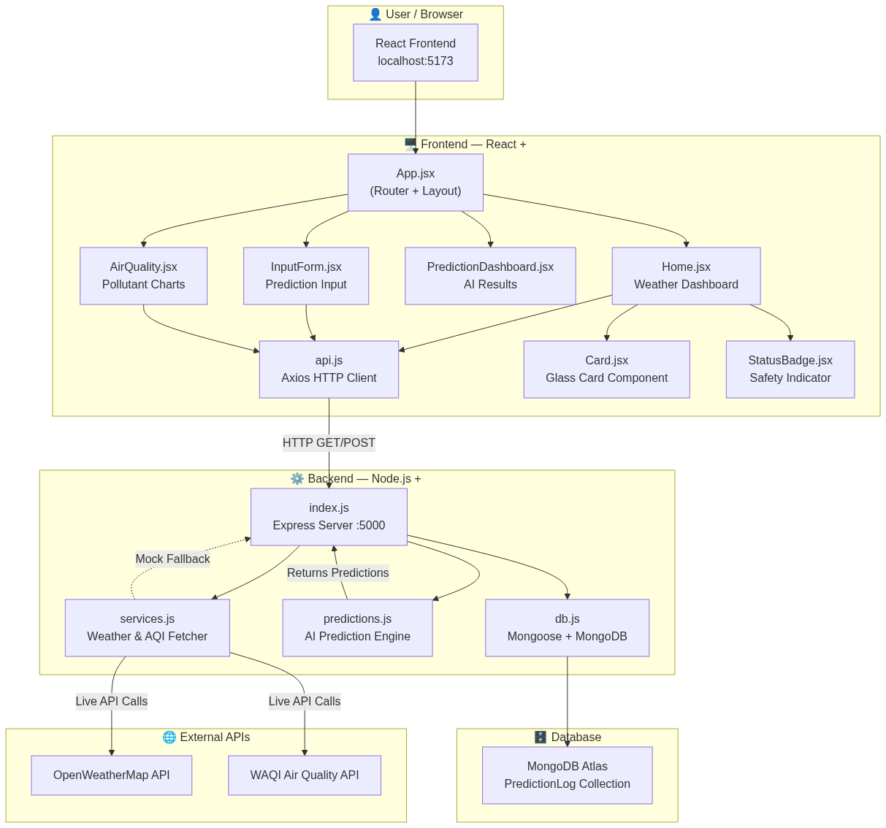

Diagram: Workflow_Diagram_2
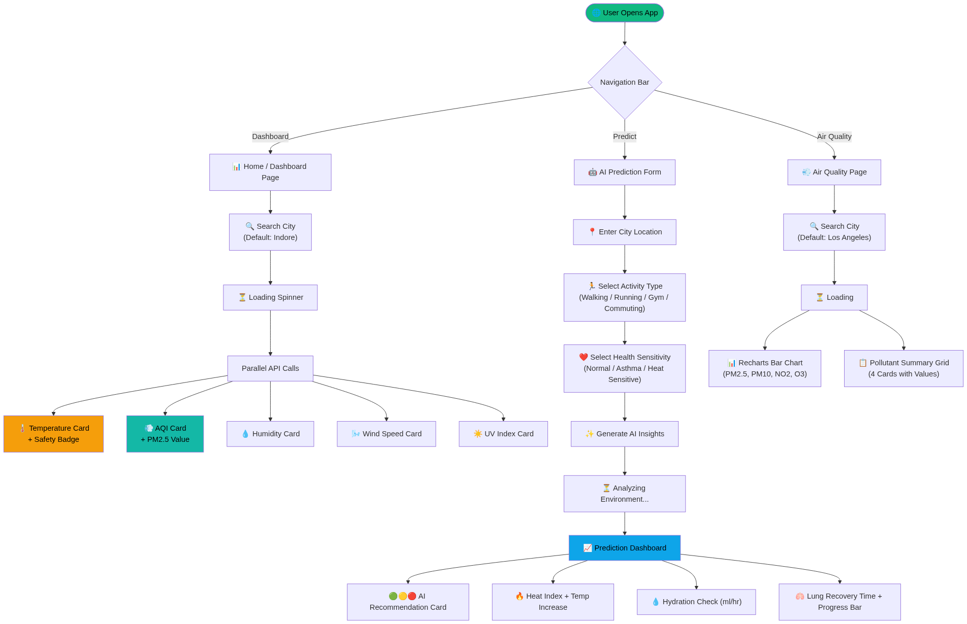

Diagram: Workflow_Diagram_5
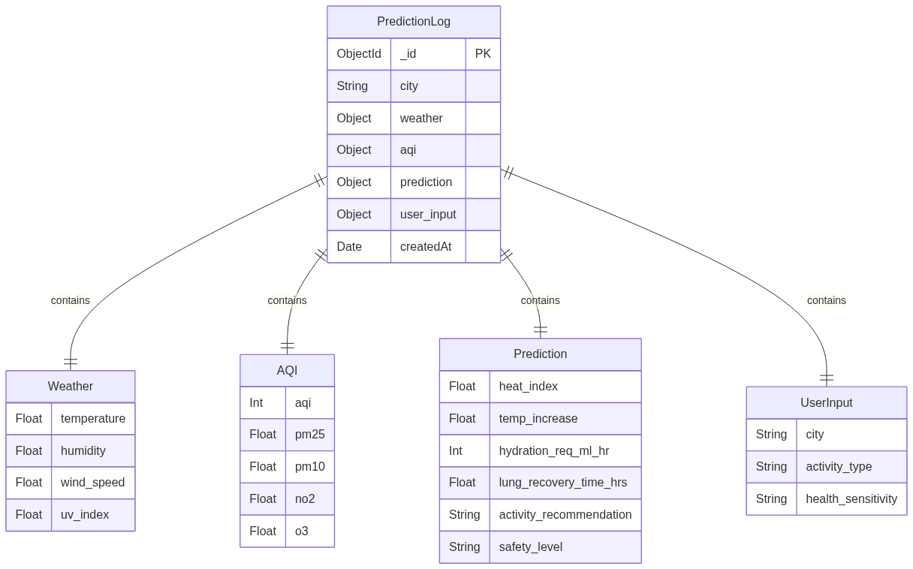

Diagram: Workflow_Diagram_6
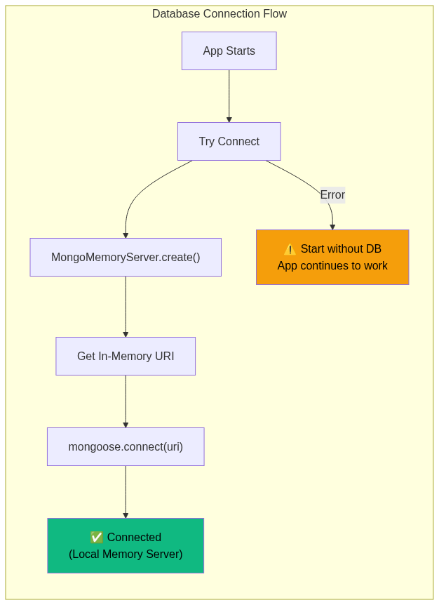

Diagram: Workflow_Diagram_8
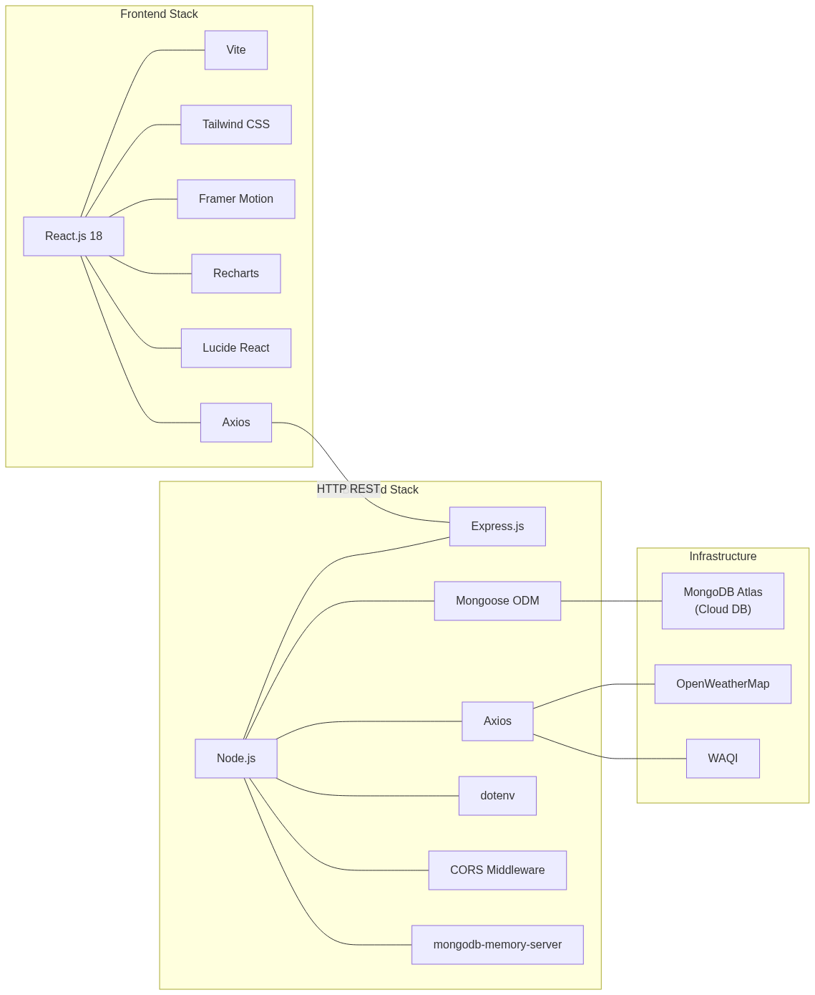

Diagram: Workflow_Diagram_9
